Supplementary material
Genome sequence analysis of H7N3 subtype avian influenza virus originated from wild birds and its potential infectivity in mice
Xin Yin¹, Tiantian Wu¹, Cheng Peng¹, Jinping Li, Shuo Liu, Guangyu Hou, Wenming Jiang*, Hualei Liu*
¹ These authors contributed equally to this work.
China Animal Health and Epidemiology Center, Qingdao, China.

Correspondence:
jiangwenming@cahec.cn
liuhualei@cahec.cn
Figure S1 shows phylogenetic relationships of NX/Y37 avian influenza virus (marked with ▲) with other avian influenza viruses circulating in recent years, based on the nucleotide sequences of their PB2 (Figure S1A), PB1 (Figure S1B), PA (Figure S1C), HA (Figure S1D), NP (Figure S1E), NA (Figure S1F), M (Figure S1G), and NS (Figure S1H) genes. Trees were constructed with MEGA6.05 software using the neighbor-joining method. Bootstrap analysis was performed with 1,000 replications and given at relevant nodes.

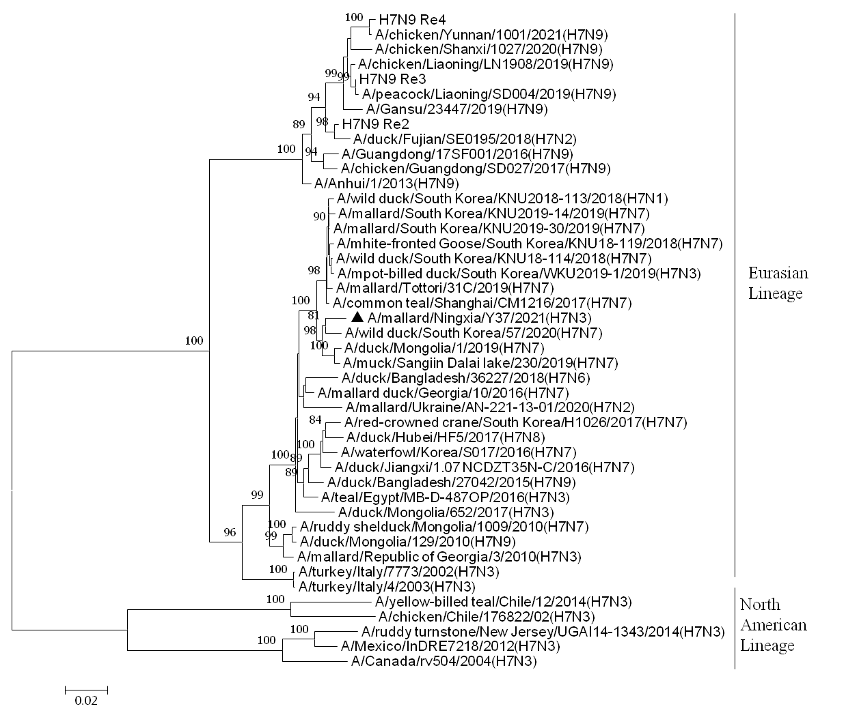
Figure S1A
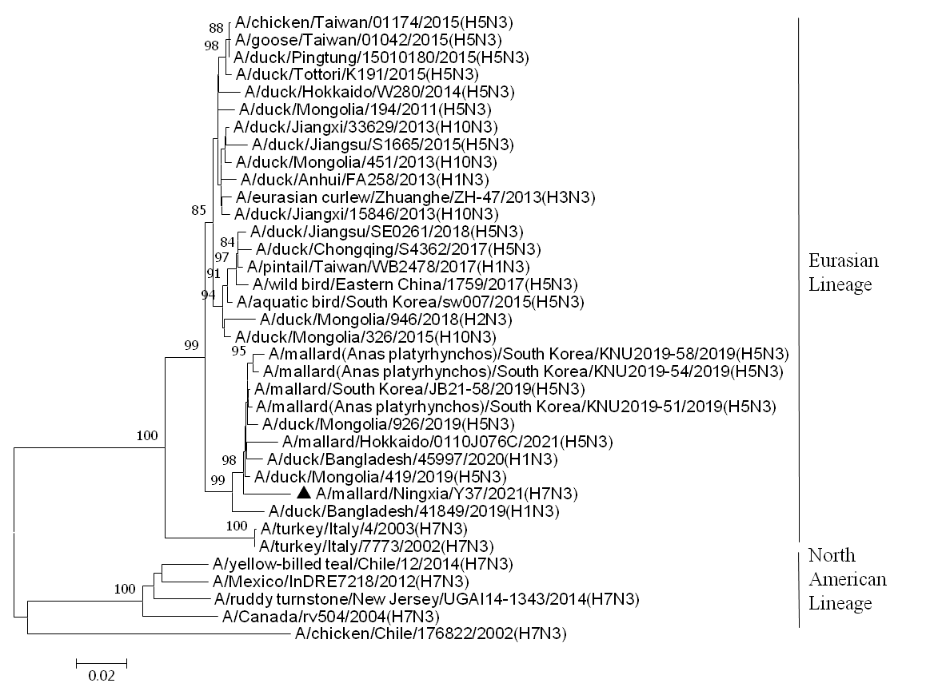
Figure S1B
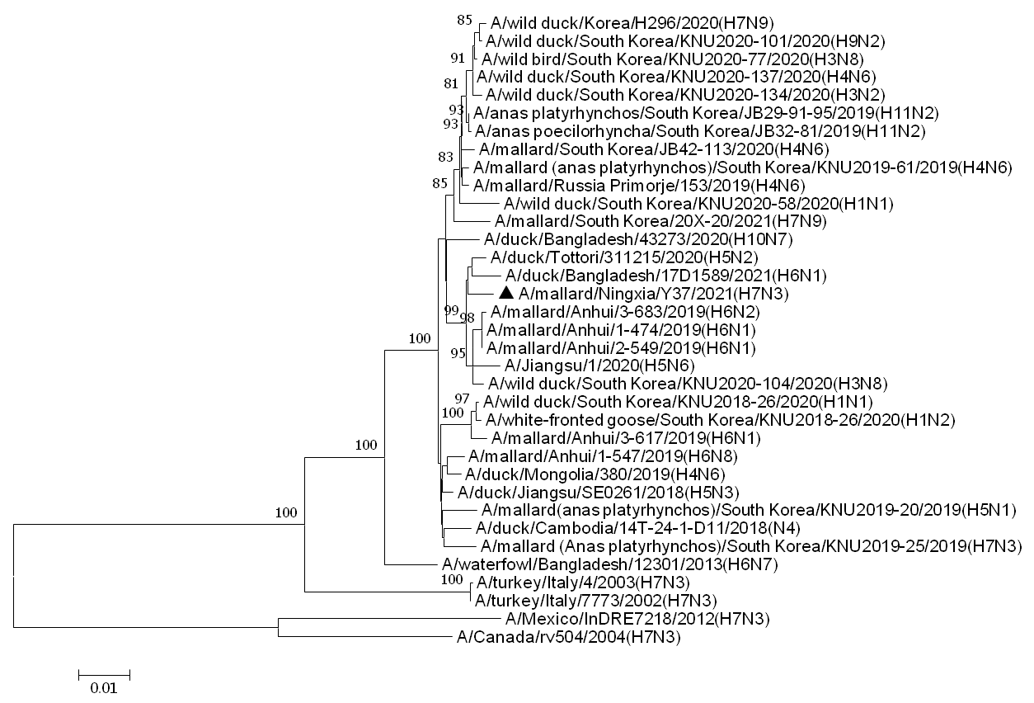
Figure S1C
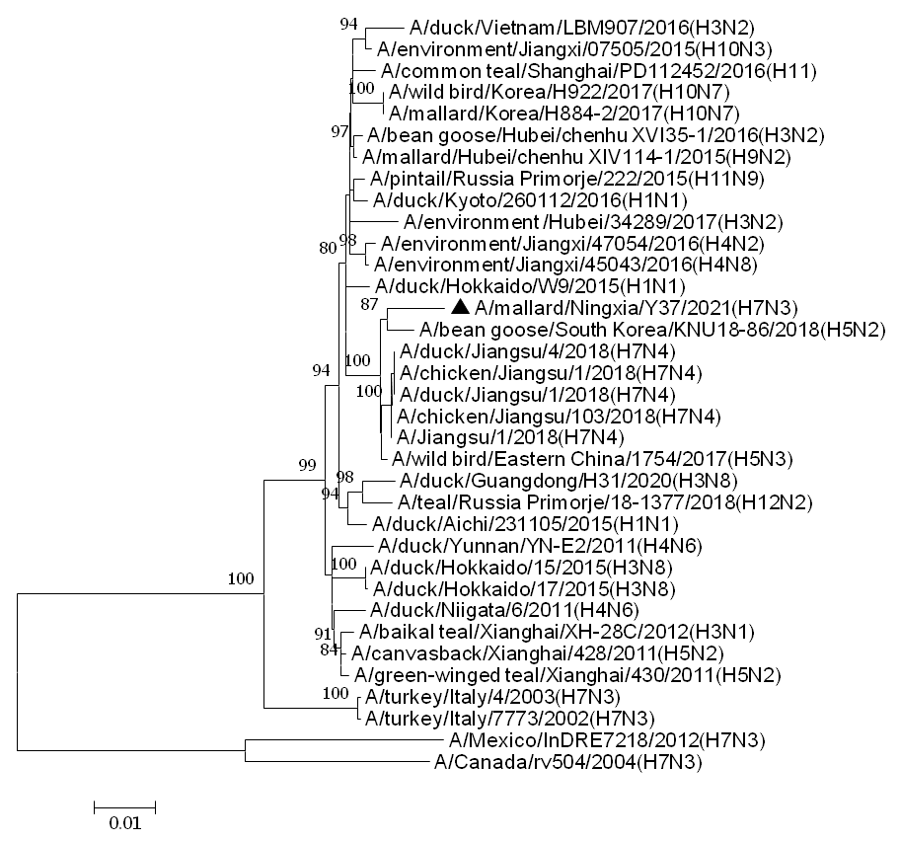
Figure S1D
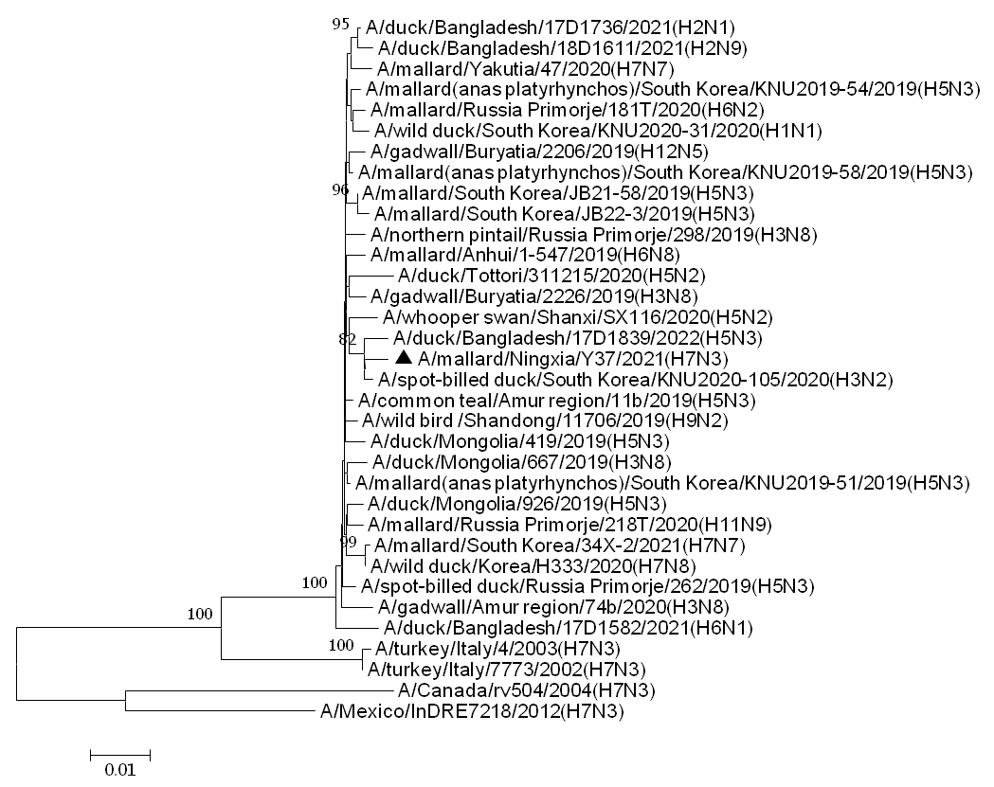
Figure S1E
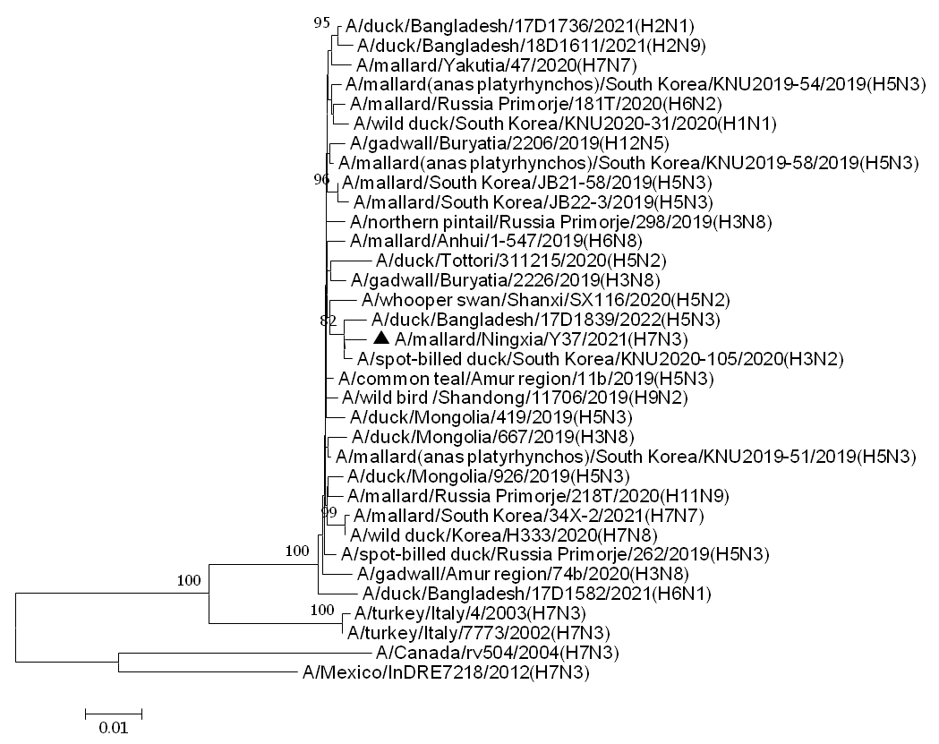
Figure S1F
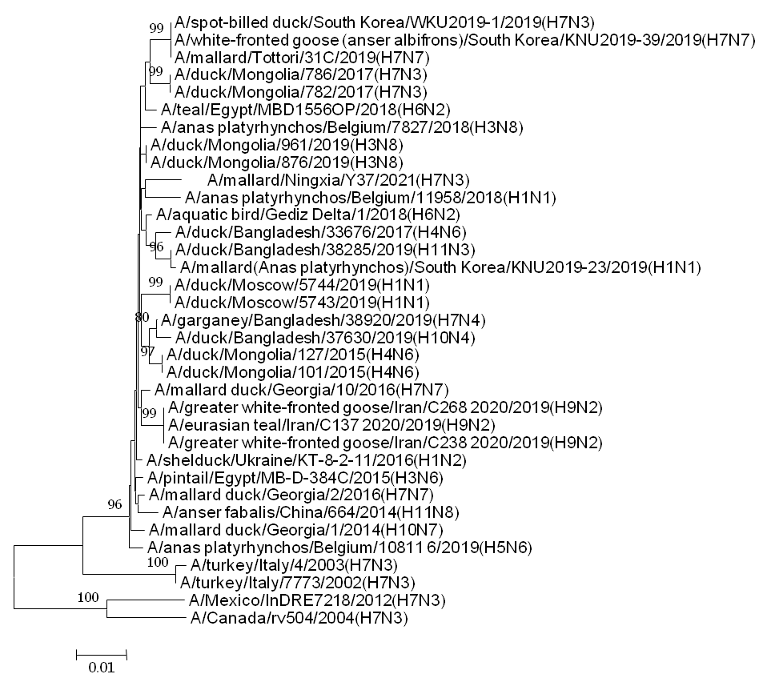
Figure S1G
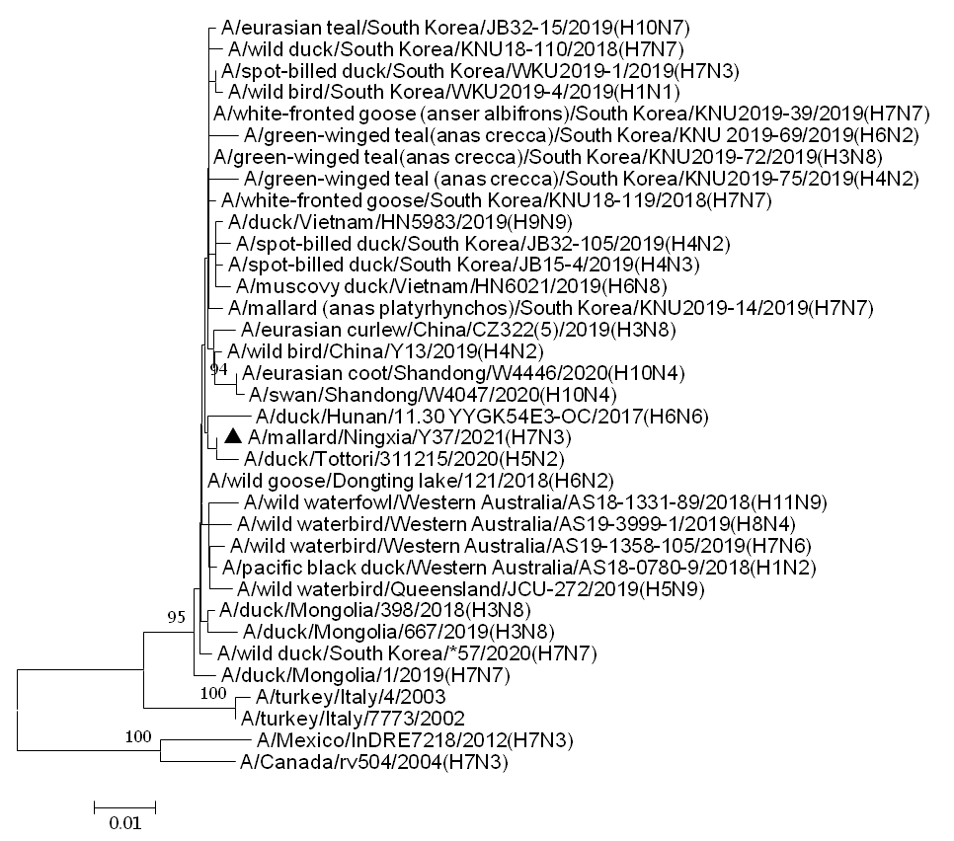
Figure S1H

