Supplementary Materials for
Anisotropic linear and nonlinear charge-spin conversion in Dirac semimetal SrIrO₃

Bin Lao^{1,2,7}, Peitao Liu^{3,7}, Xuan Zheng^{1,2,4,7}, Zengxing Lu^{1,2}, Sheng Li^{1,2}, Kenan Zhao^{1,2}, Liguang Gong^{1,2}, Tao Tang^{1,2}, Keyi Wu^{1,2}, You-guo Shi⁵, Yan Sun³, Xing-Qiu Chen³, Run-Wei Li^{1,2,6} and Zhiming Wang^{1,2,6*}

¹CAS Key Laboratory of Magnetic Materials and Devices, Ningbo Institute of Materials Technology and Engineering, Chinese Academy of Sciences, Ningbo 315201, China
²Zhejiang Province Key Laboratory of Magnetic Materials and Application Technology, Ningbo Institute of Materials Technology and Engineering, Chinese Academy of Sciences, Ningbo 315201, China
³Shenyang National Laboratory for Materials Science, Institute of Metal Research, Chinese Academy of Sciences, Shenyang 110016, China
⁴New Materials Institute, University of Nottingham Ningbo China, Ningbo 315100, China
⁵Institute of Physics, Chinese Academy of Sciences, Beijing 100190, China
⁶Center of Materials Science and Optoelectronics Engineering, University of Chinese Academy of Sciences, Beijing 100049, China
⁷These authors contributed equally: Bin Lao, Peitao Liu, Xuan Zheng.
*Email: zhiming.wang@nimte.ac.cn

S1. Angular dependence of second-harmonic longitudinal magnetoresistance

The simultaneously measured second-harmonic longitudinal magnetoresistance (R_{xx}^{2ω}) and nonlinear planar Hall effect (R_{xy}^{2ω}) as a function of angle φ are shown in Fig. S1, where φ denotes the angle between directions of an applied AC current I//[001] of 1 mA and an applied in-plane magnetic field H of 4 T. This result was obtained at 130 K because the R_{xx}^{2ω} is much noisier than R_{xy}^{2ω} at relative high temperature probably due to the large background first-harmonic component of magnetoresistance. A comparison of the angular dependences of R_{xx}^{2ω}(R_{xy}^{2ω}) exhibits sine(cosine)φ shape with a 90º angle offset as in the cases for the previous studies in Ref. [27-28]. Since the above dependence may also be ascribed to the Nernst effect, we convert the measured resistance to resistivity for a further comparison. The ratio ρ_{xy}^{2ω}/ρ_{xx}^{2ω} = (R_{xy}^{2ω}/R_{xx}^{2ω})(L/W) = 1.43, (L = 50 μm denotes the length between two adjacent voltage paths, and W = 10 μm denotes the width of current path), deviates from the isotropic contribution of longitudinal and transverse resistivity (ρ_{xy}^{2ω}/ρ_{xx}^{2ω} = 1) from the Nernst effect.
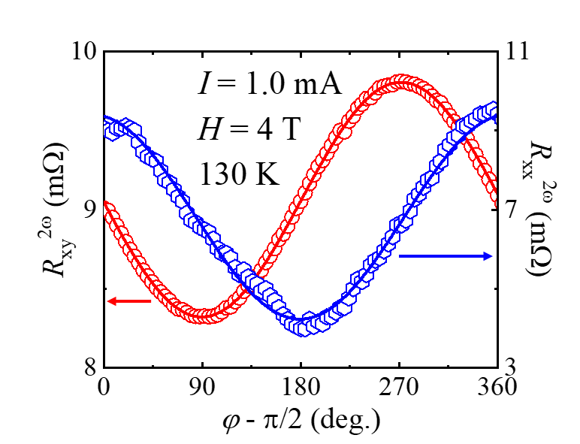
Fig. S1 Second-harmonic longitudinal magnetoresistance (R_{xx}^{2ω}) and nonlinear planar Hall effect (R_{xy}^{2ω}) as a function of angle φ.

S2. NHE results for charge current flows along SrIrO₃[1-10] and [001] directions at 130 K

The NHE measurements for current I//[1-10] were performed at low temperature of 130 K as a function of H, because the acquired V_{xy}^{2ω} signal is too noisy to extract the cosine component within the sensitivity of our measurement at 290 K. The extracted amplitudes ΔR_{xy}^{2ω} as a function of φ for varied H under a fixed I of 0.8 mA shown in Fig. S2(a). The ΔR_{xy}^{2ω} enhanced while H increasing from 3 to 5 T, and were plotted in Fig. S2(c). As stressed in our main text, the NHE results reflect the spin-momentum locking induced nonlinear spin currents orthogonal to the applied currents in the film plane. Thus the observation of NHE for I//[1-10] indicates a presence of nontrivial spin textures along SrIrO₃[001]. Correspondingly, we also measured the NHE signals of I//[001] at 130 K. The obtained ΔR_{xy}^{2ω} curves and the extracted amplitudes are shown in Fig. S2(b) and S2(c), respectively. As shown in Fig. S2(c), the slope of ΔR_{xy}^{2ω} against H for SrIrO₃[1-10] is about twofold than that for SrIrO₃[001]. The NHE coefficient Δρ_{xy}^{2ω}/(E_{x}H) at 130 K was estimated to be 0.111 mΩ·μm²·V⁻¹·T⁻¹ and 0.274 mΩ·μm²·V⁻¹·T⁻¹ for SrIrO₃[001] and SrIrO₃[1-10], respectively. For an appropriate comparison between the NHE and SOT results at 290 K, the value of Δρ_{xy}^{2ω}/(E_{x}H) for SrIrO₃[001] at 290 K was calculated by assuming the constant ratio of Δρ_{xy}^{2ω}/(E_{x}H) between the [001] and [1-10] directions when temperature changed from 130 K to 290 K. The results as described in the main texture and shown in Fig. 4(c).
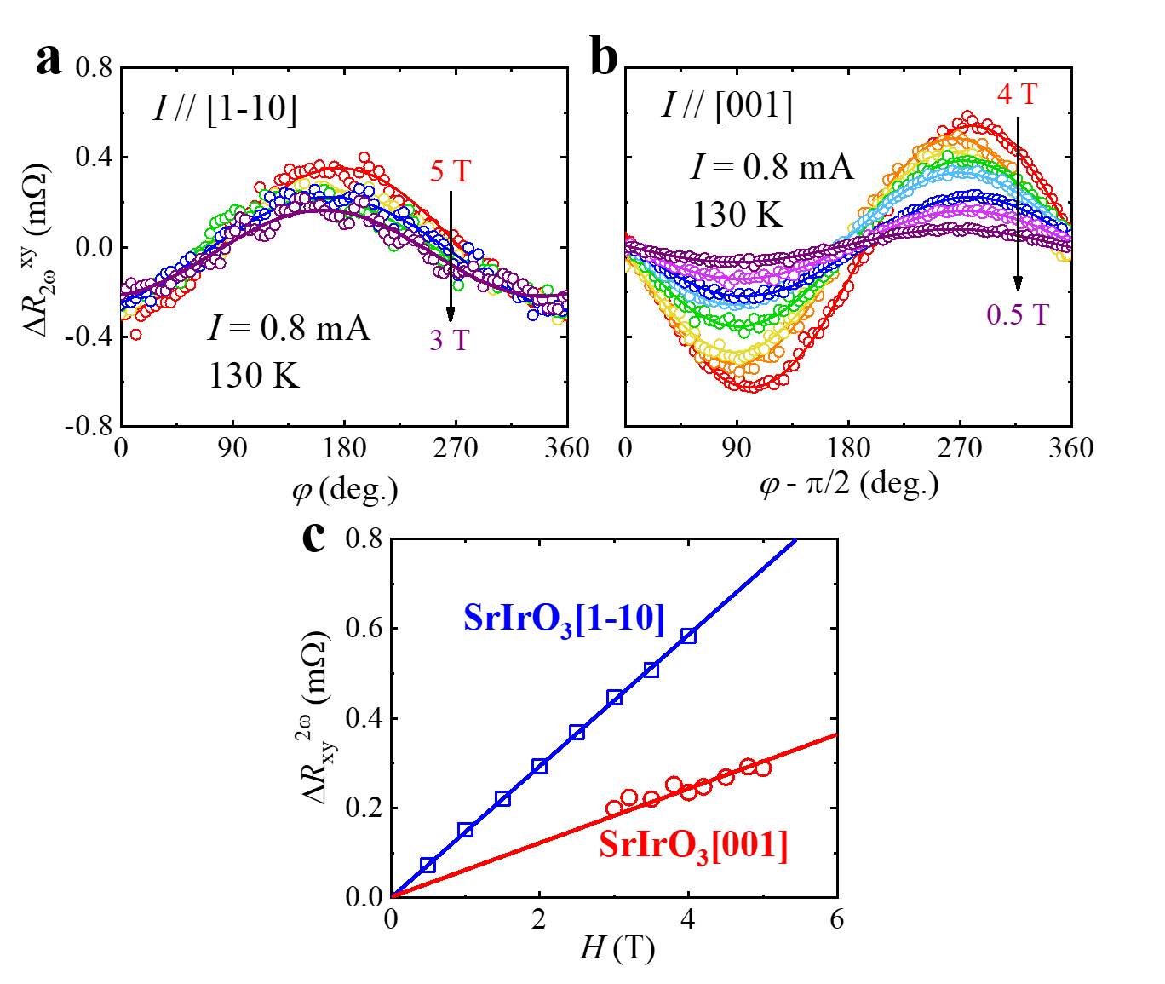
Fig. S2 a-b ΔR_{xy}^{2ω} as a function of φ with various H under a fixed I of 0.8 mA along [1-10] and [001] directions, respectively. c ΔR_{xy}^{2ω} for the SrIrO₃[001] (red opened circles) and SrIrO₃[1-10] (blue opened squares) directions at 130 K.

S3. SOT results for charge current flows along SrIrO₃[1-10] direction

The typical angular-dependent second harmonic Hall voltage V_{xy}^{2ω} for I//[1-10] was shown in Fig. S3(a). Using the Eqs.(1)-(3), the experimental data were well reproduced by considering both dampinglike and fieldlike contributions. Accordingly, the dampinglike voltage V_{DL} and fieldlike voltage V_{FL} were plotted as a function of 1/(H + H_{K}) and 1/H by varying the magnitudes of I and H, as shown in Fig. S3(b) and S3(c), respectively. The dampinglike and fieldlike effective fields, H_{DL} and H_{FL}, then were obtained from the slope of the linear fits and excluded the currents induced Oersted field, which plotted against current density J in SrIrO₃ in Fig. S3(d). The values of H_{DL}/J and H_{FL}/J were determined to be -18.9±0.7 Oe/(10¹¹ A/m²) and -27.5±0.2 Oe/(10¹¹ A/m²).
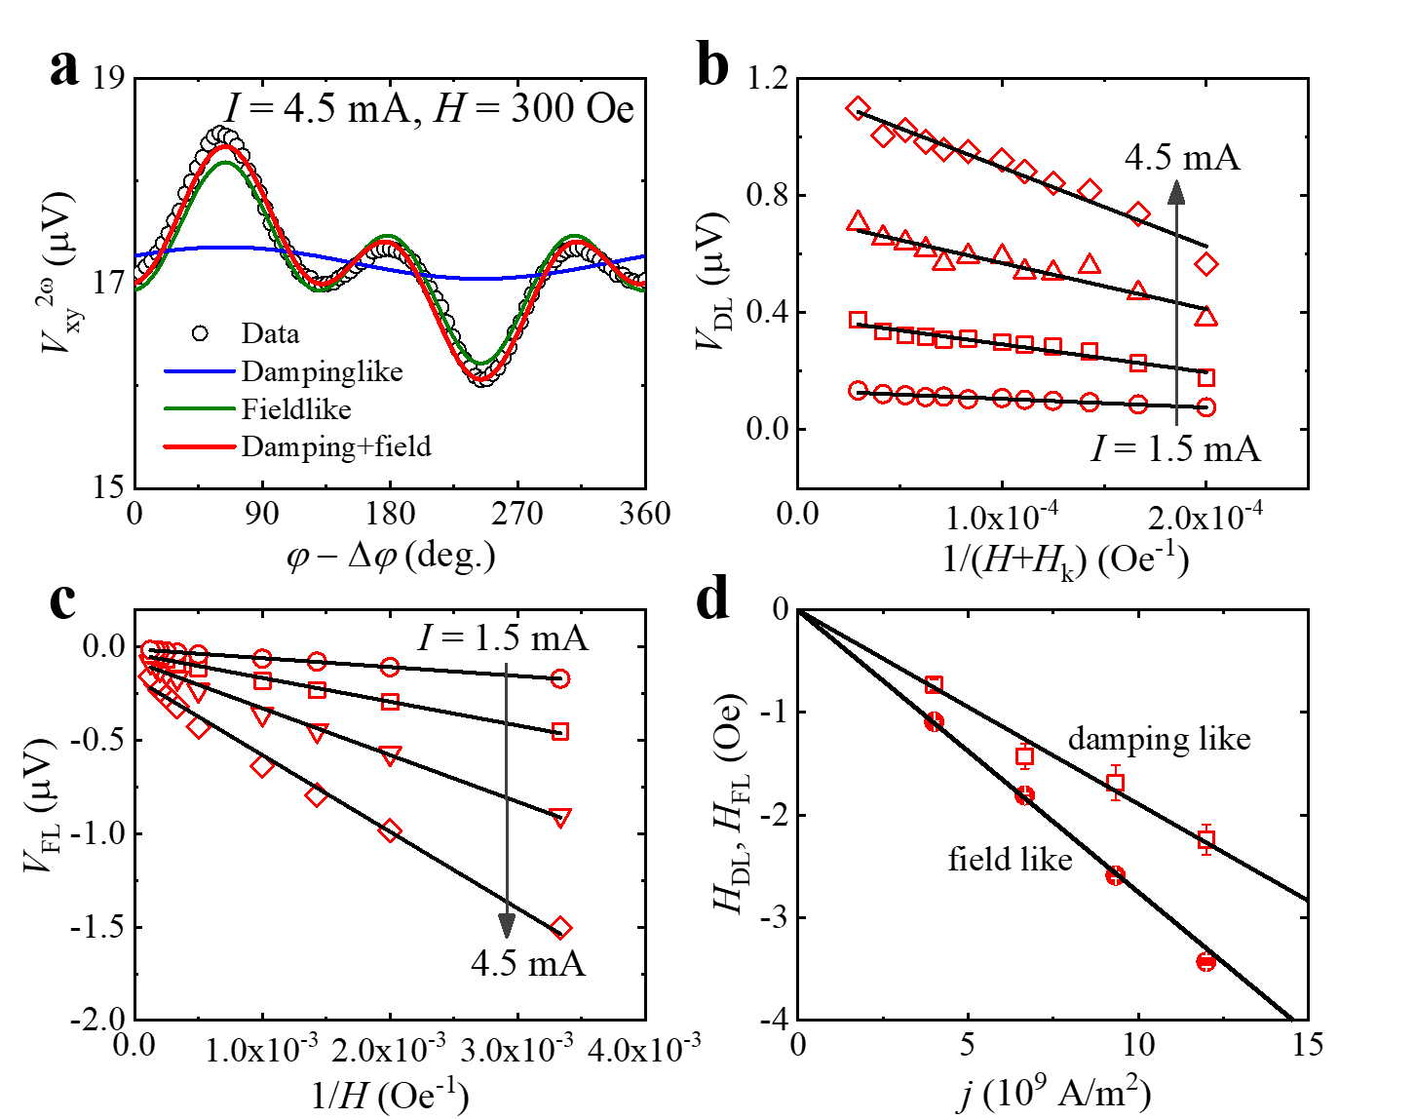
Fig. S3 a The typical angular dependent second harmonic Hall voltage V_{xy}^{2ω} and the fitted curves of the dampinglike and fieldlike components. b-c The dependence of extracted dampinglike voltage V_{DL} and fieldlike voltage V_{FL} for I varied from 1.5 to 4.5 mA on 1/(H + H_{k}) and 1/H, respectively. d The effective dampinglike and fieldlike fields, H_{DL} and H_{FL}, as a function of the SrIrO₃ layer current density J.

