Extended Data

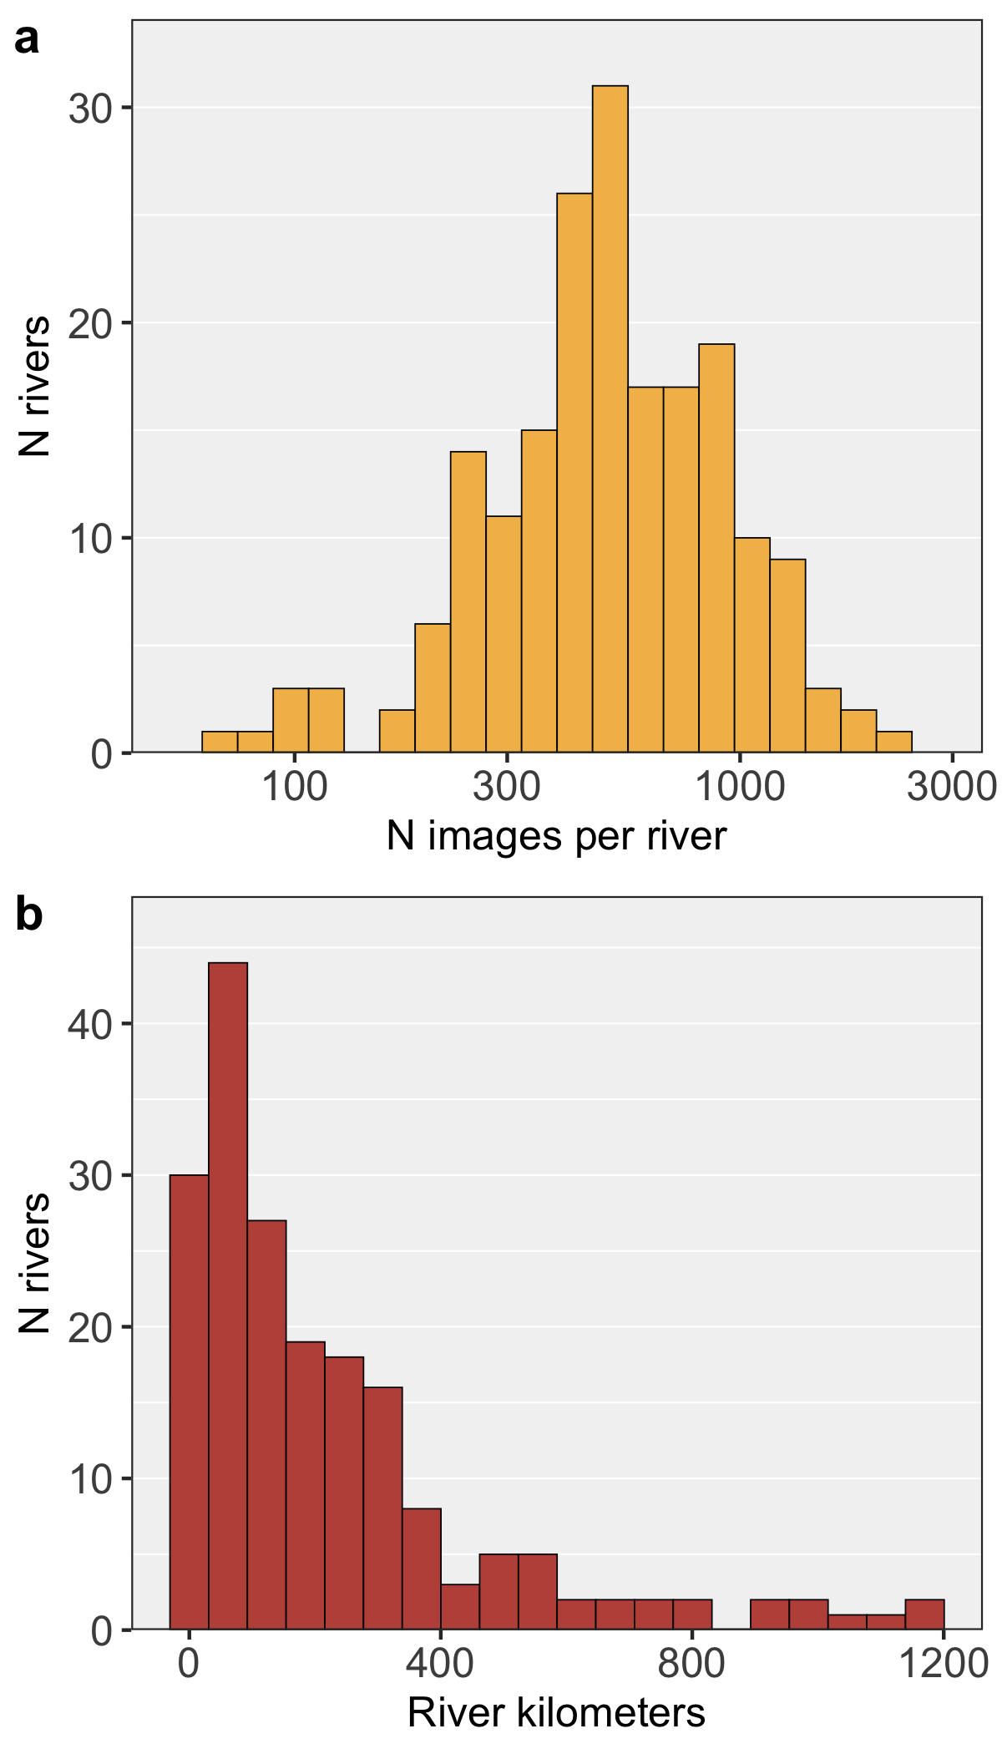
Extended Data Fig. 1. River mining Landsat image coverage. Summary plots of Landsat 5 and 7 image availability for each river transect. a, The number of images from unique days per river (mean = 595 images). b, the mapped length of each river transect (N = 173 rivers).
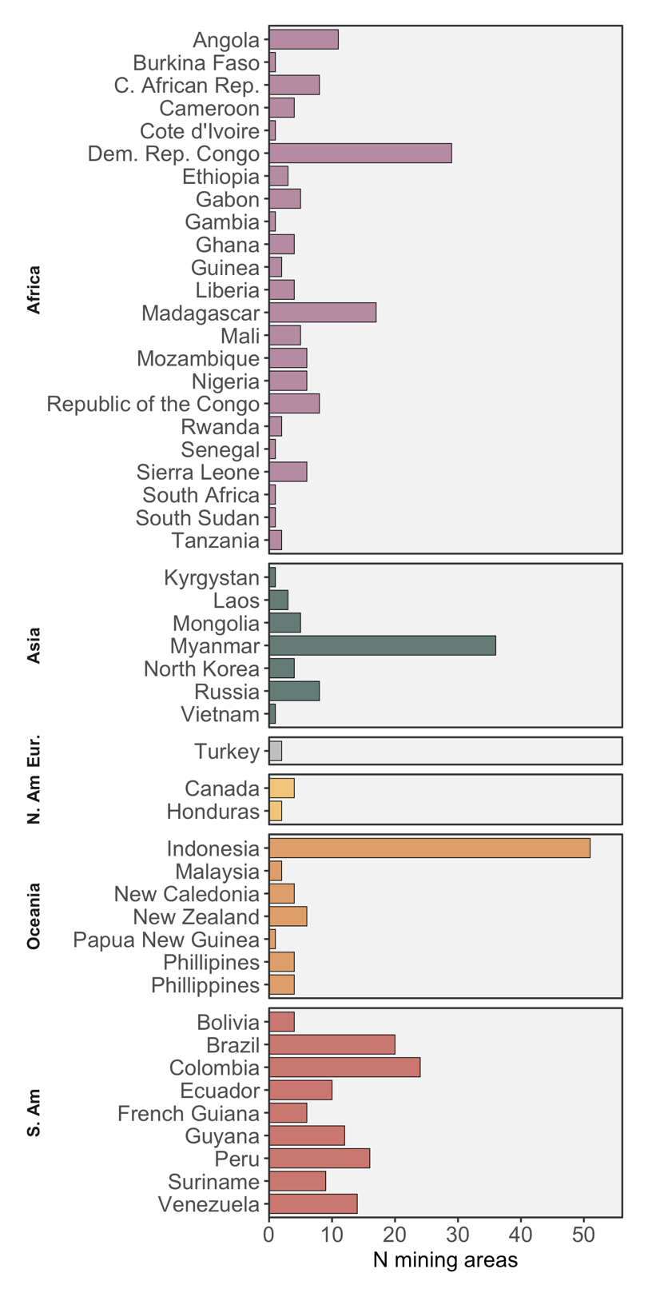
Extended Data Fig. 2. Mining areas by land mass and country. Breakdown of the number of discrete mining areas active during the Landsat record and mapped in each country (total N = 381), organized by major land mass.

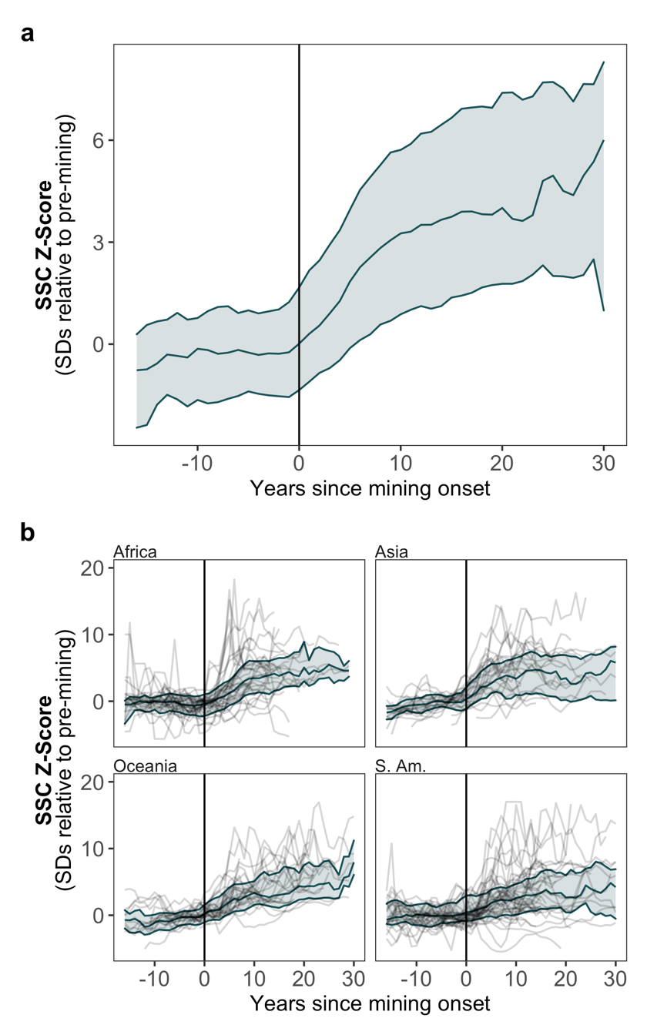
Extended Data Fig. 3. Rapid river response to mining. a, b, Chronology of average suspended sediment concentration Z-Score relative to pre-mining distributions. Year 0 is the estimated year of mining onset, with negative values showing the pre-mining period. a, An aggregate analysis of all the rivers in the study shows the global signal. b, River SSC response to mining is divided by major land mass and shows the trajectory of each river in the analysis in transparent lines. In each plot, the median value is represented by a solid line; the interquartile ranges are shaded. Rivers with mining initiated before the Landsat 5 mission began in 1984 are excluded from this analysis.

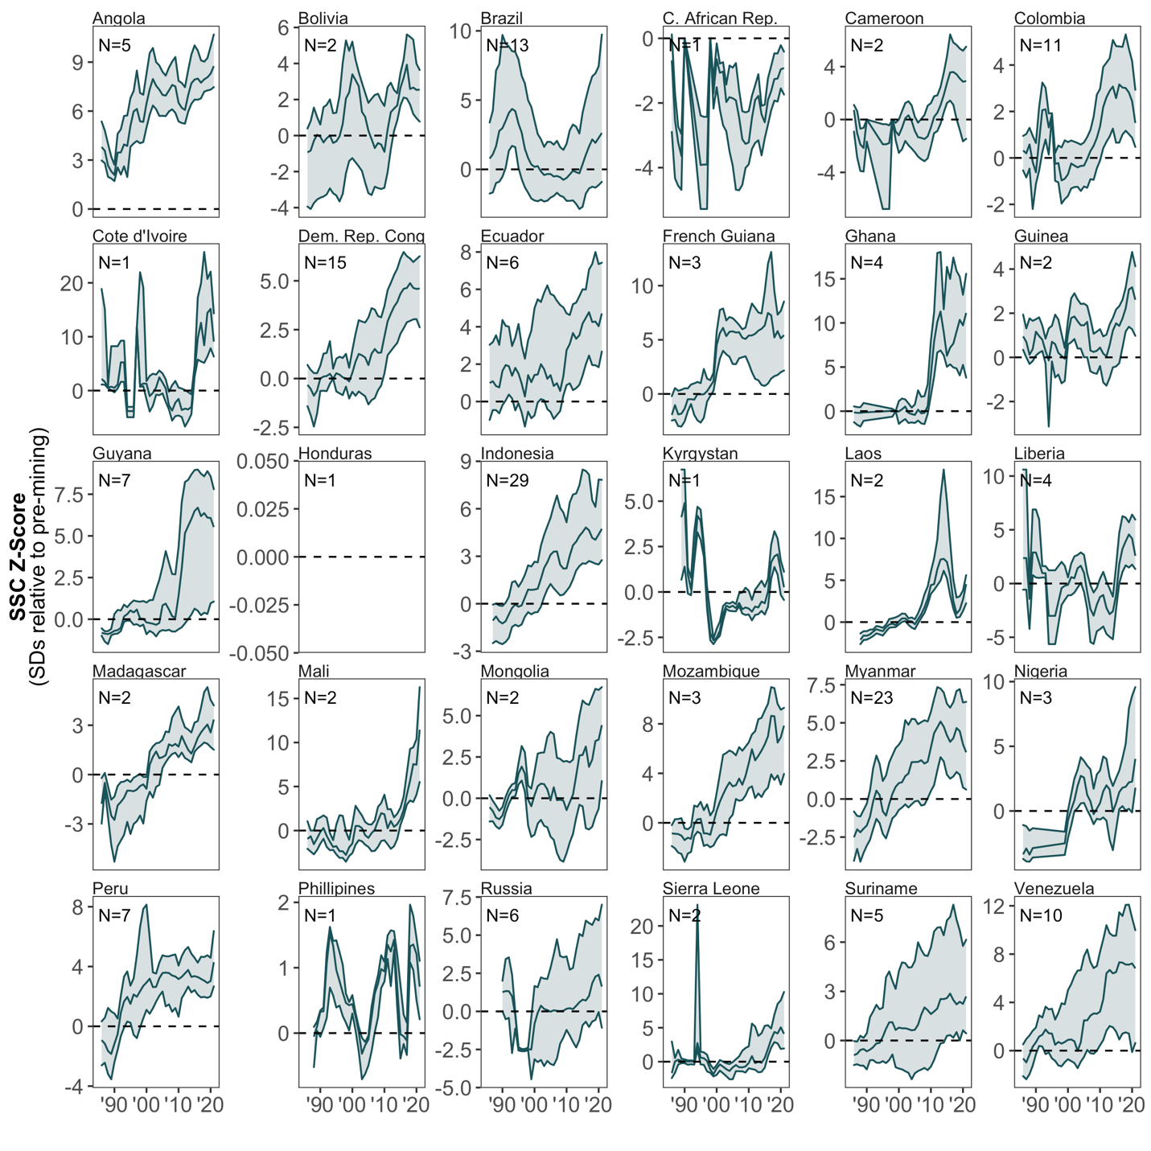
Extended Data Fig. 4. River response to river mining, by country. Change in river suspended sediment concentration relative to the pre-mining average for each country. The dashed line is the 3-year running median and the shaded ribbon spans the interquartile range.
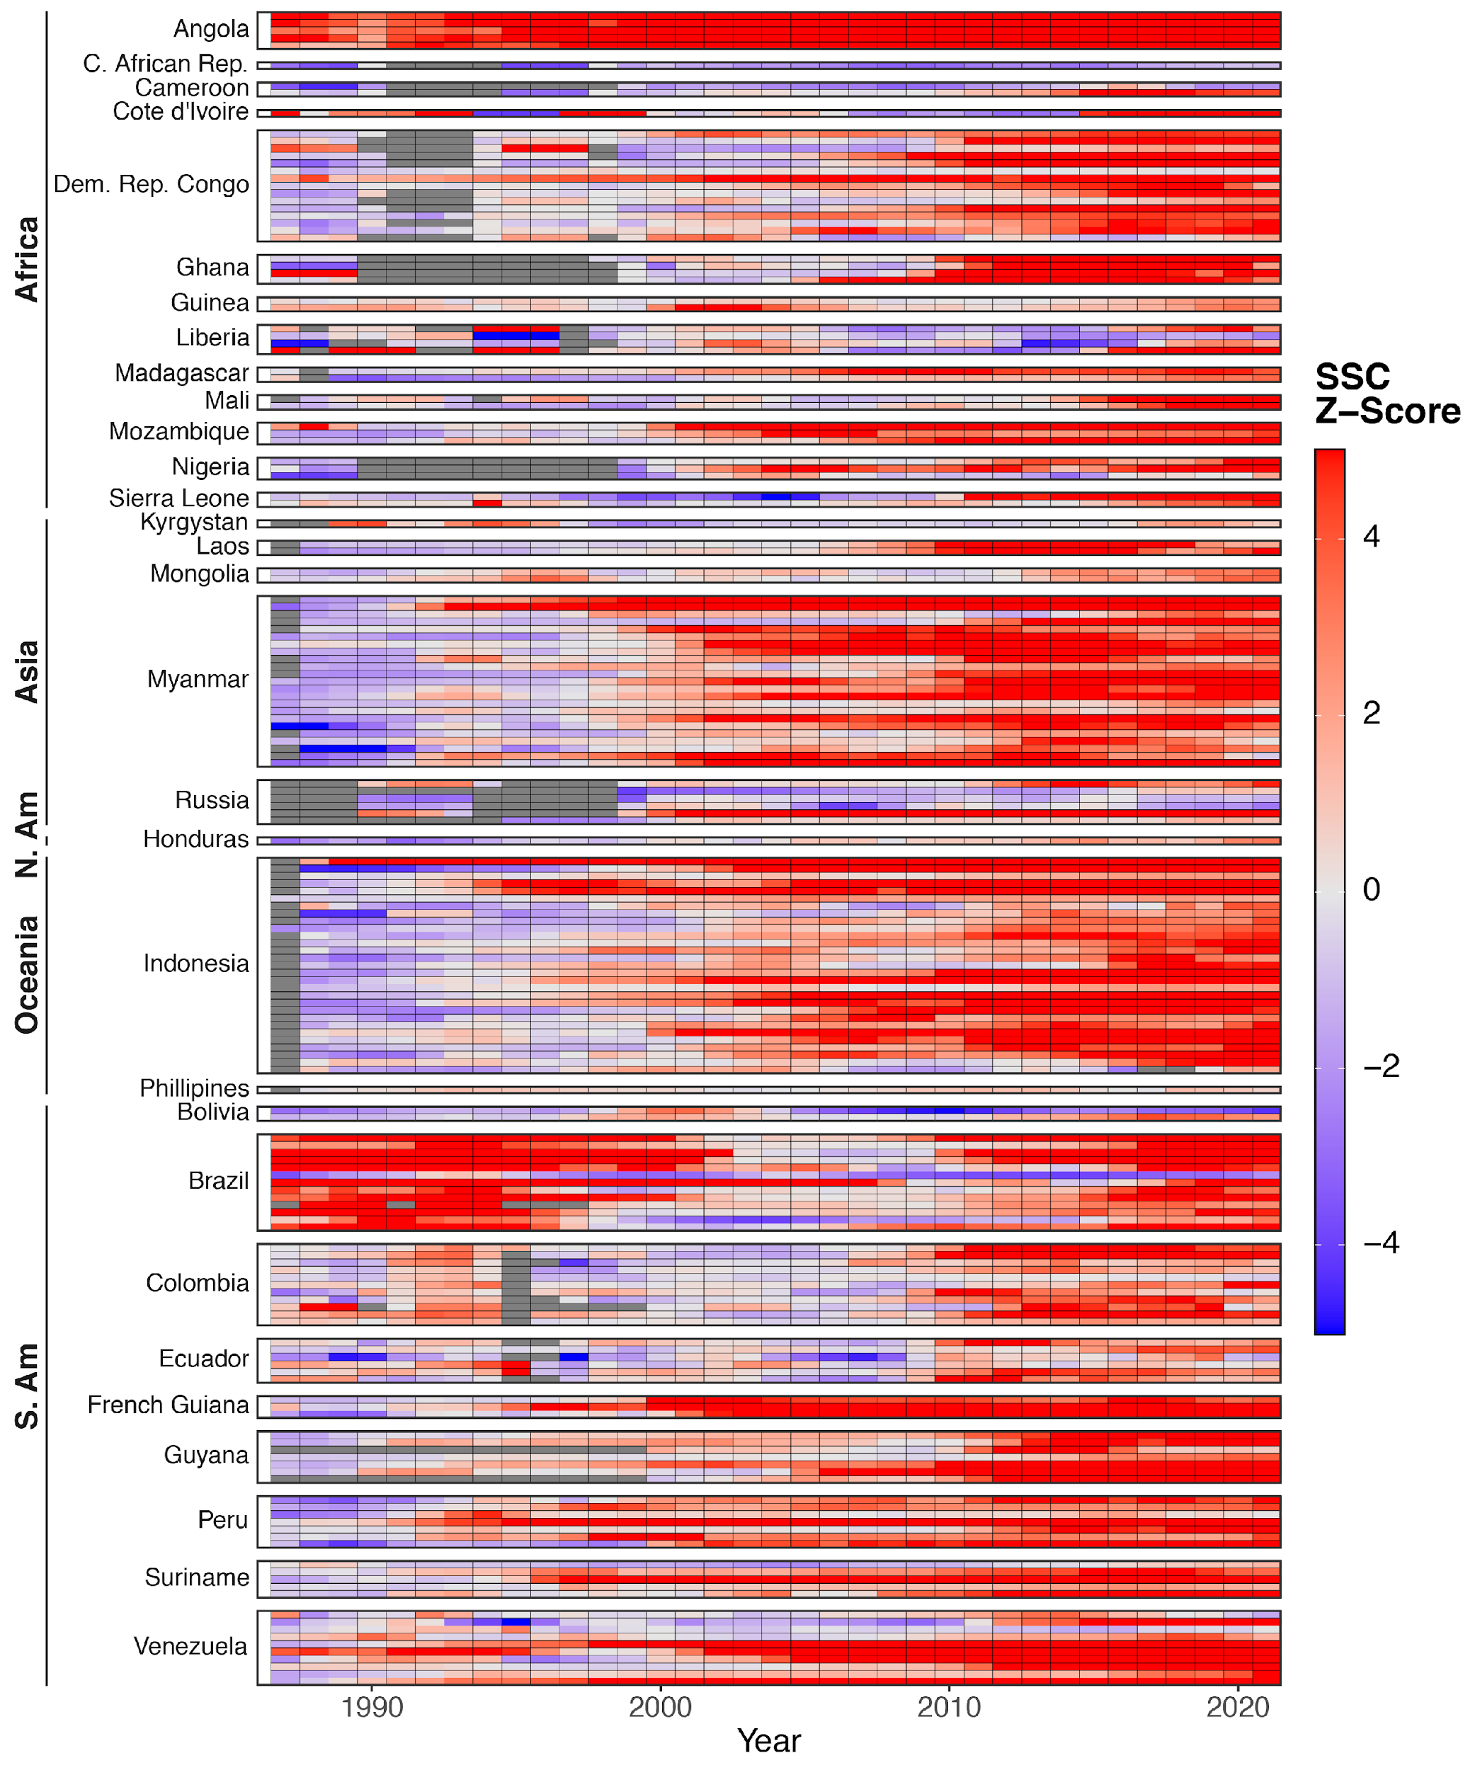
Extended Data Fig. 5. Chronology of river mining impacts, by river. Post-mining change in suspended sediment concentration, as measured by Z-Scores, relative to pre-mining conditions or an unmined analog in each river system affected by river mining. Z-Scores are computed on a 3 year running average basis to dampen outlier effects from individual years, particularly those with sparse data.
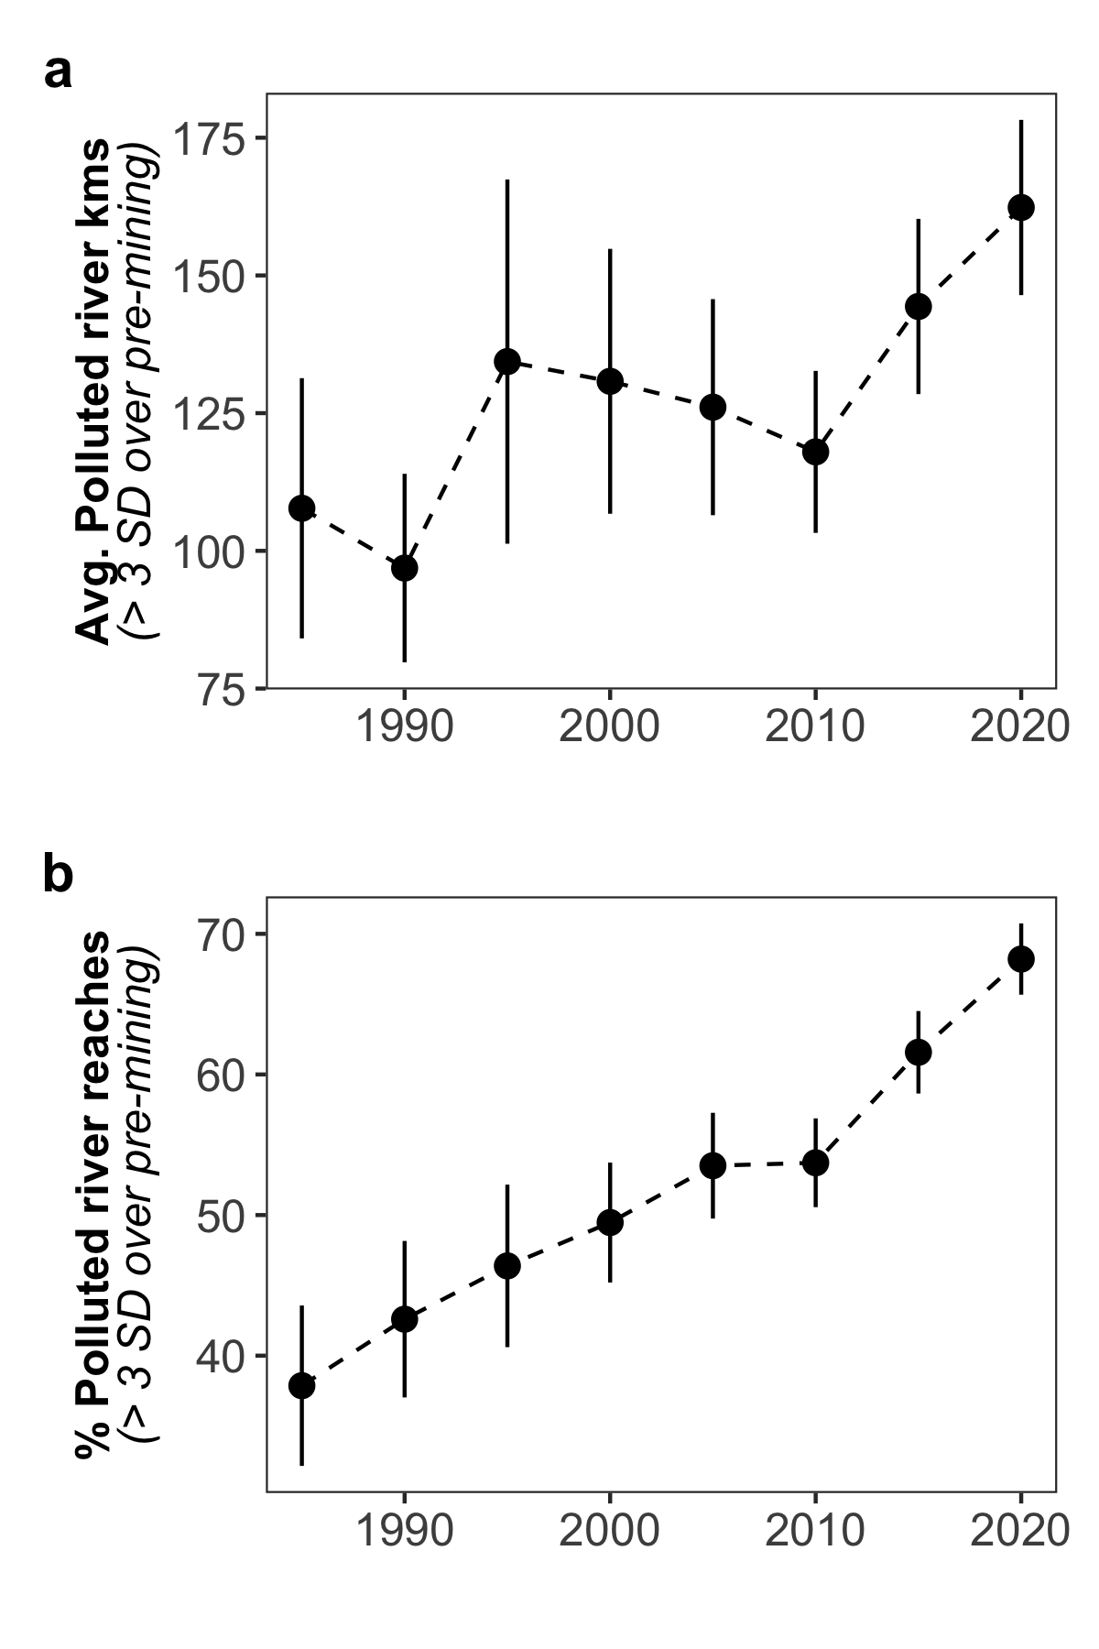
Extended Data Fig. 6. Length of river transects affected by mining. a, The average number of river kilometers at active mining sites affected by river mining with >3 SD increase in SSC relative to the reference period. b, The average percentage of river kilometers in a given mining-affected transect with a >3 SD increase in SSC relative to the reference period. Error bars indicate the standard error in the mean.

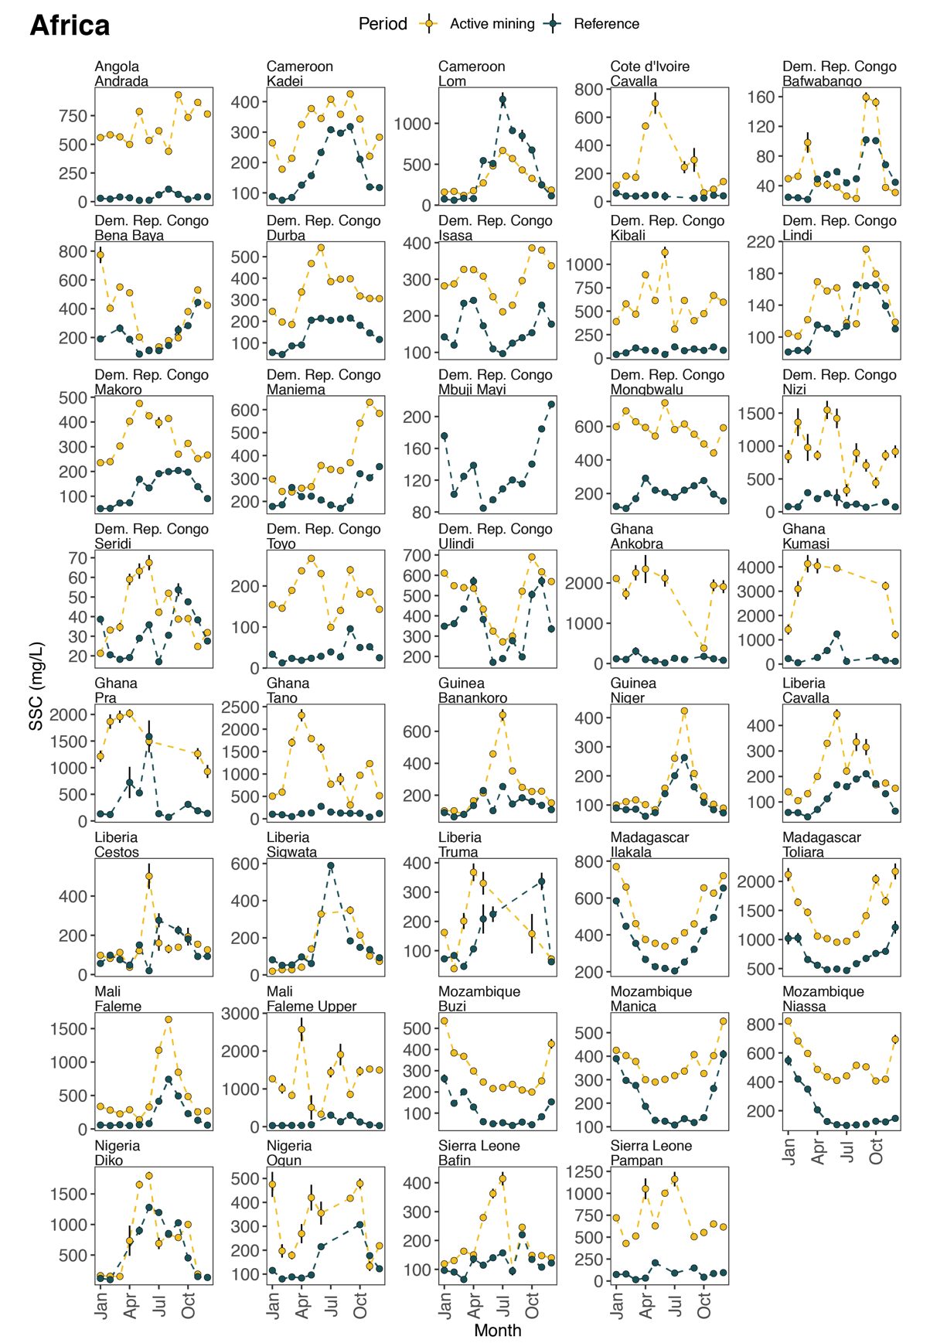
Extended Data Fig. 7. Reference and post-mining monthly average suspended sediment concentration on rivers in Africa. Error bars indicate the standard error in the mean, computed for that month across all years and river reaches in the satellite record for reference reaches (no mining, blue) and active mining reaches (along or downstream of active mining, yellow).
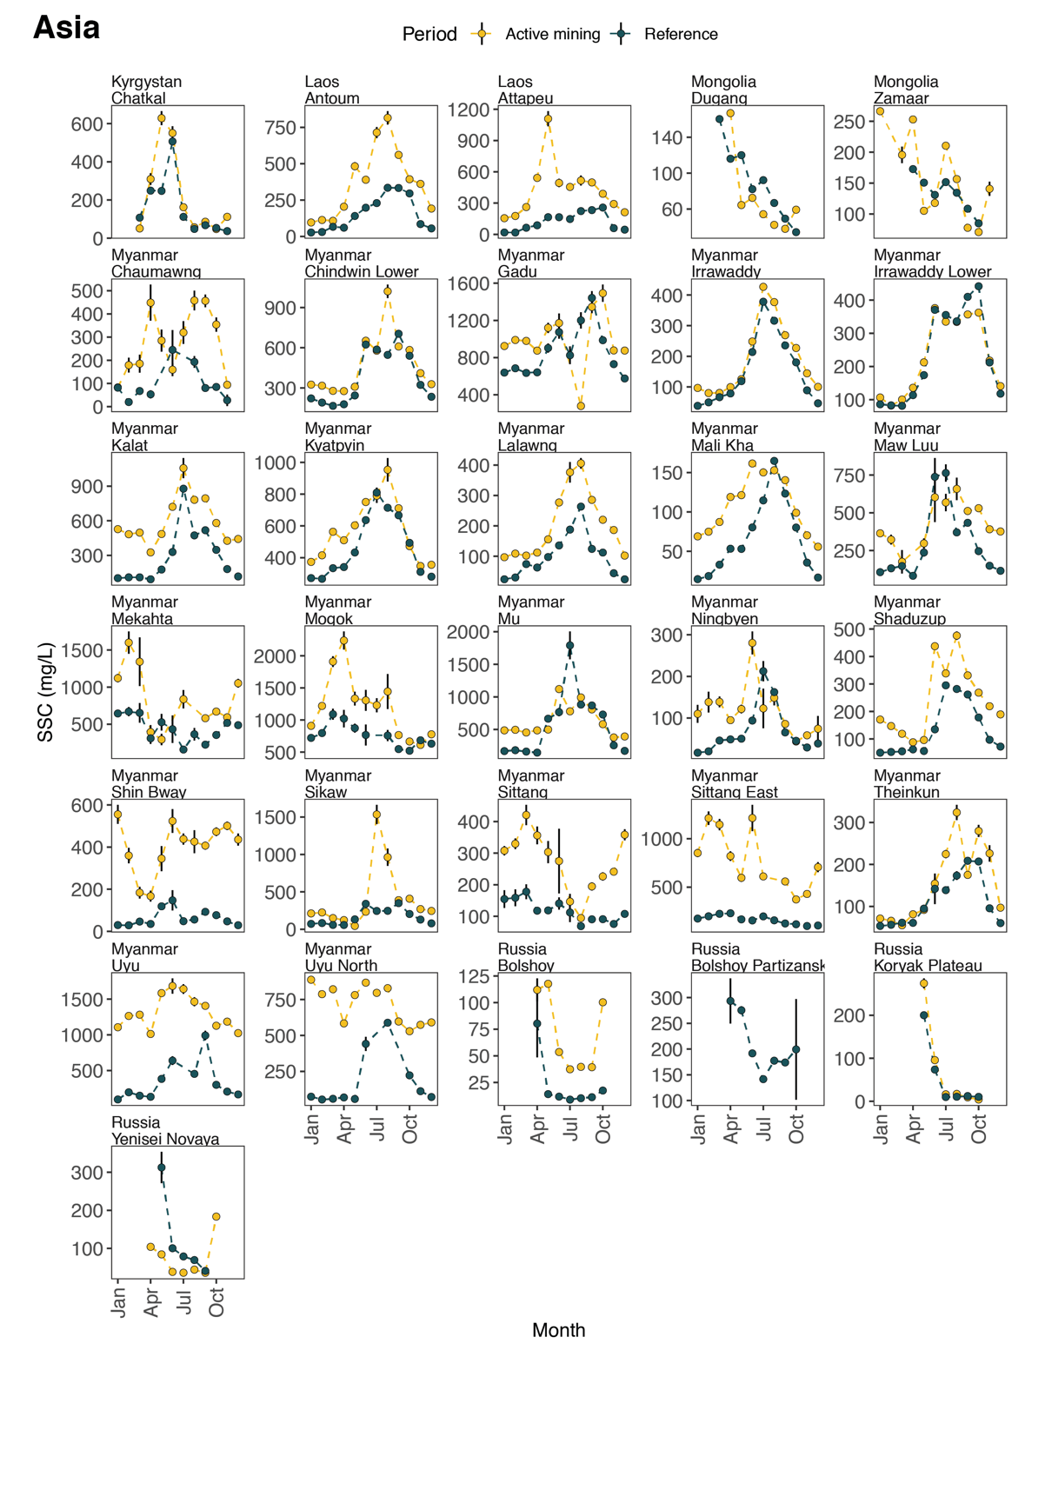
Extended Data Fig. 8. Reference and post-mining monthly average suspended sediment concentration on rivers in Asia. Error bars indicate the standard error in the mean, computed for that month across all years and river reaches in the satellite record for reference reaches (no mining, blue) and active mining reaches (along or downstream of active mining, yellow).
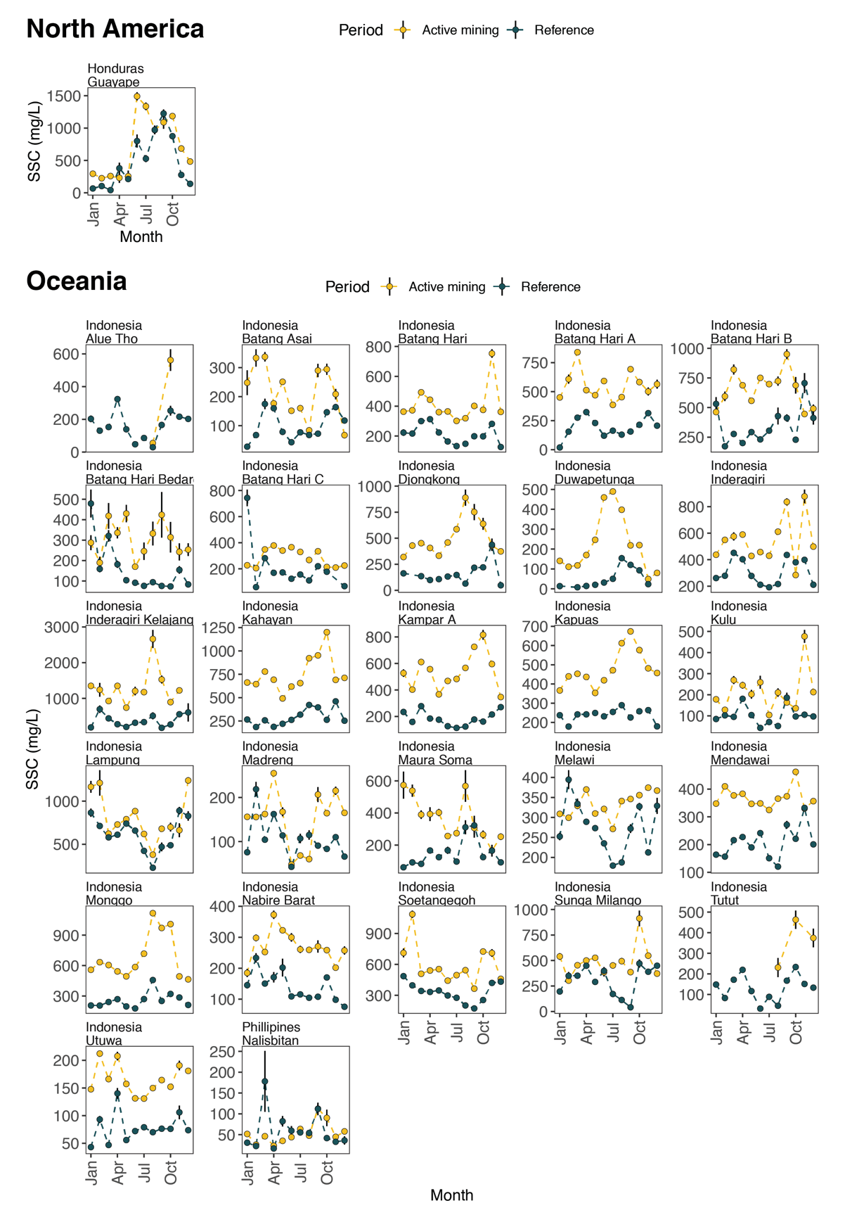
Extended Data Fig. 9. Reference and post-mining monthly average suspended sediment concentration on rivers in North America and Oceania. Error bars indicate the standard error in the mean, computed for that month across all years and river reaches in the satellite record for reference reaches (no mining, blue) and active mining reaches (along or downstream of active mining, yellow).
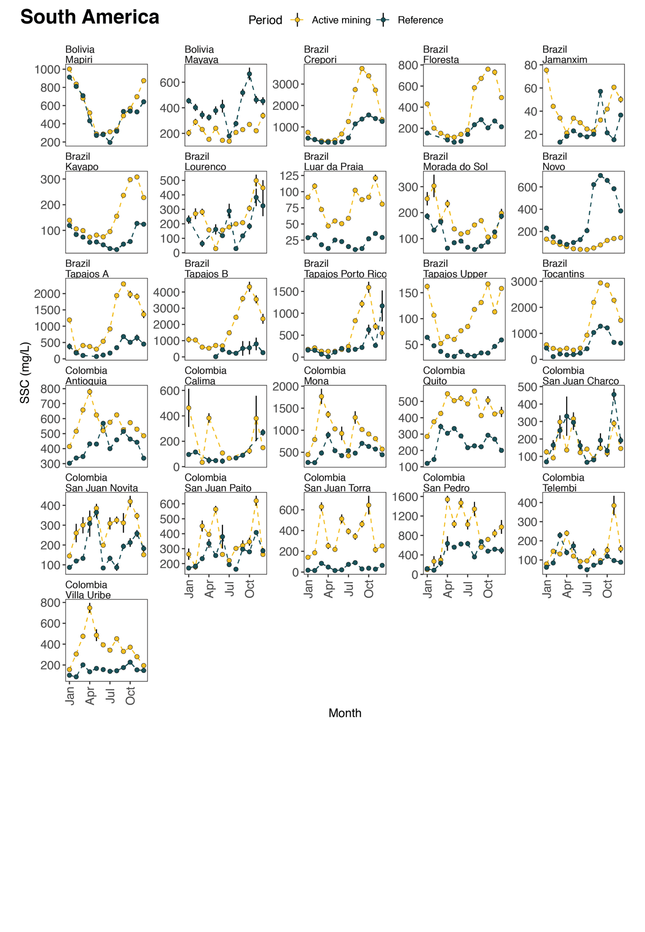
Extended Data Fig. 10. Reference and post-mining monthly average suspended sediment concentration on some rivers in South America. Error bars indicate the standard error in the mean, computed for that month across all years and river reaches in the satellite record for reference reaches (no mining, blue) and active mining reaches (along or downstream of active mining, yellow).
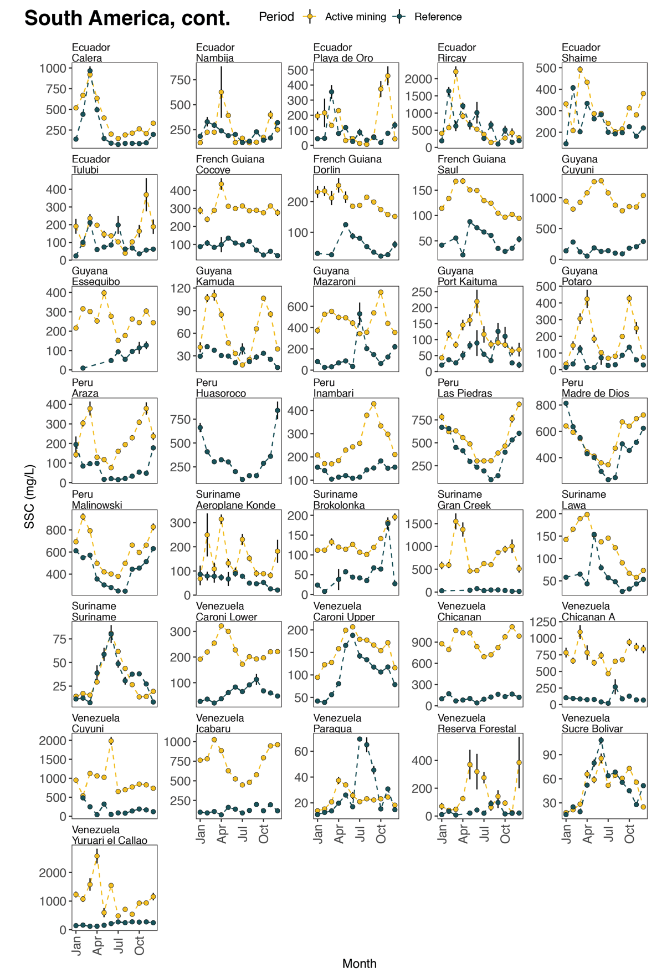
Extended Data Fig. 11. Reference and post-mining monthly average suspended sediment concentration on the remaining rivers in South America. Error bars indicate the standard error in the mean, computed for that month across all years and river reaches in the satellite record for reference reaches (no mining, blue) and active mining reaches (along or downstream of active mining, yellow).
Extended Data Table 1. River reaches with suspended sediment concentration elevated by 2, 5, and 10 times above the pre-mining mean. All values are computed for 2015–2020. Percentages are computed as the length of river with elevated SSC divided by the length of the river along or downstream of active river mining.
Reaches with elevated SSC
(relative to pre-mining)
 | 2x above (km) | 5x above (km) | 10x above (km) | Total active mining (km)
Africa | 9,240 | 4,580 | 2,260 | 15,550
 | 59% | 29% | 15%
N Rivers | 39 | 21 | 12
Asia | 2,220 | 710 | 100 | 6,910
 | 32% | 10% | 1%
N Rivers | 24 | 11 | 2
N. Am. | 10 |  |  | 90
 | 11% | 0% | 0%
N Rivers | 1
Oceania | 3,920 | 710 | 10 | 5,820
 | 67% | 12% | 0%
N Rivers | 25 | 12 | 1
S. Am. | 5,690 | 2,390 | 1,130 | 13,170
 | 43% | 18% | 9%
N Rivers | 51 | 29 | 18
Total | 21,080 | 8,390 | 3,500 | 41,540
 | 51% | 20% | 8%
N Rivers | 140 | 73 | 33

