Tables

Table S1: Sample metadata

Sample Metadata
Cicada tissue samples dissected and sequenced (16s V4 rRNA amplicons)
ID | Country | State | Locality | Dataset | Genus | Species | Tissue Type | Sex | Stage | Elevation (m) | Habitat | Latitude | Longitude | Collection Date
JK-02 | NZ | HB | ESK | B1 | Kikihia | muta-NI | gut | male | adult | 24 | grass | -39.3879 | 176.8219 | 2017
JK-26 | NZ | WN | HVY | B1 | Kikihia | muta-NI | gut | male | adult | 46 | grass | -41.1342 | 175.0151 | 2010
JK-88 | NZ | MC | BPT | B1 | Kikihia | muta-SI | gut | male | adult | 4 | grass | -43.78 | 172.7882 | 2008
JK-91 | NZ | MC | BPT | B1 | Kikihia | muta-SI | gut | male | adult | 4 | grass | -43.78 | 172.7882 | 2008
JK-112 | NZ | DN | SGB | B1 | Kikihia | muta-SI | gut | male | adult | 6 | grass | -44.9475 | 171.1405 | 2008
JK-115 | NZ | DN | SGB | B1 | Kikihia | muta-SI | gut | male | adult | 6 | grass | -44.9475 | 171.1405 | 2008
JK-29 | NZ | KA | WRD | B1 | Kikihia | muta-SI | gut | male | adult | 33 | grass | -41.8266 | 174.1374 | 2012
JK-46 | NZ | KA | CLV | B1 | Kikihia | muta-SI | gut | male | adult | 37 | grass | -42.1532 | 173.9033 | 2012
JK-52 | NZ | KA | CLV | B1 | Kikihia | muta-SI | gut | male | adult | 37 | grass | -42.1532 | 173.9033 | 2012
JK-151 | NZ | NC | BAL | B1 | Kikihia | muta-SI | gut | male | adult | 193 | grass | -42.8676 | 172.7716 | 2012
JK-67 | NZ | KA | WKK | B1 | Kikihia | muta-tuta-hybrid | gut | male | adult | 129 | grass | -42.3797 | 173.5219 | 2012
JK-70 | NZ | KA | WKK | B1 | Kikihia | muta-tuta-hybrid | gut | male | adult | 129 | grass | -42.3797 | 173.5219 | 2012
JK-73 | NZ | KA | WKK | B1 | Kikihia | muta-tuta-hybrid | gut | male | adult | 129 | grass | -42.3797 | 173.5219 | 2012
JK-76 | NZ | KA | WKK | B1 | Kikihia | muta-tuta-hybrid | gut | male | adult | 129 | grass | -42.3797 | 173.5219 | 2012
JK-133 | NZ | NC | WAI | B1 | Kikihia | muta-tuta-hybrid | gut | male | adult | 224 | grass | -42.6804 | 172.9553 | 2012
JK-136 | NZ | NC | WAI | B1 | Kikihia | muta-tuta-hybrid | gut | male | adult | 224 | grass | -42.6804 | 172.9553 | 2012
JK-139 | NZ | NC | WAI | B1 | Kikihia | muta-tuta-hybrid | gut | male | adult | 224 | grass | -42.6804 | 172.9553 | 2012
JK-142 | NZ | NC | WAI | B1 | Kikihia | muta-tuta-hybrid | gut | male | adult | 224 | grass | -42.6804 | 172.9553 | 2012
JK-145 | NZ | NC | WAI | B1 | Kikihia | muta-tuta-hybrid | gut | male | adult | 224 | grass | -42.6804 | 172.9553 | 2012
JK-58 | NZ | NC | WAI | B1 | Kikihia | muta-tuta-hybrid | gut | male | adult | 224 | grass | -42.6804 | 172.9553 | 2012
JK-61 | NZ | NC | WAI | B1 | Kikihia | muta-tuta-hybrid | gut | male | adult | 224 | grass | -42.6804 | 172.9553 | 2012
JK-100 | NZ | MB | HNC | B1 | Kikihia | muta-tuta-hybrid | gut | male | adult | 340 | grass | -42.5305 | 172.7956 | 2012
JK-94 | NZ | MB | HNC | B1 | Kikihia | muta-tuta-hybrid | gut | male | adult | 340 | grass | -42.5305 | 172.7956 | 2012
JK-109 | NZ | MB | HNB | B1 | Kikihia | muta-tuta-hybrid | gut | male | adult | 346 | grass | -42.5329 | 172.8131 | 2011
JK-118 | NZ | MB | HNB | B1 | Kikihia | muta-tuta-hybrid | gut | male | adult | 346 | grass | -42.5329 | 172.8131 | 2011
JK-121 | NZ | NC | NOW | B1 | Kikihia | muta-tuta-hybrid | gut | male | adult | 475 | grass | -42.5781 | 172.6487 | 2011
JK-124 | NZ | NC | NOW | B1 | Kikihia | muta-tuta-hybrid | gut | male | adult | 475 | grass | -42.5781 | 172.6487 | 2011
JK-127 | NZ | NC | NOW | B1 | Kikihia | muta-tuta-hybrid | gut | male | adult | 475 | grass | -42.5781 | 172.6487 | 2011
JK-08 | NZ | KA | WBS | B1 | Kikihia | muta-tuta-hybrid | gut | male | adult | 495 | grass | -42.4869 | 173.2018 | 2017
JK-44 | NZ | KA | WBS | B1 | Kikihia | muta-tuta-hybrid | gut | male | adult | 495 | grass | -42.4869 | 173.2018 | 2017
JK-11 | NZ | NN | COL | B1 | Kikihia | tuta-clade1-northwestSI | gut | male | adult | 7 | grass | -40.681 | 172.6707 | 2001
JK-14 | NZ | NN | COL | B1 | Kikihia | tuta-clade1-northwestSI | gut | male | adult | 7 | grass | -40.681 | 172.6707 | 2001
JK-32 | NZ | NN | PAJ | B1 | Kikihia | tuta-clade1-northwestSI | gut | male | adult | 31 | grass | -40.799 | 172.7459 | 2013
JK-17 | NZ | NN | WCR | B1 | Kikihia | tuta-clade1-northwestSI | gut | male | adult | 34 | grass | -40.5799 | 172.6274 | 2001
JK-41 | NZ | NN | TTA | B1 | Kikihia | tuta-clade2-northeastSI | gut | male | adult | 0 | grass | -40.5495 | 172.7216 | 2002
JK-43 | NZ | NN | RAB | B1 | Kikihia | tuta-clade2-northeastSI | gut | male | adult | 0 | grass | -41.2822 | 173.1294 | 2017
JK-20 | NZ | MB | PRI | B1 | Kikihia | tuta-clade2-northeastSI | gut | male | adult | 19 | grass | -41.3367 | 173.7644 | 2001
JK-23 | NZ | MB | PRI | B1 | Kikihia | tuta-clade2-northeastSI | gut | male | adult | 19 | grass | -41.3367 | 173.7644 | 2001
JK-103 | NZ | MB | TWI | B1 | Kikihia | tuta-clade2-northeastSI | gut | male | adult | 20 | grass | -41.3378 | 173.7606 | 2008
JK-85 | NZ | NN | ABC | B1 | Kikihia | tuta-clade2-northeastSI | gut | male | adult | 387 | grass | -41.5696 | 172.6882 | 2012
K58b | NZ | KA | CLW | B2 | Kikihia | muta-NI | bacteriome | male | adult | 25 | grass | -42.1561 | 173.9111 | 2018
K60b | NZ | KA | BDB | B2 | Kikihia | paxillulae | bacteriome | male | adult | 158 | shrub | -42.2617 | 173.77 | 2018
K56g | NZ | WN | ASB | B2 | Amphipsalta | cingulata | gut | female | adult |  |  |  |  | 2017
K21g | NZ | AK | TPE | B2 | Amphipsalta | cingulata | gut | male | adult | 4 |  | -36.84 | 174.6617 | 2018
17NzWnNev21g | NZ | WN | NEV | B2 | Amphipsalta | cingulata | gut | male | adult | 70 |  | -41.302 | 174.8292 | 2017
K18g | NZ | DN | HAM | B2 | Kikihia | acoustica-rosea | gut | male | adult | 32 | shrub | -45.3254 | 170.8176 | 2018
K54g | NZ | KA | WBS | B2 | Kikihia | acoustica-rosea | gut | male | adult | 495 | shrub | -42.4869 | 173.2018 | 2017
K35g | NZ | MK | MCR | B2 | Kikihia | acoustica-rosea | gut | male | adult | 639 | shrub | -43.8113 | 170.1119 | 2002
K13g | NZ | DN | WAI | B2 | Kikihia | angusta | gut | male | adult | 0 | grass | -45.2321 | 170.8693 | 2018
K36g | NZ | WA | FLP | B2 | Kikihia | aotea-east | gut | male | adult | 5 | grass | -41.2533 | 175.9192 | 2017
K41g | NZ | WA | FLP | B2 | Kikihia | aotea-east | gut | male | adult | 5 | grass | -41.2533 | 175.9192 | 2017
K22g | NZ | AK | TEA | B2 | Kikihia | aotea-west | gut | male | adult | 22 | grass | -36.8423 | 174.6551 | 2018
K28g | NZ | AK | TEA | B2 | Kikihia | aotea-west | gut | male | adult | 22 | grass | -36.8423 | 174.6551 | 2018
K66g | NZ | AK | TEA | B2 | Kikihia | aotea-west | gut | male | adult | 22 | grass | -36.8423 | 174.6551 | 2018
17NzAkPkr01g | NZ | AK | PKR | B2 | Kikihia | aotea-west | gut | male | adult | 153 | grass | -36.8706 | 174.555 | 2017
K40g | NZ | AK | PKR | B2 | Kikihia | cauta | gut | male | adult | 153 | forest | -36.8706 | 174.555 | 2017
K47g | NZ | AK | OLK | B2 | Kikihia | cauta | gut | male | adult | 332 | forest | -36.8834 | 174.5384 | 2017
K20g | NZ | AK | TPE | B2 | Kikihia | cutora-northauckNI | gut | male | adult | 4 | shrub | -36.84 | 174.6617 | 2018
K64g | NZ | AK | TEA | B2 | Kikihia | cutora-northauckNI | gut | male | adult | 22 | shrub | -36.8423 | 174.6551 | 2018
K17g | NZ | KA | BDB | B2 | Kikihia | flemingi | gut | male | adult | 158 | forest | -42.2617 | 173.77 | 2018
K59g | NZ | KA | BDB | B2 | Kikihia | flemingi | gut | male | adult | 158 | forest | -42.2617 | 173.77 | 2018
K32g | NZ | MB | RWR | B2 | Kikihia | horologium | gut | male | adult | 934 | shrub | -42.3302 | 172.7758 | 2017
K33g | NZ | MB | RWR | B2 | Kikihia | horologium | gut | male | adult | 934 | shrub | -42.3302 | 172.7758 | 2017
K45g | NZ | CO | OMS | B2 | Kikihia | murihikua | gut | male | adult | 846 | shrub | -45.3338 | 169.2623 | 2017
K26g | NZ | AK | HEL | B2 | Kikihia | muta-NI | gut | male | adult | 6 | grass | -36.6669 | 174.4505 | 2018
K27g | NZ | AK | HEL | B2 | Kikihia | muta-NI | gut | male | adult | 6 | grass | -36.6669 | 174.4505 | 2018
K65g | NZ | AK | HEL | B2 | Kikihia | muta-NI | gut | male | adult | 6 | grass | -36.6669 | 174.4505 | 2018
K58g | NZ | KA | CLW | B2 | Kikihia | muta-SI | gut | male | adult | 25 | grass | -42.1561 | 173.9111 | 2018
K50g | NZ | NN | ATA | B2 | Kikihia | nelsonensis | gut | male | adult | 11 | shrub | -41.2557 | 173.3004 | 2017
K8g | NZ | KA | KAI | B2 | Kikihia | paxillulae | gut | male | adult | 67 | shrub | -42.4196 | 173.6876 | 2018
K10g | NZ | KA | BDB | B2 | Kikihia | paxillulae | gut | male | adult | 158 | shrub | -42.2617 | 173.77 | 2018
K60g | NZ | KA | BDB | B2 | Kikihia | paxillulae | gut | male | adult | 158 | shrub | -42.2617 | 173.77 | 2018
K57g | NZ | MC | RVS | B2 | Kikihia | peninsularis | gut | male | adult | 420 | shrub | -43.8028 | 172.8417 | 2018
K7g | NZ | MC | RVR | B2 | Kikihia | peninsularis | gut | male | adult | 420 | shrub | -43.8028 | 172.8417 | 2018
K16g | NZ | SD | MAH | B2 | Kikihia | tuta-clade2-northeastSI | gut | male | adult | 14 | grass | -41.2906 | 173.845 | 2018
K29g | NZ | SD | MAH | B2 | Kikihia | tuta-clade2-northeastSI | gut | male | adult | 14 | grass | -41.2906 | 173.845 | 2018
K19g | NZ | BR | FWD | B2 | Kikihia | westlandica-north-inland | gut | male | adult | 29 | grass | -41.7492 | 171.4828 | 2018
K52g | NZ | BR | MMK | B2 | Kikihia | westlandica-north-inland | gut | male | adult | 170 | grass | -41.7995 | 172.314 | 2017
K11g | NZ | KA | WMA | B2 | Maoricicada | campbelli-northSI | gut | male | adult | 77 |  | -41.8825 | 174.0453 | 2018
K34g | NZ | MB | ISL | B2 | Maoricicada | campbelli-northSI | gut | male | adult | 1397 |  | -42.1766 | 172.7946 | 2017
K12g | NZ | SC | HPU | B2 | Maoricicada | campbelli-southSI | gut | male | adult | 735 |  | -44.3444 | 170.5906 | 2018
17NzBrMrv01g | NZ | BR | MRV | B2 | Maoricicada | hamiltoni-northSI | gut | male | adult | 560 |  | -42.3803 | 172.3146 | 2017
K43g | NZ | BR | MRV | B2 | Maoricicada | hamiltoni-northSI | gut | male | adult | 560 |  | -42.3803 | 172.3146 | 2017
K39g | NZ | TO | TAS | B2 | Maoricicada | iolanthe | gut | male | adult | 991 |  | -38.6959 | 176.1631 | 2017
K48g | NZ | NN | RAB | B2 | Rhodopsalta | cruentata | gut | male | adult | 0 |  | -41.2822 | 173.1294 | 2017
K38g | NZ | WA | FLP | B2 | Rhodopsalta | cruentata | gut | male | adult | 5 |  | -41.2533 | 175.9192 | 2017
K15g | NZ | SD | MAH | B2 | Rhodopsalta | cruentata | gut | male | adult | 14 |  | -41.2906 | 173.845 | 2018
K30g | NZ | SD | MAH | B2 | Rhodopsalta | cruentata | gut | male | adult | 14 |  | -41.2906 | 173.845 | 2018
K24g | NZ | BR | FWD | B2 | Rhodopsalta | cruentata | gut | male | adult | 29 |  | -41.7492 | 171.4828 | 2018
17NzBrMat01g | NZ | BR | MAT | B2 | Rhodopsalta | cruentata | gut | male | adult | 173 |  | -41.8058 | 172.3247 | 2017
K42g | NZ | WA | FLP | B2 | Rhodopsalta | leptomera | gut | male | adult | 5 |  | -41.2533 | 175.9192 | 2017
K55g | NZ | AK | BTC | B2 | Rhodopsalta | leptomera | gut | male | adult | 11 |  | -36.8863 | 174.4522 | 2017
K23g | NZ | AK | BTB | B2 | Rhodopsalta | leptomera | gut | male | adult | 12 |  | -36.8928 | 174.4488 | 2018
K61g | NZ | AK | BTB | B2 | Rhodopsalta | leptomera | gut | male | adult | 12 |  | -36.8928 | 174.4488 | 2018
K31g | NZ | SC | HPT | B2 | Rhodopsalta | microdora | gut | male | adult | 735 |  | -44.3444 | 170.5905 | 2017
K56r | NZ | WN | ASB | B2 | Amphipsalta | cingulata | reproductive | female | adult |  |  |  |  | 2017
K66r | NZ | AK | TEA | B2 | Kikihia | aotea-west | reproductive | male | adult | 22 | grass | -36.8423 | 174.6551 | 2018
K40r | NC | AK | PKR | B2 | Kikihia | cauta | reproductive | male | adult | 153 | forest | -36.8706 | 174.555 | 2017
K47r | NZ | AK | OLK | B2 | Kikihia | cauta | reproductive | male | adult | 332 | forest | -36.8834 | 174.5384 | 2017
K17r | NZ | KA | BDB | B2 | Kikihia | flemingi | reproductive | male | adult | 158 | forest | -42.2617 | 173.77 | 2018
K58r | NZ | KA | CLW | B2 | Kikihia | muta-SI | reproductive | male | adult | 25 | grass | -42.1561 | 173.9111 | 2018
K50r | NZ | NN | ATA | B2 | Kikihia | nelsonensis | reproductive | male | adult | 11 | shrub | -41.2557 | 173.3004 | 2017
K60r | NZ | KA | BDB | B2 | Kikihia | paxillulae | reproductive | male | adult | 158 | shrub | -42.2617 | 173.77 | 2018
K57r | NZ | MC | RVS | B2 | Kikihia | peninsularis | reproductive | male | adult | 420 | shrub | -43.8028 | 172.8417 | 2018
K53r | NZ | BR | MMK | B2 | Kikihia | westlandica-north-inland | reproductive | male | adult | 170 | grass | -41.7995 | 172.314 | 2017
K43r | NZ | BR | MRV | B2 | Maoricicada | hamiltoni-northSI | reproductive | male | adult | 560 |  | -42.3803 | 172.3146 | 2017
K44r | NZ | BR | MRV | B2 | Maoricicada | hamiltoni-northSI | reproductive | male | adult | 560 |  | -42.3803 | 172.3146 | 2017
K48r | NZ | NN | RAB | B2 | Rhodopsalta | cruentata | reproductive | male | adult | 0 |  | -41.2822 | 173.1294 | 2017
K55r | NZ | AK | BTC | B2 | Rhodopsalta | leptomera | reproductive | male | adult | 11 |  | -36.8863 | 174.4522 | 2017
E70 | NZ | CH | CAR | B3 | Kikihia | longula | egg |  |  | 100 |  | -44.3283 | 176.2183 | 2006
E69 | NZ | CH | TUK | B3 | Kikihia | longula | egg |  |  | 240 |  | -44.0748 | 176.5966 | 2006
E92 |  |  |  | B3 | Maoricicada | otagoensis | egg |  |  | 960 |  | -45.6203 | 167.9521 | 1995
E93 |  |  |  | B3 | Maoricicada | otagoensis | egg |  |  | 960 |  | -45.6203 | 167.9521 | 1995
E89 |  |  |  | B3 | Maoricicada | tenuis | egg |  |  | 1231 |  | -41.5759 | 173.3278 | 1995
E90 |  |  |  | B3 | Maoricicada | tenuis | egg |  |  | 1231 |  | -41.5759 | 173.3278 | 1995
E3 |  |  |  | B3 | Platypedia | putnami | egg |  |  | 2306 |  | 37.25 | -108.4167
P1Egg |  |  |  | B3 | Platypedia | putnami | egg |  |  | 2306 |  | 37.25 | -108.4167
P2Egg |  |  |  | B3 | Platypedia | putnami | egg |  |  | 2306 |  | 37.25 | -108.4167
P15 | NZ | AK | PNL | B3 | Amphipsalta | cingulata | gut | male | adult | 19 |  | -36.7861 | 175.0209 | 2014
P11 | NZ | NC | NOX | B3 | Amphipsalta | strepitans | gut | male | adult | 349 |  | -42.5707 | 172.6781 | 2012
P12 | NZ | NC | NOX | B3 | Amphipsalta | strepitans | gut | male | adult | 349 |  | -42.5707 | 172.6781 | 2012
P13 | NZ | DN | PUK | B3 | Amphipsalta | strepitans | gut | male | adult | 1263 |  | -45.38 | 170.11 | 2009
P14 | NZ | DN | PUK | B3 | Amphipsalta | strepitans | gut | male | adult | 1263 |  | -45.38 | 170.11 | 2010
P55 | NZ | SC | LDN | B3 | Kikihia | angusta | gut | male | adult | 149 | grass | -44.7817 | 170.87 | 2008
P56 | NZ | SC | LDN | B3 | Kikihia | angusta | gut | male | adult | 149 | grass | -44.7817 | 170.87 | 2008
P57 | NC | SC | LDN | B3 | Kikihia | angusta | gut | male | adult | 149 | grass | -44.7817 | 170.87 | 2008
P58 | NZ | SC | LDN | B3 | Kikihia | angusta | gut | male | adult | 149 | grass | -44.7817 | 170.87 | 2008
P59 | NZ | SC | LDN | B3 | Kikihia | angusta | gut | male | adult | 149 | grass | -44.7817 | 170.87 | 2008
P48 | NZ | OL | NLW | B3 | Kikihia | angusta | gut | male | adult | 373 | grass | -44.4833 | 169.2475 | 2008
P60 | NZ | MB | BAV | B3 | Kikihia | angusta | gut | male | adult | 1164 | grass | -42.1615 | 172.821 | 2003
P61 | NZ | MB | BAV | B3 | Kikihia | angusta | gut | male | adult | 1164 | grass | -42.1615 | 172.821 | 2003
P62 | NZ | MB | BAV | B3 | Kikihia | angusta | gut | male | adult | 1164 | grass | -42.1615 | 172.821 | 2003
P63 | NZ | MB | BAV | B3 | Kikihia | angusta | gut | male | adult | 1164 | grass | -42.1615 | 172.821 | 2003
P64 | NZ | MB | BAV | B3 | Kikihia | angusta | gut | male | adult | 1164 | grass | -42.1615 | 172.821 | 2003
P82 | NZ | GB | NUH | B3 | Kikihia | aotea-east | gut | male | adult | 10 | grass | -39.0442 | 177.7377 | 2002
P29 | NZ | ND | TAN | B3 | Kikihia | cauta | gut | male | adult | 5 | forest | -34.6293 | 172.9673 | 2003
P28 | NZ | CL | WAD | B3 | Kikihia | cauta | gut | male | adult | 6 | forest | -36.8431 | 175.6641 | 2002
P32 | NZ | BP | HAW | B3 | Kikihia | cutora-cumberi-midNI | gut | male | adult | 200 | shrub | -37.8901 | 177.5543 | 2003
P30 | NZ | BP | PYE | B3 | Kikihia | cutora-cumberi-midNI | gut | male | adult | 354 | shrub | -37.8631 | 176.1251 | 2002
P31 | NZ | WO | MKE | B3 | Kikihia | cutora-cumberi-midNI | gut | male | adult | 369 | shrub | -38.4628 | 175.3952 | 2003
P78 | NZ | WD | FOX | B3 | Kikihia | horologium | gut | male | adult | 239 | shrub | -43.4972 | 170.0427 | 2003
P22 | NZ | MK | TGP | B3 | Kikihia | horologium | gut | male | adult | 686 | shrub | -43.74 | 170.13 | 2002
P21 | NZ | NC | TEM | B3 | Kikihia | horologium | gut | male | adult | 910 | shrub | -42.9139 | 171.5588 | 2002
P70 | NZ | CH | CAR | B3 | Kikihia | longula | gut | female | adult | 100 |  | -44.3283 | 176.2183 | 2006
P69 | NZ | CH | TUK | B3 | Kikihia | longula | gut | female | adult | 240 |  | -44.0748 | 176.5966 | 2006
P72 | NZ | CH | CAR | B3 | Kikihia | longula | gut | male | adult | 100 |  | -44.3283 | 176.2183 | 2006
P71 | NZ | CH | TUK | B3 | Kikihia | longula | gut | male | adult | 240 |  | -44.0748 | 176.5966 | 2006
P73 | NZ | CH | TUK | B3 | Kikihia | longula | gut | male | adult | 240 |  | -44.0748 | 176.5966 | 2006
P46 | NZ | OL | NLW | B3 | Kikihia | murihikua | gut | male | adult | 373 | shrub | -44.4833 | 169.2475 | 2008
P47 | NZ | OL | NLW | B3 | Kikihia | murihikua | gut | male | adult | 373 | shrub | -44.4833 | 169.2475 | 2008
P49 | NZ | OL | NLW | B3 | Kikihia | murihikua | gut | male | adult | 373 | shrub | -44.4833 | 169.2475 | 2008
P50 | NZ | OL | RSC | B3 | Kikihia | murihikua | gut | male | adult | 391 | shrub | -44.502 | 168.7825 | 2008
P51 | NZ | OL | RSC | B3 | Kikihia | murihikua | gut | male | adult | 391 | shrub | -44.502 | 168.7825 | 2008
P52 | NZ | OL | RSC | B3 | Kikihia | murihikua | gut | male | adult | 391 | shrub | -44.502 | 168.7825 | 2008
P53 | NZ | OL | RSC | B3 | Kikihia | murihikua | gut | male | adult | 391 | shrub | -44.502 | 168.7825 | 2008
P54 | NZ | OL | RSC | B3 | Kikihia | murihikua | gut | male | adult | 391 | shrub | -44.502 | 168.7825 | 2008
P67 | NZ | WN | OTK | B3 | Kikihia | muta | gut | male | adult | 113 | grass | -40.8615 | 175.2346 | 2002
P66 | NZ | SC | PFR | B3 | Kikihia | muta-SI | gut | male | adult | 302 | grass | -43.9027 | 171.253 | 2003
P77 | NZ | NN | WAK | B3 | Kikihia | nelsonensis | gut | male | adult | 46 | shrub | -41.2563 | 173.303 | 2003
P74 | NZ | NN | ABC | B3 | Kikihia | nelsonensis | gut | male | adult | 387 | shrub | -41.5696 | 172.6882 | 2002
P75 | NZ | NN | HHR | B3 | Kikihia | nelsonensis | gut | male | adult | 675 | shrub | -41.0217 | 172.895 | 2003
P68 | NZ | ND | MGP | B3 | Kikihia | ochrina | gut | male | adult | 98 | shrub | -35.1957 | 173.4827 | 2003
P33 | NZ | WN | WNU | B3 | Kikihia | ochrina | gut | male | adult | 211 | shrub | -41.2493 | 174.9212 | 2002
P34 | NZ | WN | WNU | B3 | Kikihia | ochrina | gut | male | adult | 211 | shrub | -41.2493 | 174.9212 | 2002
P35 | NZ | WN | WNU | B3 | Kikihia | ochrina | gut | male | adult | 211 | shrub | -41.2493 | 174.9212 | 2002
P36 | NZ | WN | WNU | B3 | Kikihia | ochrina | gut | male | adult | 211 | shrub | -41.2493 | 174.9212 | 2002
P25 | NZ | MB | PIN | B3 | Kikihia | scutellaris | gut | male | adult | 65 | forest | -41.3483 | 173.6376 | 2002
P26 | NZ | MB | PIN | B3 | Kikihia | scutellaris | gut | male | adult | 65 | forest | -41.3483 | 173.6376 | 2002
P20 | NZ | NN | CBR | B3 | Kikihia | subalpina | gut | male | adult | 186 | forest | -41.0319 | 172.7976 | 2002
P17 | NZ | FD | NTE | B3 | Kikihia | subalpina | gut | male | adult | 290 | forest | -45.142 | 167.9098 | 2002
P19 | NZ | NN | KHA | B3 | Kikihia | subalpina | gut | male | adult | 339 | forest | -40.6366 | 172.558 | 2002
P16 | NZ | BR | HOP | B3 | Kikihia | subalpina | gut | male | adult | 438 | forest | -42.5911 | 172.4472 | 2002
P18 | NZ | MK | MCV | B3 | Kikihia | subalpina | gut | male | adult | 750 | forest | -43.7352 | 170.0956 | 2002
P65 | NZ | NN | TTA | B3 | Kikihia | tuta-clade1-northwestSI | gut | male | adult | 0 | grass | -40.5495 | 172.7216 | 2002
P81 | NZ | SD | TEN | B3 | Kikihia | tuta-clade2-northeastSI | gut | male | adult | 8 | grass | -41.1208 | 173.76 | 2013
P79 | NZ | BR | IRO | B3 | Kikihia | westlandica-north-inland | gut | male | adult | 133 | grass | -41.7867 | 172.031 | 2002
P80 | NZ | WD | RBF | B3 | Kikihia | westlandica-south | gut | male | adult | 77 | grass | -43.941 | 169.2921 | 2006
P76 | NZ | WD | KAN | B3 | Kikihia | westlandica-south | gut | male | adult | 143 | grass | -42.81 | 171.1551 | 2004
P23 | NZ | NN | KAI | B3 | Kikihia |  | gut | male | adult | 35 |  | -40.5761 | 172.6338 | 2002
P24 | NZ | NN | KAI | B3 | Kikihia |  | gut | male | adult | 35 |  | -40.5761 | 172.6338 | 2002
P27 | NZ | NN | KAI | B3 | Kikihia |  | gut | male | adult | 35 |  | -40.5761 | 172.6338 | 2002
P101 | US | NC | Brood VII | B3 | Magicicada | septendecim | gut | female | adult | 377 |  | 42.9598 | -76.193 | 2018
P102 | US | NC | Brood VII | B3 | Magicicada | septendecim | gut | female | adult | 377 |  | 42.9598 | -76.193 | 2018
P100 | US | NC | Brood VII | B3 | Magicicada | septendecim | gut | male | adult | 377 |  | 42.9598 | -76.193 | 2018
P98 | US | NC | Brood VII | B3 | Magicicada | septendecim | gut | male | adult | 377 |  | 42.9598 | -76.193 | 2018
P99 | US | NC | Brood VII | B3 | Magicicada | septendecim | gut | male | adult | 377 |  | 42.9598 | -76.193 | 2018
P43 | NZ | MC | QUR | B3 | Maoricicada | campbelli-northSI | gut | male | adult | 447 |  | -43.6747 | 171.332 | 2011
P8 | NZ | MC | PUD | B3 | Maoricicada | campbelli-northSI | gut | male | adult | 492 |  | -43.5776 | 171.5283 | 2011
P10 | NZ | OL | FRL | B3 | Maoricicada | campbelli-southSI | gut | male | adult | 369 |  | -45.3975 | 168.5936 | 2002
P4 | NZ | OL | NLW | B3 | Maoricicada | campbelli-southSI | gut | male | adult | 373 |  | -44.4833 | 169.2475 | 2008
P5 | NZ | OL | NLW | B3 | Maoricicada | campbelli-southSI | gut | male | adult | 373 |  | -44.4833 | 169.2475 | 2008
P7 | NZ | OL | NLW | B3 | Maoricicada | campbelli-southSI | gut | male | adult | 373 |  | -44.4833 | 169.2475 | 2008
P83 | NZ | OL | RSC | B3 | Maoricicada | campbelli-southSI | gut | male | adult | 391 |  | -44.502 | 168.7825 | 2008
P83x2 | NZ | OL | RSC | B3 | Maoricicada | campbelli-southSI | gut | male | adult | 391 |  | -44.502 | 168.7825 | 2008
P3 | NZ | NC | NIG | B3 | Maoricicada | cassiope | gut | female | adult | 1444 |  | -42.91 | 171.5798 | 2014
P38 | NZ | KA | FYF | B3 | Maoricicada | cassiope-northSI | gut | male | adult | 1066 |  | -42.3242 | 173.5976 | 2003
P2 | NZ | NN | STE | B3 | Maoricicada | cassiope-northSI | gut | male | adult | 1164 |  | -40.794 | 172.4601 | 2014
P39 | NZ | NC | NIG | B3 | Maoricicada | cassiope-northSI | gut | male | adult | 1444 |  | -42.91 | 171.5798 | 2014
P41 | NZ | MC | HTK | B3 | Maoricicada | clamitans | gut | male | adult | 1068 |  | -43.5324 | 171.5394 | 2012
P91 |  |  |  | B3 | Maoricicada | clamitans | gut | male | adult | 1526 |  | -44.2271 | 169.7799 | 1995
P6 | NZ | KA | KAI | B3 | Maoricicada | lindsayi | gut | male | adult | 67 |  | -42.4196 | 173.6876 | 2002
P9 | NZ | NC | NCH | B3 | Maoricicada | lindsayi | gut | male | adult | 80 |  | -42.8064 | 173.2743 | 2002
P40 | NZ | NC | WTF | B3 | Maoricicada | lindsayi | gut | male | adult | 419 |  | -42.5752 | 172.654 | 2012
P45 | NZ | MC | HUT | B3 | Maoricicada | mangu | gut | male | adult | 1581 |  | -43.4957 | 171.5363 | 2014
P1 | NZ | MK | LTM | B3 | Maoricicada | oromelaena | gut | male | adult | 916 |  | -43.6601 | 170.1779 | 2002
P42 | NZ | NC | NIG | B3 | Maoricicada | oromelaena | gut | male | adult | 1444 |  | -42.91 | 171.5798 | 2014
P92 |  |  |  | B3 | Maoricicada | otagoensis | gut | female | adult | 960 |  | -45.6203 | 167.9521 | 1995
P93 |  |  |  | B3 | Maoricicada | otagoensis | gut | female | adult | 960 |  | -45.6203 | 167.9521 | 1995
P37 | NZ | CO | RSR | B3 | Maoricicada | otagoensis | gut | male | adult | 1489 |  | -45.0401 | 168.8015 | 2001
P44 | NZ | MK | OHA | B3 | Maoricicada | phaeoptera | gut | male | adult | 1526 |  | -44.2271 | 169.7799 | 2002
P89 |  |  |  | B3 | Maoricicada | tenuis | gut | female | adult | 1231 |  | -41.5759 | 173.3278 | 1995
P90 |  |  |  | B3 | Maoricicada | tenuis | gut | female | adult | 1231 |  | -41.5759 | 173.3278 | 1995
P87 |  |  |  | B3 | Maoricicada | tenuis | gut | male | adult | 1231 |  | -41.5759 | 173.3278 | 1995
P88 |  |  |  | B3 | Maoricicada | tenuis | gut | male | adult | 1231 |  | -41.5759 | 173.3278 | 1995
P88x2 |  |  |  | B3 | Maoricicada | tenuis | gut | male | adult | 1231 |  | -41.5759 | 173.3278 | 1995
P96 | US | FL | TRA | B3 | Neotibicen | apalachicola | gut | male | adult | 35 |  | 30.4854 | -84.3856 | 2018
P97 | US | FL | TRA | B3 | Neotibicen | davisi | gut | male | adult | 35 |  | 30.4854 | -84.3856 | 2018
P85 | NZ | BR | SEW | B3 | nymph | nymph | gut |  | nymph | 864 |  | -42.4034 | 171.3426 | 2014
P86 |  |  |  | B3 | nymph | nymph | gut |  | nymph | 1587 |  | -44.631 | 168.8876
P84 |  |  |  | B3 | nymph | nymph | gut |  | nymph | 2017 |  | -45.0501 | 168.8311
P84x2 |  |  |  | B3 | nymph | nymph | gut |  | nymph | 2017 |  | -45.0501 | 168.8311
P94 |  |  |  | B3 | Caledopsalta | Caledopsalta sp. | gut | male | adult | 657 |  | -21.6167 | 165.8 | 1995
P95 |  |  |  | B3 | Caledopsalta | Caledopsalta sp. | gut | male | adult | 657 |  | -21.6167 | 165.8 | 1995
P1FG |  |  |  | B3 | Platypedia | putnami | gut | female | adult | 2306 |  | 37.25 | -108.4167
P2FG |  |  |  | B3 | Platypedia | putnami | gut | female | adult | 2306 |  | 37.25 | -108.4167
P3FG |  |  |  | B3 | Platypedia | putnami | gut | male | adult | 2306 |  | 37.25 | -108.4167
P4FG |  |  |  | B3 | Platypedia | putnami | gut | male | adult | 2306 |  | 37.25 | -108.4167
P5FG |  |  |  | B3 | Platypedia | putnami | gut | male | adult | 2306 |  | 37.25 | -108.4167

Table S2: Results of Beta regressions using either unweighted or weighted pairwise UniFrac distances as response variables and different combinations of explanatory variables (elevation, phylogeny, and habitat) across seven independently run models. Values represent effect sizes with standard errors in parentheses. Asterisks are included when effect sizes are significant (p << 0.01).
 | Unweighted UniFrac |  |  | Weighted UniFrac
Dataset/Model | Different Habitats (UniFrac) | Elevation Difference (UniFrac) | Phylogenetic (Cophenetic) Distance (UniFrac) | Different Habitats (Weighted UniFrac) | Elevation Difference (Weighted UniFrac) | Phylogenetic (Cophenetic) Distance (Weighted UniFrac)
Model 1 (Elevation)
B2 |  | 0 (0) |  |  | 0.001 (0)*
B3 |  | 0 (0) |  |  | 0 (0)
Model 2 (Elevation + Phylogeny)
B2 |  | 0 (0) | 0.199 (0.166) |  | 0.001 (0)* | -0.037 (0.266)
B3 |  | 0 (0) | 0.12 (0.262) |  | 0 (0) | 0.349 (0.216)
Model 3 (Elevation + Habitat)
B2 | 0.009 (0.042) | 0 (0) |  | -0.046 (0.066) | 0.001 (0)*
B3 | 0.022 (0.05) | 0 (0) |  | 0.019 (0.041) | 0 (0)
Model 4 (Elevation + Phylogeny + Habitat)
B2 | -0.008 (0.044) | 0 (0) | 0.209 (0.177) | -0.048 (0.07) | 0.001 (0)* | 0.025 (0.281)
B3 | 0.016 (0.055) | 0 (0) | 0.085 (0.289) | -0.012 (0.045) | 0 (0) | 0.375 (0.238)
Model 5 (Phylogeny)
B2 |  |  | 0.201 (0.159) |  |  | 0.525 (0.266)
B3 |  |  | -0.07 (0.244) |  |  | 0.131 (0.203)
Model 6 (Phylogeny + Habitat)
B2 | -0.008 (0.042) |  | 0.211 (0.169) | -0.057 (0.069) |  | 0.601 (0.281)
B3 | 0.026 (0.055) |  | -0.122 (0.268) | 0.001 (0.045) |  | 0.128 (0.223)
Model 7 (Habitat)
B2 | 0.009 (0.04) |  |  | -0.006 (0.066)
B3 | 0.016 (0.05) |  |  | 0.012 (0.041)

Table S3: Results of PERMANOVA analysis of the effect of various explanatory variables (elevation, species, and habitat) on weighted UniFrac distances among gut microbial communities across datasets.
 | B1 |  |  | B2 |  |  | B3
 | R2 | p | betadisp | R2 | p | betadisp | R2 | p | betadisp
elevation | 0.04692 | 0.035 | NA | 0.03879 | 0.035 | NA | 0.0323 | 0.053 | NA
species | 0.06444 | 0.191 | 0.7403 | 0.04876 | 0.308 | 0.02541 | 0.04987 | 0.177 | 0.006843
habitat | NA | NA | NA | 0.25632 | 0.366 | 0.6113 | 0.24083 | 0.088 | 0.244

Table S4: General 16S V4 rRNA qPCR data and associated data from 16S V4 rRNA amplicon sequencing.
Sample name | Species | Extract quantification Qubit (ng/ul) | PCR amplicon QIAxcel quantifications (ng/ul) | Predicted quantity of 16S based on amplicon dataset | Initial copy number estimate (average) | Description of amplicon taxon makeup | Number of total reads? | % Ophio/host reads | Number of bacterial reads (post-filtering) | Number of filtered reads | Percent filtered reads
Emeraldamp control | Pcr control | 2.38 (problem) | 0 | very low | 0.1 |  | Not sequenced | Not sequenced | Not sequenced | Not sequenced | Not sequenced
water control | Pcr control | too low (less than 1 ng/ul) | 0 | very low | 0.2 |  | Not sequenced | Not sequenced | Not sequenced | Not sequenced | Not sequenced
Powersoil control | powersoil? | too low (less than 1 ng/ul) | 0 | very low | 0.3 |  | 24366 | 3.2 | 19046 | 5320 | 21.8
Plate control | plate control (dneasy) | too low (less than 1 ng/ul) | 0 | very low | 0.4 |  | 4755 | 0 | 472 | 4283 | 90.1
Dneasy control 1 | dneasy | too low (less than 1 ng/ul) | 0 | very low | 0.3 |  | 30856 | 0 | 5183 | 25673 | 83.2
Dneasy control 2 | dneasy | too low (less than 1 ng/ul) | 0 | very low | 0.5 |  | 1871 | 0 | 1677 | 194 | 10.4
JK-02 | muta-NI 17.NZ.HB.BSK.01 | 6.58 | 0.69 | low | 36.2 | mix of many contributing only ~50% | 22128 | 30.8 | 10241 | 11887 | 53.7
JK-112 | muta-SI 08.NZ.DN.SGB.07 | 8.37 | 0.46 | low | 46.8 | mix of many contributing only ~60% | 19478 | 35.9 | 10114 | 9364 | 48.1
D-K40-FG | cauta 17.NZ.AK.PKR.3 | too low (less than 1 ng/ul) | 0.3 | low | 0.2 | three middle abundance taxa in graph making about 15% | 88557 | 18.8 | 19179 | 69378 | 78.3
D-K30-FG | cruentata 18.NZ.SD.MAH.2 | too low (less than 1 ng/ul) | 0 | low | 23.3 | mix of a bunch of middling abundance | 256915 | 15.8 | 4281 | 252634 | 98.3
P63-gut | angusta 03.NZ.MB.BAV.11 | 1.49 | 0 | low | 6.1 | no high abundance taxa in graph | 24692 | 8.2 | 11943 | 12749 | 51.6
P78-gut | horologium 03.NZ.WD.FOX.07 | 2.67 | 0 | low | 20.1 | no high abundance taxa in graph | 20103 | 57.4 | 3474 | 16629 | 82.7
JK-58 | muta-tuta hybrid 12.NZ.NC.WAI.13 | 9.92 | 2.31 | mid | 66.7 | ~60% Pseudomonas | 43291 | 46 | 4425 | 38866 | 89.8
JK-145 | muta-tuta-hybrid 12.NZ.NC.WAI.24 | 9 | 1.77 | mid | 37.3 | possible contaminant signal | 29163 | 31 | 15398 | 13765 | 47.2
D-K33-FG | horologium 17.NZ.MB.RWR.2 | 1.48 | 3.4 | mid | 25.3 | mix of four middling abundance taxa | 143165 | 92.9 | 5770 | 137395 | 96
D-K23-FG | leptomera 18.NZ.AK.BTB.2 | too low (less than 1 ng/ul) | 1.1 | mid | 93.1 | mix of six middling abundance taxa | 82808 | 61.8 | 15675 | 67133 | 81.1
P10-gut | campbelli-southSI 02.NZ.OL.FRL.4 | 1.38 | 0 | mid | 0.4 | ~50% Acetobacter | 80474 | 1.1 | 10167 | 70307 | 87.4
P91-gut | clamitans unknown6 (02.NZ.MK.OHA) | 1.66 | 0 | mid | 22.4 | 50% Cupriavidus | 24636 | 32.1 | 6114 | 18522 | 75.2
JK-52 | muta 12.NZ.KA.CLV.13 | 6.39 | 12.64 | high | 352.2 | 100% Enterobacteriaceae | 47778 | 0.8 | 47360 | 418 | 0.9
JK-29 | muta-SI 12.NZ.KA.WRD.01 | 7.3 | 13.18 | high | 50.3 | 100% Chryseobacterium | 23557 | 0.7 | 23313 | 244 | 1
D-K45-FG | murihikua 17.NZ.CO.OMS.2 | too low (less than 1 ng/ul) | 3 | high | 5.6 | 85% Phytoplasma | 140897 | 43.4 | 56361 | 84536 | 60
D-K60-FG | paxillulae 18.NZ.KA.BDB.2 | too low (less than 1 ng/ul) | 2.4 | high | 1.4 | 100% Phytoplasma | 156454 | 5.2 | 133495 | 22959 | 14.7
P74-gut | nelsonensis 02.NZ.NN.ABC.02 | 3.1 | 0.35 | high | 12.9 | 100% Phytoplasma | 121718 | 1.8 | 102270 | 19448 | 16
P54-gut | muruhikua 08.NZ.OL.RSC.13 | 8.8 | 6.28 | high | 179.8 | 50% Micrococcaceae | 33674 | 0.1 | 33622 | 52 | 0.2

Supplementary Figures

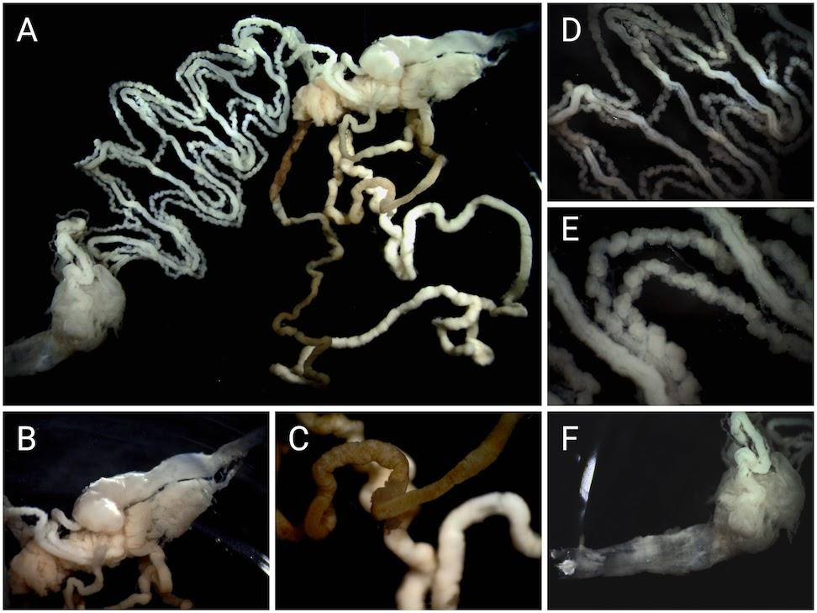

Fig. S1: Image of gut tissue dissected from nymphal Magicicada septendecim. (A) Complete gut. (B) Filter chamber. (C) Midgut. (D-E) Malphigian tubules and hindgut. (F) Rectum. Adult gut anatomy is identical to that of the nymph in these hemimetabolous insects and varies little across the family.

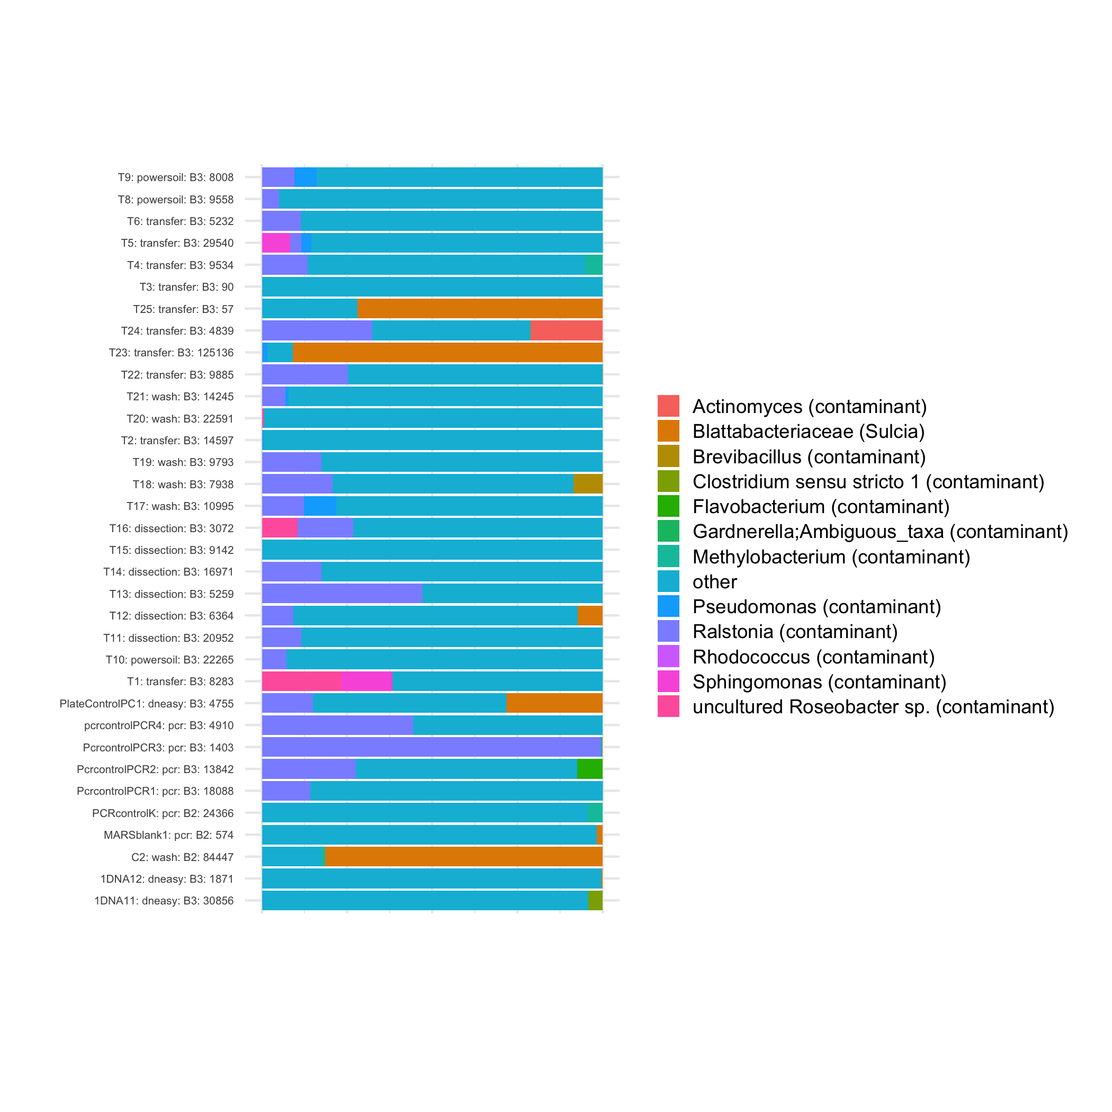

Fig. S2: Relative abundance of a subset of putative contaminants identified with Decontam. Sample labels include control type (powersoil, transfer, wash, dissection, dneasy, and pcr), the dataset in which the control was produced (B2 or B3), and the total abundance of all ASVs before dataset filtering.

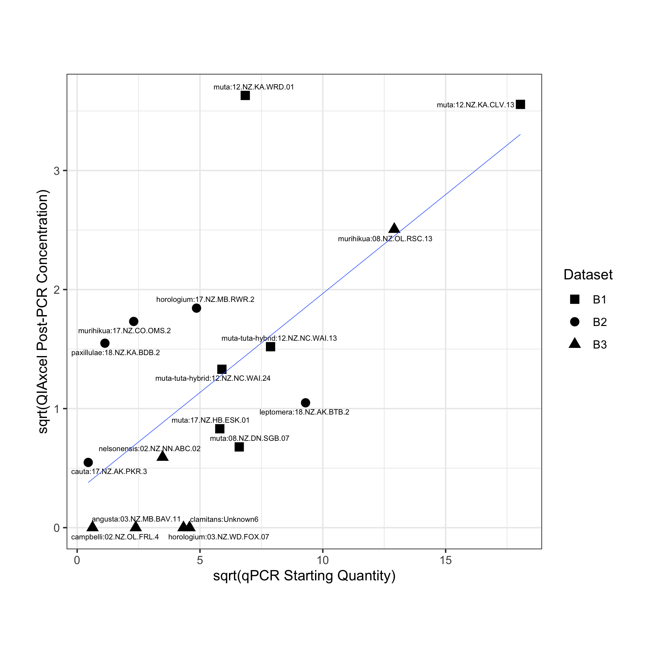

Fig. S3: The relationship between total DNA post-PCR DNA concentration and qPCR absolute abundance of 16S rRNA in a subset of samples spanning different datasets. Data based on amplification with the same 16S V4 rRNA primers used to sequence microbial communities.

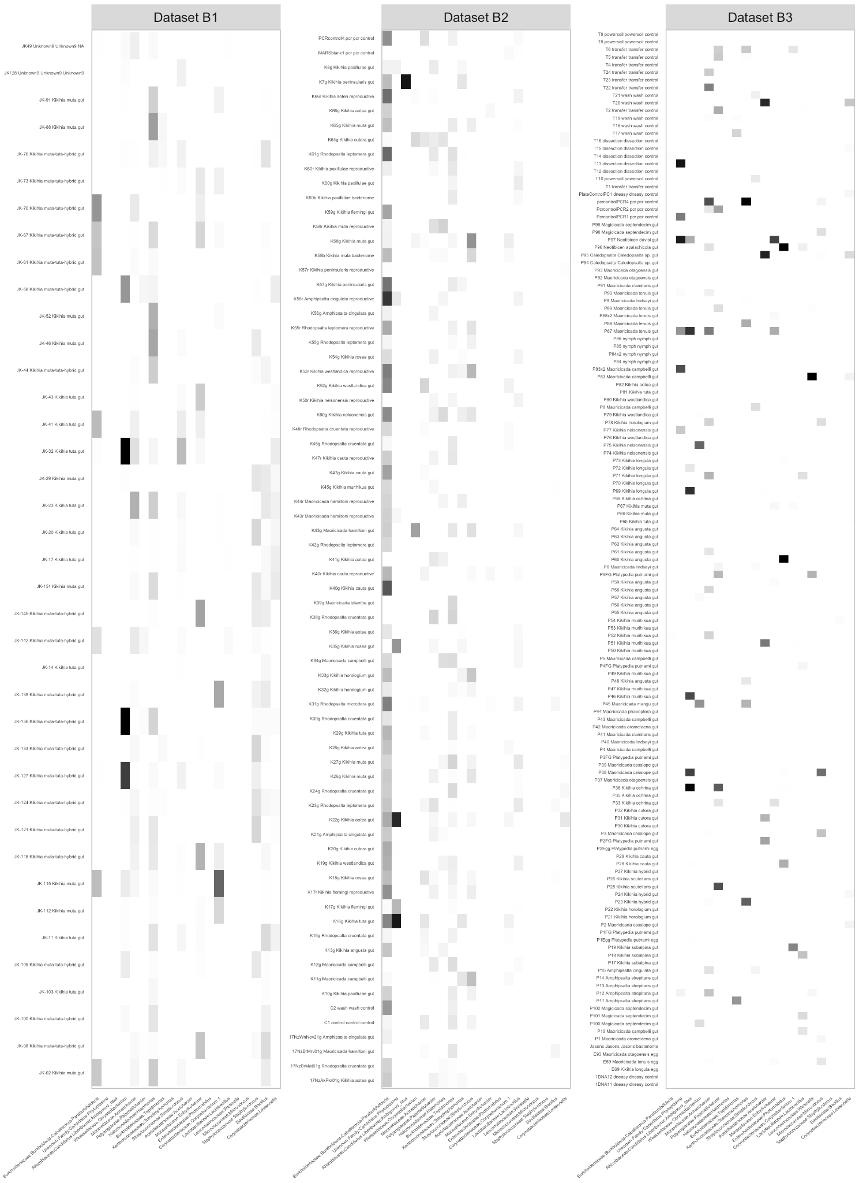Fig. S4: Relative abundance of major bacterial genera across specimens after dataset filtering. Solid black cells correspond to a relative abundance of 100% and white cells indicate absence of any particular bacterial group.

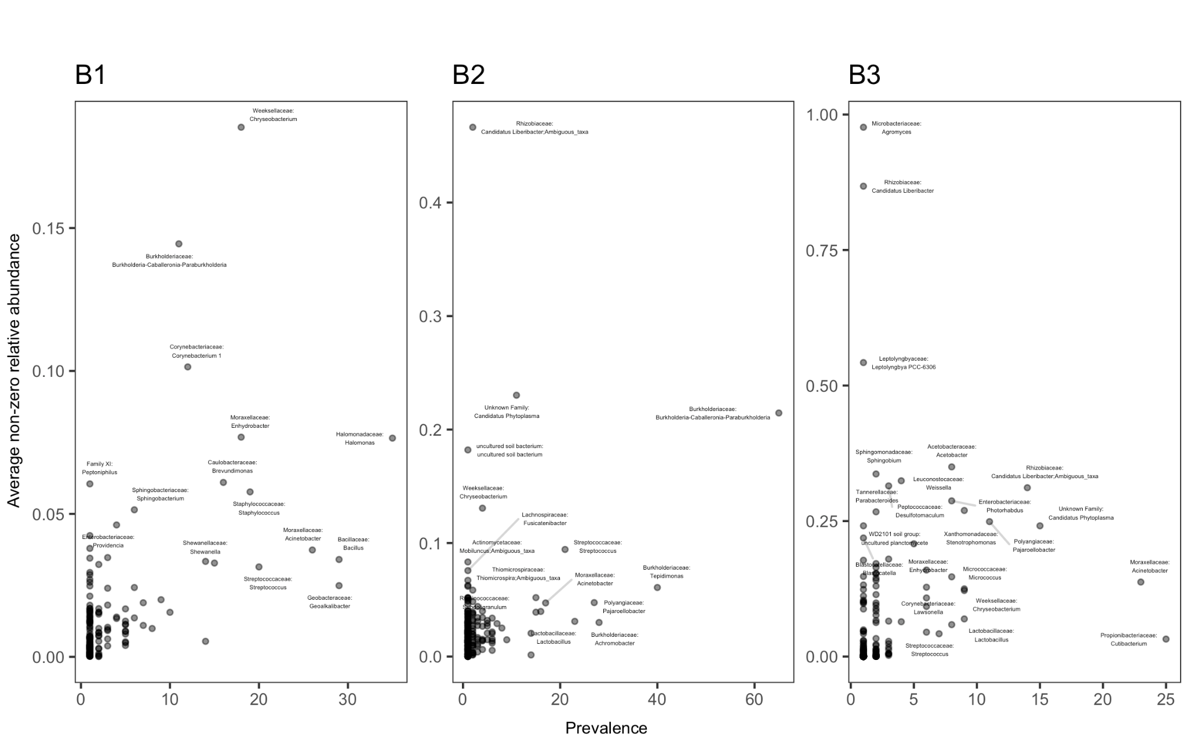

Fig. S5: Relationship between average relative abundance across all samples and prevalence across all samples per Genus-level bacterial ASV in each post-filtered dataset. Labeled taxa were included in relative abundance and ordination analyses in Fig. 2B-C. Note that relative abundances were calculated as the average of all non-zero values across samples.

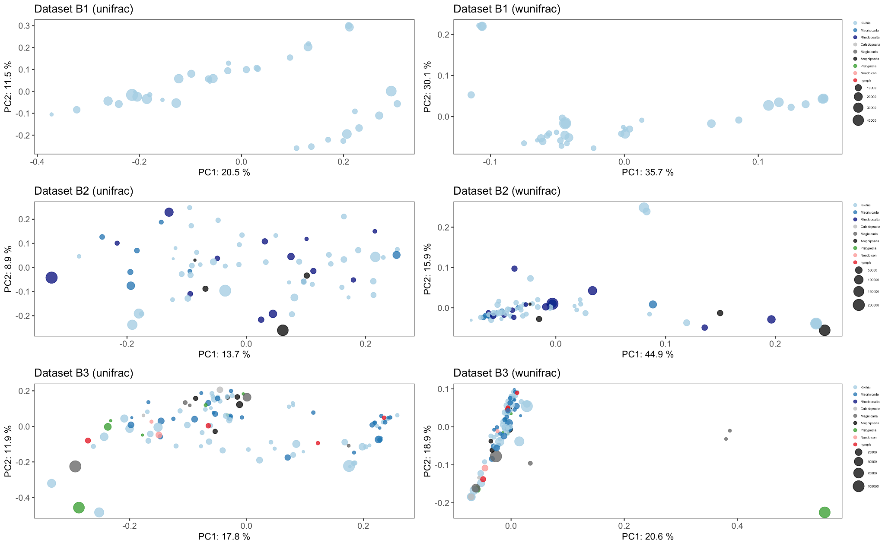

Fig. S6: PCoA ordinations of post-filtered datasets of individual samples using either unweighted (left column) or weighted (right column) UniFrac distances. Colors correspond to host genera and point sizes correspond to the total abundance of ASVs after filtering. Axis labels contain the percent variation explained by either the first or second principle components.

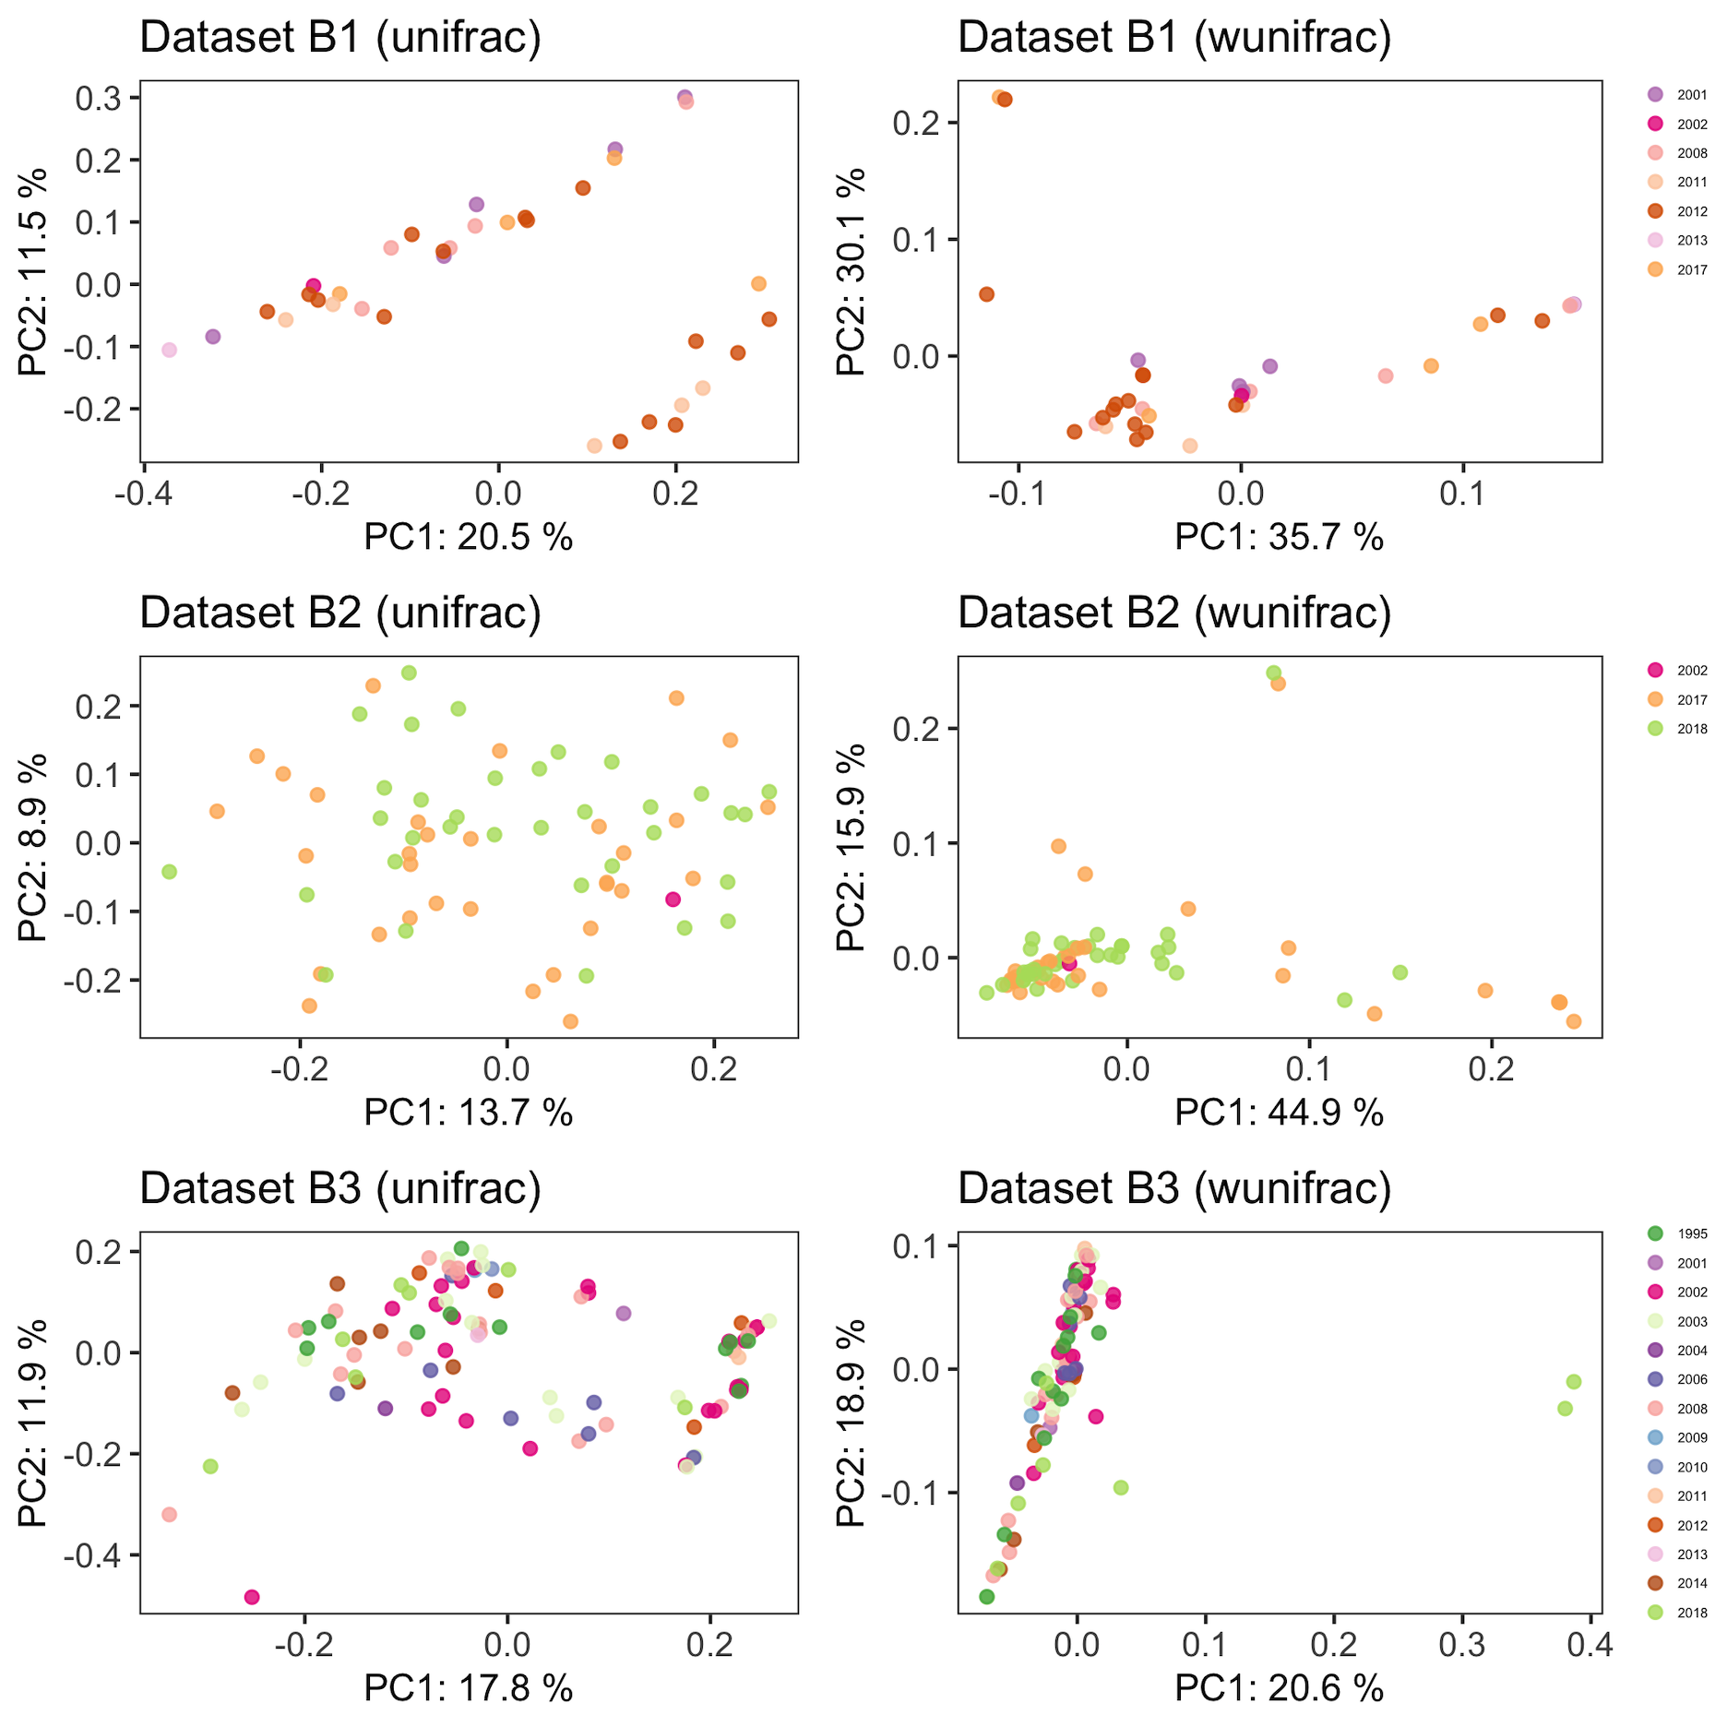

Fig. S7: PCoA ordinations of post-filtered datasets of individual samples using either unweighted (left column) or weighted (right column) UniFrac distances. Colors correspond to the year in which the sample was collected. Axis labels contain the percent variation explained by either the first or second principle components.

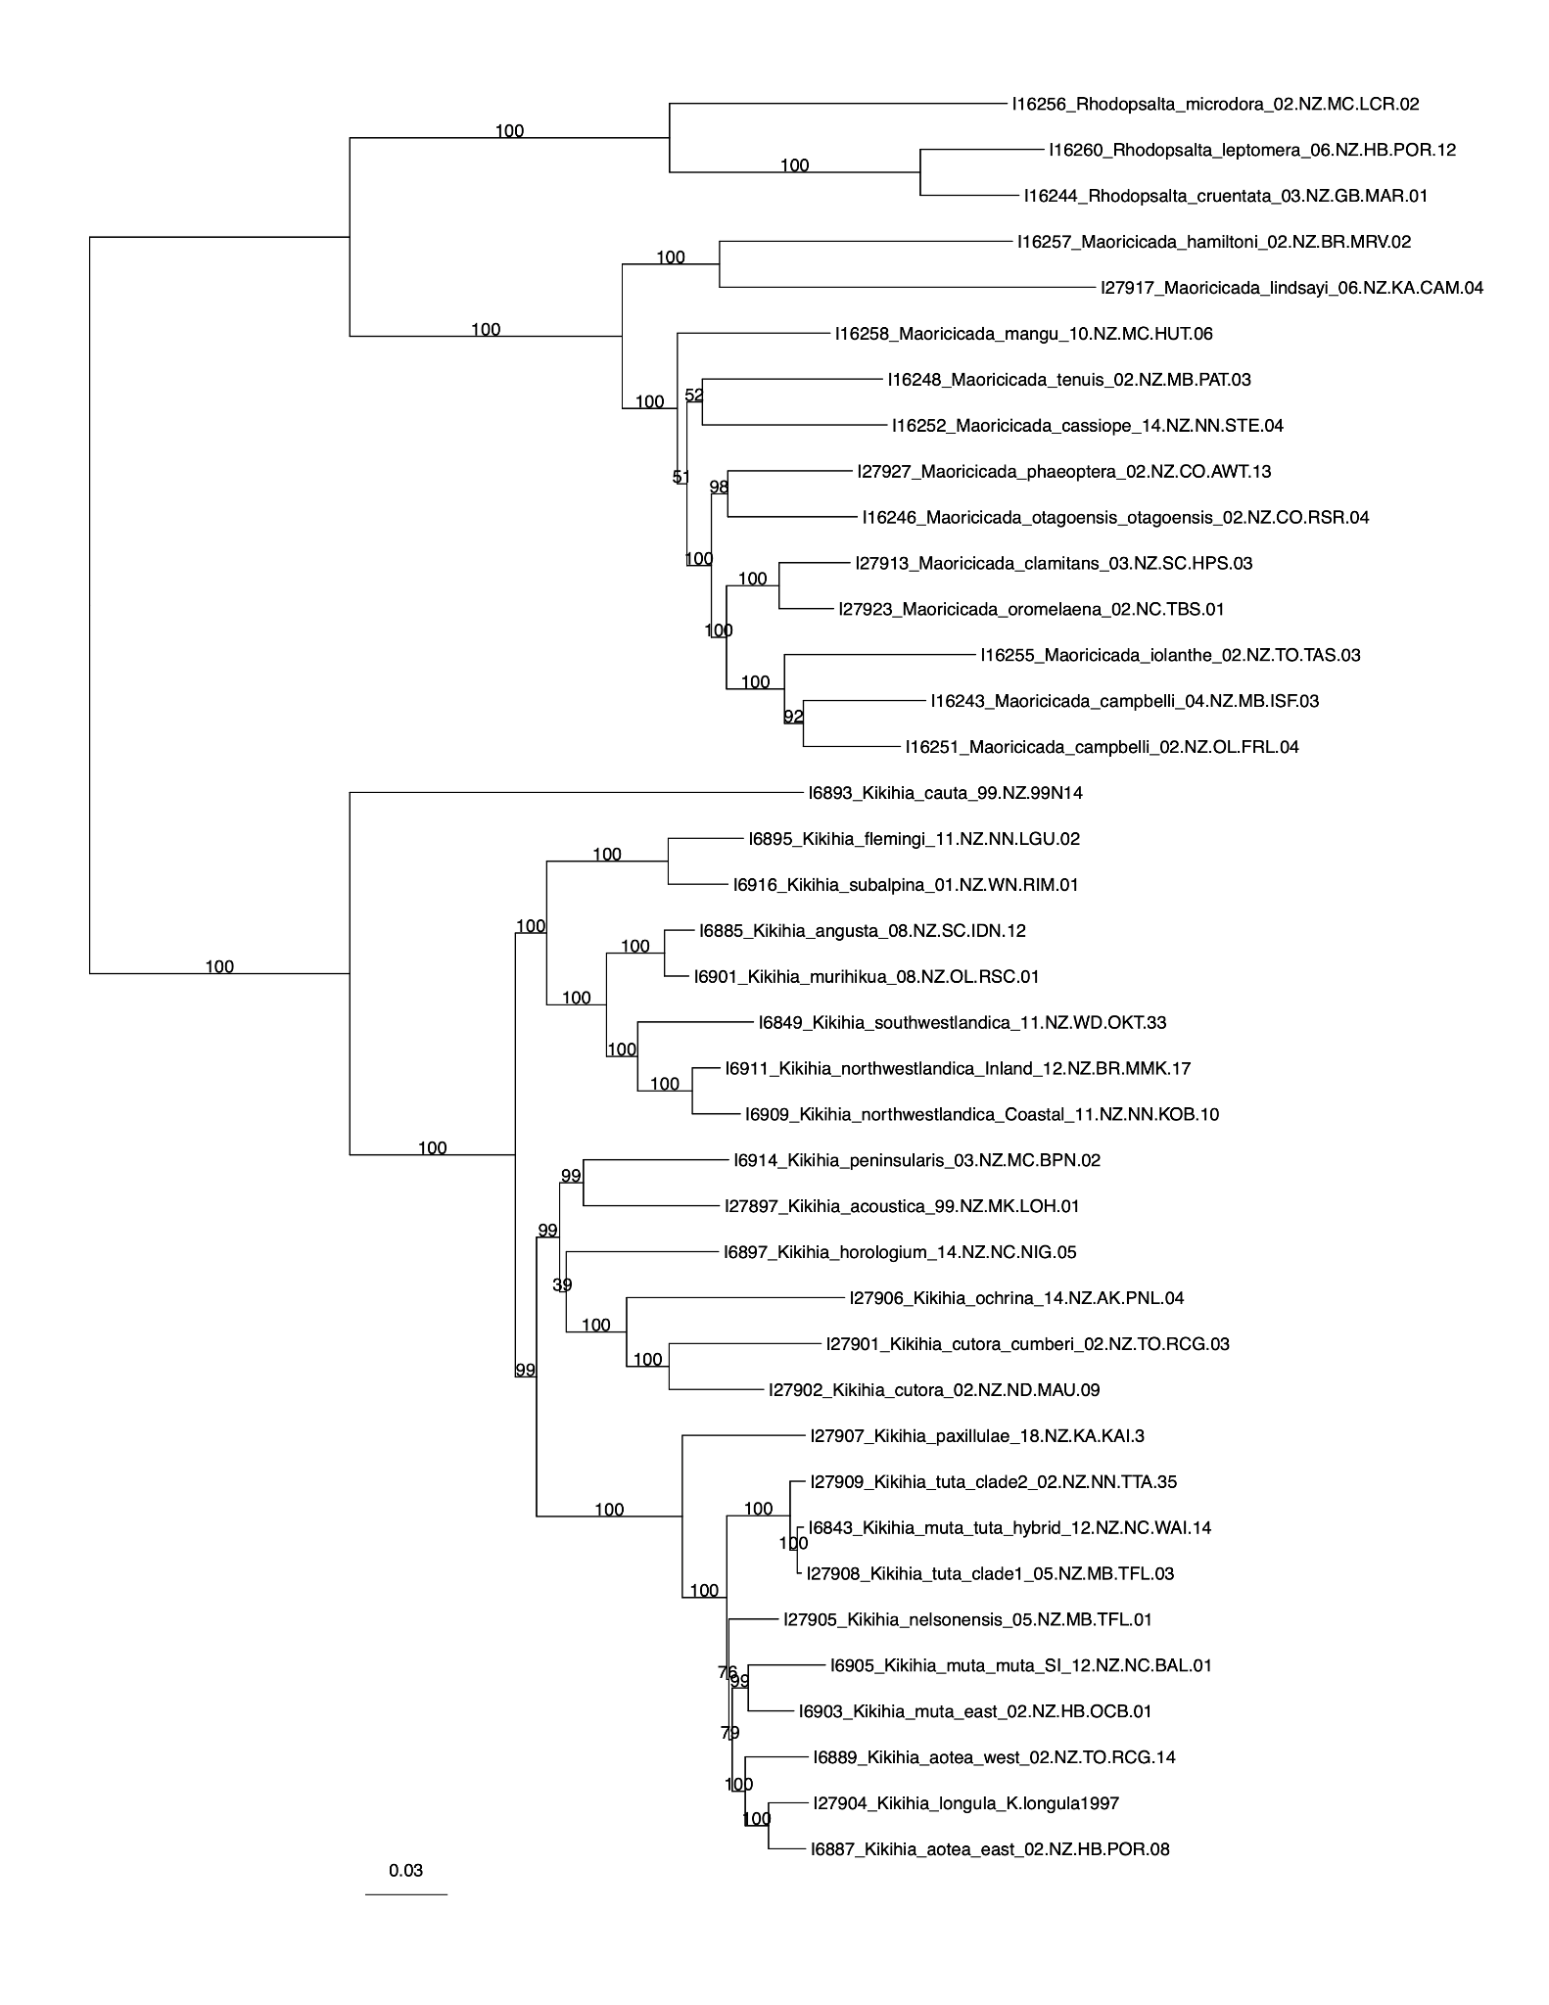

Fig. S8: Maximum likelihood phylogeny of mitochondrial genomes from New Zealand cicadas with bootstrap support values.

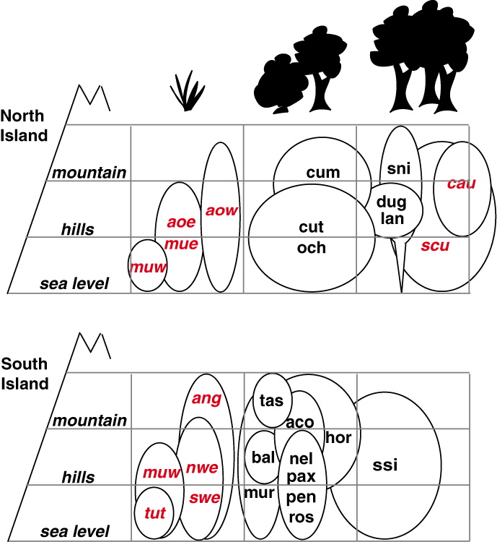

Fig. S9: Drawing of hypothetical niche space by Kathy Hill. Distributions are based on elevation and vegetation of various Kikihia species: muw (western muta), mue (eastern muta), aoe (eastern aotea), aow (western aotea), och (ochrina), cut (cutora), cum (cumberi), lan (laneorum), dug (dugdalei), sni (subalpina north island), scu (scutellaris), cau (cauta), tut (tuta), swe (southern westlandica), nwe (northern westlandica), ang (angusta), mur (murihikua), bal (balaena), tas (tasmani), ros (rosea), pen (peninsularis), pax (paxillulae), nel (nelsonensis), aco (acoustica), hor (horologium), ssi (subalpina south island).

