Supplementary Information for the Article
"Comparative epidemiology of four waves of COVID-19 in Mexico, March 2020 - April 2022"

Supplementary Table 1. Affiliated population in January 2022.

Age group | Males | Females | Males and Females
< 20 years old | 6,348,841 | 6,164,485 | 12,513,326
20 to 39 years old | 7,937,600 | 8,459,104 | 16,396,704
40 to 59 years old | 5,956,945 | 7,447,347 | 13,404,292
60 years old or more | 4,431,083 | 5,775,714 | 10,206,797
Not specified | 5,534 | 6,352 | 11,886
All age groups | 24,680,003 | 27,853,002 | 52,533,005
These figures correspond to the IMSS affiliate population to Family Doctors in January 2022.

Supplementary Table 2. Epidemic waves start and end dates and weeks.

Wave | 1st Wave | 2nd Wave | 3rd Wave | 4th Wave | All Waves
Season | Summer 2020 | Winter 2020 | Summer 2021 | Winter 2022 | -
Dates
Start | March 29th, 2020 | October 4th, 2020 | May 30th, 2021 | December 19th, 2021 | March 29th, 2020
End | October 3rd, 2020 | May 29th, 2021 | December 18th, 2021 | April 30th, 2022 | April 30th, 2022
Duration | 189 | 238 | 203 | 133 | 763
Weeks
Start | 2020-14 | 2020-41 | 2021-22 | 2021-51 | 2020-14
End | 2020-40 | 2021-21 | 2021-50 | 2022-17 | 2022-17
Duration | 27 | 34 | 29 | 19 | 109

Supplementary Table 3. Summary of COVID-19 cases and estimates by epidemic wave according to sex.
Wave | 1st Wave | 2nd Wave | 3rd Wave | 4th Wave | All Waves
Females
Number of cases
Confirmed cases | 125,510 | 269,126 | 376,913 | 586,310 | 1,357,859
Hospitalized cases | 42,105 | 60,100 | 33,606 | 16,486 | 152,297
Intubated cases | 10,033 | 11,587 | 6,351 | 1,522 | 29,493
Hospitalized deaths | 17,658 | 28,555 | 13,706 | 4,857 | 64,776
Estimations
Incidence per 1,000 affiliates | 4.5 (4.5,4.5) | 9.7 (9.6,9.7) | 13.5 (13.5,13.6) | 21.1 (21,21.1) | 48.8 (48.7,48.8)
Hospitalization % | 33.5 (33.3,33.8) | 22.3 (22.2,22.5) | 8.9 (8.8,9) | 2.8 (2.8,2.9) | 11.2 (11.2,11.3)
Intubation % | 23.8 (23.4,24.2) | 19.3 (19,19.6) | 18.9 (18.5,19.3) | 9.2 (8.8,9.7) | 19.4 (19.2,19.6)
Hospital case fatality rate % | 41.9 (41.5,42.4) | 47.5 (47.1,47.9) | 40.8 (40.3,41.3) | 29.5 (28.8,30.2) | 42.5 (42.3,42.8)
Mean days of hospital admission delay | 4.76 (4.72,4.8) | 5.78 (5.74,5.81) | 5.82 (5.78,5.87) | 3.45 (3.39,3.51) | 5.25 (5.23,5.27)
Mean in-hospital days | 9.22 (9.15,9.29) | 9.01 (8.96,9.07) | 8.66 (8.59,8.74) | 7.45 (7.35,7.56) | 8.83 (8.79,8.86)
Males
Number of cases
Confirmed cases | 139,282 | 280,830 | 385,931 | 460,323 | 1,266,366
Hospitalized cases | 63,576 | 83,872 | 42,214 | 18,126 | 207,788
Intubated cases | 17,404 | 18,313 | 8,729 | 2,279 | 46,725
Hospitalized deaths | 30,177 | 44,600 | 19,320 | 6,957 | 101,054
Estimations
Incidence per 1,000 affiliates | 5.6 (5.6,5.7) | 11.4 (11.3,11.4) | 15.6 (15.6,15.7) | 18.7 (18.6,18.7) | 51.3 (51.2,51.4)
Hospitalization % | 45.6 (45.4,45.9) | 29.9 (29.7,30) | 10.9 (10.8,11) | 3.9 (3.9,4) | 16.4 (16.3,16.5)
Intubation % | 27.4 (27,27.7) | 21.8 (21.6,22.1) | 20.7 (20.3,21.1) | 12.6 (12.1,13.1) | 22.5 (22.3,22.7)
Hospital case fatality rate % | 47.5 (47.1,47.9) | 53.2 (52.8,53.5) | 45.8 (45.3,46.2) | 38.4 (37.7,39.1) | 48.6 (48.4,48.8)
Mean days of hospital admission delay | 4.9 (4.87,4.93) | 6.07 (6.04,6.1) | 6.24 (6.19,6.28) | 3.83 (3.78,3.89) | 5.55 (5.53,5.57)
Mean in-hospital days | 9.47 (9.42,9.53) | 9.26 (9.21,9.31) | 9 (8.93,9.07) | 7.87 (7.76,7.97) | 9.15 (9.12,9.18)

Supplementary Table 4. Summary of COVID-19 cases and estimates by epidemic wave according to age groups.

Wave | 1st Wave | 2nd Wave | 3rd Wave | 4th Wave | All Waves
Age below 20 years old
Number of cases
Confirmed cases | 4,566 | 17,188 | 71,350 | 81,033 | 174,137
Hospitalized cases | 1,042 | 1,275 | 2,267 | 2,608 | 7,192
Intubated cases | 167 | 158 | 168 | 119 | 612
Hospitalized deaths | 167 | 164 | 164 | 114 | 609
Estimations
Incidence per 1,000 affiliates | 0.4 (0.4,0.4) | 1.4 (1.4,1.4) | 5.7 (5.7,5.7) | 6.5 (6.4,6.5) | 13.9 (13.9,14)
Hospitalization % | 22.8 (21.6,24.1) | 7.4 (7,7.8) | 3.2 (3,3.3) | 3.2 (3.1,3.3) | 4.1 (4,4.2)
Intubation % | 16 (13.8,18.4) | 12.4 (10.6,14.3) | 7.4 (6.4,8.6) | 4.6 (3.8,5.4) | 8.5 (7.9,9.2)
Hospital case fatality rate % | 16 (13.8,18.4) | 12.9 (11.1,14.8) | 7.2 (6.2,8.4) | 4.4 (3.6,5.2) | 8.5 (7.8,9.1)
Mean days of hospital admission delay | 2.35 (2.13,2.57) | 3.38 (3.16,3.61) | 3.78 (3.62,3.95) | 2.06 (1.94,2.17) | 2.88 (2.79,2.96)
Mean in-hospital days | 10.09(9.5,10.6) | 8.48 (8.07,8.89) | 7.1 (6.81,7.4) | 6.53 (6.28,6.79) | 7.58 (7.41,7.75)
Age from 20 to 39 years old
Number of cases
Confirmed cases | 99,864 | 235,990 | 422,107 | 556,490 | 1,314,451
Hospitalized cases | 13,532 | 15,197 | 15,723 | 5,294 | 49,746
Intubated cases | 2,121 | 2,177 | 2,431 | 268 | 6,997
Hospitalized deaths | 2,588 | 3,426 | 3,519 | 507 | 10,040
Estimations
Incidence per 1,000 affiliates | 6.1 (6.1,6.1) | 14.4 (14.3,14.5) | 25.7 (25.7,25.8) | 33.9 (33.9,34) | 80.2 (80,80.3)
Hospitalization % | 13.6 (13.3,13.8) | 6.4 (6.3,6.5) | 3.7 (3.7,3.8) | 1 (0.9,1) | 3.8 (3.8,3.8)
Intubation % | 15.7 (15.1,16.3) | 14.3 (13.8,14.9) | 15.5 (14.9,16) | 5.1 (4.5,5.7) | 14.1 (13.8,14.4)
Hospital case fatality rate % | 19.1 (18.5,19.8) | 22.5 (21.9,23.2) | 22.4 (21.7,23) | 9.6 (8.8,10.4) | 20.2 (19.8,20.5)
Mean days of hospital admission delay | 4.88 (4.81,4.96) | 5.91 (5.83,5.98) | 6.34 (6.27,6.41) | 2.69 (2.59,2.79) | 5.42 (5.38,5.46)
Mean in-hospital days | 8.67 (8.55,8.79) | 8.62 (8.51,8.73) | 8.42 (8.31,8.53) | 7.22 (7.03,7.41) | 8.42 (8.36,8.48)
Age from 40 to 59 years old
Number of cases
Confirmed cases | 102,347 | 197,524 | 200,662 | 342,125 | 842,658
Hospitalized cases | 42,695 | 53,172 | 24,597 | 8,577 | 129,041
Intubated cases | 10,312 | 10,950 | 5,183 | 972 | 27,417
Hospitalized deaths | 15,603 | 22,024 | 9,753 | 2,444 | 49,824
Estimations
Incidence per 1,000 affiliates | 7.6 (7.6,7.7) | 14.7 (14.7,14.8) | 15 (14.9,15) | 25.5 (25.4,25.6) | 62.9 (62.7,63)
Hospitalization % | 41.7 (41.4,42) | 26.9 (26.7,27.1) | 12.3 (12.1,12.4) | 2.5 (2.5,2.6) | 15.3 (15.2,15.4)
Intubation % | 24.2 (23.7,24.6) | 20.6 (20.3,20.9) | 21.1 (20.6,21.6) | 11.3 (10.7,12) | 21.2 (21,21.5)
Hospital case fatality rate % | 36.5 (36.1,37) | 41.4 (41,41.8) | 39.7 (39,40.3) | 28.5 (27.5,29.5) | 38.6 (38.3,38.9)
Mean days of hospital admission delay | 5 (4.96,5.04) | 6.23 (6.2,6.27) | 6.31 (6.25,6.36) | 3.85 (3.76,3.94) | 5.68 (5.66,5.71)
Mean in-hospital days | 9.63 (9.56,9.7) | 9.53 (9.47,9.59) | 9.25 (9.16,9.34) | 7.93 (7.78,8.07) | 9.4 (9.36,9.44)
Age 60 years old or more
Number of cases
Confirmed cases | 58,015 | 99,254 | 68,725 | 66,985 | 292,979
Hospitalized cases | 48,412 | 74,328 | 33,233 | 18,133 | 174,106
Intubated cases | 14,837 | 16,615 | 7,298 | 2,442 | 41,192
Hospitalized deaths | 29,477 | 47,541 | 19,590 | 8,749 | 105,357
Estimations
Incidence per 1,000 affiliates | 5.7 (5.6,5.7) | 9.7 (9.7,9.8) | 6.7 (6.7,6.8) | 6.6 (6.5,6.6) | 28.7 (28.6,28.8)
Hospitalization % | 83.4 (83.1,83.7) | 74.9 (74.6,75.2) | 48.4 (48,48.7) | 27.1 (26.7,27.4) | 59.4 (59.2,59.6)
Intubation % | 30.6 (30.2,31.1) | 22.4 (22.1,22.7) | 22 (21.5,22.4) | 13.5 (13,14) | 23.7 (23.5,23.9)
Hospital case fatality rate % | 60.9 (60.5,61.3) | 64 (63.6,64.3) | 58.9 (58.4,59.5) | 48.2 (47.5,49) | 60.5 (60.3,60.7)
Mean days of hospital admission delay | 4.75 (4.71,4.78) | 5.79 (5.76,5.82) | 5.89 (5.84,5.93) | 4.07 (4.01,4.13) | 5.34 (5.32,5.36)
Mean in-hospital days | 9.33 (9.26,9.4) | 9.01 (8.96,9.07) | 8.88 (8.8,8.96) | 7.84 (7.74,7.94) | 8.95 (8.92,8.99)
Epidemic waves correspond to the on-set of symptoms year-week periods as outlined in Supplementary Table 2. Estimations with 95% confidence intervals are shown.

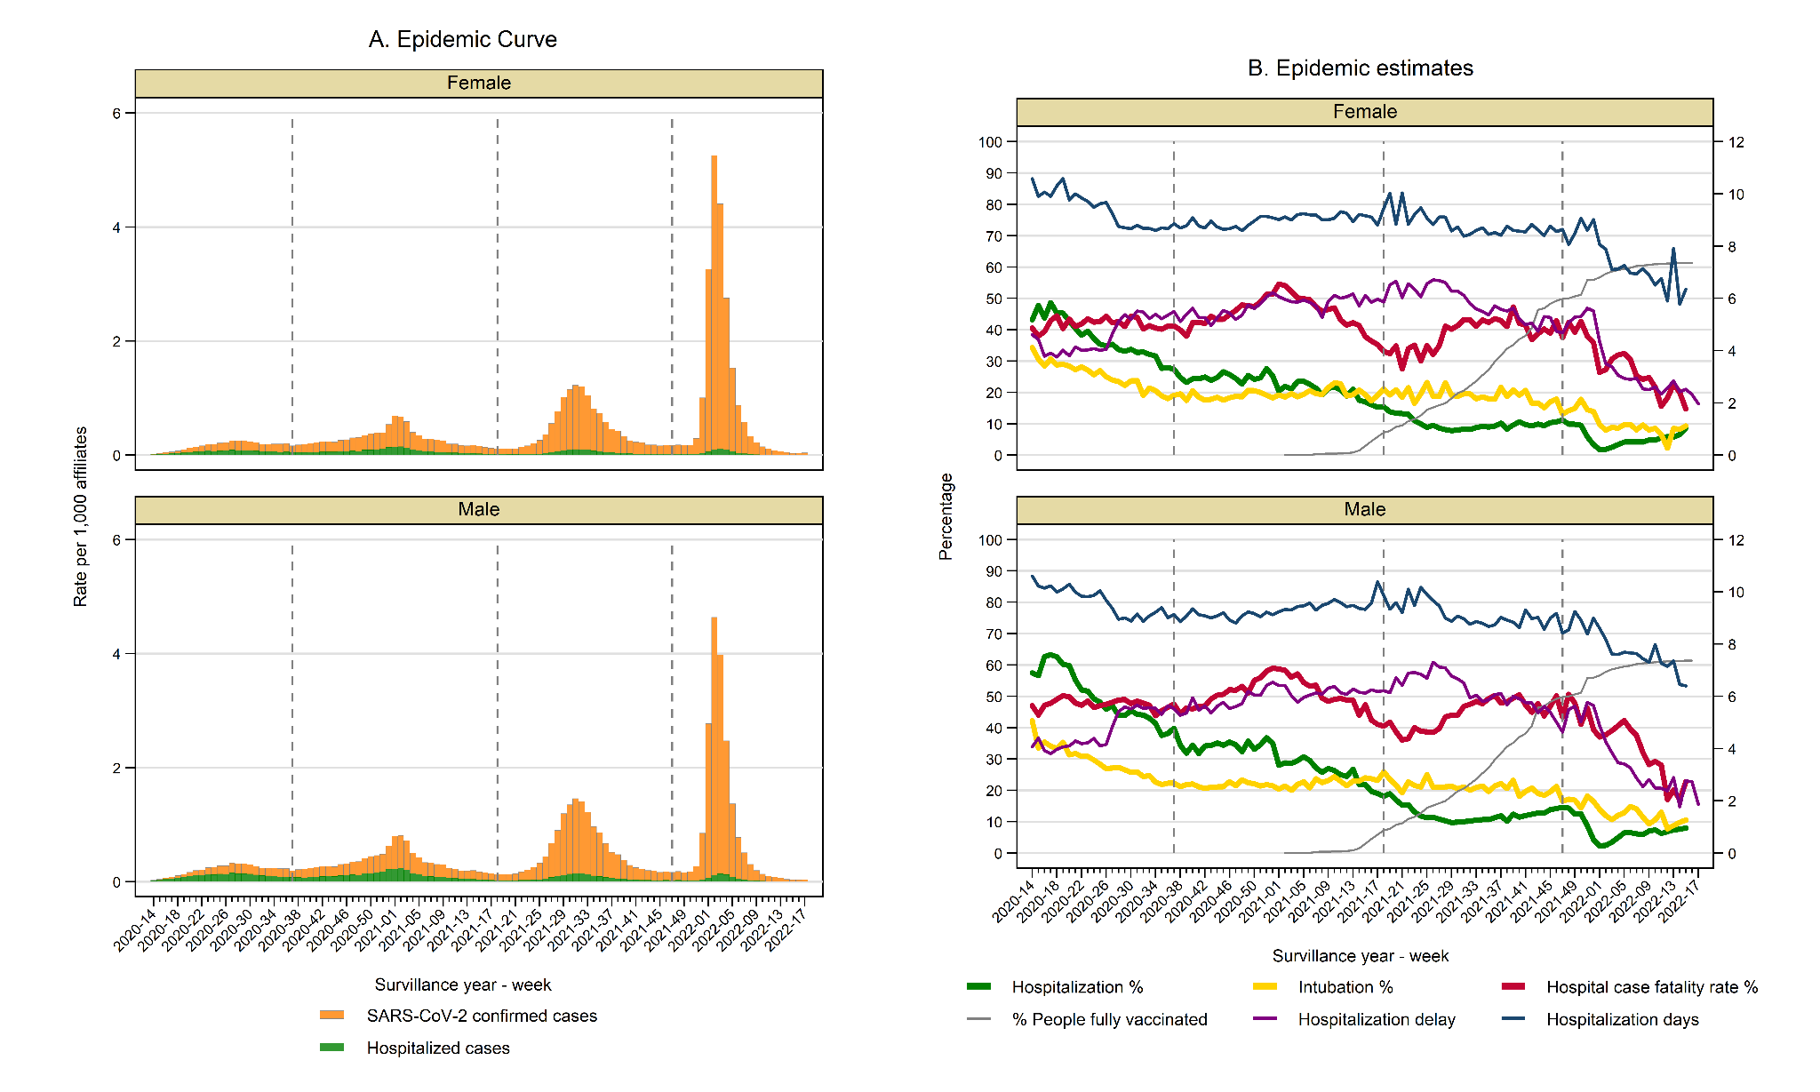
Supplementary Figure 1 COVID-19 epidemic curve and estimates in males and females
Panel A shows the COVID-19 rate of confirmed cases per 100,000 affiliates (orange bars for total cases and green bars for hospitalized cases). Panel B contains the weekly trend of the following estimations: hospitalization percentage (green line), intubation percentage (yellow line), hospital case fatality rate (red line), hospitalization delay in days (purple line in the left axis) and hospitalization days (blue line in the left axis). The percentage of people fully vaccinated in the country is also shown in a gray line.
Figures include the onset of symptoms week period from 2020-14 (April 1st, 2020) to 2022-17 (April 30th, 2022). Dotted vertical lines represent the separation of the four epidemic waves.
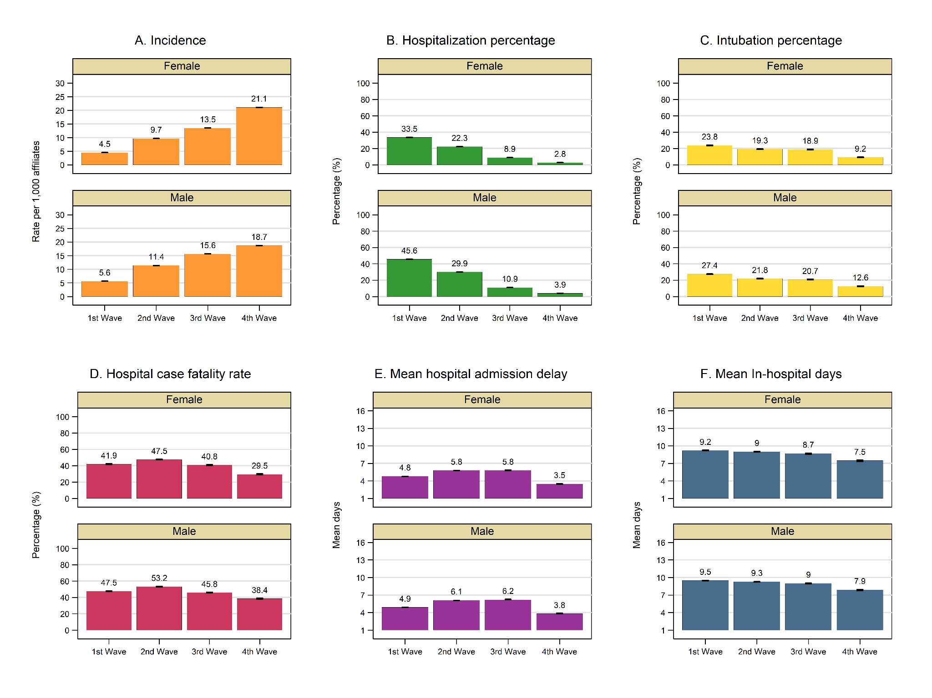
Supplementary Figure 2. COVID-19 estimates according to the four epidemic waves in males and females
The figure shows the following estimations with a 95% confidence interval: case incidence (orange bars), hospitalization percentage (green bars), mean hospital admission delay (purple bars) intubation percentage (yellow bars), hospital case fatality rate (red bars), and mean hospitalization days (blue bars).
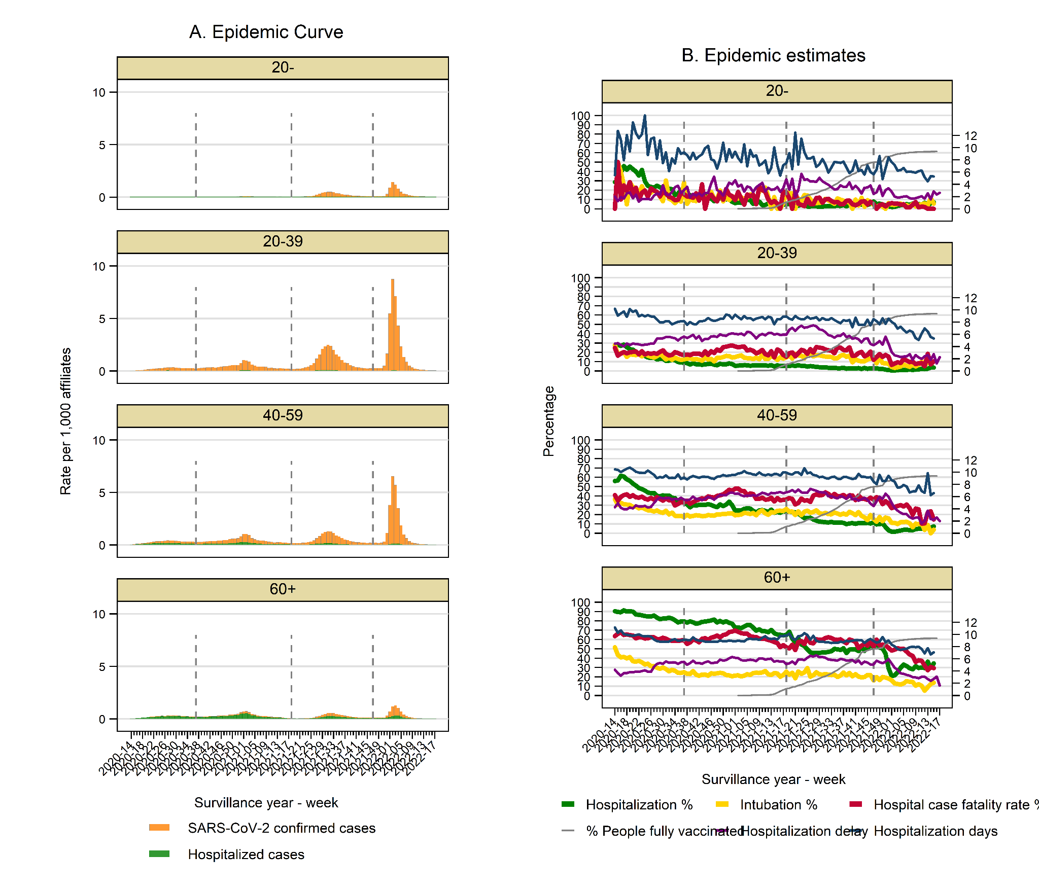
Supplementary Figure 3. COVID-19 epidemic curve and estimates according to age group
Panel A shows the COVID-19 rate of confirmed cases per 100,000 affiliates (orange bars for total cases and green bars for hospitalized cases). Panel B contains the weekly trend of the following estimations: hospitalization percentage (green line), intubation percentage (yellow line), hospital case fatality rate (red line), hospitalization delay in days (purple line in the left axis) and hospitalization days (blue line in the left axis). The percentage of people fully vaccinated in the country is also shown in a gray line.
Figures include the onset of symptoms week period from 2020-14 (April 1st, 2020) to 2022-17 (April 30th, 2022). Dotted vertical lines represent the separation of the four epidemic waves.
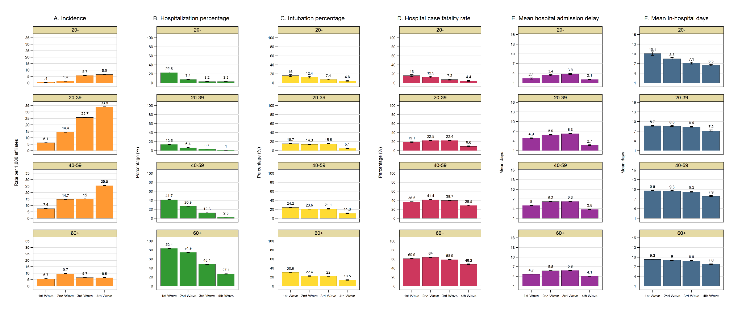
Supplementary Figure 4. COVID-19 estimates across four epidemic waves by age group.
The figure shows the following estimations with a 95% confidence interval: case incidence (orange bars), hospitalization percentage (green bars), mean hospital admission delay (purple bars) intubation percentage (yellow bars), hospital case fatality rate (red bars), and mean hospitalization days (blue bars).

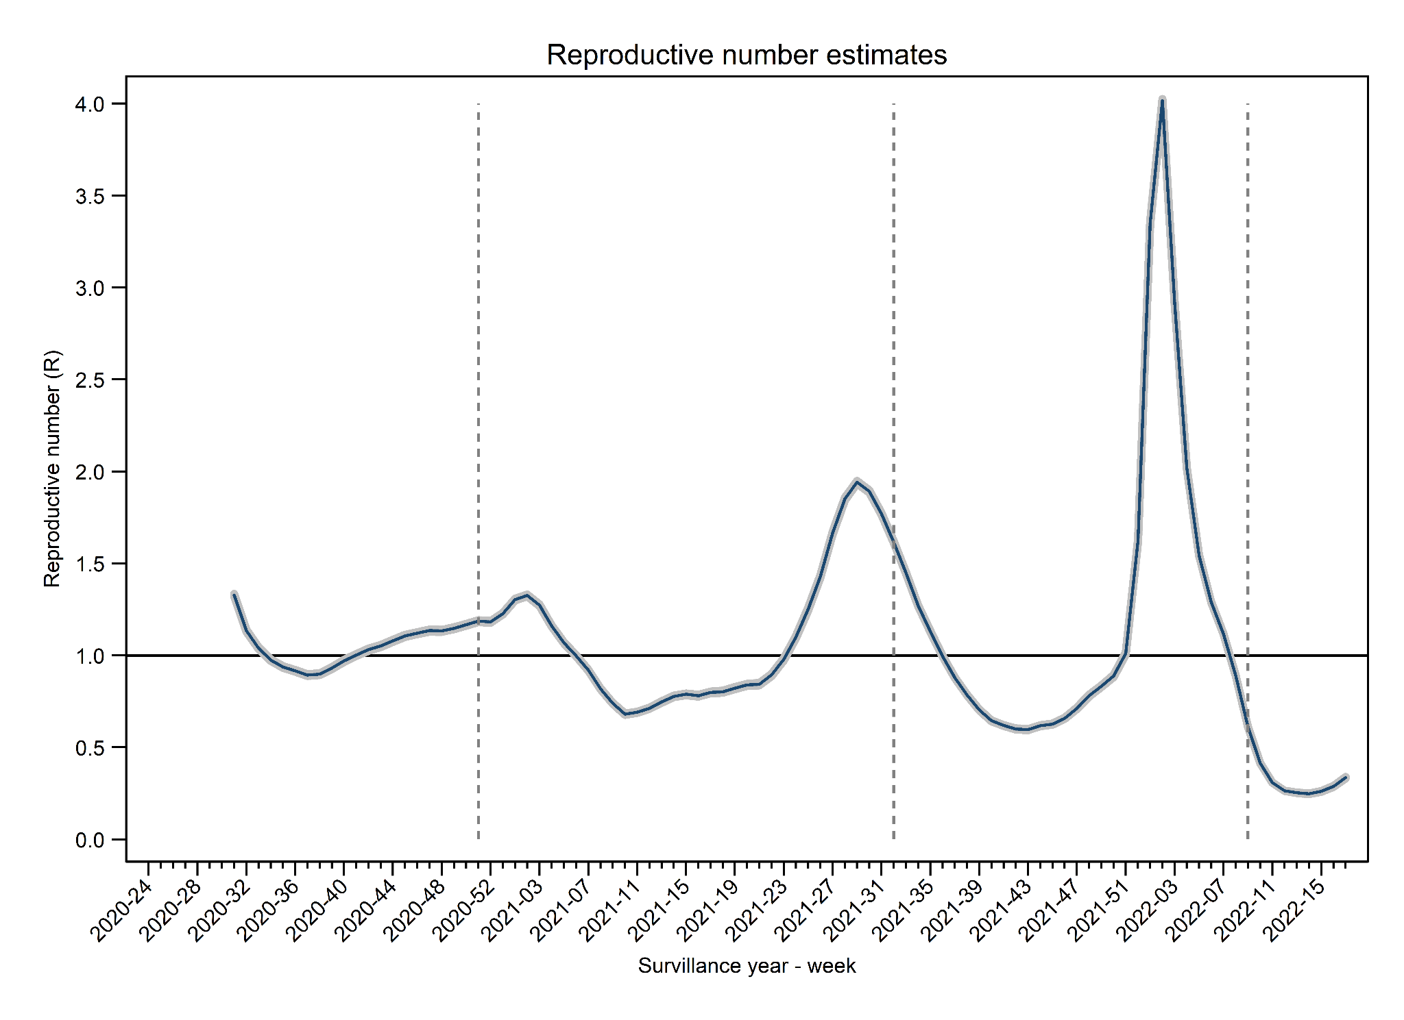
Supplementary Figure 5. COVID-19 reproduction numbers.
The figure shows the weekly COVID-19 reproductive number for confirmed cases with onset of symptoms from 2020-24 (June 7th, 2020) to 2022-17 (April 30th, 2022). Dotted vertical lines represent the separation of the four epidemic waves. Median and 5 and 95 percentiles are shown.

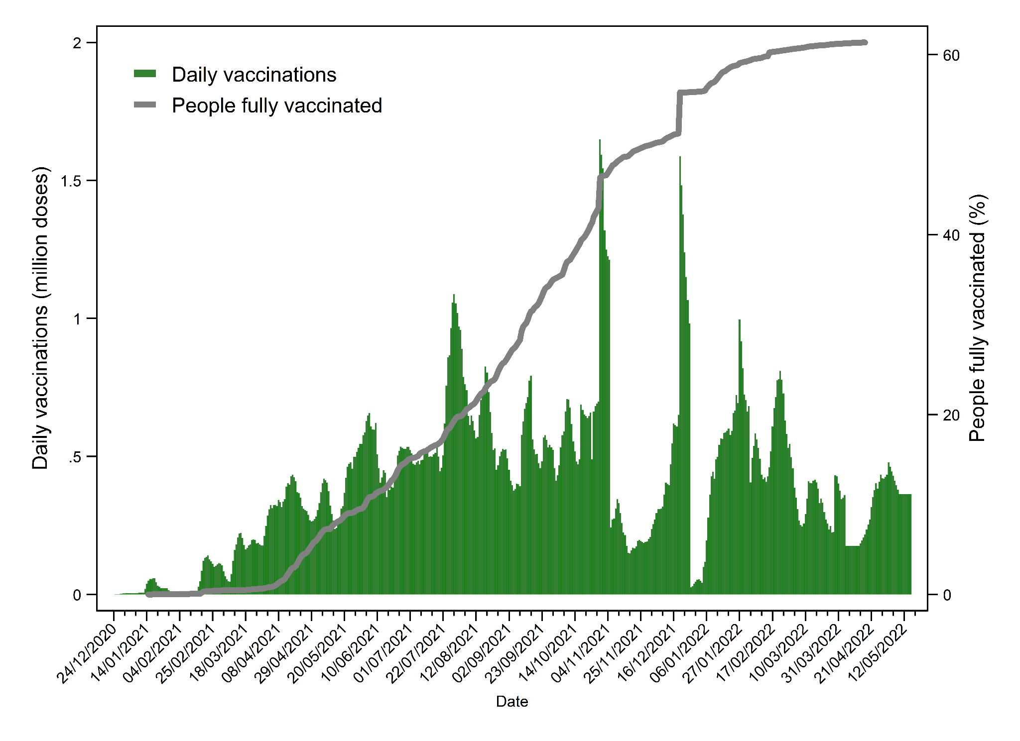
Supplementary Figure 6. Daily COVID-19 vaccinations and people fully vaccinated in Mexico.
Green bars represent the daily vaccinations. The gray line in the left axis shows the cumulative percentage of people fully vaccinated. Data were obtained from https://ourworldindata.org/covid-vaccinations

