Supplementary Material

Table of Contents
Table S1. Bias from Bland-Altman and linear correlation parameters of venous blood hemoglobin measurements using each HemoCue apparatus versus the cyanmethemoglobin method 2
Figure S1. Bland Altman plot and box plot of hemoglobin (Hb) measurement difference (g/dL) in capillary versus venous blood samples as analyzed using the cyanmethemoglobin method. 3
Table S2. Bland-Altman plots of hemoglobin concentration determined using the HemoCue in different blood sample sources versus using the cyanmethemoglobin method with venous blood by age group. 4
Figure S2. Concordance plots by age group and sampling method 5
Figure S3. Frequency distributions of the difference between adjusted* hemoglobin measurement results using the HemoCue in three types of blood sample sources, against the cyanmethemeglobin method in venous blood 6
Table S3. Mixed linear regression model* for differences in hemoglobin (Hb) sampling methods 7
Table S4. Bland Alman of the Hb mean differences to venous blood in the reference method*, by number of measurement using HemoCue 9
Table S5. Random effects of the mixed linear regression model on differences in hemoglobin measurement 9

Table S1. Bias from Bland-Altman and linear correlation parameters of venous blood hemoglobin measurements using each HemoCue apparatus versus the cyanmethemoglobin method
Number of HemoCue apparatus* | Bland-Altman bias | Intercept | Slope | n
1 | 0.345 | .0025454 | 1.027402 | 80
2 | 0.365 | 0.8078831 | 0.9651042 | 34
3 | 0.332 | 0.0229337 | 1.023791 | 68
4 | 0.423 | -0.3411198 | 1.06057 | 26
5 | 0.400 | -2.380941 | 1.227373 | 26
6 | 0.148 | -0.1218974 | 1.021328 | 64
All | 0.314 | 0.024098 | 1.022877 | 298

*Each HemoCue was used for only one person; these results represent the combined effect of apparatus and personnel skills.

Figure S1. Bland Altman plot and box plot of hemoglobin (Hb) measurement difference (g/dL) in capillary versus venous blood samples as analyzed using the cyanmethemoglobin method.

- Bland Altman Plot | - Box plot
Mean ∂ Hb= 0.097 ±0.426, 95%CI (-0.737,0.931)  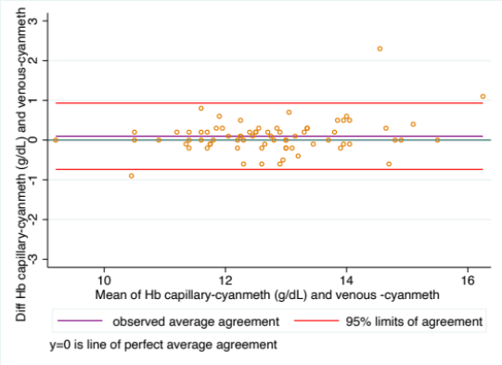 | 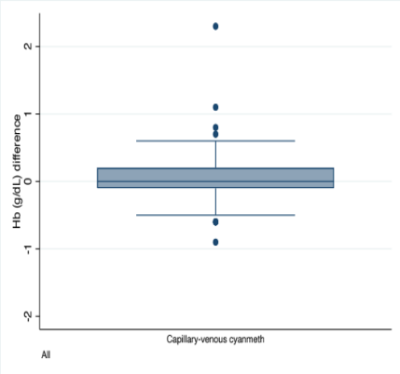

Table S2. Bland-Altman plots of hemoglobin concentration determined using the HemoCue in different blood sample sources versus using the cyanmethemoglobin method with venous blood by age group.

Age group | Sampling method using HemoCue | Concordance | Pearson correlation | Relative bias | Hb mean difference (g/dL) | SD
Children | Venous | 0.943 | 0.948 | 0.994 | -0.007 | 0.311
Children | Pool (first and second lecture) | 0.867 | 0.87 | 0.997 | -0.064 | 0.395
Children | Drop (second and third drop) | 0.557 | 0.612 | 0.942 | 0.096 | 1.052
Women | Venous | 0.978 | 0.98 | 0.998 | -0.02 | 0.307
Women | Pool (first and second lecture) | 0.971 | 0.972 | 0.999 | -0.04 | 0.337
Women | Drop (second and third drop) | 0.886 | 0.968 | 0.916 | 0.624 | 0.483
Older Adults | Venous | 0.973 | 0.973 | 1.0 | 0.026 | 0.373
Older Adults | Pool (first and second lecture) | 0.958 | 0.959 | 0.999 | 0.036 | 0.371
Older Adults | Drop (second and third drop) | 0.864 | 0.915 | 0.944 | 0.554 | 0.722

Figure S2. Concordance plots by age group and sampling method
 | Preschoolers | Women | Elderly
Venous | 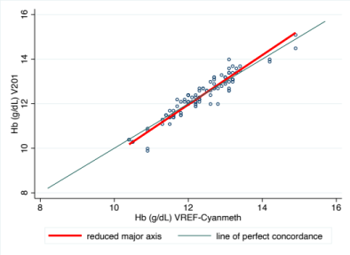 | 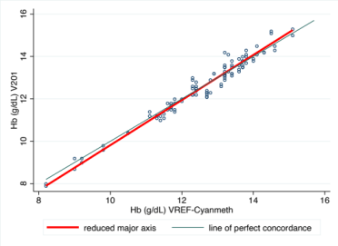 | 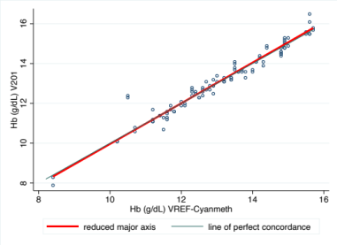
Pooled capillary blood | 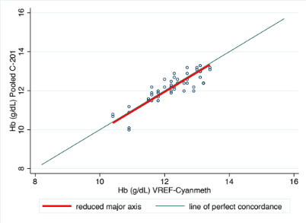 | 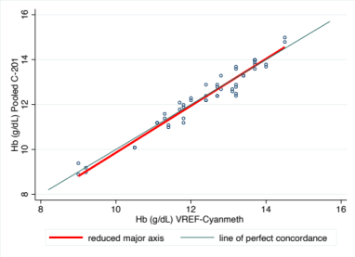 | 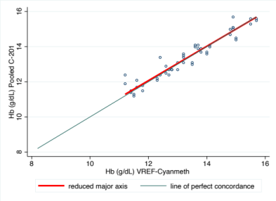
Drops of capillary blood blood | 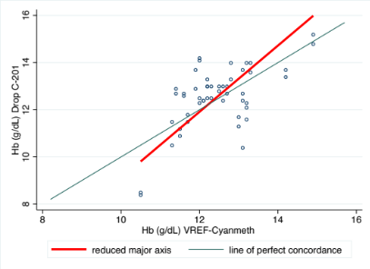 | 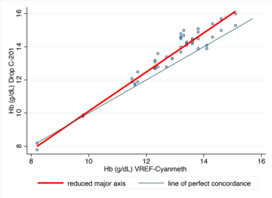 | 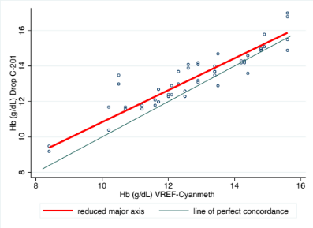

Figure S3. Frequency distributions of the difference between adjusted* hemoglobin measurement results using the HemoCue in three types of blood sample sources, against the cyanmethemeglobin method in venous blood

- Before adjustment

Venous blood | Pooled capillary blood | Drops of capillary blood
Mean ∂ Hb= 0.31 ± 0.31  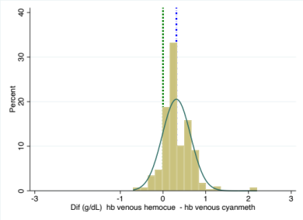 | Mean ∂ Hb= 0.29± 0.36  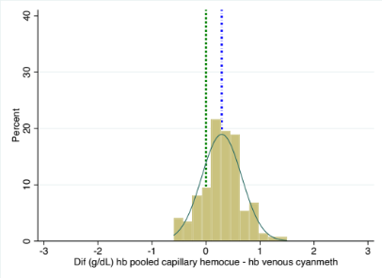 | Mean ∂ Hb= 0.73± 0.81  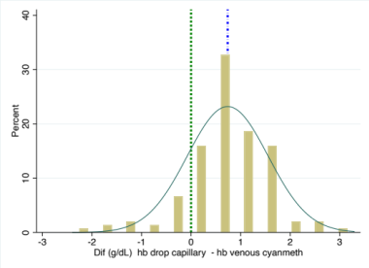

- After adjustment

Venous blood | Pooled capillary blood | Drops of capillary blood
Mean ∂ Hb= -0.0002 ± 0.31  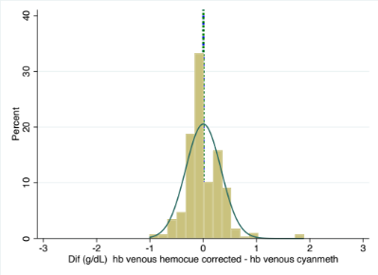 | Mean ∂ Hb=-0.02 ± 0.36  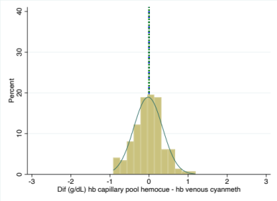 | Mean ∂ Hb=0.42 ± 0.81  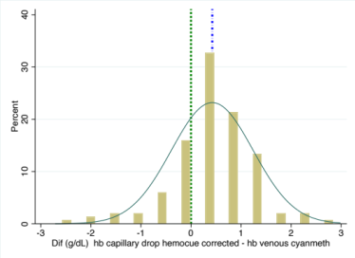
* The hemoglobin values from the HemoCue were adjusted by subtracting the average bias of 0.314 g/dL

Table S3. Mixed linear regression model* for differences in hemoglobin (Hb) sampling methods
*Before adjustment
 | All |  |  |  |  | Children |  |  |  |  |  |  |  | Women |  |  |  |  |  |  |  | Older Adults
 | Coef | p-value | 95%CI |  |  | Coef |  | p-value |  | 95%CI |  |  |  | Coef |  | p-value |  | 95%CI |  |  |  | Coef |  | p-value |  | 95%CI
Sampling method (ref: venous cyanmeth.)
Venous ABX hemocounter | 0.08 | 0.059 | (-0.003 0.15) |  |  | 0.06 |  | 0.506 |  | (-0.11, 0.22) |  |  |  | 0.1 |  | 0.065 |  | (-0.01, 0.21) |  |  |  | 0.07 |  | 0.274 |  | (-0.06, 0.2)
Capillary cyanmethemoglobin | 0.09 | 0.09 | (-0.01, 0.19) |  |  | -0.05 |  | 0.621 |  | (-0.27, 0.16) |  |  |  | 0.18 |  | 0.018 |  | (0.03, 0.33) |  |  |  | 0.14 |  | 0.096 |  | (-0.03, 0.32)
Venous HemoCue | 0.26 | <0.001 | (0.17, 0.35) |  |  | 0.24 |  | 0.009 |  | (0.06, 0.42) |  |  |  | 0.22 |  | <0.001 |  | (0.09, 0.34) |  |  |  | 0.3 |  | <0.001 |  | (0.16, 0.45)
Pooled capillary HemoCue | 0.28 | <0.001 | (0.19, 0.37) |  |  | 0.23 |  | 0.012 |  | (0.05, 0.41) |  |  |  | 0.26 |  | <0.001 |  | (0.13, 0.38) |  |  |  | 0.35 |  | <0.001 |  | (0.21, 0.5)
Drop capillary HemoCue | 0.74 | <0.001 | (0.65, 0.83) |  |  | 0.43 |  | <0.001 |  | (0.25, 0.6) |  |  |  | 0.95 |  | <0.001 |  | (0.83, 1.07) |  |  |  | 0.86 |  | <0.001 |  | (0.72, 1.01)
Intercept | 12.2 | <0.001 | (11.67, 12.7) |  |  | 12.28 |  | <0.001 |  | (11.9, 12.66) |  |  |  | 12.7 |  | <0.001 |  | (12.15, 12.99) |  |  |  | 14.7 |  | <0.001 |  | (13.42, 15.92)

*After adjustment
 | All |  |  |  |  |  |  |  |  |  |  | Children |  |  |  |  |  |  |  |  |  |  |  |  |  | Women |  |  |  |  |  |  |  |  |  |  |  |  |  | Older Adults
 | Coef | p-value |  |  | 95%CI |  |  |  |  |  | Coef |  |  |  | p-value |  |  | 95%CI |  |  |  |  |  |  | Coef |  |  |  | p-value |  |  | 95%CI |  |  |  |  |  | Coef |  |  |  | p-value |  |  | 95%CI
Sampling Method (ref: venous cyanmeth)
Venous ABX hemocounter | 0.08 |  | 0.059 | (0, 0.16) |  |  |  |  |  | 0.06 |  |  |  | 0.506 |  |  | (-0.11, 0.22) |  |  |  |  |  |  | 0.10 |  |  |  | 0.065 |  |  | (-0.01, 0.21) |  |  |  |  |  |  |  | 0.07 |  |  |  | 0.274 |  |  | (-0.06, 0.2)
Capillary cyanmethemoglobin | 0.09 |  | 0.09 | (-0.01, 0.2) |  |  |  |  |  | -0.05 |  |  |  | 0.621 |  |  | (-0.27, 0.16) |  |  |  |  |  |  | 0.18 |  |  |  | 0.018 |  |  | (0.03, 0.33) |  |  |  |  |  |  |  | 0.14 |  |  |  | 0.096 |  |  | (-0.03, 0.32)
Venous HemoCue | -0.06 |  | 0.219 | (-0.15, 0.03) |  |  |  |  |  | -0.07 |  |  |  | 0.434 |  |  | (-0.25, 0.11) |  |  |  |  |  |  | -0.09 |  |  |  | 0.135 |  |  | (-0.22, 0.03) |  |  |  |  |  |  |  | -0.01 |  |  |  | 0.923 |  |  | (-0.15, 0.14)
Pooled Capillary HemoCue | -0.03 |  | 0.534 | (-0.12, 0.06) |  |  |  |  |  | -0.08 |  |  |  | 0.383 |  |  | (-0.26, 0.1) |  |  |  |  |  |  | -0.05 |  |  |  | 0.409 |  |  | (-0.18, 0.07) |  |  |  |  |  |  |  | 0.04 |  |  |  | 0.577 |  |  | (-0.1, 0.18)
Drop capillary HemoCue | 0.43 |  | <0.001 | (0.34, 0.52) |  |  |  |  |  | 0.11 |  |  |  | 0.218 |  |  | (-0.07, 0.29) |  |  |  |  |  |  | 0.64 |  |  |  | <0.001 |  |  | (0.51, 0.76) |  |  |  |  |  |  |  | 0.55 |  |  |  | <0.001 |  |  | (0.41, 0.69)
Intercept | 12.2 |  | <0.001 | (11.67, 12.7) |  |  |  |  |  | 12.28 |  |  |  | <0.001 |  |  | (11.9, 12.66) |  |  |  |  |  |  | 12.58 |  |  |  | <0.001 |  |  | (12.15, 13) |  |  |  |  |  |  |  | 14.7 |  |  |  | <0.001 |  |  | (13.42, 15.92)
*Adjusted by age and sex

Table S4. Bland Alman of the Hb mean differences to venous blood in the reference method*, by number of measurement using HemoCue
Number of Hb measurement in HemoCue | Venous  ∂ ± SD, (95%CI) | Pooled capillary  ∂ ± SD, (95%CI) | Drop capillary  ∂ ± SD, (95%CI)
First | -0.044±0.30, (-0.636, 0.549) | -0.034± 0.33, (-0.687, 0.619) | 0.350±0.81, (-1.128, 1.98)
Second | 0.043±0.35, (-0.650, 0.736) | -0.010± 0.40, (-0.798, 0.778) | 0.49±0.82, (-1.121, 2.120)
Mean | 0.000±0.30, (-0.599, 0.598) | -0.034±0.33, (-0.687, 0.619) | 0.35±0.80, (-1.228, 1.928)
* Venous blood samples analyzed using the cyanmethemoglobin method.

Table S5. Random effects of the mixed linear regression model on differences in hemoglobin measurement
 | σ² |  | % of Total variance
Group of population | Subject | Residual | Subject | Residual
All | 1.67 | 0.12 | 93.3% | 6.7%
Children | 0.79 | 0.16 | 82.5% | 17.5%
Women | 2.25 | 0.07 | 97.0% | 3.0%
Older adults | 1.95 | 0.10 | 92.7% | 7.3%

