Supplementary

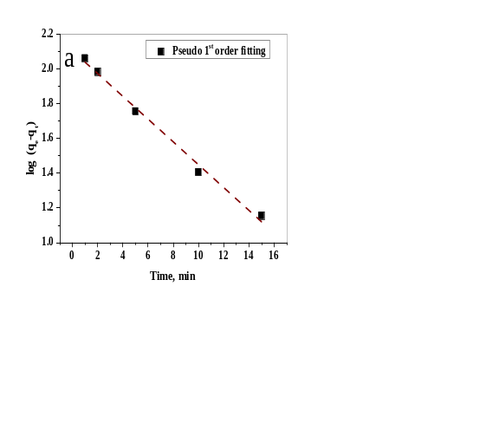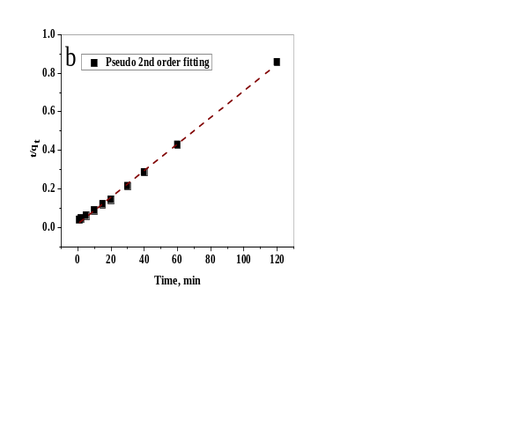
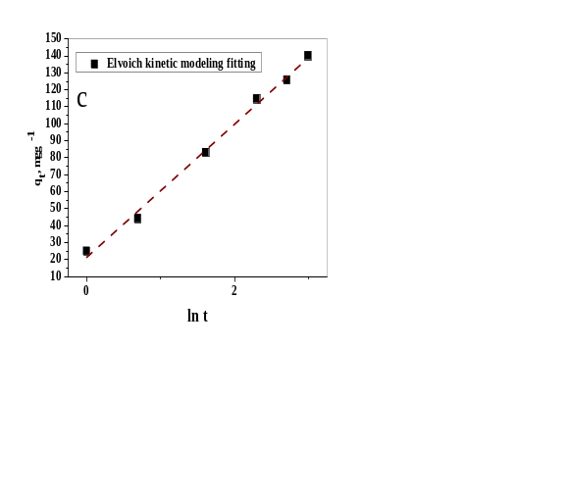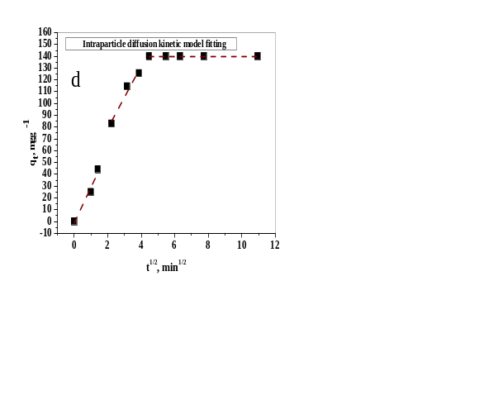
S.1. Kinetic modelling fitting for the sorption of RE³⁺ onto BaSO₄.CaSO₄ composite

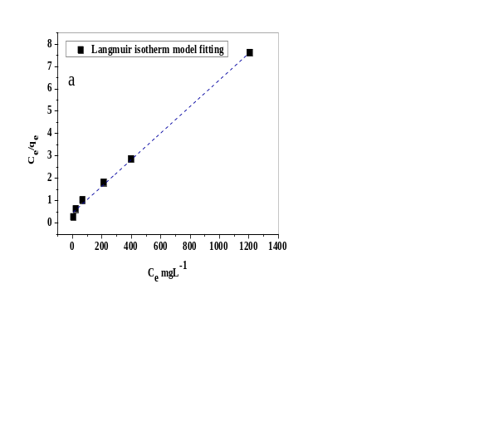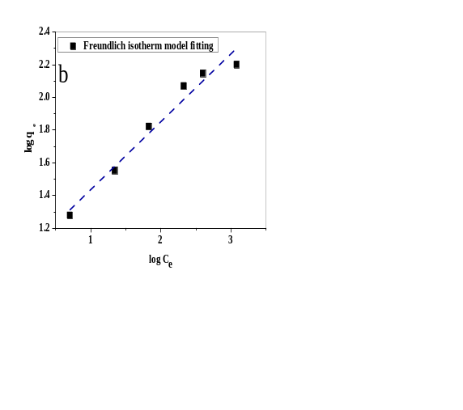
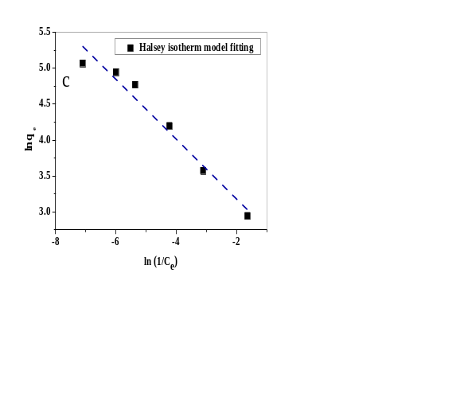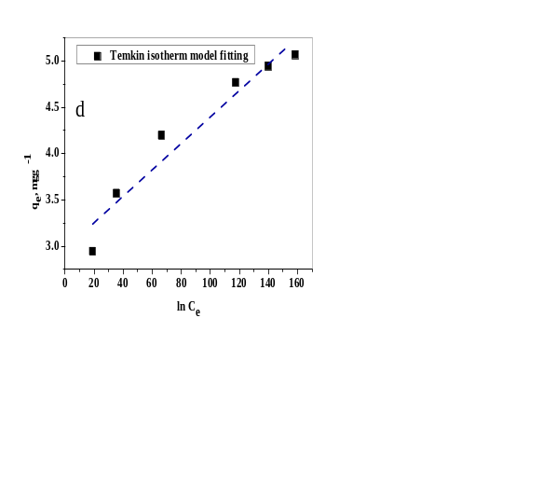
S.2. Isotherm modelling Fitting for the sorption of RE³⁺ onto BaSO₄.CaSO₄ composite
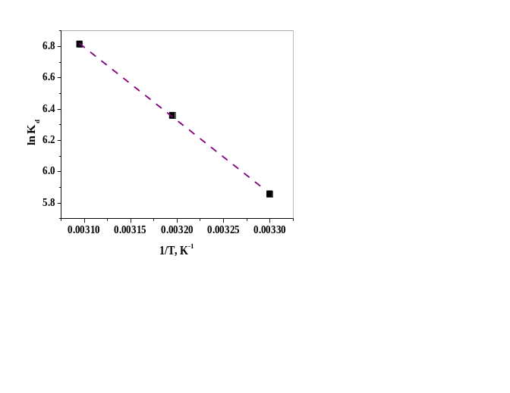
S.3.Thermodynamic plot of the sorption of RE³⁺ onto BaSO₄.CaSO₄ composite

