Supplementary material
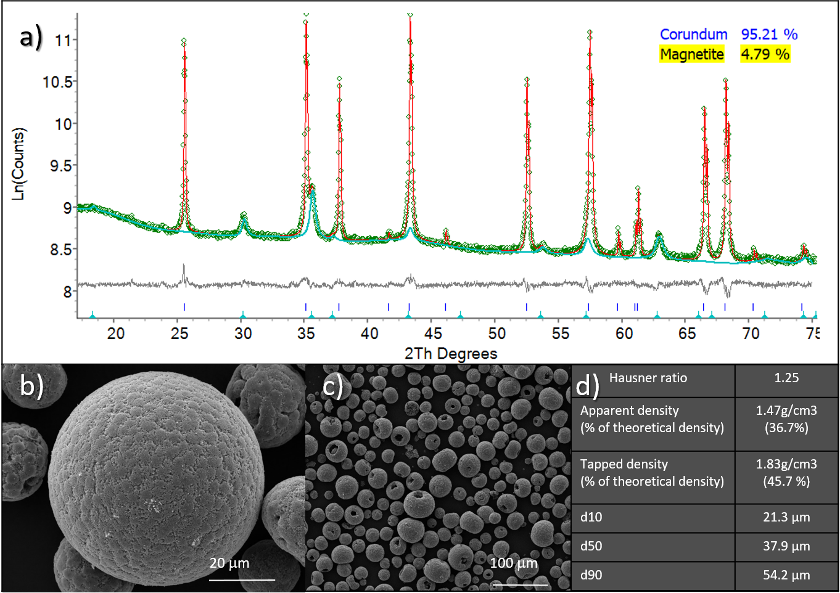
Fig. S1 Powder characterisation by XRD and SEM. a Diffraction pattern of the powder: red line is the fitted curve to the experimental data (green markers). The turquoise line shows fitting of the magnetite phase; b, c SEM images of the alumina granules with 5 vol% of magnetite d macroscopic properties of the starting powder.

