Contents of this file
Figure A1
Introduction
This supporting information provides the figure discussed in the main article
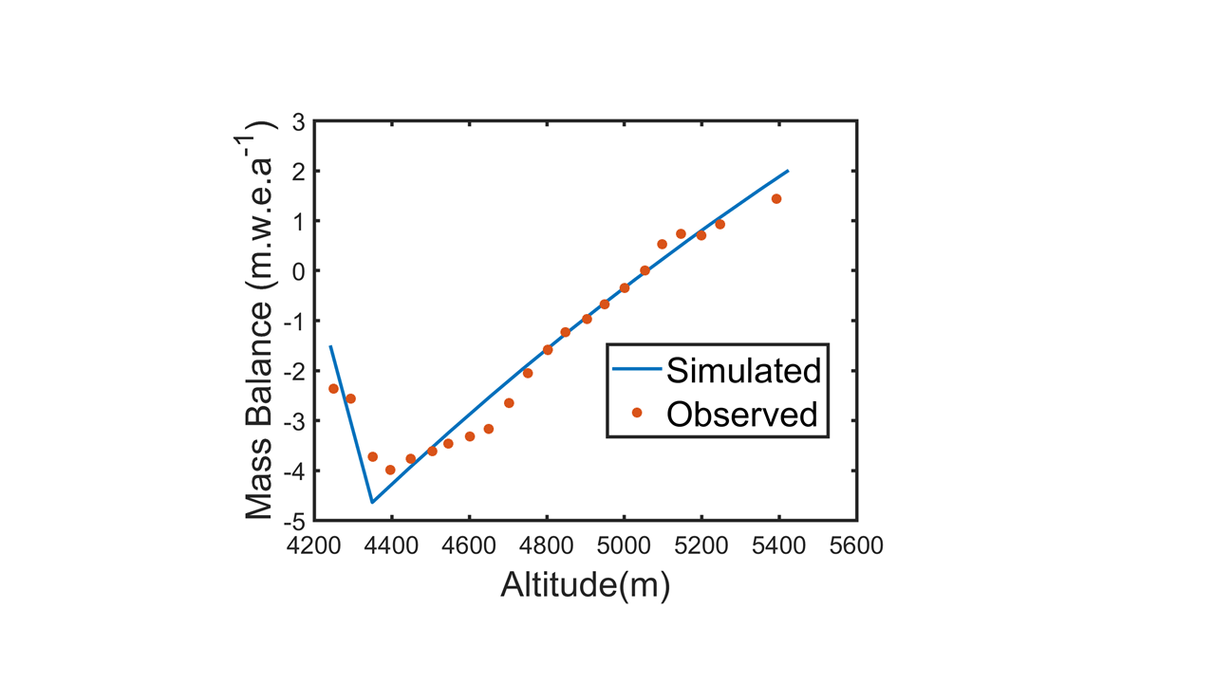
Figure A1: Shows the surface mass balance profile of the Chhota Shigri glacier for the period 2002-2011. Red dots indicate observed mass balance values. Blue represents modelled mass balance. This was used to test the validity of the mass balance model.

