Table 1 Chemical composition of 316L sheets used in the experiments
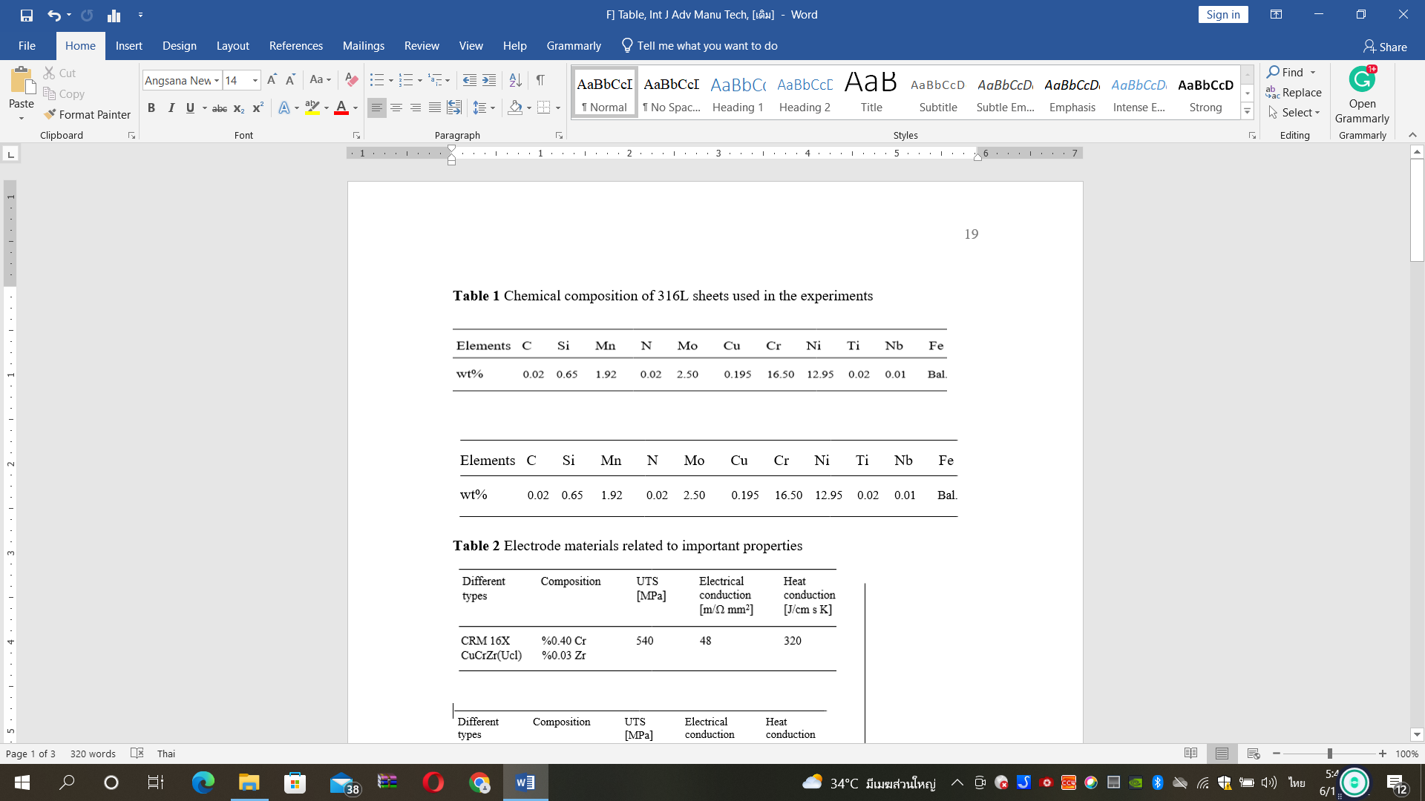

Table 2 Electrode materials related to important properties

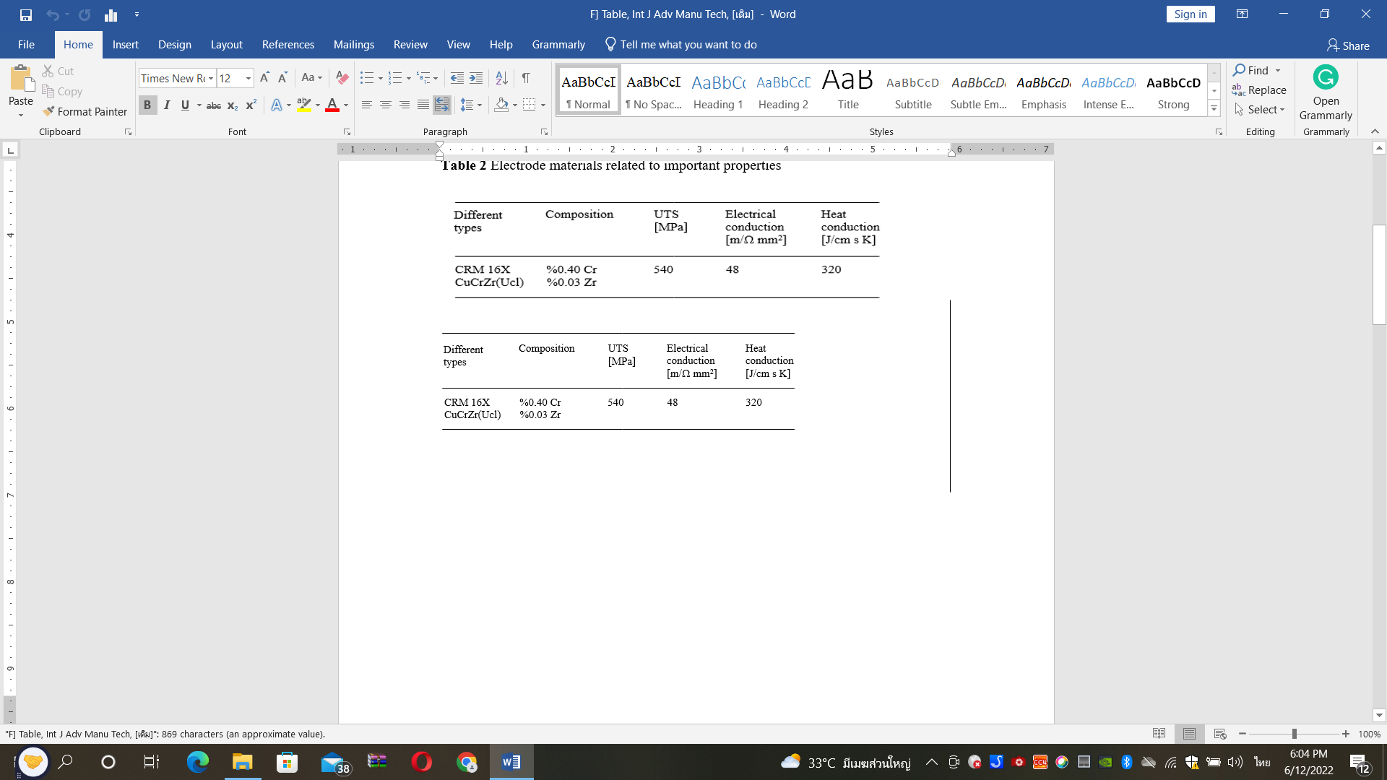

Table 3 The ratio of welding current to welding time on the tensile-shear and tensile-peel force

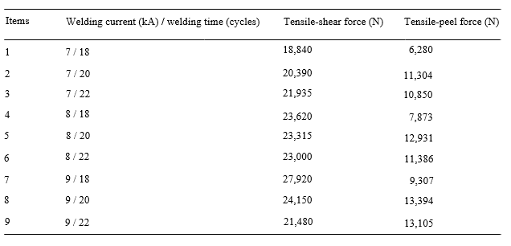

Table 4 The ratio of welding current to welding time on the weld nugget cross-sectional area characteristic parameters relative to Fig. 9, tensile-shear testing as the left data, and tensile-peel testing as the right data

