Supplementary Information

Simultaneously trapping solvents molecules and anions for stable and safe potassium-ion batteries

Authors: Removed for double-blinded peer review

This PDF file includes:

Methods
Supplementary Figs. 1 to 36
Supplementary Tables 1 to 6
Supplementary References

Methods
Chemicals
All chemicals, including vanadium pentoxide (V₂O₅, 99.99%), ammonium phosphate monobasic (NH₄H₂PO₄, 99%), potassium fluoride (KF, 99%), oxalic acid dihydrate (H₂C₂O₄·2H₂O, 99.8%), 3,4,9,10-perylenetetracarboxylic diimide (PTCDI, 99%), commercial graphite, potassium iodide (KI, 99%), copper nitrate trihydrate (99%), 2,5-dihydroxyterephthalic acid (99%), N,N-dimethyformamide (DMF, 99.8%), 1,3,5-Benzenetricarboxylic acid (BTC,99%), zircomiun tetrachloride (99.5%), trifluoroacetic acid (TFA, 99%), fumaric acid (FA, 99.5%), Poly(sodium 4-styrenesulfonate) (PSS, >98%), 1,3-diazaindene (99%), 2-methylimidazole (MIM, >98%), zinc acetate dihydrate (98%), zinc chloride (99%), diethylamine (DEA, 99.8%), potassium bis(fluoroslufonyl)imide (KFSI, 99.5%), ethylene carbonate (EC, >99%), diethyl carbonate (DEC, >99%), N-methyl-2-pyrrolidone (NMP, 99.5%), polyvinylidene fluoride (PVDF, average M_{w} ~534,000) and methanol (99.95%), ethanol (99.95%) were bought from Sigma-Aldrich. All the chemicals were used as received.
Materials synthesis
Preparation of zeolitic imidazolate framework powders: 1,3-diazaindene (354.4 mg, 3 mmol) and Zn(CH₃COO)₂·2H₂O (263.4 mg, 1.2 mmol) were dissolved in water (100 ml) and stirred for 3 h at 28 °C. The mixture was aged for one day, and the zeolitic imidazolate framework precipitates were collected by centrifugation. After immersion in 60 °C ethanol for a week and during the period, the ethanol solvent was replaced 3 times. The solid was separated by centrifugation and dried to yield the product as a white powder (ca. 450 mg). In addition, a vacuum heat treatment at 200 °C for 24 h was necessary to activate the zeolitic imidazolate framework materials before further usage.
Preparation of various metal organic framework (MOF-x; x = A, B, C, D, E) powders: The MOF-A (Cu-MOF-74) was synthesized by a simple hydrothermal method. 80 ml DMF was mixed with 4 ml ethanol firstly. Then, 8 mmol copper nitrate trihydrate and 4 mmol 2,5-dihydroxyterephthalic acid were added to the prepared mixture solvent. After constant stirring at 28 °C for 1 h, the solution was transferred into a Teflon bomb and heated at 80 °C for 24 h. The precipitates were collected and followed by a 60 °C ethanol treat for a week. The final products were collected by centrifugation. MOF-B (CuBTC): 8 mmol/L ethanol solution of cupric nitrate trihydrate (200 mL) was mixed with 200 mL the same concentration ethanol solution of BTC. The precipitates was collected and followed by a hot ethanol treat for a week. The products were collected by centrifugation. After the products were obtained, PSS was used to modify the products to obtain the final powders¹. MOF-C (UiO-67): 100 mg zircomiun tetrachloride and 116 mg FA were dissolved into a mixture solvent of DMF and TFA in a ratio of 20:1 (20 ml). Then, the solution was transferred into an autoclave and hydrothermally-treated at 120 °C for 72 h. After that, the precipitates were washed with fresh DMF several times and then collected by centrifugation. Subsequently, the precipitates were suffered a 60 °C ethanol treat for a week. MOF-D (ZIF-8): after stirred 300 mL methanol solution containing 523 mg zinc acetate dihydrate and 658 mg MIM for 4 h, an ageing time of one day was needed to yield the final white products. The MOF-D was washed with ethanol for three times, and immersed in hot ethanol for a week. Finally, the products were collected by centrifugation. MOF-E (poly[Zn₂(BIM)₄]): 0.612 g zinc chloride was dissolved in 23 mL DMF to form a homogeneous solution (solution-1). Solution-2: 0.354 g BIM was dissolved in 23 mL DMF with 0.22 g DEA and stirred for 20 min. Solution-2 was added dropwise to solution-1 under stirring. Subsequently, the reaction solution was transferred to a Teflon bomb and kept at 130 °C for 24 h. The precipitates were collected and immersed in hot ethanol for a week before final centrifugation. In addition, a vacuum heat treatment at 200 °C for 24 h was used to activate the MOF-x (x = A, B, C, D, E) materials before further usage.
Preparation of potassium vanadium fluorophosphates (KVPO₄F; KVPF): Topically, the stoichiometric amounts of V₂O₅, KF, NH₄H₂PO₄ and H₂C₂O₄·2H₂O (100% excess) were mixed and ball milled at 450 r min⁻¹ for 24 h with the support of ethanol. After vacuum drying the milling slurry at 120 °C for 24 h, the material was heated at 310 °C for 2 h and 700 °C for 8 h under argon atmosphere to obtain the final product.
Films preparation
Mixing the prepared 200 °C activated materials and PVDF with a weight ratio of 9:1 in NMP to harvest the slurries. The slurries were coated on aluminum foils using a doctor blade and dried at 80 °C for 8 h, and then immersed in room temperature methanol for 30 min to obtain flexible films. The prepared films were punched into small discs (14 mm in diameter), reactivated overnight under vacuum at 200 °C and transferred to a standard glove box.
Graphite, ketjen black, and PVDF (ratio: 8:1:1, in weight) were stirred in NMP for 12 h and then slurried on Al foil. After drying, punch the covered Al foil into small electrode discs with weighing approximately 1.2 mg cm⁻². In addition, KVPF, KI and PTCDI were used as active materials, and the same method (with weight ratio changed to 7:2:1) was used to prepare electrode discs. The active materials on each piece weighs about 1.0-1.2 mg (PTCDI, KI) and 1.4-1.7 mg (KVPF) for further usage. The zeolitic imidazolate framework slurry above was poured onto those electrodes to obtain zeolitic imidazolate framework-covered electrodes.
Electrolyte preparation
1 M KFSI-EC/DEC (1/1, v/v) electrolyte was prepared in conventional ways. Generally, 5 ml EC (70 °C) and 5 ml DEC (28 °C) were mixed quickly, then 10 mmol KFSI powder was added to the mixture solvent with constant stirring. Then the obtained 1 M KFSI-EC/DEC electrolyte was then divided into two parts for further usage. One part of the prepared 1 M KFSI-EC/DEC solution was used as a standard electrolyte (BSTE) before the formation of simultaneously trapped electrolyte. The reactivated zeolitic imidazolate framework plates and corresponding covered electrodes, and reactivated MOF-x (x = A, B, C, D, E) films were immersed into the other part of 1 M KFSI-EC/DEC electrolyte, and treated at 80 °C for 48 h to soak electrolyte molecules into framework traps. Then, the zeolitic imidazolate framework plates and corresponding covered electrodes were taken out, wiped with tissues and dried under a vacuum for 20 h at 80 °C to get rid of any possible electrolyte solvents on the surface to harvest the final simultaneously trapped electrolyte (ASTE).And thus, the ASTE and ASTE-covered electrodes were formed. The reactivated MOF-x (x = A, B, C, D, E) films were also taken out and suffered the same heat treatment to sacrifice free solvent molecules and, hence, forming the electrolytes obtained by treating MOF-x (x = A, B, C, D, E) with simultaneously trapping strategy. As for the saturated KFSI-EC/DEC electrolyte, enough KFSI powders were added to 10 ml EC/DEC (1:1, v/v) solution until slight precipitate appeared.
Electrochemical Measurements
All CR2032-type coin cells were assembled in an argon-filled environment with lower than 0.5 ppm of water and oxygen, and were used to evaluate the electrochemical performance. The K metal foil was directly placed on the prepared ASTE-covered electrode, without using any liquid electrolyte, to assemble the rechargeable half cell. In addition, BSTE, ca. 60 µl/mg (based on weight of active material), and the Whatman glass fiber (separators) were also used and assembled in typical way to construct PIBs with BSTE for comparisons. Before each electrochemical test, the batteries were left in an open circuit overnight. For the full coin cells assembling, the pre-potassiated graphite anode was obtained by cycling for 5 cycles and then discharged to 0.01 V with the P/N ratio is about 1:1.05. Pouch cells were assembled by careful sandwich ASTE between the anode and cathode (double-sided integrating, P/N ratio, 1:1.05), without using any liquid electrolyte, here the mass loading of PTCDI to ca. 9.4 mg cm⁻². Aluminium and nickel strips were attached as electrode tabs to the sides of the cathodes and anodes. Note that we use Al foils instead of Cu foils as anode current collectors in order to pursue lower weight in this work. The nickel welding here is only for better and more intuitive distinction between cathode and anode after sealing. And then the cells were packed using the aluminium laminated materials with side and top sealing, followed by vacuum sealing with gentle pressing. The galvanostatic charge/discharge processes of as-prepared batteries were performed by Neware BTS battery testing system. The K||Cu cells and K||K symmetric cells were prepared with BSTE-infiltrated glass fibers and ASTE, respectively. BSTE-infiltrated glass fiber, ASTE, and the electrolytes obtained by treating MOF-x (x = A, B, C, D, E) with simultaneously trapping strategy were used as interlayers, sandwiched by K fiols and Al fiols to assemble K||Al batteries. The Linear sweep voltammetry (LSV, with Al as the working electrode and K as counter and reference electrodes) and Chronoamperometry (CA) tests were performed using electrochemical workstation.
Characterizations
X-ray diffraction (XRD) and in-situ XRD measurements were performed on a Bruker D8 Advanced diffractometer with different gratings. Scanning electron microscopy (SEM, JEOL JSM-6380LV FESEM) was used to characterize the morphology of all the samples. Thermogravimetric analysis (TGA) is obtained from a thermal analyzer (mettle Toledo TGA/SDTA 851) at a temperature rise rate of 10 ºC/min from room temperature to 250 °C in a nitrogen-filled atmosphere. Raman spectroscopy was performed using a JOBIN YVON HR800 system equipped with a 514 nm diode laser (for framework walls) and a 532 nm diode laser (for conducting matrix), and the scattering signal was enhanced by Raman spectroscopy (SHINERS) techniques. Liquid nitrogen-assisted preparation of cryo-electron microscopy (cryo-EM) samples by pouring powder onto copper grids. Recordings were then performed on a JEM-2100F cryo-EM with OneView and K2 cameras and a field emission gun operating at 200 keV. Symmetric K||K cells were assembled in a modified Swagelok cells with X-ray transparent polymer-based housing with ASTE and BSTE-infiltrated glass fiber as separator in an glovebox for X-ray microtomography experiments. Cells were allowed to equilibrate at room temperature overnight and followed by cycling for 100 h (0.1 mA cm^{–2}, 0.2 mAh cm⁻²) before final tests. Monochromatric hard X-ray microtomography was then carried out on diondo d2 (120 kV). The Swagelok cells were rotated 180° under the X-ray, and the shadows cast by the samples were converted to image stacks with ~1,800 images in each stack. The stacks were re-sliced with Tomviz software to obtain the cross-sectional and bottom surface tomography slices.
Calculation of ionic conductivity
According to the conventional protocol of the ionic-conductivity measurement, we measured the ion conductivity of BSTE and ASTE, respectively. Topically, the electrolytes were placed between two Cu plates to prepare the cells². Note that what we actually measured here is the overall ionic-conductivity of the BSTE-infiltrated glass fiber, we don’t want to measure that of them separately, as it is more in line with the actual battery operation and is also more suitable for comparison. On the other hand, the prepared ASTE was also sandwiched between two stainless steel plates. All the cells were equilibrated at the room temperature for 3 h before performing measurement. The ionic-conductivity was measured by the AC impedance method using electrochemical workstation in the frequency range from 0.01 Hz to 1 MHz and calculated according the equation (1). Where σ is the ion conductivity, l is the distance (cm) between the two Cu plates, S is the area (cm²) of the Cu plate and the R (Ω) was calculated from the impedance Nyqiusit plot.
σ = l/SR (1)
Calculation Method
The molecular dynamics (MD) simulation system consisted of zeolitic imidazolate framework, K⁻, FSI⁻, and organic solvents molecules. The atomistic structures of zeolitic imidazolate framework were constructed as described in Ref. 3. The zeolitic imidazolate framework characteristics (Supplementary Table 1), such as gravimetric and volumetric surface areas, pore-volume, and mean pore size, were calculated using Zeo⁺⁺ software 8 with a nitrogen probe radius of 1.86 Å. As shown in Supplementary Figs. 11-14, the charge distribution on the zeolitic imidazolate framework unit, FSI⁻, EC, and DEC molecules were obtained by exchange correlation function was optimized using the generalized gradient approximation (GGA). Supplementary Table 2 show the key parameters of MD simulation systems, such as the number of cation-anion pairs in the simulation box, the length of the framework, and the size of the simulation box. The framework with 210 K⁺, 210 FSI⁻, 143 EC, and 78 DEC (the ratio of K⁺, FSI⁻, EC, and DEC was 1:1:0.67:0.37.) were loaded into a rectangular boxe with the size of X (27.0 Å), Y (27.0 Å), and Z (124.0 Å) by Packmol. Next, the Amber 2020 software was used for the molecular dynamics simulation. After the system was minimized, heated, and balanced, we embarked on the phase simulation. The minimization process was carried out under the NVE ensemble. In this ensemble, the number of particles N, the volume V, and the energy E were kept constant⁶. The energy minimization was carried out in a total of 20,000 steps. The steepest descent method was used for the first 5,000 steps, and the conjugate gradient method was converted after 6,000 steps; the system imposes periodic boundaries (ntb=1). Note that the energy information was outputted to mdout and mdinfo files every 100 steps. After the production phase simulation was over, the cpptraj module in the Amber 2020 software was used to analyze the density distribution of anions, cations, and solvent molecules in the pores of the molecular dynamics trajectory. The heating, equilibrium, and production phase process was carried out under the NVT (in which the temperature T rather than the energy E was fixed) using the customized MD software GROMACS⁷. The heating process had a total of 40,000 steps with a step length of 0.5 fs; the system imposed a constant volume periodic boundary (ntb=1), and we did not control the pressure (ntp=0). The cutoff distance for non-bond interaction was 4.0 Å. The parameters (ntc=2, ntf=2) were imposed to SHAKE key length constraint, and, at the same time, the pseudo-random seed was added for the Langevin thermostat. The heating process was controlled by nmr (nmropt=1). The initial temperature was 0 K, and the temperature was slowly raised to 301 K within 30,000 steps and maintained at 10,000 steps⁶. The charging dynamics were ascertained within a temperature range of 300-400 K due to the large impact of temperature on the dynamic properties and capacity. In addition, a total of more than 20 million steps were carried out in the production phase simulation process, and a potential field was added in the Z direction at this time. We took the molecular/ion coordinates in the channel as the object and performed cluster analysis on the trajectory to obtain a snapshot of the distribution of representative channel molecules or ions, and then performed quantitative calculations of single-point energy and properties (on the CASTEP module of Materials Studio 2019 software).

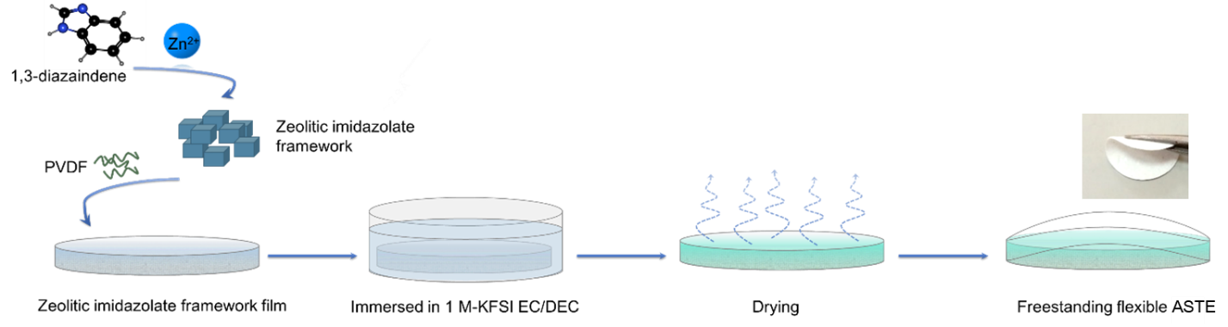

Supplementary Fig. 1.
Manufacturing ASTE. Schematic diagrams of all preparation processes of ASTE and the corresponding optical photograph.

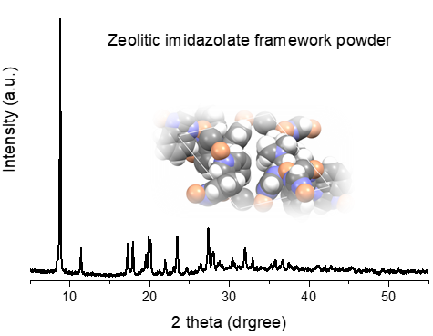
Supplementary Fig. 2.
XRD pattern of the prepared zeolitic imidazolate framework powder . Inset: schematic illustration of the structure.

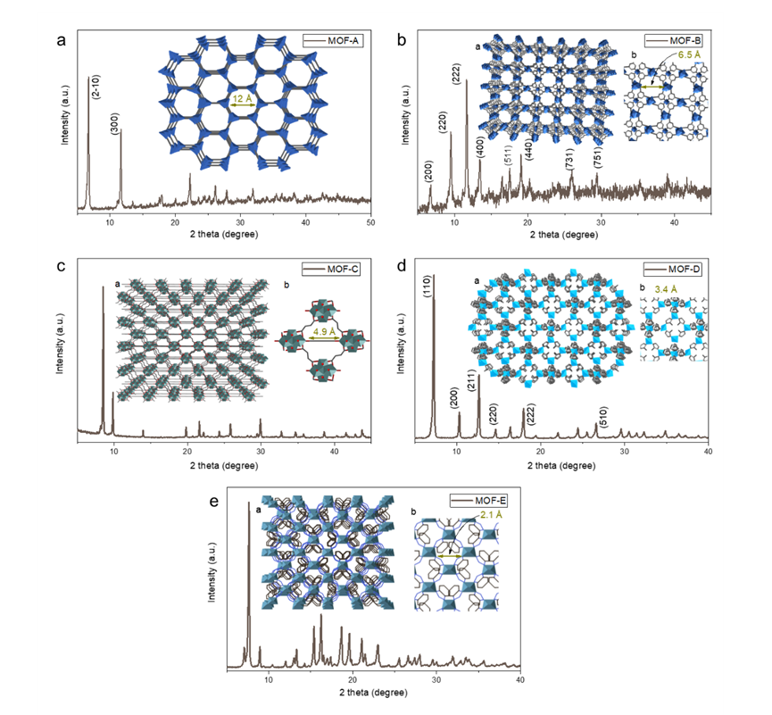
Supplementary Fig. 3.
XRD patterns of different MOF samples. a, MOF-A. Insets: simulated structure. b, MOF-B. Insets: The schematic illustration of structure (a) and enlarged view of the 6.5 Å MOF traps (b). c, MOF-C. Insets: The schematic illustration of structure (a) enlarged view of the 4.9 Å traps (b). d, MOF-D. Insets: The schematic illustration of structure (a) enlarged view of the 3.4 Å traps (b). e, MOF-F. Insets: The schematic illustration of structure (a) enlarged view of the 2.1 Å MOF traps (b).

Supplementary Fig. 4.
The pore size distribution of different MOF materials.

Supplementary Fig. 5.
Oxidative stability. LSV results of electrolytes obtained by treating MOF-x (x = A, B, C, D, E) with simultaneously trapping strategy. Marked as A, B, C, D, and E.
In order to construct the desired ion solvation trap, we have paid attention to MOF materials. Along with the structural features of nanoporous, MOF, a material composed of metal ion nodes and organic ligands, is widely used in the field of chemical.⁴⁻⁶ The porous nature makes it serve as a container for absorbing conductive matrix and possible to be part of the desired electrolyte architecture. The solvation state of K⁺ structure inside MOF traps may be controlled by adjusting the pore size of the MOF. We chose various pore sizes (Supplementary Figs. 3,4) here to construct electrolyte. To screen those MOF matrixes for constructing a electrolyte of which might be provide suitable ion traps for K⁺, we initially determined the oxidative stability of various obtained electrolytes (Fig. 4a (main text), Supplementary Fig. 5). These results indicate that the electrolyte prepared with the zeolitic imidazolate framework with a pore size of 2.9 Angstroms has the highest oxidative stability (higher than 5.9 V). This indicates that the oxidative stability is related to both the placement of certain K⁺-coordinating functionality within the pore network (especially, the pore size) and the manifestation of an MOF architecture that restricts the solvent molecules that can be bound to K⁺ within the pore network so that it might, in turn, have higher oxidative stability therein.

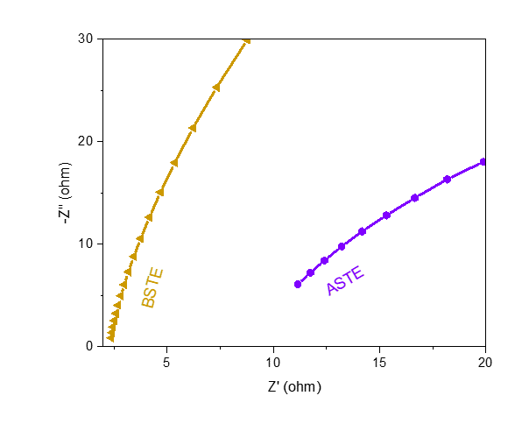

Supplementary Fig. 6.
AC impedance spectra of different electrolytes. At room temperature, the corresponding K⁺ ionic conductivity of BSTE = 0.847 mS cm⁻¹, ASTE = 0.182 mS cm⁻¹.

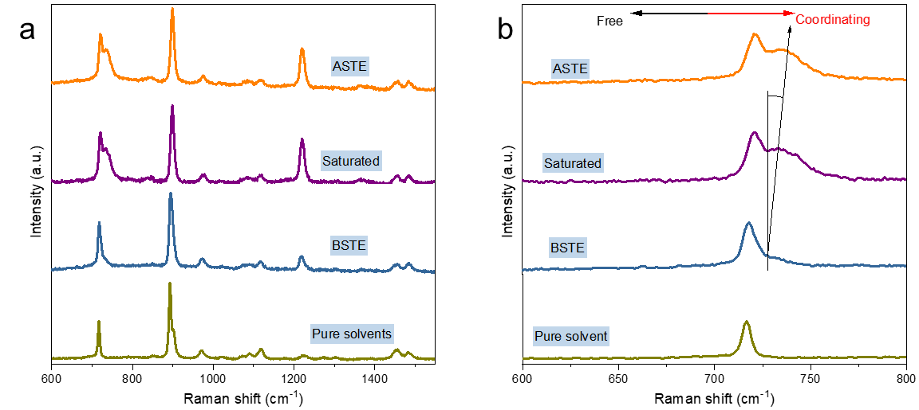

Supplementary Fig. 7.
Raman full spectrums. a, Full survey Raman of ASTE and different liquid solvents (pure solvents,1 M and saturated KFSI-EC/DEC). b, Migration of the peak of S-N stretching in FSI⁻.
Dissolution of KFSI into the solutions results in the peak of S-N stretching toward a coordinating stretching vibration (higher wavenumber), which implies that K⁺ coordination with FSI⁻ is enhanced and the population of FSI⁻ free ions decreases.

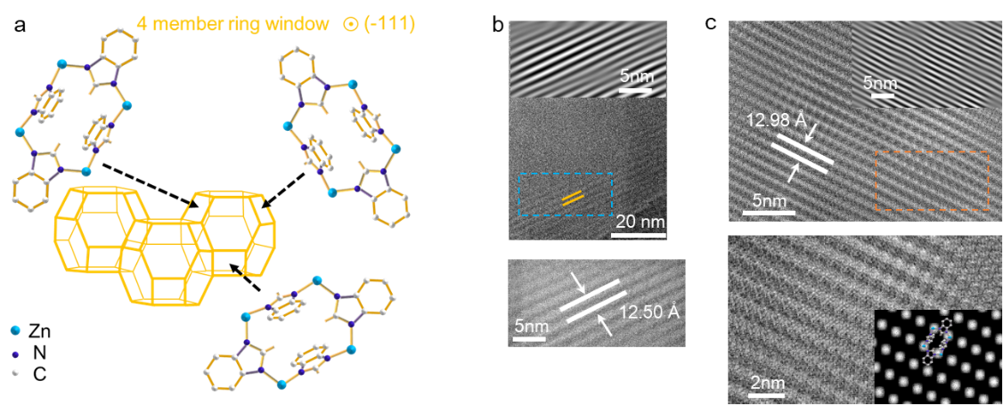
Supplementary Fig. 8.
Cryo-EM test. a, Representations of the SOD (for definitions of three-letter abbreviations, see Reticular Chemistry Structure Resource topology building units of the zeolitic imidazolate framework)³. Hydrogen atoms have been omitted for clarity. b,c, Cryo-EM images of zeolitic imidazolate framework (b) and ASTE (c).

Supplementary Fig. 9.
Zeolitic imidazolate framework (-111) and ASTE (-111) lattice measurement. The (-111) lattice spacing of empty zeolitic imidazolate framework particle is measured to be 12.50 Å. The (-111) lattice spacing of ASTE is measured to be 12.98 Å, an expansion of ca. 3.8%.

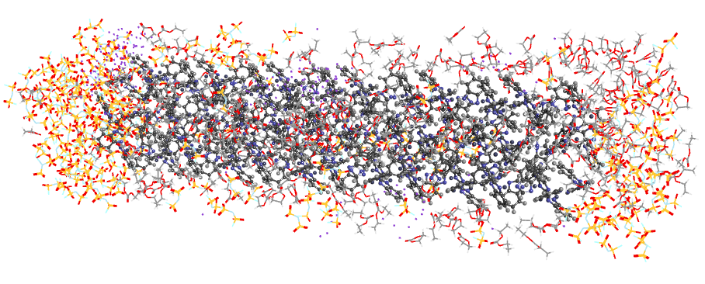
Supplementary Fig. 10.
MD simulation system. The all system consisted of zeolitic imidazolate frameworks, anions and cations, and organic solvents. The ratio of K⁺, FSI⁻, EC, and DEC is 1:1:0.67:0.37 (based on the Raman results).

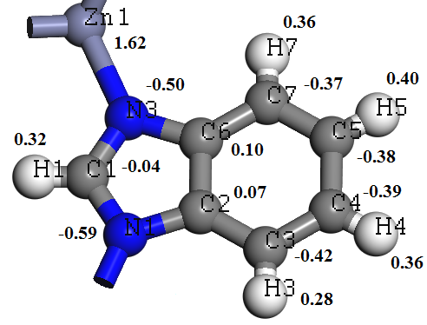
Supplementary Fig. 11.
Calculated charge distribution in zeolitic imidazolate framework unit. The atom names and the corresponding charge distribution of zeolitic imidazolate framework unit as calculated from Gaussian 09 software useing the b3lyp/6-31g(d) functional basis set to optimize.

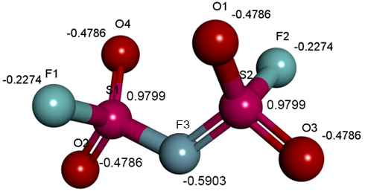
Supplementary Fig. 12.
Calculated charge distribution in FSI⁻. The atom names and the corresponding charge distribution of FSI⁻ as calculated from Gaussian 09 software useing the b3lyp/6-31g(d) functional basis set to optimize. The total charge is -1 e⁻.

Supplementary Fig. 13.
Calculated charge distribution in EC. The atom names and the corresponding charge distribution of EC as calculated from Gaussian 09 software using the b3lyp/6-31g(d) functional basis set to optimize. The total charge is 0.

Supplementary Fig. 14.
Calculated charge distribution in DEC. The atom names and the corresponding charge distribution of DEC as calculated from Gaussian 09 software using the b3lyp/6-31g(d) functional basis set to optimize. The total charge is 0.

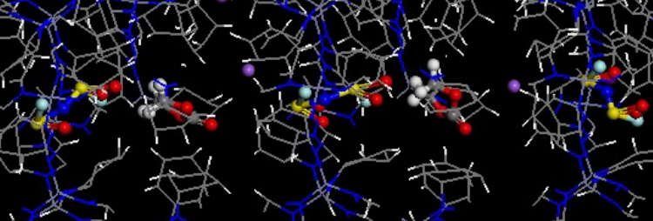
Supplementary Fig. 15.
A snapshot of the MD simulation of trapped ions at 1 V potential.

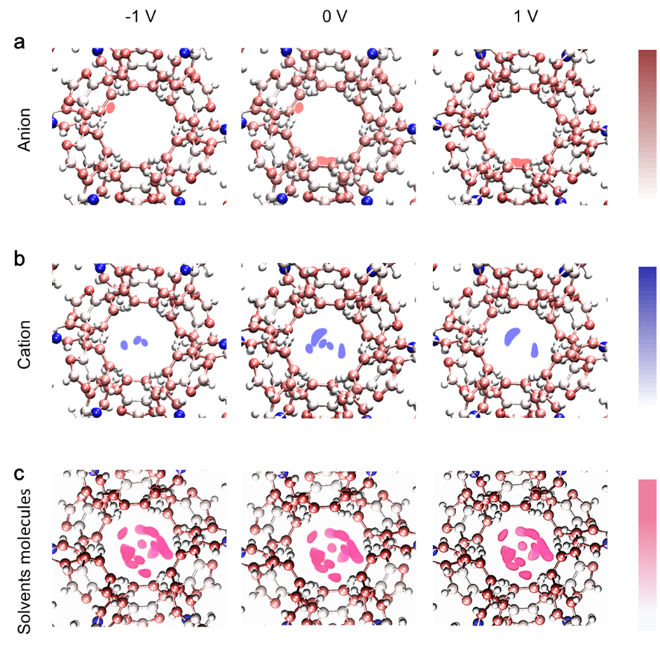

Supplementary Fig. 16.
Ions and molecules density distributions in the ASTE. In-plane two-dimensional image of the FSI⁻ (a), K⁺ (b), and solvents molecules (c) distribution in the studied traps. Each image is based on simulated data averaged along the pore axis.

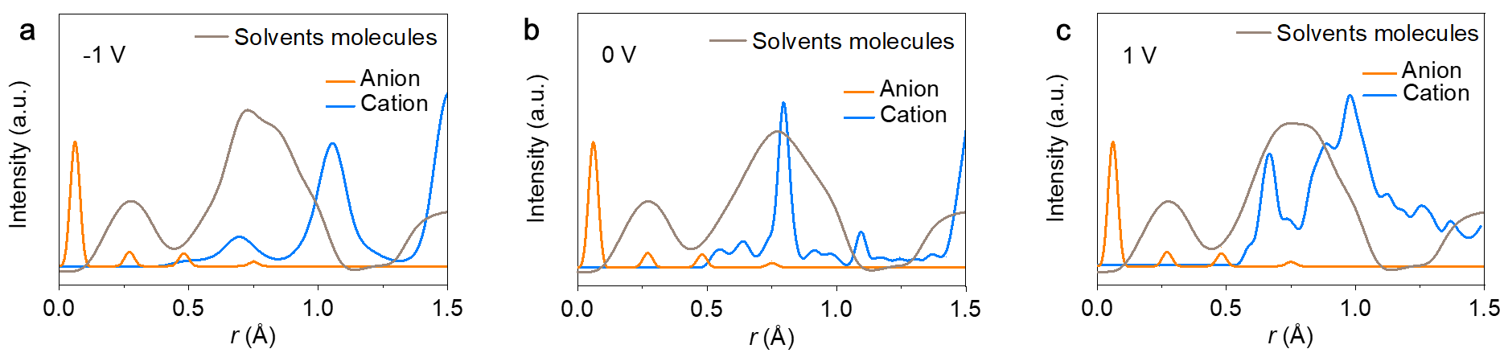

Supplementary Fig. 17.
Ions and molecules radial number distributions in the ASTE. a, -1 V. b, 0 V. c, 1 V. r=0.0 Å stands for the periphery.

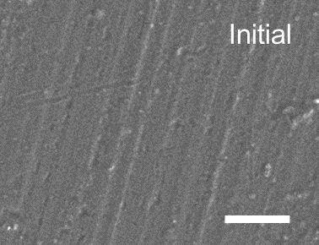

Supplementary Fig. 18.
Morphology observation. SEM image of the initial state of the Al foil used in this work. Scale bar, 2 μm.

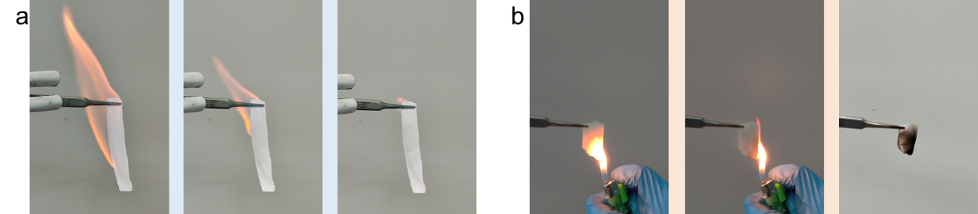

Supplementary Fig. 19.
Flame tests of BSTE-infiltrated glass fiber separator and ASTE. a, BSTE-infiltrated glass fiber separator. b, The whole process of flame test of ASTE.
It can be seen from the whole process of the ASTE flame test that there is no open flame in the whole process, only the framework block was carbonized after ignition, demonstrated the high safety of ASTE.

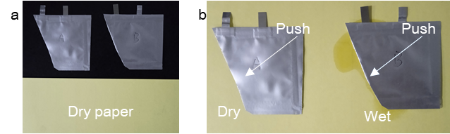

Supplementary Fig. 20.
The electrolyte leakage test. Comparison of electrolyte leakage in rechargeable batteries with ASTE (marked A) and BSTE (marked B) before test (a), and pressing the pouch on a piece of dry paper (b).

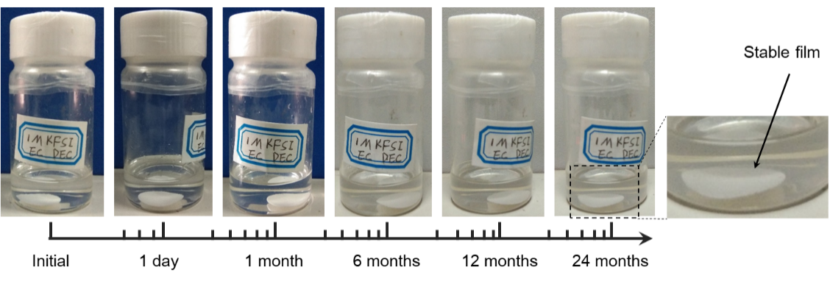

Supplementary Fig. 21.
Morphology stability. Immersing the zeolitic imidazolate framework film in the electrolyte over 2 years. It retained stable morphologies in electrolyte.

Supplementary Fig. 22.
Structural stability. The consistent XRD peaks of the zeolitic imidazolate framework film after soaking in the precursor solution over 24 months (cf. Supplementary Fig. 21).

Supplementary Fig. 23.
Chemical stability. The XRD patterns of ASTE cycled (0.1 mA cm⁻² (current density), 0.2 mAh cm⁻² (area capacity density)) for different time.

Supplementary Fig. 24.
Coulomb efficiency of K||Cu cells (0.1 mA cm⁻², 0.3 mAh cm⁻²) cycling in different electrolytes. Inset: the 83 th charge profiles of K||Cu cells cycled in ASTE and BSTE.

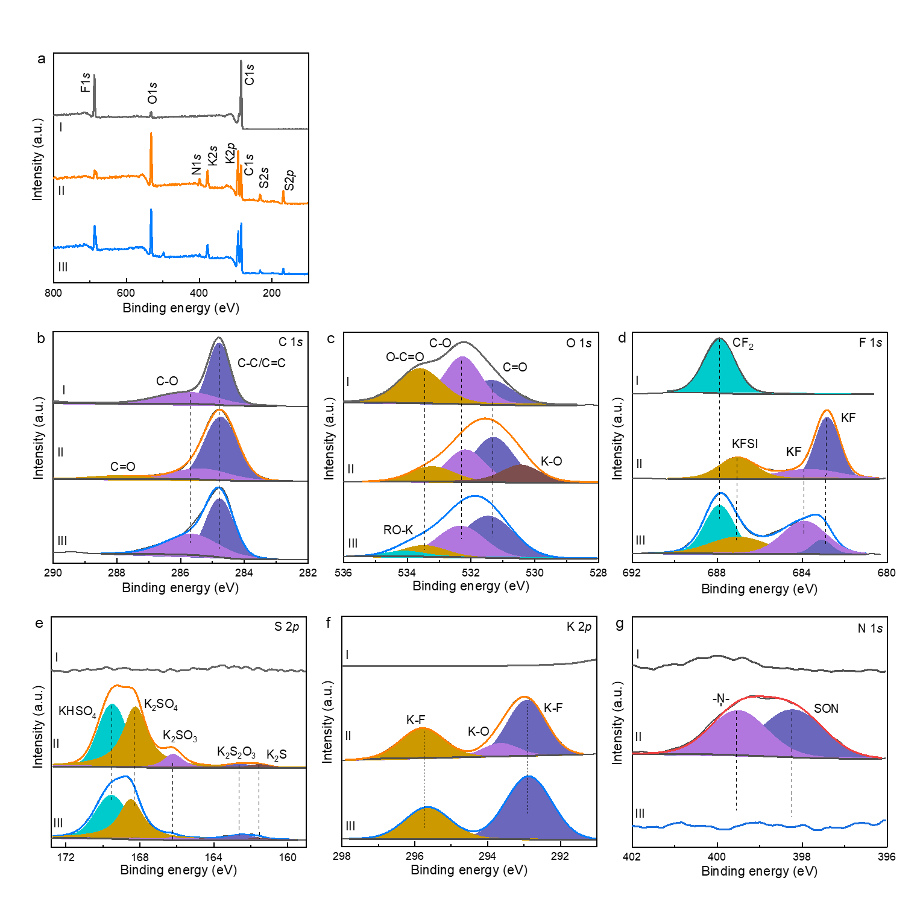

Supplementary Fig. 25.
XPS analysis of surface passivation films of graphites in BSTE and ASTE. a, Full survey XPS. b-g, High-resolution XPS spectra of C 1s (b), O 1s (c), F 1s (d), S 2p (e), K 2p (f) and N 1s (g). (I) represents the pristine state, (II) represents the state after cycling in ASTE, and (III) represents the state after cycling in BSTE.
To understand the effective passivation film formation on the graphite electrode surface with ASTE, the chemical composition of the electrode surface was studied after 5 cycles using XPS. For comparison, the corresponding graphite surface in its pristine state and after cycling with BSTE were also studied. The high-resolution C 1s spectra (b) of the graphite electrodes cycled in BSTE, and ASTE exhibit the peaks of C-O and C-C/C=C. A small peak at around 288 eV corresponding to C=O could also be observed in the electrode cycled in ASTE. Compared to the pristine graphite electrode, it is obvious that the C-O peak area of the electrode after cycling in BSTE is larger than the pristine one, while the corresponding peak area in ASTE is almost the same as the pristine. The increase in peak area is probably due to the decompositions of EC/DEC in BSTE, indicating that it suffers more severe solvolysis on graphite electrodes than ASTE. In addition, there is also evidence to support such solvolysis in the O 1s spectra (RO-K bond, the cyan peak in c). Another difference between the three profiles in the O spectrum is that the middle profile has a K-O bond, which corresponds to potassium oxide (K₂O). In (e), a new element, S, appeared in the spectra, a product of the decomposition of KFSI. In the case of ASTE, the peak intensity and area of sulfur-related inorganics in the spectrum are larger than those in the case of BSTE, indicating that more inorganics will be formed on the surface of the graphite cycled in ASTE. Our previous work confirmed that this robust inorganic-rich passivation film is beneficial to improving Coulombic efficiency, which is also consistent with the Coulombic efficiency in this work (rapid increase to 97% after five cycles). The K-O bond appeared in high-resolution K 2p spectra (f), consistent with the O spectrum. Regarding the electrode surface after five cycles in the traditional system, no obvious peak was observed in the N 1s spectra (g). On the contrary, elemental N participated and formed nitrogen-containing inorganics on the surface of graphite. Collectively, the XPS study revealed that the passivation films on ASTE-cycled graphite electrodes are inorganic, and that these inorganics may beneficial to highly reversiblity.

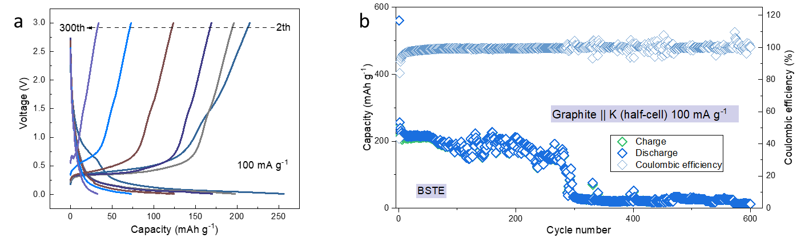

Supplementary Fig. 26.
Electrochemical performance of the graphite||K half-cell cycled in the BSTE. a, Charge-discharge profiles in the first 300 cycles. b, long-term cycle performance.

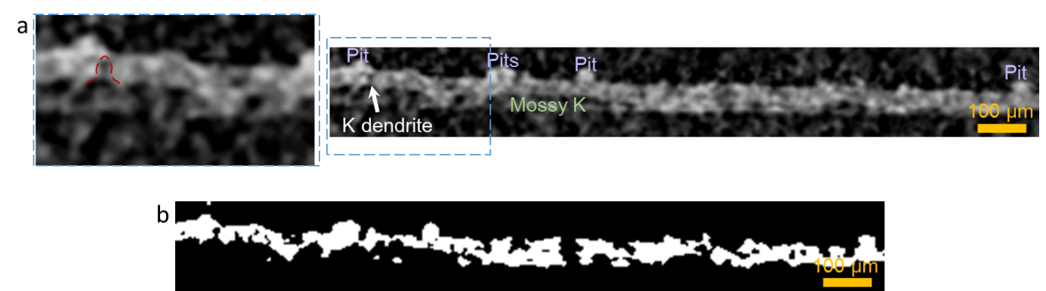

Supplementary Fig. 27.
Magnified X-ray computed microtomography images. a, Cross-sectional analysis of synchrotron hard X-ray computed microtomography for visualizing the cycled (0.1 mA cm⁻², 0.2 mAh cm⁻²; 100 h in K||K symmetric cells) electrode-electrolyte interface with BSTE. A potassium dendrite can be observed at the location marked with a red dashed line (left) and depicted with a white arrow (right). b, Black and white treatment result of the electrode-electrolyte interface after cycling.

Supplementary Fig. 28.
The well-matched XRD pattern of KVPF powder sample.

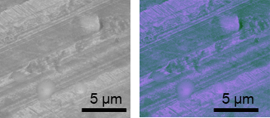

Supplementary Fig. 29.
Aluminum current collector images. SEM image (left) and corresponding colored image (right) of the aluminum current collector inside the KVPF|BSTE|K battery after galvanostatic charged (Fig. 4b, main text). Corrosion spots are clearly visible.

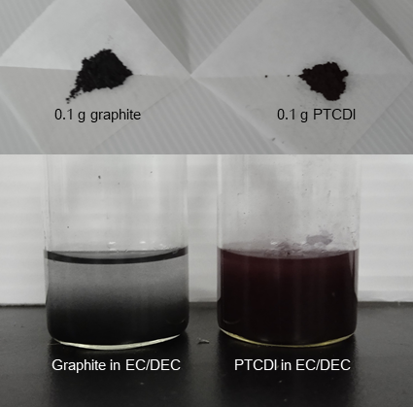

Supplementary Fig. 30.
Solubility test. Photos of 0.1 g graphite (for comparison) and 0.1 g PTCDI dissolved in EC/DEC (1/1, by vol.) solutions.
If PTCDI were insoluble, the dispersion would appear clear (like 0.1 g graphite in EC/DEC), as in the case of graphite rather than turbid.

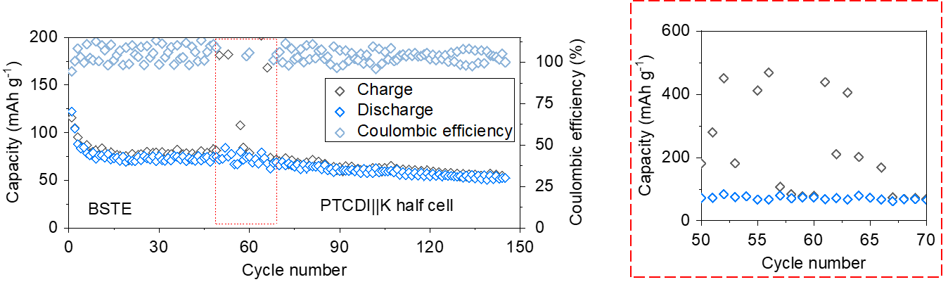

Supplementary Fig. 31.
Electrochemical performance of the PTCDI||K half-cell in BSTE.

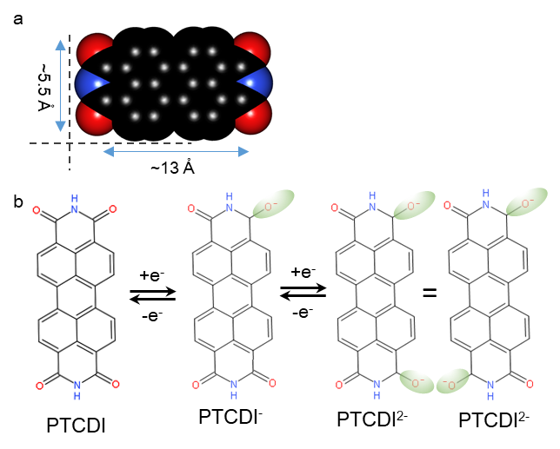

Supplementary Fig. 32.
The visualization of molecular valence orbitals. a, PTCDI, b, PTCDI⁻ and PTCDI²⁻. The available migration path in ASTE is ca. 2.9 Å of width, smaller than the length of serial PTCDI^{n-} (n=1,2) redox intermediates (~5.5 Å).

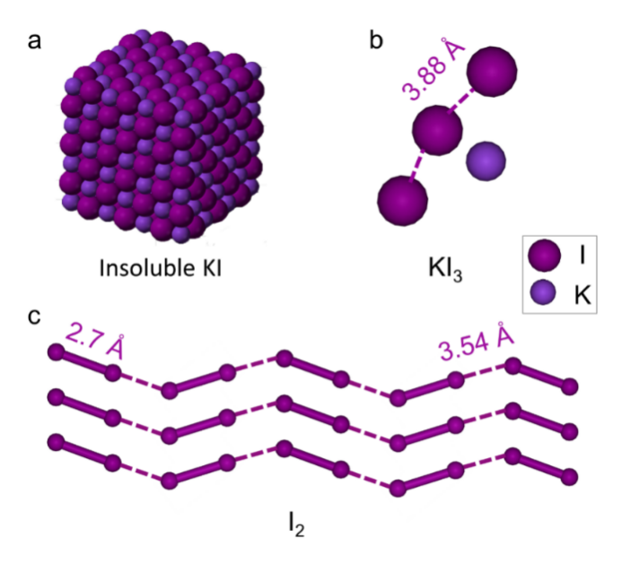

Supplementary Fig. 33.
The visualization of molecules. a, Insoluble KI. b, KI₃. c, I₂.
The available migration path of the framework in ASTE is 2.9 Å of width, smaller than the length of KI₃ and I₂⁷⁻¹⁰. confirming this ASTE configuration we designed can prevent the “shuttle effect” of serial I₃⁻ and I₂. Note that the KI is insoluble, so it wouldn't cause the “shuttle effect”. The reaction equation of the KI electrode during the full process of charge and discharge is as follows:
3 KI ↔ 2 K⁺ + KI₃ + 2 e⁻ (2)
2 KI₃ ↔ 2 K⁺ + 3 I₂ + 2 e⁻ (3)

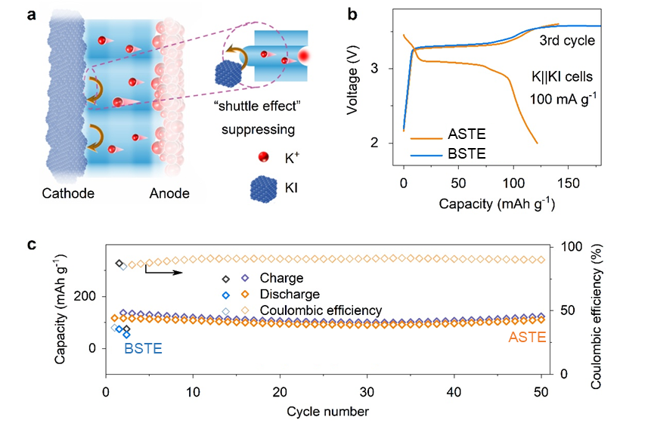

Supplementary Fig. 34.
Suppression of the “shuttle effect”. a, Schematic showing the “shuttle effect” suppression. The frameworks in ASTE act as sieves for the soluble iodide (ca. 2.9 Å, significantly smaller than that of the iodide), thus addressing its issue of the “shuttle effect”. b,c, The third cycle of charge-discharge profiles (b) and cycling performances (c) of K||KI batteries equipped with ASTE and BSTE.

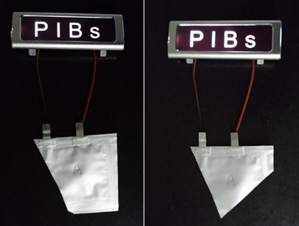

Supplementary Fig. 35.
Safe test. The cell with ASTE can power an light-emitting diodes light even after being cut.

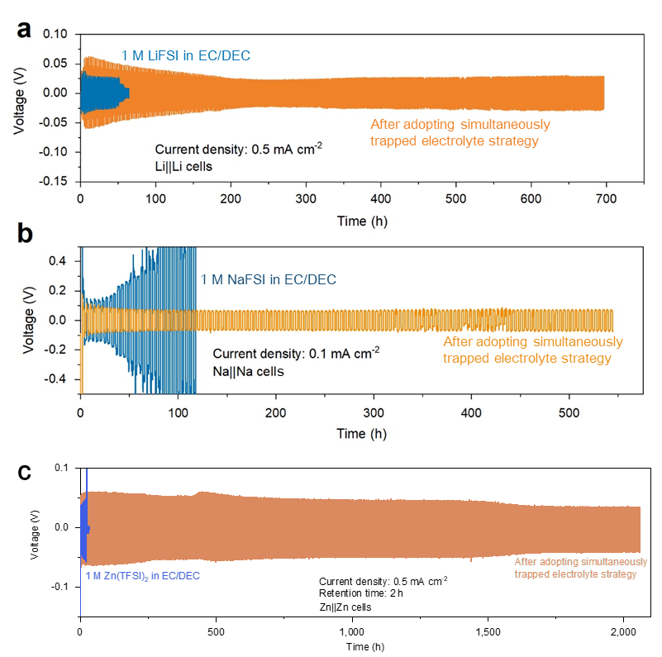

Supplementary Fig. 36.
An attempt at adopting simultaneously trapped electrolyte strategy in various metal symmetrical batteries. a, Li||Li cells. b, Na||Na cells. c, Zn||Zn cells. The huge difference in the charge-discharge profiles for these symmetrical cells cycled with different electrolytes have proved that our strategy can prolong the cycle life of various metal batteries, and is feasible and can be extanded.

Supplementary Table 1.
Physical structural properties of zeolitic imidazolate framework.
Surface area (m² g⁻¹) | V (cm³ g⁻¹) | $\text{ρ}$ (g cm⁻³) | d (nm) | l(nm) | P
2000.0753 | 0.1027 | 1.3899 | 0.2928 | 0.5135 | 0.1427
V is the pore volume normalized to mass;
$\text{ρ}$ is the mass density;
d is the pore diameter;
l represents the volume-to-surface rate of the traps (i.e., the pore volume divided by its surface area);
P denotes the porosity of the zeolitic imidazolate framework (i.e., the ratio of accessible pore volume to the total volume of the solid-ion traps).

Supplementary Table 2.
The number of cation-anion pairs, the box size used in our simulations, and the length of the modeled ASTE.
Number of cation-anion pairs | Box size: X, Y, Z (nm) | ASTE length (nm)
210.0 | 2.7, 2.7, 12.4 | 9.0

Supplementary Table 3.
Comparison of the ability of electrolytes to suppress potassium dendrites.
Electrolyte | Cycle-parameters | Cycle-life (hours) | References
0.8 M KPF₆ in EC/DEC | 0.5 mA cm⁻² | ~90 | P. Natl. Acad. Sci. USA 117, 5588-5594 (2020)¹¹
0.8 M KPF₆ in EC/DEC | 2 mA cm⁻² | 360 | P. Natl. Acad. Sci. USA 117, 5588-5594 (2020)¹¹
2 M KFSI in TEP | 1 mA cm⁻²;  1 mAh cm⁻² | 750 | Angew. Chem. Int. Ed. 59, 3638-3644 (2020)¹²
KFSI/TMP = 3/8 | 1 mA cm⁻²;  1 mAh cm⁻² | 500 | Adv. Mater. 33, 2006313 (2021)¹³
1 M KFSI in EC/DEC (FEC, 5wt%) | 1 mA cm⁻²;  1 mAh cm⁻² | ~200 | Joule 2, 1534-1547 (2018)¹⁴
0.5 KPF₆ EC/DEC | 1 mA cm⁻²;  1 mAh cm⁻² | 2,300 | Adv. Energy Mater. 9, 1902697 (2019)¹⁵
1 M KTFSI in DME | 0.1 mA cm⁻²;  0.02 mAh cm⁻² | 200 | Nat. Commun. 9, 1339 (2018)¹⁶
1 M KFSI in DME | 1 mA cm⁻²;  1 mAh cm⁻² | 1,100 | ACS Energy Lett. 7, 401-409 (2022)¹⁷
3 M KFSI in DME | 0.1 mA cm⁻²;  0.1 mAh cm⁻² | 58 | Nano Energy 96, 107131 (2022)¹⁸
1 M KPF₆ in DME | 0.05 mA cm⁻²;  0.1 mAh cm⁻² | 180 | ACS Energy Lett. 5, 3124-3131 (2020)¹⁹
5 M KFSI in DME | 0.05 mA cm⁻²;  0.1 mAh cm⁻² | 180 | ACS Energy Lett. 5, 3124-3131 (2020)¹⁹
0.8 M KPF₆ in EC/DEC/PC | 0.5 mA cm⁻²;  0.5 mAh cm⁻² | 200 | Adv. Mater. 32, 1906735 (2020)²⁰
ASTE | 0.1 mA cm⁻²;  0.2 mAh cm⁻² | 5,000 | This work

Supplementary Table 4.
Comparison of the electrochemical performances of KVPF||K half-cells obtained y configuring different electrolytes.
Electrolyte |  | Electrode | Current density | Initial capacity  (mAh g⁻¹) | Cycle-life | References
0.7 M KPF₆ in EC/DEC |  | KVPO₄F | 5 mA g⁻¹ | ~105 | 30 | Adv. Energy Mater. 8, 1801591 (2018)²¹
1 M KPF₆ in EC/PC/FEC | KVPO₄F/C |  | 20 mA g⁻¹ | 106.5 | 100 | Nano Lett. 22, 4933-4940 (2022)²²
1 M KPF₆ in PC |  | KVPO₄F | 20 mA g⁻¹ | ~78 | 150 | Sci. Bull. 67, 151-160 (2022)²³
0.6 M KPF₆ in PC/FEC |  | multi-component coated KVPO₄F | 20 mA g⁻¹ (activation)  50 mA g⁻¹ (cycling) | 95 | 50 | Chem. Eng. J. 433, 134634 (2022)²⁴
0.8 M KPF₆ in EC:DEC |  | KVPO₄F@3DC | 500 mA g⁻¹ | 60 | 550 | Sci. Bull. 65, 1242-1251 (2020).²⁵
0.7 M KPF₆ in EC:DEC |  | KVPO₄F | 5 mA g⁻¹ | 68 | 50 | Chem. Commun. 53, 5208-5211 (2017)²⁶
ASTE |  | KVPO₄F | 50 mA g⁻¹ | ~90 | 1,000 | This work

Supplementary Table 5.
Comparison of the electrochemical performances of PTCDI-based electrodes for potassium-ion half-cells obtained by configuring different electrolytes.
Electrolyte | Electrode | Current density | Initial capacity  (mAh g⁻¹) | Cycles (capacity  retention) | References
1 M KPF₆ in PC/EC | PTCDI | 500 A g⁻¹ | ~125 | 100 (65%) | J. Mater. Chem. A 7, 24454-24461 (2019)²⁷
22 M KCF₃SO₃ aqueous electrolyte | PTCDI | 20C | 110 | 1,000 (77%) | Nat. Energy 4, 495-503 (2019)²⁸
5 M KFSI in EC/DMC/DEC | PTCDI | 100 mA g⁻¹ | 156 | 100 (92%) | J.Mater. Chem. A 7, 20127-20131 (2019)²⁹
5 M KFSI in DME | PTCDI | 1,000 mA g⁻¹ | 157 | 1,000 (62.9%) | J.Mater. Chem. A 7, 20127-20131 (2019)²⁹
KCF₃SO₃ modified electrolytes | PTCDI | 1,000 mA g⁻¹ | ~122 | 200 (65%) | Nat. Sustain. 5, 225-234 (2022)³⁰
1 M KPF₆ + 0.05 M LiTFSI in DME | PTCDI-DAQ | 100 mA g⁻¹ | 220 | 100 (95%) | Adv. Funct. Mater. 30, 2000675 (2020)³¹
ASTE | PTCDI | 50 mA g⁻¹ | 122 | 2,100 (76%) | This work

Supplementary Table 6.
Parameters for the pouch cell with ASTE.
Parameter | Pouch cell
Specific capacity (PTCDI) (mAh g⁻¹) | 123±4
Mass loading (PTCDI) (mg cm⁻²) | 9.4±0.2
Cathode mass loading (mg cm⁻²) | 13.4±0.3
Area capacity (single face) (mAh cm^{–2}) | 1.156±0.02
Average output voltage (V) | 1.72
Active area (cm²) | (9×15)×2×7=1890
Al foil (mg cm⁻²) | 4.75 ± 0.02
Package+tabs (g) | 2
Pouch-cell mass (g) | 52.88
Capacity (Ah) | 2.18
Energy (Wh) | 3.75

Supplementary References
1. Chang, Z. et al. Fabricating better metal-organic frameworks separators for Li–S batteries: Pore sizes effects inspired channel modification strategy. Energy Stor. Mater. 25, 164-171 (2020).
2. Bai, S. et al. Permselective metal-organic framework gel membrane enables long-life cycling of rechargeable organic batteries. Nat. Nanotechnol. 16, 77-84 (2021).
3. Park, K. S. et al. Exceptional chemical and thermal stability of zeolitic imidazolate frameworks. P. Natl. Acad. of Sci. USA 103, 10186 (2006).
4. Lu, G. et al. Imparting functionality to a metal-organic framework material by controlled nanoparticle encapsulation. Nat. Chem. 4, 310-316 (2012).
5. Bloch, E. D. et al. Hydrocarbon separations in a metal-organic framework with open iron(II) coordination sites. Science 335, 1606-1610 (2012).
6. Liang, L. et al. Carbon dioxide capture and conversion by an acid-base resistant metal-organic framework. Nat. Commun. 8, 1223 (2017).
7. Zhang, X. et al. Confinement of iodine molecules into triple-helical chains within robust metal-organic frameworks. J. Am. Chem. Soc. 139, 16289-16296 (2017).
8. Dai, Q., MacFarlane, D. R., Howlett, P. C. & Forsyth, M. Rapid I⁻/I₃⁻ diffusion in a molecular-plastic-crystal electrolyte for potential application in solid-state photoelectrochemical cells. Angew. Chem. Int. Ed. 44, 313-316 (2005).
9. Whangbo, M. H., Williams, J. M., Schultz, A. J., Emge, T. J. & Beno, M. A. Importance of intermolecular hydrogen.cntdot.hydrogen and hydrogen.cntdot.anion contacts for the lattice softness, the electron-phonon coupling, and the superconducting transition temperatures, Tc, of organic conducting salts β-(ET)₂X (X- = IBr₂⁻, AuI₂⁻, I₃⁻). J. Am. Chem. Soc. 109, 90-94 (1987).
10. Najbar, J. & Mac, M. Mechanisms of fluorescence quenching of aromatic molecules by potassium iodide and potassium bromide in methanol–ethanol solutions. J. Chem. Soc., Faraday Trans. 87, 1523-1529 (1991).
11. Hundekar, P. et al. In situ healing of dendrites in a potassium metal battery. P. Natl. Acad. of Sci. USA 117, 5588-5594 (2020).
12. Liu, S. et al. An intrinsically non-flammable electrolyte for high-performance potassium batteries. Angew. Chem. Int. Ed. 59, 3638-3644 (2020).
13. Liu, S. et al. Manipulating the solvation structure of nonflammable electrolyte and interface to enable unprecedented stability of graphite anodes beyond 2 years for safe potassium-ion batteries. Adv. Mater. 33, 2006313 (2021).
14. Zhang, W., Pang, W. K., Sencadas, V. & Guo, Z. Understanding high-energy-density Sn₄P₃ anodes for potassium-ion batteries. Joule 2, 1534-1547 (2018).
15. Wang, H. et al. Artificial solid-electrolyte interphase enabled high-capacity and stable cycling potassium metal batteries. Adv. Energy Mater. 9, 1902697 (2019).
16. Gu, Y. et al. Designable ultra-smooth ultra-thin solid-electrolyte interphases of three alkali metal anodes. Nat. Commun. 9, 1339 (2018).
17. Park, J. et al. Stable solid electrolyte interphase for long-life potassium metal batteries. ACS Energy Lett. 7, 401-409 (2022).
18. Wang, J., Yan, W. & Zhang, J. High area capacity and dendrite-free anode constructed by highly potassiophilic Pd/Cu current collector for low-temperature potassium metal battery. Nano Energy 96, 107131 (2022).
19. Zhang, J. et al. Model-based design of stable electrolytes for potassium ion batteries. ACS Energy Lett. 5, 3124-3131 (2020).
20. Liu, P. et al. Dendrite-free potassium metal anodes in a carbonate electrolyte. Adv. Mater. 32, 1906735 (2020).
21. Kim, H. et al. A new strategy for high-voltage cathodes for K-ion batteries: Stoichiometric KVPO4F. Adv. Energy Mater. 8, 1801591 (2018).
22. Liao, J. et al. Synthesis of KVPO₄F/carbon porous single crystalline nanoplates for high-rate potassium-ion batteries. Nano Lett. 22, 4933-4940 (2022).
23. He, Y. et al. Confining ultrafine SnS nanoparticles in hollow multichannel carbon nanofibers for boosting potassium storage properties. Sci. Bull. 67, 151-160 (2022).
24. He, X.-D., Zhang, L.-M., Jiang, C.-H. & Chen, C.-H. Elevating cyclability of an advanced KVPO₄F cathode via multi-component coating strategy for high-performance potassium-ion batteries. Chem. Eng. J. 433, 134634 (2022).
25. Liu, Z., Wang, J. & Lu, B. Plum pudding model inspired KVPO₄F@3DC as high-voltage and hyperstable cathode for potassium ion batteries. Sci. Bull. 65, 1242-1251 (2020).
26. Chihara, K., Katogi, A., Kubota, K. & Komaba, S. KVPO₄F and KVOPO₄ toward 4 volt-class potassium-ion batteries. Chem. Commun. 53, 5208-5211 (2017).
27. Bai, Y. et al. Perylenetetracarboxylic diimide as a high-rate anode for potassium-ion batteries. J. Mater. Chem. A 7, 24454-24461 (2019).
28. Jiang, L. et al. Building aqueous K-ion batteries for energy storage. Nat. Energy 4, 495-503 (2019).
29. Xiong, M., Tang, W., Cao, B., Yang, C. & Fan, C. A small-molecule organic cathode with fast charge–discharge capability for K-ion batteries. J. Mater. Chem. A 7, 20127-20131 (2019).
30. Ge, J., Fan, L., Rao, A. M., Zhou, J. & Lu, B. Surface-substituted Prussian blue analogue cathode for sustainable potassium-ion batteries. Nat. Sustain. 5, 225-234 (2022).
31. Hu, Y. et al. Novel insoluble organic cathodes for advanced organic K-ion batteries. Adv. Funct. Mater. 30, 2000675 (2020).

