Supporting Information

Dual-responsive disassembly of core-shell nanoparticles with self-supplied H₂O₂ and autocatalytic Fenton reaction for enhanced chemodynamic therapy

Mengran Peng†, ‡, Enguo Ju†, ‡, *, Yuqin Wang†, Shixian Lv‖, Dan Shao§, Haixia Wang†, Yu Tao†, *, Yue Zheng†, *, Mingqiang Li†, ┴, *

† Laboratory of Biomaterials and Translational Medicine, Center for Nanomedicine, Department of Dermato-Venereology, The Third Affiliated Hospital, Sun Yat-sen University, Guangzhou 510630, China
‖ School of Materials Science and Engineering, Peking University, Beijing 100871, China
§ Institutes of Life Sciences, School of Medicine, South China University of Technology, Guangzhou 510006, China
┴ Guangdong Provincial Key Laboratory of Liver Disease Research, Guangzhou 510630, China

Corresponding authors
E-mail addresses:
jueng@mail.sysu.edu.cn (Enguo Ju)
zhengy58@mail.sysu.edu.cn (Ye Zheng)
taoy28@mail.sysu.edu.cn (Yu Tao)
limq567@mail.sysu.edu.cn (Mingqiang Li)

‡ Contributed equally to this paper.

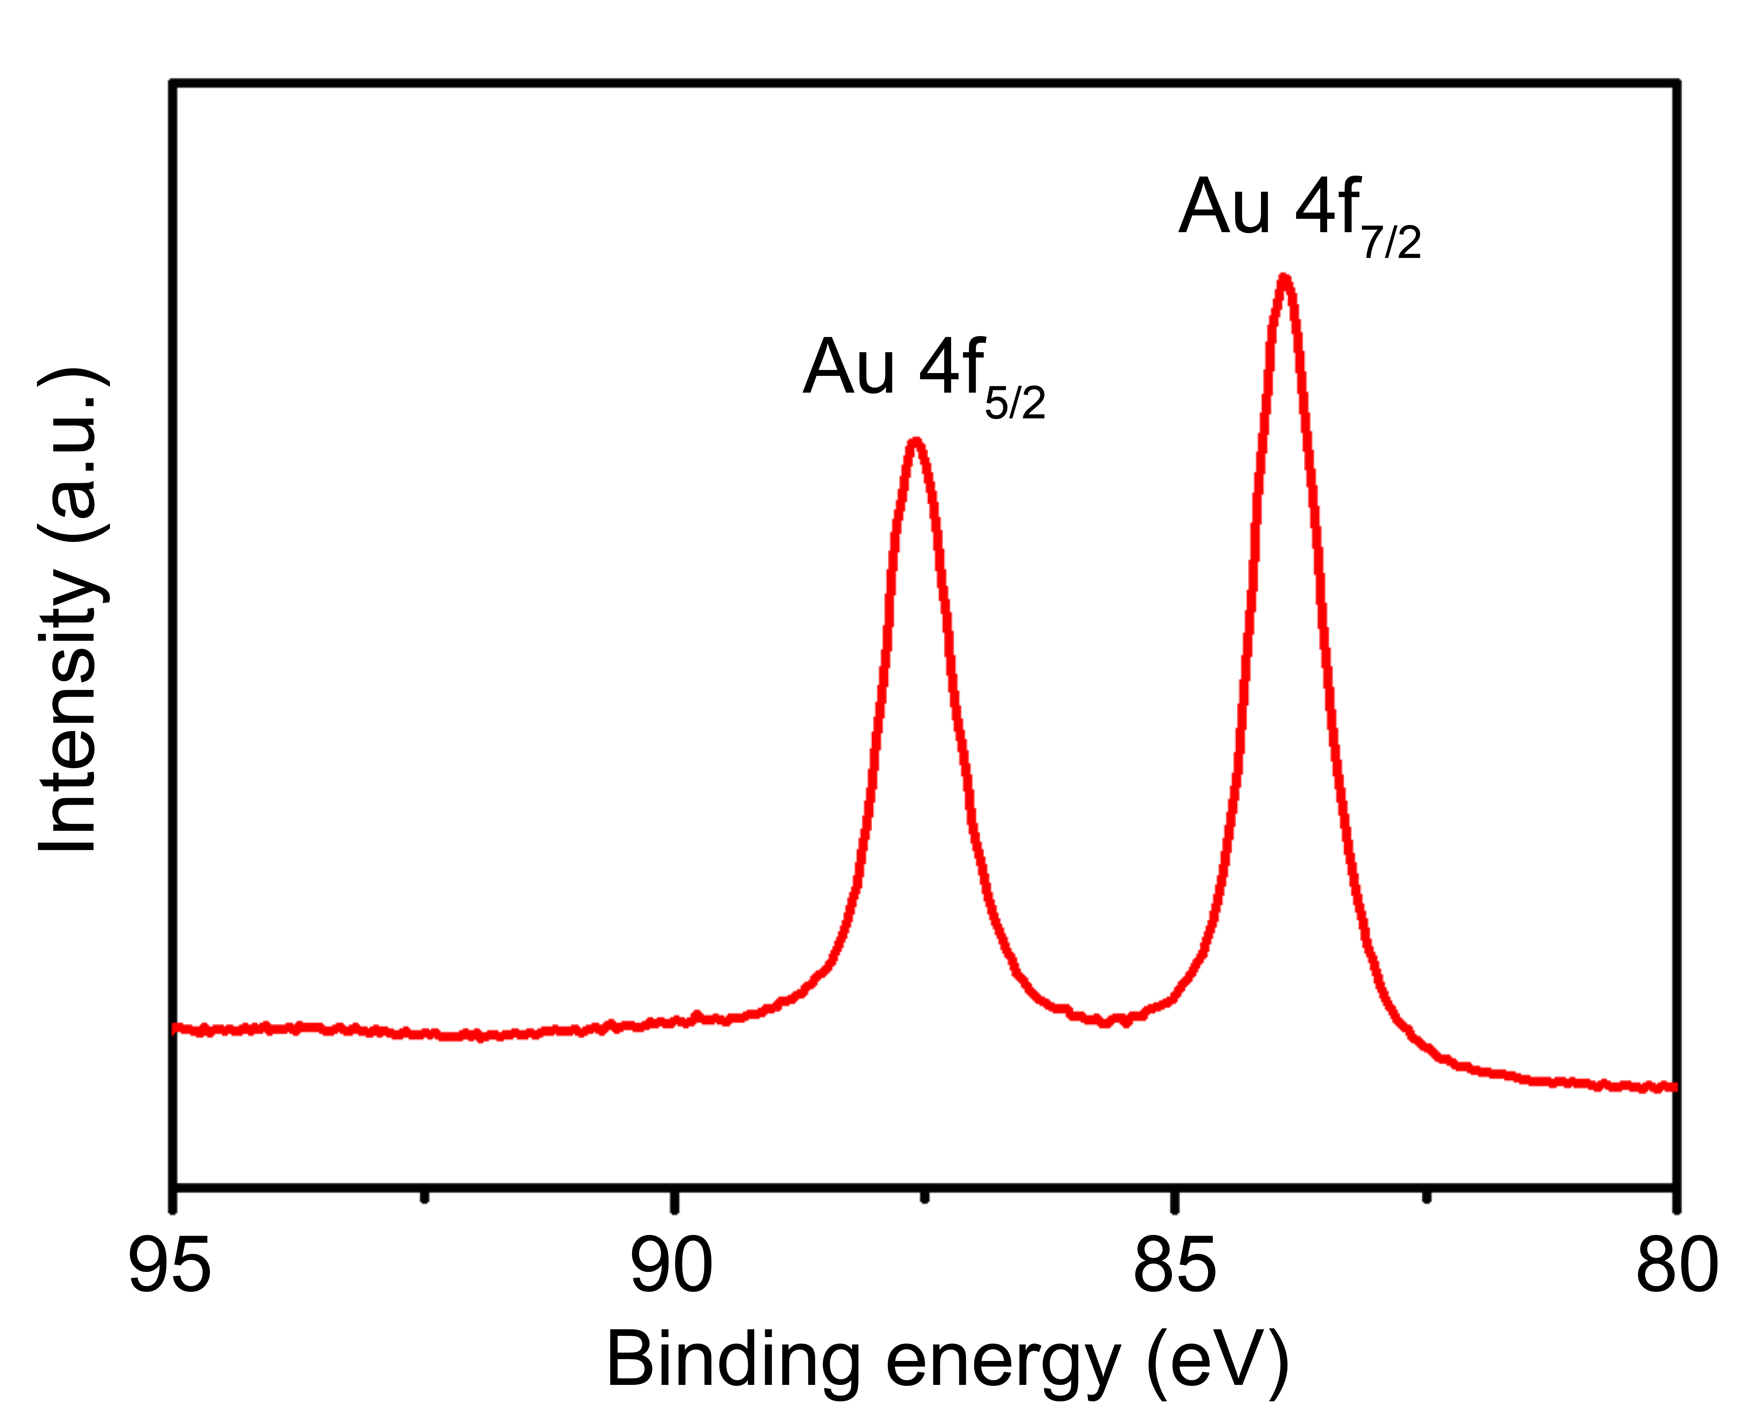
Figure S1. XPS spectra of Au element in Au@MPN.

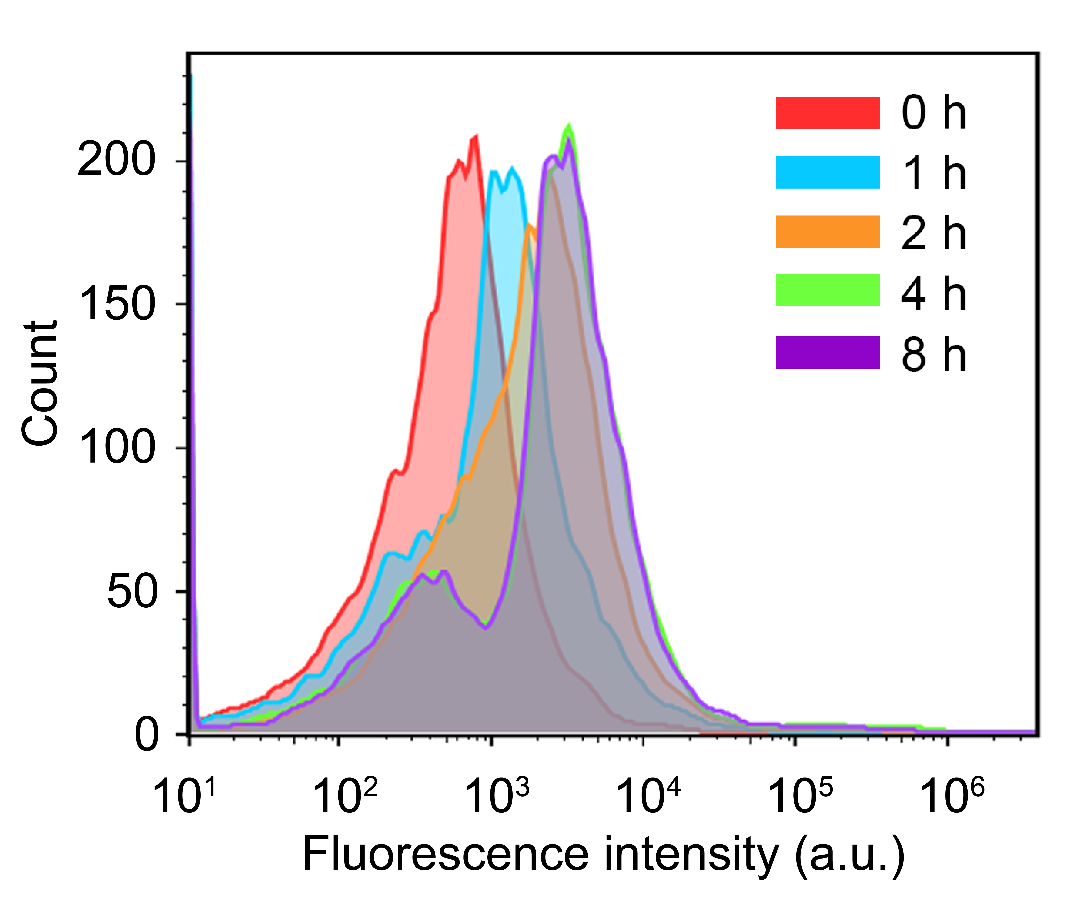
Figure S2. Flow cytometric analysis of cellular uptake of Rhodamine B-loaded Au@MPN for various incubation times.

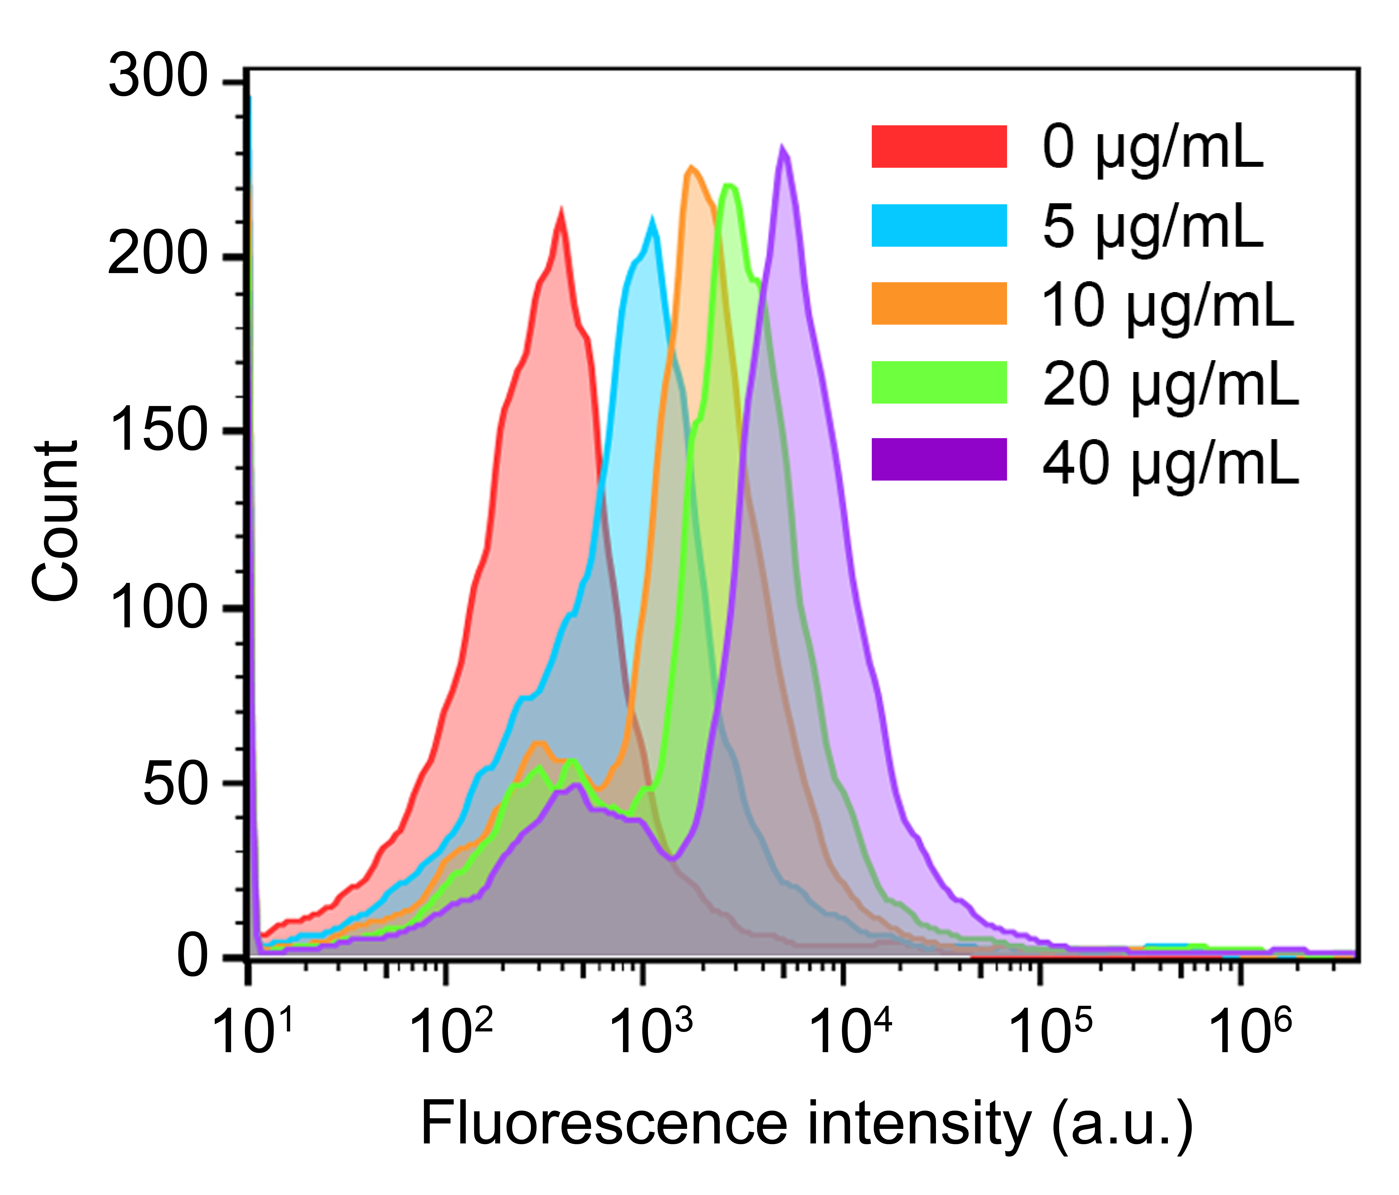
Figure S3. Flow cytometric analysis of cellular uptake of various concentrations of Rhodamine B-loaded Au@MPN.

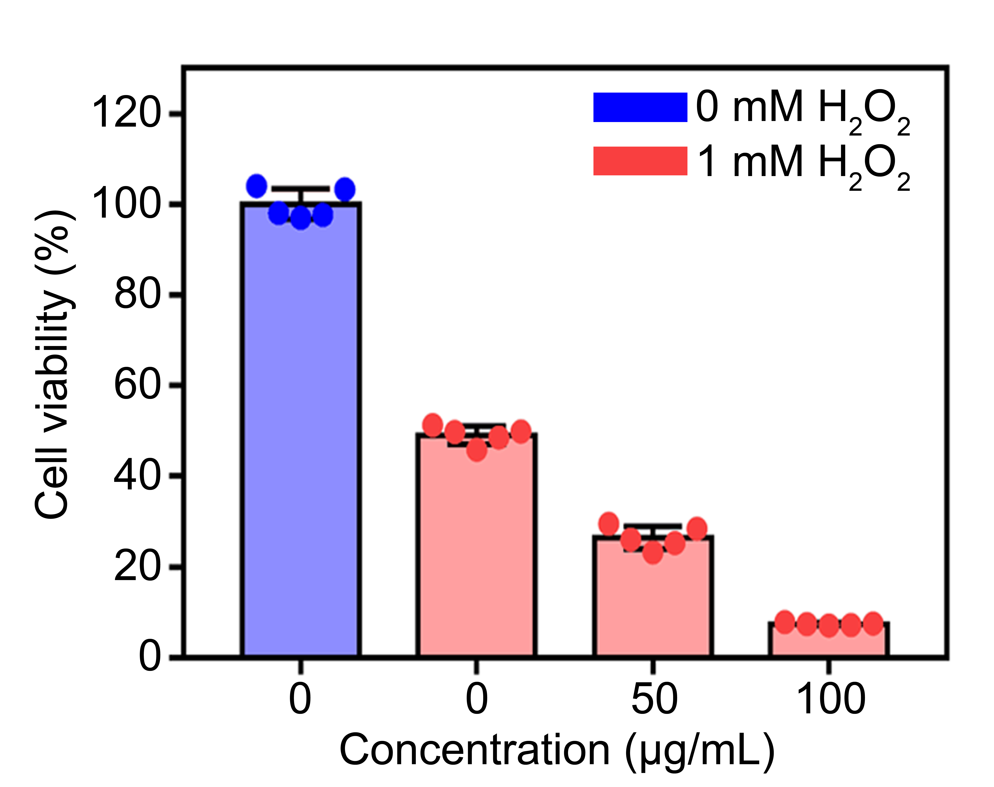
Figure S4. Cell viability of B16F10 cells incubated with different concentrations of Au@MPN with or without H₂O₂.

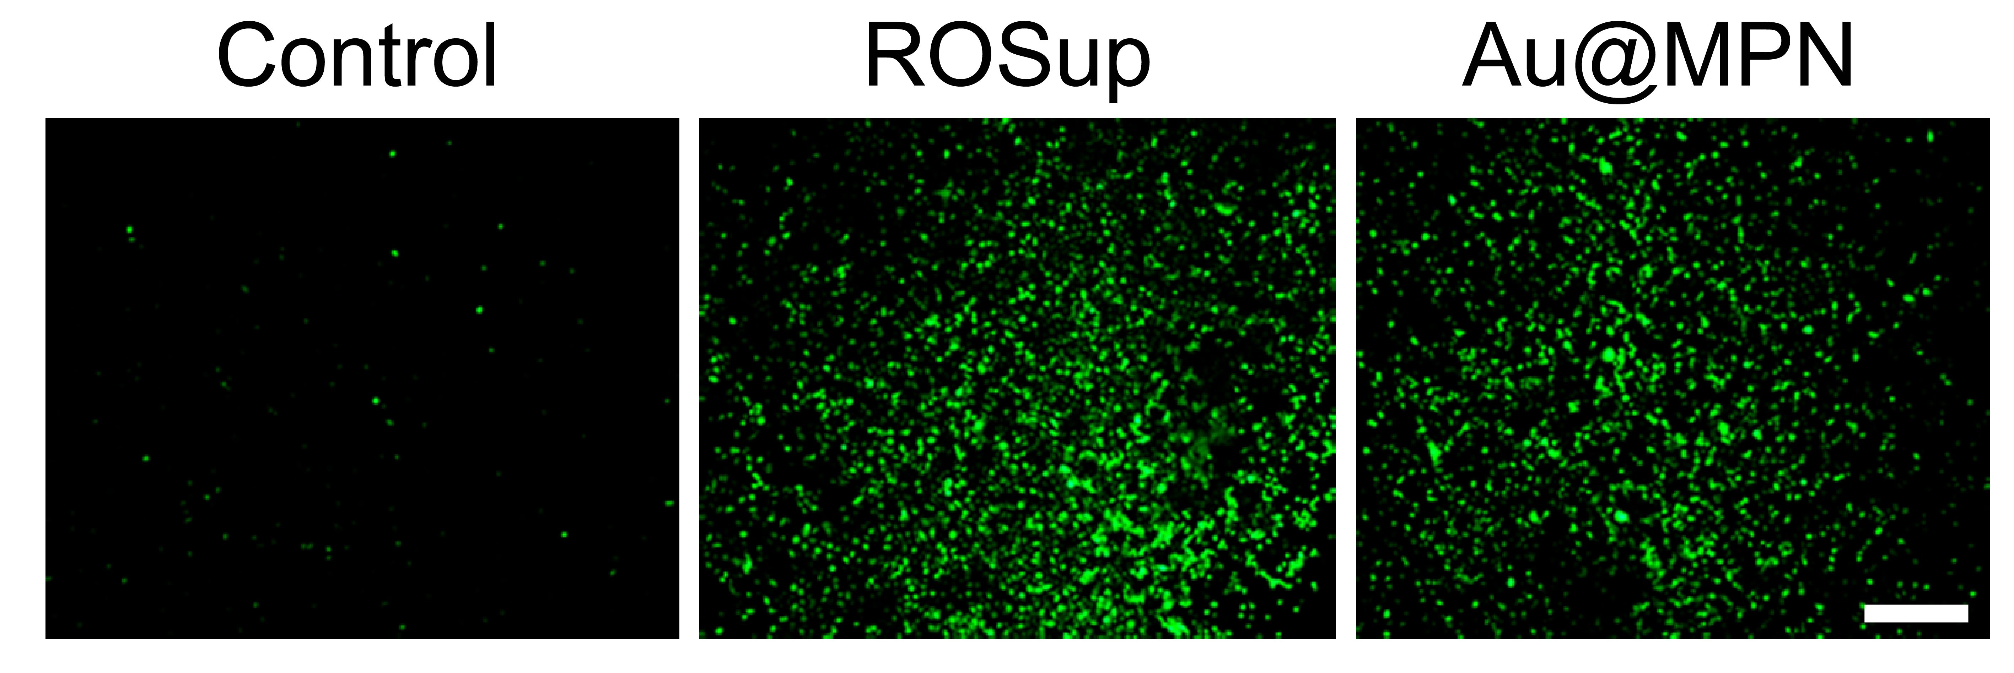
Figure S5. The intracellular ROS levels in B16F10 cells with different treatments stained with DCFH-DA. The scale bar represents 200 μm.

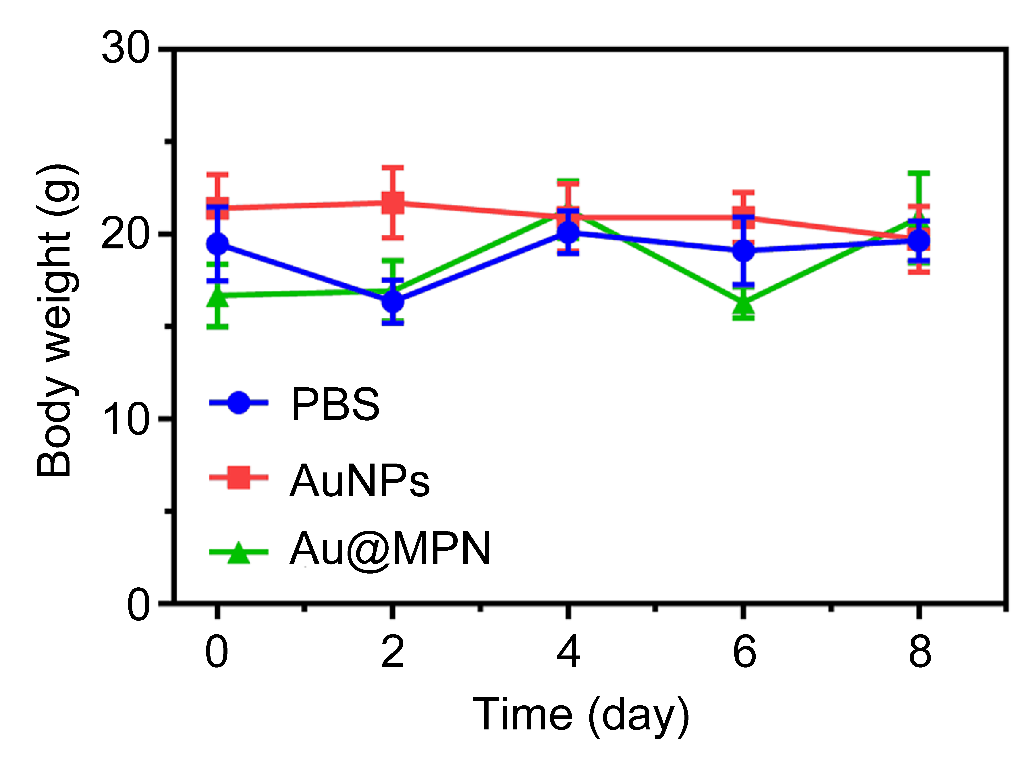
Figure S6. The changes in the body weight of mice treated with PBS, AuNPs, and Au@MPN through intratumoral injection.

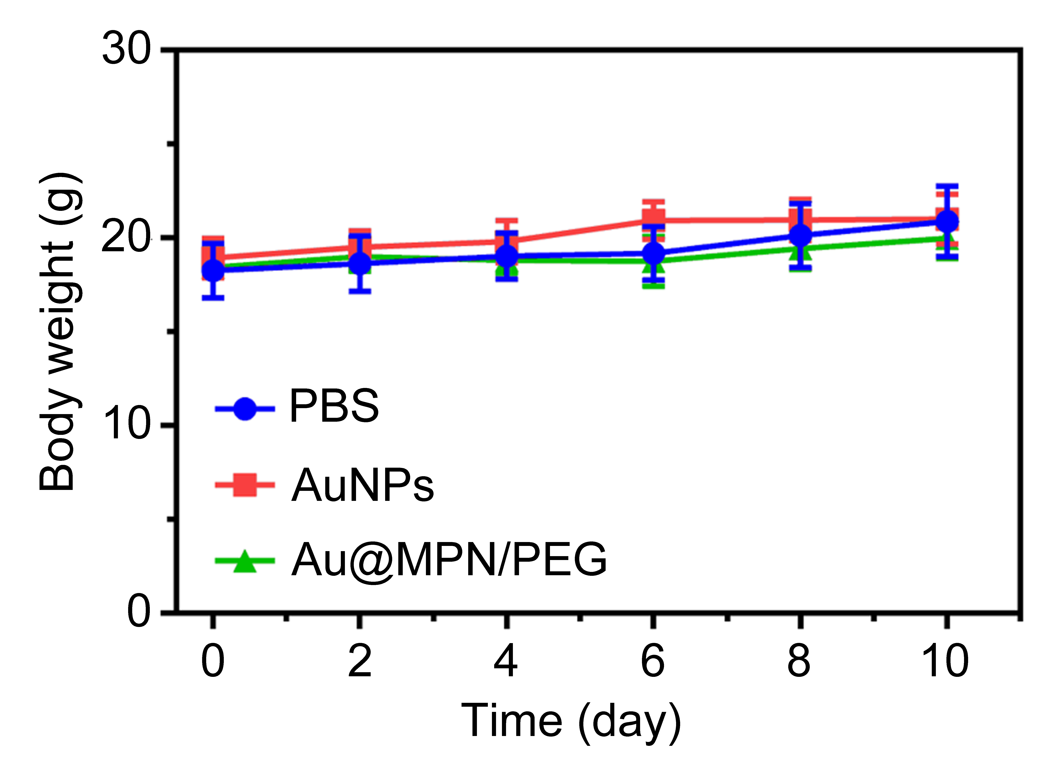
Figure S7. The changes in the body weight of mice treated with PBS, AuNPs, and Au@MPN/PEG through intravenous injection.

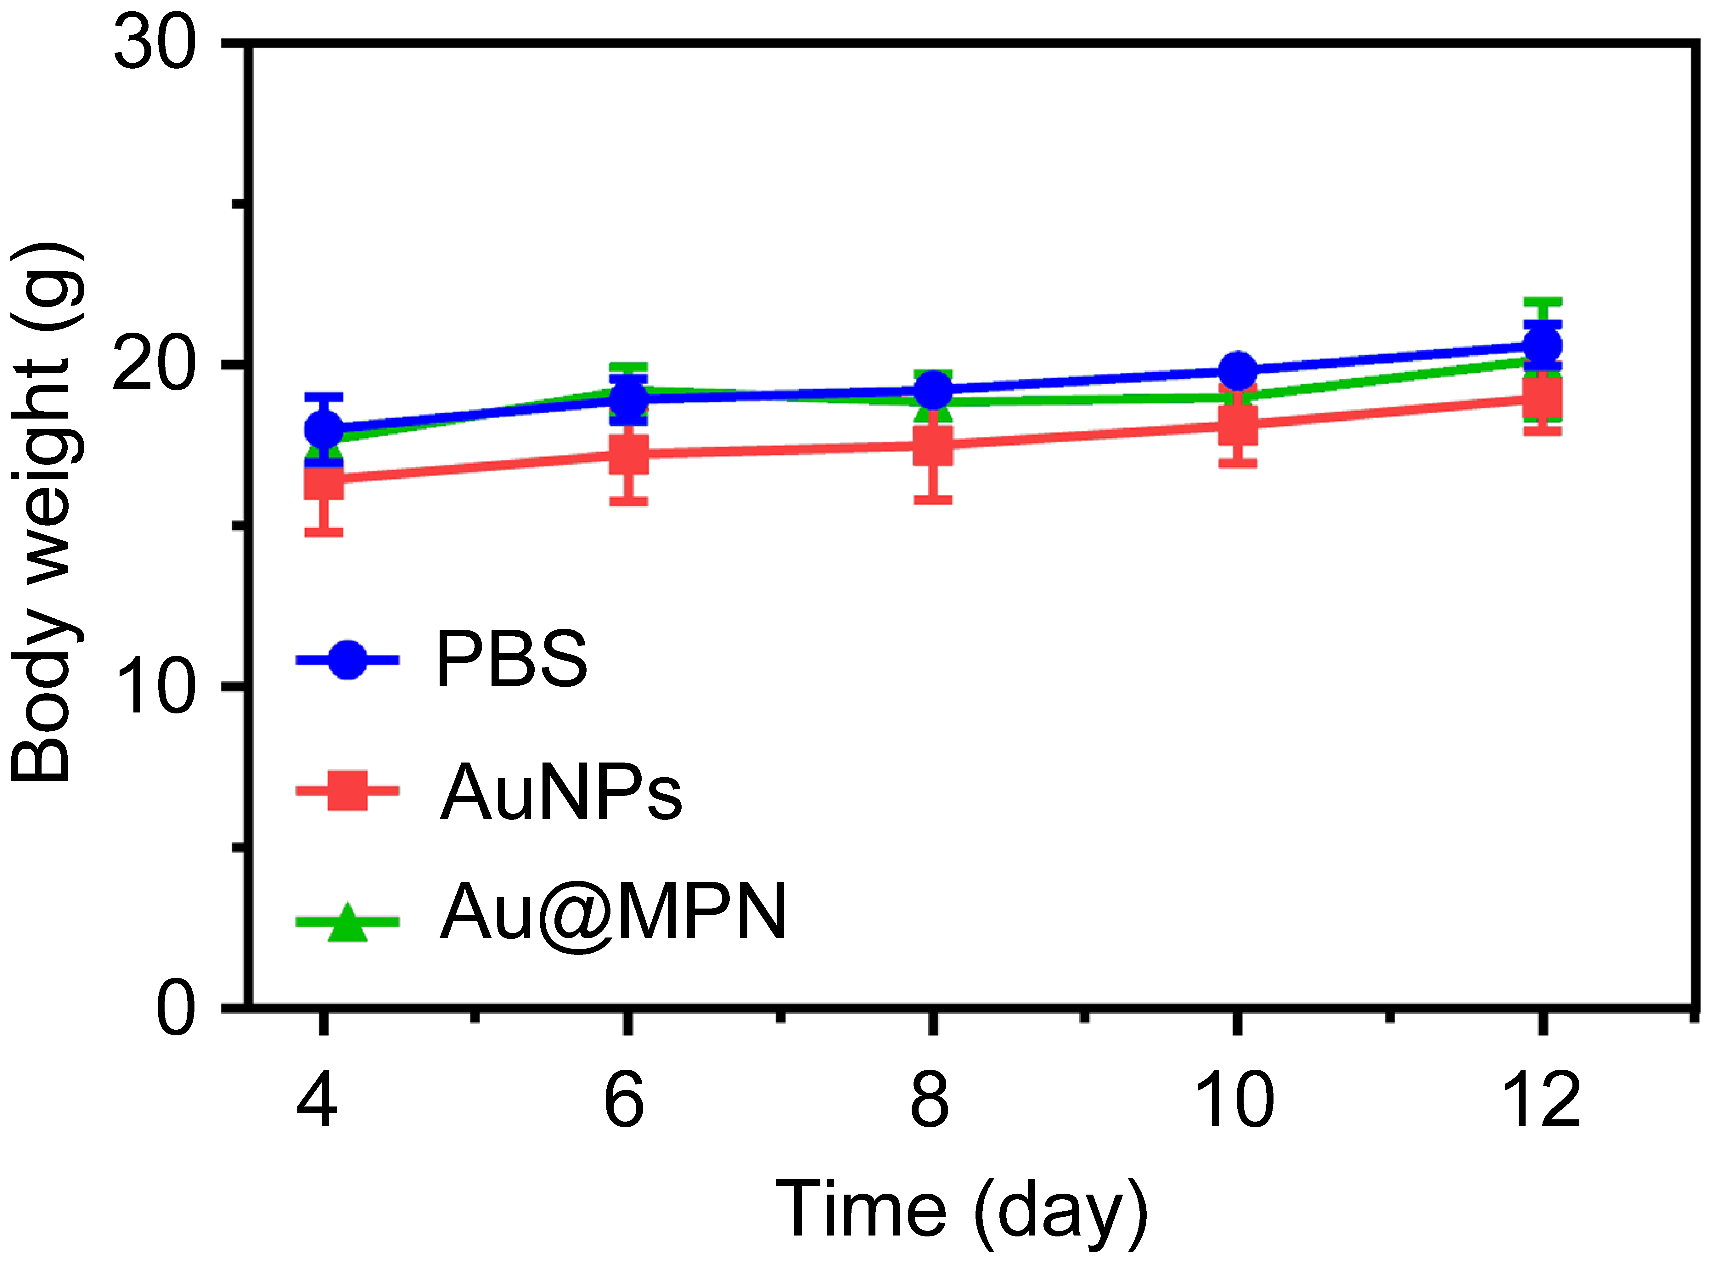
Figure S8. The changes in the body weight of mice treated with PBS, AuNPs, and Au@MPN through intratracheal instillation.

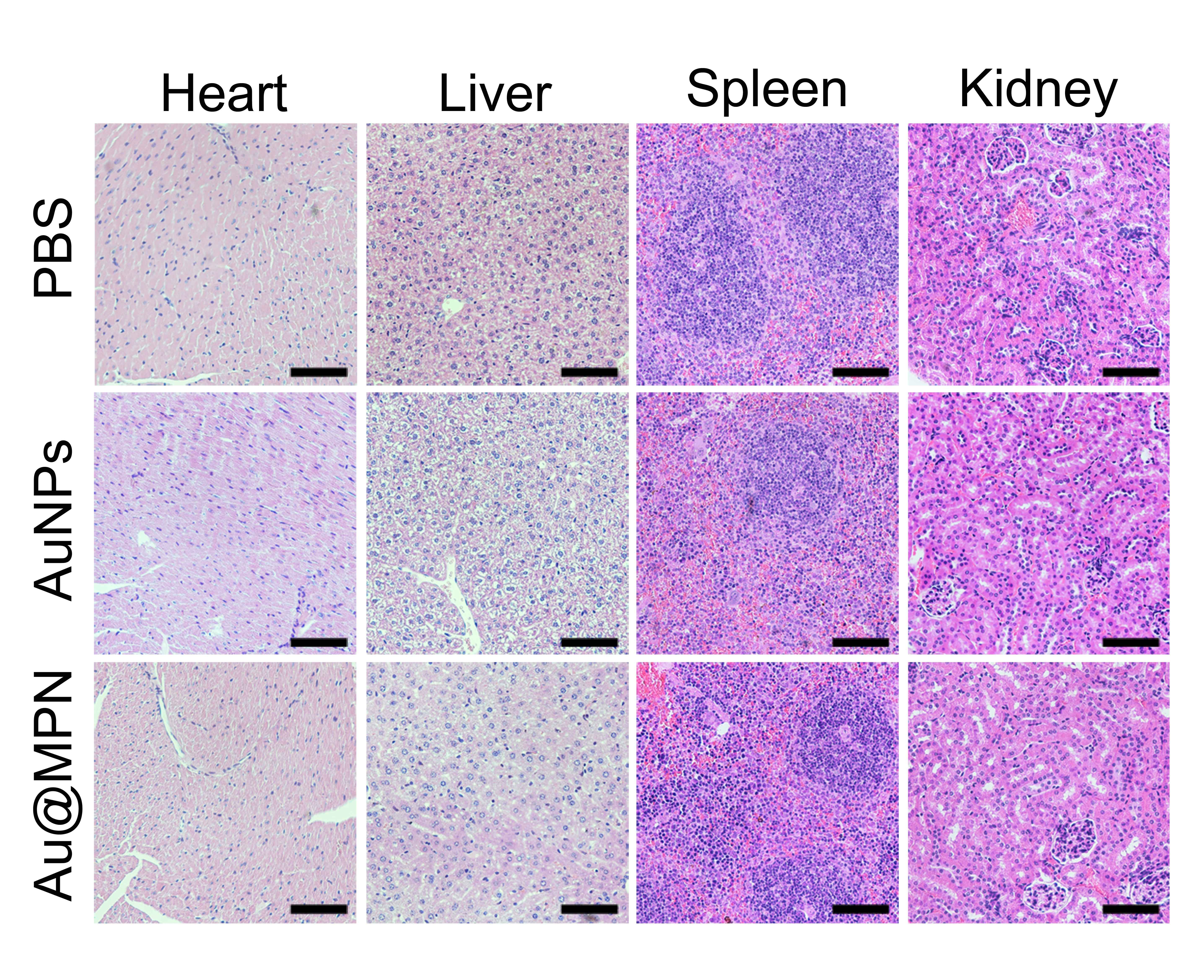
Figure S9. The representative images of H&E staining of major organs from mice treated with PBS, AuNPs, and Au@MPN through intratracheal instillation. The scale bars represent 100 μm.

