Supplementary Material
tps://doi.org/10.1038/s41467-021-27671-0Evangelos
Title: Net-zero CO₂ emissions scenarios for Switzerland
Evangelos Panos^{*,1}, Ramachandran Kannan¹, Stefan Hirschberg¹, Tom Kober¹
¹Laboratory for Energy Systems Analysis, Paul Scherrer Institute, Forschungsstr 111, CH-5232, Villigen PSI, Switzerland
*Corresponding author, email: evangelos.panos@psi.ch

Number of pages: 29
Number of tables: 1
Number of figures: 40
Number of notes: 6

Contents:
Supplementary Notes 1: The Swiss TIMES Energy Systems Model (STEM) structure
Supplementary Notes 2: Links of STEM with other sectoral models in the SCCER JASM
Supplementary Notes 3: Main assumptions of the assessed scenarios
Supplementary Notes 4: Additional results
Supplementary Notes 5: Comparison between CLI and the other net-zero scenarios
Supplementary Notes 6: Sensitivity analysis on existing nuclear power plants lifetime

Supplementary Notes 1: The Swiss TIMES Energy Systems Model (STEM) structure
The Swiss TIMES Energy systems Model (STEM) has a long-term horizon (2010 – 2100) with 288 intra-annual operating hours (four seasons and three typical days per season with 24h resolution). Each milestone year is therefore divided into sub-annual timeslices to describe the intra-day, weekly, and seasonal variations of end-use loads within a year (e.g., heating, cooking, driving, etc.). The timeslices are organised into four hierarchy levels, as shown in Figure 1.
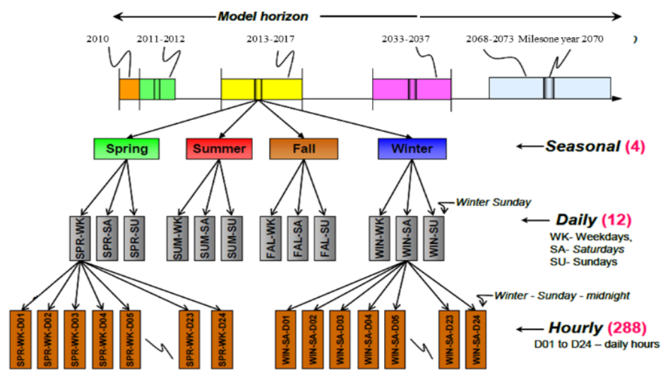
Figure 1: The timeslice tree in STEM
The duration of each timeslice is expressed as a fraction of the year so that the sum of all timeslices multiplied with their duration result in 8760 hours. The different technologies represented in STEM can operate at different levels of the timeslice tree (e.g., power plants operate at the hourly levels, while seasonal storages operate at the seasonal level).
STEM covers the whole Swiss energy system (Figure 2) with a broad suite of energy and emission commodities, technologies and infrastructure, from resource supply to energy conversion and usage in 17 energy demand subsectors. The main energy demand sectors in STEM are industry, residential, commercial and transport. The industrial sector is further delineated into seven subsectors: food and textiles, paper and pulp, chemicals, cement and non-ferrous metals, basic metals, construction, metal tools together with machinery and other industries. In each industrial subsector, the following energy end-uses (energy service demands) are identified: space heating, water heating, process heat, lighting, air conditioning, electrical equipment, motors and other uses. The model represents a large range of technologies to supply the demands of each sub-sector, which allow for modelling energy efficiency improvements and fuel switching.
For the residential sector, different types of buildings are distinguished. Depending on their year of construction, the buildings are classified into existing buildings (constructed before 2005) and new buildings (constructed after 2005). The buildings are classified into single- and multi-family buildings to reflect different size classes. In STEM, a range of residential energy technologies are modelled to meet the energy demand for the following energy uses: space heating, water heating, air conditioning, electronic equipment, appliances, cooking, lighting, washing and refrigeration.
The transport sector in STEM comprises passenger and freight transport. The model distinguishes between road freight transport (heavy duty and light duty trucks) and rail goods transport. Passenger transport is further disaggregated into public and private transport. Public transport includes buses, rails and aviation. Private passenger transport covers cars and motorcycles and several technologies thereof.
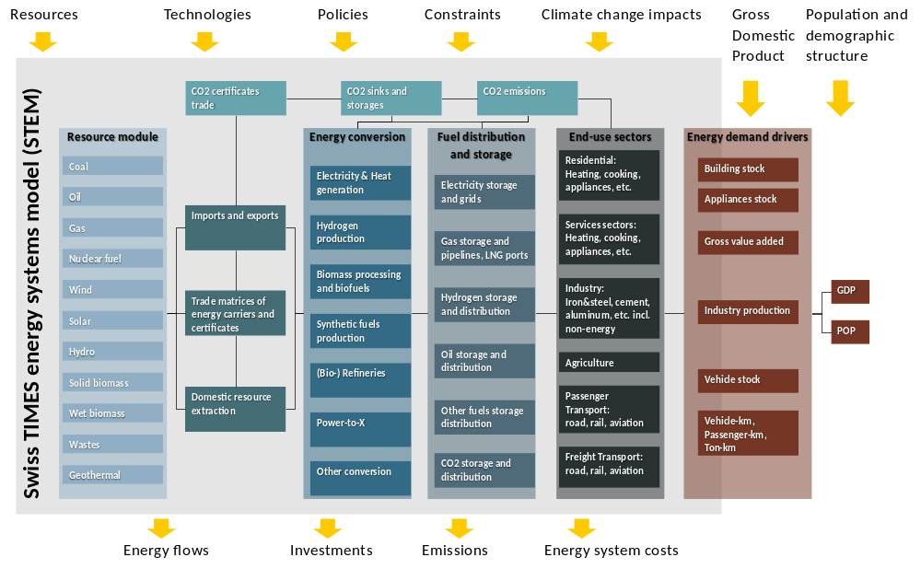
Figure 2: Overview of STEM structure
For each demand subsector, the energy service demand is given exogenously, based on a set of drivers. Starting from the gross domestic product and demographic structure developments, a building stock model is applied^{1,2} to calculate floor area for heating, lighting and cooling demands. The population developments influence the demand for hot water. The electrical appliances stock, which defines the demand for non-heating uses of electricity, is calculated via a choice model. In the services sectors, the floor area also drives space heating, cooling, and lighting demands. The floor area is derived via econometrically estimated equations from the sectoral gross value added. The latter also is used to estimate the energy service demands for process heat and other uses in the services sectors. In industry, the energy service demand for production processes is based on the production index in each subsector¹. Finally, Gompertz functions model vehicle ownership rates in transport, while the mobility demands per transport mode in vehicle- and passenger kilometres are taken from national projections³.
It is important to note that for each energy service demand in each end-use sector, the hourly profile of the demand is exogenously given to the model⁴. Thus, space heating and water heating profiles, driving profiles, process heat profiles, lighting profiles, etc., which indicate the need for a particular energy service within a day, are also included in the model. In Figure 3, we provide some examples of the hourly profiles in STEM.
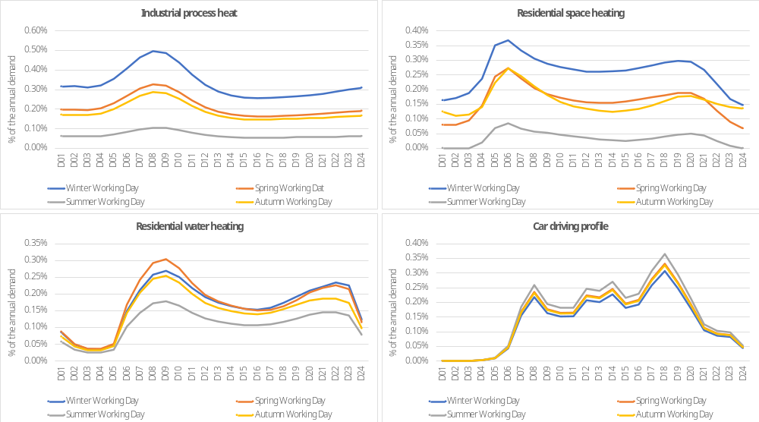
Figure 3: Examples of the hourly profiles included in STEM. The residential space heating profile is the weighted average of existing and newly constructed single- and multi-family houses, using the energy service demand for each type of house as a weight.
Within the transformation sector, the electricity sector represents the most comprehensive and detailed modelled part with four electricity grid transmission and distribution levels, from very high to low voltage. Different power plant and storage options are connected to each grid level, as shown in Figure 7. The electricity supply sector includes four different grid levels. Grid level 1 corresponds to 220/380 kV, grid level 3 to 36 – 150 kV, grid level 5 to 1 – 36 kV, and grid level 7 to 400V – 1 kV. The grid levels 2, 4 and 6 are transformation levels. The representation of the electricity grid accounts for economic and not physical electricity flows among the different voltage levels by considering transmission costs, distribution costs and efficiency losses. The grid lines of the transmission grid are assumed to be fully dispatchable, and grid line characteristics such as thermal capacity, resistance and reactance are accounted for via DC power flow modelling. However, the capacity of the transmission grid lines does not enter into the calculation for the required reserve margin in the electricity sector.
For a comprehensive description of the model and its features, the reader is directed to the several recent studies published with STEM^{1,4–8}.

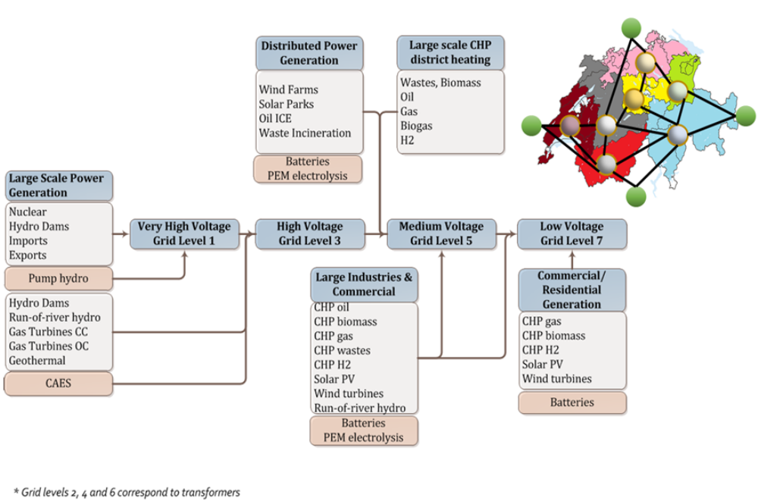
Figure 4: Overview of the electricity sector representation in STEM
Supplementary Notes 2: Links of STEM with other sectoral models in the Swiss Competence Centre for Energy Research Joint Activity Scenarios and Modelling (SCCER JASM) framework
The current analysis was performed in the context of the SCCR JASM. JASM is a joint activity of several modelling teams within the eight Swiss Competence Centre for Energy Research (SCCER) to define and analyse scenarios for reaching net-zero greenhouse gas emissions in Switzerland by the middle of the century⁹. Each one of the eight SCCERs looked at a particular challenge of the Swiss energy transition by combining interdisciplinary research from all Swiss universities and institutes. The SCCER program ran from 2013 to 2020, and it was funded with 250 million Swiss francs over these eight years. Since 2014, more than 1300 researchers have worked at the SCCERs each year on average and launched more than 1500 projects¹⁰. The SCCER “Future Energy Efficient Buildings & Districts (FEEB&D)” dealt with energy efficiency and CO₂ emissions in the built environment. The SCCER “Efficiency of Industrial Processes (EIP)” dealt with energy efficiency and CO₂ emissions in industrial applications. The SCCER “Supply of Electricity (SoE)” analysed possible contributions to the power supply from deep geothermal energy and hydropower. The SCCER “Biomass for Swiss Energy Future (BIOSWEET)” aimed to contribute to greater use of low-value biomass in the Swiss energy system given the technological, economic, environmental, systemic and societal challenges involved. The SCCER “Future Swiss Electrical Infrastructure (FURIES)” worked on future power grid technologies enabling the seamless and sustainable powering of Swiss homes, businesses and communities based on traditional and new renewable energy resources. The SCCER “Heat and Electricity Storage (HaE)” focused on energy storage solutions for electricity, heat, hydrogen, and synthetic fuels. The SCCER “Efficient Technologies and Systems for Mobility (Mobility)” applied an interdisciplinary approach that addressed and integrated technical, economic and user-related topics with a connection to the decarbonisation of the transport sector. The SCCER “Energy, Society and Transition (CREST)” was set up to cover the key societal, economic and non-technical aspects of the energy transition.
Turning to the SCCER “Joint Activity Scenarios and Modelling (JASM)”, JASM combined the modelling capabilities of all eight SCCERs mentioned above to develop a set of scenarios for the transition of the Swiss energy system towards a net-zero emissions system over the next few decades. The JASM framework includes energy systems and sectoral models using a consistent set of drivers and scenarios definitions. Sectoral models are models for the residential and industrial sector, hydrological models estimating the impact of climate change on hydropower generation, models to assess the climate change impacts on heating and cooling demands, and electricity grid models⁹. In the context of the SCCER JASM, STEM was enhanced in the areas shown in Table 1, including insights and data results from the other eight SCCERs.
Table 1: Updates in STEM data based on collaborations with the sectoral models in SCCER Joint Activity Scenarios and Modeling, as well as on collaborations with other SCCERs
Sector | Data | Collaboration of STEM in the context of SCCER JASM
Upstream | Renewable potentials | Updated based on collaboration between PSI, ETH and WSL from SCCER “Biomass for Swiss Energy Future”¹¹
Upstream | Import prices | Update of cross-border prices for fuels and energy carriers based on joint work between PSI, ETH. For the electricity cross border prices, the results from the SWISSMOD electricity grid model were used¹²
Upstream | CO2 domestic sequestration | Latest estimations from the SCCER “Supply of Electricity”¹³
Upstream | Cross-border trade capacities | Net Transfer Capacities for cross-border electricity exchanges were derived from the SWISSMOD electricity grid model
Upstream | Hydropower climate change impacts | Water inflow profiles were obtained from SWISSMOD simulations for three climate change scenarios RCP8.5, RCP4.5 and RCP2.6
Conversion | Electricity production technologies | Costs and performance updated from PSI reports¹⁴, also in the context of SCCER “Supply of Electricity” and SCCER “Joint Activity Scenarios and Modelling”
Conversion | Hydrogen production technologies | Costs and performance updated from ETH and PSI collaboration¹⁵
Conversion | Biofuel production technologies | Costs and performance updated from SCCER “Biomass for Swiss Energy Future”
Conversion | Synthetic fuels production | Costs and performance updated from SCCER “Heat and Electricity Storage”¹⁶
End-use | Transport technologies | Costs and performance for vehicles updated from SCCER “Efficient Technologies and Systems for Mobility”¹⁷
End-use | Building stock and renovation rates | Flow-stock model based on PSI modelling and collaboration with SCCER “Future Energy Efficient Buildings & Districts”²
End-use | Demand profiles | Electricity and heat hourly demand profiles updated from SCCER “Future Energy Efficient Buildings & Districts”^{18,19}
End-use | Industry energy conservation measures | Costs and potentials updated form SCCER “Efficiency of Industrial Processes”^{20–23}
End-use | Electric appliances | Costs and potentials from SCCER “Future Energy Efficient Buildings & Districts”²⁴
End-use | Climate change impacts on heating and cooling demands | The HDD and CDD from three climate change scenarios simulations were used to modify the levels of heating and cooling demands in the context of SCCER “Future Energy Efficiency Buildings & Districts”²

Supplementary Notes 3: Main assumptions of the assessed scenarios
The reader is directed to the corresponding supplementary data and assumptions EXCEL file for a comprehensive overview of key assumptions used in the STEM scenarios assessed in this study. These main assumptions described in the EXCEL file, with references to the sources, include:
- Economic and demographic assumptions¹⁵
- Residential demand drivers^{2,25,26}
- Services, industry and agriculture demand drivers¹
- Transport demand drivers³
- Import prices and cross border capacities¹⁵
- Resource potentials^{14,15,27,28}
- Technology costs and efficiencies^{7,11,14,15,27,29,30}
- Sectoral policies of the core BAU and CLI scenarios
Supplementary Notes 4: Additional results
Additional results are provided in the corresponding supplementary EXCEL file with results from all the scenarios assessed in this study in a tabular format. Below key insights are briefly described, which are supportive of the analysis presented in the main text of this paper.
Key milestones to net-zero: Figure 5 shows the emissions trajectory in the CLI scenario and key near- and long-term milestones to get on track for achieving the net-zero CO₂ emissions target in 2050. Credible step-by-step plans to reach the target are needed, especially for the buildings and transport sectors. The challenge is that in order to meet the 2030 emissions targets, decisive actions are needed to triple within this decade the share of heat pumps in buildings, the sales of electric cars and the installed capacity of solar PV.
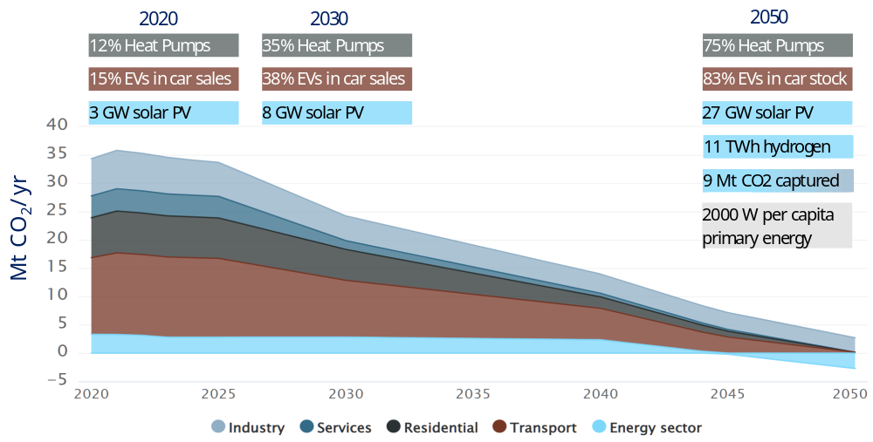
Figure 5: Key milestones for Switzerland to achieve net-zero CO2 emissions in 2050, based on the CLI scenario.
Role of building renovation: Figure 6 clearly shows the importance of building renovation in the post-2030 period, when the space and water heating supply need to be decarbonised. In ANTI and SECUR scenarios, renovation needs to be accelerated until 2030 to attain fuel savings that are much higher than the fuel savings achieved in the rest of the scenarios almost 20 years later.
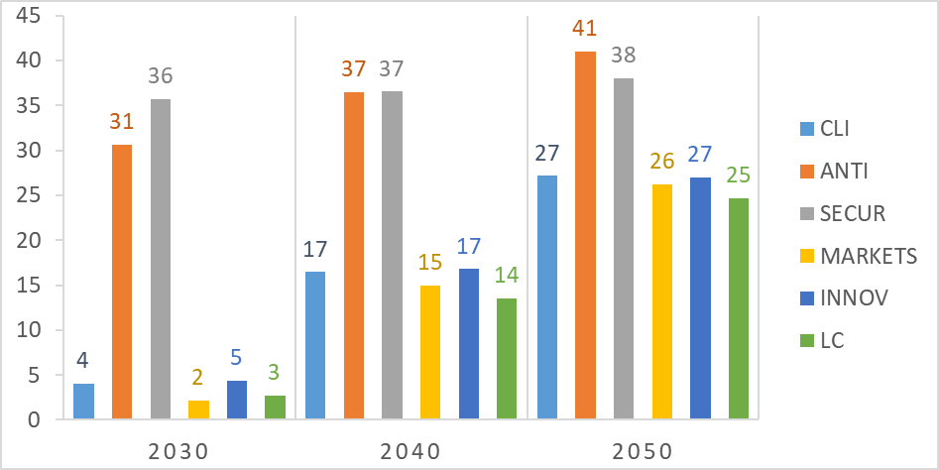
Figure 6: Fuel savings in PJ/yr, in each scenario due to building renovation in the residential sector in each milestone year.
This outcome highlights the challenge that ANTI and SECUR scenarios face in a context of limited exploitation of domestic renewable energy and limited imports of zero-carbon fuels if the emissions reduction targets for 2030 are to be met. However, if the transition of the buildings sector via renovation and technology/fuel switch accelerates, there is a much lower reliance on negative emissions technologies in the post-2040 periods.
Moreover, Figure 6 shows that the renovation needs are quite similar in all other scenarios, except in ANTI and SECUR, and should achieve about 1 TWh/yr. fuel savings in 2030 and 7.5 TWh/yr in 2050, independently of the technical progress and the level of energy markets’ integration. This outcome suggests that supporting and accelerating building renovation should be on the policy agenda to achieve net-zero emissions in 2050.
Role of domestic bioenergy resources: Bioenergy is a key energy carrier towards a net-zero energy system. The total primary supply of bioenergy is 53-80% higher in 2050 compared to 2015 levels in all scenarios achieving the net-zero CO2 emissions target in 2050 (for comparison, in BAU, the total primary supply of bioenergy in 2050 is only 16% higher than 2015). Figure 7 shows the use of domestic bioenergy resources in the different sectors of the energy system. It also highlights the challenge in mobilising manure collection for biogas production, improving waste collection and using it with CCS in the power sector to deliver negative emissions, and expanding the use of forest wood combined with CCS in hydrogen production. There is also a shift from wood chips and firewood to pellets because of their advantage of higher energy density, efficiency, easier storage and distribution.
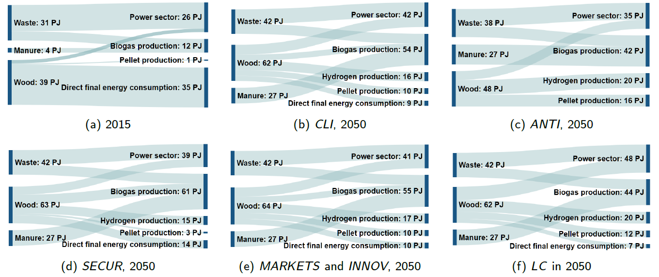
Figure 7: Use of domestic bioenergy resources. The charts show the input of bioenergy to the energy conversion and final consumption. The power sector refers to bioenergy input for electricity and heat production. Biogas production refers to the amount of bioenergy used for producing biogas either from wet or woody biomass. Hydrogen production refers to the wood input for producing hydrogen via wood gasification. Pellet production refers to wood required for domestic pellet production. And, direct final energy consumption refers to the amount of bioenergy directly consumed in the end-use sectors.
Role of biogas: Biogas produced from manure and solid biomass and waste is used to decarbonise end-use sectors. Biogas production from wood gasification (syngas) contributes when the demand for biogas is high, and its production from non-woody biomass cannot be further scaled up due to resource limits. Biogas imports occur when technical, certification and legal aspects are sufficiently addressed via a higher integration of energy markets.
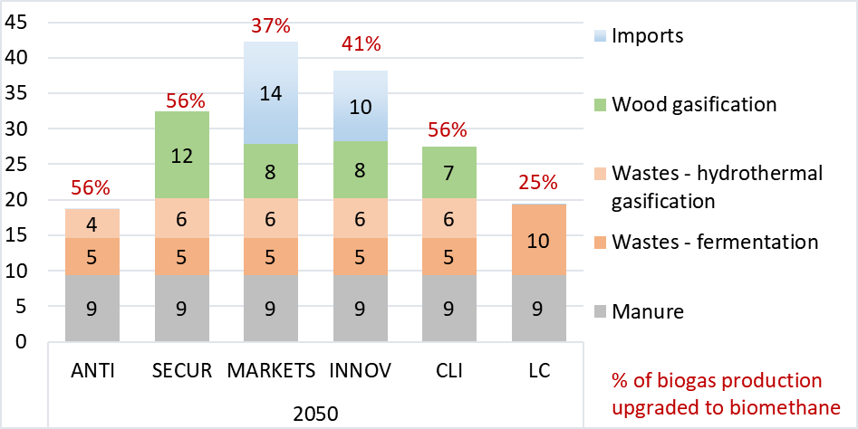
Figure 8: Production routes of domestic biogas and syngas in all scenarios. The chart shows the biogas production from its source in 2050 in PJ/yr. The percentages above the bars denote the percentage of biogas upgraded to biomethane in 2050.
Biogas upgrade to biomethane emerges in all scenarios and variants, ranging from 4 to 17 PJ in 2050. SECUR has the highest biomethane production due to limits in imports of zero-carbon gases. In contrast, ANTI and LC have the lowest biomethane supply because it does not entirely substitute natural gas in buildings, as in the other variants. In ANTI, this is because of the large deployment of energy conservation (see also Figure 6), while in LC, because in the absence of emissions standards in buildings, the residential heat retains fossil-based heating with remaining emissions being offset in the energy conversion sector.
Electricity imports needs in a net-zero energy system: The electricity net imports in the CLI scenario are shown in Figure 9. The annual net imports increase over time and peak in the 2040s when the nuclear phase-out has been completed, but solar PV and wind electricity has not been scaled-up yet. In the last decade, the further uptake of new renewables in electricity supply reduces the net imports needs despite increasing energy supply needs.
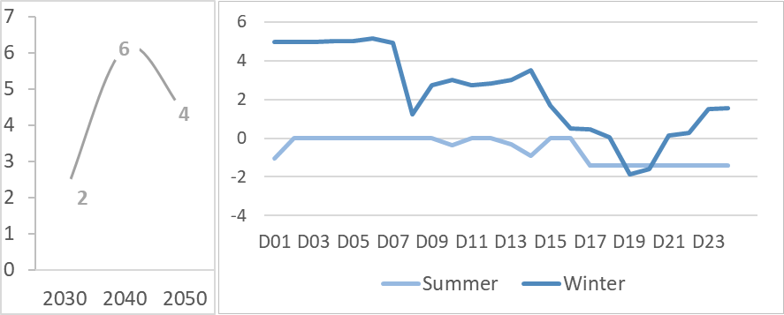
Figure 9: Annual electricity net imports in the CLI scenario in TWh/yr (left) and electricity imports/exports hourly profiles in a typical working day in Summer and Winter in GW (right). D01-D24 denote hours in a typical day.
The electricity imports occur in winter. As shown in Figure 9 on the right-hand side, the imports of electricity peak at around 5 GW in a typical winter working day. Across the year, the electricity imports in winter range from 3 TWh in SECUR to 8 TWh in MARKETS and INNOV in 2050.
Import dependency: In 2050, the import dependency of Switzerland drops to 17-20% compared to 82% in 2020 (Figure 10).
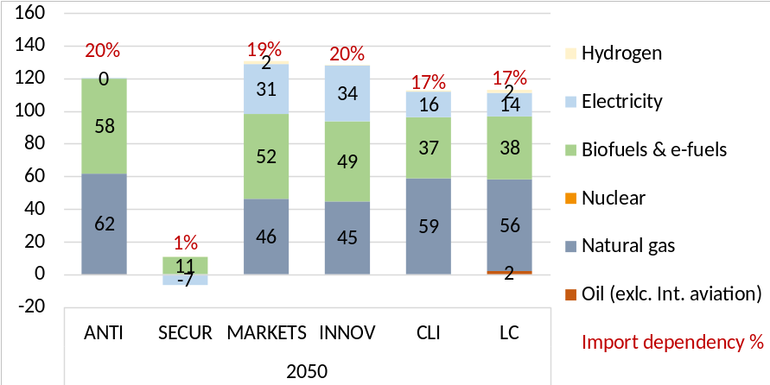
Figure 10: Requirements in net imports of different energy carriers in 2050, in all scenarios, in PJ/yr. The percentages above the bars indicate the import dependency in each scenario.
However, this reduction in import dependency does not necessarily imply that the supply security improves in the future compared to today because there is a shift in imports from fossil fuels (and uranium) to electricity, bioenergy and e-fuels, which require the development of (new) infrastructures and are sensitive to weather and climate conditions, on top of the geopolitical conditions that also concern the security of supply today. Security of supply could be still threatened by factors representing potential import-related challenges, including rare metals, which are not covered by the scope of the import dependency shown in the figure.
Power-to-X: Power-to-X technologies are part of the energy transition. Hydrogen is needed to decarbonise those sectors where electrification is more costly or even impossible. Moreover, hydrogen produced from renewable electricity can increase the energy system's flexibility to integrate high shares of variable renewable energy. As shown in Figure 11, about a quarter of the produced hydrogen from electricity in the CLI scenario is stored and seasonally shifted from summer to other seasons (mainly winter).
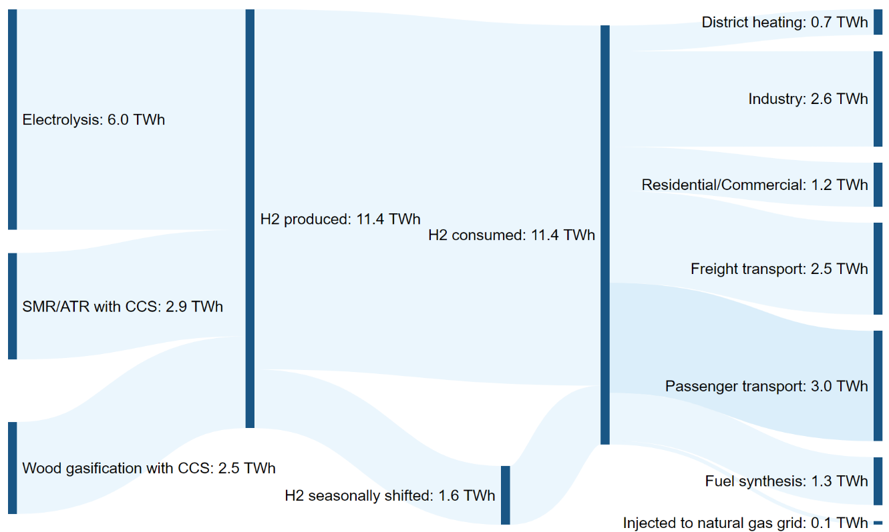
Figure 11: Power-to-X pathways showing production and demand for hydrogen and its role in seasonal balancing, as well as the sector coupling enabled by Power-to-X in the CLI scenario in 2050.
Investment needs in new hydrogen infrastructure: Figure 12 shows the cumulative investments, both in physical and monetary terms, to the P2X and hydrogen-related technologies from 2030 to 2050. The cumulative capital outlays to electrolysis account for about half of the investment in hydrogen production technologies. The cumulative investment expenditures for hydrogen distribution and storage are more than twice those for hydrogen production. When also including the investments for the distribution and equipment in hydrogen fuel stations, the total investment in hydrogen distribution, storage and vehicle fuelling infrastructure is more than 4.5 times higher than the investment in hydrogen production.
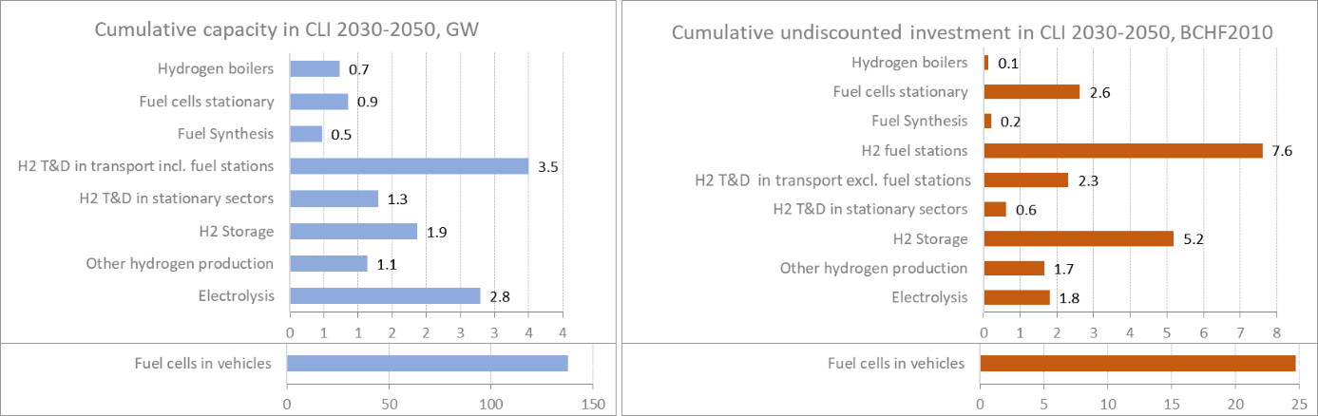
Figure 12: Cumulative installed capacity (left) and cumulative investments in H₂-related technologies (right). The capacity refers to GW_{H2} for production, storage and distribution technologies, GWel for stationary and mobile fuel cells, and GWth for fuel synthesis. The investments in mobile fuel cells refer to the total car cost minus the glider cost
In the total CAPEX for hydrogen distribution and storage infrastructure (including fuel service stations), pipelines have the highest share with more than 60%. Fuel service stations, by accounting only for the stations’ equipment and not for pipelines and trucks delivering hydrogen to them, account for 25%. Another 10% is directed to hydrogen storage and the rest to hydrogen distribution with trucks. The hydrogen delivery in the mobility sectors dominates the transmission, distribution and storage costs. It accounts for more than 90% of the total capital outlays in hydrogen distribution infrastructure, indicating the sector's importance for the penetration of hydrogen. The lion’s share in the expenditures in hydrogen technologies is on the demand side, which is almost two-thirds of the total amount spent between 2030 and 2050 in hydrogen-related technologies. Among the demand technologies, the fuel cell stacks in vehicles alone absorb more than 90% of the total investment expenditures in hydrogen demand technologies. The rest 10%, is mainly allocated to stationary fuel cells.
Deployment of flexibility options in all energy sectors: High shares of solar in electricity production induce seasonal mismatch, which accentuates after the nuclear phase-out. The bulk of distributed generation is mostly balanced at the medium and low voltage levels (Figure 15).
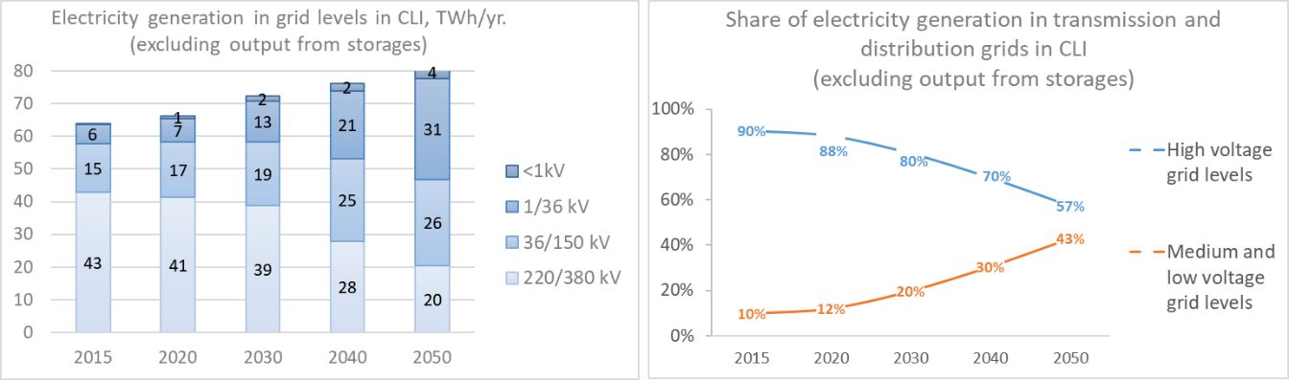
Figure 13: Structure of the electricity generation per voltage level in the CLI scenario, excluding the output from energy storage
Co-location of batteries with solar and wind generators enables predictable power supply management by combining storage and generator systems (Figure 14).
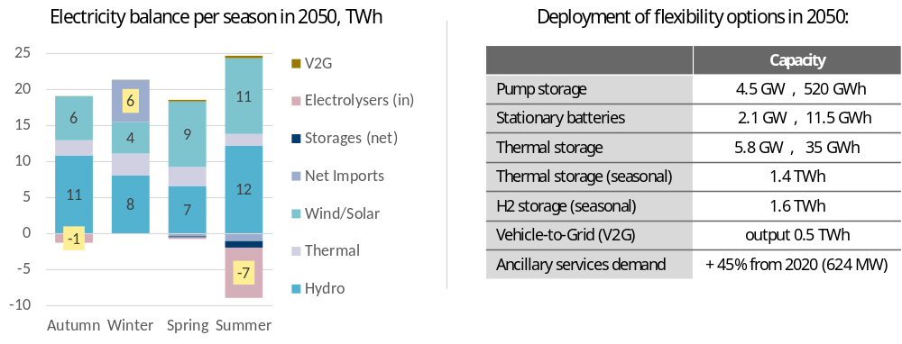
Figure 14: Seasonal balancing needs of the electricity production via electrolysis (left) in the CLI scenario in 2050, and deployment of energy storage and other flexibility options in the same scenario in 2050.
Hydro-storage remains the main provider of the secondary positive operating reserve (aFRR+). New business models emerge via the smart integration of smaller distributed units such as CHPs, batteries and heat pumps (Figure 13).
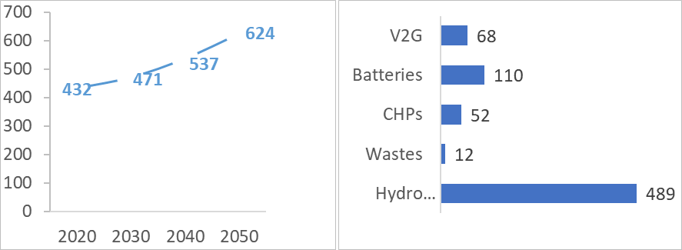
Figure 15: Maximum demand for secondary positive operating reserve (aFRR+) in MW (left) and maximum contribution by technology in the secondary positive reserve provision in 2050 in MW (right) in the CLI scenario – note that the numbers of the maximum provision of technology do not add.
In the CLI scenario, the electricity supply peaks in summer, driven by the solar resource availability and the high penetration of solar PV, while the electricity demand peaks in winter (Figure 16). The shape of the electricity load profile in 2050 does not have the characteristic peaks in the morning and afternoon hours, which are seen today. Still, it is mostly bell-shaped around noon when solar PV production is at its highest levels. This means that the electricity consumption adapts to the new supply patterns and shifts mainly to the noon hours.
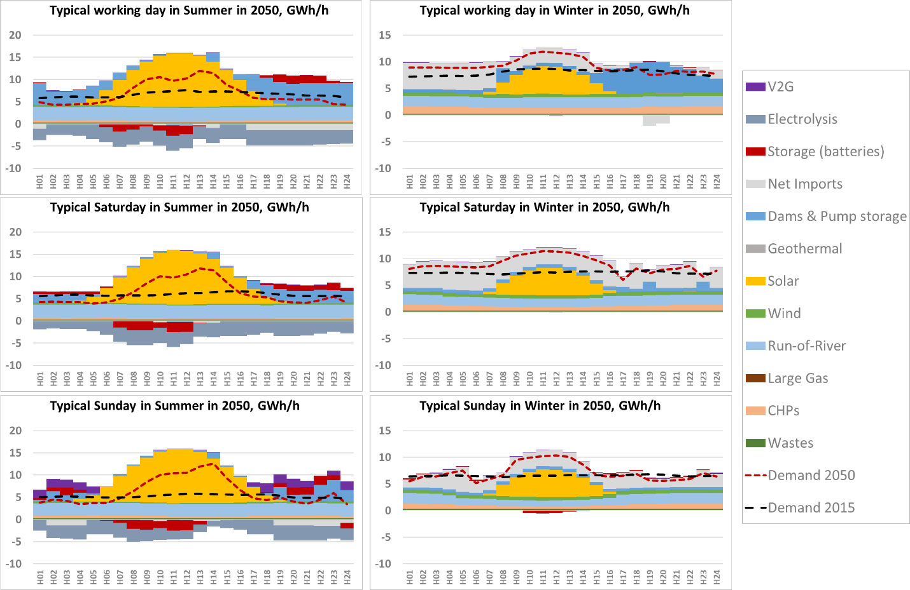
Figure 16: Hourly dispatch profile for average days in STEM in the CLI scenario for the summer and winter seasons in 2050.
This is facilitated by the coordinated deployment of a number of flexibility options that decouple the electricity consumption from the provision of the energy service demand, such as storage, smart charging and discharging of electric vehicles, as well as by demand-side management (Figure 17)
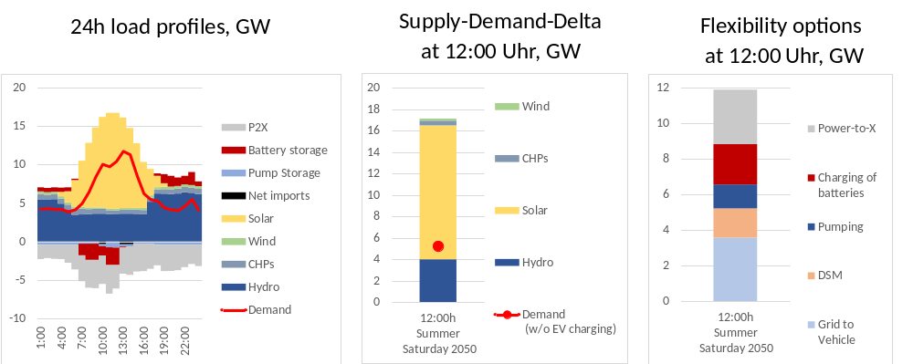
Figure 17: Deployment and coordination of flexibility options to cope with intra-day imbalances in electricity supply and demand. The figure refers to a typical Saturday in Summer in 2050 for the CLI scenario.
The future of the gas grid: The decarbonisation of the end-use sectors could impose challenges in maintaining and operating the existing natural gas pipeline networks. In 2020, the natural gas consumption was around 120 PJ/yr. In the CLI scenario, by 2050, natural gas consumption drops by 50% (Figure 18). However, injections to the gas grid from biomethane and biogas, as well as hydrogen and e-gases, sustain gas in the gas pipelines at the level of 74 PJ/yr.
Hydrogen blending in natural gas grids faces challenges related to the lower energy density of natural gas, the risk of increasing the spreading of flames and can alter the quality of natural gas.
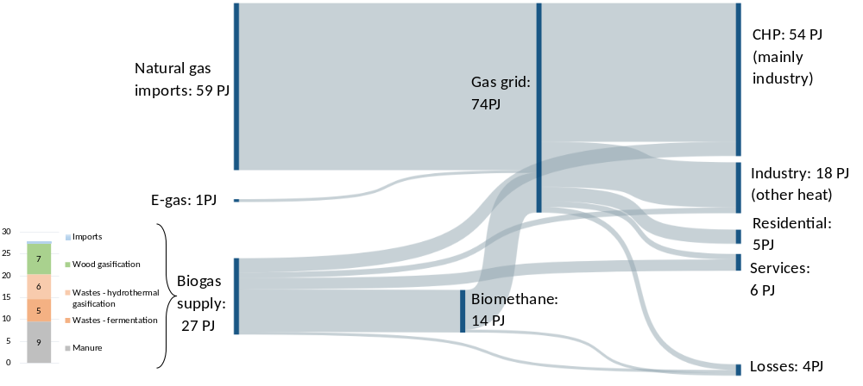
Figure 18: Natural gas, syn- and biogas, and e-gases imports in the Swiss energy system in 2050 in the CLI scenario.
Repurposing existing natural gas pipelines for 100% hydrogen distribution is likely to be technically feasible, but this will be a large undertaking due to the need to convert the majority of end-use equipment. The feasibility of using existing high-pressure transmission networks completely for hydrogen distribution is less clear than the low-pressure networks, not only because of logistical reasons for keeping gas transmission networks in operation but also because of technical issues arising from the high pressures. Since the natural gas is supplied by complex networks with many interconnections linked to a central transmission system, it would be hard to isolate parts of the networks for repurposing. Moreover, repurposing does not eliminate the need to have hydrogen on tap and ready to feed into converted networks. In the end, hydrogen production and distribution infrastructure must be developed before the conversion process of the natural gas grid. In the current analysis, the repurposing of the gas infrastructure occurs mainly as a transition option by converting the easier parts of the network first until the full deployment of hydrogen-specific infrastructure. In this light, 75% of the hydrogen delivered by pipelines in 2030 is achieved through repurposed gas pipelines. By 2050, the share of repurposed pipelines to the total hydrogen pipeline deliveries drops to 11%.
The cost of carbon: The avarage abatement cost of CO₂ in the CLI scenario is around 420 CHF/t. The average abatement cost can be 2-3 times higher in those scenarios lacking low-cost alternatives due to limited deployment of domestic renewables or imports.
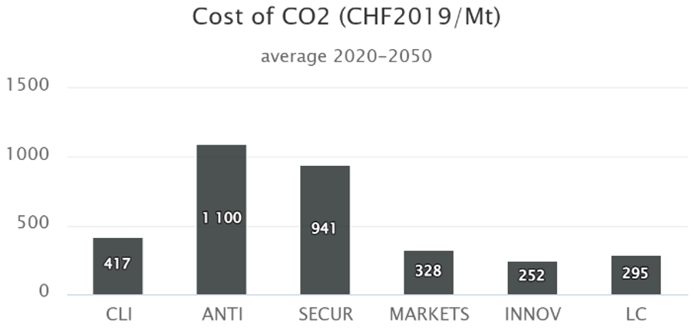
Figure 19: Average abatement cost of CO2 over the period of 2020 to 2050 in the different net-zero scenarios
Supplementary Notes 5: Comparison between CLI and the other net-zero scenarios
Below a comparative summary of the key findings between CLI and the other net-zero scenarios is given. The reader is also directed to the full report of STEM in the context of SCCER JASM³¹.
- ANTI vs CLI
The storyline in the ANTI scenario builds on lower international cooperation, lower energy market integration and lower innovation in clean technologies than in CLI. This results in lower availability of electricity imports and other zero-carbon energy carriers, together with higher costs of clean and low-carbon technologies.
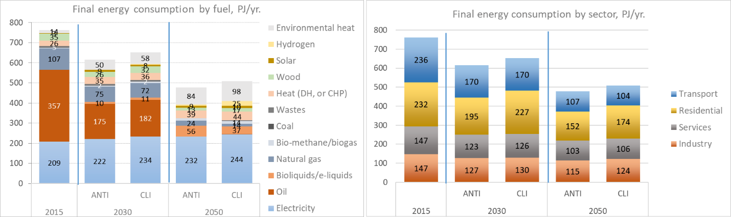
Figure 20: Final energy consumption by fuel and sector between ANTI and CLI scenarios.
In ANTI, the low availability of imported zero-carbon energy carriers and the low exploitation rate of domestic renewable sources limit the decarbonisation options in the end-use sectors. As a result, the switching to cleaner technologies is hampered by the limited zero-carbon energy carriers and renewables. The residential and industrial sectors would need to implement additional renovation and energy conservation measures to meet the climate targets (Figure 6 and Figure 18). The energy conservation measures are deployed not only at a larger scale than in CLI but almost a decade earlier. Despite the lower energy consumption in ANTI, the electrification of final consumption in this scenario remains at the levels of CLI in 2050.
In transport, the segment of large-sized cars does not shift to electricity or hydrogen as in CLI by 2050. In ANTI, there are still 0.7 million cars with conventional hybrid drivetrains by 2050 (Figure 19).
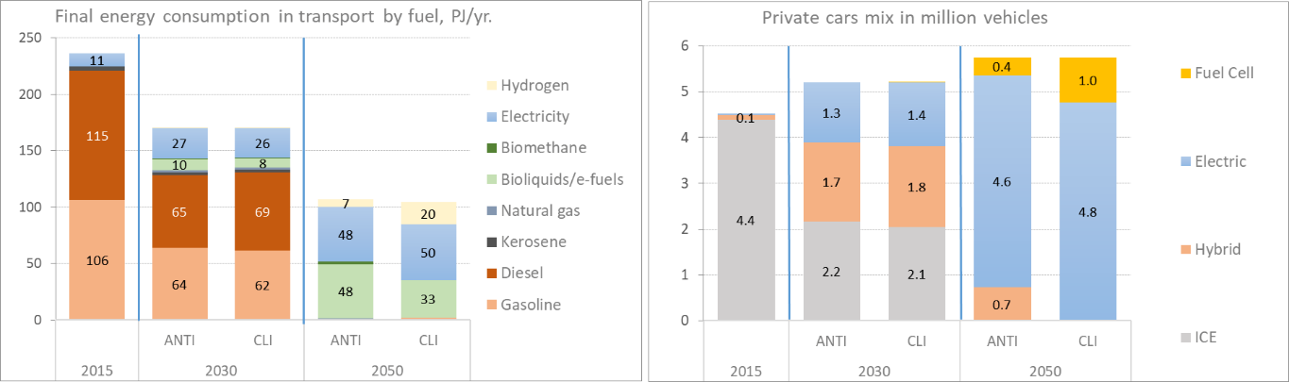
Figure 21: Comparison of the transport sector developments between ANTI and CLI scenarios.
In ANTI, the emissions from the ETS sectors are higher than in CLI in 2030, which implies that ANTI fails to achieve the intermediate targets. Similarly, the near-term vehicle emissions standards are challenged in transport, especially in long-distance transport. Overall, the need for developing CCS and negative emissions technologies in ANTI is less than in CLI because of the reduced final energy consumption (Figure 20) as energy conservation measures are deployed.
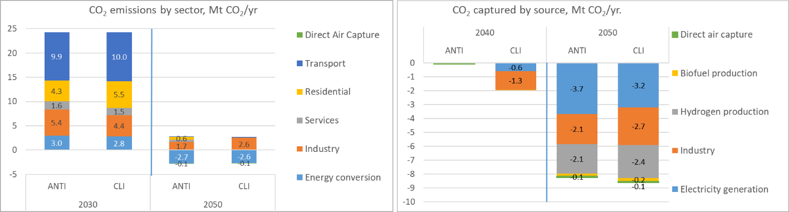
Figure 22: CO₂ emissions and CO₂ captured by sector, excluding international aviation, between ANTI and CLI scenarios.
- SECUR vs CLI
SECUR emphasises reducing import dependency, not only for electricity but also for the rest of the energy carriers. It aims at achieving the net-zero ambition with the highest possible reliance on domestic means and resources. To this end, SECUR assumes a high social acceptance related to the exploitation of domestic bioenergy.
The final energy consumption in SECUR is lower than in CLI due to the deployment of energy conservation measures to cope with the absence of imported fuels and energy carriers (Figure 21). It can be argued that the final energy consumption in SECUR is close to ANTI levels by 2050. The electricity share in final energy consumption in SECUR remains at CLI levels. In SECUR, there is the highest penetration of hydrogen in final energy consumption across all scenarios, as domestic green hydrogen production increases to supply the energy needs with e-fuels in the absence of imported fossil or zero-carbon fuels.
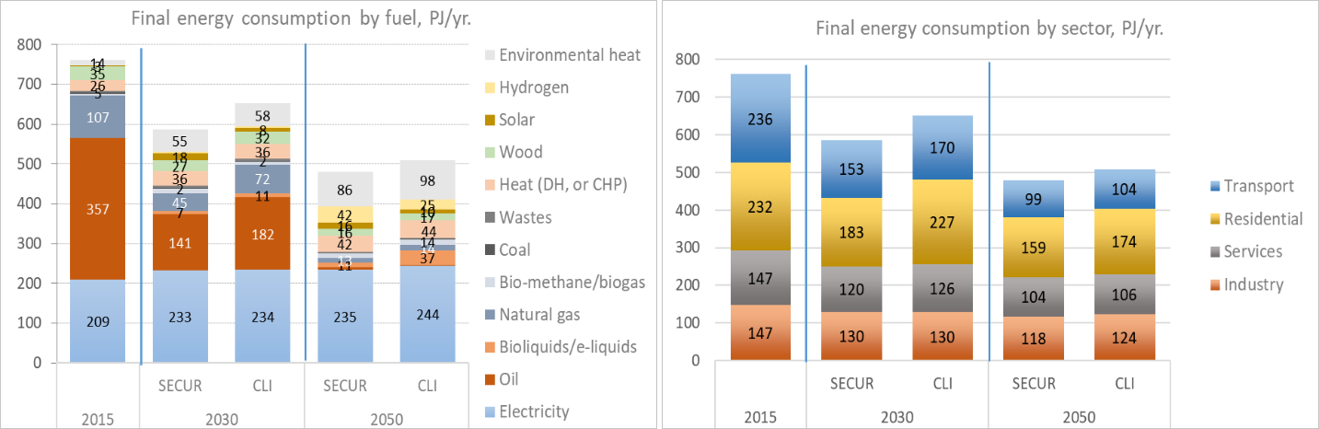
Figure 23: Final energy consumption by fuel and sector between SECUR and CLI scenarios.
Transport decarbonisation relies more on fuel cell drivetrains than in the other scenarios. Because of the zero imports of electricity and clean fuels in SECUR, green hydrogen production and domestic synthetic e-fuels are key options to achieve large emissions reduction in mobility sectors.
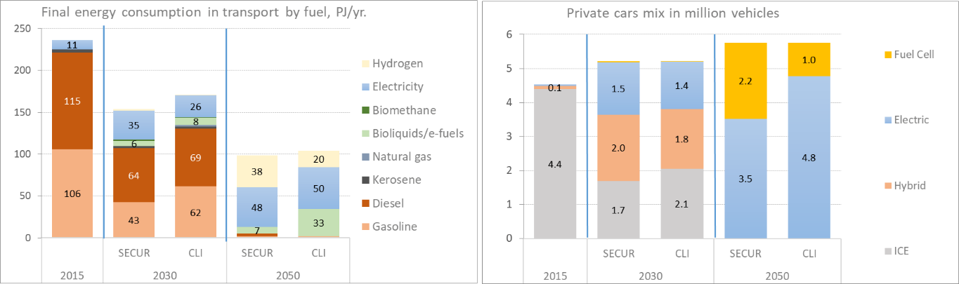
Figure 24: Comparison of the transport sector developments between SECUR and CLI scenarios.
The SECUR scenario describes a hydrogen-based economy. Hydrogen is directly consumed in mobility and stationary sectors, but more than 40% of the produced quantities are used for fuel synthesis. Among the synthetic fuels, gas accounts for more than 90%, with the rest being liquids (Figure 23). The SECUR scenario reaches the highest hydrogen production and consumption levels across all assessed scenarios. It demonstrates the technical and systemic capabilities of scaling-up hydrogen production using domestic resources, under the condition that these resources can be fully exploited. In SECUR, the hydrogen production needs to scale up a decade earlier than in CLI to meet the increased need for zero-carbon fuels in the Swiss energy system, if imports are not available. By 2050, in SECUR, hydrogen production is twice the level seen in the CLI scenario. Electrolysis becomes a key technology in the context of limited gas imports and constrained wood resources needed to deploy SMR/ATR and gasification, respectively. The electricity used in electrolysis is from run-of-river hydropower (as in the rest of the assessed scenarios) and solar PV electricity, either in industrial facilities or colocated (on-site) with the electrolysers. While in all scenarios assessed, the dominant technology for electrolysis is Polymer-Electrolyte-Membrane (PEM), in SECUR, high-temperature electrolysis via Solid Oxide Electrolyser Cells (SOEC) prevails in 2050 to reap efficiency gains.
Transport has the lion’s share in hydrogen consumption in the end-use sectors, followed by industrial applications. Hydrogen use is prioritised to the sectors with the fewer decarbonisation options, as there is a very limited direct use of hydrogen in residential and commercial sectors. Hydrogen also contributes to the seasonal balancing of the Swiss energy system. The seasonal hydrogen shifts in SECUR exceed those in the CLI scenario, as about 2.3 TWh of hydrogen are seasonally shifted in SECUR in 2050 (Figure 24) compared to 1.6 TWh in CLI (Figure 11). The role of hydrogen in balancing the Swiss energy system is even more pronounced in SECUR when accounting for the hydrogen transformed to synthetic fuels as contributions to seasonal balancing.
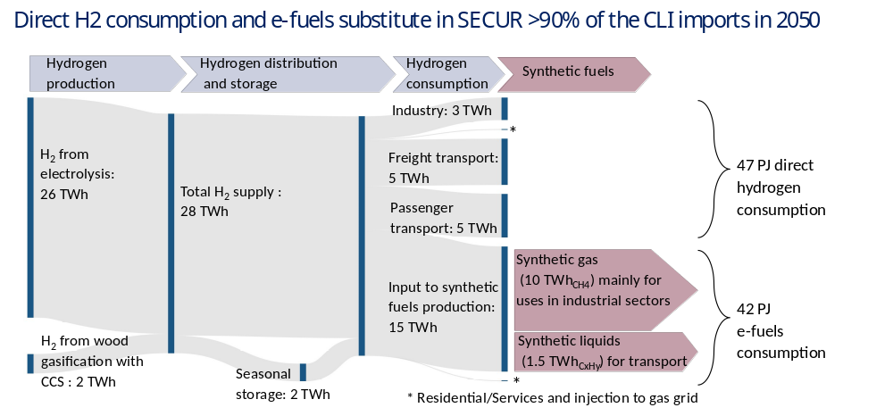
Figure 25: Power-to-X pathway and synthetic e-fuels production in SECUR in 2050
In SECUR, the residential and services sectors are fully decarbonised. Any remaining emissions by 2050 are from transport (0.4 Mt CO₂/yr.), mainly from trucks, and industry (2.1 Mt CO₂/yr.). However, SECUR requires about 1.2 Mt CO₂/yr. less carbon capture than CLI, which is attributable to the limited availability of imported fossil fuels that induce fuel switch to low-carbon alternatives and energy conservation deployment earlier in this scenario, accelerating the energy transition. The SECUR scenario achieves the ETS targets, the buildings emissions standards, and the vehicle emissions standards assumed in CLI.
The main outcomes from the SECUR scenario are the technical feasibility of achieving the net-zero target in 2050 with only domestic means (albeit at high costs) and that the early restrictions in the use of fossil fuels could significantly reduce the need for relying on negative emissions technologies in the later years.
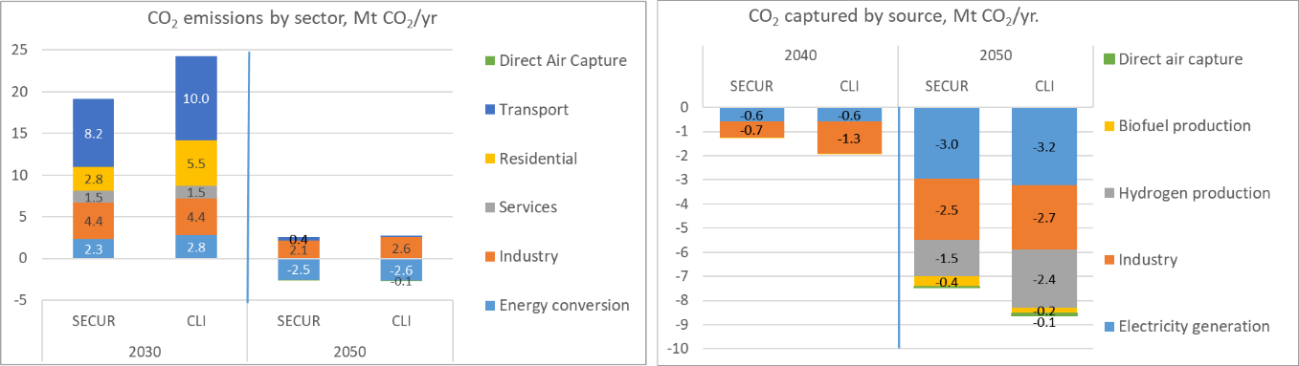
Figure 26: CO₂ emissions and CO₂ captured by sector, excluding international aviation, between SECUR and CLI scenarios
- MARKETS vs CLI
MARKETS considers higher global cooperation and integration of the Swiss, European and global energy markets than the CLI scenario. Moreover, it assumes lower costs for technologies facilitating the emergence of local energy markets, such as storage and decentralised energy supply, and reinforcing cross-border capacities and domestic grids.
Compared to CLI, the MARKETS scenario does not display significant differences in the final energy consumption mix other than the slightly higher electrification in the post-2030 period due to the increased low-cost electricity imports. This is sought mainly in the private cars sector, where electric cars amount to roughly 4.9 million compared to 4.8 million in CLI in 2050. At the same time, hydrogen consumption in transport is somewhat lower than CLI.
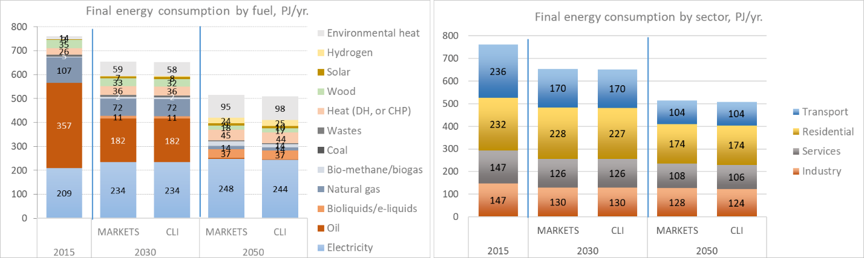
Figure 27: Final energy consumption by fuel and sector between MARKETS and CLI scenarios.
The integration of local markets brings an earlier introduction of hydrogen in the Swiss energy system compared to CLI. Better access to international hydrogen markets also enables imports of hydrogen. In general, the development of domestic hydrogen production routes remains important even in a context with good availability of imports of hydrogen and e-fuels because the Power-to-X pathways contribute to the seasonal balancing of the system.
Because the MARKETS scenario is very similar to the CLI scenario in energy supply and consumption, the CO₂ capture needs are at the same level as CLI.
- INNOV vs CLI
The INNOV scenario derives from MARKETS by additionally assuming coordinated global climate change mitigation policies and R&D investments that reduce the costs of low-carbon technologies via innovation to cope with the stringent climate targets worldwide.
The final energy consumption mix in INNOV shows the same trends as in the MARKETS and CLI scenarios. However, the total final energy consumption is lower than in CLI, which is attributable to increased renovation and energy conservation (due to lower costs) and efficiency improvements in electric and fuel cell vehicles (Figure 26).
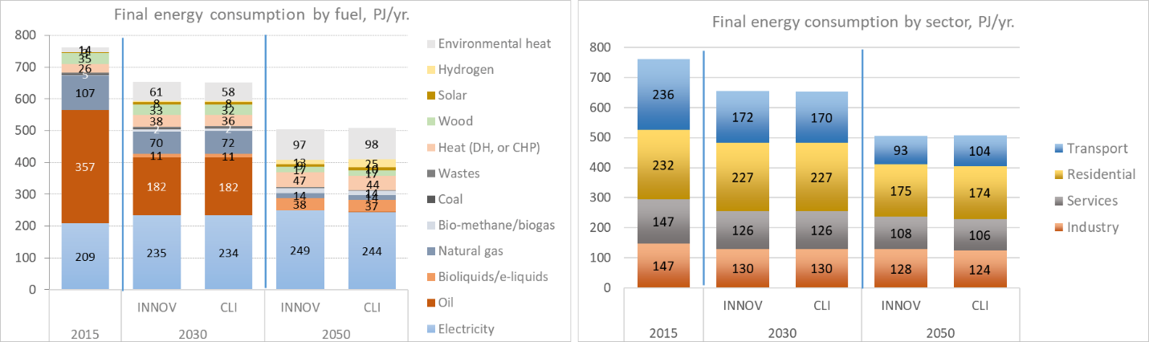
Figure 28: Final energy consumption by fuel and sector between INNOV and CLI scenarios.
In transport, already in 2030, the private cars sector displays higher electrification in INNOV than in the CLI scenario (Figure 27). This is because of the improvement of the efficiency in EVs, which is partly attributable to the improvement of batteries per se and partly to the improvement of the designs and materials of EVs (such as user-centric designs which directly or indirectly impact consumption in a significant way, including visibility, thermal comfort, ergonomics, postural comfort, noise and vibration, etc., integration of advanced systems and components to optimise occupant comfort and well-being with respect to energy consumption, and novel materials to improve thermal insulation).
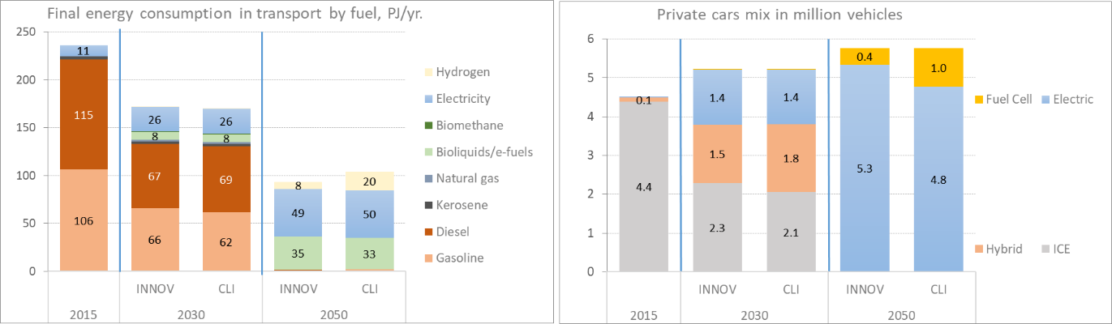
Figure 29: Comparison of the transport sector developments between INNOV and CLI scenarios.
Despite the lower hydrogen consumption in transport, mainly because of the higher electrification of the sector, the use of hydrogen in the stationary sectors remains at the levels of CLI. Moreover, INNOV shows increased use of hydrogen for synthetic gas, driven by the cost reductions in Power-to-X technologies. The seasonal balancing of the energy system in INNOV is mainly achieved via synthetic fuels.
The reliance on negative emissions technologies in INNOV is less than in MARKETS and CLI scenarios due to efficiency gains in energy conversion and consumption, despite the similarities in the technology mix for energy supply and demand (Figure 28)
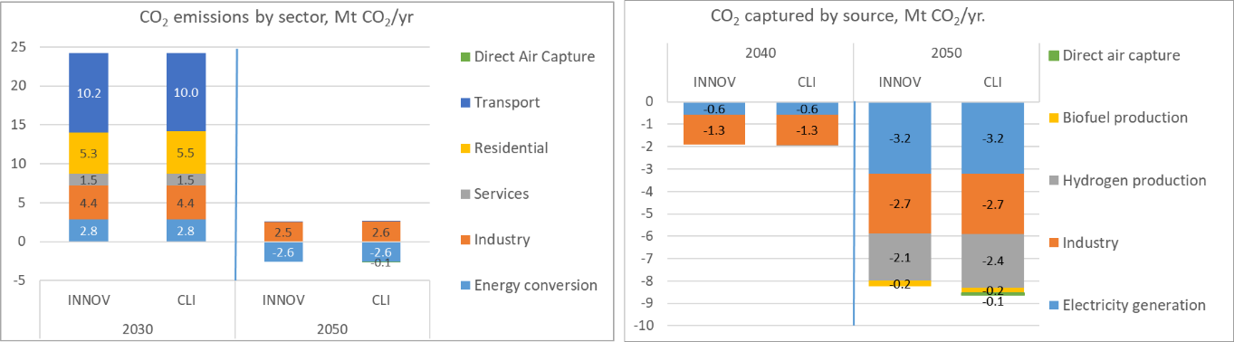
Figure 30: CO₂ emissions and CO₂ captured by sector, excluding international aviation, between INNOV and CLI scenarios
- LC vs CLI
The LC scenario does not include sectoral abatement policies, such as targets and standards or ETS linear reduction factors, as CLI does. It only imposes the overall CO₂ emissions targets in 2030 and 2050. This scenario provides insights regarding the compatibility of the suggested sectoral policies in the amended CO₂ Act with the cost-optimal migration decisions.
The final energy consumption in LC is similar to CLI. The main differences are the higher consumption of gas at the expense of hydrogen in LC and the lower heat from on-site CHPs and district heating (Figure 29). This is attributable to the relaxation of the emissions standards in buildings and the relaxation of the ETS emissions reduction targets. By relaxing sectoral emissions targets, the most expensive zero-carbon options, such as hydrogen and heat from distributed CHPs, do not scale up to the levels seen in CLI. Moreover, the relaxation of the standards results in a lesser need for expensive energy conservation measures in the demand sectors.
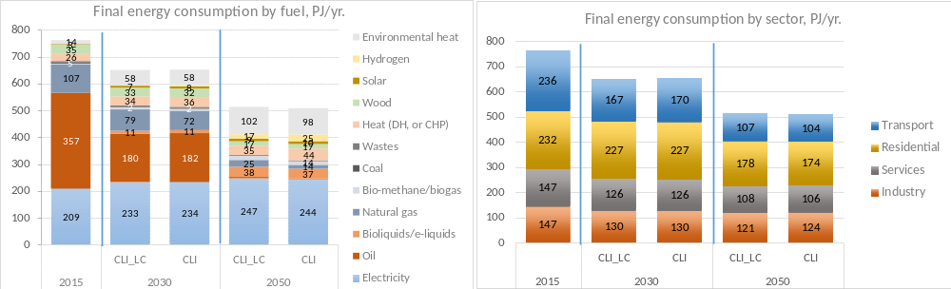
Figure 31: Final energy consumption by fuel and sector between LC and CLI scenarios.
There is an increased hybridisation of cars in transport in 2030 due to the absence of stringent vehicle emissions standards. There is a higher uptake of electric cars in the last decade and a stronger reliance on long-distance transport on synthetic fuels instead of hydrogen (Figure 30).
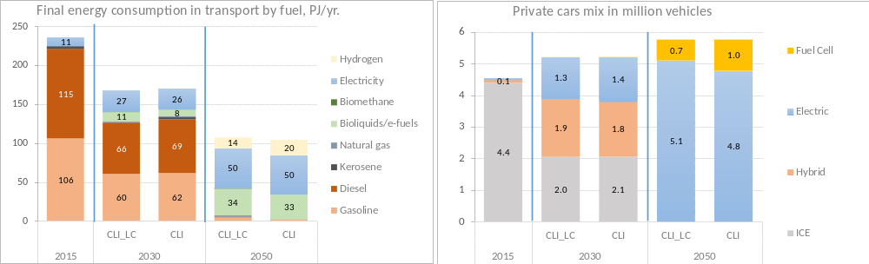
Figure 32: Comparison of the transport sector developments between LC and CLI scenarios.
Due to the absence of sectoral emissions mitigation policies, the LC scenario requires higher amounts of captured CO₂ than CLI and a stronger reliance on negative emissions technologies. The emissions not abated in the demand sectors are offset in energy conversion sectors (Figure 32). The electricity generation sector delivers increased negative emissions in LC compared to CLI. At the same time, the emissions in industry in LC are also lower in 2050 due to the higher availability of bioenergy, which in CLI is used in buildings to meet the emissions standards imposed in residential heating.
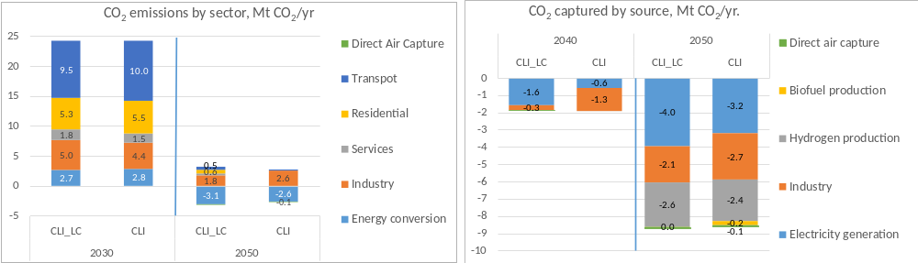
Figure 33: CO₂ emissions and CO₂ captured by sector, excluding international aviation, between LC and CLI scenarios.
The main outcome of the analysis of the LC scenario is that uncoordinated sectoral policies should be avoided in order to achieve a cost-efficient energy transition. If sectoral policies are imposed without accounting for possible lower-cost mitigation options in other sectors, they could result in higher upfront costs for the investors and consumers. However, in the absence of sectoral policies that bring emissions reductions forward, increased reliance on negative emissions technologies is necessary. Therefore, policymakers should carefully balance the stringency and timing of sectoral policies to account for and detect possible inefficiencies in their implementation resulting from the complex interactions between the energy sectors.

Supplementary Notes 6: Sensitivity analysis on existing nuclear power plants lifetime
The analysis of the CLI scenario assumed a lifetime of 60 years for the existing nuclear power plant. Given the uncertainty of the timing of the existing nuclear power phase-out, as the operational security is the sole criterion for decommission, a sensitivity analysis of CLI with a lifetime of 50 years for the existing nuclear power plants was performed. The scenario CLI_NUC50 shares the same socioeconomic and technical assumptions and sectoral policies with the CLI scenario, except for the lifetime of the nuclear power plants, which is set to 50 years.
Figure 33 shows the final energy consumption by sector and fuel in the CLI_NUC50 scenario compared to CLI. While the final energy consumption mix in 2050 is very similar in both scenarios, the trajectories are different. In CLI_NUC50, the final energy consumption is lower by 9 PJ/yr. in 2030 and 11 PJ/yr. in 2040. This is attributable to the increased deployment of energy conservation measures to cope with the scarcity in electricity supply. It follows that the total electricity consumption in CLI_NUC50 is lower by 1.2 TWh/yr. in 2030 and 1.6 TWh/yr. in 2040 than CLI. However, by 2050 the CLI_NUC50 arrives at levels similar to CLI.
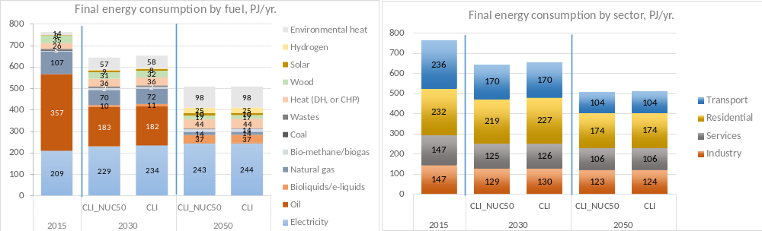
Figure 34: Final energy consumption by fuel and sector between CLI_NUC50 and CLI scenarios
The additional energy conservation measures taken in CLI_NUC50 are mainly sought in the residential sector. The CLI_NUC50 needs to double the renovation rates of existing buildings in 2030 compared to CLI, resulting in fuel savings of 9 PJ/yr. instead of 4 PJ/yr in CLI (see Figure 6). In 2040, the required fuel savings in the residential sector amount to 21 PJ/yr. compared to 17 PJ/yr. in CLI, while in 2050, both scenarios come to about 27 PJ/yr. The increased renovation rates in CLI_NUC50 are triggered by the need to meet the emissions standards in the buildings sectors assumed in the scenario. This result suggests that in a context of an earlier phase-out of nuclear power plants, the decarbonisation of the residential sector would rely on bringing forward in time by five years (expensive) energy conservation measures.
The energy transition in transport in CLI_NUC50 is similar to CLI. The sector is hardly affected by the earlier nuclear phase-out, as its electrification progresses at the same rate in both scenarios from 2020 to 2050 (Figure 34). Hence, CLI_NUC50 in 2030, 2040 and 2050 has the same fuel mix in transport as CLI and the same fleet composition, with the slight difference of about 100,000 more plug-in cars in 2050 at the expense of battery-electric cars.
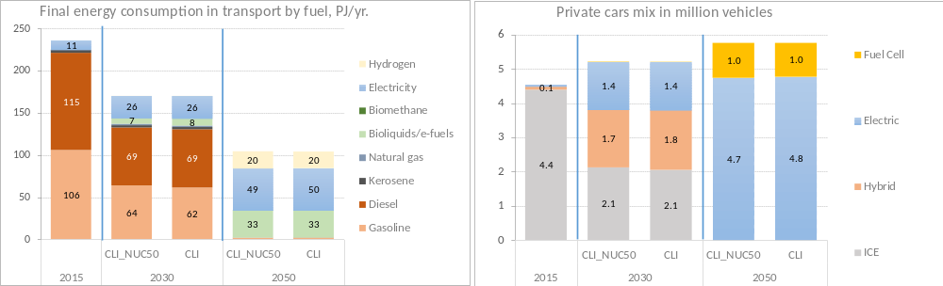
Figure 35: Comparison of the transport sector developments between CLI_NUC50 and CLI scenarios.
The hydrogen production in CLI_NUC50 shows a higher reliance on SMR/ATR in 2040 than CLI due to the scarcity of low-cost electricity. However, by 2050, as the electricity supply from new renewable sources scales up and reaches the levels attained in CLI, electrolysis becomes the dominant technology also in CLI_NUC50 and contributes to the seasonal balancing of the energy system (Figure 35).
The hydrogen consumption patterns in CLI_NUC50 are the same as in CLI. However, the hydrogen used for domestic e-fuel production is twice in CLI_NUC50 than in CLI. About 6.5 PJ/yr of synthetic fuels (of which 4.4 PJ/yr. synthetic gas) are produced in 2050 in CLI_NUC50 compared to 3.4 PJ/yr. in CLI. The increased consumption of synthetic e-gases in CLI_NUC50 are attributable to electricity and hydrogen production. In electricity supply, e-gases are used in flexible CHPs to balance the system in 2050. In hydrogen production, e-gas produced by excess electricity in summer is used in winter in SMR/ATR with CCS to sustain hydrogen consumption in the Swiss energy system.
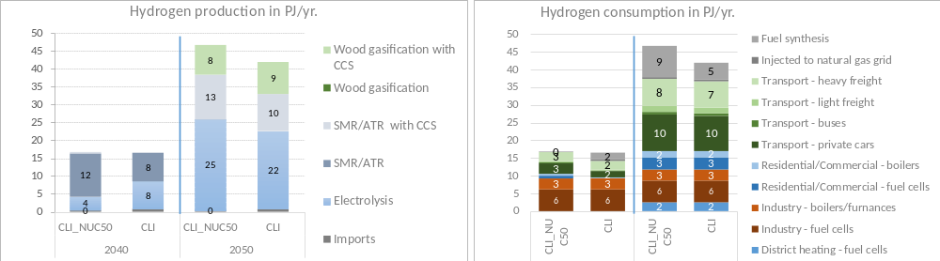
Figure 36: Hydrogen production and consumption in CLI_NUC50 and CLI
The overall electricity supply and demand in CLI_NUC50 compared to CLI is shown in Figure 36. Bringing the nuclear phase-out forward by ten years implies additional net imports of electricity of 6 TWh/yr. in 2030 to cover the electricity supply gap. By 2040 the electricity supply mix in CLI_NUC50 relies more on solar PV electricity than in CLI, 18 TWh/yr. in CLI_NUC50 compared to 15 TWh/yr. in CLI. In contrast, the net imports of electricity remain at CLI levels and amount to 4 TWh/yr by 2040. In 2050, the electricity supply mix in CLI_NUC50 does not display significant differences from the electricity supply mix in CLI. It is worthy to note that despite the earlier nuclear phase-out, no large scale gas generation is installed in Switzerland. The installation of large scale gas generation in a net-zero scenario would require CO₂ capture and storage. The uncertainties in domestically storing CO₂, and the limited potential assumed in this study, challenge the installation of large scale CCS power plants before 2040 in Switzerland.
The electricity demand by sector is also shown in Figure 36. In 2030, the electricity consumption in industry and services sectors is reduced by 0.5 TWh/yr. in CLI_NUC50 compared to CLI, while in the residential sector is reduced by 0.7 TWh/yr. In 2040, the electricity consumption in CLI_NUC50 is lower by 0.3 TWh/yr in industry and services compared to CLI, and in residential by 1.1 TWh/yr. However, by 2050, the electricity consumption in stationary sectors in CLI_NUC50 reverts to CLI levels. The energy sector affected most by the earlier phase-out of the nuclear power plants is the buildings sector.
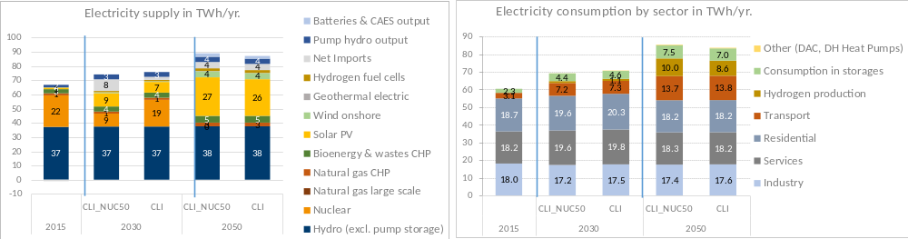
Figure 37: Electricity production and consumption in CLI_NUC50 and CLI scenarios
The net imports of energy carriers in CLI_NUC50 show higher electricity imports in 2030 than in CLI to fill the electricity supply gap as large-scale gas generation is not deployed in Switzerland. In 2040, the CLI_NUC50 scenario requires higher gas imports than in CLI, mainly due to the larger share of SMR/ATR in hydrogen supply. By 2050, the net imports in CLI_NUC50 are at similar levels as in CLI (Figure 37).
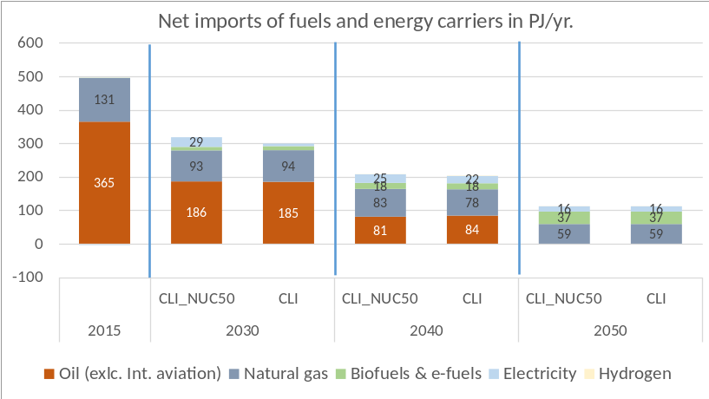
Figure 38: Net imports of energy carriers (excluding nuclear fuel) in CLI_NUC50 and CLI scenarios
Figure 38 shows that despite the earlier phase-out of nuclear power, the requirements in captured CO₂ emissions in CLI_NUC50 are only slightly higher than in CLI by 0.2 Mt/yr. in 2050. This is attributable to the same sectoral policies that CLI_NUC50 and CLI scenarios shares, such as building and vehicle emissions standards and ETS targets. This outcome suggests that in order to avoid overreliance on negative emissions technologies in a context of a quicker nuclear phase-out, coordinated sectoral policies should be deployed in both the energy supply and demand sectors with clear near-term targets.
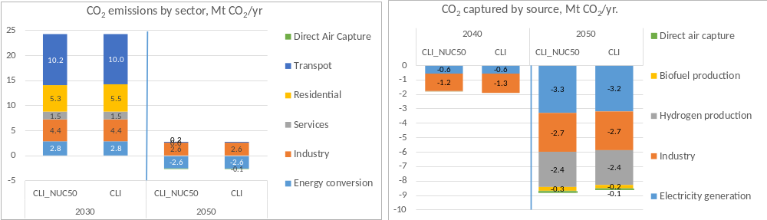
Figure 39: CO₂ emissions and CO₂ captured by sector, excluding international aviation, between CLI_NUC50 and CLI scenarios.
Figure 39 shows the derived policy costs in all scenarios achieving net-zero CO2 emissions in 2050 with 60 and 50 years lifetime of nuclear power plants. On average, across all scenarios, the increase in the policy costs triggered by the earlier nuclear phase-out is about 10% from 2020 to 2050. CLI scenario shows about 10 billion CHF2019 higher cost when the phase-out is brought earlier by a decade. The cost of INNOV, MARKET, and SECUR scenarios increases by 11 billion CHF/year, while the cost of ANTI scenarios increases by 4 billion CHF/year.
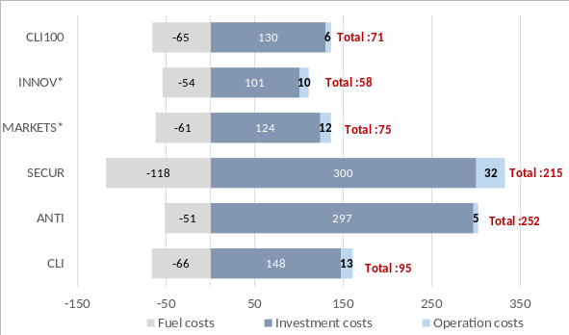 | 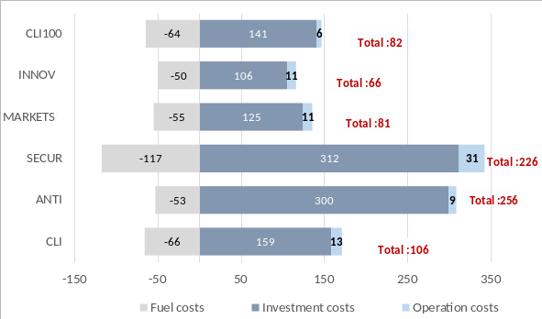
(a) | (b)

Figure 40: Cumulative policy costs 2020-2050 discounted at 2.5% in BCHF2019. (a) cumulative policy costs in net-zero scenarios with 60 years lifetime. (b) cumulative policy costs in net-zero scenarios with 50 years lifetime. The calculation of the policy costs is based on the difference of the cumulative total energy system cost in the net-zero scenarios from the cumulative energy system cost in the BAU scenario. In (a), the BAU scenario assumes 60 years lifetime of nuclear power plants, while in (b), the BAU scenario assumes 50 years lifetime of nuclear power plants.
This result indicates that limited exploitation of domestic renewable potentials combined with limited imports of zero-carbon fuels due to the failure of international agreements and energy markets integration has higher impacts on the cost-effectiveness of the energy transition than the timing of the nuclear phase-out. Viewed another way, this result suggests that an earlier nuclear phase-out would need to be associated with accelerated exploitation of domestic renewable resources and an early scale-up of renewable electricity supply in association with appropriate flexibility mechanisms across all energy sectors to maintain a cost-effective energy transition.
References
1. Kober, Tom et al. Swiss Industry: Price Elasticities and Demand Developments for Electricity and Gas (SWIDEM). (2020).
2. Streicher, K. N. et al. Optimal building retrofit pathways considering stock dynamics and climate change impacts. Energy Policy 152, 112220 (2021).
3. Mathys, N. & Justen, A. Perspectives of the Swiss passenger and freight transport until 2040 - Technical report. (2016).
4. Kannan, R. & Turton, H. Switzerland energy transition scenarios - development and application of the Swiss TIMES Energy system Model (STEM). Final Report to Swiss Federal Office of Energy, Bern (2014).
5. Panos, E., Kober, T. & Wokaun, A. Long term evaluation of electric storage technologies vs alternative flexibility options for the Swiss energy system. Appl. Energy 252, (2019).
6. Kannan, R. & Hirschberg, S. Interplay between electricity and transport sectors – Integrating the Swiss car fleet and electricity system. Transp. Res. Part A Policy Pract. 94, 514–531 (2016).
7. Panos, E. & Kannan, R. The role of domestic biomass in electricity, heat and grid balancing markets in Switzerland. Energy 112, (2016).
8. Panos, E. & Kannan, R. Challenges and Opportunities for the Swiss Energy System in Meeting Stringent Climate Mitigation Targets. in Limiting Global Warming to Well Below 2°C: Energy System Modelling and Policy Development, (eds. Giannakidis, G., Karlsson, K., Labriet, M. & Gallachóir, B. Ó.) 155–172 (2018).
9. JASM. Transformation of the Swiss Energy System for a Net-Zero Greenhouse Gas Emission Society. (2021).
10. Innosuise. SCCER Energy Funding Programme 2013 - 2020. (2021).
11. Guidati, G. et al. Biomass and Waste Potentials for Energy Use. (2020).
12. Schlecht, I. & Weigt, H. Swissmod: A Model of the Swiss Electricity Market. ( FoNEW Discussion Paper 2014/01, 2014).
13. Guidati, G. & Wieland, U. SCCER-SoE Science Report. (2019).
14. Bauer, C., Cox, B., Heck, T. & Zhang, X. Potentials, costs and environmental assessment of electricity generation technologies - Update. (2019).
15. Marcucci, A., Panos, E., Guidati, G., Schlecht, I. & Giardini, D. JASM Framework and Drivers Definition. (2020).
16. Schmidt, T. J. & Roth, J. Technical Report. SCCER HaE-Storage – Annual Activity Report. (2018).
17. SCCER Mobility. Efficient Technologies and Systems for Mobility. (2020).
18. Murray, P., Marquant, J., Niffeler, M., Mavromatidis, G. & Orehounig, K. Optimal transformation strategies for buildings, neighbourhoods and districts to reach CO2 emission reduction targets. Energy Build. 207, 109569 (2020).
19. Yilmaz, S., Rinaldi, A. & Patel, M. K. DSM interactions: What is the impact of appliance energy efficiency measures on the demand response (peak load management)? Energy Policy 139, 111323 (2020).
20. Zuberi, M. J. S., Li, X., Wallerand, S. A., Marechal, F. & Patel, M. K. Energy efficiency in industry sector. (2020).
21. Zuberi, M. J. S. & Patel, M. K. Bottom-up analysis of energy efficiency improvement and CO2 emission reduction potentials in the Swiss cement industry. J. Clean. Prod. 142, 4294–4309 (2017).
22. Zuberi, M. J. S. & Patel, M. K. Cost-effectiveness analysis of energy efficiency measures in the Swiss chemical and pharmaceutical industry. Int. J. Energy Res. 43, 313–336 (2019).
23. Zuberi, M. J. S., Tijdink, A. & Patel, M. K. Techno-economic analysis of energy efficiency improvement in electric motor driven systems in Swiss industry. Appl. Energy 205, 85–104 (2017).
24. Yilmaz, S. et al. Analysis of the impact of energy efficiency labelling and potential changes on electricity demand reduction of white goods using a stock model: The case of Switzerland. Appl. Energy 239, 117–132 (2019).
25. Panos, E. An econometric building stock model for Switzerland. (2020).
26. Panos, E. Forecasting the ownership of electric appliances using a simple logit model. (2020).
27. Bauer, C., S. Hirschberg (eds.), Y. Bäuerle, S. Biollaz, A. Calbry-Muzyka, B. Cox, T. Heck, M. Lehnert, A. Meier, H.-M. Prasser, W. Schenler, K. Treyer, F. Vogel, H.C. Wieckert, X. Zhang, M. Zimmermann, V. Burg, G. Bowman, M. Erni, M. Saar, M.Q. Tran “Potentials, costs and environmental assessment of electricity generation technologies.” PSI, WSL, ETHZ, EPFL. Paul Scherrer Institut, Villigen PSI, Switzerland (2017)
28. Gutzwiller, S., Rigassi, R. & Eicher, H. Abwasserwaermenutzung Potenzial, Wirtschaftlichkeit und Foerderung. (2008).
29. IEA. The Future of Hydrogen. The Future of Hydrogen (2019).
30. Sacchi, R., Bauer, C., Cox, B. & Mutel, C. Carculator: an open-source tool for prospective environmental and economic life cycle assessment of vehicles. when, where and how can battery-electric vehicles help reduce greenhouse gas emissions? (2021).
31. Panos, E., Kober, T., Kannan, R. & Hirschberg, S. Long term energy transformation pathways - Integrated Scenario Analysis with the Swiss TIMES energy systems model. (2021). doi:https://doi.org/10.3929/ethz-b-000509023

