Figure S1:
Plots of “leave-one-out” analyses for MR analyses of the causal effect of obesity on KOA
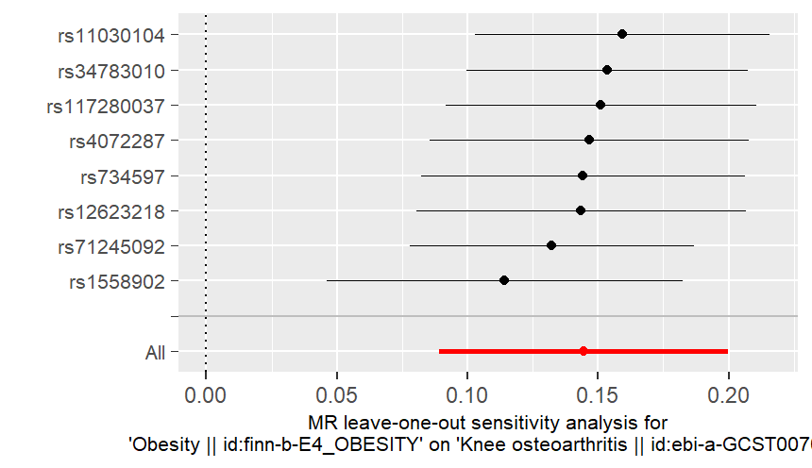

Figure S2:
Plots of “leave-one-out” analyses for MR analyses of the causal effect of smoking on KOA

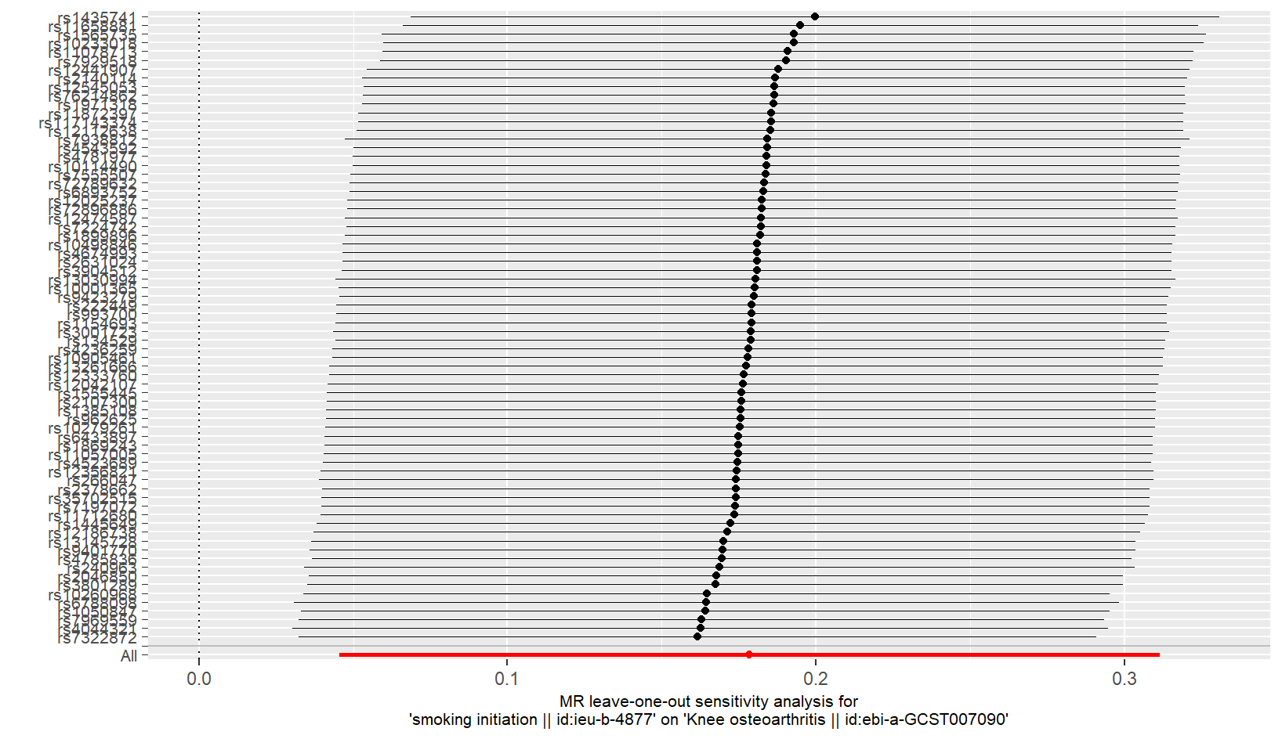

Figure S3:
Plots of “leave-one-out” analyses for MR analyses of the causal effect of alcohol drinking on KOA
