Supporting information

Electrospun Polyacrylonitrile/cellulose nanofibers supported gold nanoparticles for liquid-phase aerobic oxidation of benzyl alcohol to benzaldehyde

Table of Contents
Fig. S1. SEM images and diameter distributions of the PC nanofibers (a) PC_0-1; (b) PC_1-3; (c) PC_1-1; (d) PC_3-1; (e) PC_0-1 at voltage of 20kV.
Fig. S2. TGA and Heat flow profiles under oxygen (red line) and nitrogen (black line) atmosphere of the PC_31 nanofibers.
Fig. S3. Conversion of BzOH obtained with the different AuNPs-nanofibers.
Fig. S4. AuNPs/PC_31
Fig. S4. Dependence of BzOH conversion on the reaction time over AuNPs/PC_31 with and without filtration of the catalyst.
Table S1. BET measurement results of different samples

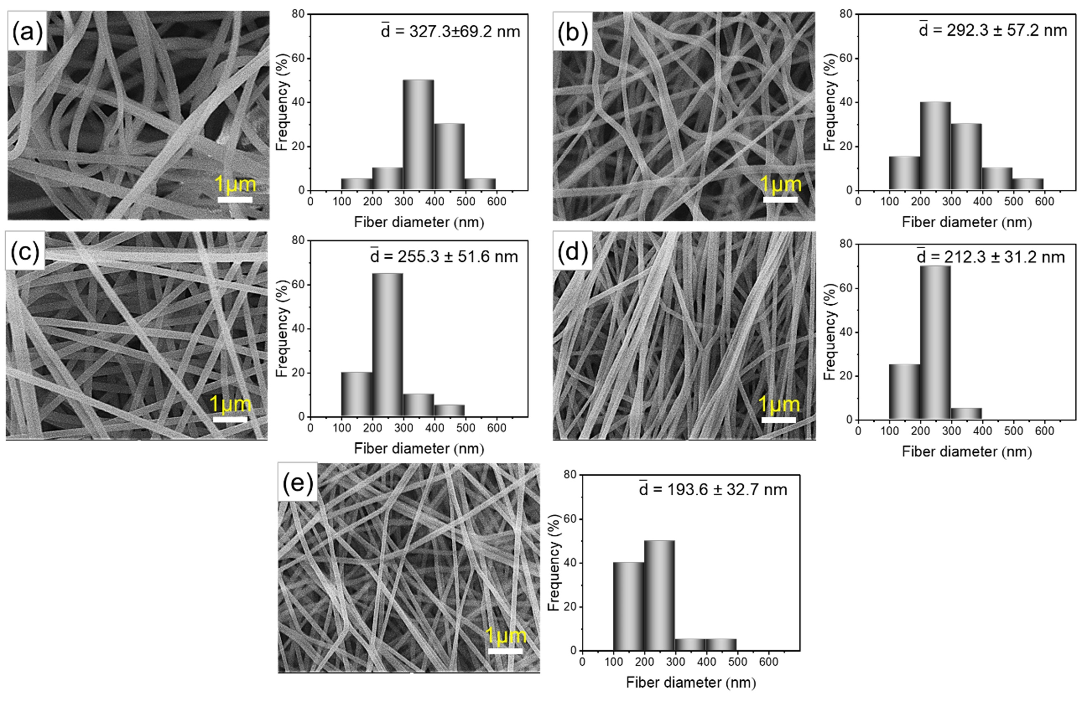
Fig. S1. SEM images and diameter distributions of the PC nanofibers (a) PC_0-1; (b) PC_1-3; (c) PC_1-1; (d) PC_3-1; (e) PC_0-1 at voltage of 20kV.

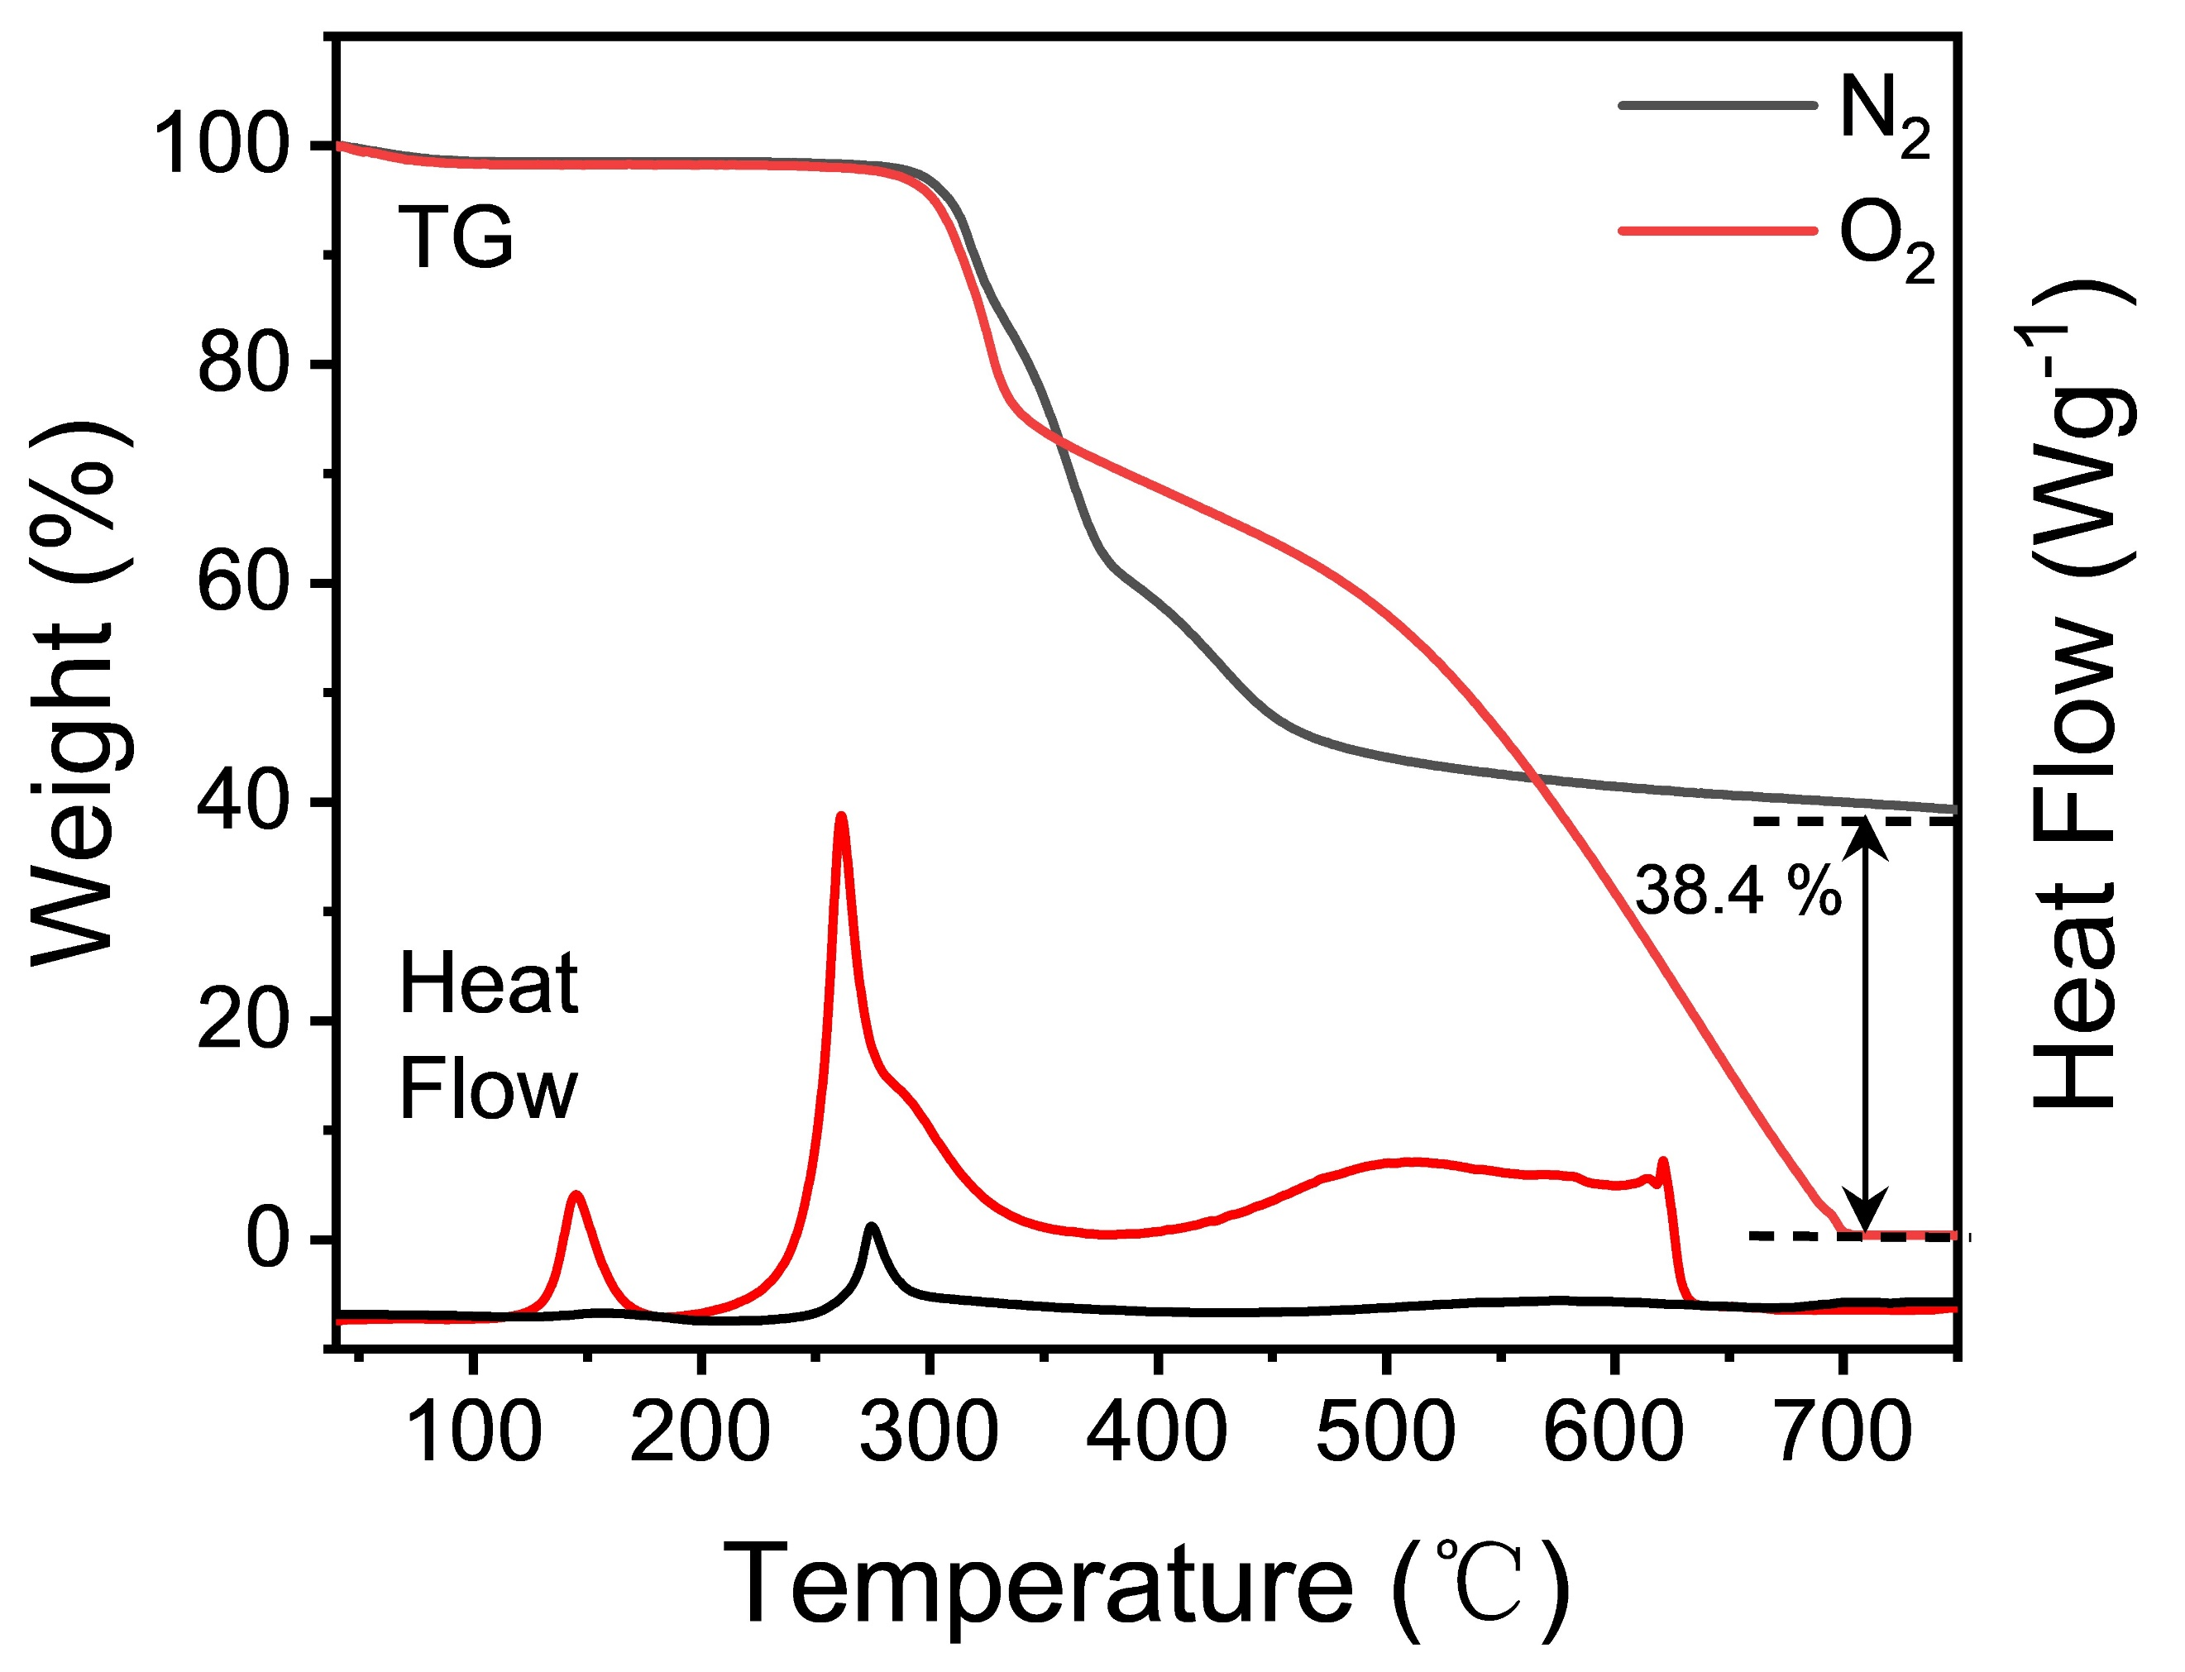
Fig. S2. TGA and Heat flow profiles under oxygen (red line) and nitrogen (black line) atmosphere of the PC_31 nanofibers

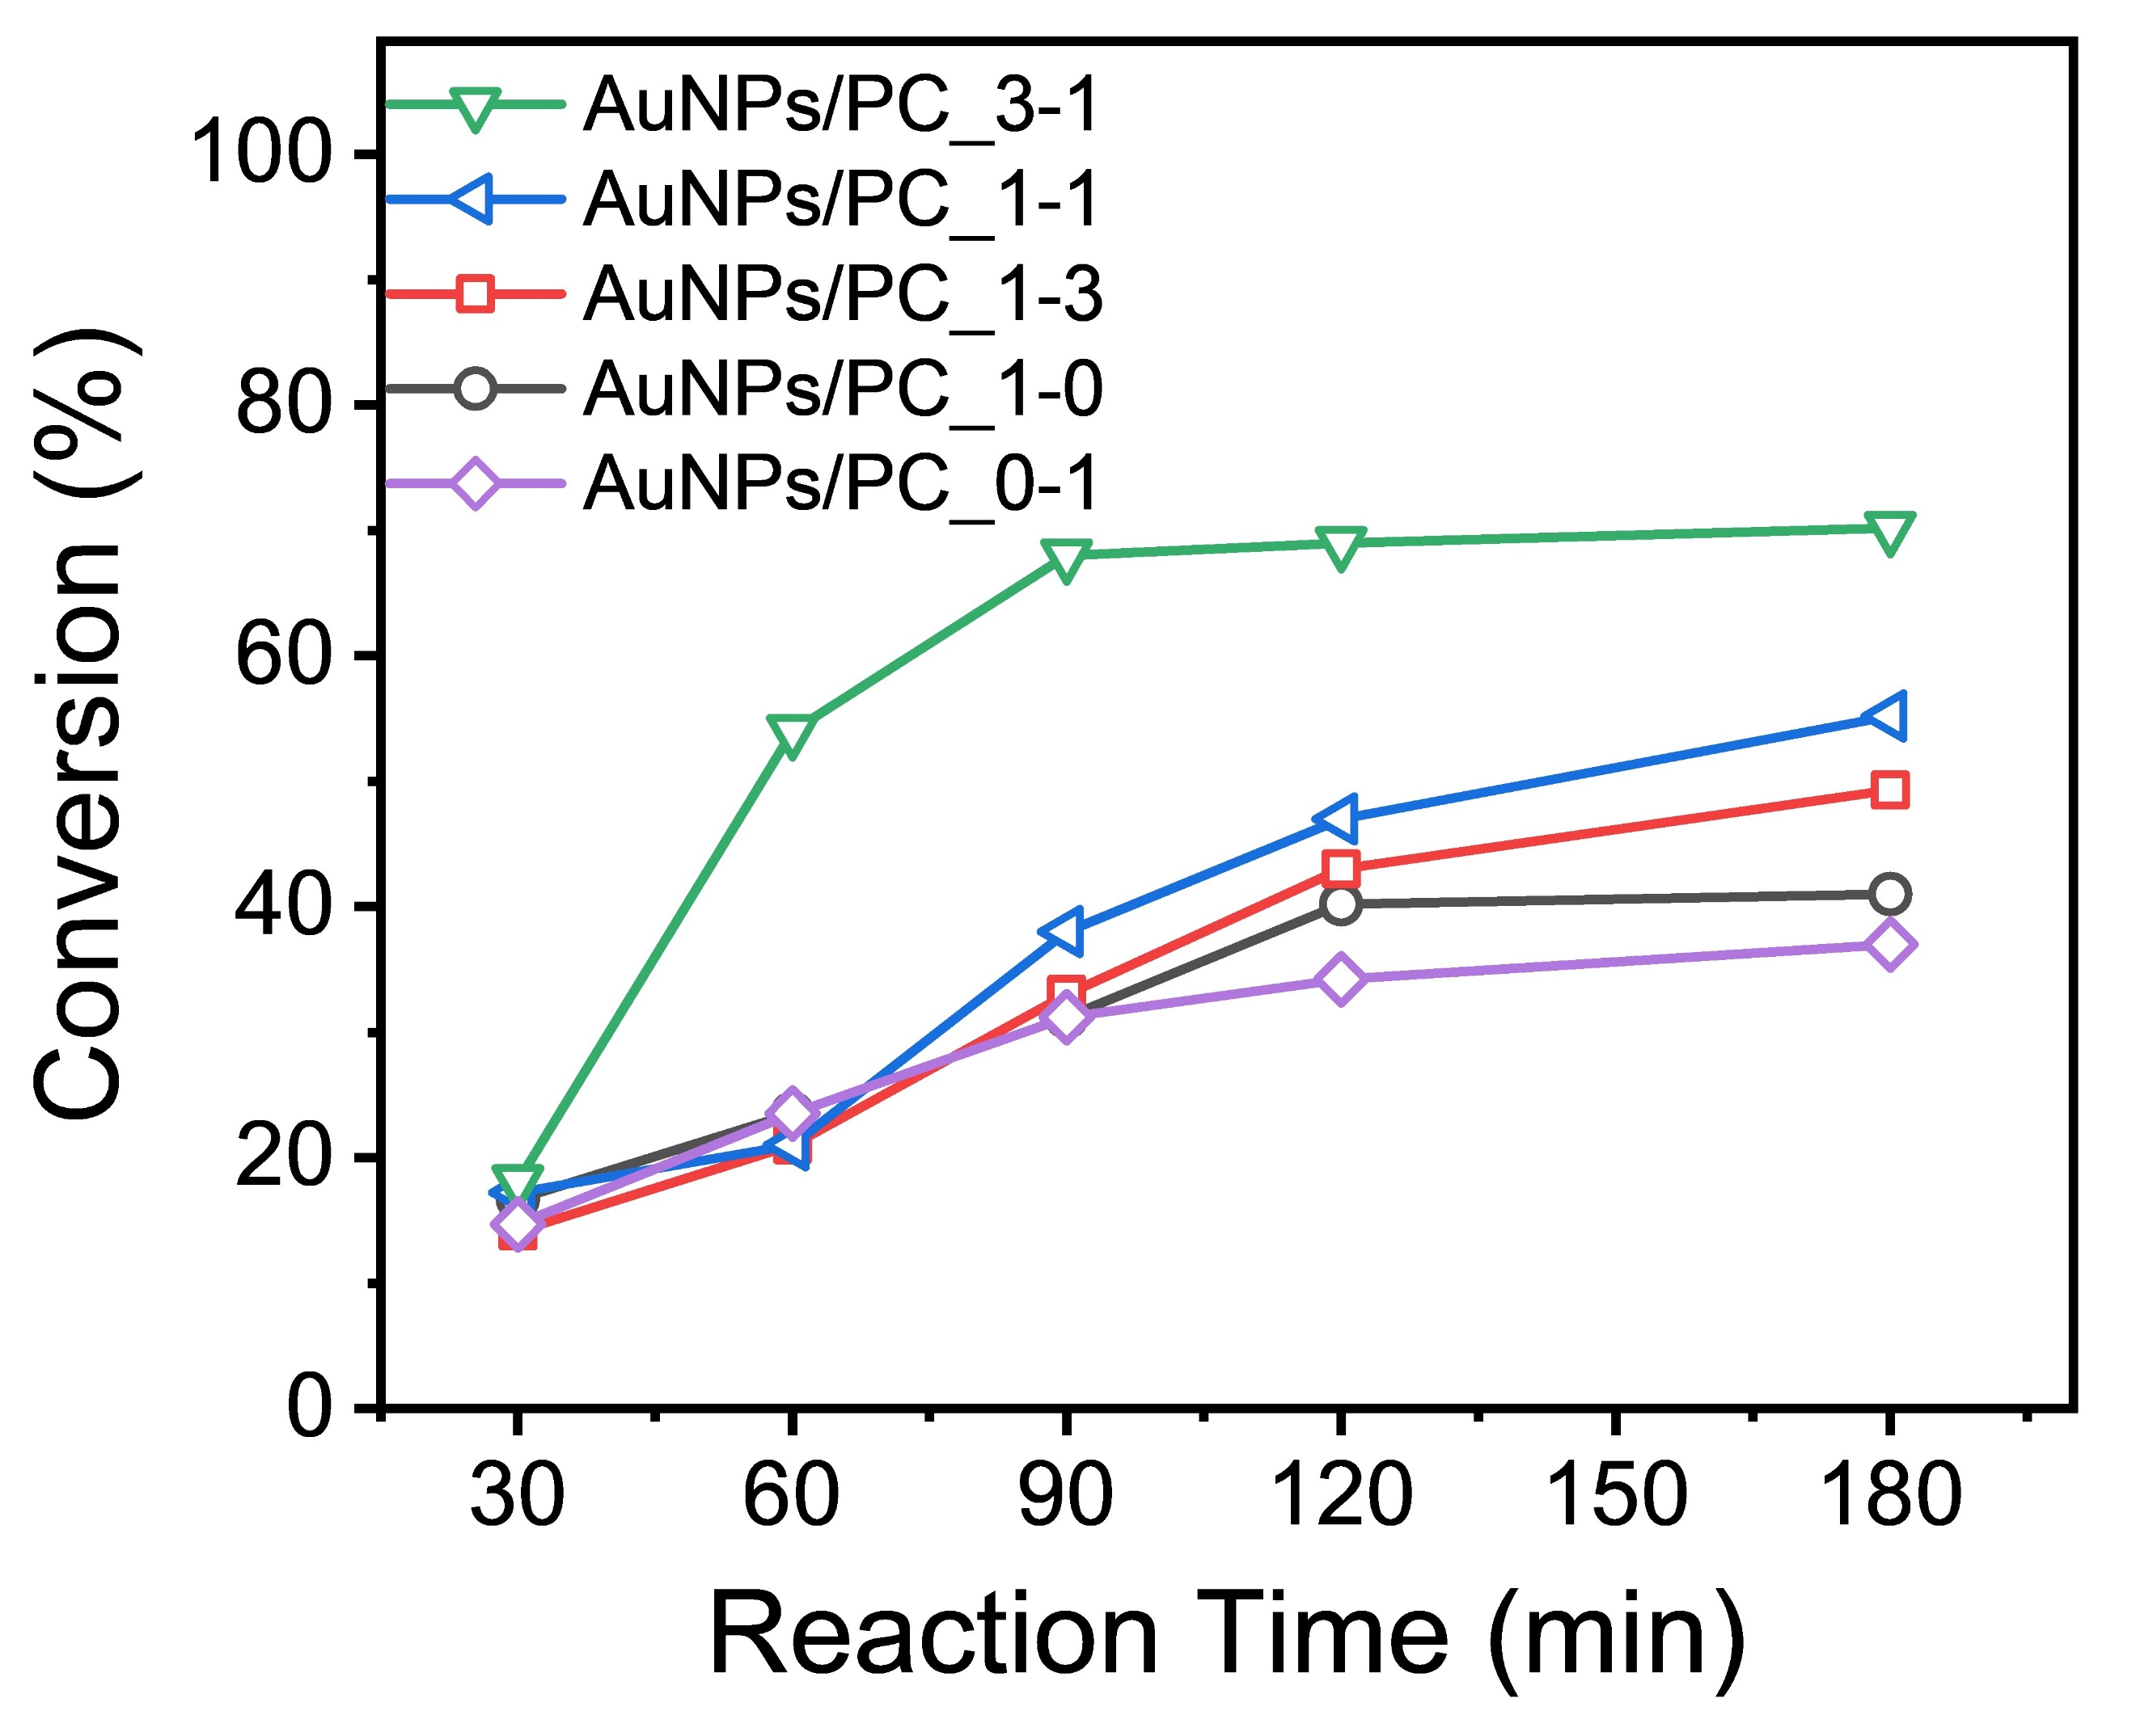
Fig. S3. Conversion of BzOH obtained with the different AuNPs-nanofibers.

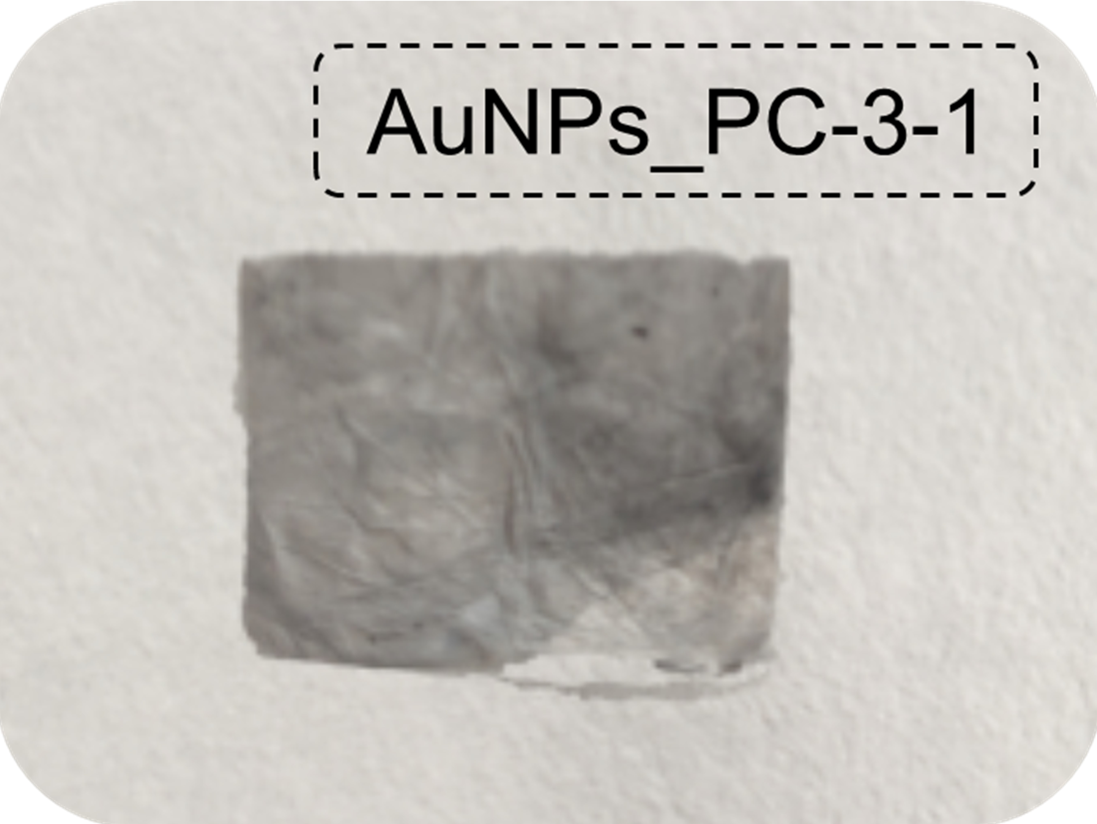
Fig. S4. The photo of the catalyst AuNPs_PC-3-1 (fresh)

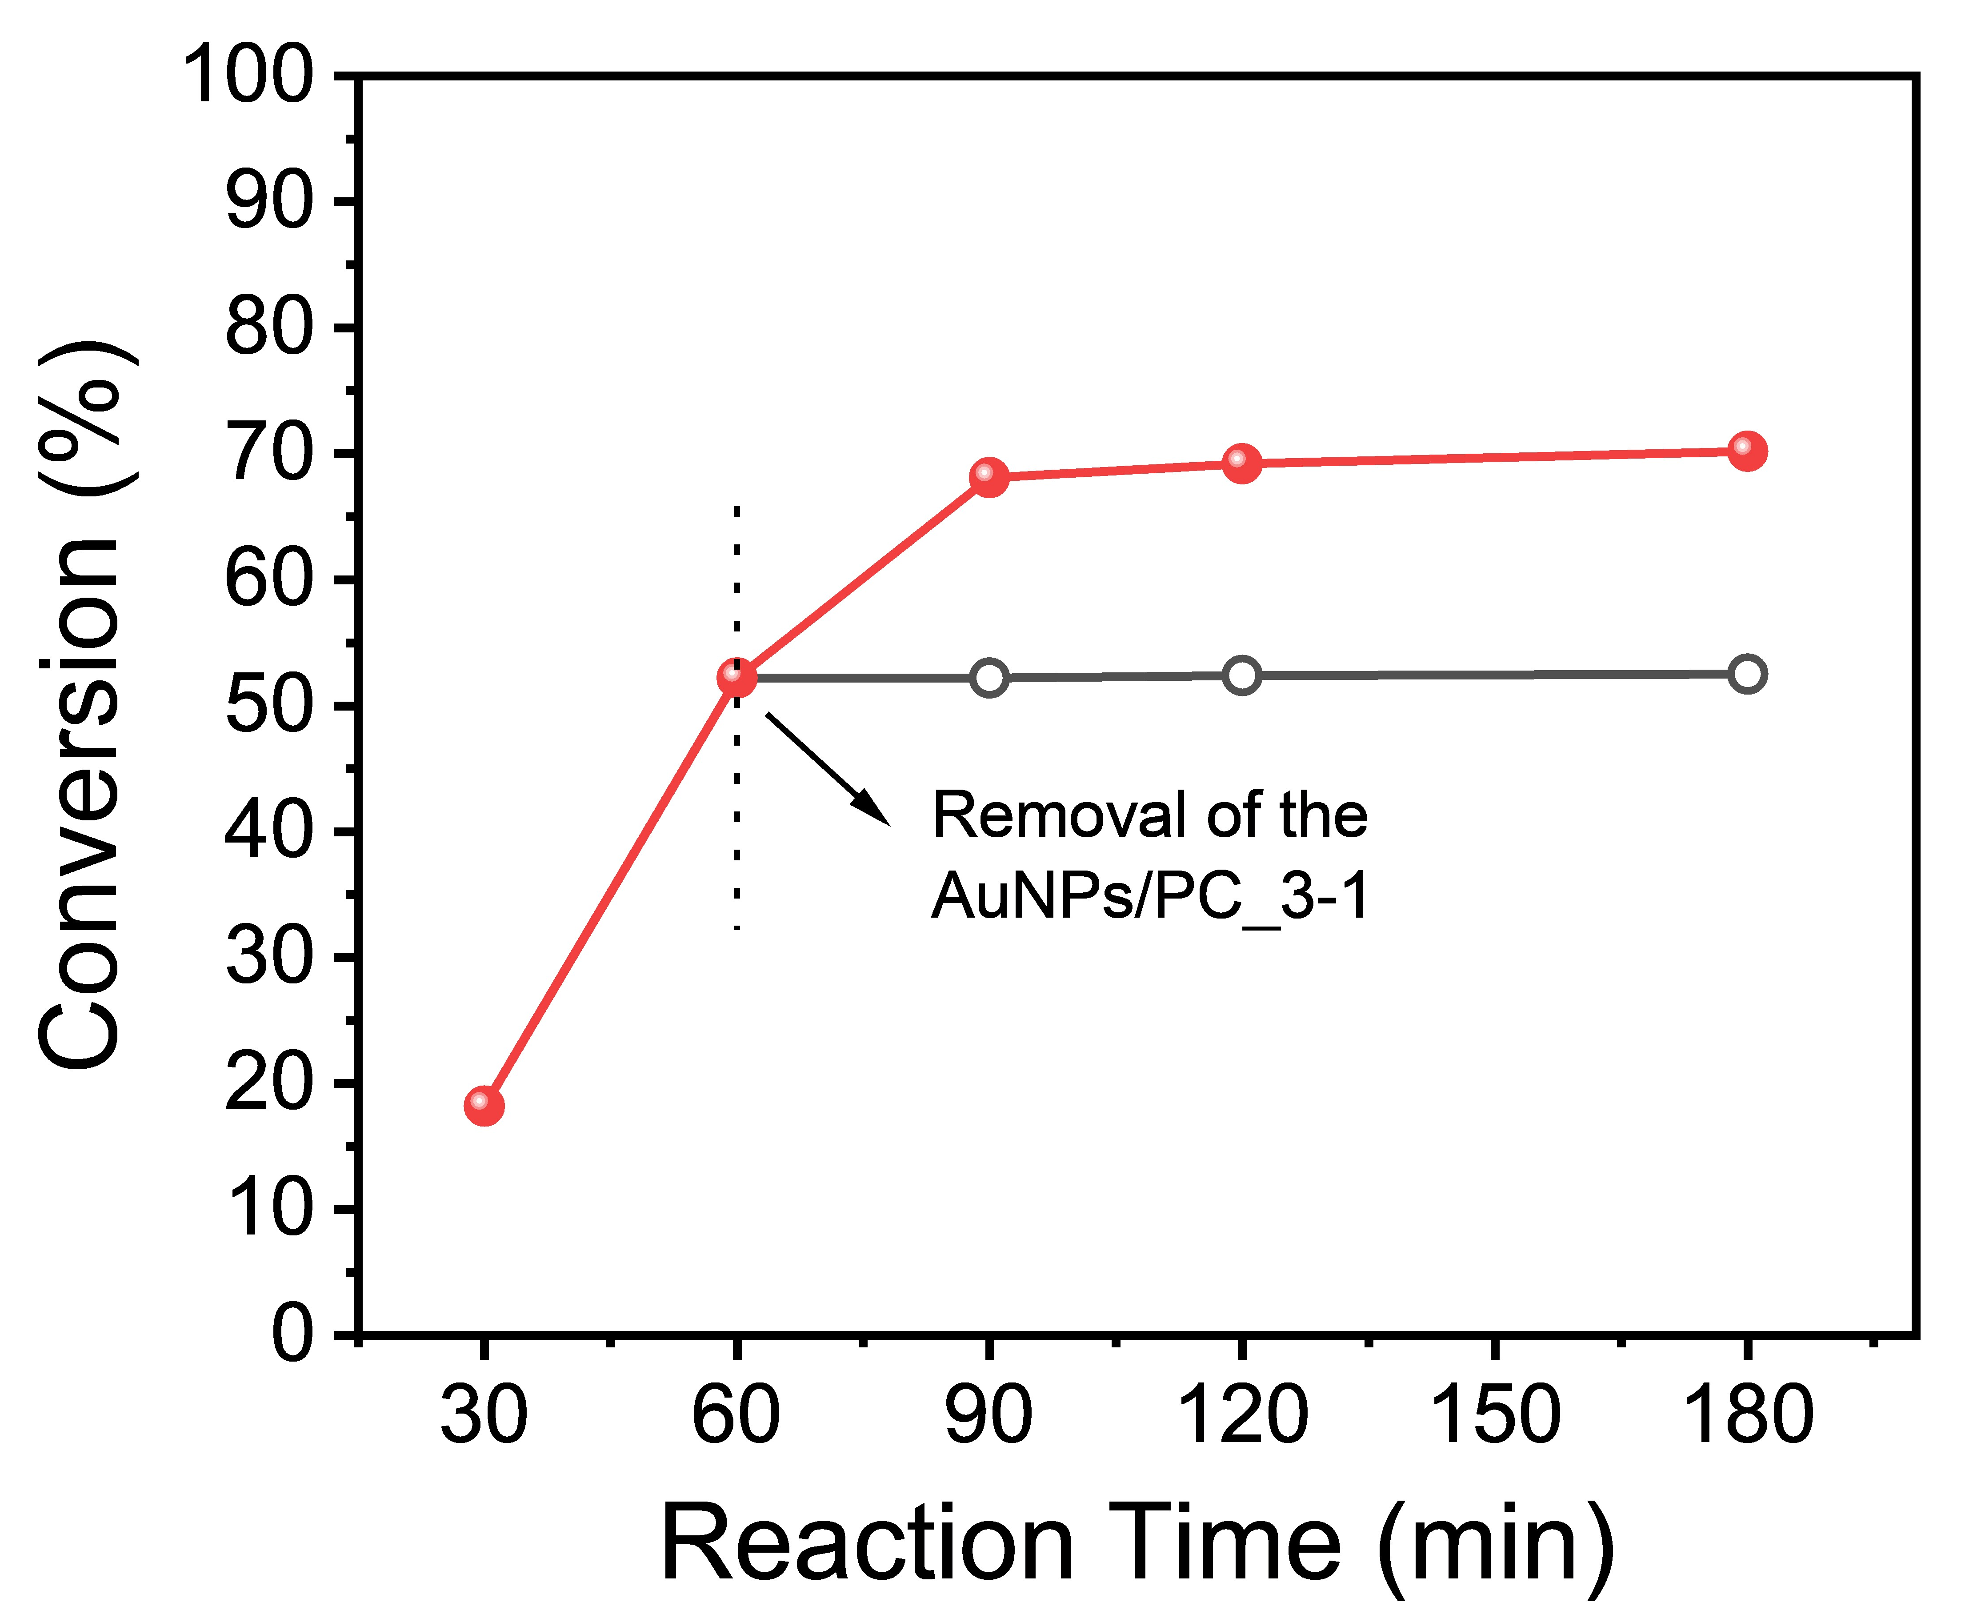
Fig. S5. Dependence of BzOH conversion on the reaction time over AuNPs/PC_31 with and without filtration of the catalyst.

Table S1. BET measurement results of different samples
Catalyst | Surface area (m²/g) |  | Pore width (nm)
PC₋10 | 16.3 | 11.47
PC₋11 | 37.5 | 17.31
PC₋31 | 40.1 | 18.15
PC₋13 | 38.1 | 16.54
PC₋01 | 52.3 | 22.31
AuNPs/PC͢͢₋31 | 40.5 | 19.14

