Supplementary Material
Supplementary Figure 1. Quality control and dimensionality reduction of lung adenocarcinoma data. (A and G) The number of detectable genes, transcripts, and the proportion of mitochondrial genes per cell in the sample. (B and H) Volcano plots of genes with unstable expression in cells identified by differential analysis. The red dots represent the 1500 highly variable genes, and the black dots represent genes with relatively stable expression. (C and I) Correlation analysis between the number of genes in cells and the depth of probing. The Pearson correlation coefficients were 0.9 and 0.91, respectively. (D and J) PCA dimensionality reduction results show that PCA does not separate cells well. (E and K) Gravel plots of PC number versus standard deviation. As PC increases, the standard deviation no longer decreases or decreases by a small margin, implying that subsequent PCs do not contribute much to the results. In this article we have selected the top 14 PCs for further analysis. (F and L) The first 14 PCs were well separated into cell clusters after t-SNE dimensionality reduction.

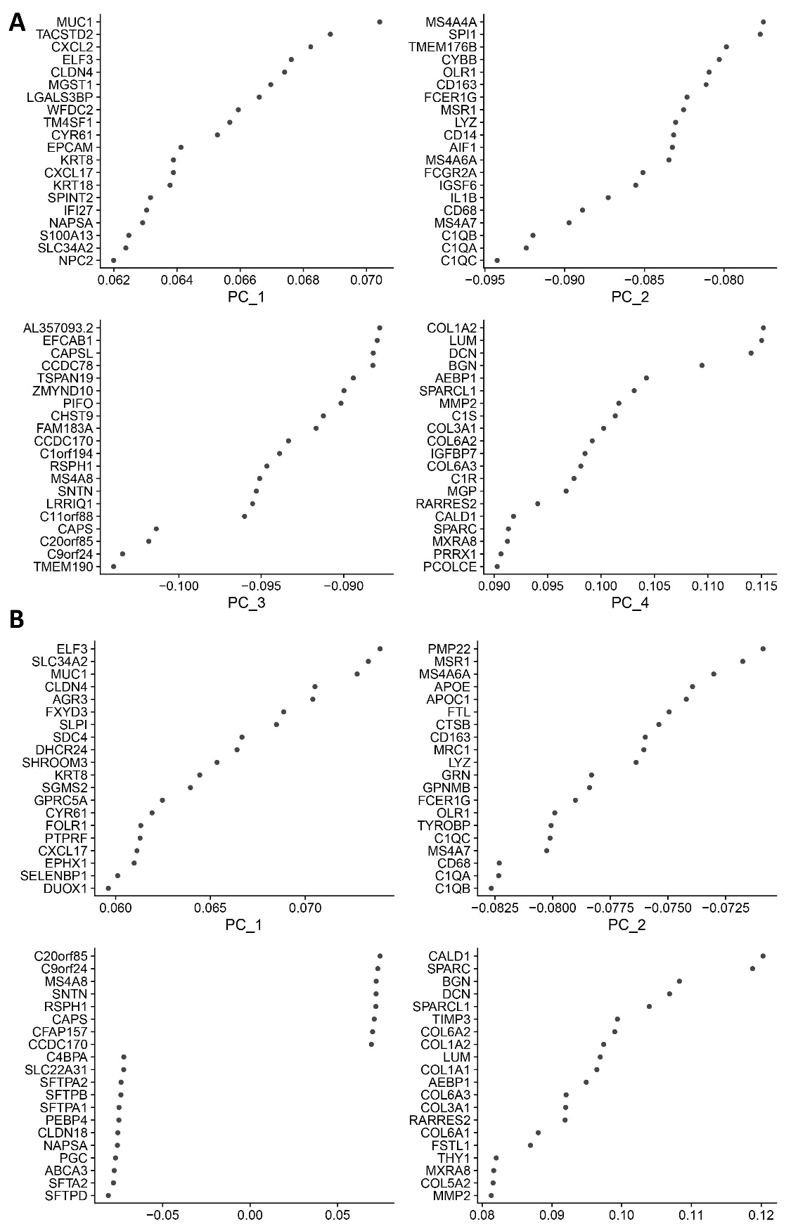
Supplementary Figure 2. Representative genes in PC1 to PC4. The dot plots show the top 20 representative genes in each PC.
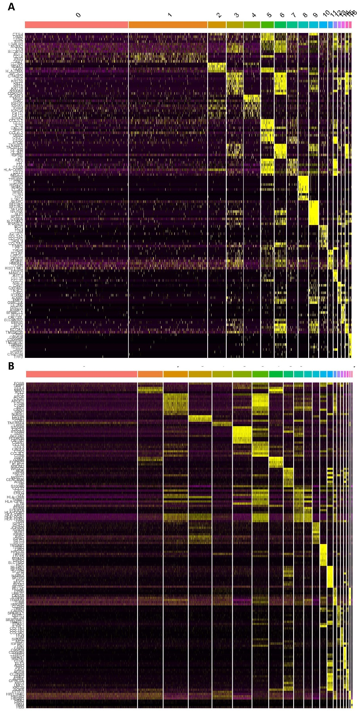
Supplementary Figure 3. Heat map of the expression of marker genes in each clusters. Yellow represented high expression and purple represents low expression.

