Tab. 1 Lotus element design simplification and integration
1 | The shape of the flower bud | 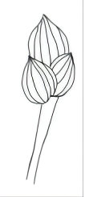
2 | The shape of the lotus in full bloom | 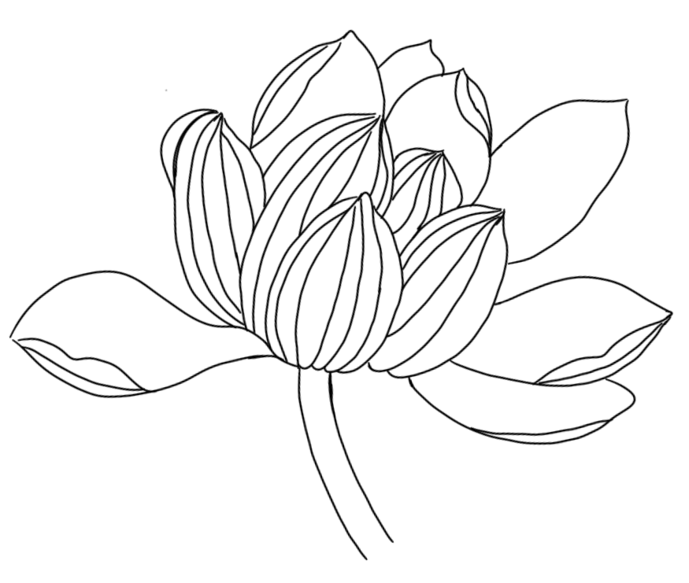
3 | Lotus leaf shape | 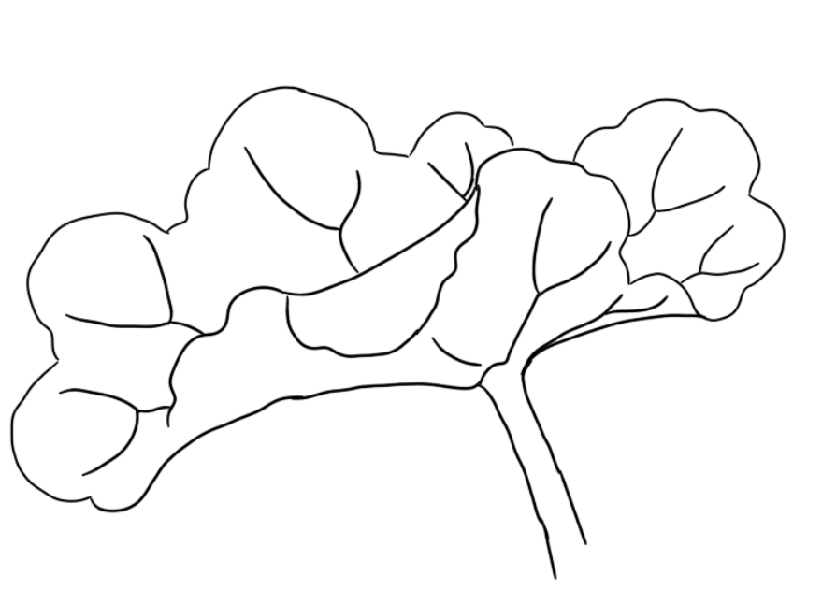
4 | Mixed parts of lotus and lotus leaves | 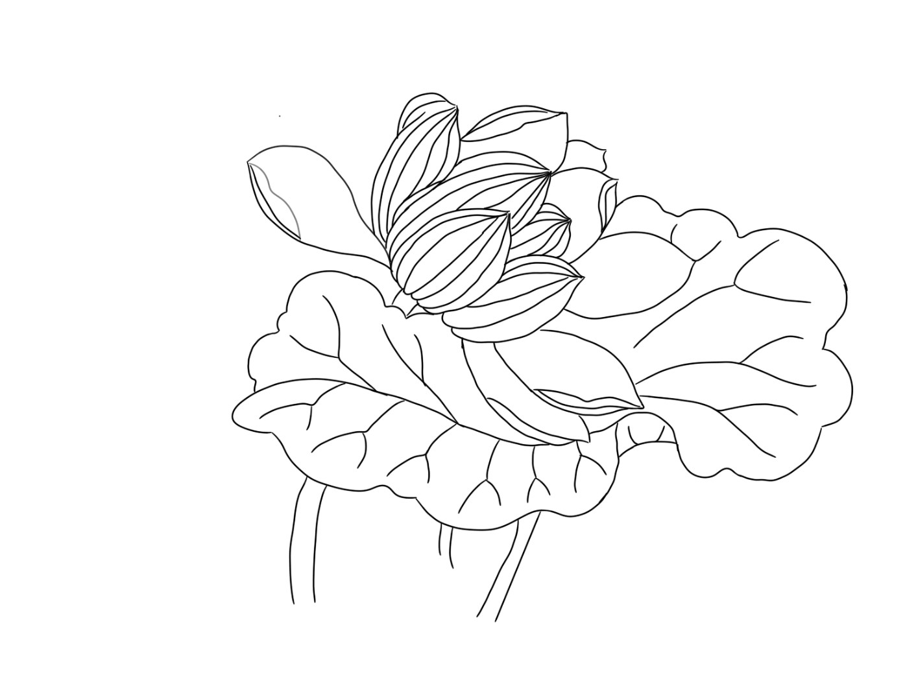

Tab.2 Simplified integration table of flower element design
Time/flower name | feature | picture | simplify | Time/flowe | feature | picture | simplify
1：00  Waxberry flower | Like Silk moth beard, filament is white and anther is kidney-like | 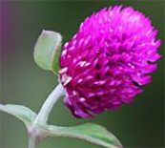 | 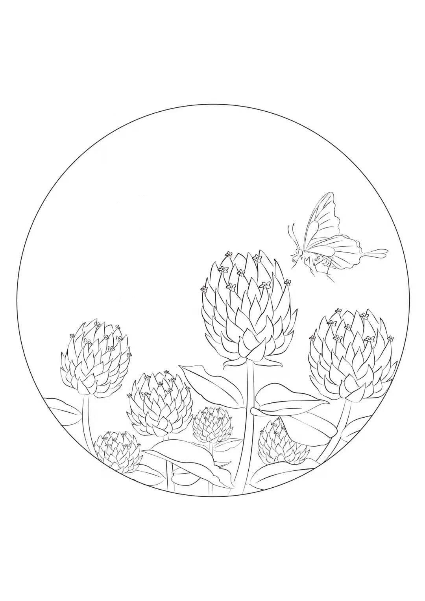 | 2：00  Cnidium monnieri | Umbrella-type flower, white, petal obovate | 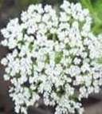 | 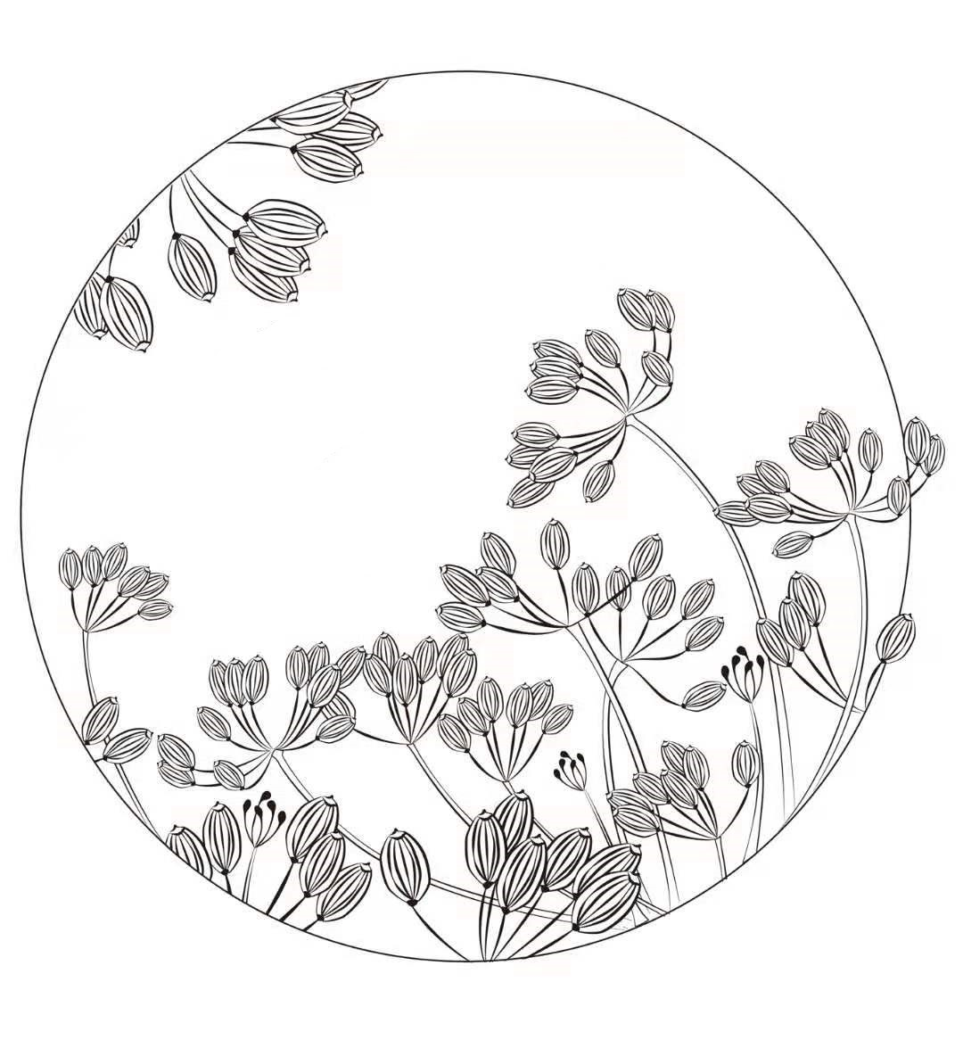
3：00  Hop | Egg palmate，male flower array as panicle, female flower as spike | 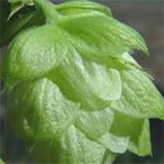 | 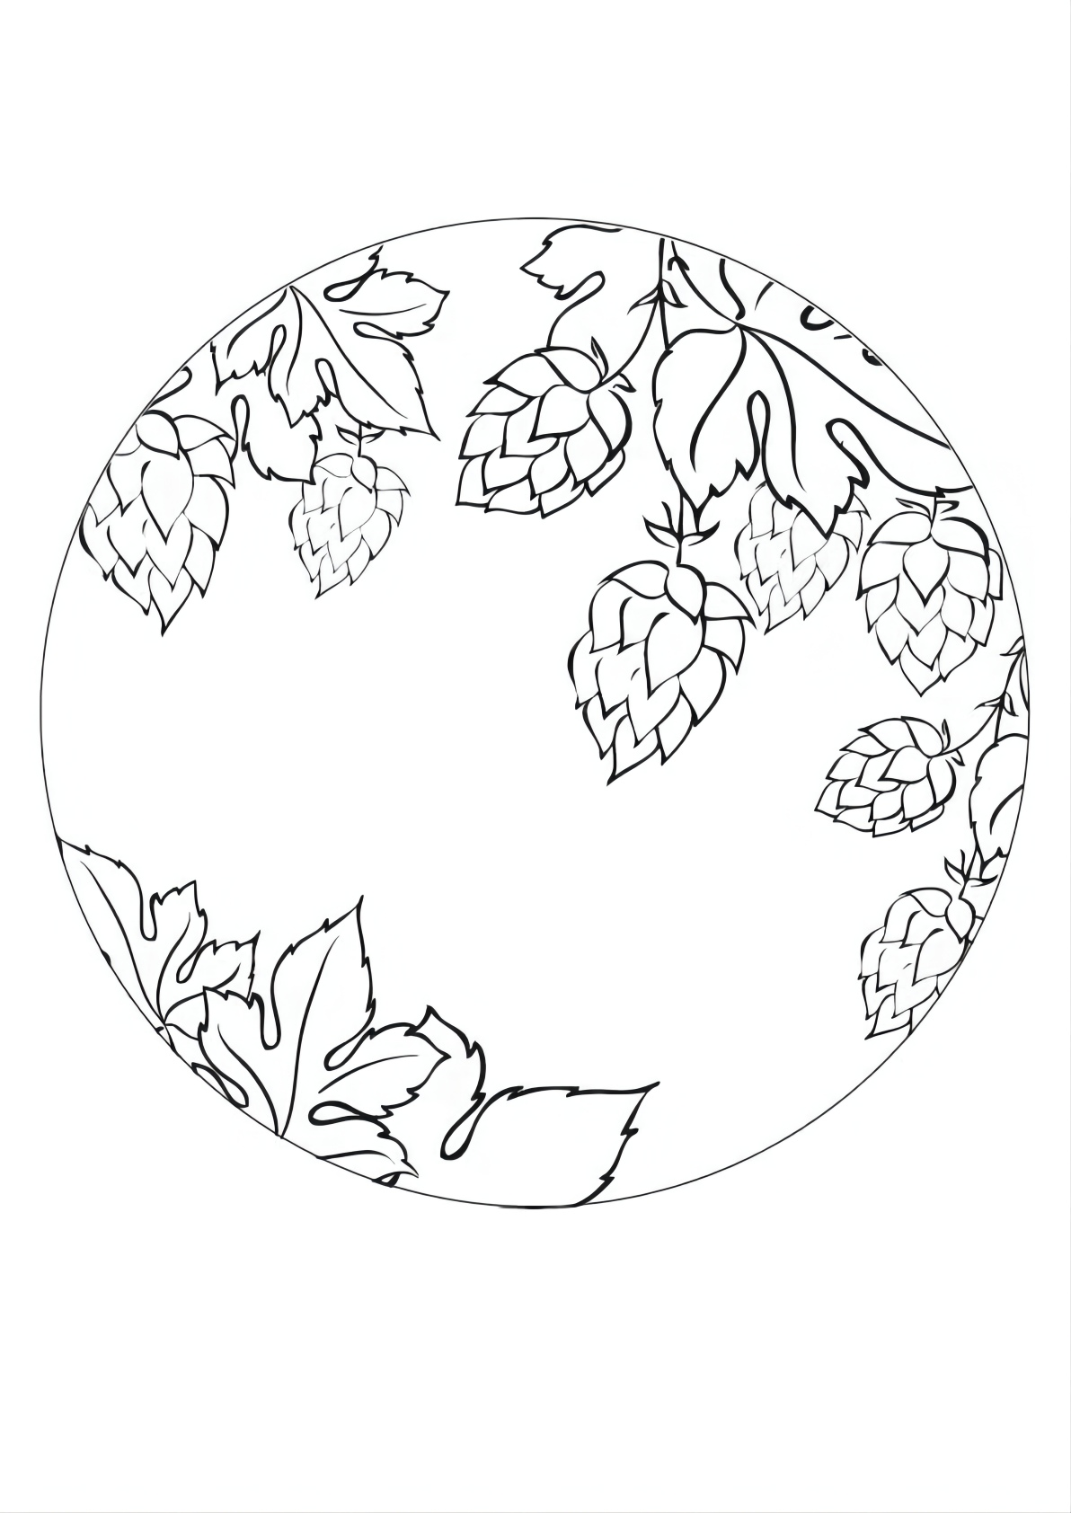 | 4：00  Morning glory | Corolla funnel like,bluish violet, purplish red | 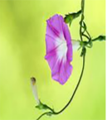 | 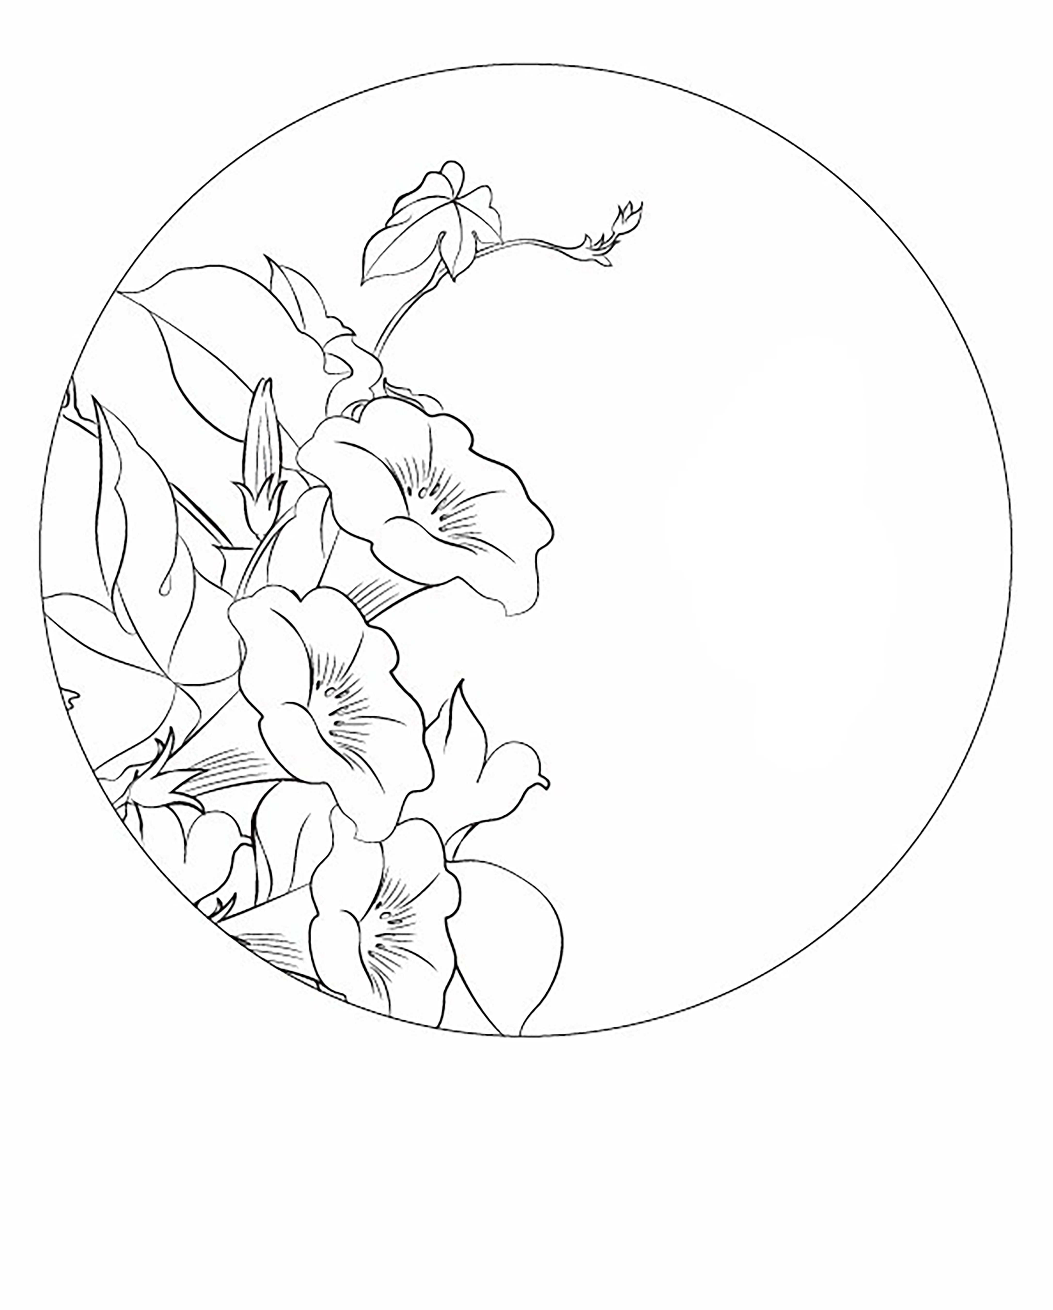
5：00  Wild rose | Corymb conical, stylus stretch, receptacle mouth as columnar | 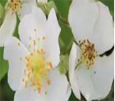 | 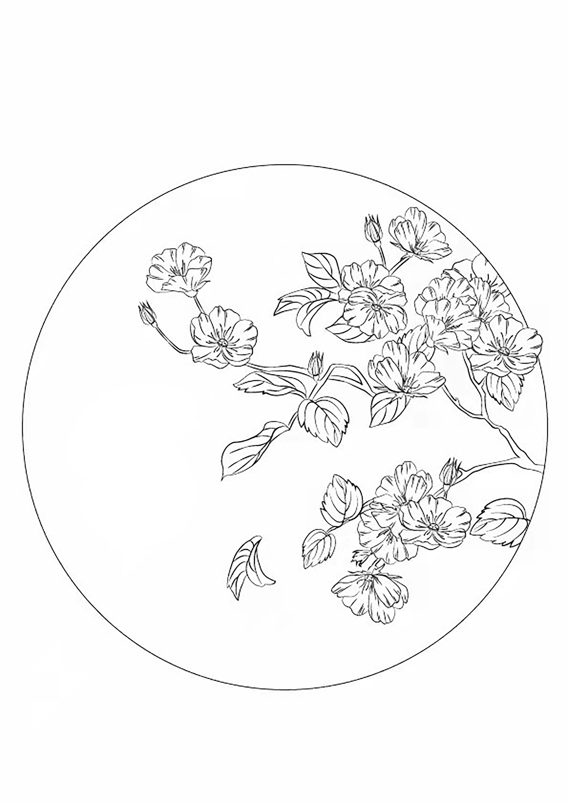 | 6：00  Dragon  sunflower | Scorpion tail inflorescence，shallow cup shape, teeth oval | 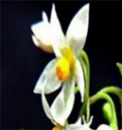 | 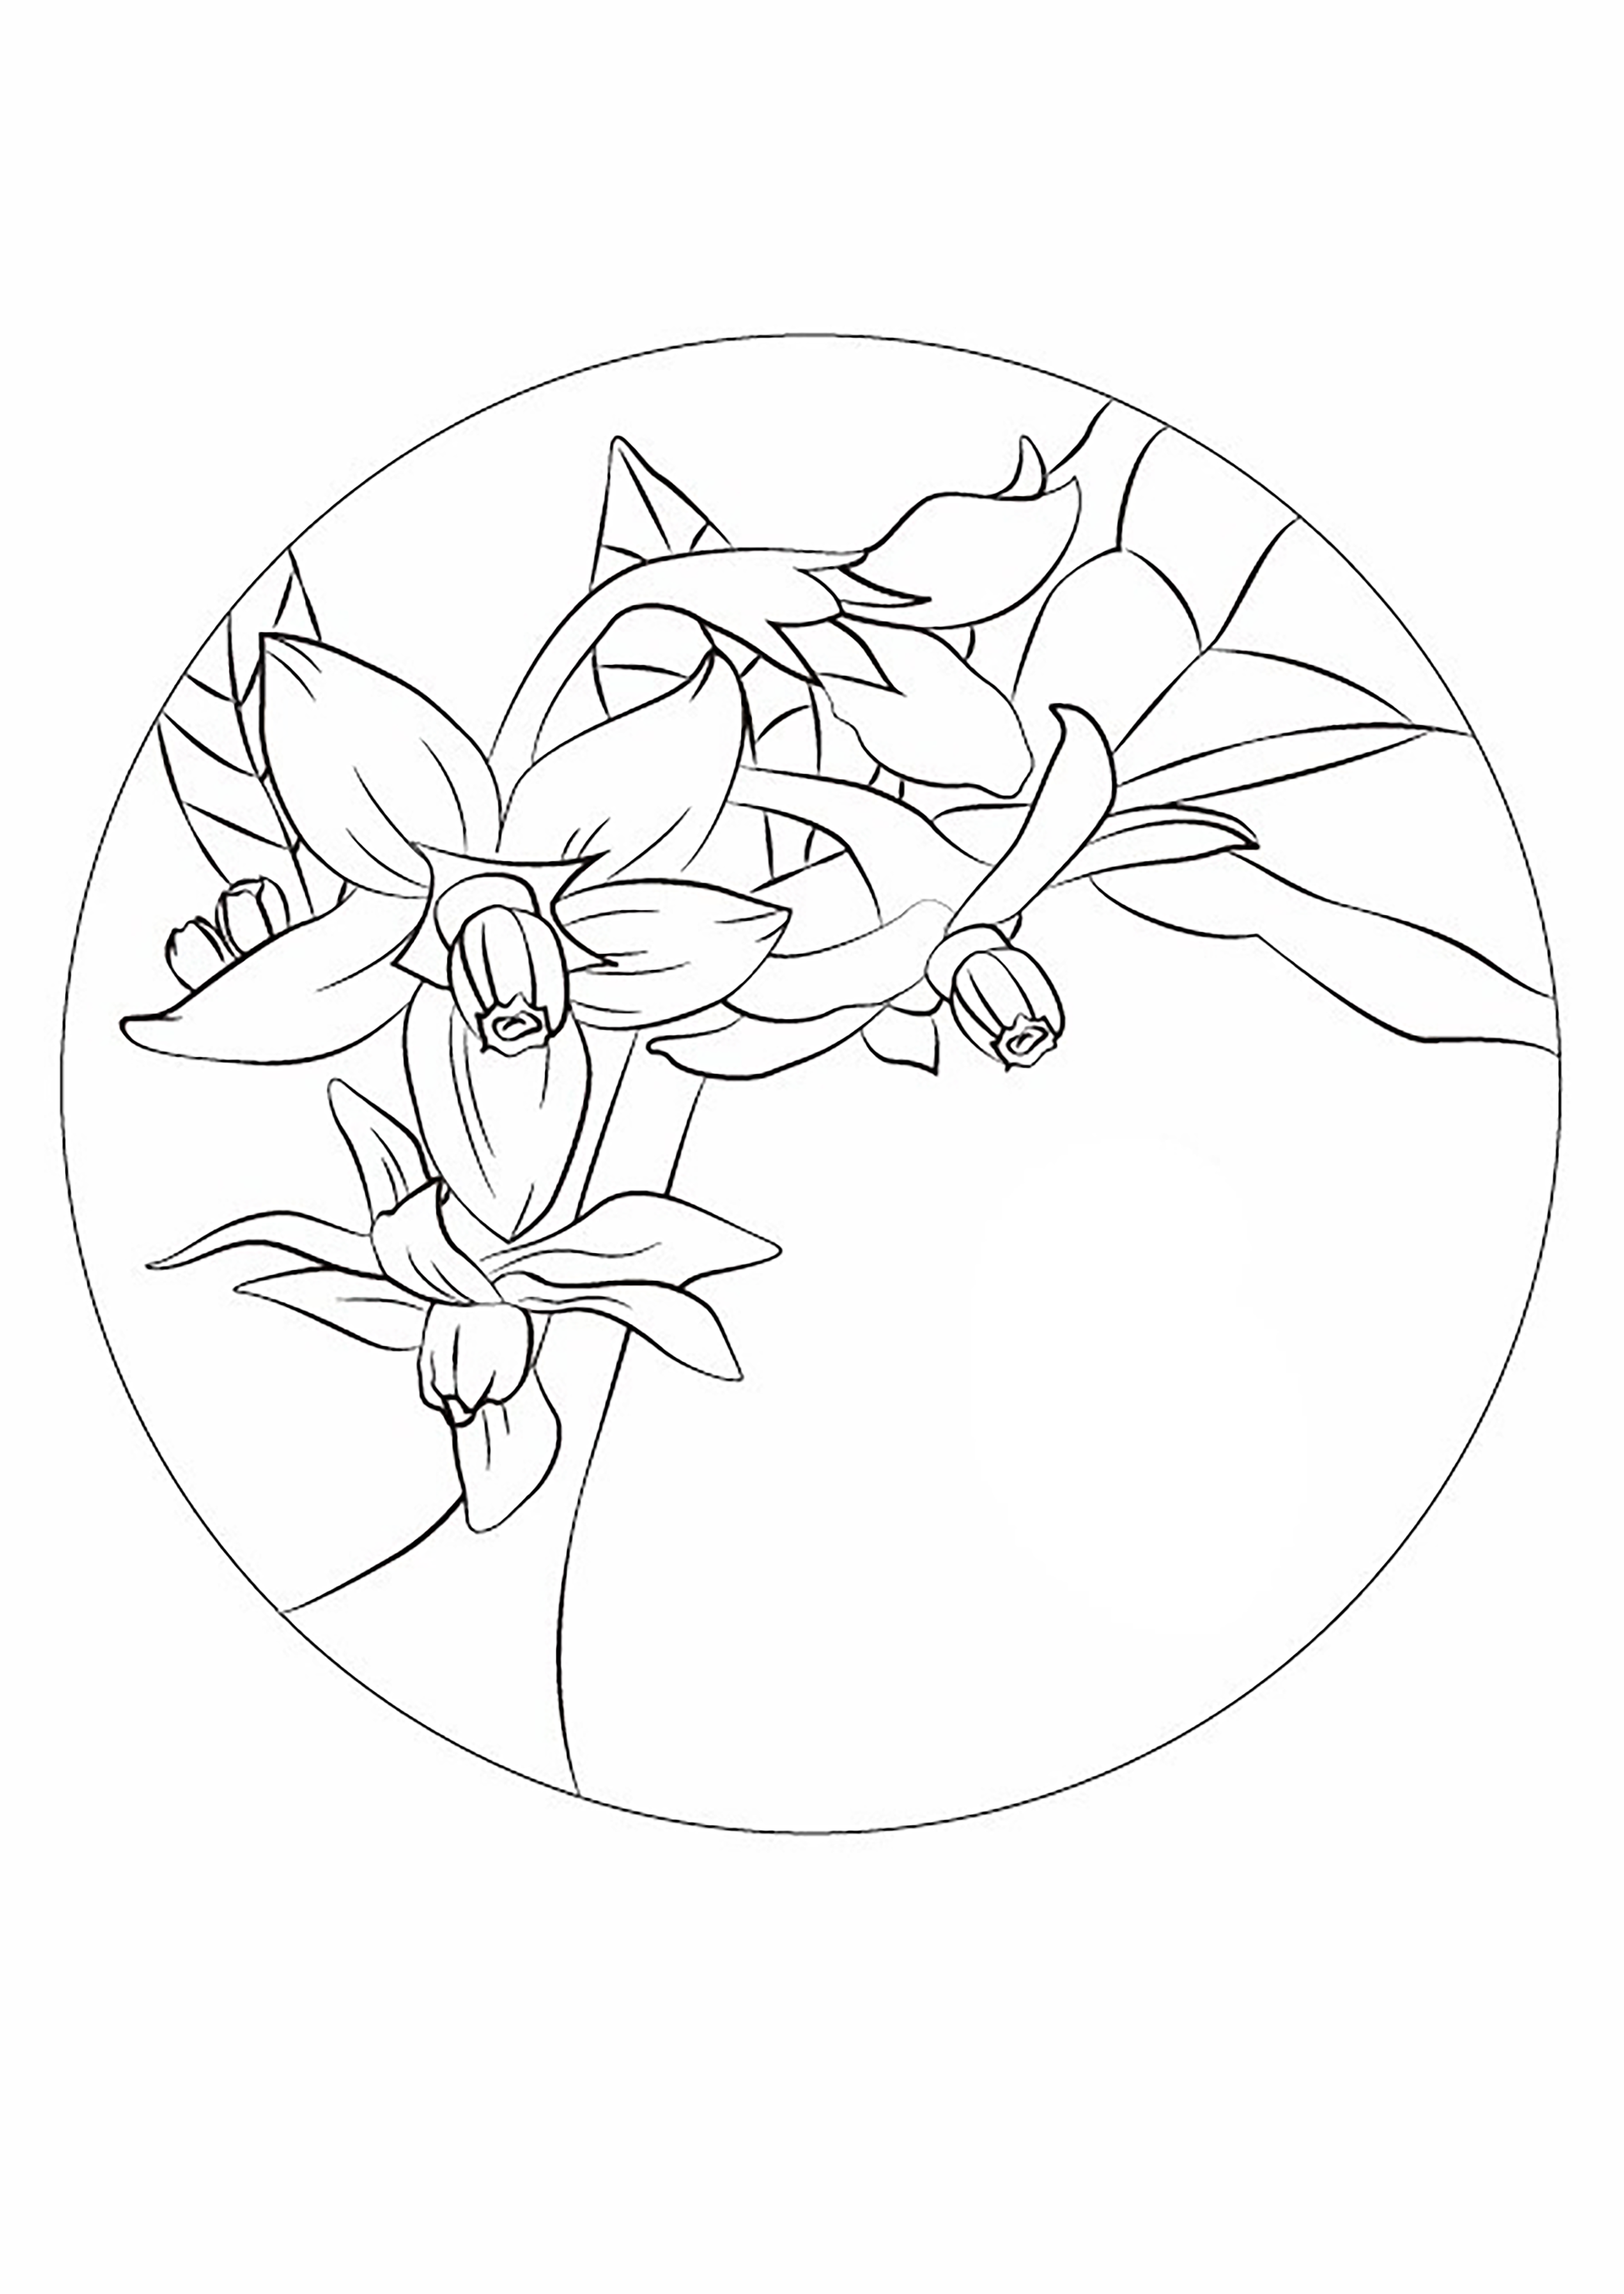
7：00  Peony flower | Petal is obovate, flower disk is shallow cup shape | 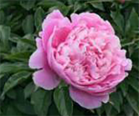 | 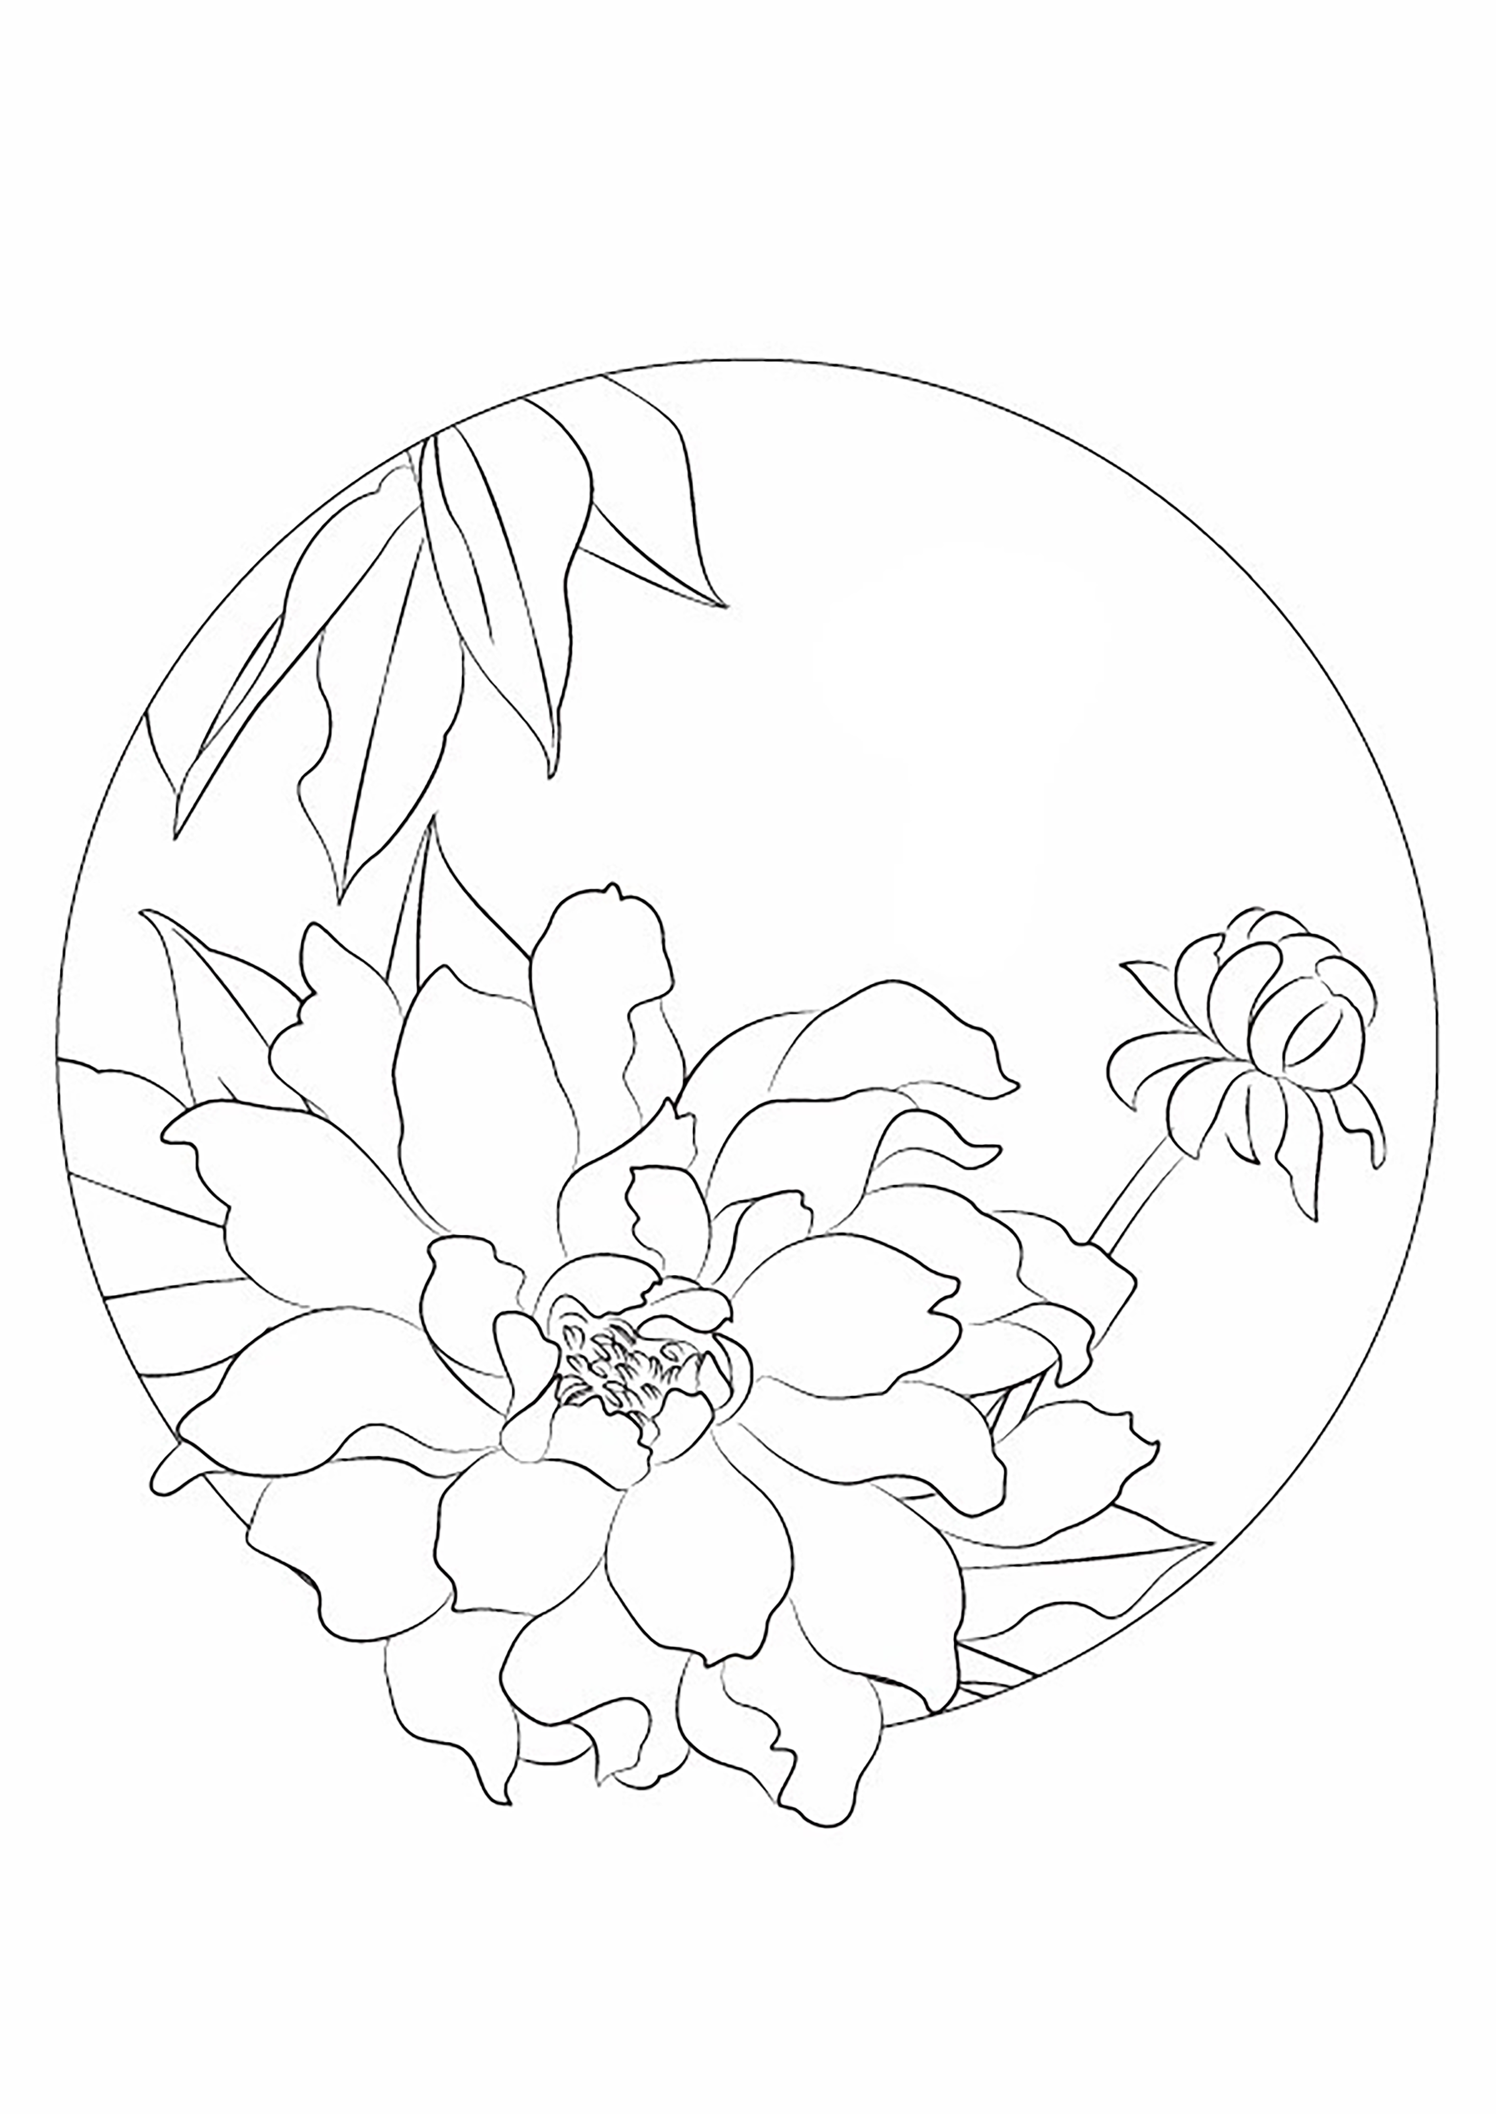 | 8：00  Lotus | Petals are embedded in the receptacle point, leaves are shield round | 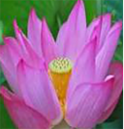 | 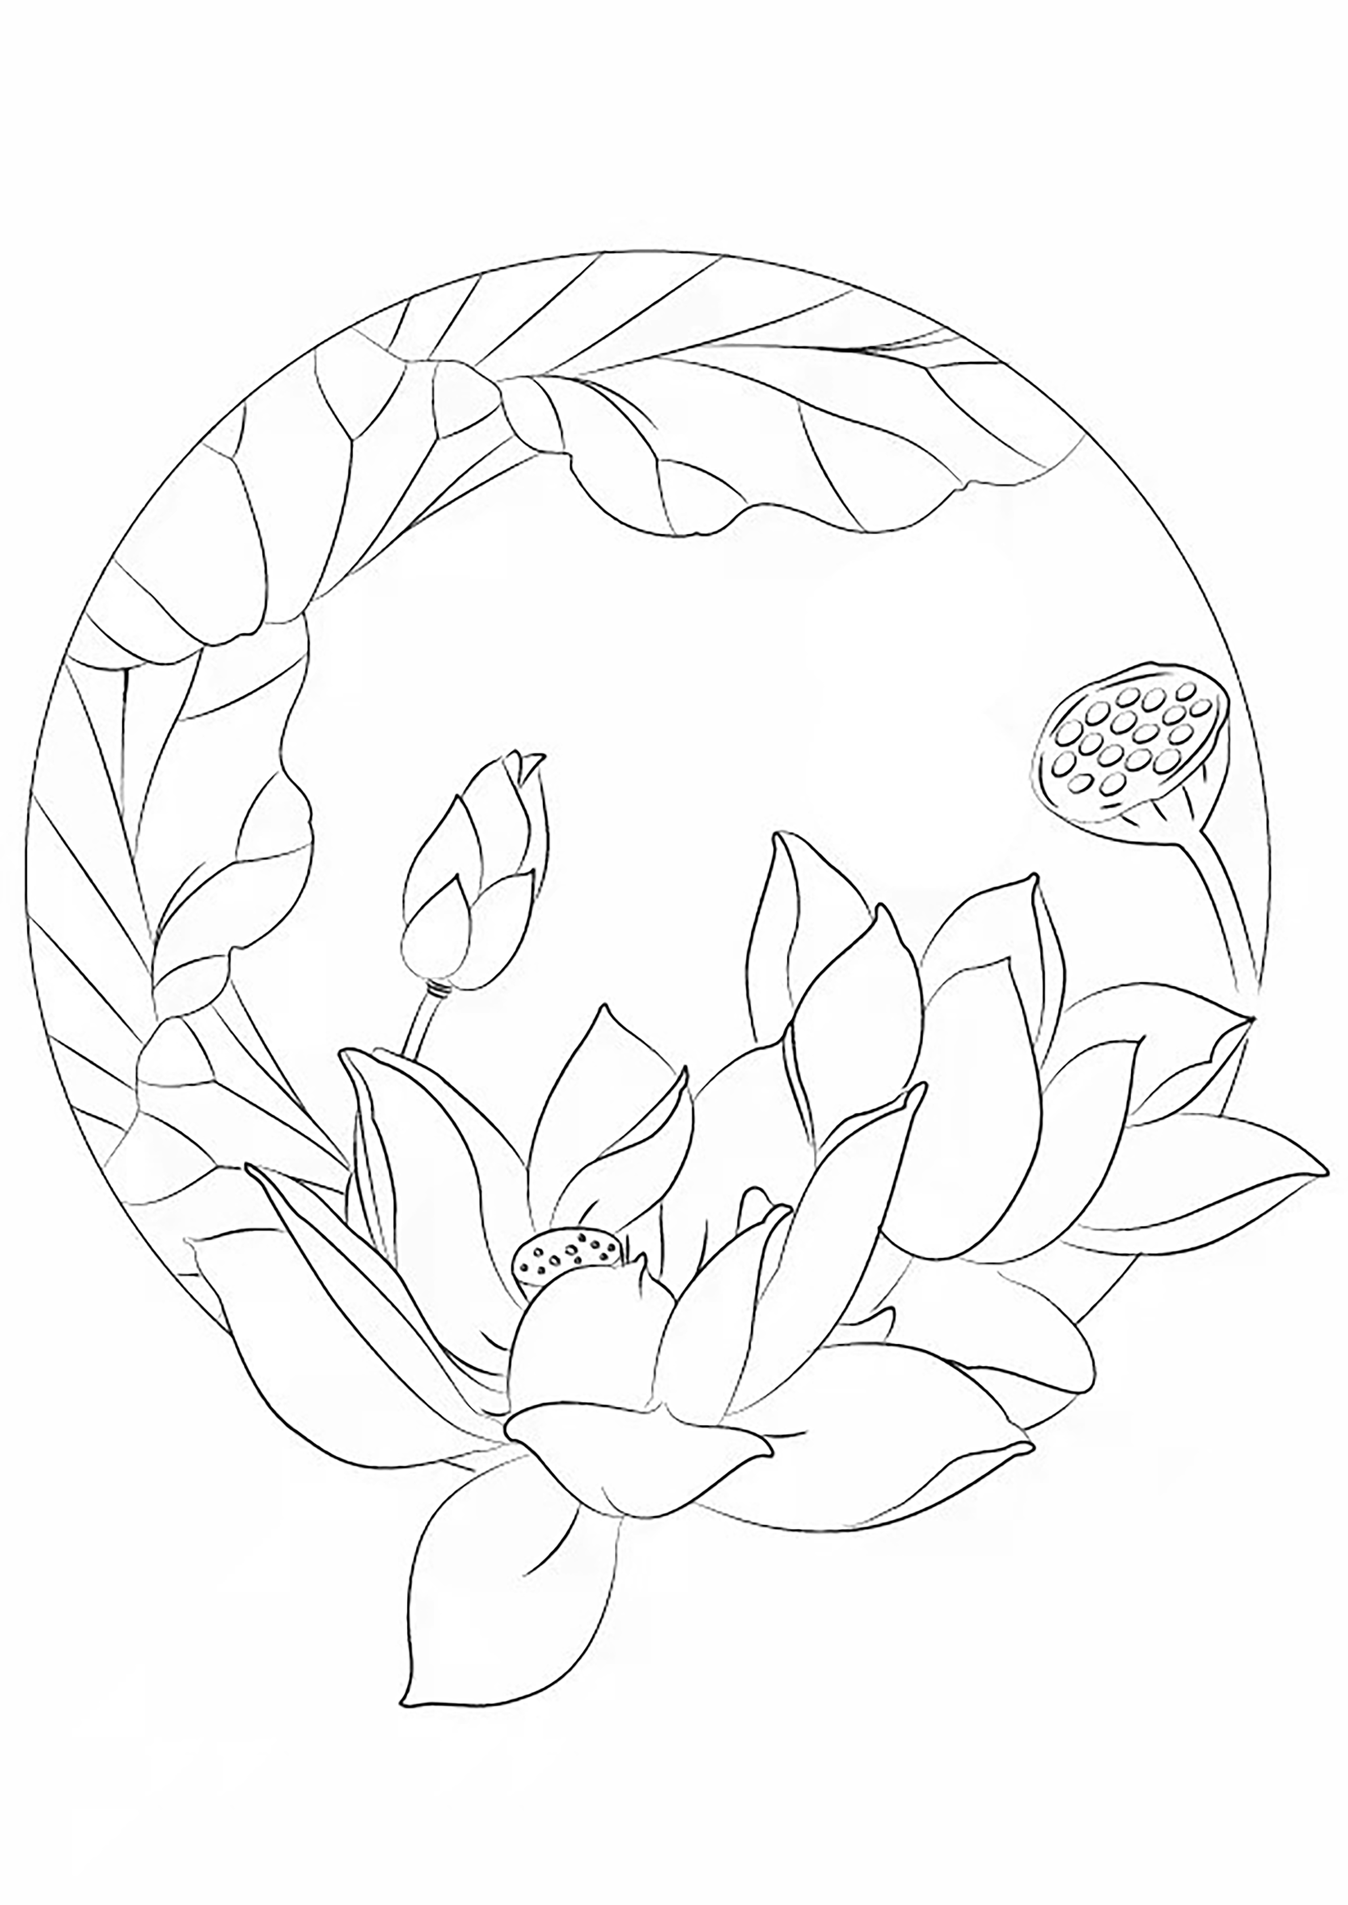
9：00  Prickly cauliflower | Flowers are lavender, like a small hydrangea after blossom | 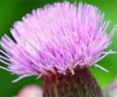 | 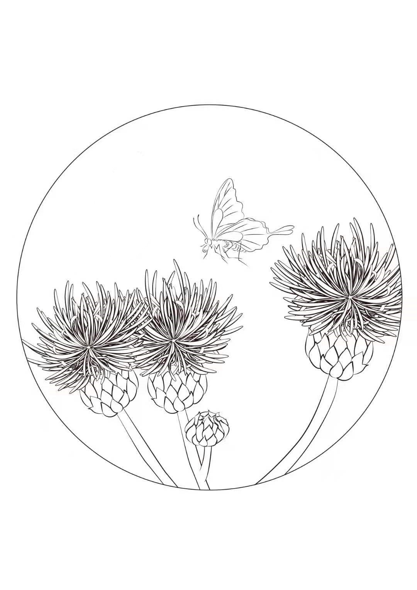 | 10：00  Barbed skullcap | Flower cluster grows on the top of fleshy stem | 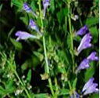 | 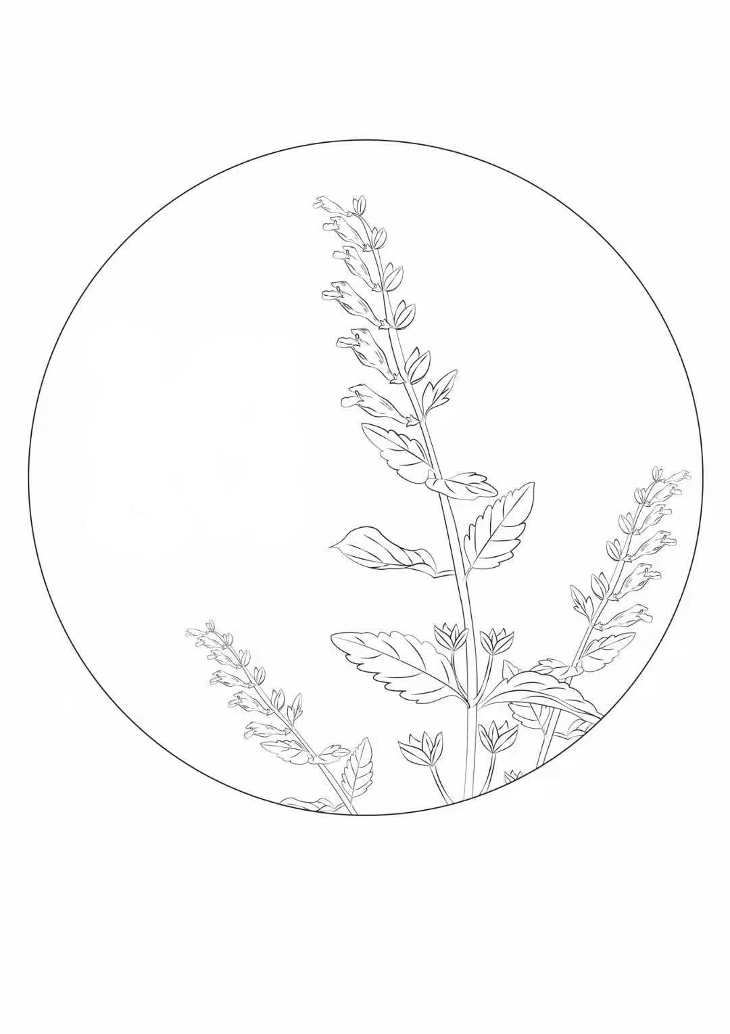
11：00  Big claw grass flower | Flower cyme sparse, sepals ovate, 5 valve cleft | 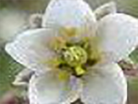 | 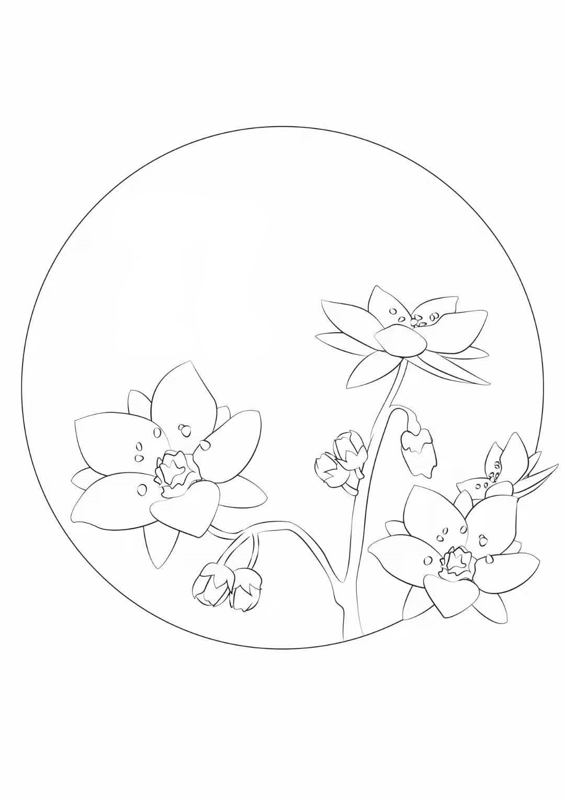 | 12：00  Portulaca grandiflora | Five sepals, lanceolate, covered with stellate pilose and setae on the outside | 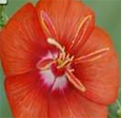 | 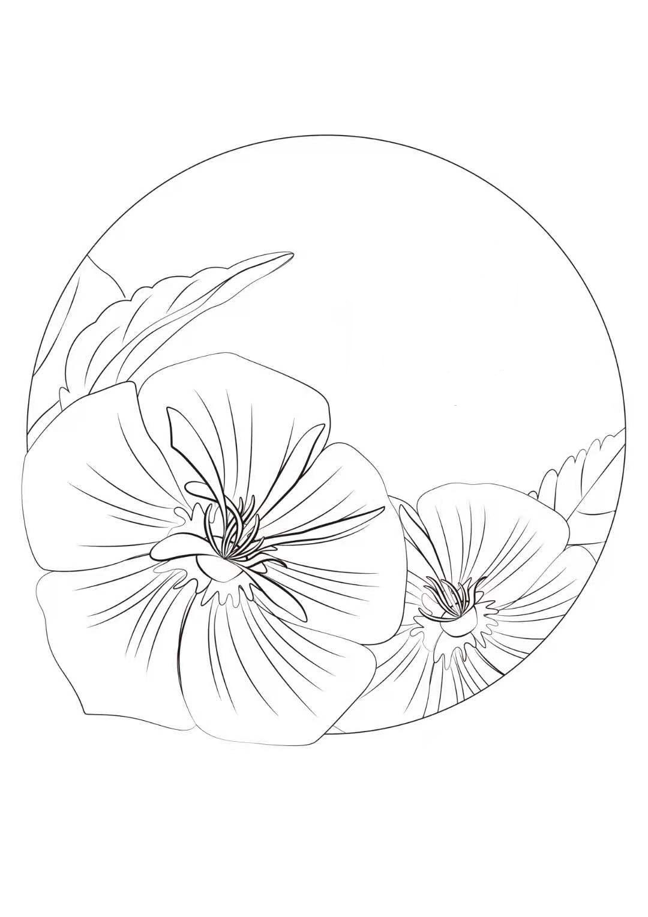
13：00  Sunflower | Round horny, hard, leaf blade widely ovate with alternation and rough | 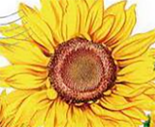 | 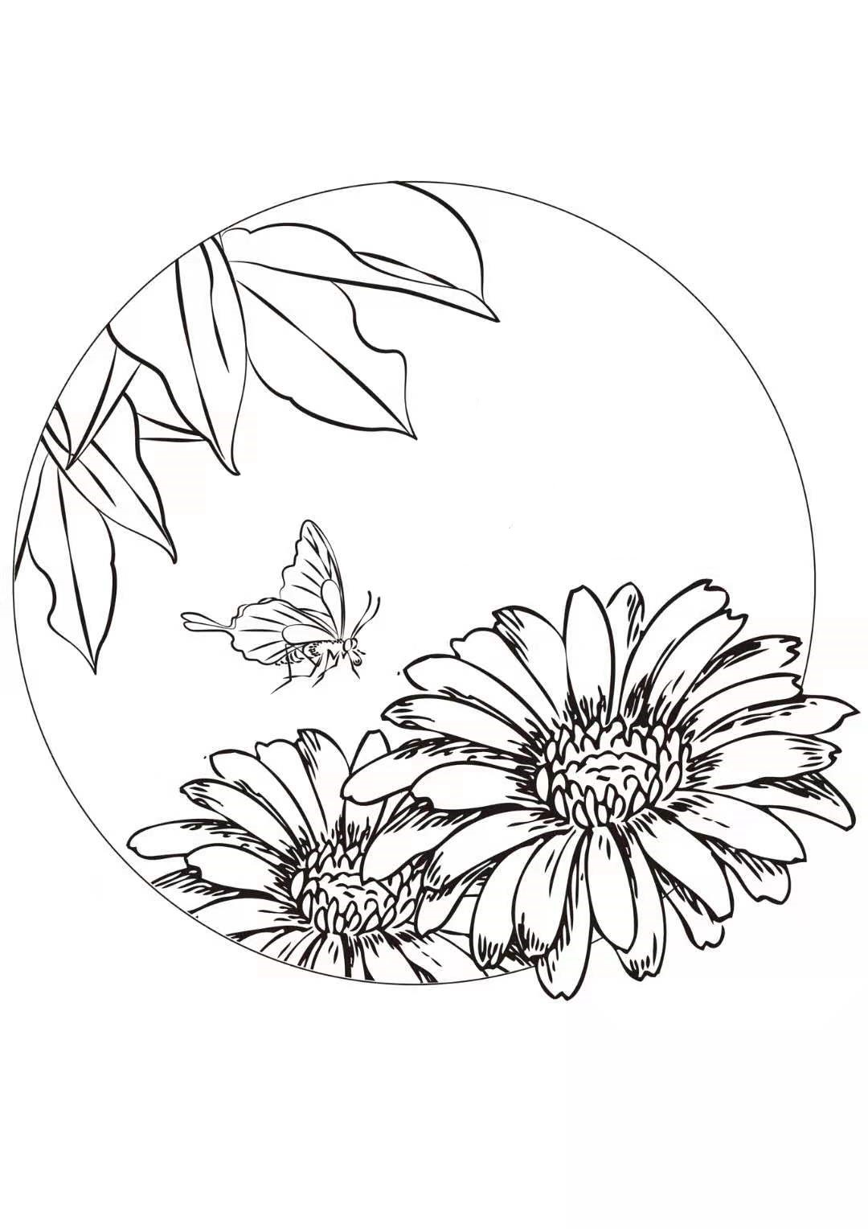 | 14：00  Coreopsis | Involucre cup shape, tip toothed, flowers of tubuliflorous plants | 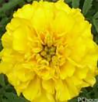 | 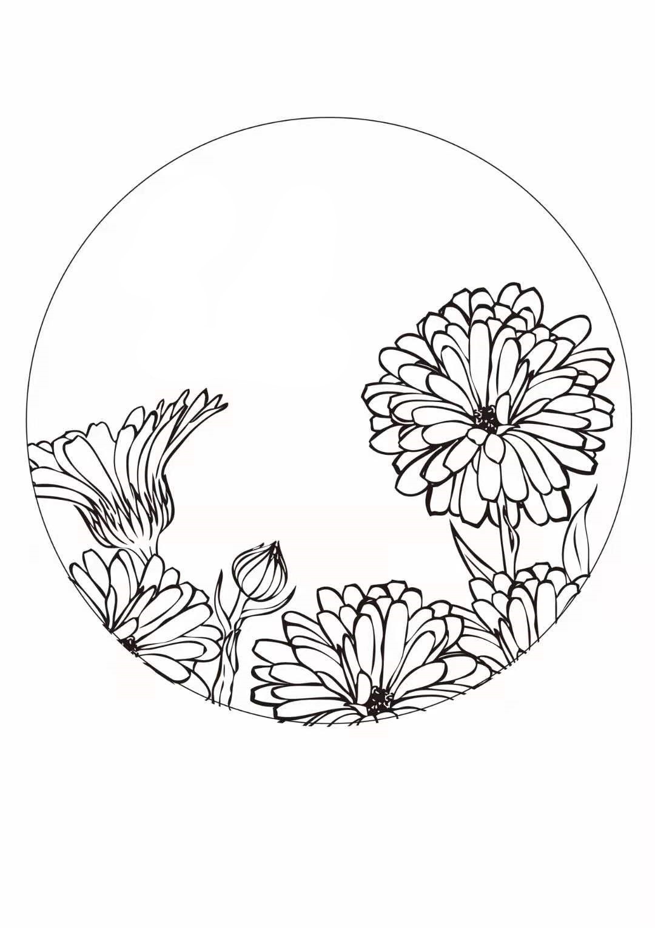
15：00  Red snow Chrysanthemum | Pedicel apex clavate with prong, dark orange | 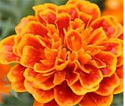 | 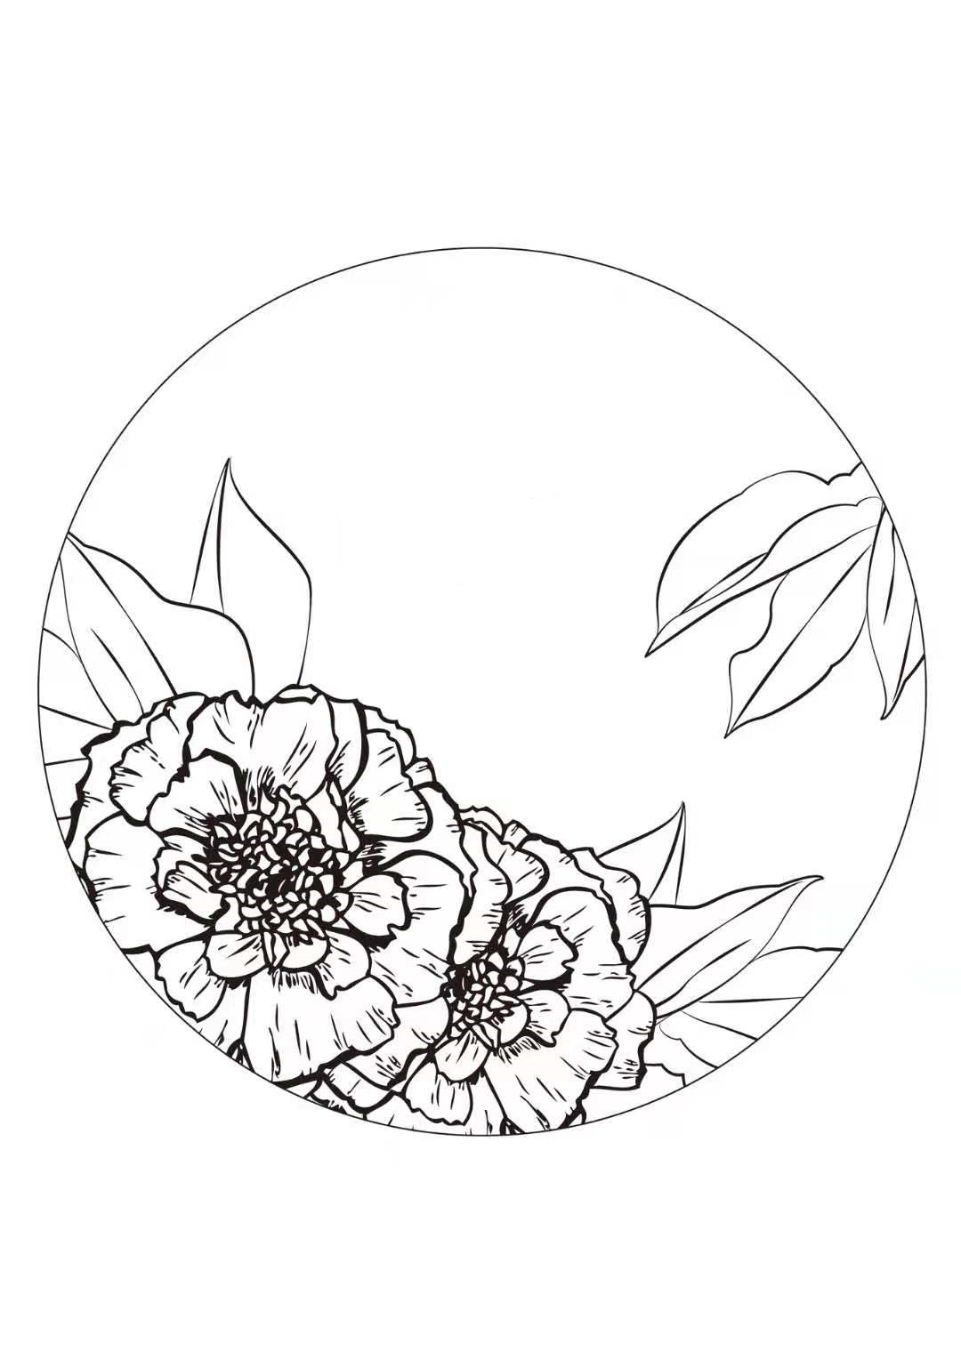 | 16：00  Pomegranate flowers | Calyx campanulate, succulence, with smooth wax on the surface | 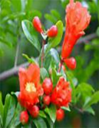 | 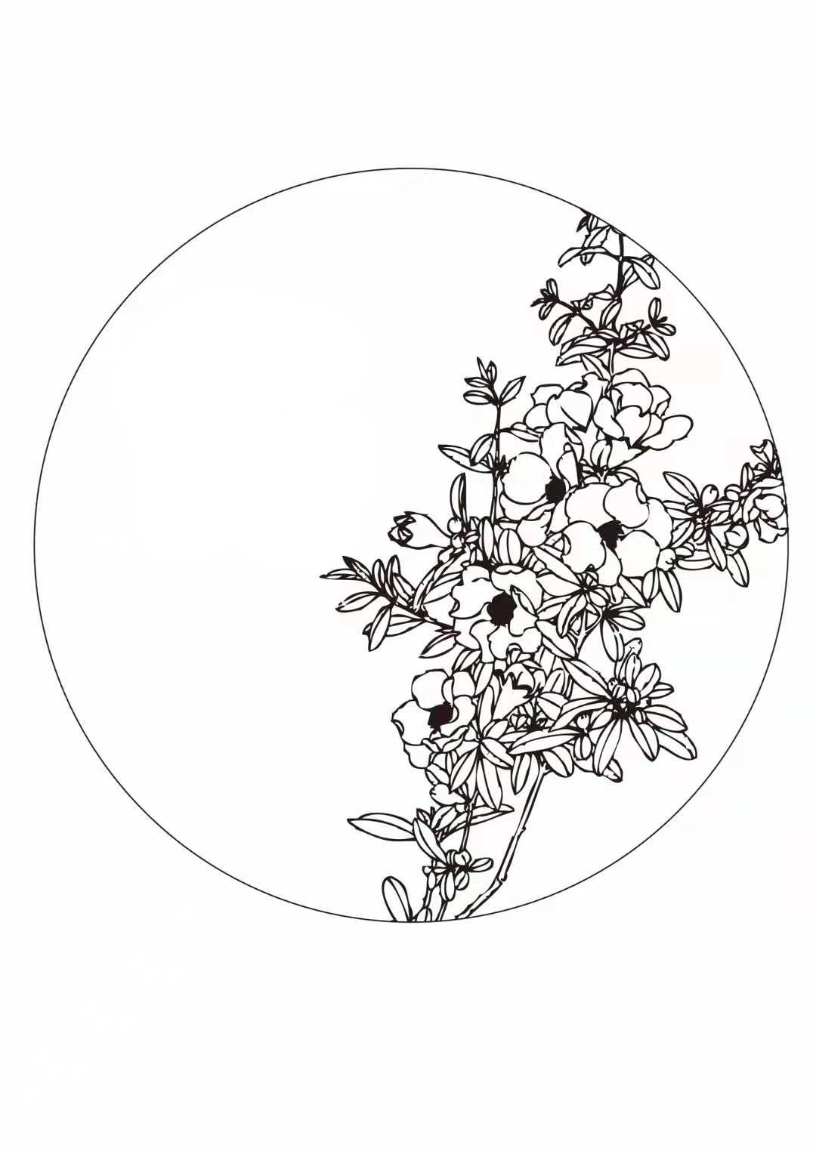
17：00  mirabilis jalapa | Flower involucre campanulate, perianth purplish red,  tall footed dish achenes globose shape | 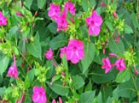 | 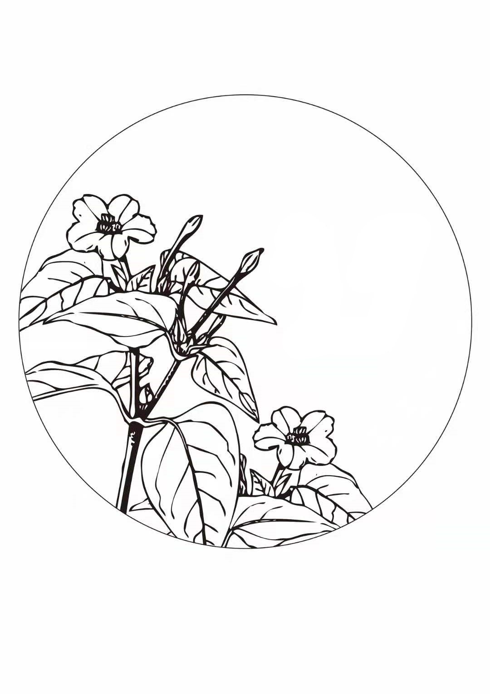 | 18: 00  tobacco flower | The flowers are trumpet shaped, contains white, purple, the inflorescence is pseudoracemose | 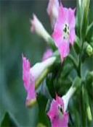 | 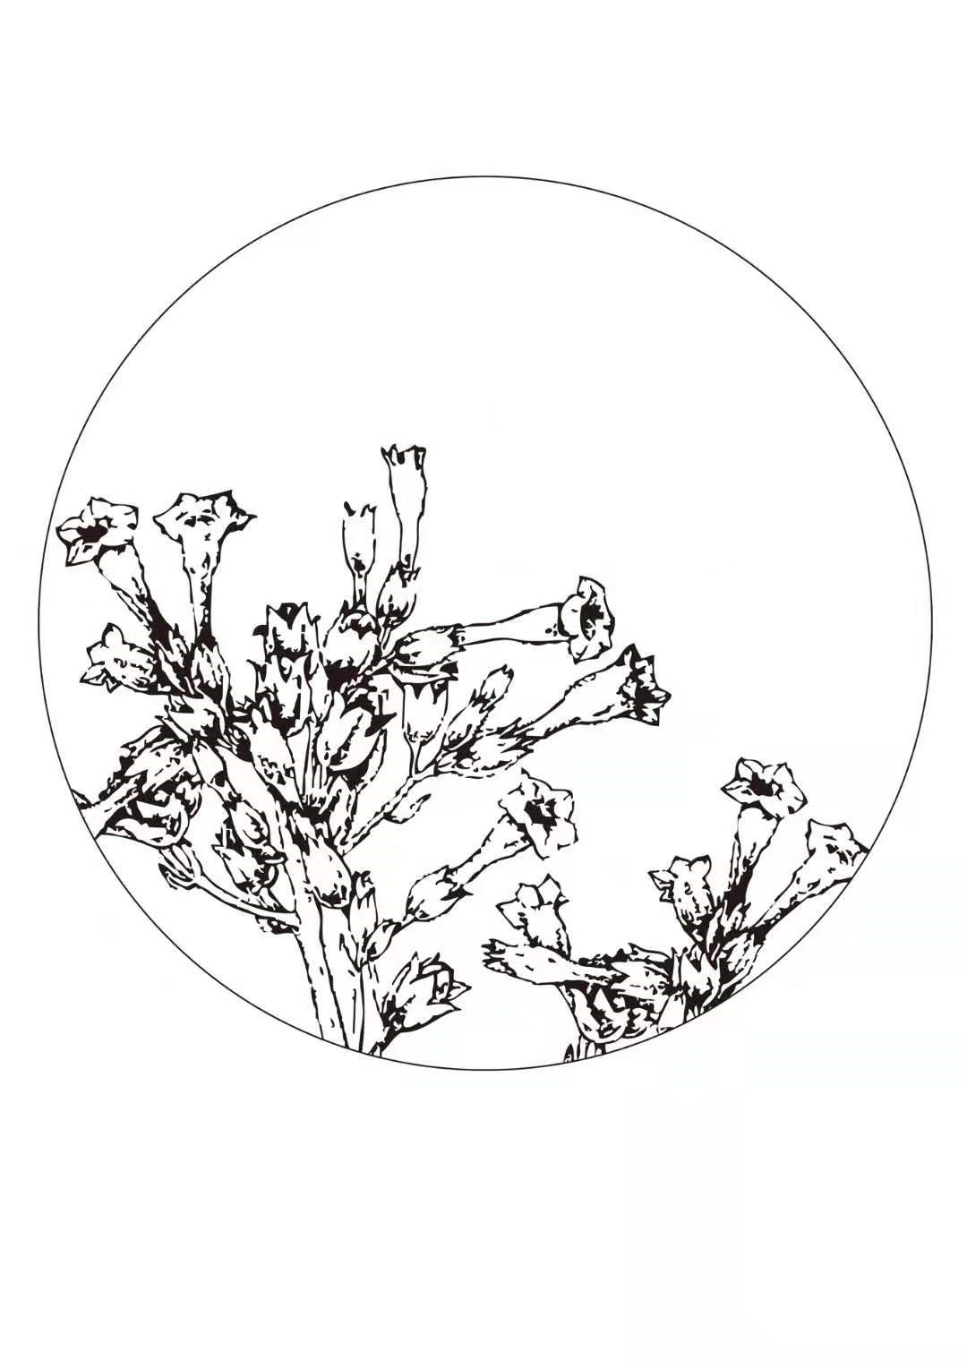
19：00  moonlight flower | The flowers are racemose, sepals ovate, corolla is white, green in petals. | 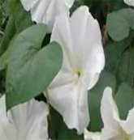 | 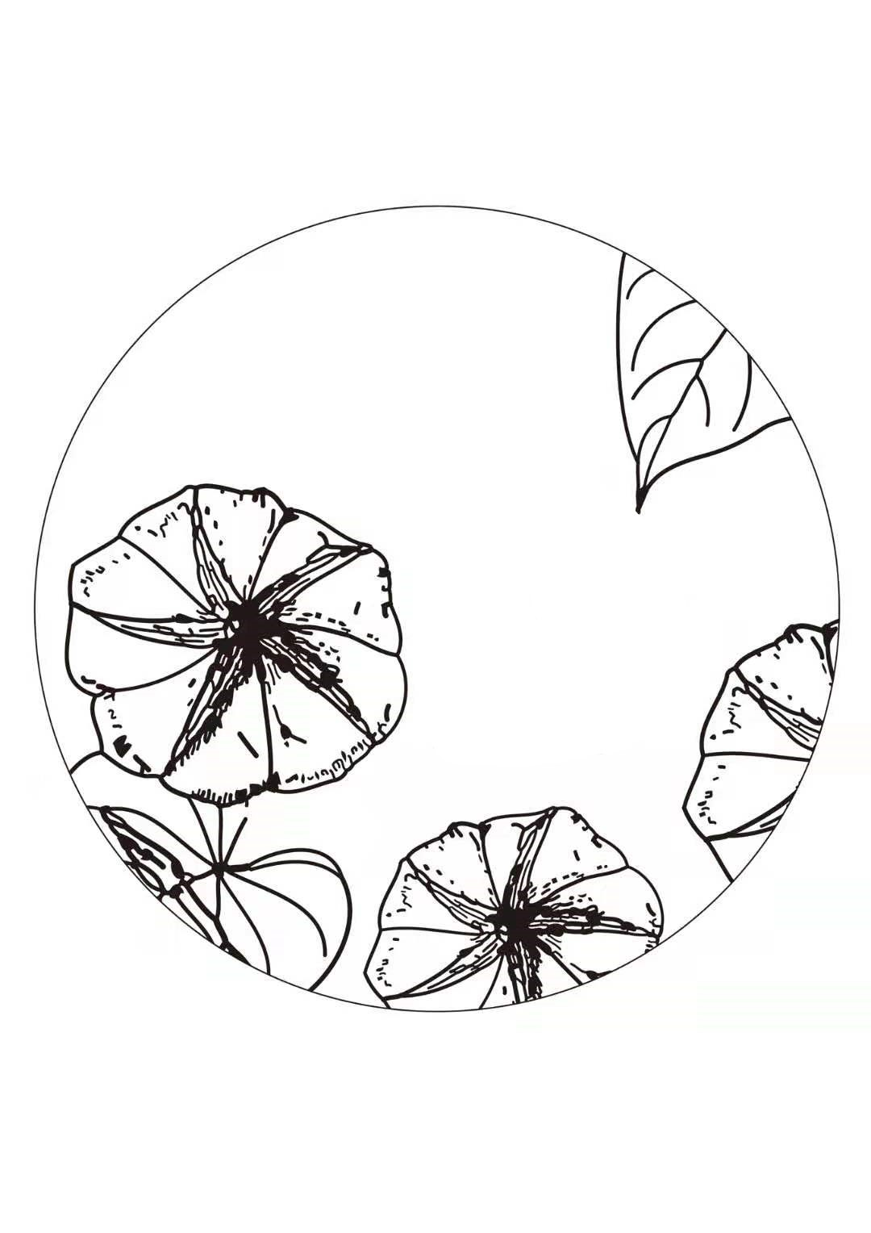 | 20：00  Chinese trumpet creeper | Short panicle, calyx campanulate, lobes lanceolate. | 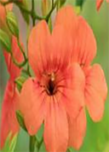 | 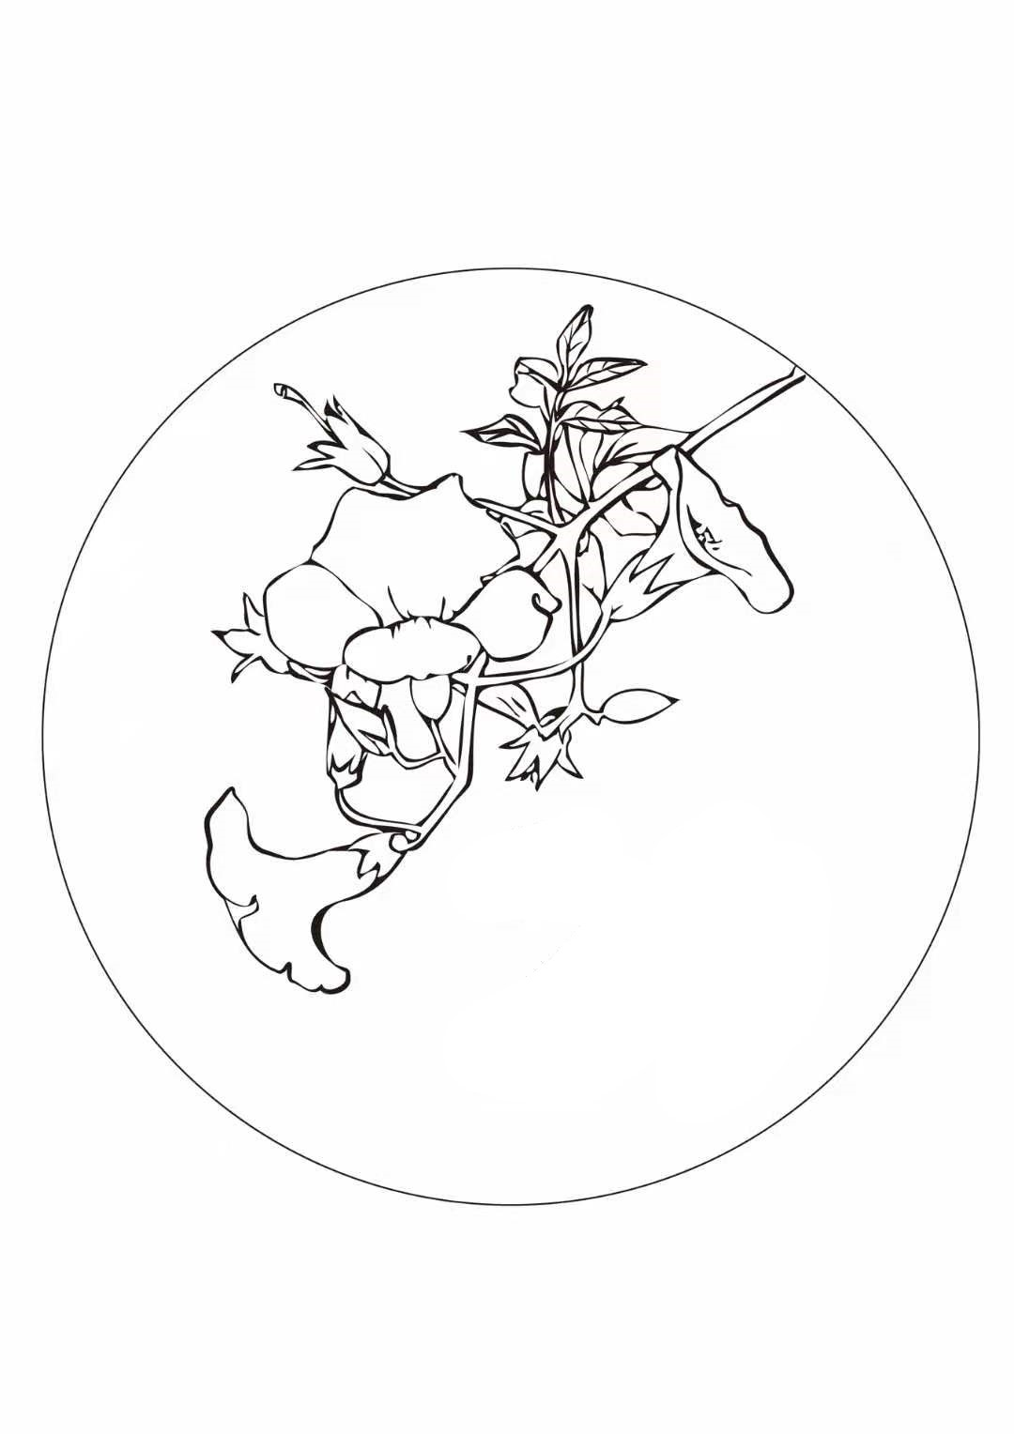
21: 00  broad-leaved epiphyllum | Lanceolate funnel; awn pointed, margin erose. | 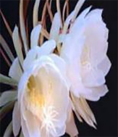 | 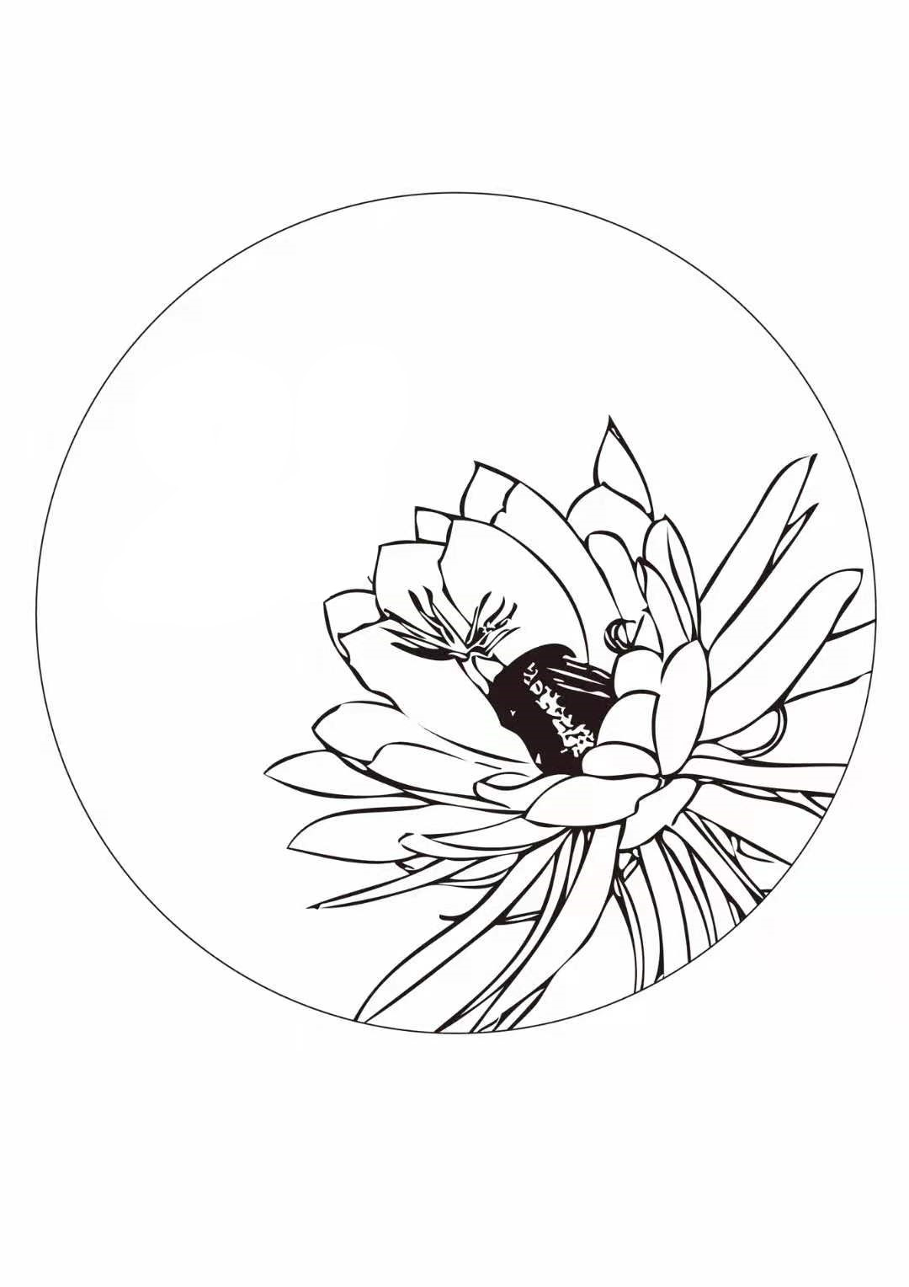 | 22: 00  scabish | Scabish is 5 sepals, heart shaped. | 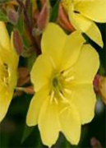 | 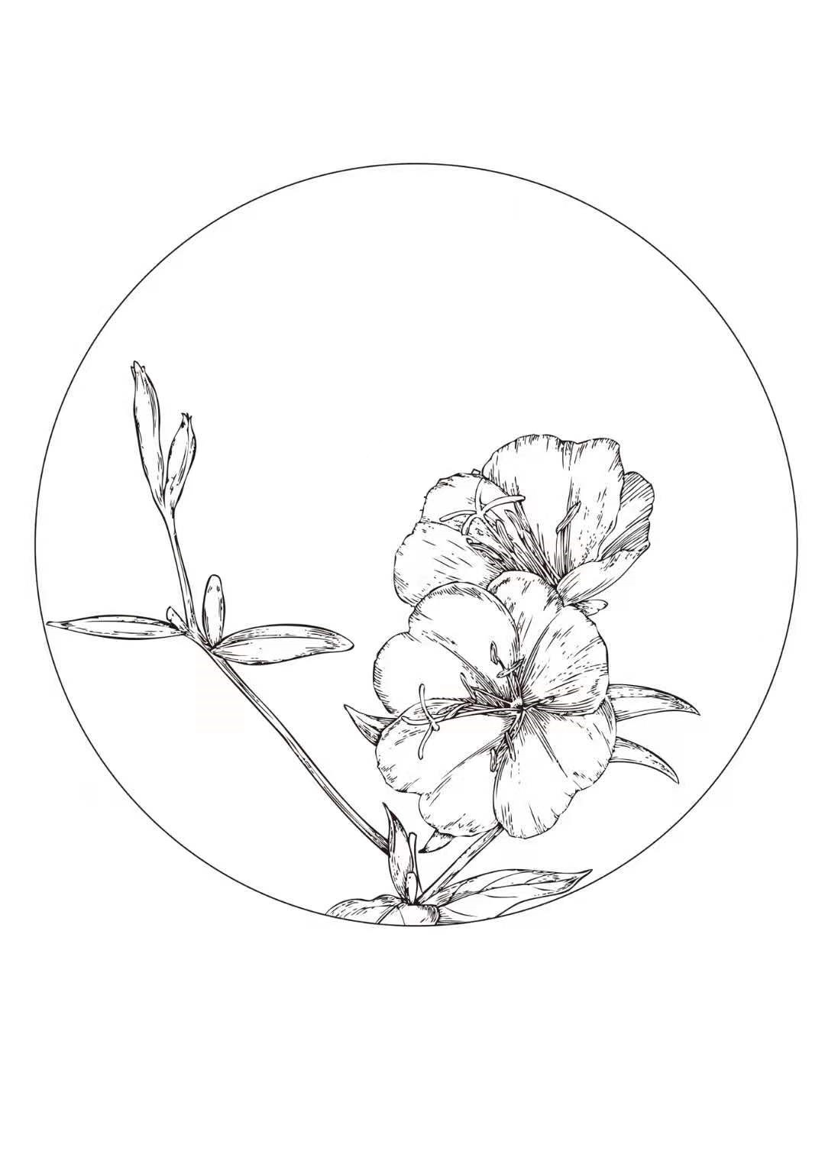
23 : 00  night willow herb | Corolla is chartreuse, high footed disk shape. | 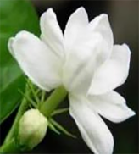 | 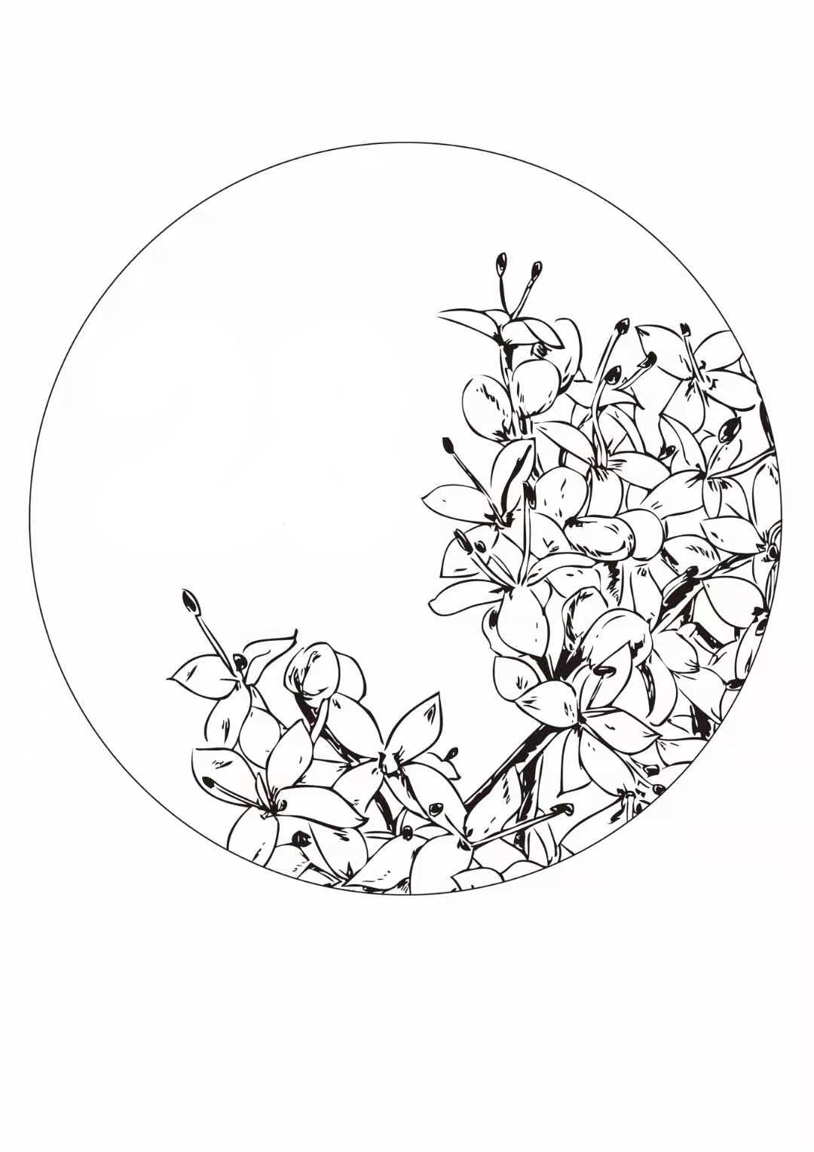 | 24: 00  Portulaca oleracea L. | Flowers clustered, branches yellow, a keel shaped ridge on the back. | 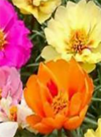 | 