Supplemental information for the manuscript “Differential modulation of the bacterial endophytic microbiome of Festuca arundinaceae (tall fescue) cultivars by the plant-growth promotion strain Streptomyces albidoflavus UYFA156”

(5 pages)

FIGURES

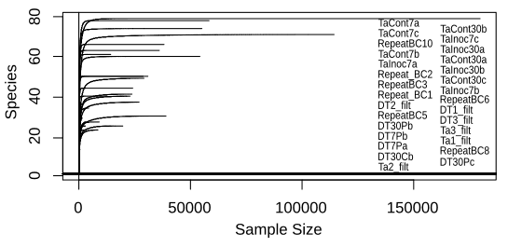
Supplementary figure 1. Rarefaction curves of all the samples used in this experiment. Labels of each curve are on the right ordered by species number.

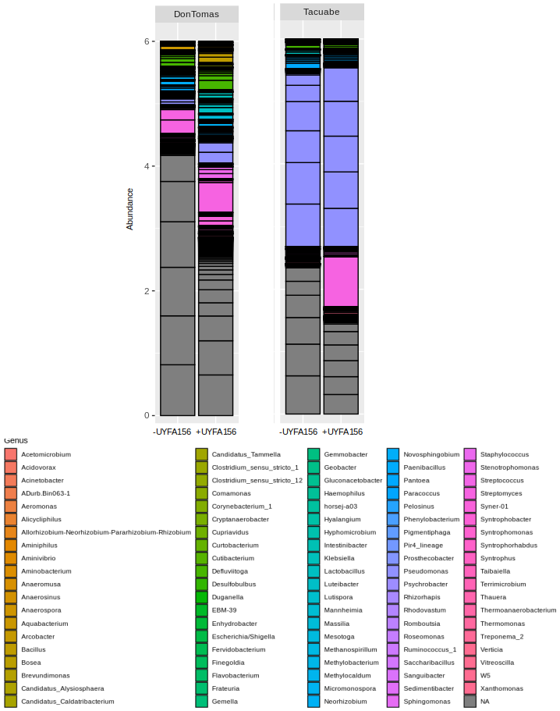
Supplementary figure 2. Bar plots of community structure within bacterial endophytic communities of cultivars DT (Don Tomas) and Ta (Tacuabe) at the genus taxonomic level, without (-UYFA156) and with (+UYFA156) inoculation.

TABLES

Supplementary Table 1. Experimental design of the endophytic microbiomes experiment. Three biological replicates per treatment were made of the composite of 7 tubes with 3 plants of tall fescue each. Seed treatments were not inoculated, since inoculation was carried out on plantlets at the time of their introduction to the tubes.

 | SFRO Don Tomás |  | Tacuabé |  | total  (n)
 | Control  (w/o UYFA156) | Test  (w/ UYFA156) | Control  (w/o UYFA156) | Test  (w/ UYFA156) | total  (n)
seeds | 3 reps |  | 3 reps |  | 6
7 dpi | 3 reps | 3 reps | 3 reps | 3 reps | 12
30 dpi | 3 reps | 3 reps | 3 reps | 3 reps | 12
total (n) | 9 | 6 | 9 | 6 | 30

Supplementary Table 2: Proportion of selected groups at different taxonomic levels within the whole endophytic bacterial microbiome of inoculated plants (UYFA156) and uninoculated plants (control). Taxonomic groups that influenced significantly in the differences between control and inoculated plant microbiomes within each cultivar and time are indicated (** < 0.001; * 0.01- 0.05; ‘ 0.05 - 0.07) next to the % variation (var) explained by the group. Numbers in bold denote the higher value of the two in each comparison. Cells in grey indicate the group was not found in the cultivar.

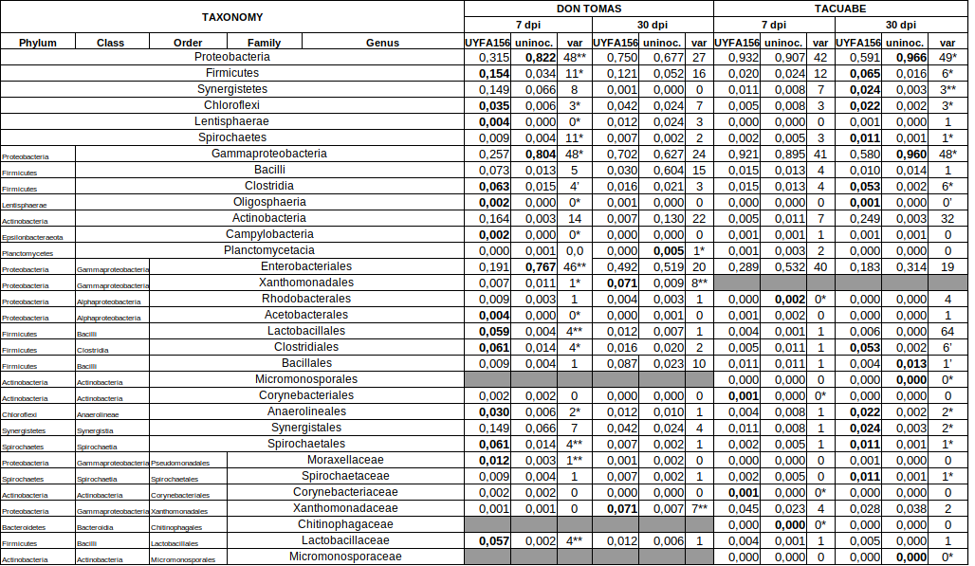
(1 of 2)

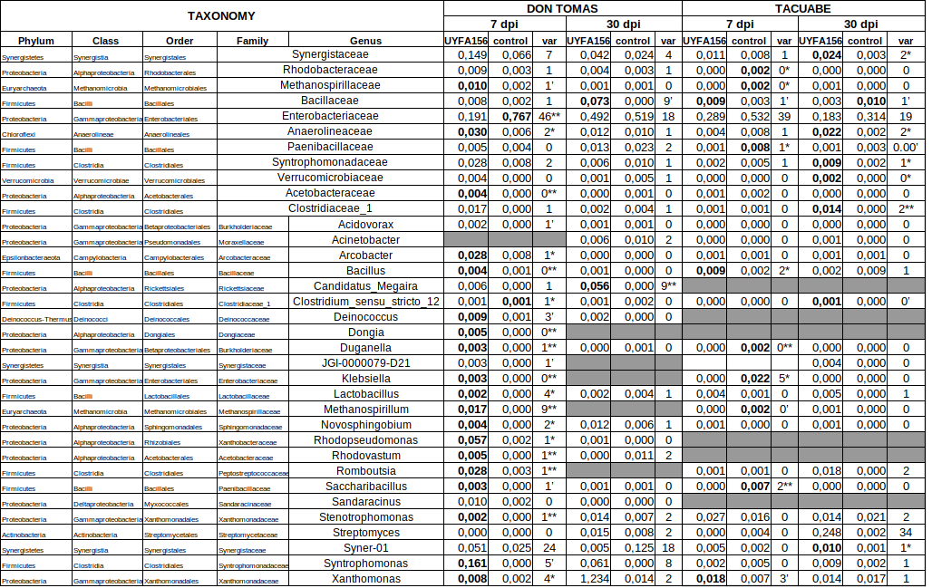
(2 of 2)

