Appendix
Appendix 1: Patient Evaluation Interview
Evaluation of facilitators and barriers to HIV testing services (HTS) among children of people living with HIV (PLHIV) and currently accessing care and treatment services at selected CDC-supported health facilities in Nigeria
DO NOT READ THIS SECTION aloud: Prior to beginning the interview, remind the participant that you will be recording the interview. Before beginning to ask questions, note the facility ID, date, and participant ID aloud on the recording.
***TURN ON AUDIO RECORDER NOW***
Facility ID: _______________________________ Date: ______________________
Participant ID: ________________ Interview Start Time: ________ End time: __________
Interviewer: State aloud facility ID, date, participant ID.
READ: Before we begin with the interview questions, I would like to ask you again if you are still willing to participate in the study (allow participant to answer yes or no). If no, stop interview. If yes, ask the participant if they are still willing to have their responses audio recorded. If no, stop the interview. If yes, continue to questions below.
I will start by asking you basic questions about yourself. If you do not understand something that I ask, please let me know.
Is the respondent male or female? | ☐ Male  ☐ Female
What is your current age? | Age: ________  D.O.B: Day ___ Month ___ Year ___
What is your current marital status? | ☐ Single  ☐ Married  ☐ Living Together (not married)  ☐ Divorced  ☐ Widowed  ☐ Separated  ☐ Other (________________________)
What is the highest level of school you completed? | ☐ No school/less than primary  ☐ Primary  ☐ Secondary  ☐ Tertiary  ☐ Post-graduate Degree
Have you done any work in the last 12 months for which you received cash or goods as payment? | ☐ Yes  ☐ No  ☐ Don’t know
Have you done any work in the last thirty days for which you received or will receive cash or goods as payment? | ☐ Yes  ☐ No  ☐ Don’t know
What is your religion? | ☐ Christian  ☐ Muslim  ☐ Others: (________________________)  ☐ No religion
How many living biological children do you have? | Enter number here: _____________
What is the age and sex of the child(ren)? | - Age: Sex:  - Age: Sex:  - Age: Sex: | - Age: Sex:  - Age: Sex:  - Age: Sex:

Thank you for answering the previous questions. I will now ask you questions about your HIV status, HIV care, and current treatment status. I understand some of these questions may make you feel uncomfortable or may be difficult to answer. Please take the time you need to answer the questions. Remember, your name will not be attached to any of your answers. I will start by asking you questions about yourself and then will ask questions about your child(ren).
- Is this the facility that you use most often to access HIV-related services (i.e. HIV testing, HIV care, HIV treatment)?
- What services do you usually access from this facility?
- Why do you choose to use this facility?
- What things do you like about this facility?
- What things do you dislike about this facility?
- What was the month and year of your first HIV-positive test result? Please give your best guess.
- Can you tell me more about your decision to get tested for HIV (why did you decide to get tested for HIV)?
- Who have you disclosed your status to?
- What influenced your decision to disclose (not disclose) your HIV status? (i.e. stigma, culture, etc)
- What month and year did you first see a doctor, clinical officer, or nurse for HIV medical care? Use your best guess.
- Prior to today, when is the last time you saw a doctor, clinical officer, or nurse for HIV medical care?
- What month and year did you first start taking HIV medication (ARVs)? Use your best guess.
- Can you tell me about your decision to take ARVs (why did you decide to begin taking ARVs)? (i.e. I feel better, I was told I needed to take them, etc)
- What factors make it difficult to take your HIV medication every day? (i.e. food shortage, stigma, side effects, cost of medication, cost of transport, feel healthy, etc)
Thank you. I would now like to ask a few questions about your partner (skip if participant reported they are single, separated, divorced, or widowed).
- Has your spouse/partner been tested for HIV?
- Did they share their HIV test result with you?
- If yes and if your spouse/partner is HIV-positive – are they taking HIV medications?
Thank you. I would now like to move to the final set of questions. These questions are about your biological children.
- Has your child / Have all of your children been tested for HIV and received their results?
  - If yes, ask questions 19-22 below. If not all children have been tested, skip to question 29. If no children have been tested, skip to question 30
- What influenced your decision to have your child/ren tested for HIV?
- What factors made it easier for you to get your child/children tested for HIV?
- What factors made it difficult for you to get your child/children tested for HIV?
- Did your child/did any of your children test positive for HIV?
  - If yes, continue to question 23. If no, skip to question 33
- Is your child/children currently enrolled in HIV care and treatment?
  - If yes, continue to question 24. If no, skip to question 28
- What factors facilitated your decision to enroll your child/children in care and treatment?
- What factors made it difficult to enroll your child/children in care and treatment?
- What factors make it easier to keep your child on treatment?
- What factors make it difficult to keep your child on treatment? (after participant answers skip to question 33)
- What influenced your decision not to enroll your child/children in HIV care and treatment? (skip to question 33)
- What influenced your decision not to test each of your children for HIV? (after participant responds, skip to question 31)
- What influenced your decision to not test your children for HIV?
- What factors would make it easier for you to get your child/ren tested for HIV?
- What factors make it difficult for you to get your child/ren tested for HIV?
- Thank you. Do you have anything else that you would like to add that you didn’t share above.
This concludes our interview. Thank you for your time and responses. Do you have any final questions for me?

Figures
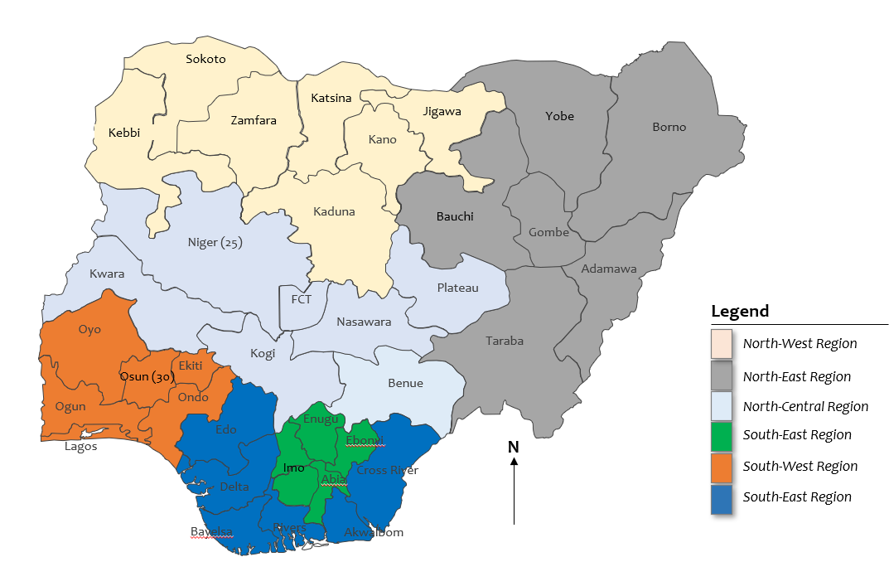
Figure 1: Map of Nigeria showing the states and 6 geopolitial states

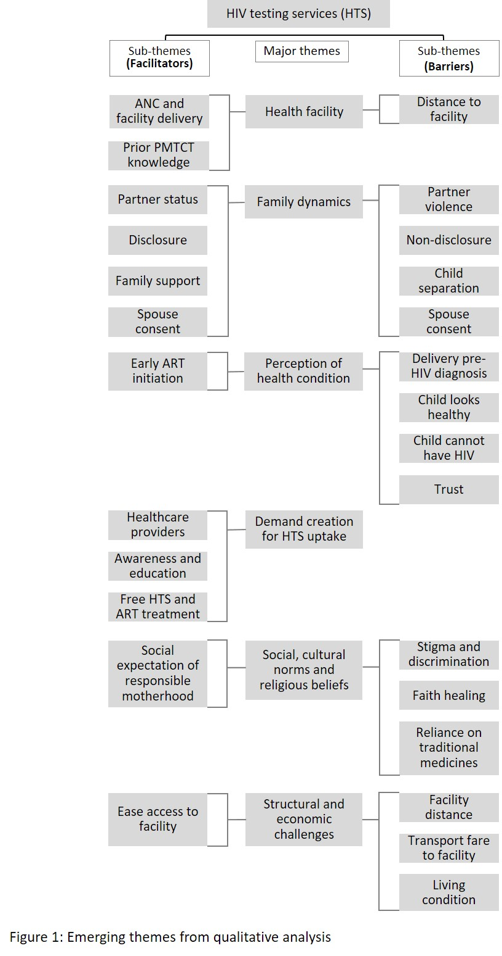

Figure 2: Major themes on facilitators and barriers to uptake of services

