Supplementary Information
Net-zero emissions aviation
Candelaria Bergero^{1*}, Greer Gosnell², Dolf Gielen³, Seungwoo Kang^{3,4}, Morgan Bazilian², and Steven J. Davis^{1,5*}

¹ Department of Earth System Science, University of California, Irvine, Irvine, CA
² The Payne Institute for Public Policy, Colorado School of Mines, Golden, CO

³ Innovation and Technology Center, International Renewable Energy Agency, Bonn, Germany

⁴ OneTech, TotalEnergies, Paris-Saclay, France
⁵ Department of Civil and Environmental Engineering, University of California, Irvine, Irvine, CA

*corresponding authors: mcberge1@uci.edu and sjdavis@uci.edu
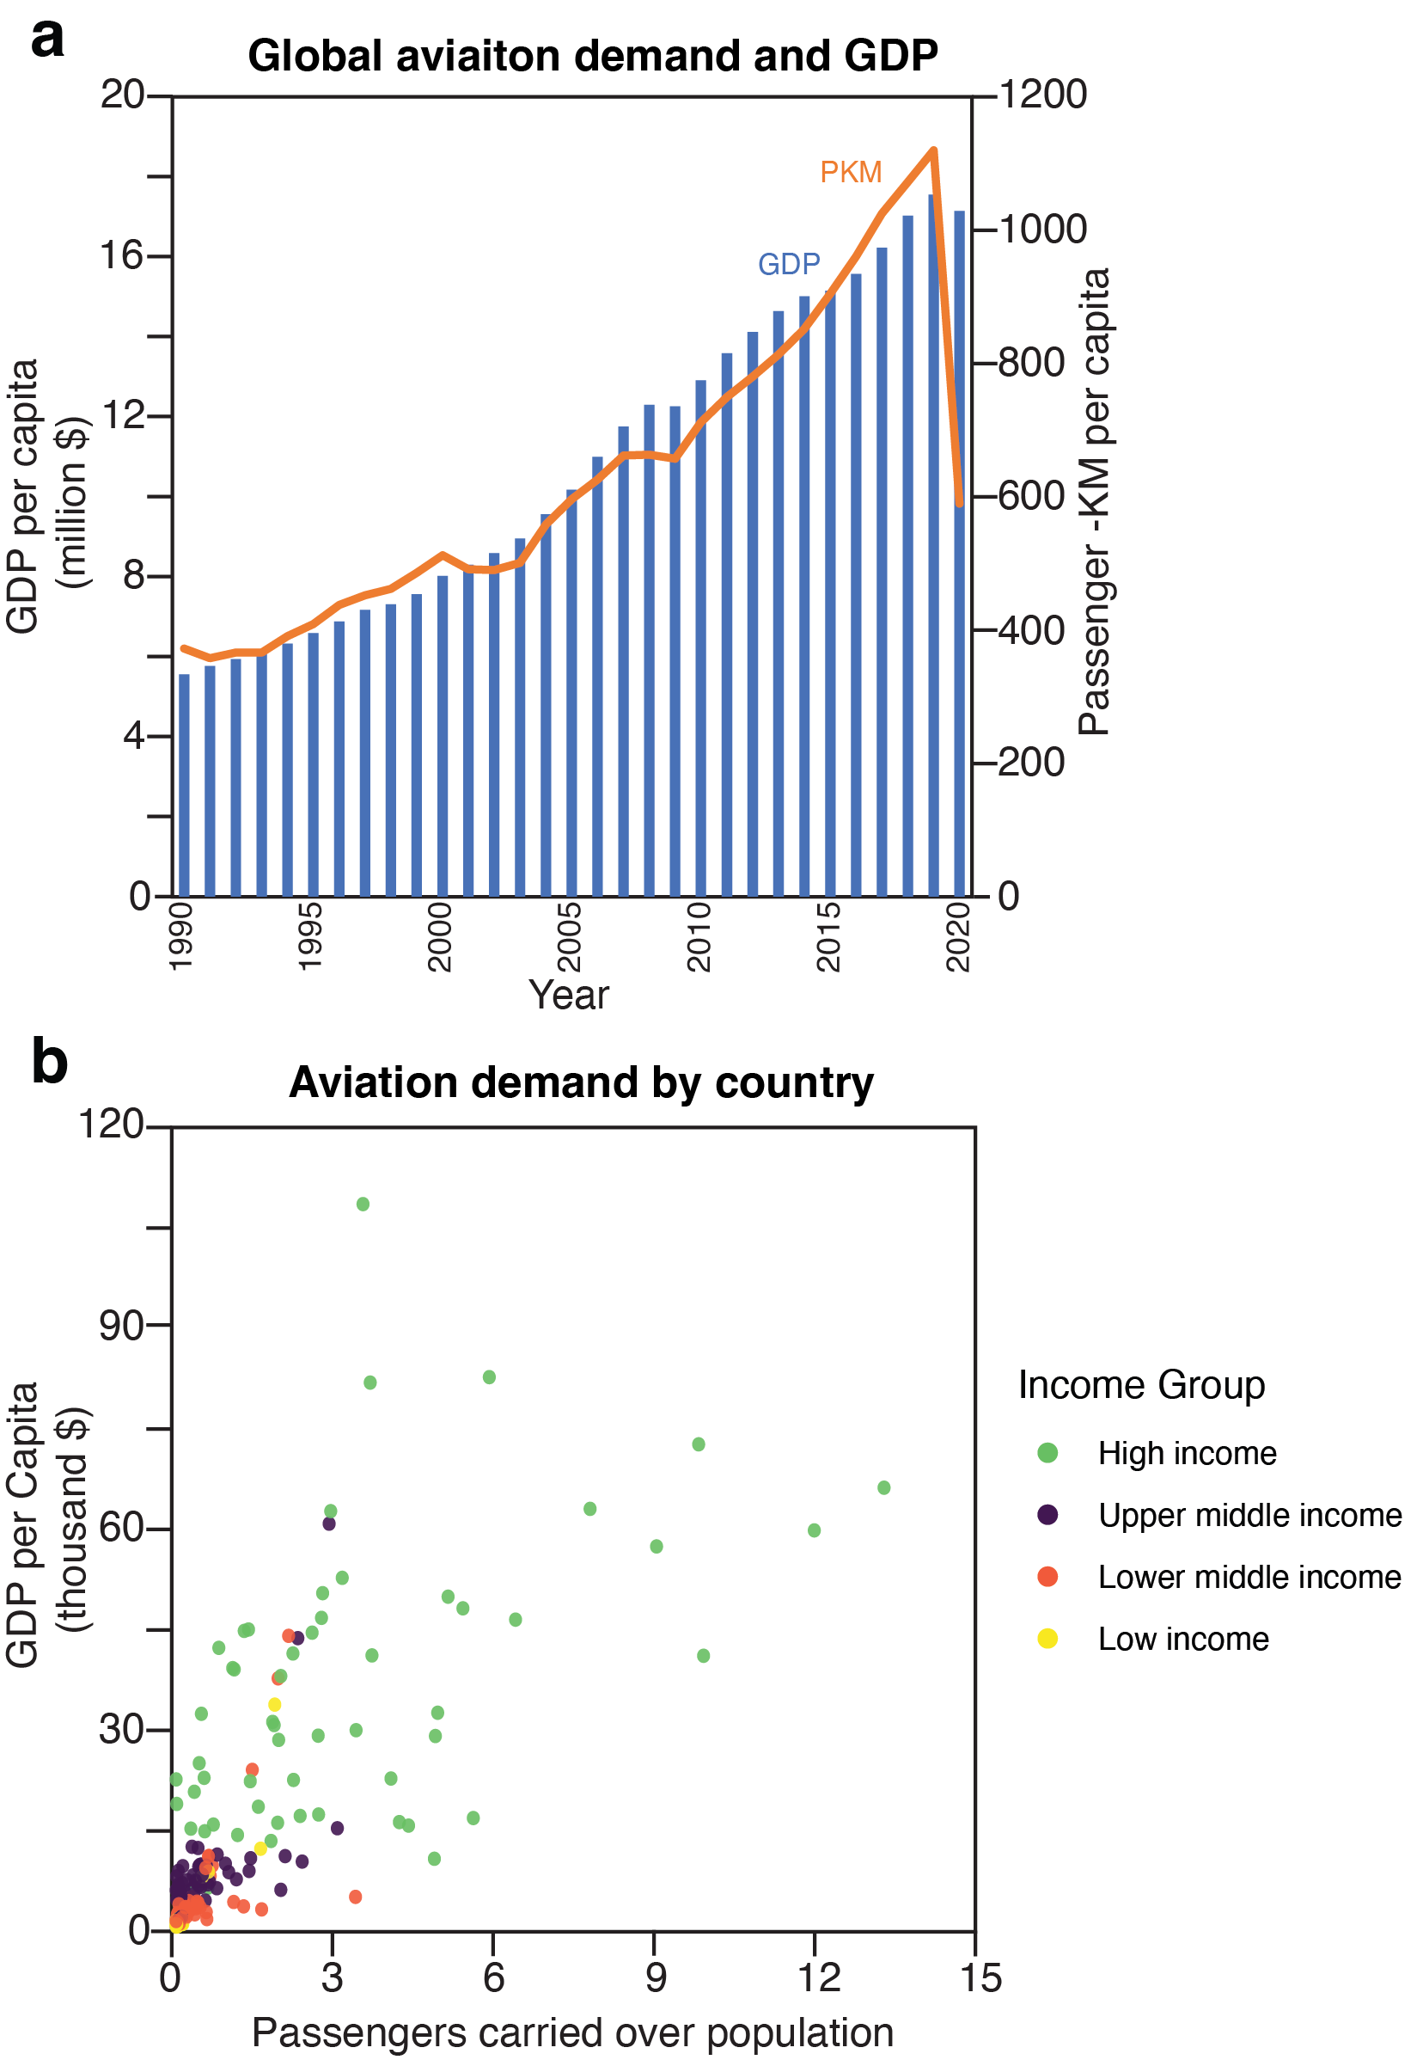
Supplementary Fig. 1 | (b) Global gross domestic product per capita compared to passenger-kilometers per capita. GDP per capita data from the World Bank¹, PKM data from ICAO, global population data from the World Bank². (b) Aviation demand by country based on passengers carried over country’s population and GDP per capita all data from the World Bank^{1–3}. Income group classification is also with data form World Bank⁴. Panel (b) omits Ireland (GDP per capita of $80,886 and passengers carried per capita of 34.5). All data form panel (b) is for 2019, except for Aruba (2018 values), Jamaica (2018 values), Gabon (2016 values), Eritrea (2015 values), Yemen (2018 values) because of data availability.
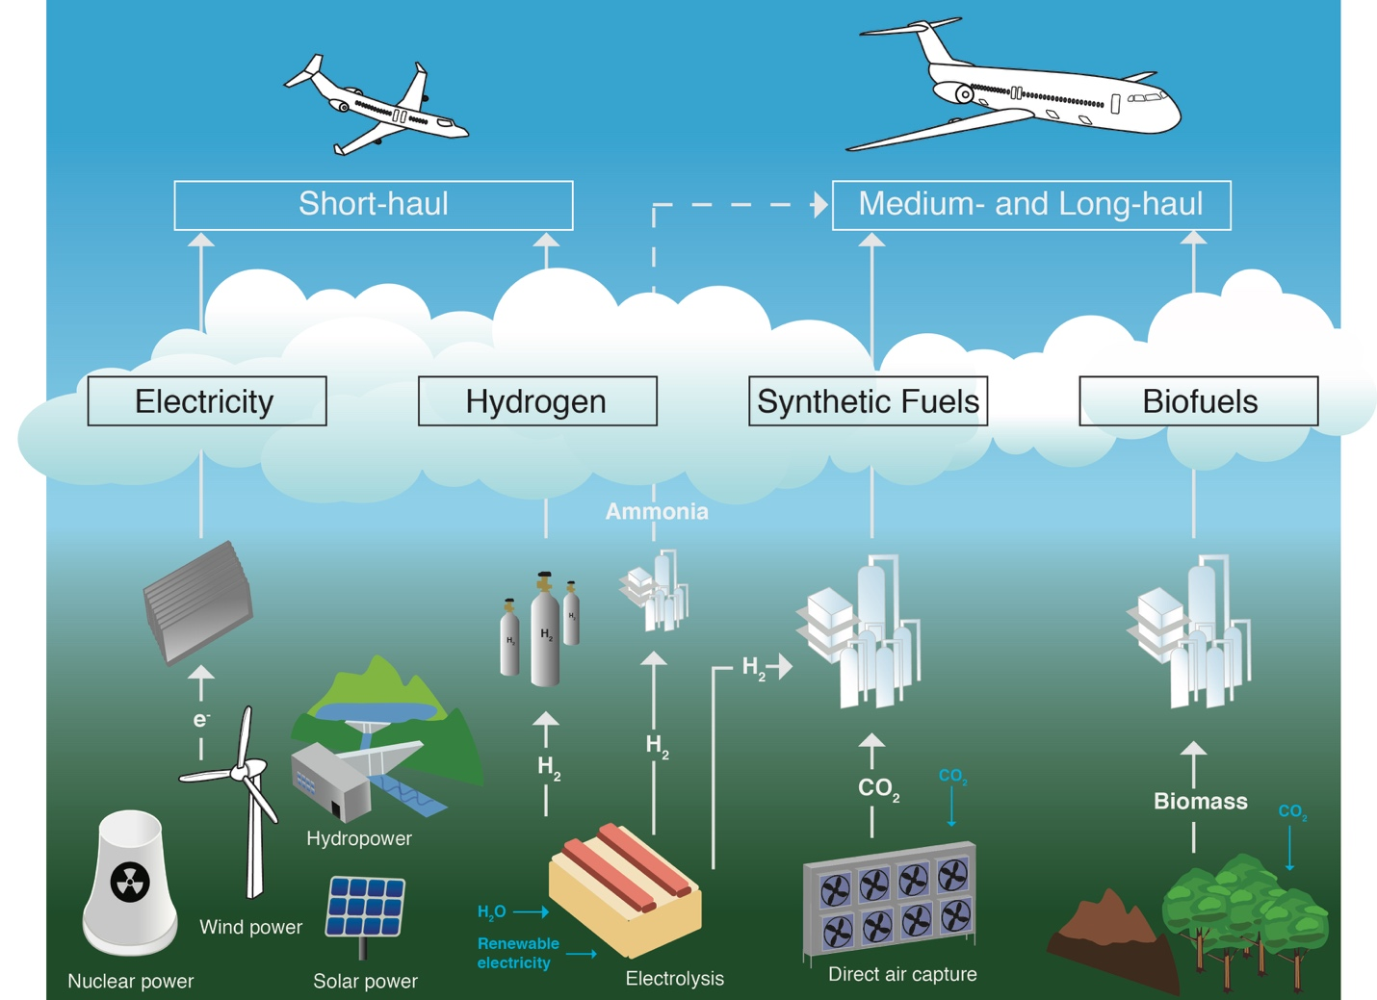
Supplementary Fig. 2 | Schematic with different decarbonization options for aviation based on flight time: short-haul (<3 hours), medium-haul (3-6 hours), and long-haul (>6 hours)⁵. Four main fuels are considered: electricity^{6–8}, hydrogen^{7–9}, synthetic fuels^{7,8,10–12}, and biofuels^{7–9,13–17}. We have also added a potential ammonia pathway⁹. The categories are not exclusive and are meant to depict a simple representation of decarbonizing aviation.

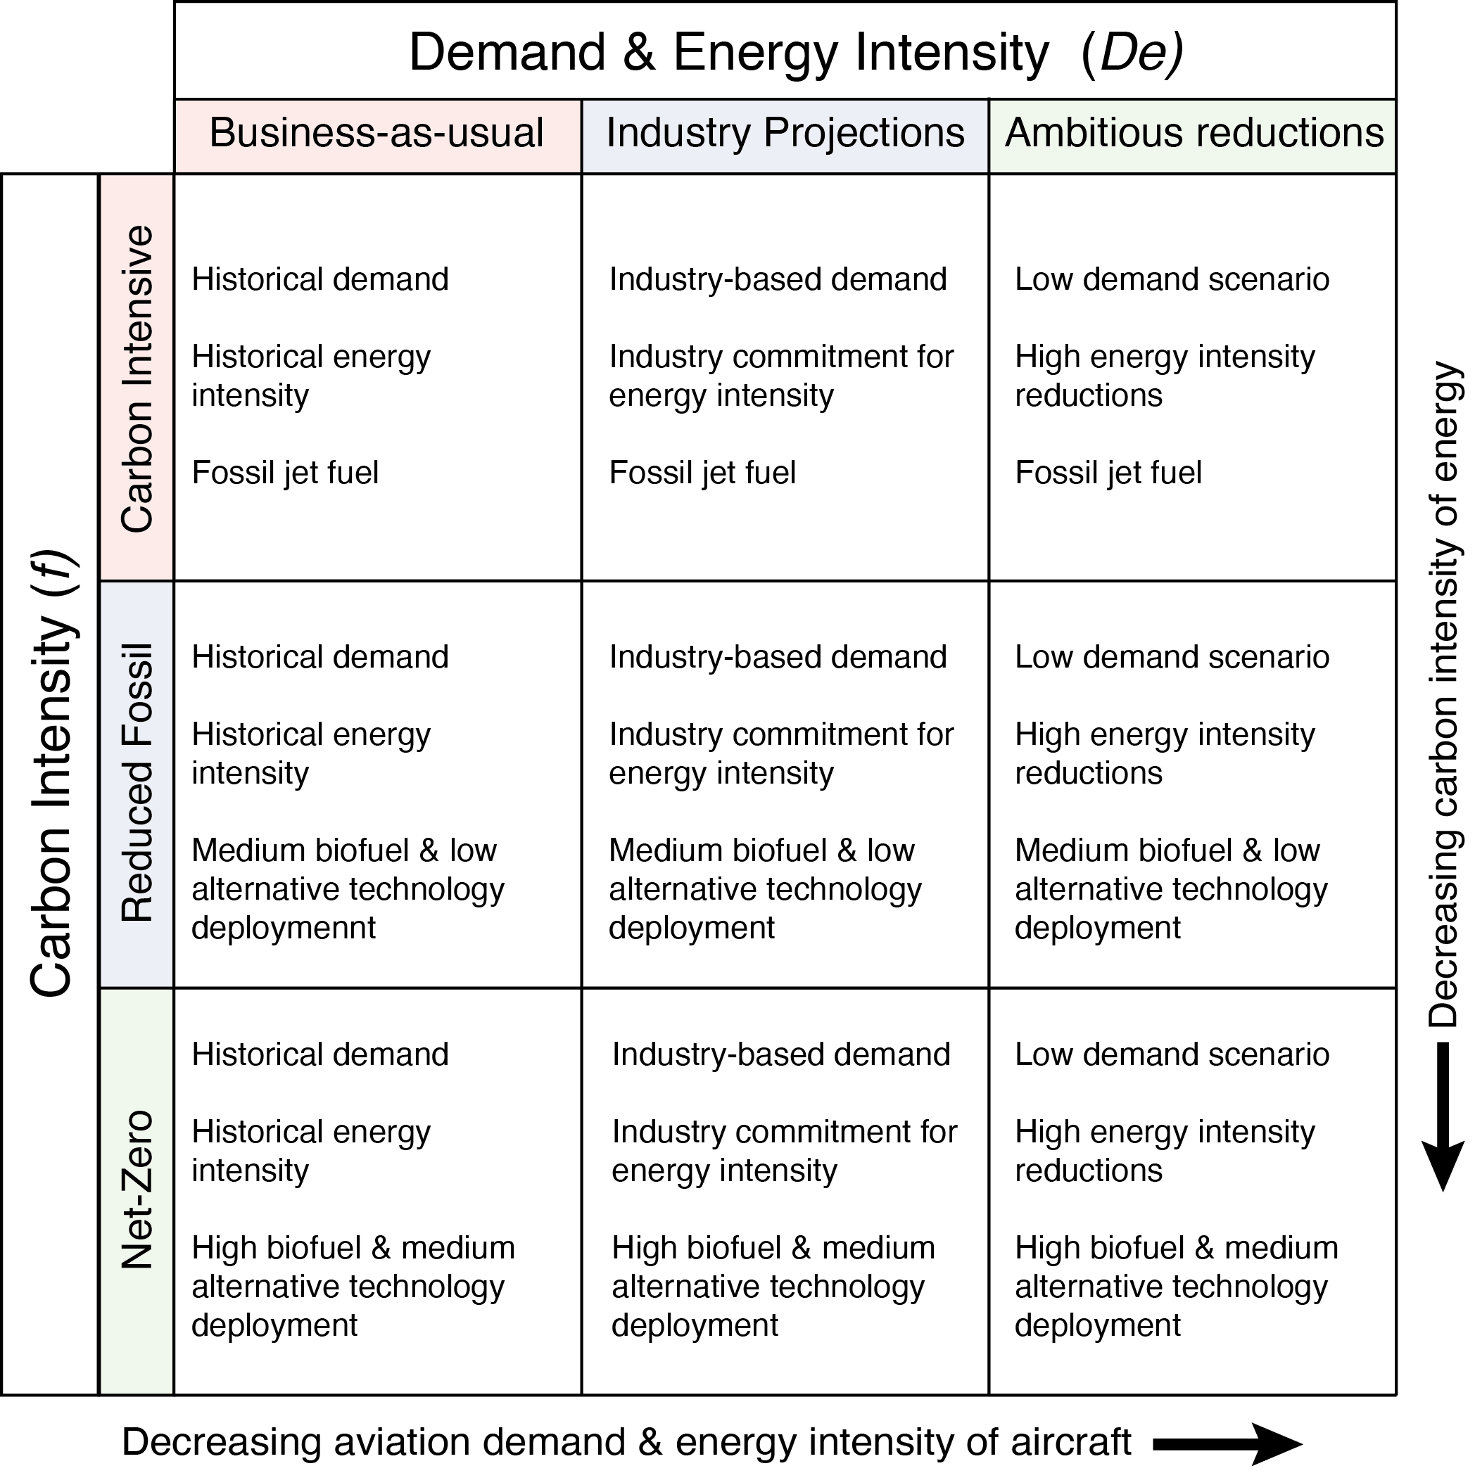
Supplementary Fig. 3| Nine scenarios for future global aviation emissions based on the Kaya identity. More details on Supplementary Table 1.

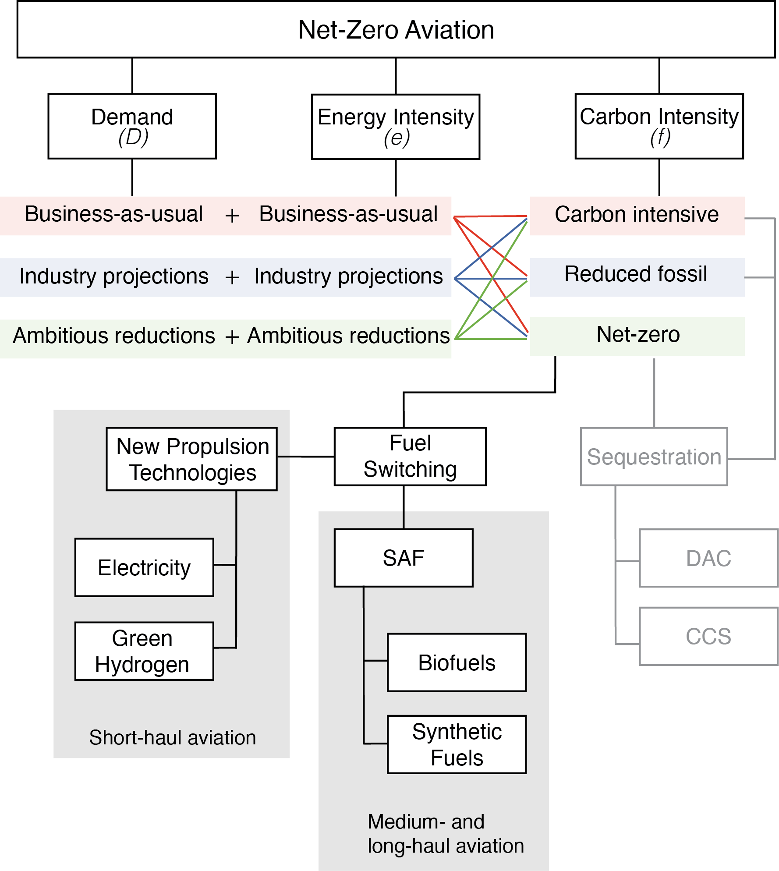
Supplementary Fig. 4 | Schematic for Kaya properties in net-zero aviation and our scenario design. We pair demand (D) and energy intensity (e) assumptions with different carbon intensities (f), resulting in nine scenarios. Net-zero technologies are included based on flight duration (short-, medium-, and long-haul)⁵. Sequestration pathways for direct air capture (DAC) and carbon capture and storage (CCS) are greyed out since they are not analyzed in this study, though are alternatives for decarbonization. We highlight two fuel switching options: sustainable aviation fuels (SAFs) and new propulsion technologies.

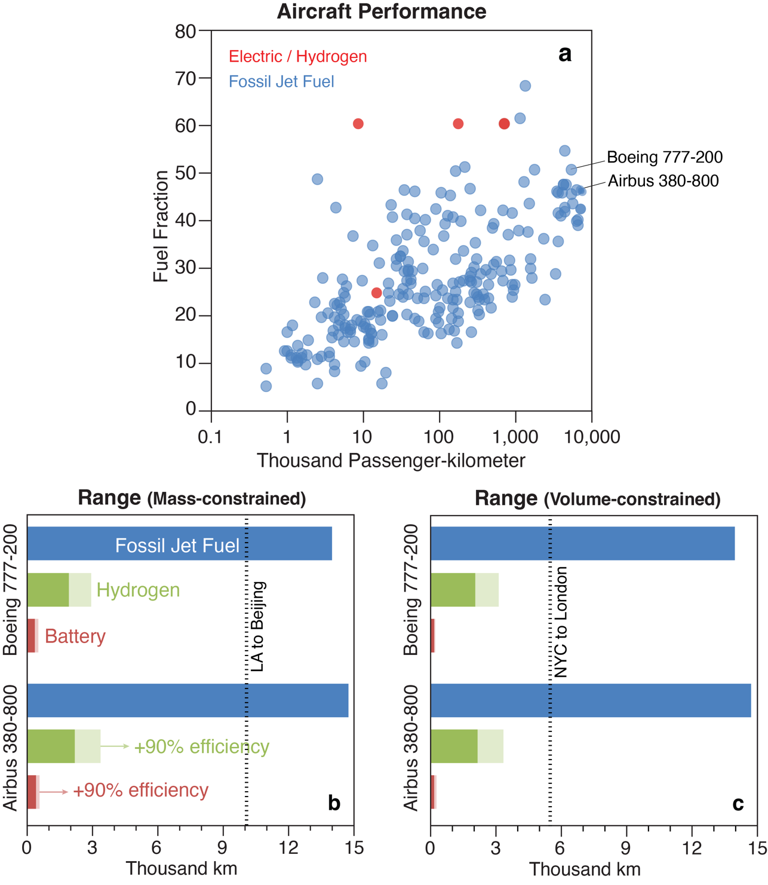
Supplementary Fig. 5 | The role of different fuels powering aviation. Panel (a) shows aircraft performance for different planes based on fuel fraction and thousand passenger-kilometer, with data from ICAO¹⁸. Blue dots represent fossil jet fuel powered planes, and red dots represent planes powered by electricity or hydrogen. Total range for two types of long-haul planes are shown in terms of mass (b) and volume (c). Blue represents the maximum possible distance to fly in thousand km for each type of plane powered by fossil jet fuel, while green represents hydrogen and red battery powered. The lighter shades assume up to 90% higher efficiency based on⁶. There are two reference flights added as a dashed line in panels (b) and (c): from Los Angeles (LAX) to Beijing (PEK), and from New York City (JFK) to London (LHR). For total range based on mass (b) we assume 60% maximum fuel fraction (remainder allocated to passengers, seats, cargo, etc.), for the battery weight we assume 260 Wh/kg of a 18650 Li-ion cell, and for hydrogen weight 1500 kWh/t¹⁹. For total range based on volume (c) we assume that the volume of batteries and hydrogen is 1.5 times the volume of fossil jet fuel, and that the volume of batteries is 0.0785 kWh/L of 18650 Li-ion cell, and 1 kWh/L for hydrogen.

Supplementary Table 1| The Kaya Identity Sources and Explanations
 | Emissions (F) | Demand (D) | Energy intensity (e = E/D) | Carbon intensity (f = F/E)
 | Mt CO₂ | Ton-km equivalent | MJ/ton-km equivalent | Mt CO₂/ MJ
Historical | Historical emissions (1990-2020) from IEA²⁰. 2021 emissions from CMP and adjusted by previous year difference between CMP and IEA (13%)²¹. | Passenger demand from ICAO (1990-2019)^{22,23}. 2020 and 2021 values were estimated based on emissions²¹.  Freight demand from 1990-2020 from the World Bank Data²⁴. For 2021 we assume that cargo demand grew 7.9% in 2021 compared to 2019 based on IATA’s estimates²⁵.  Passenger demand was converted from “passenger-km” to “ton-km-equivalent” assuming 90 kg by passenger on average, consistent with IEA²⁶. | Energy intensity was calculated for 1990-2019 based on total aviation demand (passenger and freight)^{22–24} and total aviation fuel consumption from IEA’s World Energy Statistics and Balances²⁷.  For 2020-2021 we assume that the yearly average 3% energy intensity reduction from 1990-2019 is met. | We consider tank-to-wake emissions only, which excludes fuel production and includes only carbon combustion emissions for all fuels with values from¹⁴, which are 73.5 gCO_{2e}/MJ for fossil jet fuel, 0 gCO_{2e}/MJ for biofuels, synthetic fuels and alternative technologies (EV-powered planes and green hydrogen).
 | Emissions (F) | Demand (D) | Energy intensity (e = E/D) | Carbon intensity (f = F/E)
 | Mt CO₂ | Ton-km equivalent | MJ/ton-km equivalent | Mt CO₂/ MJ
Projections | Future emissions projected based on different parameters from the Kaya identity. | Future demand scenarios follow three pathways: | Future energy intensity scenarios follow three pathways: | Future carbon intensity scenarios follow three trajectories:
Projections |  | 1. Business-as-usual scenario following historical GDP growth of 4% per year, which represents the 1980-2019 average²⁸ with industry-based²⁹ recovery of returning to 2019 levels by 2024. | 1. Business-as-usual scenario following 1% yearly energy intensity improvements continue into the future³⁰. | 1. Carbon Intensive scenario where jet fuel continues to power planes.
Projections |  | 2. Industry projections scenario low-growth projection of 2.9% per year for passenger demand and 2.5% yearly increase for freight²⁹, with industry-based²⁹ recovery of returning to 2019 levels by 2024. | 2. Industry projections scenario commitment of achieving 2% increases per year³¹. | 2. A Reduced fossil scenario that follows a pathway with 65% sustainable aviation fuels and 13% new propulsion planes by 2050, following IATA’s net zero emissions plan³².
Projections |  | 3. An Ambitious reductions scenario where demand remains nearly flat, increasing by 12% by 2050 compared to 2019, consistent with the assumptions from the IEA’s Net-zero scenario³³. No recovery. | 3. An Ambitious reductions scenario where energy intensities are consistent with the IEA’s Net-zero scenario⁸, which we extend to 2050. | 3. A Net-Zero scenario where biofuels power 100% of medium- and long-haul aviation by 2050, and alternative fuels powers 50% of short-haul flights, with the remainder being powered by biofuels.

Supplementary Table 2 | Synthetic Fuel Costs in USD/liter
 |  | Hydrogen Unit Cost (USD/kg H₂)
 |  | 0 | 1 | 2 | 3 | 4 | 5 | 6
Carbon Unit Cost (USD/kg CO₂) | 0 | 0.00 | 0.37 | 0.74 | 1.11 | 1.48 | 1.85 | 2.22
Carbon Unit Cost (USD/kg CO₂) | 0.1 | 0.29 | 0.66 | 1.03 | 1.40 | 1.77 | 2.14 | 2.51
Carbon Unit Cost (USD/kg CO₂) | 0.2 | 0.58 | 0.95 | 1.32 | 1.69 | 2.06 | 2.43 | 2.80
Carbon Unit Cost (USD/kg CO₂) | 0.3 | 0.87 | 1.24 | 1.61 | 1.98 | 2.35 | 2.72 | 3.09
Carbon Unit Cost (USD/kg CO₂) | 0.4 | 1.16 | 1.53 | 1.90 | 2.27 | 2.64 | 3.01 | 3.38
Carbon Unit Cost (USD/kg CO₂) | 0.5 | 1.45 | 1.82 | 2.19 | 2.56 | 2.93 | 3.30 | 3.67
Carbon Unit Cost (USD/kg CO₂) | 0.6 | 1.74 | 2.11 | 2.48 | 2.85 | 3.22 | 3.59 | 3.96

Supplementary Table 3 | HEFA Fuel Costs in USD/liter
 |  | Inversed Efficiency (kg biomass / kg fuel)
 |  | 0 | 1 | 2 | 3 | 4 | 5 | 6 | 7
Feedstock Cost (USD/kg biomass) | 0 | 0.00 | 0.42 | 0.84 | 1.26 | 1.69 | 2.11 | 2.53 | 2.95
Feedstock Cost (USD/kg biomass) | 0.1 | 0.00 | 0.50 | 1.01 | 1.51 | 2.02 | 2.52 | 3.02 | 3.53
Feedstock Cost (USD/kg biomass) | 0.2 | 0.00 | 0.59 | 1.17 | 1.76 | 2.35 | 2.93 | 3.52 | 4.11
Feedstock Cost (USD/kg biomass) | 0.3 | 0.00 | 0.67 | 1.34 | 2.01 | 2.68 | 3.35 | 4.02 | 4.69
Feedstock Cost (USD/kg biomass) | 0.4 | 0.00 | 0.75 | 1.50 | 2.26 | 3.01 | 3.76 | 4.51 | 5.26
Feedstock Cost (USD/kg biomass) | 0.5 | 0.00 | 0.83 | 1.67 | 2.50 | 3.34 | 4.17 | 5.01 | 5.84
Feedstock Cost (USD/kg biomass) | 0.6 | 0.00 | 0.92 | 1.83 | 2.75 | 3.67 | 4.59 | 5.50 | 6.42
Feedstock Cost (USD/kg biomass) | 0.7 | 0.00 | 1.00 | 2.00 | 3.00 | 4.00 | 5.00 | 6.00 | 7.00
Feedstock Cost (USD/kg biomass) | 0.8 | 0.00 | 1.08 | 2.17 | 3.25 | 4.33 | 5.41 | 6.50 | 7.58
Feedstock Cost (USD/kg biomass) | 0.9 | 0.00 | 1.17 | 2.33 | 3.50 | 4.66 | 5.83 | 6.99 | 8.16

Supplementary Table 4 | FT Fuel Costs in USD/liter
 |  | Inversed Efficiency (kg biomass / kg fuel)
 |  | 0 | 1 | 2 | 3 | 4 | 5 | 6 | 7
Feedstock Cost (USD/kg biomass) | 0 | 0.00 | 0.16 | 0.31 | 0.47 | 0.63 | 0.79 | 0.94 | 1.10
Feedstock Cost (USD/kg biomass) | 0.1 | 0.00 | 0.24 | 0.48 | 0.72 | 0.96 | 1.20 | 1.44 | 1.68
Feedstock Cost (USD/kg biomass) | 0.2 | 0.00 | 0.32 | 0.64 | 0.97 | 1.29 | 1.61 | 1.93 | 2.26
Feedstock Cost (USD/kg biomass) | 0.3 | 0.00 | 0.40 | 0.81 | 1.21 | 1.62 | 2.02 | 2.43 | 2.83
Feedstock Cost (USD/kg biomass) | 0.4 | 0.00 | 0.49 | 0.98 | 1.46 | 1.95 | 2.44 | 2.93 | 3.41
Feedstock Cost (USD/kg biomass) | 0.5 | 0.00 | 0.57 | 1.14 | 1.71 | 2.28 | 2.85 | 3.42 | 3.99
Feedstock Cost (USD/kg biomass) | 0.6 | 0.00 | 0.65 | 1.31 | 1.96 | 2.61 | 3.26 | 3.92 | 4.57
Feedstock Cost (USD/kg biomass) | 0.7 | 0.00 | 0.74 | 1.47 | 2.21 | 2.94 | 3.68 | 4.41 | 5.15
Feedstock Cost (USD/kg biomass) | 0.8 | 0.00 | 0.82 | 1.64 | 2.45 | 3.27 | 4.09 | 4.91 | 5.73
Feedstock Cost (USD/kg biomass) | 0.9 | 0.00 | 0.90 | 1.80 | 2.70 | 3.60 | 4.50 | 5.41 | 6.31

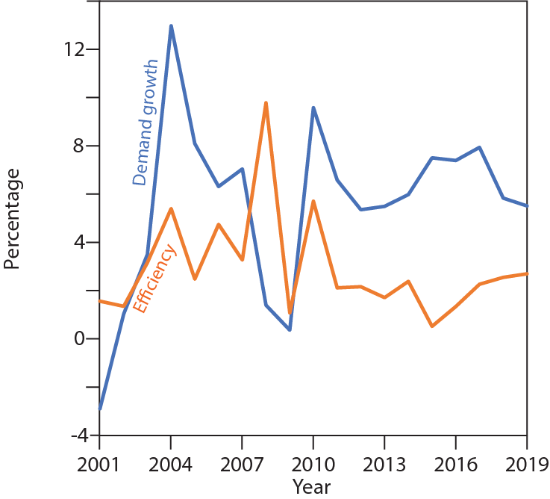
Supplementary Fig. 6| Percentage growth per year for passenger aviation demand compared to previous year and percentage change in energy intensity for passenger aviation compared to previous year. Passenger demand data from ICAO and energy intensity data from IEA²⁶.
Supplementary References
1. World Bank. GDP per capita (current US$). Available at: https://data.worldbank.org/indicator/ny.gdp.pcap.cd.
2. World Bank. Population, total. Available at: https://data.worldbank.org/indicator/SP.POP.TOTL.
3. World Bank (2020b). Air transport, passengers carried. World Bank (2020b) (2020). Available at: https://data.worldbank.org/indicator/IS.AIR.PSGR. (Accessed: 24th June 2022)
4. World Bank. World Bank Country and Lending Groups. Available at: https://datahelpdesk.worldbank.org/knowledgebase/articles/906519-world-bank-country-and-lending-groups.
5. IATA. FHT Flight haul type - ATSB. (2020). Available at: https://guides.developer.iata.org/v202/docs/atsb-fht?highlight=. (Accessed: 19th May 2022)
6. Epstein, A. H. & O’Flarity, S. M. Considerations for reducing aviation’s CO2 with aircraft electric propulsion. J. Propuls. Power 35, 572–582 (2019).
7. World Economic Forum. Clean Skies for Tomorrow Sustainable Aviation Fuels as a Pathway to Net-Zero Aviation Terms of use and disclaimer. (2020).
8. IEA. Aviation – Analysis. (2021). Available at: https://www.iea.org/reports/aviation. (Accessed: 12th November 2021)
9. Siddiqui, O. & Dincer, I. A comparative life cycle assessment of clean aviation fuels. Energy 234, 121126 (2021).
10. Li, X. et al. Greenhouse Gas Emissions, Energy Efficiency, and Cost of Synthetic Fuel Production Using Electrochemical CO2 Conversion and the Fischer-Tropsch Process. Energy and Fuels 30, 5980–5989 (2016).
11. Ueckerdt, F. et al. Potential and risks of hydrogen-based e-fuels in climate change mitigation. Nat. Clim. Chang. 2021 115 11, 384–393 (2021).
12. Schmidt, P., Batteiger, V., Roth, A., Weindorf, W. & Raksha, T. Power-to-Liquids as Renewable Fuel Option for Aviation: A Review. Chemie Ing. Tech. 90, 127–140 (2018).
13. Vardon, D. R., Sherbacow, B. J., Guan, K., Heyne, J. S. & Abdullah, Z. Realizing “net-zero-carbon” sustainable aviation fuel. Joule 6, 16–21 (2022).
14. Bosch, J., de Jong, S., Hoefnagels, R. & Slade, R. Aviation biofuels: strategically important, technically achievable, tough to deliver. (2017).
15. O’Connell, A., Kousoulidou, M., Lonza, L. & Weindorf, W. Considerations on GHG emissions and energy balances of promising aviation biofuel pathways. Renew. Sustain. Energy Rev. 101, 504–515 (2019).
16. Hamelinck, C., Cuijpers, M., Spoettle, M. & Bos, A. van den. Biofuels for aviation . (2013).
17. IRENA. Reaching Zero with Renewables: Biojet fuels. (2021).
18. ICAO. ICAO Doc8643. (2022). Available at: https://doc8643.com/search/icao. (Accessed: 24th May 2022)
19. DOE. Hydrogen Storage | Department of Energy. October (2012).
20. IEA. Detailed CO2 estimates, IEA CO2 Emissions from Fuel Combustion Statistics: Greenhouse Gas Emissions from Energy (database). (2022). doi:https://doi.org/10.1787/data-00429-en
21. Carbon Monitor Project. CO2 emissions. (2022). Available at: https://carbonmonitor.org/international-aviation. (Accessed: 14th February 2022)
22. ICAO. The air transport industry. (2014). Available at: https://www.icao.int/sustainability/documents/AirTransport-figures.pdf. (Accessed: 29th June 2022)
23. ICAO. The World of Air Transport in 2019. (2020). Available at: https://www.icao.int/annual-report-2019/Pages/the-world-of-air-transport-in-2019.aspx. (Accessed: 29th June 2022)
24. World Bank. Air transport, freight (million ton-km) | Data. Available at: https://data.worldbank.org/indicator/IS.AIR.GOOD.MT.K1. (Accessed: 14th February 2022)
25. Freight Waves. IATA forecasts 2021 air cargo revenues to hit record $175B - FreightWaves. (2021). Available at: https://www.freightwaves.com/news/iata-forecasts-2021-air-cargo-revenues-to-hit-record-175b. (Accessed: 14th February 2022)
26. IEA. Energy intensity of passenger aviation in the Net Zero Scenario, 2000-2030 – Charts – Data & Statistics - IEA. (2021). Available at: https://www.iea.org/data-and-statistics/charts/energy-intensity-of-passenger-aviation-in-the-net-zero-scenario-2000-2030. (Accessed: 28th February 2022)
27. IEA. Oil demand by product for non-OECD countries. IEA World Energy Statistics and Balances (database) (2022). doi:https://doi.org/10.1787/data-00511-en
28. IMF. World Economic Outlook Database. (2021). Available at: https://www.imf.org/en/Publications/WEO/weo-database/2021/October. (Accessed: 14th February 2022)
29. ICAO. Appendix A: Traffic Forecasts. (2021). Available at: https://www.icao.int/sustainability/Documents/Post-COVID-19 forecasts scenarios tables.pdf. (Accessed: 12th November 2021)
30. Zheng, X. S. & Rutherford, D. Fuel burn of new commercial jet aircraft: 1960 to 2019. (2020).
31. ICAO. Resolution A40-18: Consolidated statement of continuing ICAO policies and practices related to environmental protection – Climate change. 1–9 (2019).
32. IATA. IATA - Net-Zero Carbon Emissions by 2050. (2021). Available at: https://www.iata.org/en/pressroom/2021-releases/2021-10-04-03/. (Accessed: 13th December 2021)
33. IEA. Net Zero by 2050 A Roadmap for the Global Energy Sector. (2021).

