Supplementary material

Supplementary figures

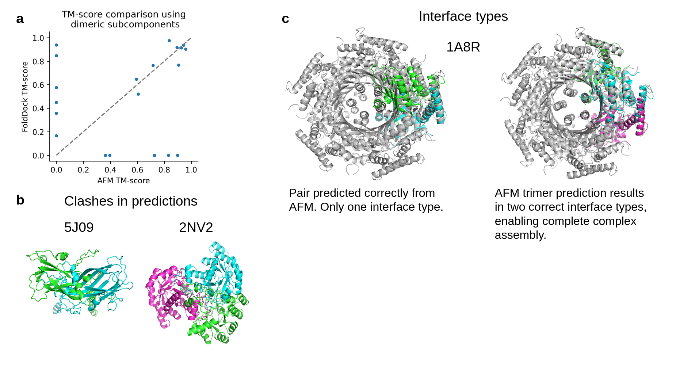

Supplementary Figure 1. a) TM-scores for the 21 complexes that could be assembled to completion using pairwise interactions with AFM or FoldDock (AF) respectively. b) Clashes in the predictions are shown for pairwise and trimeric interactions belonging to the complexes 5J09 and 2NV2 respectively. c) Assembly overlaps occur due to only one possible configuration being predicted. PDB ID 1A8R, is a homo 10-mer, containing only one unique chain (A10). This means that all interactions are between copies of this chain. When predicting pairwise interactions, only one conformation is found. This can be circumvented by predicting trimeric interactions.

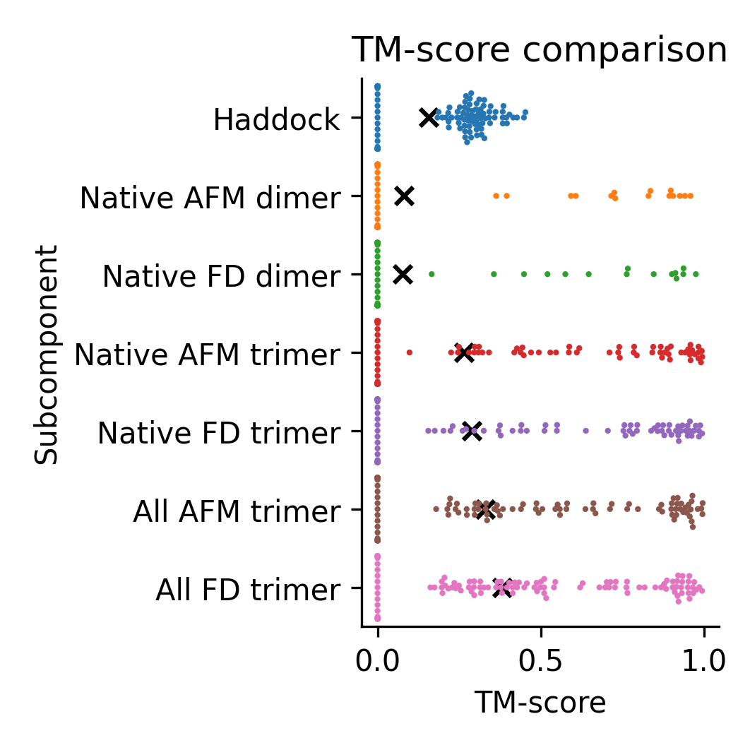
Supplementary Figure 2. TM-scores for the complexes that could be assembled to completion using Haddock with native chain structures, FoldDock (FD) or AFM and predicted native dimeric, native trimeric and all trimeric subcomponents, respectively. The complete set of complexes from the three approaches (n=140) is shown, with scores of zero representing missing complexes for each approach. The points display the TM-score of the individual complexes and the black “x” marks the average scores. The average TM-scores are 0.16, 0.08, 0.08, 0.27, 0.29, 0.33 and 0.38 from top to bottom, respectively.

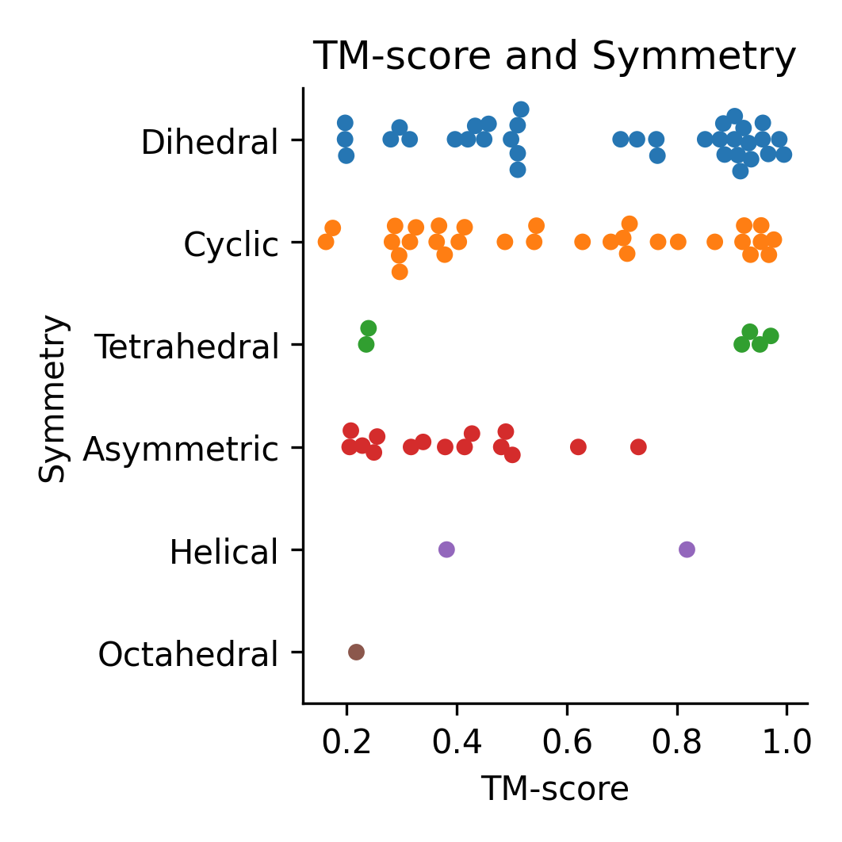
Supplementary Figure 3. TM-score and symmetry for the complete assembled complexes (n=91) using all possible trimers predicted with FoldDock. The number of assembled complexes per symmetry are: Dihedral: 36, Cyclic: 31, Tetrahedral: 6, Asymmetric: 15, Helical: 2 and Octahedral: 1. The median TM-scores are: Dihedral: 0.75, Cyclic: 0.54, Tetrahedral: 0.93, Asymmetric: 0.38, Helical: 0.60, Octahedral: 0.22.

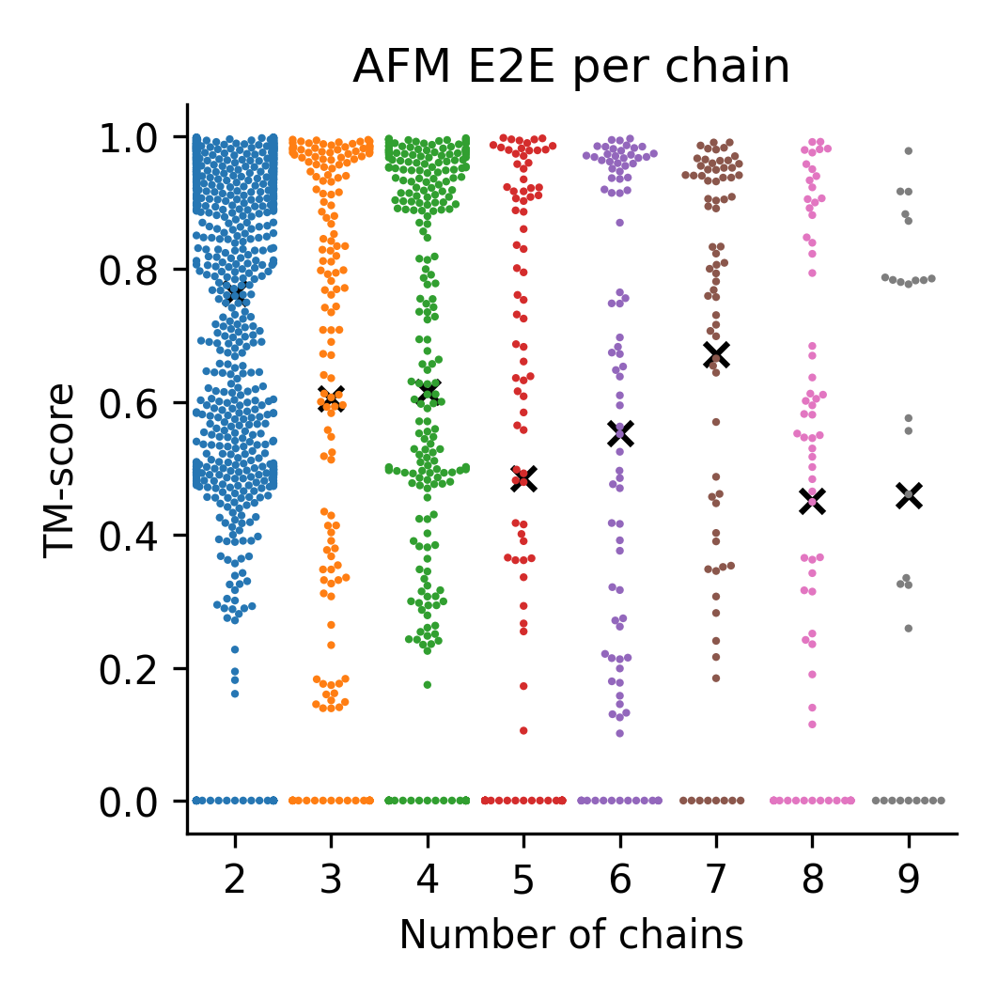
Supplementary Figure 4. TM-score for AFM E2E on a dataset without homology to the AFM training set consisting of 931 dimers, 164 trimers, 269 tetramers, 103 pentamers, 91 hexamers, 74 heptamers, 73 octamers and 28 nonamers. The black “x” marks the average for each oligomer and each point represents one sample. The samples at 0 are those that failed due to memory limitations. The average score decreases with the number of chains.

Supplementary tables
Supplementary Table 1. Median TM-score and the number of complexes assembled to completion for AlphaFold-multimer (AFM) and FoldDock using different subcomponents.
Method | Subcomponent | Median TM-score | Complete assemblies out of 175 in total
AFM | Native dimer | 0.83 | 15
FoldDock | Native dimer | 0.77 | 15
AFM | Native trimer | 0.74 | 55
FoldDock | Native trimer | 0.88 | 58
AFM | All-trimer | 0.61 | 74
FoldDock | All-trimer | 0.51 | 91

Supplementary Table 2. Average TM-score and the number of complexes assembled to completion across all approaches for AlphaFold-multimer (AFM) and FoldDock.
Method | Subcomponent | Average TM-score | Complete assemblies out of 175 in total
AFM | Native dimer | 0.10 | 113
FoldDock | Native dimer | 0.09 | 113
AFM | Native trimer | 0.33 | 113
FoldDock | Native trimer | 0,36 | 113
AFM | All-trimer | 0.41 | 113
FoldDock | All-trimer | 0.47 | 113

