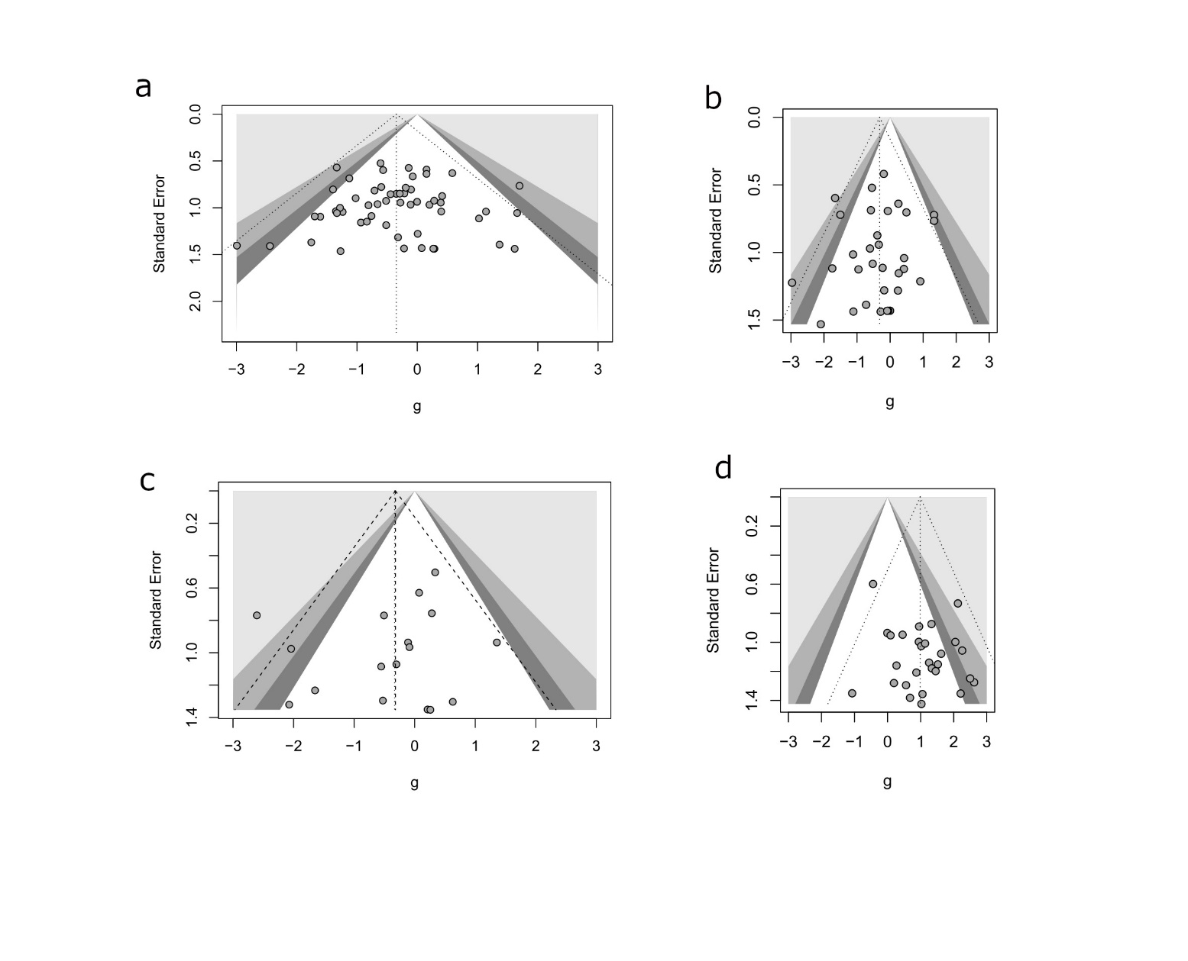
Fig.S2. Funnel plots for the different unconditioned behaviours discussed in the manuscript. Dotted lines show the distribution of reported effect sizes. Shaded regions indicate the significance of the reported effect size. (a) Elevated plus maze, (b) Open field test, (c) Sucrose preference test, (d) Forced swim test. The symmetry of each plot indicates that there was no publication bias in the studies selected for the meta-analyses.

