Table 2. The 2D-structure, molecular weight, and binding affinities with selected protein targets (kcal/mol) of 19 highly bioactive compounds derived from SR.

Compound Name | M.Weight | α-amylase | α- glucosidase | DPP-4 | GLP-IR | PPAR-γ | PTP1B | Compounds Structure
Salidroside | 300.3 | -7.6 | -9.2 | -7.8 | -7.2 | -7.7 | -7.7 | 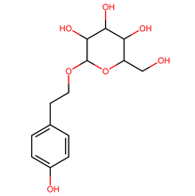
3b,12a-Dihydroxy-5b-cholanic acid | 392.6 | -8.9 | -10.9 | -9 | -8.9 | -7.4 | -7.4 | 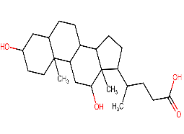
5-p-Coumaroylquinic acid | 338.3 | -7.8 | -8.6 | -7.1 | -7.3 | -7.9 | -7.7 | 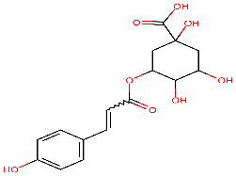
Luteolin | 286.2 | -8.6 | -9.3 | -9 | -7.3 | -7.1 | -7.3 | 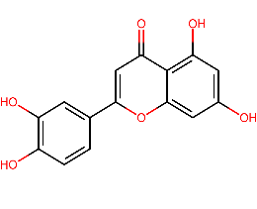
Genistein | 270.2 | -8.4 | -8.9 | -8.8 | -7 | -7.5 | -7.1 | 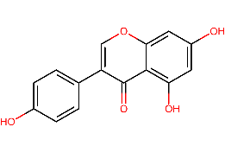
Esculin | 340.2 | -7.4 | -8.5 | -7.8 | -7.3 | -7.3 | -8.1 | 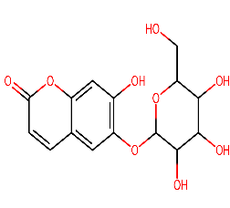
Diosmetin | 300.2 | -7.8 | -8.8 | -9.2 | -7.3 | -7.1 | -7.1 | 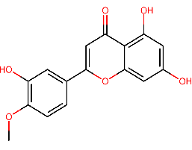
4-Coumaroylquinic acid | 338.3 | -7.5 | -8.4 | -7.7 | -7.3 | -8 | -7.5 | 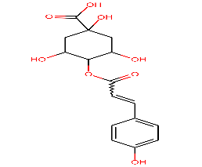
3-O-caffeoylshikimic acid | 336.2 | -7.7 | -8.7 | -7.3 | -7.3 | -7.6 | -7 | 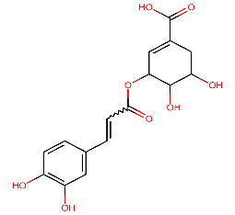
Ethyl chlorogenate isomer 1 | 382.4 | -7.6 | -8.8 | -7.8 | -7.3 | -7.9 | -7.3 | 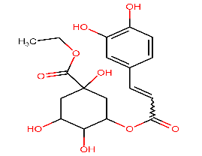
Sterebin N | 338.5 | -8.3 | -9.4 | -7.7 | -7.9 | -7.7 | -7.1 | 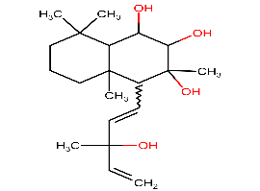
Steviolmonoside | 480.6 | -9.6 | -10.1 | -8.4 | -9.1 | -7.1 | -8 | 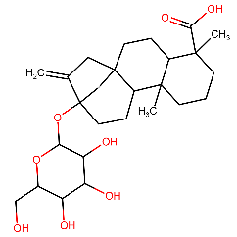
4-O-caffeoylshikimic acid | 336.2 | -8 | -8.9 | -8.2 | -7.5 | -7.7 | -7.4 | 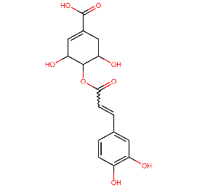
Austroinulin | 322.5 | -8.5 | -9.7 | -7.4 | -8.5 | -8.1 | -8 | 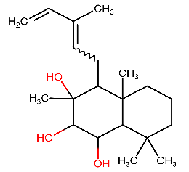
3-Coumaroylquinic acid | 320.2 | -7.7 | -8.8 | -8 | -7.1 | -7.9 | -8 | 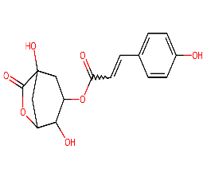
Sterebin B | 352.5 | -8.4 | -8.2 | -7.3 | -7.7 | -7.2 | -7.1 | 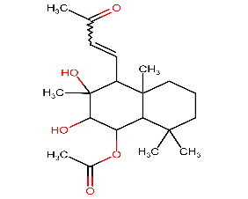
Sterebin E | 338.5 | -8.9 | -9.1 | -7.3 | -8 | -7.1 | -7.2 | 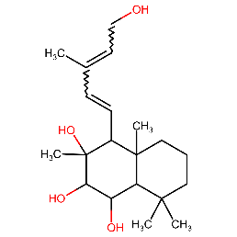
6-O-Acetylaustroinulin | 364.5 | -8.7 | -8.3 | -7.4 | -7.7 | -7.4 | -7 | 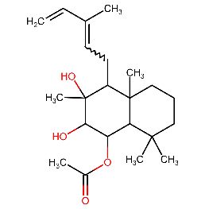
Isosteviol | 318.4 | -9 | -9.7 | -7.4 | -8.4 | -7.9 | -7 | 