Supplementary material
Materials and Methods
PK and PD sample preparation
For pharmacokinetics analysis, blood samples were collected with dipotassium ethylenediaminetetra acetic acid (K₂EDTA) tubes, and plasma samples were prepared by centrifugation for 10 min at approximately 2000 g and 4ºC.
For measuring of serum glucose and C-peptide, blood samples were collected with Serum Separator Tubes, and obtained serum samples following centrifugation for 10-15 min at approximately 1100-1300 g after standing for a minimum of 30 minutes.
For measuring of plasma GLP-1, blood samples were collected into Becton Dickenson BD P800 tubes that contained K₂EDTA and proprietary additives. Plasma samples were prepared by centrifugation for 20 min at approximately 1100-1300 g.
All plasma samples obtained were stored at -70ºC or lower until shipment on dry ice for analysis. Serum samples were refrigerated prior to analysis.

Analytical methods
- Dorzagliatin and sitagliptin
Dorzagliatin and sitagliptin concentrations in plasma were determined by validated liquid chromatography-tandem mass spectrometry (LC-MS/MS) methods (Frontage Laboratories, Inc., Pennsylvania, USA). The concentrations were calculated by using peak area ratios and linear regression with 1/x² weighting to generate the best-fit concentration-response relationship.
For Dorzagliatin, the lower limit of quantitation (LLOQ) in plasma was 1 ng/mL with linearity to 1200 ng/mL; the accuracy of this assay was between 0.0 – 8.3%, and the precision was ≤6.1%. For sitagliptin, the LLOQ of was 1 ng/mL, with linearity to 1000 ng/mL; the accuracy of this assay was between 0.7 – 9.7%, and the precision was ≤9.0%.
No obvious interference was observed in human plasma between sitagliptin and dorzagliatin. The stability of both analytes in human plasma was validated to cover the period from sample collection to sample analysis. It was proved that the LC-MS/MS methods demonstrated acceptable accuracy, precision, and stability under different conditions for both analytes.
- GLP-1
GLP-1 in human plasma was determined by well-validated enzyme-linked immunosorbent assays at Mercordia (Uppsala, Sweden). Mercodia Total GLP-1 NL-ELISA kit (10-1278-01) was employed for Total GLP-1 measurement, with validated LLOQ of 1.7 pmol/L and ULOQ of 940 pmol/L. Millipore High Sensitivity Active GLP-1 Chemiluminescent ELISA kit (EZGLPHS-35K) was used for active GLP-1 measurement, with validated LLOQ of 1.32 pmol/L and ULOQ of 74.52 pmol/L. The concentration of GLP-1 was interpolated using five parameter Marquardt logistic equation model. Both assays had good relative accuracy and precision.
Figure S1. Overall study design in the studies. (CRC=clinical research center)

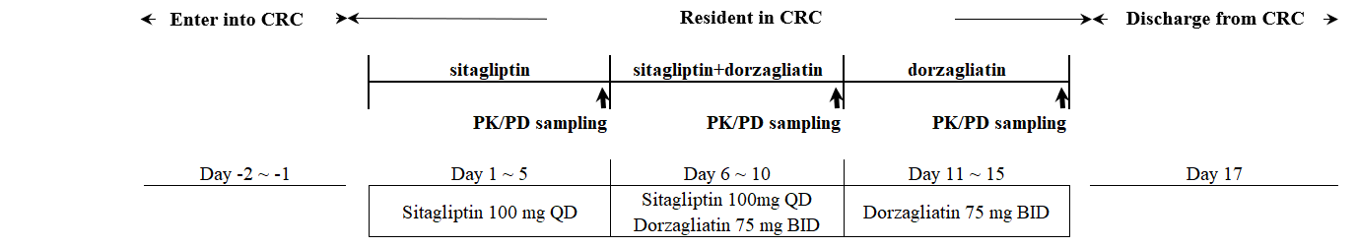

Figure S2. Glucose, C-peptide and GLP-1 concentration-time curves under sitagliptin, sitagliptin+dorzagliatin, and dorzagliatin therapy.
- Glucose b. C-peptide
c. GLP-1_{total} d. GLP-1_{active}

Figure S3. Pharmacokinetic dorzagliatin exposure-time curve and GLP-1 concentration-time curve of dorzagliatin (Dorza) and sitagliptin+dorzagliatin (Dorza+Sita) therapy.

Figure S4. Forest plot of dorzagliatin and sitagliptin drug-drug interaction assessment of PK parameters
The dotted lines indicate bioequivalence limits of 80% and 125%

Table S1. Adverse events and hypoglycaemic events (safety population)
 | Sitagliptin | Dorzagliatin | Sitagliptin
 | Sitagliptin | Dorzagliatin | +Dorzagliatin
 | (N=15) | (N=15) | (N=15)
TEAE | 5 (33.3) | 4 (26.7) | 4 (26.7)
Headache | 2 (13.3) | 2 (13.3) | 1 (6.7)
Rash | 0 | 1 (6.7) | 1 (6.7)
Dermatitis | 1 (6.7) | 0 | 0
Pruritus | 0 | 0 | 1 (6.7)
Rash erythematous | 0 | 1 (6.7) | 0
Constipation | 1 (6.7) | 0 | 0
Abdominal pain upper | 0 | 0 | 0
Nausea | 0 | 0 | 1 (6.7)
Vomiting | 0 | 0 | 0
Vision blurred | 0 | 0 | 0
Dizziness | 0 | 0 | 0
Syncope | 0 | 0 | 0
Anemia | 0 | 0 | 0
Tinnitus | 0 | 0 | 0
Chest pain | 0 | 0 | 0
Hunger | 0 | 0 | 1 (6.7)
Glycosuria | 1 (6.7) | 0 | 1 (6.7)
Pruritus genital | 0 | 0 | 0
Nasal congestion | 1 (6.7) | 0 | 0
Hyperkalemia | 0 | 0 | 0
Severe TEAE | 0 | 0 | 0
SAE | 0 | 0 | 0
Possibly or probably related | 1 (6.7) | 2 (13.3) | 3 (20.0)
Discontinuation due to AE | 0 | 1 (6.7) | 0
Hypoglycemia | 0 | 0 | 1 (6.7)
Blood glucose < 54 mg/dL (3.0 mmol/L) | 0 | 0 | 1 (6.7)
Values are presented as n (%). n (%) = number and percent of subjects in the specified group.
AE=adverse event. TEAE = treatment emergent adverse event. SAE=serious adverse event. Adverse events were considered treatment-emergent if not present prior to initiation of the treatment with study drug on Day 1 or already present but worsened in either severity or frequency following exposure to the treatment.

