Supplementary Information for
Alarm communication predates eusociality in termites

David Sillam-Dussès, Vojtěch Jandák, Petr Stiblik, Olivier Delattre, Thomas Chouvenc, Ondřej Balvín, Josef Cvačka, Delphine Soulet, Jiří Synek, Marek Brothánek, Ondřej Jiříček, Michael S. Engel*, Thomas Bourguignon, Jan Šobotník*
- Michael S. Engel (msengel@ku.edu) & Jan Šobotník (sobotnik@ftz.czu.cz)

Included in this document:
  - Analytical chemistry method
  - Figures S1-S6
  - Tables S1-S4
  - References not included in the main text

Provided outside of this document:
  - Dataset S1: List of characters (from X1 to X33) from the wood roach Cryptocercus punctulatus and from termites. Information about alarm characters is retrieved from literature when indicated or from our experiments when no literature reference is provided (in that case, the country of collection of the species is given). All characters are used in the analysis (except X1-X4 which have been excluded from Multiple Correspondence Analysis because they resulted from other characteristics). “?” means that no information is available or the character is inapplicable. Tables and figures with species codes refer to the ones of this table. The caste ratio of workers and soldiers used in the experimental groups is indicated for the species studied in the behavioural experiments. Life type refers to the classification of Abe (1), i.e. one-piece life-type for termites that feed on wood in which they also nest, intermediate life-type for termites which nest in wood but can colonize new food sources through underground galleries, and separate life-type for species in which workers forage outside the nest.
  - Movie S1: Experimental set-up to record in an anechoic room the tremulations (vibroacoustic behaviour) of individuals of the wood roach Cryptocercus punctulatus and the termites Mastotermes darwiniensis, Hodotermopsis sjostedti, Neotermes cubanus, Glossotermes oculatus, Reticulitermes flavipes, Labiotermes labralis, Termes hospes, and Constrictotermes cyphergaster. The circles show one specific individual whose vibroacoustic communication displayed on the following graph.

Analytical chemistry:
Cold-anesthetized termites were dissected using a stereomicroscope. Termite heads with the frontal gland from 2-20 individuals were placed into a 2-mL clear glass vial, crushed using a glass rod and the vial was closed with a PTFE/silicone septum cap.
The headspace extraction of volatiles was carried out using an SPME fiber holder for manual sampling equipped with a fused silica fiber coated with 30 µm polydimethylsiloxane (Supelco, Bellefonte, USA). The holder needle was passed through the vial septum and the fiber was exposed for 10 minutes at room temperature. The analytes were desorbed at 220°C in a split/splitless injector of a 5975B quadrupole mass spectrometer coupled to a 6890N gas chromatograph (Agilent, Santa Clara, CA). The separation was achieved on a DB-5ms capillary column (30 m × 0.25 mm, a film thickness of 0.25 µm, Agilent) at a constant flow mode (1 ml/min) with helium as a carrier gas. The temperature program was: 40°C (1 min), then 5°C/min to 200°C, then 15°C/min to 320°C (3 min). The temperatures of the transfer line, ion source, and quadrupole were 280°C, 230°C, and 150°C, respectively. The compounds were ionized by 70 eV electrons.
The liquid extraction was achieved by adding 50 - 100 µl of hexane to freshly crushed termite heads. The extracts were analyzed on the same GC-MS instrument and the same column as above with slightly modified parameters. The injector held at 250°C and operated with a split ratio of 1:20 injected 1 μl of the extract. The temperature program was as follow: 50°C (1 min), then 15°C/min to 200°C, then 6°C/min to 320°C (3 min); total run time was 34 min. Data were recorded with a 4-min solvent delay.

Fig. S1: GC/MS full-scan chromatograms of compounds from soldier heads obtained by hexane extraction (A, C) or from SPME-headspace (B, D) in Mastotermes darwiniensis (A, B) and Glossotermes oculatus (C, D).
Mastotermes darwiniensis: A: Heads of 5 soldiers were extracted in 32 μl of hexane, and 1 μl of the extract was injected into the GC/MS. Data show a strong signal of p-benzoquinone and numerous peaks of hydrocarbons, likely of cuticular origin. B: Heads of 5 soldiers were crushed at the bottom of a 2-mL glass vial. The vial was sealed, the SPME holder needle was passed through the vial septum, and the fiber was exposed for 10 minutes at room temperature. The volatiles were desorbed in the GC injector. Data show a strong signal of p-benzoquinone and three siloxane peaks marked by an asterisk (laboratory contamination).
Glossotermes oculatus: C: Heads of 10 soldiers were extracted as described above for M. darwiniensis. Data show the absence of any specific compound which plays the role of the alarm pheromone. The peaks at higher retention times (Chol) can be attributed to aliphatic compounds with high molecular weight, likely hydrocarbons (tR = 28.5 min and 30.4 min) or cholesterol (tR = 26.9 min). D: Heads of 6 soldiers were crushed and analyzed by SPME as described above for M. darwiniensis. Data show the absence of any specific compound which could be the alarm pheromone in this species.
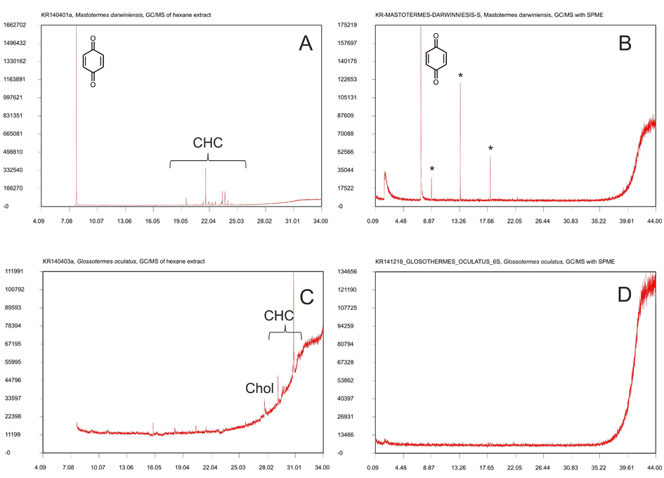

Fig. S2: Workflow of vibroacoustic recording. Detailed explanation of data acquisition for the vibroacoustic experiments.
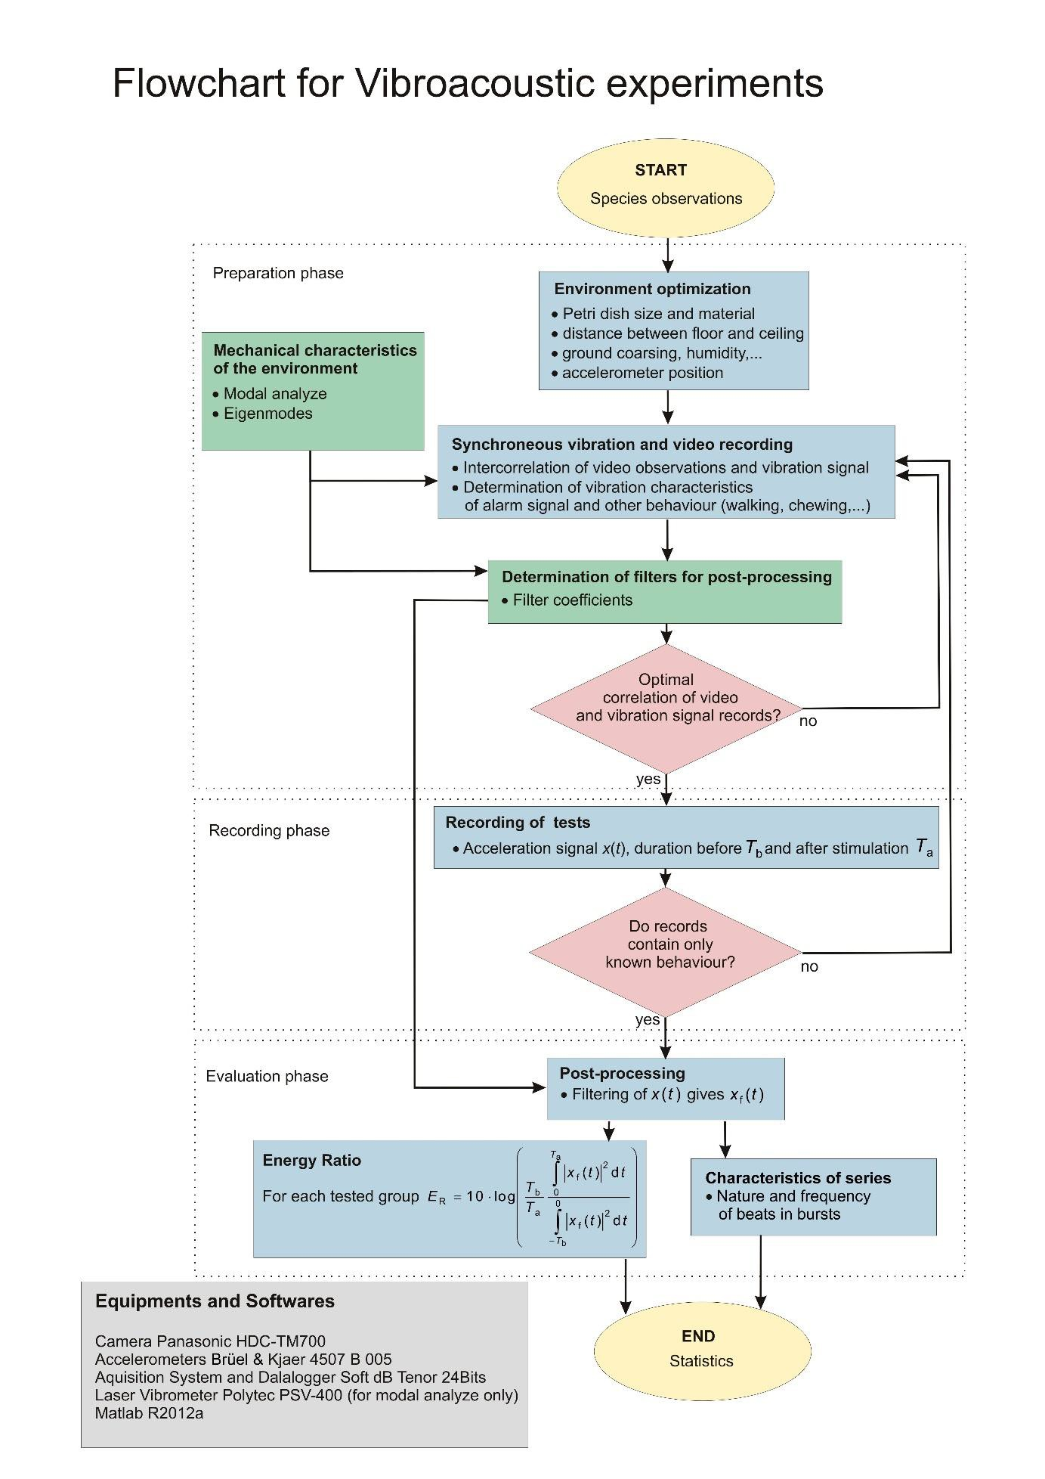

Fig. S3: Schematic representation of the vibroacoustic alarm communication. Black upward arrows represent tremulation beats, blue upward arrows represent drumming beats, and blue downward arrows represent head-banging beats. The beats are separated by short (at high frequency; in green) or long (at low frequency; in yellow) breaks and the average duration between each beat is indicated.

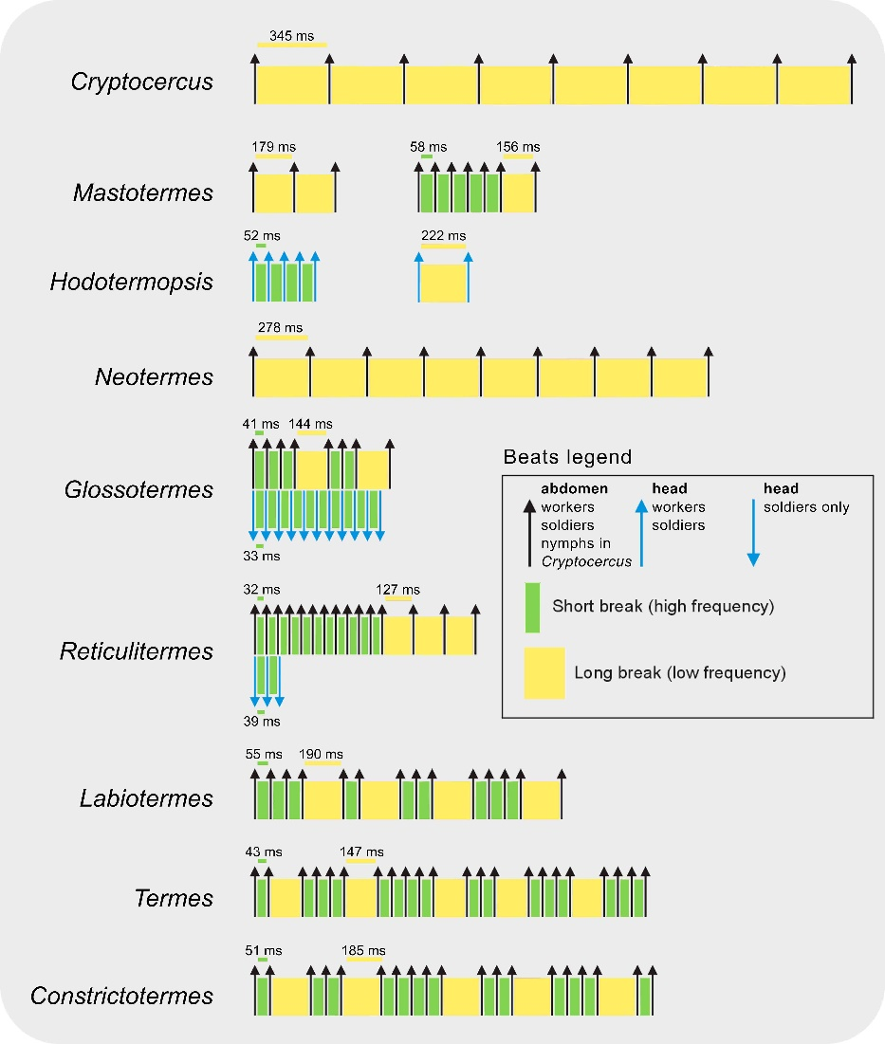
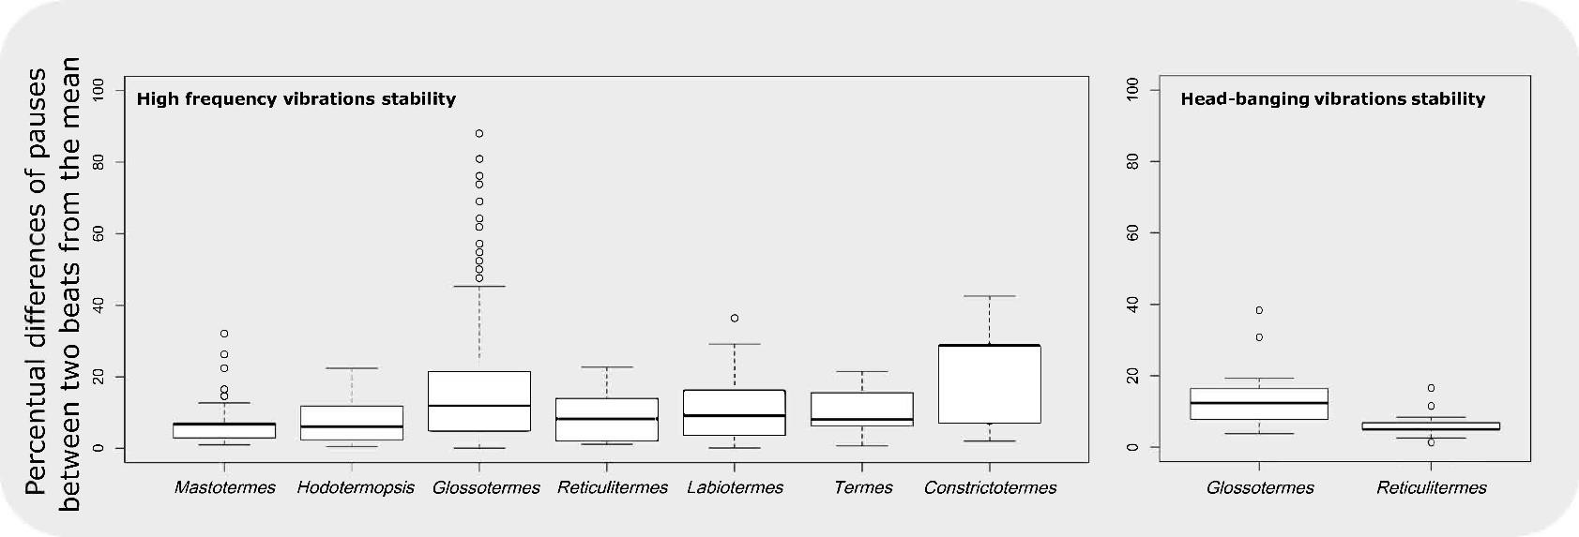
Fig. S4: Stability of vibrations frequency. Stability of pauses in high tremulations and head-banging among studied termites. The values are given as percentual difference from the mean duration.

Fig. S5: Multiple Correspondence Analysis (MCA) analysis showing the ecological variables with the strongest effects upon the vibroacoustic communication. Constraining variables of the MCA analyses were counted for the strongest effect in the three first axes and they presented 6 variables (family, food source, nest material, foraging area, chemical alarm, and food hardness) which showed distribution for the most significant axes. See Dataset S1 for characters’ legends.
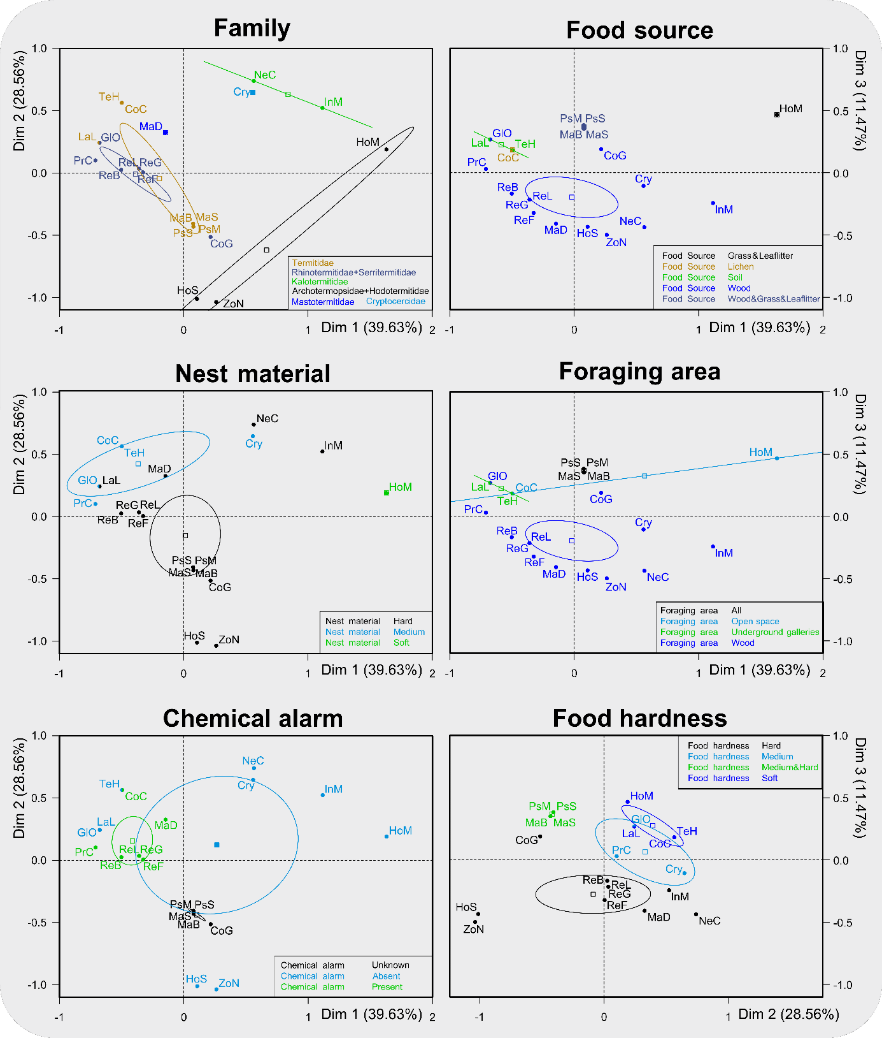

Fig. S6: Correlation analysis between ecological characters and alarm characters. Correlation is indicated by green fields; blank means no correlation.
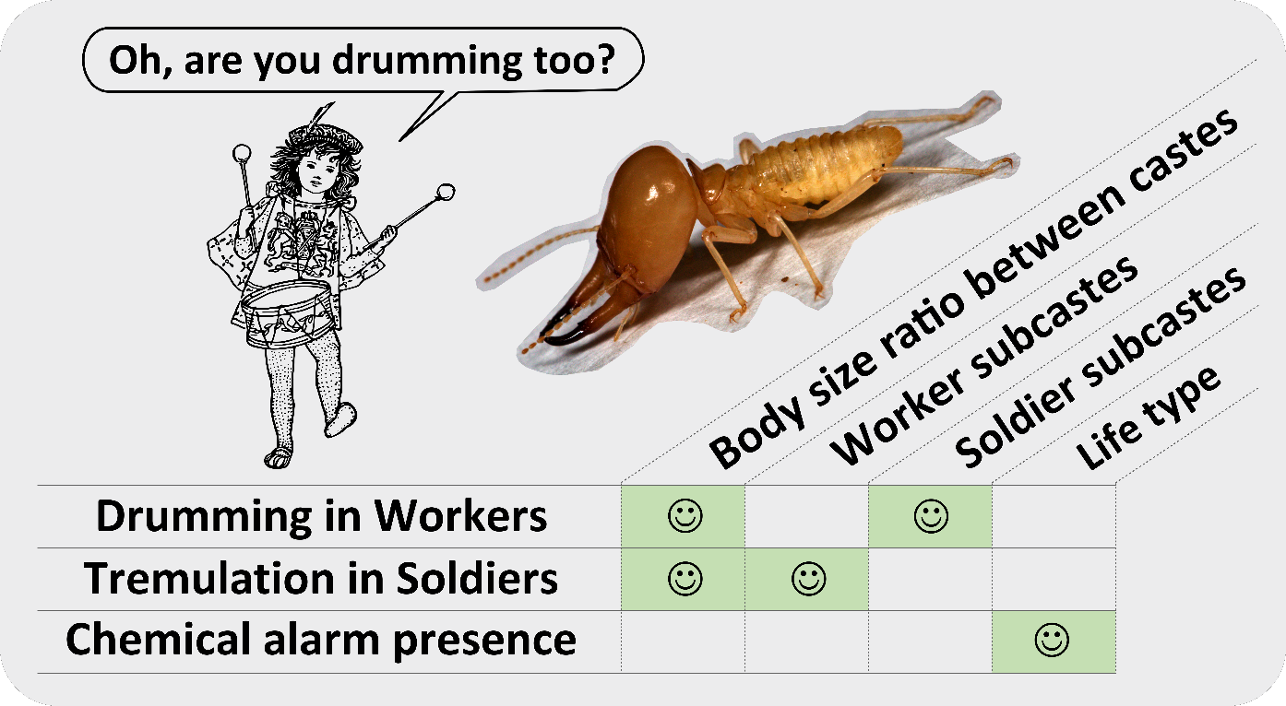

Table S1: Normalized speed-of-motion (mm/s ± SE) of nymphs in the wood roach Cryptocercus, and of workers and soldier within termite groups in natural caste ratio (according to Haverty (2) or to our unpublished observations; for details see Dataset S1) in Petri dish stimulated with light flash (light), air current (air), one crushed worker head (CWH) or one crushed soldier head (CSH). The locomotion speed is given as an average scored from two nymphs in the wood roach, or from two workers and two soldiers in termites per experiment. The changes in locomotion speed for workers and soldiers, and the respective P-values for all comparisons between stimulations and controls are presented for short-term (1 min) and long- term (6 min) response to the stimuli. Negative values indicate that termites were more active prior to the stimulation. Kruskal-Wallis and post-hoc two-by-two permutation tests results are given for workers and soldiers independently. The value of Kruskal-Wallis test is given (H) and P’-values for all tests are given for P < 0.05 at the last line for each species. “NS” indicates non-significant results. “NA” indicates not applicable. "-" indicates that the overall comparison (Kruskal-Wallis test) was not significant in one given species.
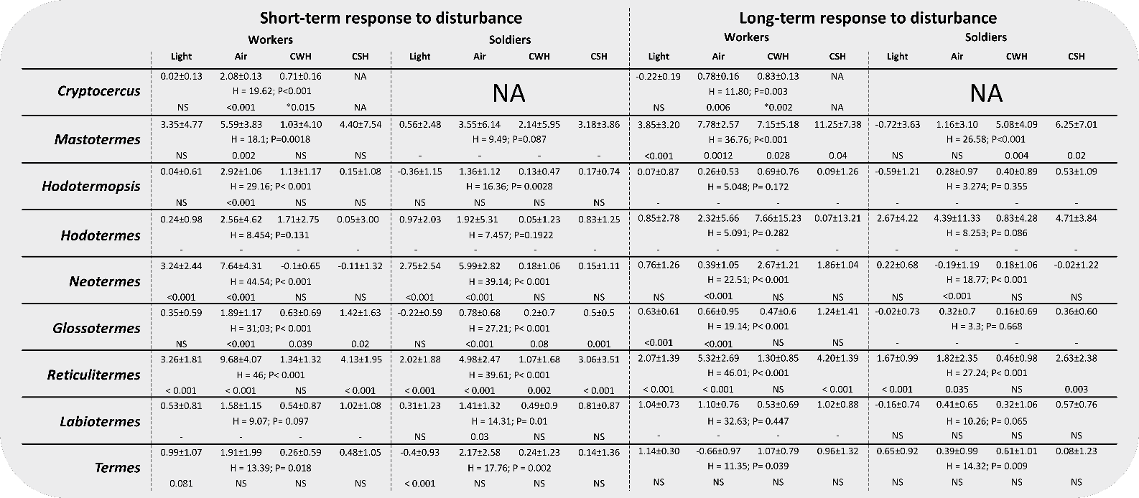

Table S2: Identity of the compounds (detected from glandular extracts or SPME collections) released from labial glands or the frontal gland in the termite species studied. Some of the compounds are used as alarm pheromones (CHC = cuticular hydrocarbons; Ø = no compound detected; N.A. = not available).
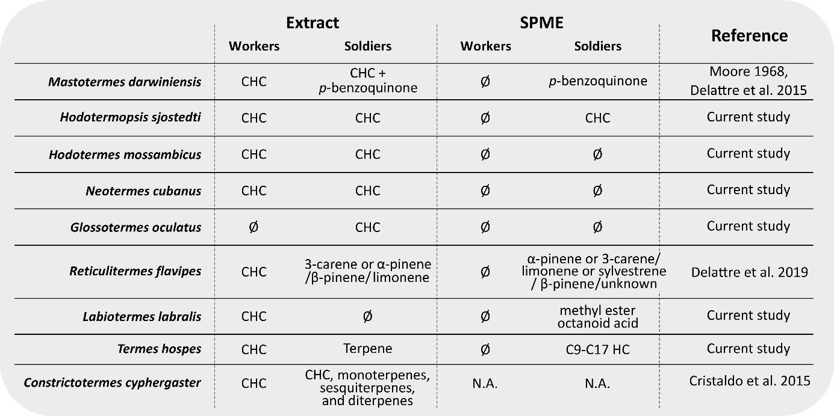

Table S3: Long-term differences in vibroacoustic alarm signaling after air blow expressed as normalized activity prior vs. after disturbance. Termites usually responded by increased vibroacoustic activity after the disturbance. The exception of Hodotermes is due the fact that according our knowledge it misses any alarm communication.
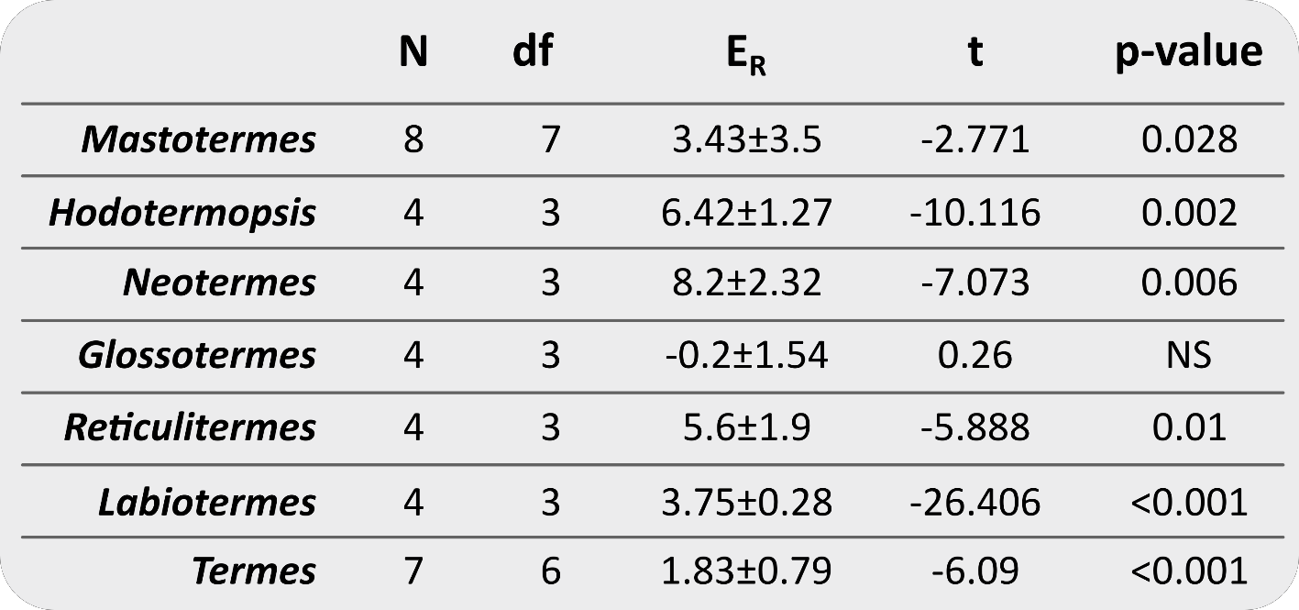

Table S4: Overview of responses (running and/or vibrating) of workers and soldiers of different termite species after exposure to crushed soldier head (CSH – alarm pheromone simulation) in the experimental conditions of Table 2. Increased locomotion activity (running) or vibration activity indicates behavioural response to alarm pheromone.
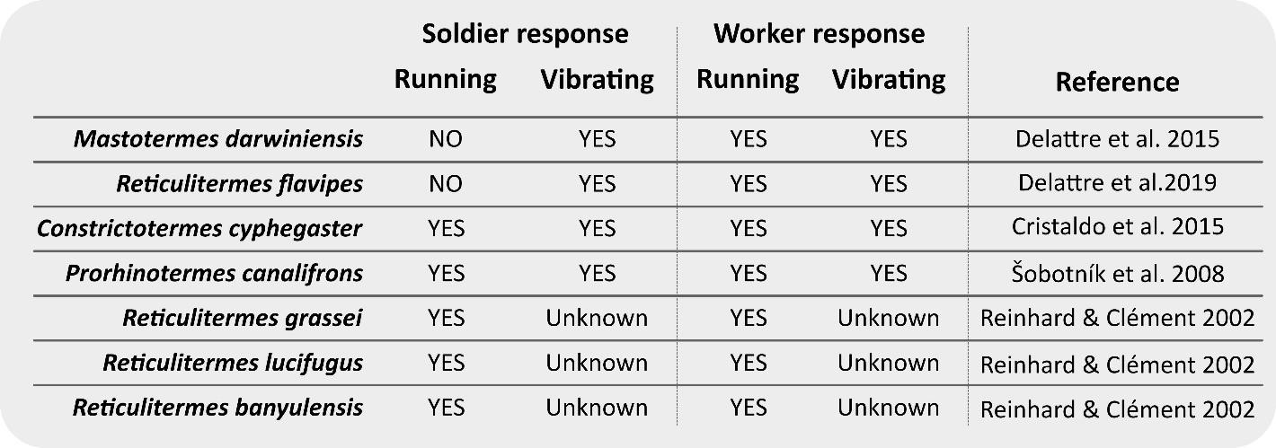

References
- Abe, T. “Evolution of life types in termites” in Evolution and Coadaptation in Biotic Communities, S. Kawano, J. H. Connell, and T. Hidaka, Eds. (1987) pp. 125–148.
- Haverty, M. I. The proportion of soldiers in termite colonies: a list and a bibliography.
Sociobiology 2, 199–216 (1977).

