Supplementary Material
Anti-Corrosion potential of the Ortho and Para-Substituted Schiff Bases of 2-Methoxybenzaldehyde on Fe (110) surface in acid medium: Synthesis, DFT and Molecular Dynamics Studies
Collins U. Ibeji*^{1,2}, Damilola C. Akintayo³*, Henry O. Oluwasola¹, Eric O. Akintemi³
¹Department of Pure and Industrial Chemistry, Faculty of Physical Sciences, University of Nigeria, Nsukka 410001, Enugu State, Nigeria.
²Catalysis and Peptide Research Unit, School of Health Sciences, University of KwaZulu-Natal, Westville Campus, Durban 4041, South Africa.
³School of Chemistry and Physics, University of KwaZulu-Natal, P.M.B. X54001, Durban, 4000, South Africa.
*Corresponding authors: ugochukwu.ibeji@unn.edu.ng (C. U. Ibeji). ORCID: 0000-0003-4762-2256; damilolaakintayo141@gmail.com (D. C. Akintayo). ORCID: 0000-0003-1742-3571

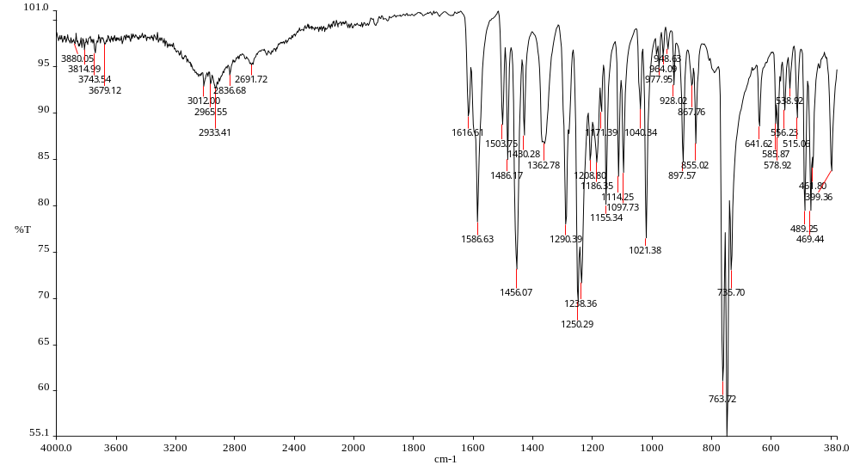

Figure S1: FTIR of (E)-2-((2-methoxybenzylidene)amino)phenol (L1)

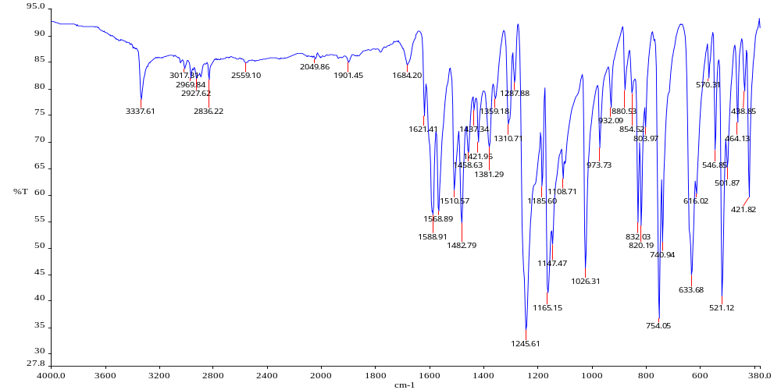
Figure S2: (E)-2-((4-methoxybenzylidene)amino)phenol (L2)

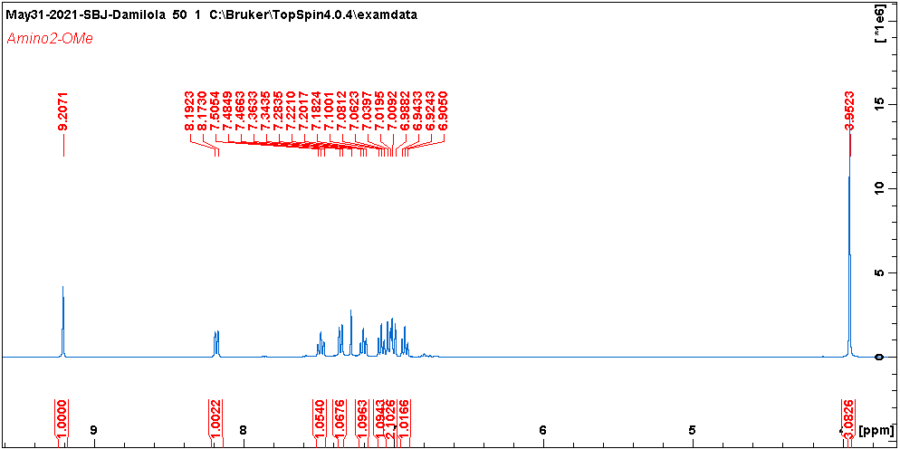
Figure S3: ¹H NMR(E)-2-((2-methoxybenzylidene)amino)phenol (L1)

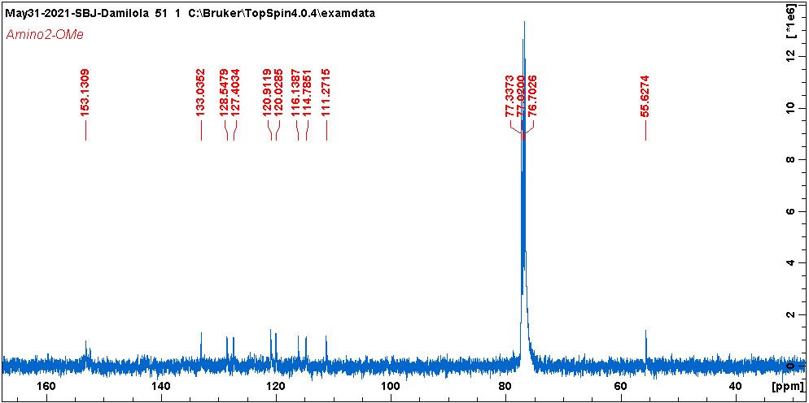
Figure S4: ¹³C NMR(E)-2-((2-methoxybenzylidene)amino)phenol (L2)

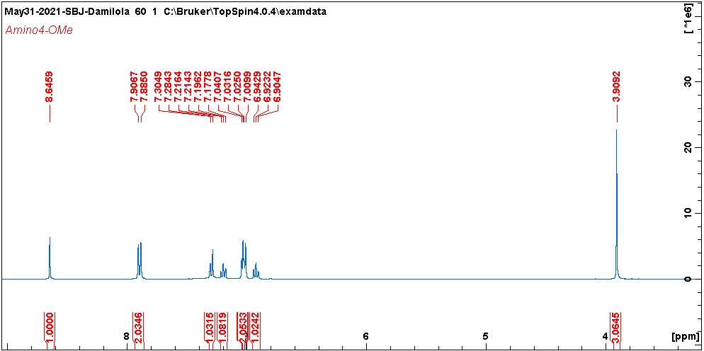
Figure S5: ¹H NMR(E)-2-((4-methoxybenzylidene)amino)phenol (L2)

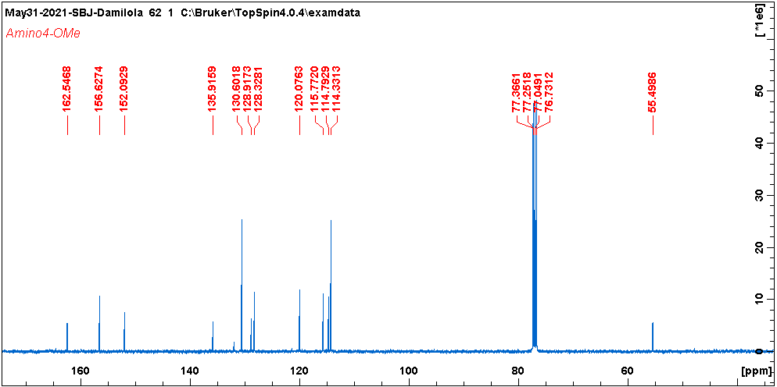
Figure S6: ¹³C NMR(E)-2-((4-methoxybenzylidene)amino)phenol (L2)

Figure S7: Langmuir adsorption isotherm plots for mild steel in 0.1 M HCl containing various concentrations of (a) L1 and (b) L2 inhibitor at temperatures of 303 K, 333 K, and 363 K for 3 h

Figure S8: Arrhenius plot of mild steel in 0.1M HCl medium in blank or varying concentration of (a) L1 and (b) L2

Figure S9: Transition state plot of log CR/T vs. 1/T for mild steel corrosion in 0.1 mol L⁻¹ HCl in the absence and presence of varying concentration of (a) L1 and (b) L2

