Supporting information – ZnO NRs

Exemplary, Figure S1 (a) shows a 10 kV-SE image at of a typical cross-section of a ZnO NR film grown at 90°C for 3 hours on a drop-casted seeded substrate. To demonstrate the very good coverage of the ZnO NRs over the seeded substrate, a low magnification top-view SE image of the same sample as in Figure S1 (a) is shown in Figure S1 (b). The precise calculation of the density of NRs (per µm²) was not possible due to the large angular distribution of the NRs with respect to the substrate normal.
Figure S1 (a) Cross-section SE image at 10 kV of as-grown ZnO NRs at 90°C for 3 hours on a drop-casted seeded substrate. The scale bar represents 200 nm. (b) Top-view SE image at 10 kV of the same sample, showing very good coverage of ZnO NRs over a large area of substrate. The scale bar denotes 2 µm.

Fig. S2 shows the low temperature CL spectra of the a-plane ZnO single crystal with varying acceleration voltage from 5 kV to 15 kV. A 2-fold enhancement of the UV emission can be observed at HV = 5 kV which can be translated to a probing depth (70% electron energy loss) of 100 nm for the Au NP-coated half of the sample. At higher HV (probing depth of approximately 350 nm for 10 kV and 550 nm for 15 kV), a decreased enhancement of approximately 1.4 is found, agreeing with the Au-ZnO interaction being strongest close to the surface (cf. Table 4 in main text).

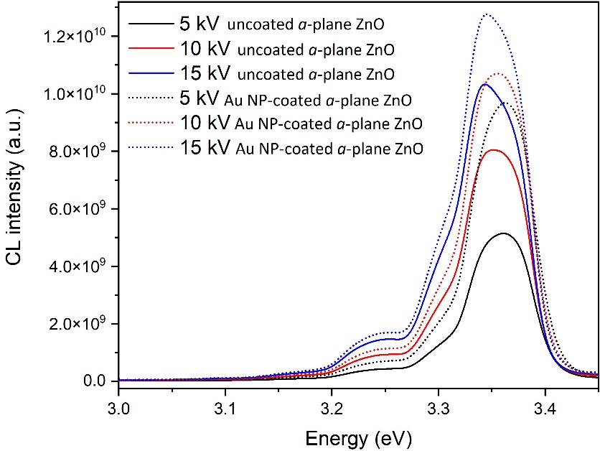
Figure S2 CL spectra of uncoated (solid) and Au NP-coated (dotted) a-plane ZnO single crystal at T = 10 K and varying the acceleration voltage from 5 to 15 kV.

