Supplementary Figure legends

Supplementary Figure 1. Map of Hainan province showing locations of the nine collection study sites. L1 = Yinggeling (YGL), mountain; L2 = Huangjingjiaoling (HJJL), mountain; L3 = Danzhou (DZ), residential areas; L4 = Dongfang (DF), residential areas; L5 = Haikou (HK), residential areas; L6 = Jianfengling (JFL), mountain; L7 = Baisha (BS), residential areas; L8 = Sanya (SY), residential areas; L9 = Lingao (LG), farmland.

Supplementary Figure 2. Mean relative abundances of bacterial genera in all samples from nine sites. YGL, Yinggeling; HJJL, Huangjingjiaoling; DZ, Danzhou; DF, Dongfang; HK, Haikou; JFL, Jianfengling; BS, Baisha; SY, Sanya; LG, Lingao; LE, Leopoldamys edwardsi; RN, Rattus norvegicus; RL, Rattus losea.

Supplementary Figure 3. Upset plot visualizing the relationship among all rat species at different sites. The plot performed using the Sangerbox tools, a free online platform for data analysis (http://www.sangerbox.com/tool). YGL, Yinggeling; HJJL, Huangjingjiaoling; DZ, Danzhou; DF, Dongfang; HK, Haikou; JFL, Jianfengling; BS, Baisha; SY, Sanya; LG, Lingao. LE, Leopoldamys edwardsi; RN, Rattus norvegicus; RL, Rattus losea.

Supplementary Figure 1
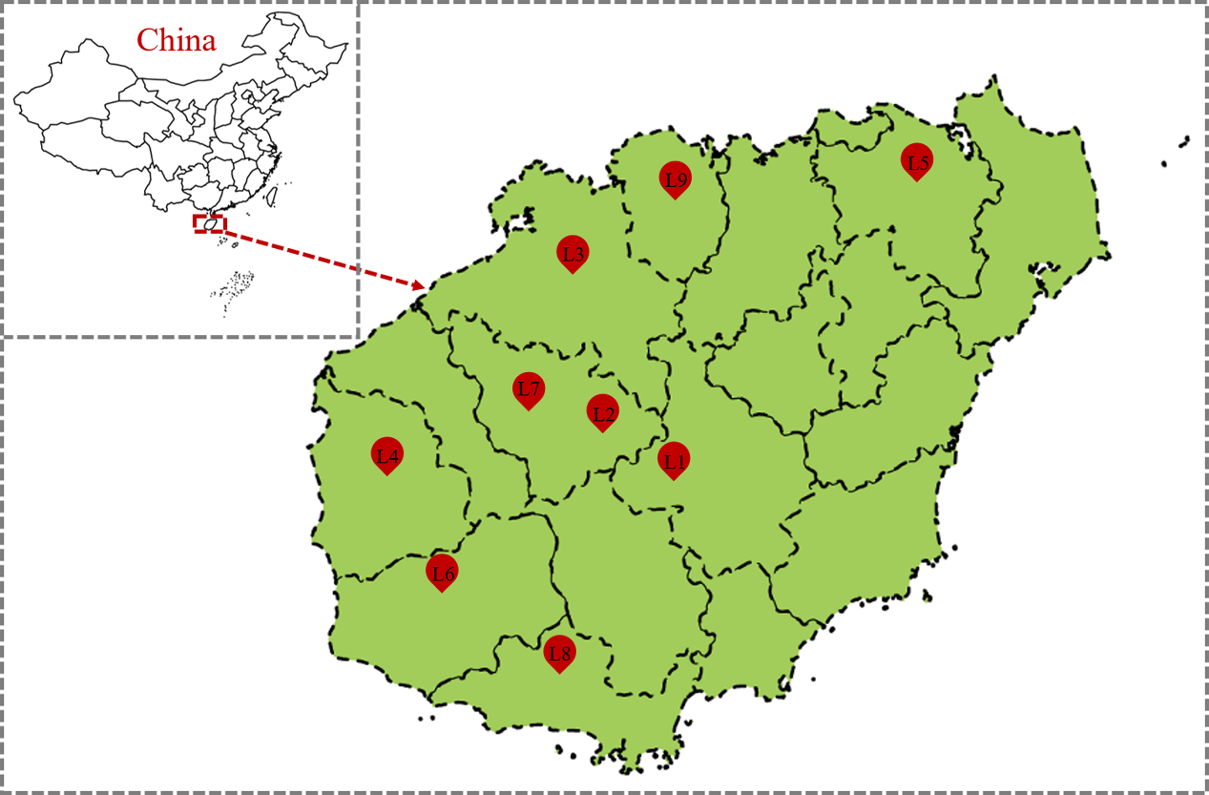

Supplementary Figure 2
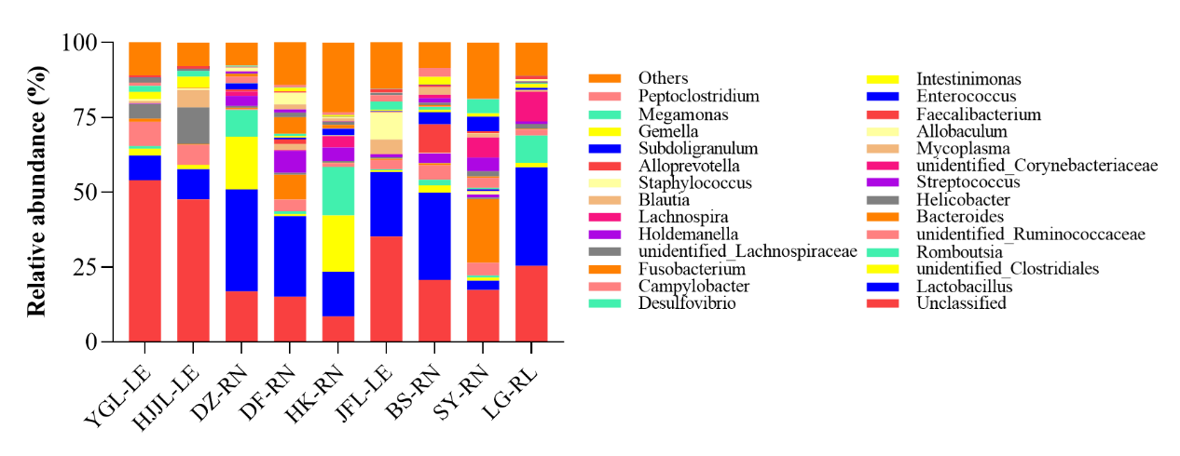
Supplementary Figure 3
