Table S1 Optimization of the action conditions of compound flora.
number | temperature | pH | inoculation amount | salt concentration | time
 | 25℃ | 7 | 2% | 1% | 12h
 | 28℃ | 7 | 2% | 1% | 12h
1 | 30℃ | 7 | 2% | 1% | 12h
 | 32℃ | 7 | 2% | 1% | 12h
 | 35℃ | 7 | 2% | 1% | 12h
 | 30℃ | 5 | 2% | 1% | 12h
 | 30℃ | 6 | 2% | 1% | 12h
2 | 30℃ | 7 | 2% | 1% | 12h
 | 30℃ | 8 | 2% | 1% | 12h
 | 30℃ | 9 | 2% | 1% | 12h
 | 30℃ | 7 | 1% | 1% | 12h
 | 30℃ | 7 | 2% | 1% | 12h
3 | 30℃ | 7 | 3% | 1% | 12h
 | 30℃ | 7 | 4% | 1% | 12h
 | 30℃ | 7 | 5% | 1% | 12h
 | 30℃ | 7 | 2% | 1% | 12h
 | 30℃ | 7 | 2% | 2% | 12h
4 | 30℃ | 7 | 2% | 3% | 12h
 | 30℃ | 7 | 2% | 4% | 12h
 | 30℃ | 7 | 2% | 5% | 12h

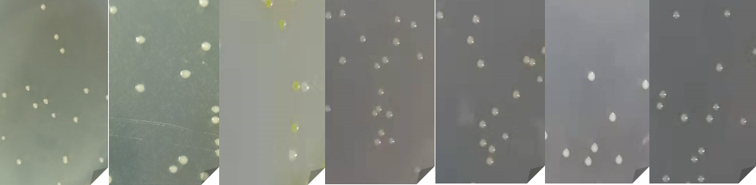
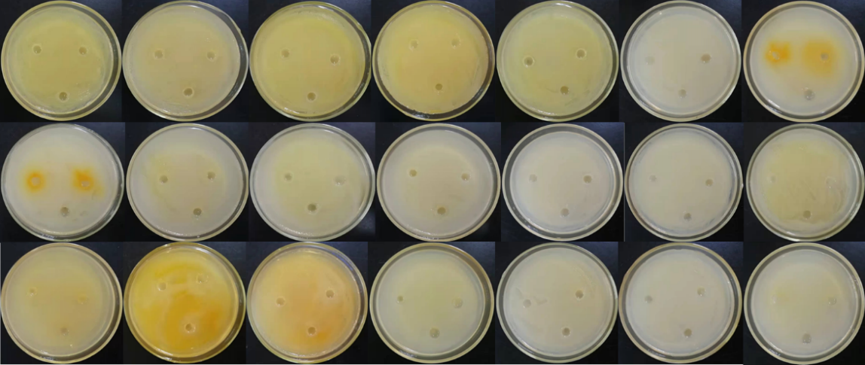
A
B

Fig S1. A: The colony morphology of seven HM-tolerant strains in the laboratory. From left to right: C1-h, C4-h, C8-h, M1-h, M3-h, P2-h, P3-h. B: The antagonism among the seven strains was from left to right in each row: 1)C1-h+C4-h、C1-h+C8-h、C1-h+M1-h、C1-h+M3-h、C1-h+P2-h、C1-h+P3-h、P2-h+C8-h; 2) C4-h+C8-h、C4-h+M1-h、C4-h+M3-h、C4-h+P2-h、C4-h+P3-h、M3-h+P2-h、M3-h+P3-h; 3) C8-h+M1-h、C8-h+M3-h、C8-h+P3-h、M1-h+M3-h、M1-h+P2-h、M1-h+P3-h、P2-h+P3-h.

Table S2 Description of colony morphology of seven HM-tolerant strains.
Strain number | Colony morphology
C1-h | Yellow round colony, small and opaque, moist and smooth surface, raised center and neat edge, easy to provoke
C4-h | Yellow round colony, large colony, convex center, smooth surface, neat edge, easy to provoke
C8-h | The colony center is orange yellow, the colony is large, the surface is wet and smooth, the edge is neat, and it is easy to provoke
M1-h | White round colony, convex center, wet and smooth surface, neat edge, easy to provoke
M3-h | White round colony, convex center, wet and smooth surface, neat edge, easy to provoke
P2-h | Off white colony, round, moist surface, neat edge, easy to provoke
P3-h | Yellow round colony, smooth surface, neat edge, easy to provoke

Fig. S2. A: Plant height and root length; B: Biomass; C: Chlorophyll content.
Fig. S3. Removal rate of Pb, Cd and Mn in tailings soil after remediation.

Table S3 Plant heavy metal enrichment coefficients of T + P and T + M + P treatment groups
HMs(mg/kg)/Groups | Pb | Cd | Mn
T+P | 77.6 | 1.0 | 690
HMs enrichment factor | 3.54% | 8.47% | 69.77%
T+M+P | 170 | 1.85 | 876
HMs enrichment factor | 7.75% | 15.68% | 88.57%

