Supplementary Information

Phosphorylation in liquid sulphur dioxide under prebiotically plausible conditions

Constanze Sydow¹, Christiane Seiband¹, Alexander F. Siegle¹, Oliver Trapp^{*1,2}

Contents
1. Methods 3
1.1 Materials 3
1.2 Pressure apparatus 3
2. Quantitative evaluation of phosphorylated compounds 4
2.1 Model CE electropherogram 4
2.2 Calibration plots 5
2.3 Reactions with adenosine 11
2.4 Reactions with 5’ AMP 40
2.5 Reactions with 5’ ADP 42
2.6 Reactions with cytidine 47
2.7 Reactions with uridine 50
2.8 Reactions with guanosine 53
2.9 Reactions with deoxycytidine 55
2.10 Reactions with deoxythymidine 57
3 Extracted ion electropherograms and mass spectra (CE-MS) 60
3.1 Reactions with adenosine 60
3.1 Reactions with H₃PO₄ 72
3.2 Reaction with 5’ AMP 73
3.3 Reactions with 5’ ADP 74
3.4 Reaction with cytidine 76
3.5 Reaction with uridine 78
3.6 Reaction with guanosine 79
3.7 Reaction with deoxyadenosine 80
3.8 Reaction with deoxyguanosine 81
3.9 Reaction with deoxycytidine 82
3.10 Reaction with deoxythymidine 84
3.11 Reaction with glycerol 85
3.12 Reaction with glyceraldehyde 86
3.13 Reaction with ribose 87
3.14 Reaction with sodium lactate 88
3.15 Reaction with serine 89
3.18 Reaction of the complete nucleoside mixture 90
4 MS/MS Spectra of p-N-p-N and N-p-p-N species 95

Methods

Materials
Chemicals were ordered from Sigma Aldrich, TCI, Alfa Aesar and abcr chemicals in analytical grade and were used without further purification. 5’-adenylic acid-3’,5’-adenosine phosphate (5’-p^{V}-A-3’-p^{V}-5’-A) was obtained from metabion. Aqueous solutions were prepared with deionized water obtained from a VWR Puranity PU 15 (VWR, Leuven, Belgium). Sulphur dioxide (SO₂) N38 (99.98%) was purchased from Air Liquide Germany.

Pressure apparatus
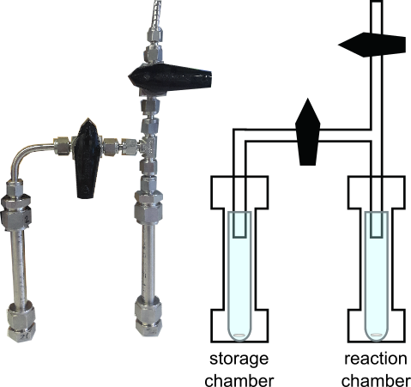
Figure S1. Stainless steel pressure apparatus for phosphorylation reactions in liquid SO₂. subunits contain 3.5 mL test tubes and magnetic stir bars.

2. Quantitative evaluation of phosphorylated compounds

2.1 Model CE electropherogram
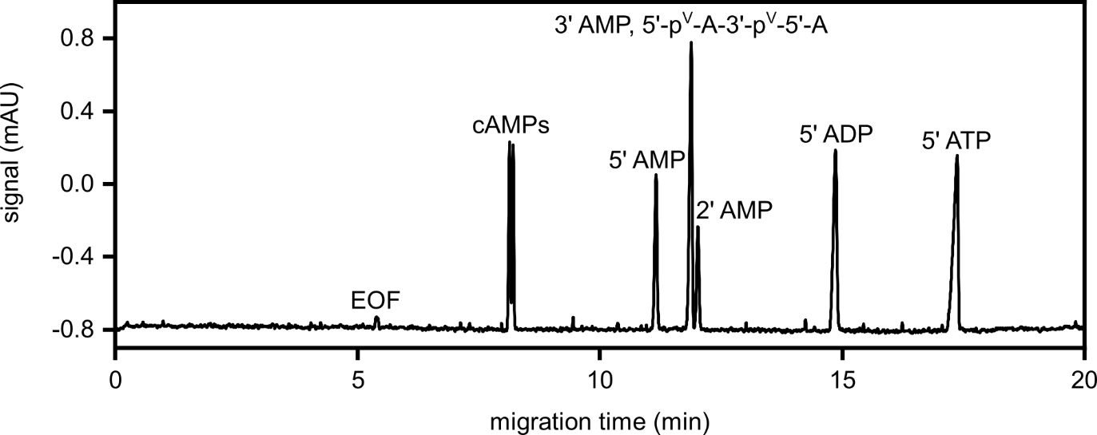
Figure S2. Model CE electropherogram of adenosine phosphate species (each 25 µM) with labelled peaks (electroosmotic flow (EOF), cyclic adenosine monophosphates (cAMPs), 5’ adenosine monophosphate (5’ AMP), 3’ adenosine monophosphate (3’ AMP), 5’-adenylic acid-3’,5’-adenosine phosphate (5’-p^{V}-A-3’-p^{V}-5’-A), 2’ adenosine monophosphate (2’ AMP), 5’ adenosine diphosphate (5’ ADP) and 5’ adenosine triphosphate (5’ ATP). Analytes were detected at 254 nm. Conditions for the CE separation: bare fused silica (BFS) capillary (l = 80 cm, length to detector: 71.5 cm); background electrolyte (BGE): NH₄FA (30 mM, pH 9.5); CE inlet: 30 kV, pressure driven sample injection: 30 mbar for 10 s.

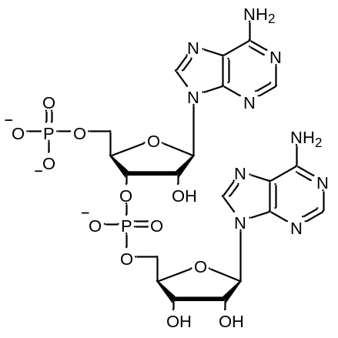
Figure S3. Structure of 5’-adenylic acid-3’,5’-adenosine phosphate (5’-p^{V}-A-3’-p^{V}-5’-A).

2.2 Calibration plots
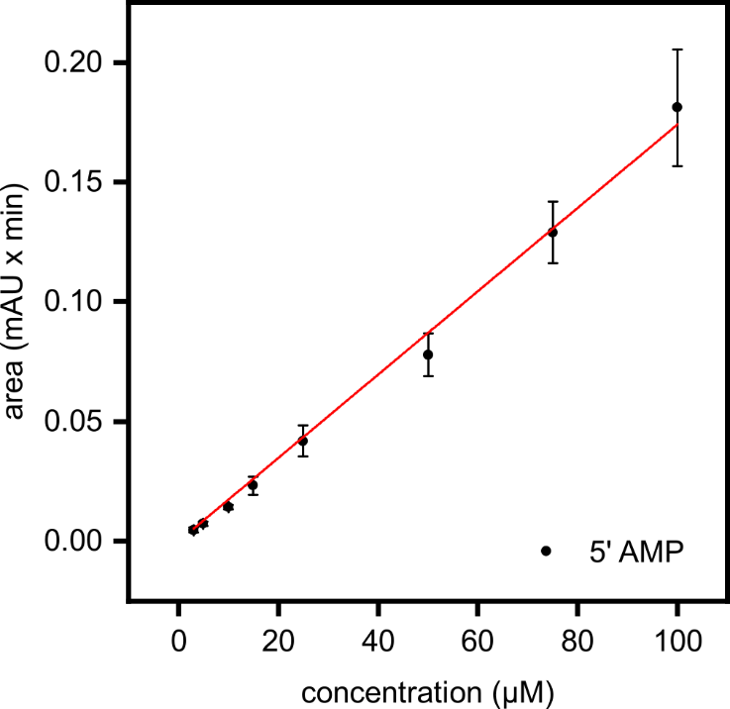
Figure S4. Calibration plot of 5’ AMP (m = 0.00174 ± 3.42621E-5, R² = 0.997). 5’ AMP was detected at 254 nm. Calibration curve was recorded in triplicates. Conditions of the electrophoretic separation: BFS capillary (l = 80 cm, length to detector: 71.5 cm); BGE: NH₄FA (30 mM, pH 9.5); CE inlet: 30 kV, pressure driven sample injection: 30 mbar for 10 s.

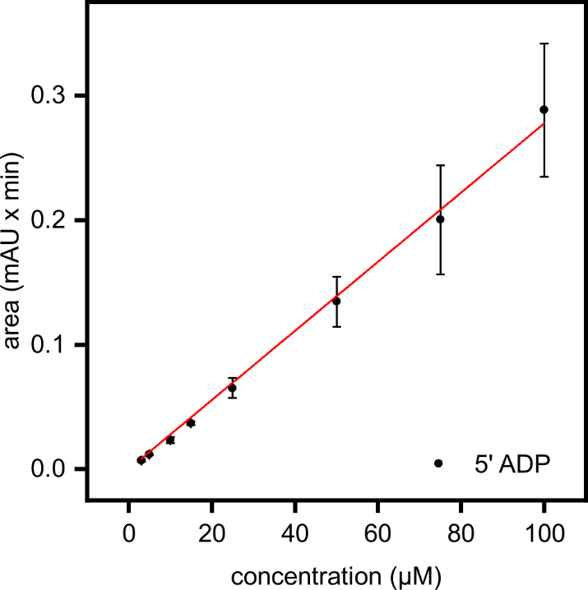
Figure S5. Calibration plot of 5’ ADP (m = 0.00278 ± 4.41685E-5, R² = 0.998). 5’ ADP was detected at 254 nm. Calibration curve was recorded in triplicates. Conditions for the CE separation: BFS capillary (l = 80 cm, length to detector: 71.5 cm); BGE: NH₄FA (30 mM, pH 9.5); CE inlet: 30 kV, pressure driven sample injection: 30 mbar for 10 s.
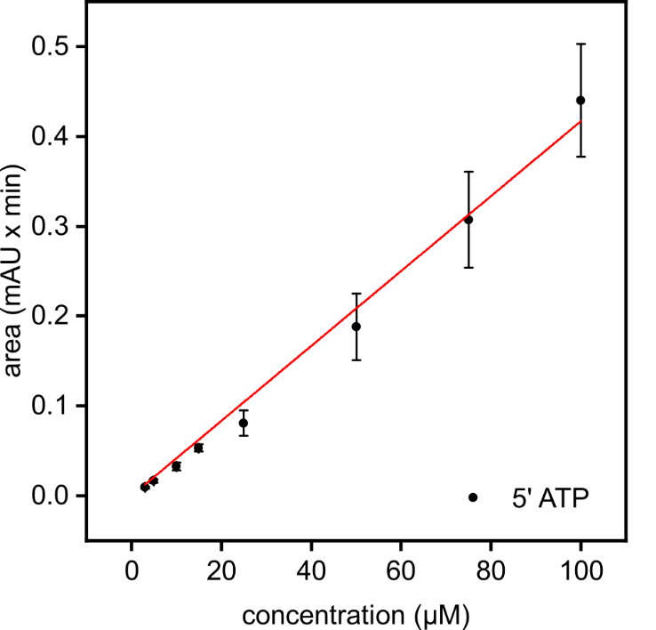
Figure S6. Calibration plot of 5’ ATP (m = 0.00417 ± 1.14115E-4, R² = 0.994). 5’ ATP was detected at 254 nm. Calibration curve was recorded in triplicates. Conditions for the CE separation: BFS capillary (l = 80 cm, length to detector: 71.5 cm); BGE: NH₄FA (30 mM, pH 9.5); CE inlet: 30 kV, pressure driven sample injection: 30 mbar for 10 s.

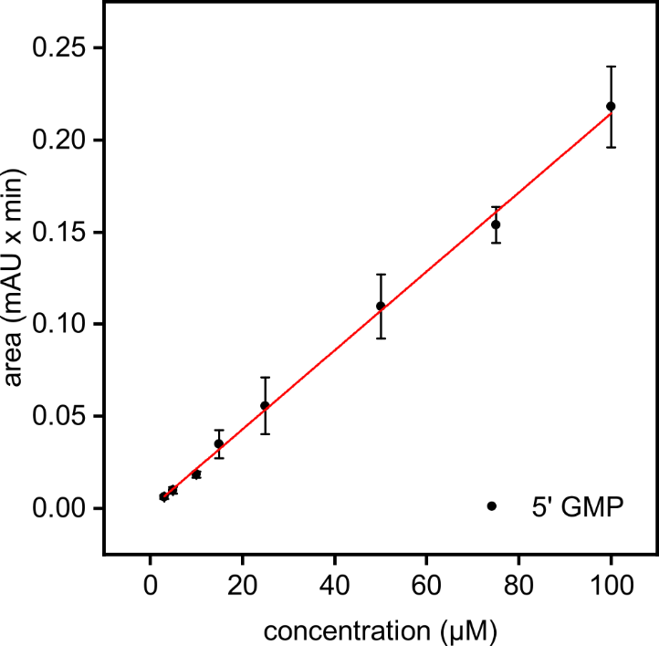
Figure S7. Calibration plot of 5’ guanosine monophosphate (5’ GMP) (m = 0.00214 ± 2.57224E-5, R² = 0.998). 5’ GMP was detected at 254 nm. Calibration curve was recorded in triplicates. Conditions for the CE separation: BFS capillary (l = 80 cm, length to detector: 71.5 cm); BGE: NH₄FA (30 mM, pH 9.5); CE inlet: 30 kV, pressure driven sample injection: 30 mbar for 10 s.

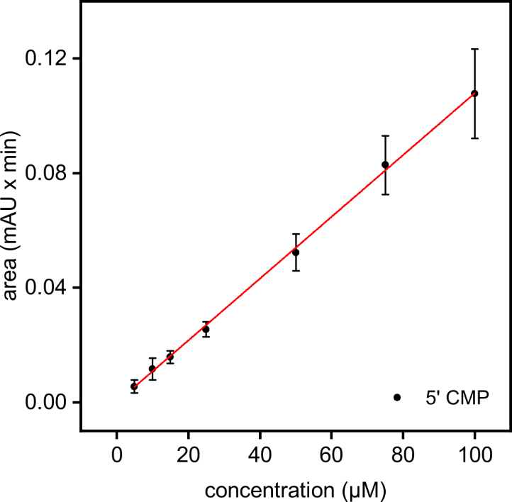
Figure S8. Calibration plot of 5’ cytidine monophosphate (5’ CMP) (m = 0.00108 ± 9.19523E-6, R² = 0.999). 5’ CMP was detected at 254 nm. Calibration curve was recorded in triplicates. Conditions for the CE separation: BFS capillary (l = 80 cm, length to detector: 71.5 cm); BGE: NH₄FA (30 mM, pH 9.5); CE inlet: 30 kV, pressure driven sample injection: 30 mbar for 10 s.

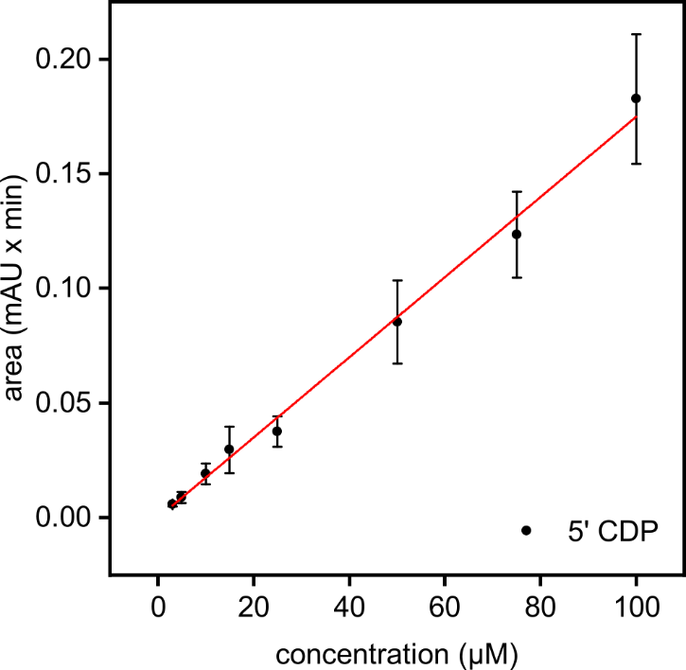
Figure S9. Calibration plot of 5’ cytidine diphosphate (5’ CDP) (m = 0.00175 ± 3.63983E-5, R² = 0.996). 5’ CDP was detected at 254 nm. Calibration curve was recorded in triplicates. Conditions for the CE separation: BFS capillary (l = 80 cm, length to detector: 71.5 cm); BGE: NH₄FA (30 mM, pH 9.5); CE inlet: 30 kV, pressure driven sample injection: 30 mbar for 10 s.

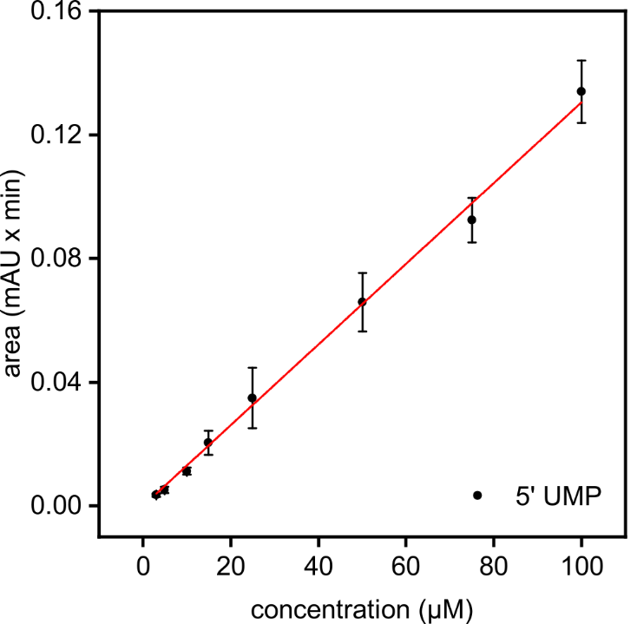
Figure S10. Calibration plot of 5’ uridine monophosphate (5’ UMP) (m = 0.0013 ± 2.00939E-5, R² = 0.998). 5’ UMP was detected at 254 nm. Calibration curve was recorded in triplicates. Conditions for the CE separation: BFS capillary (l = 80 cm, length to detector: 71.5 cm); BGE: NH₄FA (30 mM, pH 9.5); CE inlet: 30 kV, pressure driven sample injection: 30 mbar for 10 s.

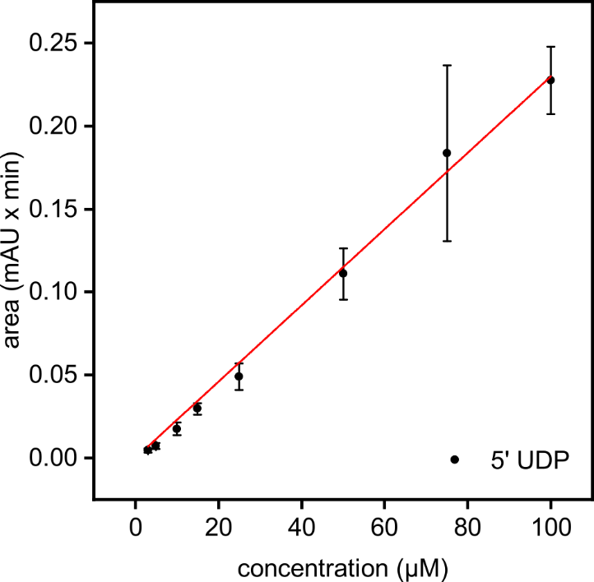
Figure S11. Calibration plot of 5’ uridine diphosphate (5’ UDP) (m = 0.0023 ± 4.66751E-5, R² = 0.997). 5’ UDP was detected at 254 nm. Calibration curve was recorded in triplicates. Conditions for the CE separation: BFS capillary (l = 80 cm, length to detector: 71.5 cm); BGE: NH₄FA (30 mM, pH 9.5); CE inlet: 30 kV, pressure driven sample injection: 30 mbar for 10 s.

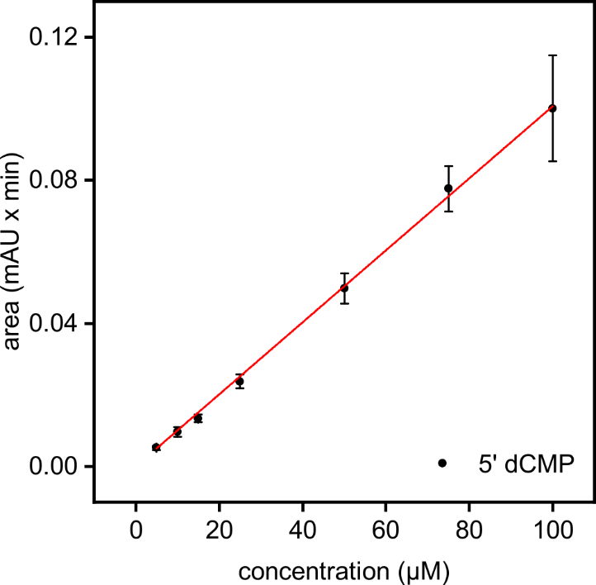
Figure S12. Calibration plot of 5’ deoxycytidine monophosphate (5’ dCMP) (m = 0.00101 ± 9.44669E-6, R² = 0.999). 5’ dCMP was detected at 254 nm. Calibration curve was recorded in triplicates. Conditions for the CE separation: BFS capillary (l = 80 cm, length to detector: 71.5 cm); BGE: NH₄FA (30 mM, pH 9.5); CE inlet: 30 kV, pressure driven sample injection: 30 mbar for 10 s.

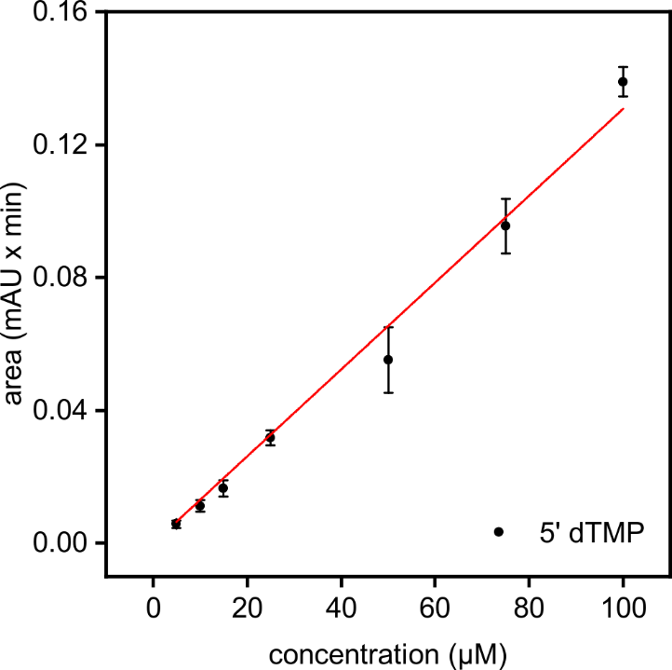
Figure S13. Calibration plot of 5’ deoxythymidine monophosphate (5’ dTMP) (m = 0.00131 ± 4.08834E-5, R² = 0.994). 5’ dTMP was detected at 254 nm. Calibration curve was recorded in triplicates. Conditions for the CE separation: BFS capillary (l = 80 cm, length to detector: 71.5 cm); BGE: NH₄FA (30 mM, pH 9.5); CE inlet: 30 kV, pressure driven sample injection: 30 mbar for 10 s.

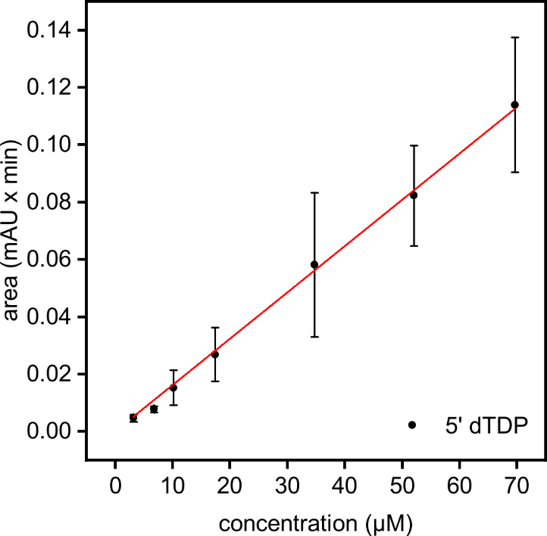
Figure S14. Calibration plot of 5’ deoxythymidine diphosphate (5’ dTDP) (m = 0.00162 ± 2.08208E-5, R² = 0.999). 5’ dTDP was detected at 254 nm. Calibration curve was recorded in triplicates. Conditions for the CE separation: BFS capillary (l = 80 cm, length to detector: 71.5 cm); BGE: NH₄FA (30 mM, pH 9.5); CE inlet: 30 kV, pressure driven sample injection: 30 mbar for 10 s.

2.3 Reactions with adenosine

2.3.1 Variation of the H₃PO₃ concentration
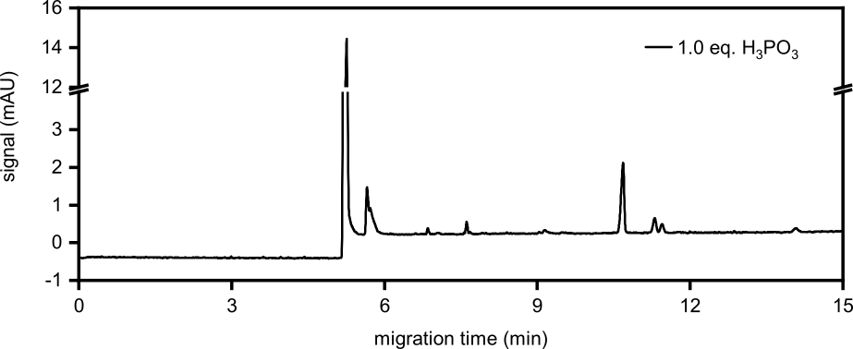
Figure S15. First analysis run of the reaction starting from adenosine (A) (100 mM, 1.0 eq.) and H₃PO₃ (1.0 eq.) after 7 d. The sample was diluted to 1 mM referring to the initial A concentration.

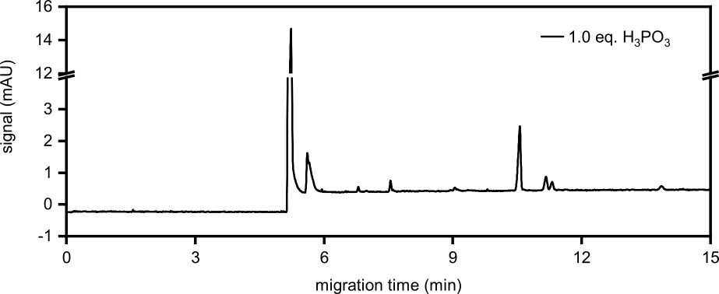
Figure S16. Second analysis run of the reaction starting from A (100 mM, 1.0 eq.) and H₃PO₃ (1.0 eq.) after 7 d. The sample was diluted to 1 mM referring to the initial A concentration.

Table S1. First analysis run of the reaction starting from A (100 mM, 1.0 eq.) and H₃PO₃ (1.0 eq.) after 7 d. The sample was diluted to 1 mM referring to the initial A concentration.
Product | Integral  (mAU x min) | c_{sample vial}  (µM) | c_{reaction mixture}  (mM) | Yield  (%)
5’ AMP | 0.1311 | 75.35 | 7.54 | 7.54
5’ ADP | 0.0111 | 3.98 | 0.40 | 0.40

Table S2. Second analysis run of the reaction starting from A (100 mM, 1.0 eq.) and H₃PO₃ (1.0 eq.) after 7 d. The sample was diluted to 1 mM referring to the initial A concentration.
Product | Integral  (mAU x min) | c_{sample vial}  (µM) | c_{reaction mixture}  (mM) | Yield  (%) | Ø Yield  (%)
5’ AMP | 0.1403 | 80.66 | 8.07 | 8.07 | 7.80 ± 0.38
5’ ADP | 0.0124 | 4.46 | 0.45 | 0.45 | 0.42 ± 0.03

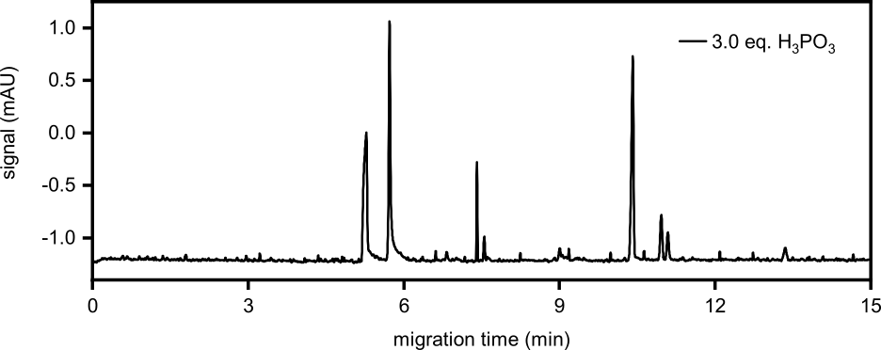
Figure S17. First analysis run of the reaction starting from A (100 mM, 1.0 eq.) and H₃PO₃ (3.0 eq.) after 7 d. The sample was diluted to 300 µM referring to the initial A concentration for determination of the 5’ AMP yield.

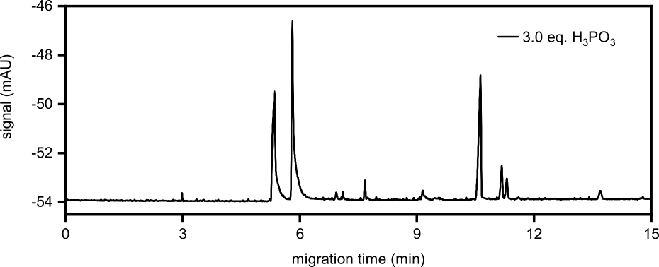
Figure S18. First analysis run of the reaction starting from A (100 mM, 1.0 eq.) and H₃PO₃ (3.0 eq.) after 7 d. The sample was diluted to 1 mM referring to the initial A concentration for determination of the 5’ ADP yield.

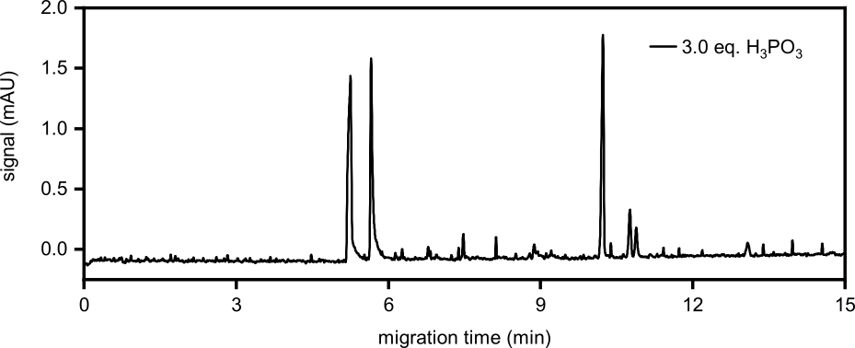
Figure S19. Second analysis run of the reaction starting from A (100 mM, 1.0 eq.) and H₃PO₃ (3.0 eq.) after 7 d. The sample was diluted to 300 µM referring to the initial A concentration for determination of the 5’ AMP yield.

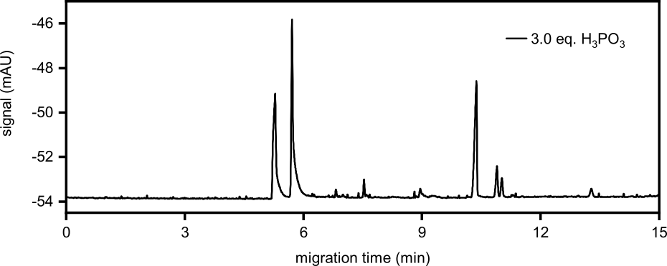
Figure S20. Second analysis run of the reaction starting from A (100 mM, 1.0 eq.) and H₃PO₃ (3.0 eq.) after 7 d. The sample was diluted to 1 mM referring to the initial A concentration for determination of the 5’ ADP yield.

Table S3. First analysis runs of the reaction starting from A (100 mM, 1.0 eq.) and H₃PO₃ (3.0 eq.) after 7 d. The sample was diluted to 300 µM referring to the initial A concentration for determination of the 5’ AMP yield and to 1 mM for determination of the 5’ ADP yield.
Product | Integral  (mAU x min) | c_{sample vial}  (µM) | c_{reaction mixture}  (mM) | Yield  (%)
5’ AMP | 0.0955 | 54.87 | 18.29 | 18.29
5’ ADP | 0.0245 | 8.81 | 0.88 | 0.88

Table S4. Second analysis runs of the reaction starting from A (100 mM, 1.0 eq.) and H₃PO₃ (3.0 eq.) after 7 d. The sample was diluted to 300 µM referring to the initial A concentration for determination of the 5’ AMP yield and to 1 mM for determination of the 5’ ADP yield.
Product | Integral  (mAU x min) | c_{sample vial}  (µM) | c_{reaction mixture}  (mM) | Yield  (%) | Ø Yield  (%)
5’ AMP | 0.0912 | 52.42 | 17.47 | 17.47 | 17.88 ± 0.58
5’ ADP | 0.0264 | 9.50 | 0.95 | 0.95 | 0.92 ± 0.05

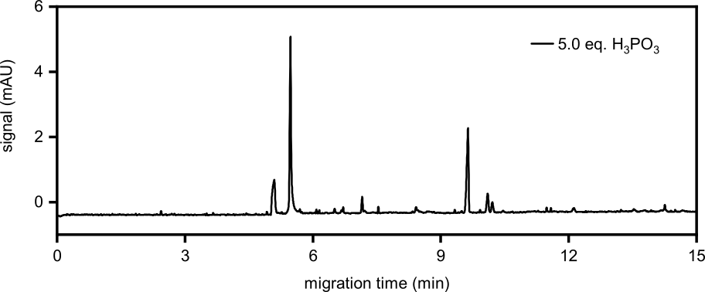
Figure S21. First analysis run of the reaction starting from A (100 mM, 1.0 eq.) and H₃PO₃ (5.0 eq.) after 7 d. The sample was diluted to 500 µM referring to the initial A concentration for determination of the 5’ AMP yield.

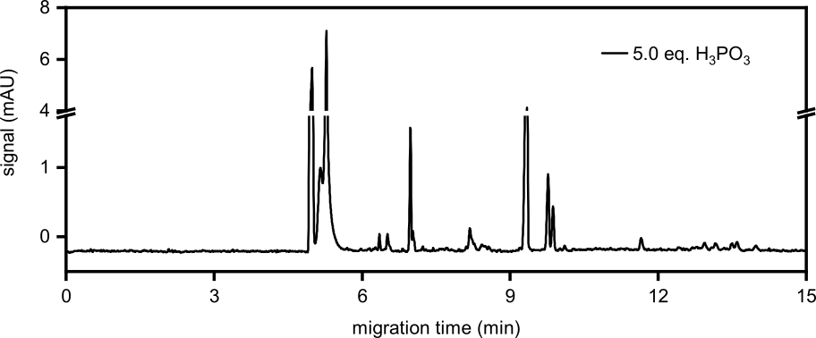
Figure S22. First analysis run of the reaction starting from A (100 mM, 1.0 eq.) and H₃PO₃ (5.0 eq.) after 7 d. The sample was diluted to 1 mM referring to the initial A concentration for determination of the 5’ ADP yield.

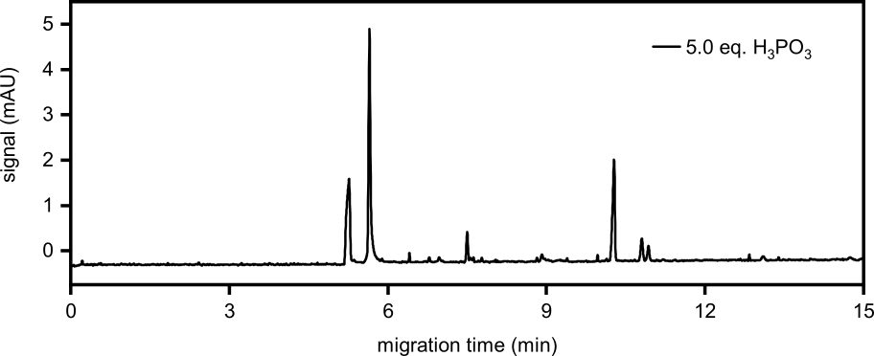
Figure S23. Second analysis run of the reaction starting from A (100 mM, 1.0 eq.) and H₃PO₃ (5.0 eq.) after 7 d. The sample was diluted to 500 µM referring to the initial A concentration for determination of the 5’ AMP yield.

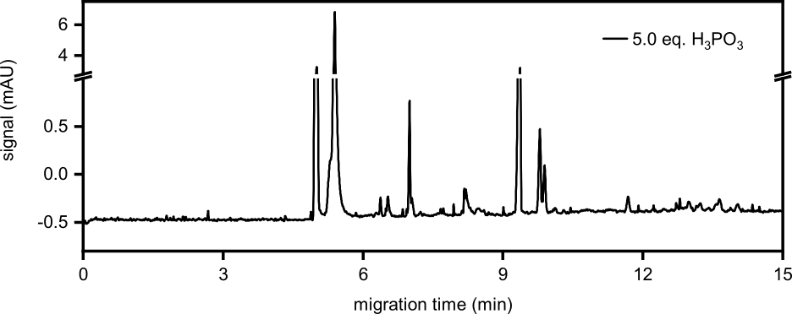
Figure S24. Second analysis run of the reaction starting from A (100 mM, 1.0 eq.) and H₃PO₃ (5.0 eq.) after 7 d. The sample was diluted to 1 mM referring to the initial A concentration for determination of the 5’ ADP yield.

Table S5. First analysis runs of the reaction starting from A (100 mM, 1.0 eq.) and H₃PO₃ (5.0 eq.) after 7 d. The sample was diluted to 500 µM referring to the initial A concentration for determination of the 5’ AMP yield and to 1 mM for determination of the 5’ ADP yield.
Product | Integral  (mAU x min) | c_{sample vial}  (µM) | c_{reaction mixture}  (mM) | Yield  (%)
5’ AMP | 0.1305 | 75.02 | 15.00 | 15.00
5’ ADP | 0.0103 | 3.72 | 0.37 | 0.37

Table S6. Second analysis runs of the reaction starting from A (100 mM, 1.0 eq.) and H₃PO₃ (5.0 eq.) after 7 d. The sample was diluted to 500 µM referring to the initial A concentration for determination of the 5’ AMP yield and to 1 mM for determination of the 5’ ADP yield.
Product | Integral  (mAU x min) | c_{sample vial}  (µM) | c_{reaction mixture}  (mM) | Yield  (%) | Ø Yield  (%)
5’ AMP | 0.1144 | 65.75 | 13.15 | 13.15 | 14.08 ± 1.31
5’ ADP | 0.0098 | 3.52 | 0.35 | 0.35 | 0.36 ± 0.01

2.3.2 Variation of the urea concentration
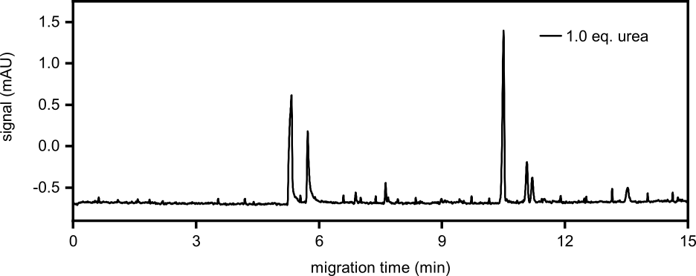
Figure S25. First analysis run of the reaction starting from A (100 mM, 1.0 eq.), H₃PO₃ (3.0 eq.) and urea (1.0 eq.) after 7 d. The sample was diluted to 200 µM referring to the initial A concentration for determination of the 5’ AMP yield.

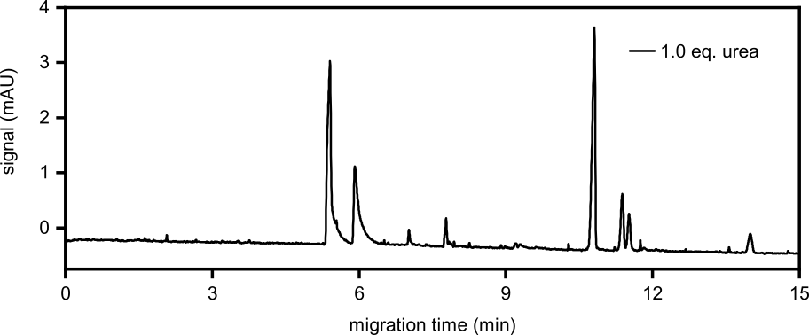
Figure S26. First analysis run of the reaction starting from A (100 mM, 1.0 eq.), H₃PO₃ (3.0 eq.) and urea (1.0 eq.) after 7 d. The sample was diluted to 500 µM referring to the initial A concentration for determination of the 5’ ADP yield.

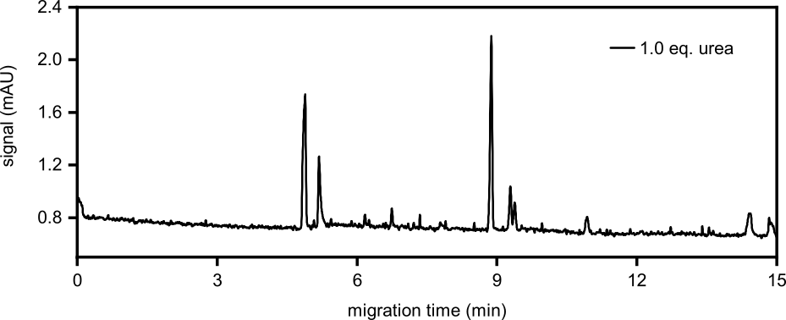
Figure S27. Second analysis run of the reaction starting from A (100 mM, 1.0 eq.), H₃PO₃ (3.0 eq.) and urea (1.0 eq.) after 7 d. The sample was diluted to 200 µM referring to the initial A concentration for determination of the 5’ AMP yield.

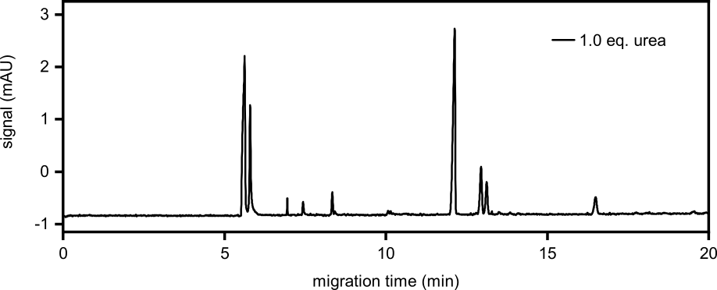
Figure S28. Second analysis run of the reaction starting from A (100 mM, 1.0 eq.), H₃PO₃ (3.0 eq.) and urea (1.0 eq.) after 7 d. The sample was diluted to 500 µM referring to the initial A concentration for determination of the 5’ ADP yield.

Table S7. First analysis runs of the reaction starting from A (100 mM, 1.0 eq.), H₃PO₃ (3.0 eq.) and urea (1.0 eq.) after 7 d. The sample was diluted to 200 µM referring to the initial A concentration for determination of the 5’ AMP yield and to 500 µM for determination of the 5’ ADP yield.
Product | Integral  (mAU x min) | c_{sample vial}  (µM) | c_{reaction mixture}  (mM) | Yield  (%)
5’ AMP | 0.1095 | 62.91 | 31.45 | 31.45
5’ ADP | 0.0316 | 11.38 | 2.28 | 2.28

Table S8. Second analysis runs of the reaction starting from A (100 mM, 1.0 eq.), H₃PO₃ (3.0 eq.) and urea (1.0 eq.) after 7 d. The sample was diluted to 200 µM referring to the initial A concentration for determination of the 5’ AMP yield and to 500 µM for determination of the 5’ ADP yield.
Product | Integral  (mAU x min) | c_{sample vial}  (µM) | c_{reaction mixture}  (mM) | Yield  (%) | Ø Yield  (%)
5’ AMP | 0.0764 | 43.90 | 21.95 | 21.95 | 26.70 ± 6.72
5’ ADP | 0.0303 | 10.90 | 2.18 | 2.18 | 2.23 ± 0.07

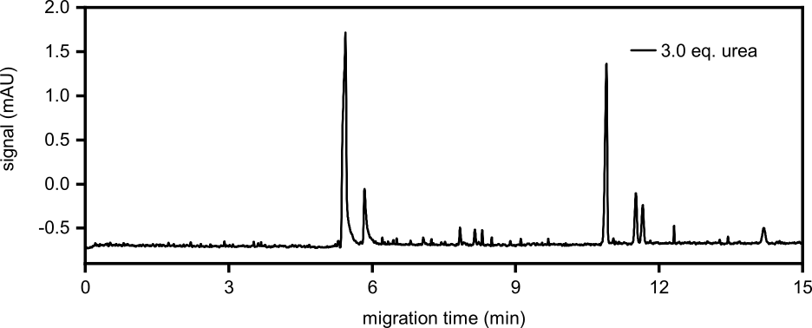
Figure S29. First analysis run of the reaction starting from A (100 mM, 1.0 eq.), H₃PO₃ (3.0 eq.) and urea (3.0 eq.) after 7 d. The sample was diluted to 250 µM referring to the initial A concentration for determination of the 5’ AMP yield.

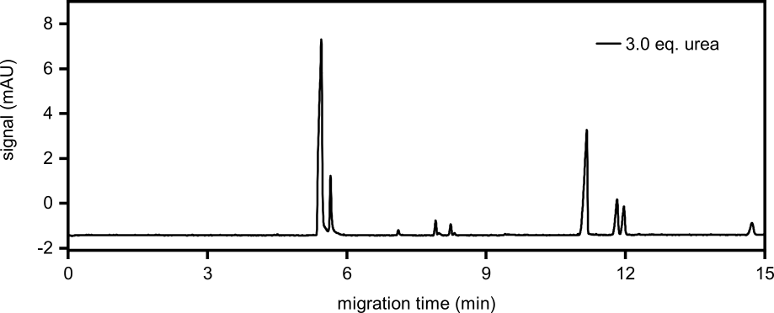
Figure S30. First analysis run of the reaction starting from A (100 mM, 1.0 eq.), H₃PO₃ (3.0 eq.) and urea (3.0 eq.) after 7 d. The sample was diluted to 1 mM referring to the initial A concentration for determination of the 5’ ADP yield.

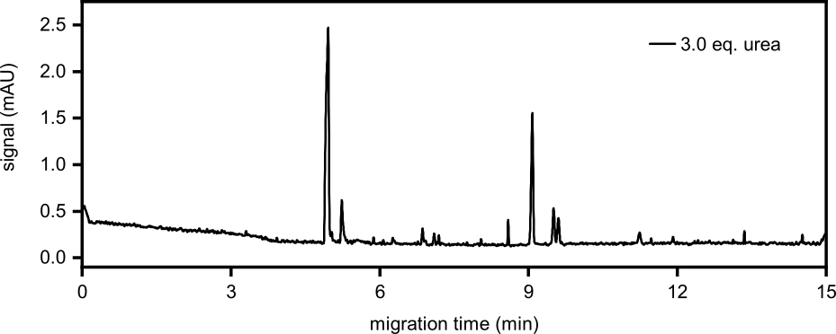
Figure S31. Second analysis run of the reaction starting from A (100 mM, 1.0 eq.), H₃PO₃ (3.0 eq.) and urea (3.0 eq.) after 7 d. The sample was diluted to 250 µM referring to the initial A concentration for determination of the 5’ AMP yield.

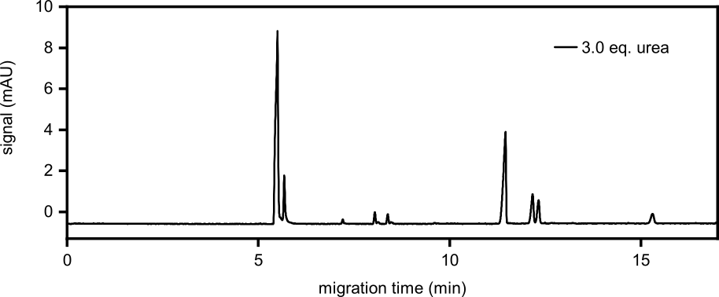
Figure S32. Second analysis run of the reaction starting from A (100 mM, 1.0 eq.), H₃PO₃ (3.0 eq.) and urea (3.0 eq.) after 7 d. The sample was diluted to 1 mM referring to the initial A concentration for determination of the 5’ ADP yield.

Table S9. First analysis runs of the reaction starting from A (100 mM, 1.0 eq.), H₃PO₃ (3.0 eq.) and urea (3.0 eq.) after 7 d. The sample was diluted to 250 µM referring to the initial A concentration for determination of the 5’ AMP yield and to 1 mM for determination of the 5’ ADP yield.
Product | Integral  (mAU x min) | c_{sample vial}  (µM) | c_{reaction mixture}  (mM) | Yield  (%)
5’ AMP | 0.1093 | 62.84 | 25.14 | 25.14
5’ ADP | 0.0463 | 16.64 | 1.66 | 1.66

Table S10. Second analysis runs of the reaction starting from A (100 mM, 1.0 eq.), H₃PO₃ (3.0 eq.) and urea (3.0 eq.) after 7 d. The sample was diluted to 250 µM referring to the initial A concentration for determination of the 5’ AMP yield and to 1 mM for determination of the 5’ ADP yield.
Product | Integral  (mAU x min) | c_{sample vial}  (µM) | c_{reaction mixture}  (mM) | Yield  (%) | Ø Yield  (%)
5’ AMP | 0.0630 | 36.18 | 14.47 | 14.47 | 19.80 ± 7.54
5’ ADP | 0.0424 | 15.26 | 1.53 | 1.53 | 1.59 ± 0.10

2.3.3 Variation of the adenosine concentration
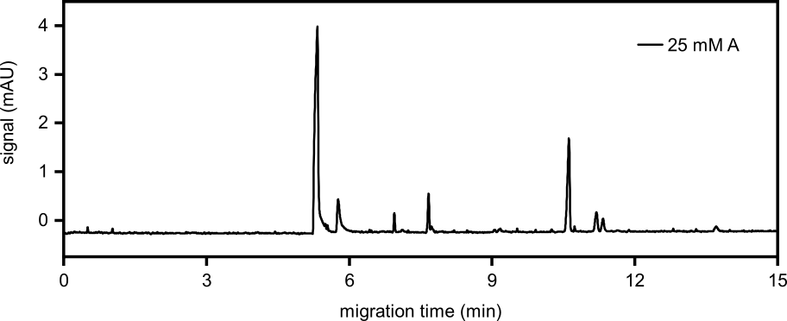
Figure S33. First analysis run of the reaction starting from A (25 mM, 1.0 eq.) and H₃PO₃ (1.0 eq.) after 7 d. The sample was diluted to 500 µM referring to the initial A concentration for determination of the 5’ AMP yield.

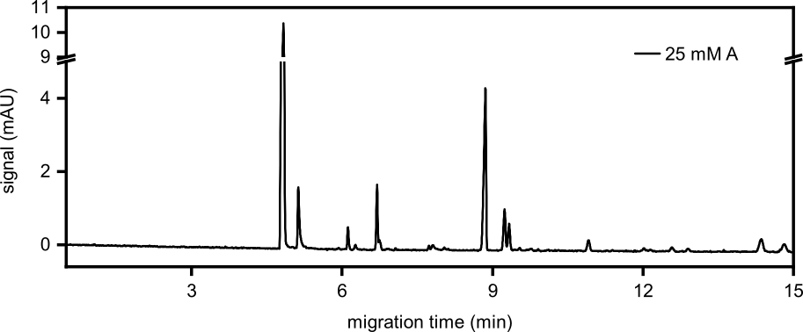
Figure S34. First analysis run of the reaction starting from A (25 mM, 1.0 eq.) and H₃PO₃ (1.0 eq.) after 7 d. The sample was diluted to 1 mM referring to the initial A concentration for determination of the 5’ ADP yield.

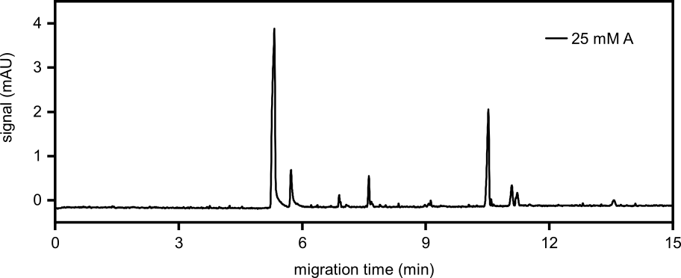
Figure S35. Second analysis run of the reaction starting from A (25 mM, 1.0 eq.) and H₃PO₃ (1.0 eq.) after 7 d. The sample was diluted to 500 µM referring to the initial A concentration for determination of the 5’ AMP yield.

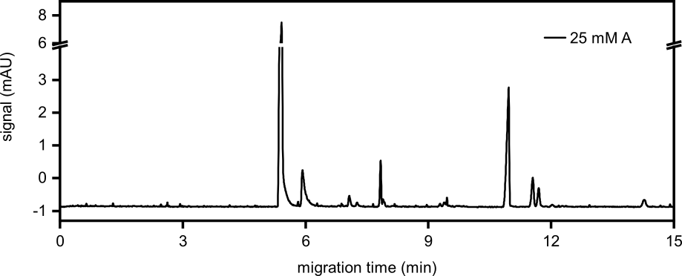
Figure S36. Second analysis run of the reaction starting from A (25 mM, 1.0 eq.) and H₃PO₃ (1.0 eq.) after 7 d. The sample was diluted to 1 mM referring to the initial A concentration for determination of the 5’ ADP yield.

Table S11. First analysis runs of the reaction starting from A (25 mM, 1.0 eq.) and H₃PO₃ (1.0 eq.) after 7 d. The sample was diluted to 500 µM referring to the initial A concentration for determination of the 5’ AMP yield and to 1 mM for the determination of the 5’ ADP yield.
Product | Integral  (mAU x min) | c_{sample vial}  (µM) | c_{reaction mixture}  (mM) | Yield  (%)
5’ AMP | 0.1090 | 62.66 | 3.13 | 12.53
5’ ADP | 0.0174 | 6.26 | 0.16 | 0.63

Table S12. Second analysis runs of the reaction starting from A (25 mM, 1.0 eq.) and H₃PO₃ (1.0 eq.) after 7 d. The sample was diluted to 500 µM referring to the initial A concentration for determination of the 5’ AMP yield and to 1 mM for the determination of the 5’ ADP yield.
Product | Integral  (mAU x min) | c_{sample vial}  (µM) | c_{reaction mixture}  (mM) | Yield  (%) | Ø Yield  (%)
5’ AMP | 0.1240 | 71.24 | 3.56 | 14.25 | 13.39 ± 1.21
5’ ADP | 0.0201 | 7.25 | 0.18 | 0.72 | 0.68 ± 0.07

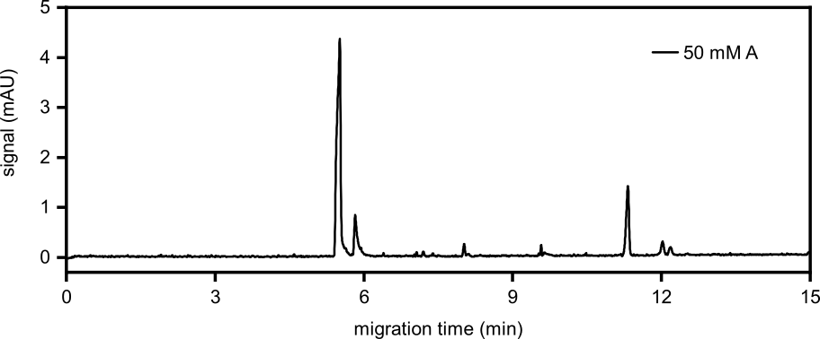
Figure S37. First analysis run of the reaction starting from A (50 mM, 1.0 eq.) and H₃PO₃ (1.0 eq.) after 7 d. The sample was diluted to 500 µM referring to the initial A concentration for determination of the 5’ AMP yield.

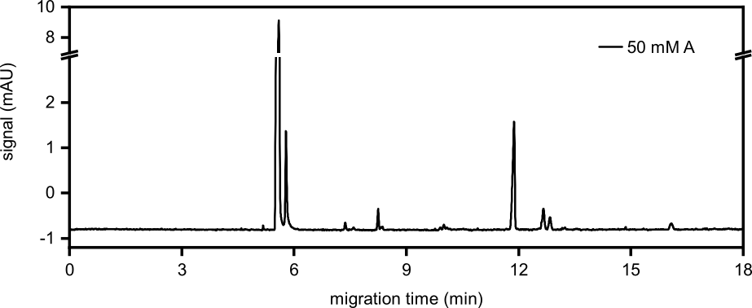
Figure S38. First analysis run of the reaction starting from A (50 mM, 1.0 eq.) and H₃PO₃ (1.0 eq.) after 7 d. The sample was diluted to 1 mM referring to the initial A concentration for determination of the 5’ ADP yield.

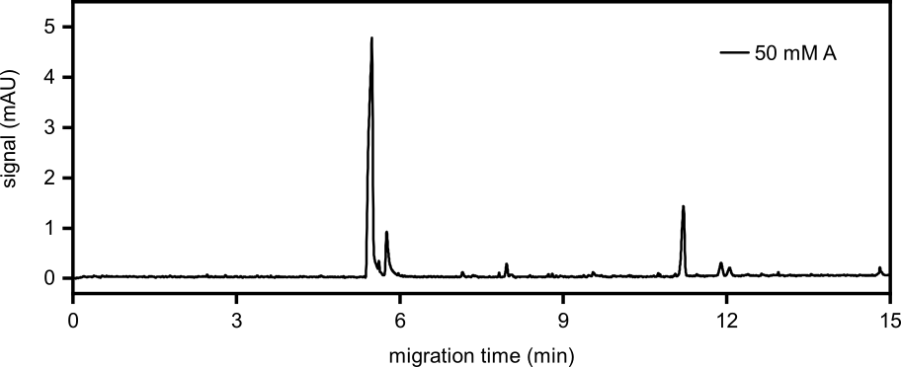
Figure S39. Second analysis run of the reaction starting from A (50 mM, 1.0 eq.) and H₃PO₃ (1.0 eq.) after 7 d. The sample was diluted to 500 µM referring to the initial A concentration for determination of the 5’ AMP yield.

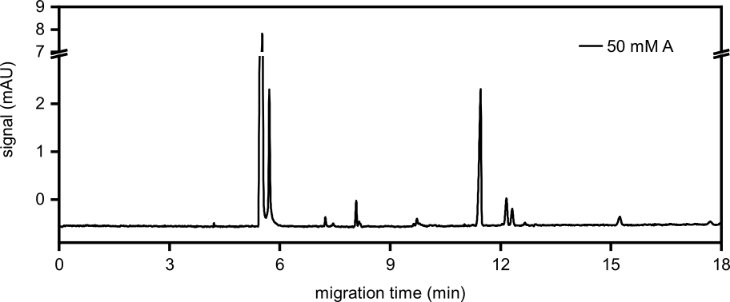
Figure S40. Second analysis run of the reaction starting from A (50 mM, 1.0 eq.) and H₃PO₃ (1.0 eq.) after 7 d. The sample was diluted to 1 mM referring to the initial A concentration for determination of the 5’ ADP yield.

Table S13. First analysis runs of the reaction starting from A (50 mM, 1.0 eq.) and H₃PO₃ (1.0 eq.) after 7 d. The sample was diluted to 500 µM referring to the initial A concentration for determination of the 5’ AMP yield and to 1 mM for determination of the 5’ ADP yield.
Product | Integral  (mAU x min) | c_{sample vial}  (µM) | c_{reaction mixture}  (mM) | Yield  (%)
5’ AMP | 0.0936 | 53.80 | 5.38 | 10.76
5’ ADP | 0.0127 | 4.58 | 0.23 | 0.46

Table S14. Second analysis runs of the reaction starting from A (50 mM, 1.0 eq.) and H₃PO₃ (1.0 eq.) after 7 d. The sample was diluted to 500 µM referring to the initial A concentration for determination of the 5’ AMP yield and to 1 mM for determination of the 5’ ADP yield.
Product | Integral  (mAU x min) | c_{sample vial}  (µM) | c_{reaction mixture}  (mM) | Yield  (%) | Ø Yield  (%)
5’ AMP | 0.0855 | 49.13 | 4.91 | 9.83 | 10.29 ± 0.66
5’ ADP | 0.0143 | 5.16 | 0.26 | 0.52 | 0.49 ± 0.04

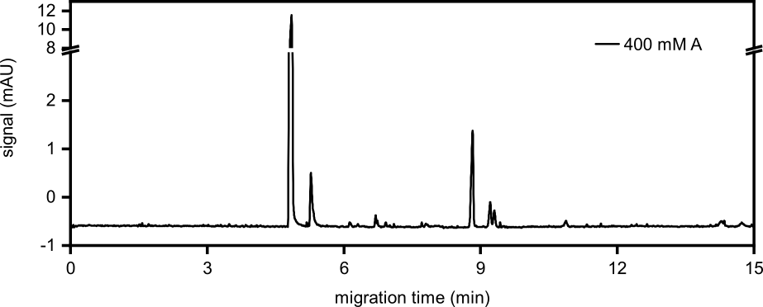
Figure S41. First analysis run of the reaction starting from A (400 mM, 1.0 eq.) and H₃PO₃ (1.0 eq.) after 7 d. The sample was diluted to 1 mM referring to the initial A concentration for determination of the 5’ AMP yield.

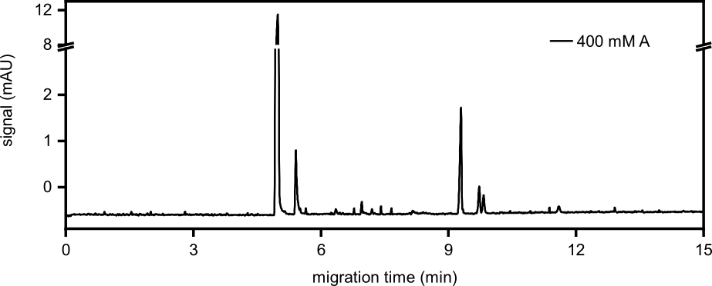
Figure S42. Second analysis run of the reaction starting from A (400 mM, 1.0 eq.) and H₃PO₃ (1.0 eq.) after 7 d. The sample was diluted to 1 mM referring to the initial A concentration for determination of the 5’ AMP yield.

Table S15. First analysis run of the reaction starting from A (400 mM, 1.0 eq.) and H₃PO₃ (1.0 eq.) after 7 d. The sample was diluted to 1 mM referring to the initial A concentration for determination of the 5’ AMP yield.
Product | Integral  (mAU x min) | c_{sample vial}  (µM) | c_{reaction mixture}  (mM) | Yield  (%)
5’ AMP | 0.1043 | 59.94 | 23.97 | 5.99

Table S16. Second analysis run of the reaction starting from A (400 mM, 1.0 eq.) and H₃PO₃ (1.0 eq.) after 7 d. The sample was diluted to 1 mM referring to the initial A concentration for determination of the 5’ AMP yield.
Product | Integral  (mAU x min) | c_{sample vial}  (µM) | c_{reaction mixture}  (mM) | Yield  (%) | Ø Yield  (%)
5’ AMP | 0.1047 | 60.17 | 24.07 | 6.02 | 6.01 ± 0.02

2.3.4 Time dependence of the reaction
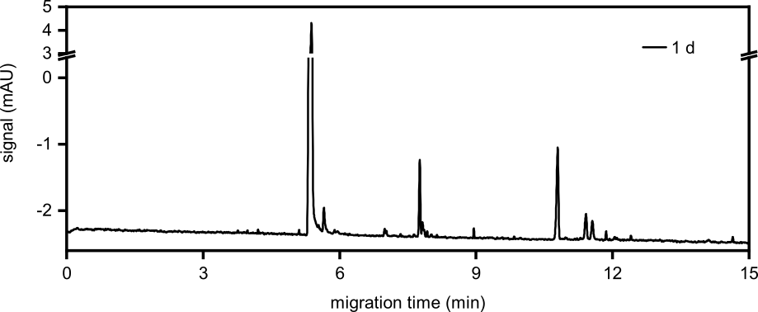
Figure S43. First analysis run of the reaction starting from A (100 mM, 1.0 eq.), H₃PO₃ (3.0 eq.) and urea (1.0 eq.) after 1 d. The sample was diluted to 500 µM referring to the initial A concentration for determination of the 5’ AMP yield.

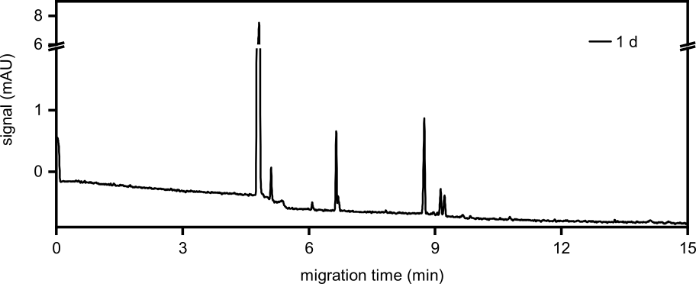
Figure S44. Second analysis run of the reaction starting from A (100 mM, 1.0 eq.), H₃PO₃ (3.0 eq.) and urea (1.0 eq.) after 1 d. The sample was diluted to 500 µM referring to the initial A concentration for determination of the 5’ AMP yield.

Table S17. First analysis run of the reaction starting from A (100 mM, 1.0 eq.), H₃PO₃ (3.0 eq.) and urea (1.0 eq.) after 1 d. The sample was diluted to 500 µM referring to the initial A concentration for determination of the 5’ AMP yield.
Product | Integral  (mAU x min) | c_{sample vial}  (µM) | c_{reaction mixture}  (mM) | Yield  (%)
5’ AMP | 0.0659 | 37.86 | 7.57 | 7.57

Table S18. Second analysis run of the reaction starting from A (100 mM, 1.0 eq.), H₃PO₃ (3.0 eq.) and urea (1.0 eq.) after 1 d. The sample was diluted to 500 µM referring to the initial A concentration for determination of the 5’ AMP yield.
Product | Integral  (mAU x min) | c_{sample vial}  (µM) | c_{reaction mixture}  (mM) | Yield  (%) | Ø Yield  (%)
5’ AMP | 0.0604 | 34.74 | 6.95 | 6.95 | 7.26 ± 0.44

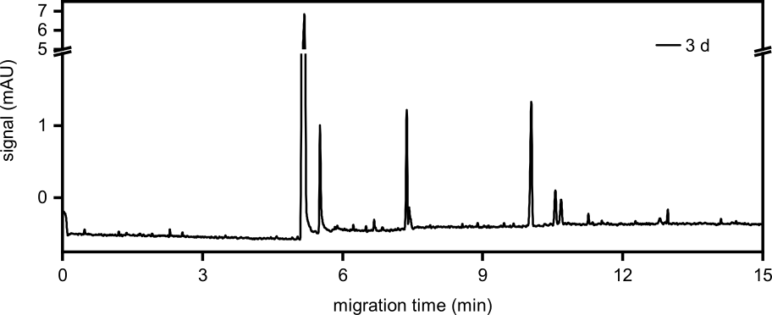
Figure S45. First analysis run of the reaction starting from A (100 mM, 1.0 eq.), H₃PO₃ (3.0 eq.) and urea (1.0 eq.) after 3 d. The sample was diluted to 500 µM referring to the initial A concentration for determination of the 5’ AMP yield.

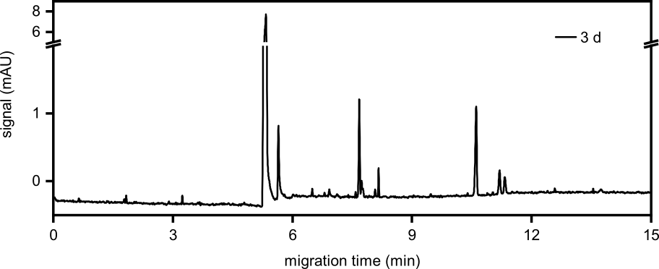
Figure S46. Second analysis run of the reaction starting from A (100 mM, 1.0 eq.), H₃PO₃ (3.0 eq.) and urea (1.0 eq.) after 3 d. The sample was diluted to 500 µM referring to the initial A concentration for determination of the 5’ AMP yield.

Table S19. First analysis run of the reaction starting from A (100 mM, 1.0 eq.), H₃PO₃ (3.0 eq.) and urea (1.0 eq.) after 3 d. The sample was diluted to 500 µM referring to the initial A concentration for determination of the 5’ AMP yield.
Product | Integral  (mAU x min) | c_{sample vial}  (µM) | c_{reaction mixture}  (mM) | Yield  (%)
5’ AMP | 0.0585 | 33.59 | 6.72 | 6.72

Table S20. Second analysis run of the reaction starting from A (100 mM, 1.0 eq.), H₃PO₃ (3.0 eq.) and urea (1.0 eq.) after 3 d. The sample was diluted to 500 µM referring to the initial A concentration for determination of the 5’ AMP yield.
Product | Integral  (mAU x min) | c_{sample vial}  (µM) | c_{reaction mixture}  (mM) | Yield  (%) | Ø Yield  (%)
5’ AMP | 0.0736 | 42.30 | 8.46 | 8.46 | 7.59 ± 1.23

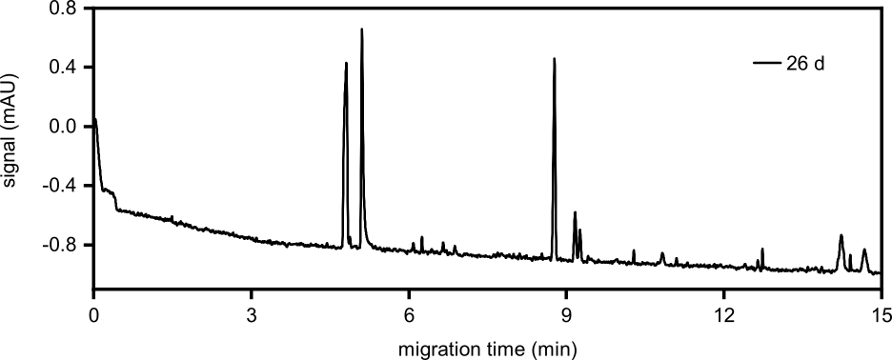
Figure S47. First analysis run of the reaction starting from A (100 mM, 1.0 eq.), H₃PO₃ (3.0 eq.) and urea (1.0 eq.) after 26 d. The sample was diluted to 200 µM referring to the initial A concentration for determination of the 5’ AMP yield.

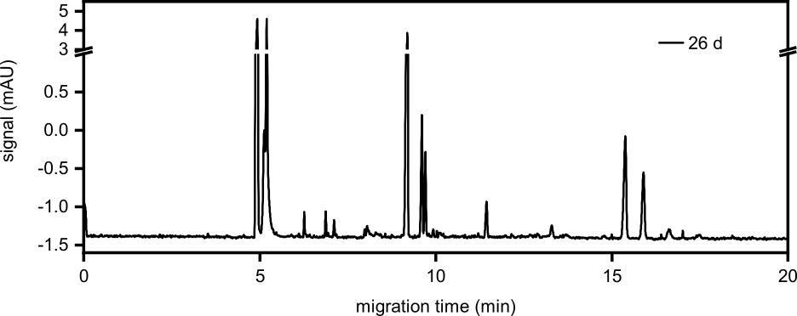
Figure S48. First analysis run of the reaction starting from A (100 mM, 1.0 eq.), H₃PO₃ (3.0 eq.) and urea (1.0 eq.) after 26 d. The sample was diluted to 1 mM referring to the initial A concentration for determination of the 5’ ADP yield.

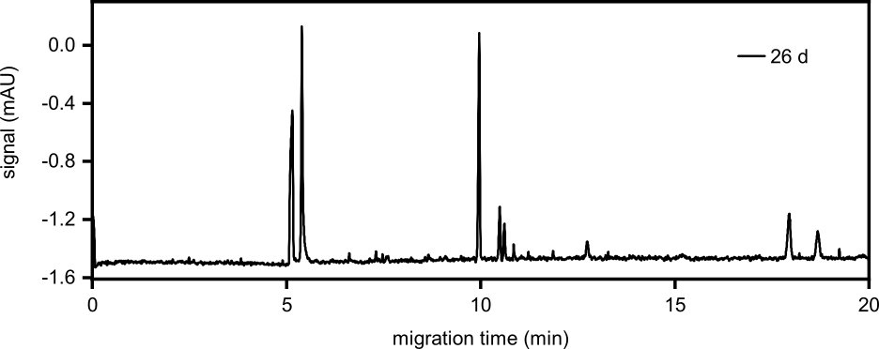
Figure S49. Second analysis run of the reaction starting from A (100 mM, 1.0 eq.), H₃PO₃ (3.0 eq.) and urea (1.0 eq.) after 26 d. The sample was diluted to 200 µM referring to the initial A concentration for determination of the 5’ AMP yield.

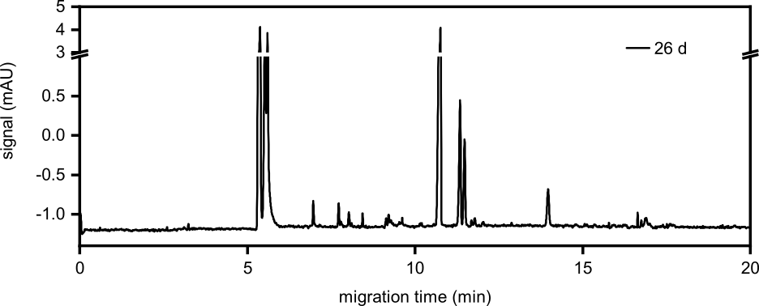
Figure S50. Second analysis run of the reaction starting from A (100 mM, 1.0 eq.), H₃PO₃ (3.0 eq.) and urea (1.0 eq.) after 26 d. The sample was diluted to 1 mM referring to the initial A concentration for determination of the 5’ ADP yield.

Table S21. First analysis runs of the reaction starting from A (100 mM, 1.0 eq.), H₃PO₃ (3.0 eq.) and urea (1.0 eq.) after 26 d. The sample was diluted to 200 µM referring to the initial A concentration for determination of the 5’ AMP yield and to 1 mM for determination of the 5’ ADP yield.
Product | Integral  (mAU x min) | c_{sample vial}  (µM) | c_{reaction mixture}  (mM) | Yield  (%)
5’ AMP | 0.0605 | 34.78 | 17.39 | 17.39
5’ ADP | 0.0257 | 9.23 | 0.92 | 0.92

Table S22. Second analysis runs of the reaction starting from A (100 mM, 1.0 eq.), H₃PO₃ (3.0 eq.) and urea (1.0 eq.) after 26 d. The sample was diluted to 200 µM referring to the initial A concentration for determination of the 5’ AMP yield and to 1 mM for determination of the 5’ ADP yield.
Product | Integral  (mAU x min) | c_{sample vial}  (µM) | c_{reaction mixture}  (mM) | Yield  (%) | Ø Yield  (%)
5’ AMP | 0.0698 | 40.12 | 20.06 | 20.06 | 18.72 ± 1.89
5’ ADP | 0.0333 | 11.98 | 1.20 | 1.20 | 1.06 ± 0.19

2.4 Reactions with 5’ AMP
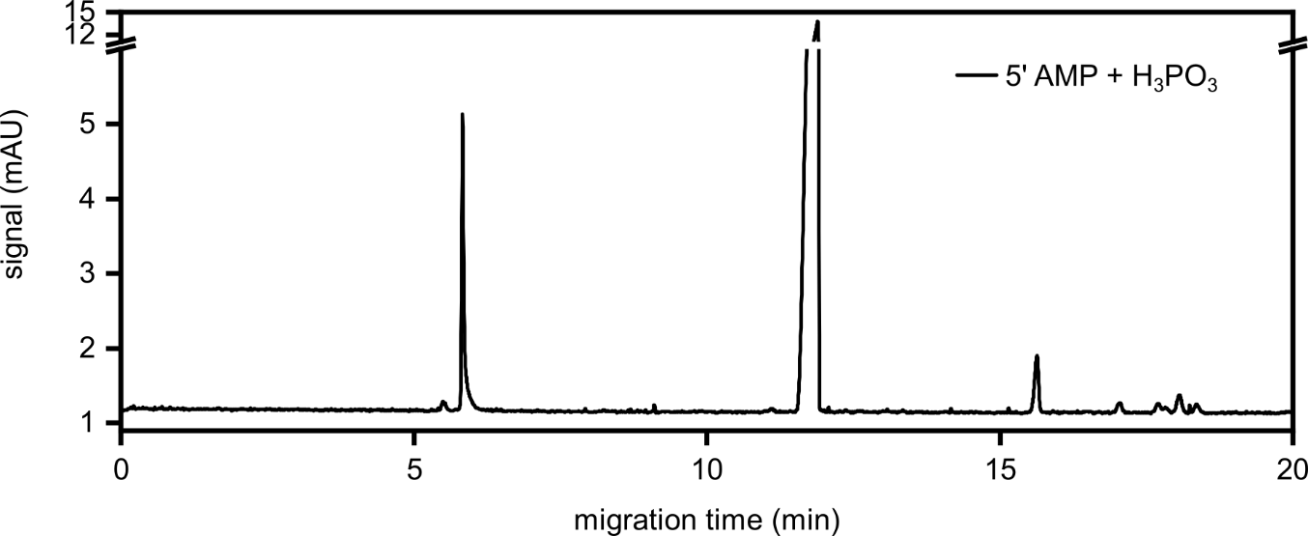
Figure S51. First analysis run of the reaction starting from 5’ AMP (100 mM, 1.0 eq.), H₃PO₃ (3.0 eq.) and urea (1.0 eq.) after 7 d. The sample was diluted to 1 mM referring to the initial 5’ AMP concentration for determination of the 5’ ADP and 5’ ATP yield.

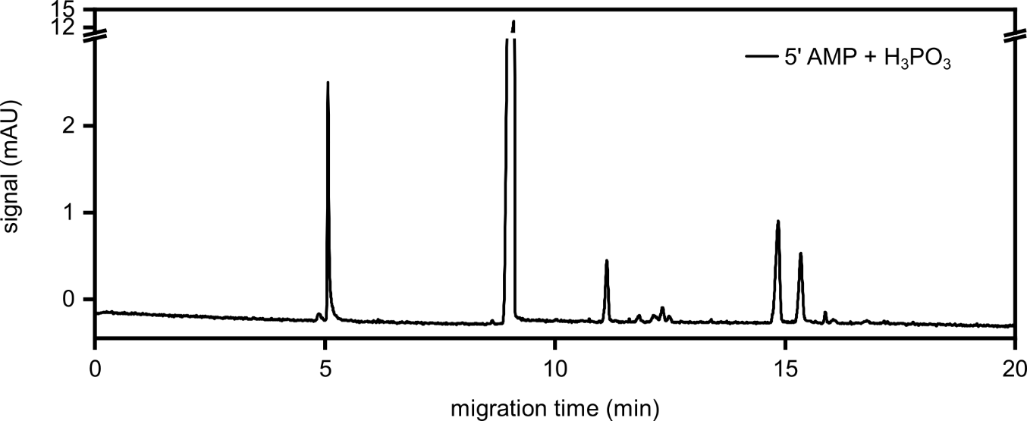
Figure S52. Second analysis run of the reaction starting from 5’ AMP (100 mM, 1.0 eq.), H₃PO₃ (3.0 eq.) and urea (1.0 eq.) after 7 d. The sample was diluted to 1 mM referring to the initial 5’ AMP concentration for determination of the 5’ ADP and 5’ ATP yield.

Table S23. First analysis run of the reaction starting from 5’ AMP (100 mM, 1.0 eq.), H₃PO₃ (3.0 eq.) and urea (1.0 eq.) after 7 d. The sample was diluted to 1 mM referring to the initial 5’ AMP concentration for determination of the 5’ ADP and 5’ ATP yield.
Product | Integral  (mAU x min) | c_{sample vial}  (µM) | c_{reaction mixture}  (mM) | Yield  (%)
5’ ADP | 0.0618 | 22.22 | 2.22 | 2.22
5’ ATP | 0.0216 | 5.18 | 0.52 | 0.52

Table S24. Second analysis run of the reaction starting from 5’ AMP (100 mM, 1.0 eq.), H₃PO₃ (3.0 eq.) and urea (1.0 eq.) after 7 d. The sample was diluted to 1 mM referring to the initial 5’ AMP concentration for determination of the 5’ ADP and 5’ ATP yield.
Product | Integral  (mAU x min) | c_{sample vial}  (µM) | c_{reaction mixture}  (mM) | Yield  (%) | Ø Yield  (%)
5’ ADP | 0.0489 | 17.59 | 1.76 | 1.76 | 1.99 ± 0.33
5’ ATP | 0.0106 | 2.53 | 0.25 | 0.25 | 0.39 ± 0.19

2.5 Reactions with 5’ ADP
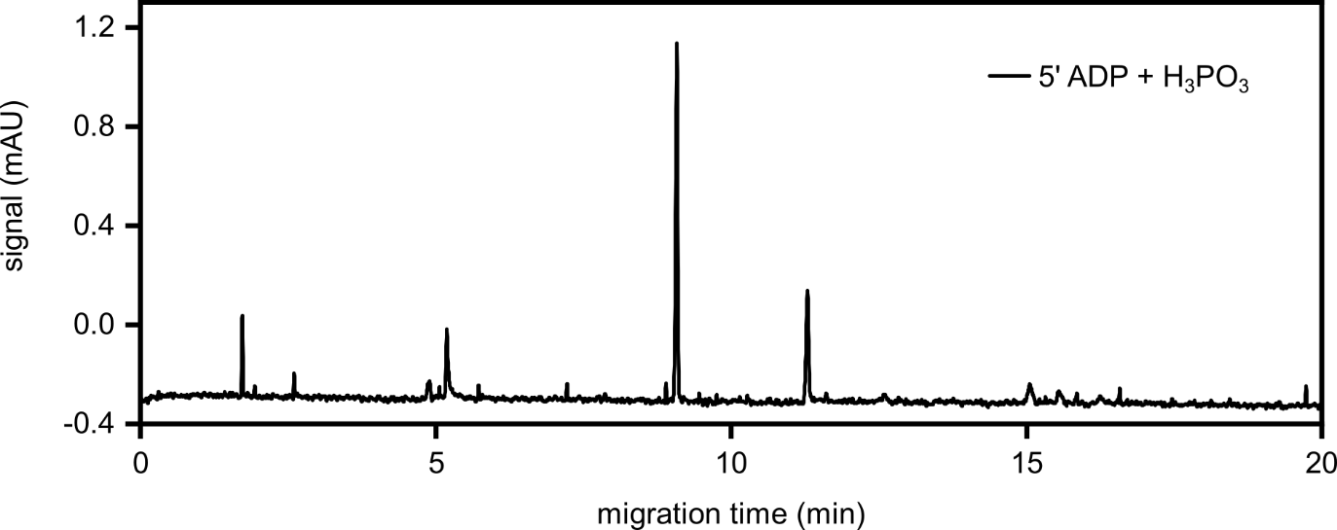
Figure S53. First analysis run of the reaction starting from 5’ ADP (100 mM, 1.0 eq.), H₃PO₃ (3.0 eq.) and urea (1.0 eq.) after 7 d. The sample was diluted to 50 µM referring to the initial 5’ ADP concentration for determination of the 5’ AMP yield.

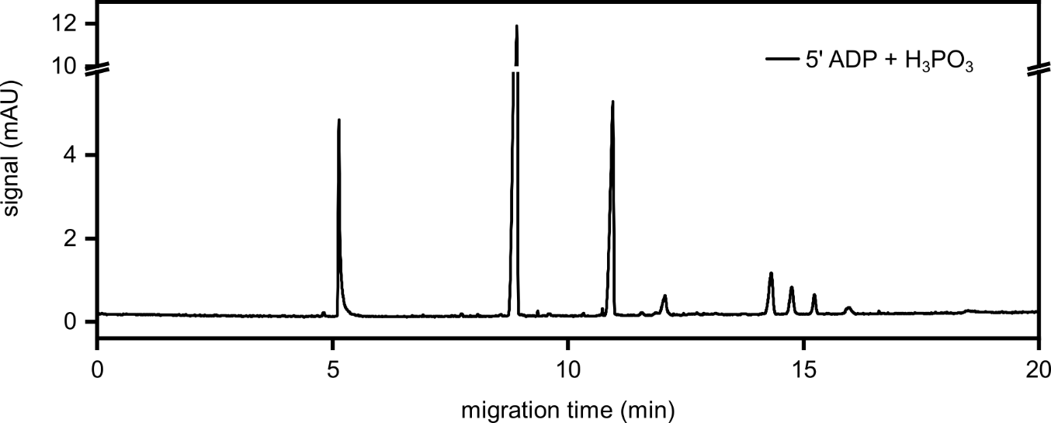
Figure S54. First analysis run of the reaction starting from 5’ ADP (100 mM, 1.0 eq.), H₃PO₃ (3.0 eq.) and urea (1.0 eq.) after 7 d. The sample was diluted to 1 mM referring to the initial 5’ ADP concentration for determination of the 5’ ATP yield.

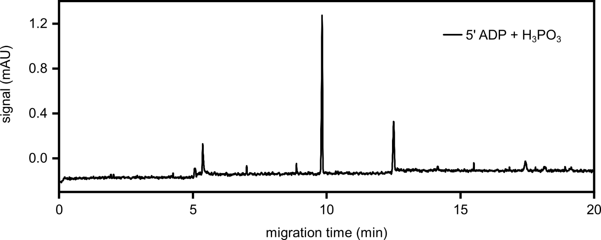
Figure S55. Second analysis run of the reaction starting from 5’ ADP (100 mM, 1.0 eq.), H₃PO₃ (3.0 eq.) and urea (1.0 eq.) after 7 d. The sample was diluted to 50 µM referring to the initial 5’ ADP concentration for determination of the 5’ AMP yield.

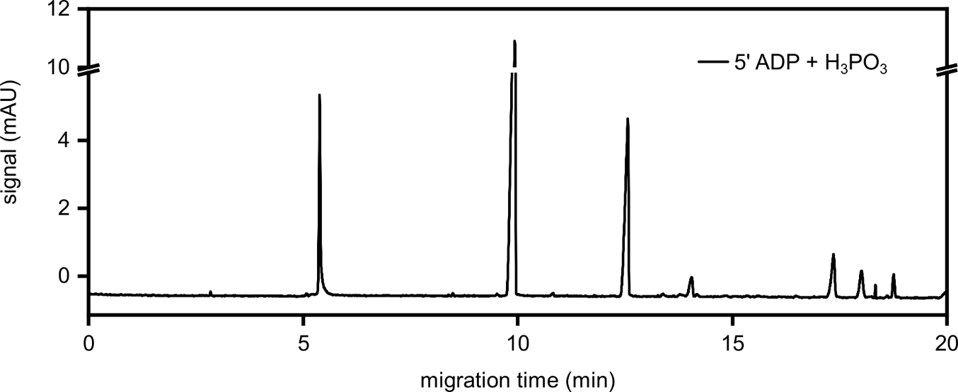
Figure S56. Second analysis run of the reaction starting from 5’ ADP (100 mM, 1.0 eq.), H₃PO₃ (3.0 eq.) and urea (1.0 eq.) after 7 d. The sample was diluted to 1 mM referring to the initial 5’ ADP concentration for determination of the 5’ ATP yield.

Table S25. First analysis runs of the reaction starting from 5’ ADP (100 mM, 1.0 eq.), H₃PO₃ (3.0 eq.) and urea (1.0 eq.) after 7 d. The sample was diluted to 50 µM referring to the initial 5’ ADP concentration for determination of the 5’ AMP yield and to 1 mM for determination of the 5’ ATP yield.
Product | Integral  (mAU x min) | c_{sample vial}  (µM) | c_{reaction mixture}  (mM) | Yield  (%)
5’ AMP | 0.0576 | 33.11 | 66.21 | 66.21
5’ ATP | 0.0430 | 10.30 | 1.03 | 1.03

Table S26. Second analysis runs of the reaction starting from 5’ ADP (100 mM, 1.0 eq.), H₃PO₃ (3.0 eq.) and urea (1.0 eq.) after 7 d. The sample was diluted to 50 µM referring to the initial 5’ ADP concentration for determination of the 5’ AMP yield and to 1 mM for determination of the 5’ ATP yield.
Product | Integral  (mAU x min) | c_{sample vial}  (µM) | c_{reaction mixture}  (mM) | Yield  (%) | Ø Yield  (%)
5’ AMP | 0.0621 | 35.71 | 71.43 | 71.43 | 68.82 ± 3.69
5’ ATP | 0.0479 | 11.48 | 1.15 | 1.15 | 1.09 ± 0.08

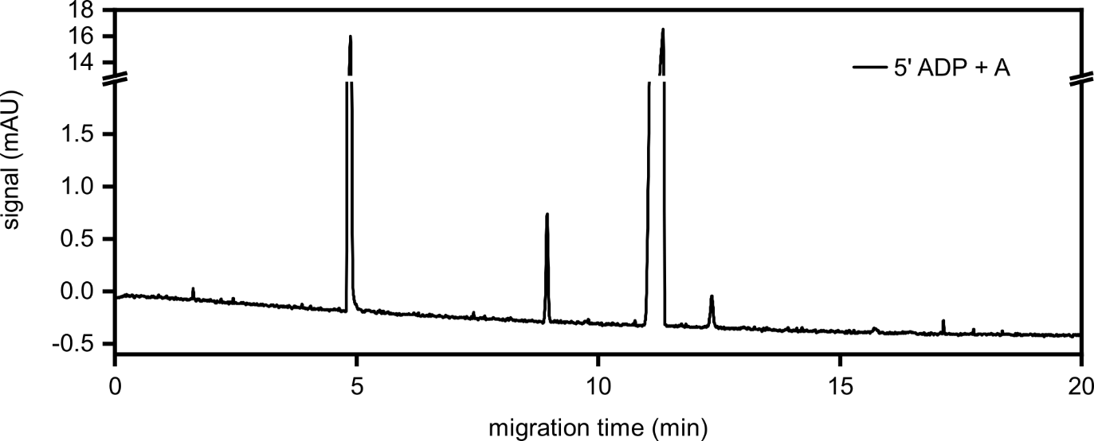
Figure S57. First analysis run of the reaction starting from 5’ ADP (100 mM, 1.0 eq.), A (1.0 eq.) and urea (1.0 eq.) after 7 d. The sample was diluted to 1 mM referring to the initial 5’ ADP concentration for determination of the 5’ AMP and 5’ ATP yield.

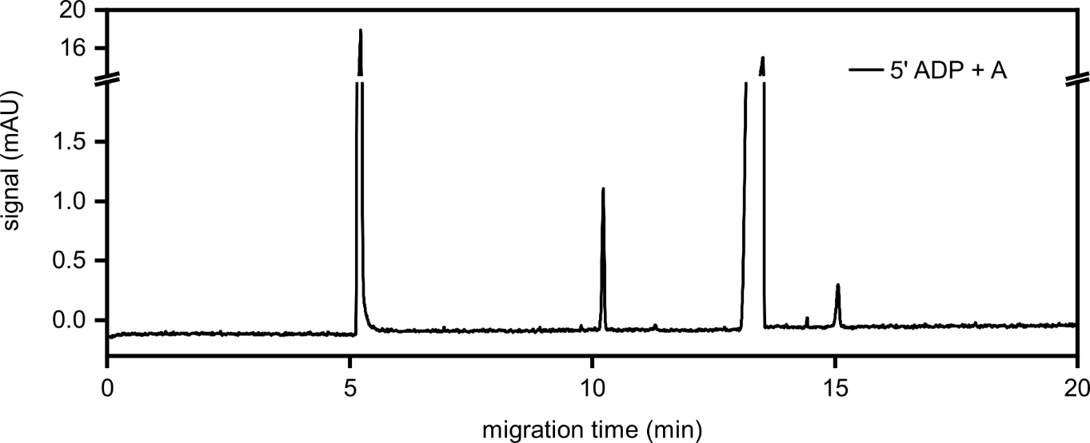
Figure S58. Second analysis run of the reaction starting from 5’ ADP (100 mM, 1.0 eq.), A (1.0 eq.) and urea (1.0 eq.) after 7 d. The sample was diluted to 1 mM referring to the initial 5’ ADP concentration for determination of the 5’ AMP and 5’ ATP yield.

Table S27. First analysis run of the reaction starting from 5’ ADP (100 mM, 1.0 eq.), A (1.0 eq.) and urea (1.0 eq.) after 7 d. The sample was diluted to 1 mM referring to the initial 5’ ADP concentration for determination of the 5’ AMP and 5’ ATP yield.
Product | Integral  (mAU x min) | c_{sample vial}  (µM) | c_{reaction mixture}  (mM) | Yield  (%)
5’ AMP | 0.0549 | 31.53 | 3.15 | 3.15
5’ ATP | 0.0196 | 4.69 | 0.47 | 0.47

Table S28. Second analysis run of the reaction starting from 5’ ADP (100 mM, 1.0 eq.), A (1.0 eq.) and urea (1.0 eq.) after 7 d. The sample was diluted to 1 mM referring to the initial 5’ ADP concentration for determination of the 5’ AMP and 5’ ATP yield.
Product | Integral  (mAU x min) | c_{sample vial}  (µM) | c_{reaction mixture}  (mM) | Yield  (%) | Ø Yield  (%)
5’ AMP | 0.0621 | 35.69 | 3.57 | 3.57 | 3.36 ± 0.29
5’ ATP | 0.0247 | 5.92 | 0.59 | 0.59 | 0.53 ± 0.09

2.6 Reactions with cytidine
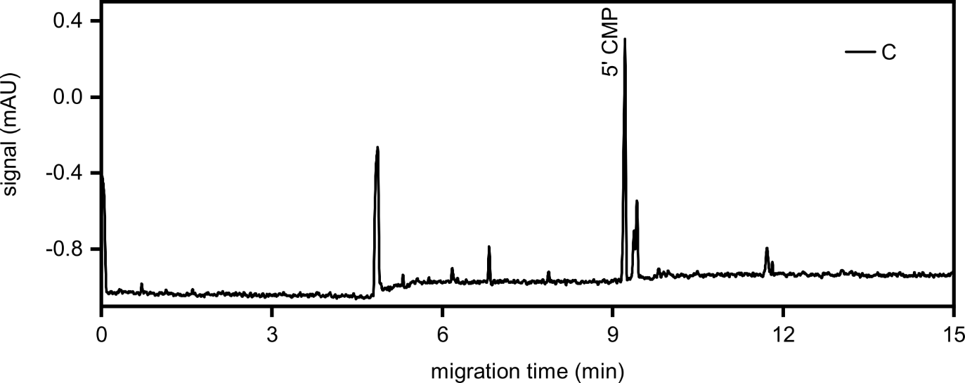
Figure S59. First analysis run of the reaction starting from cytidine (C) (100 mM, 1.0 eq.), H₃PO₃ (3.0 eq.) and urea (1.0 eq.) after 7 d. The sample was diluted to 200 µM referring to the initial C concentration for determination of the 5’ CMP yield.

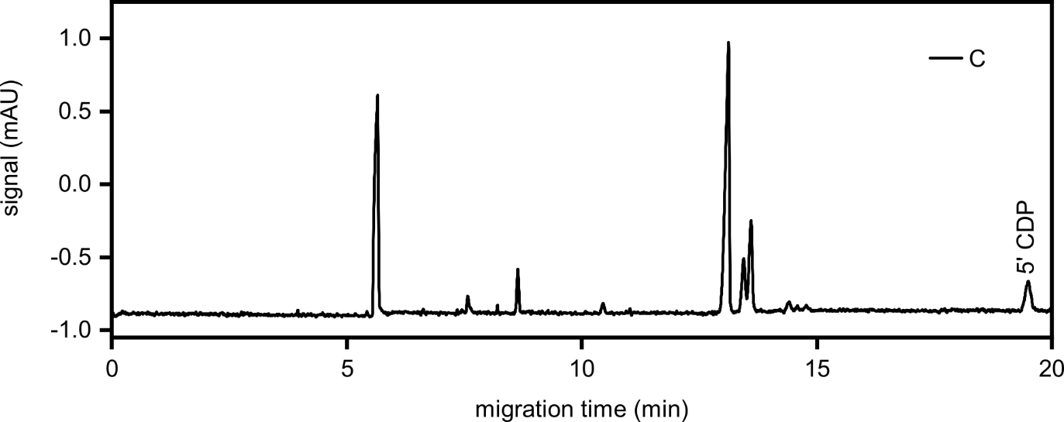
Figure S60. First analysis run of the reaction starting from C (100 mM, 1.0 eq.), H₃PO₃ (3.0 eq.) and urea (1.0 eq.) after 7 d. The sample was diluted to 500 µM referring to the initial C concentration for determination of the 5’ CDP yield.

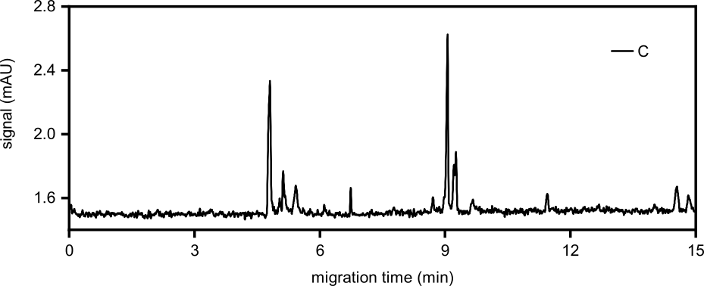
Figure S61. Second analysis run of the reaction starting from C (100 mM, 1.0 eq.), H₃PO₃ (3.0 eq.) and urea (1.0 eq.) after 7 d. The sample was diluted to 200 µM referring to the initial C concentration for determination of the 5’ CMP yield.

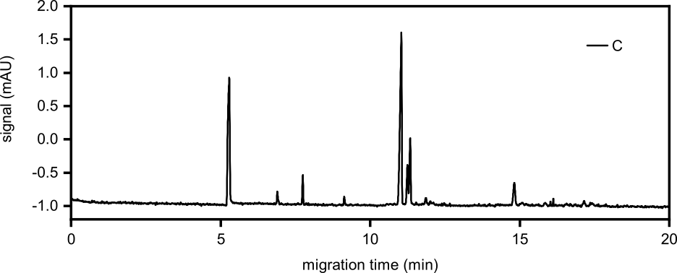
Figure S62. Second analysis run of the reaction starting from C (100 mM, 1.0 eq.), H₃PO₃ (3.0 eq.) and urea (1.0 eq.) after 7 d. The sample was diluted to 500 µM referring to the initial C concentration for determination of the 5’ CDP yield.

Table S29. First analysis runs of the reaction starting from C (100 mM, 1.0 eq.), H₃PO₃ (3.0 eq.) and urea (1.0 eq.) after 7 d. The sample was diluted to 200 µM referring to the initial C concentration for determination of the 5’ CMP yield and to 500 µM for determination of the 5’ CDP yield.
Product | Integral  (mAU x min) | c_{sample vial}  (µM) | c_{reaction mixture}  (mM) | Yield  (%)
5’ CMP | 0.0537 | 49.70 | 24.85 | 24.85
5’ CDP | 0.0287 | 16.39 | 3.28 | 3.28

Table S30. Second analysis runs of the reaction starting from C (100 mM, 1.0 eq.), H₃PO₃ (3.0 eq.) and urea (1.0 eq.) after 7 d. The sample was diluted to 200 µM referring to the initial C concentration for determination of the 5’ CMP yield and to 500 µM for determination of the 5’ CDP yield.
Product | Integral  (mAU x min) | c_{sample vial}  (µM) | c_{reaction mixture}  (mM) | Yield  (%) | Ø Yield  (%)
5’ CMP | 0.0463 | 42.90 | 21.45 | 21.45 | 23.15 ± 2.40
5’ CDP | 0.0244 | 13.96 | 2.79 | 2.79 | 3.04 ± 0.34

2.7 Reactions with uridine
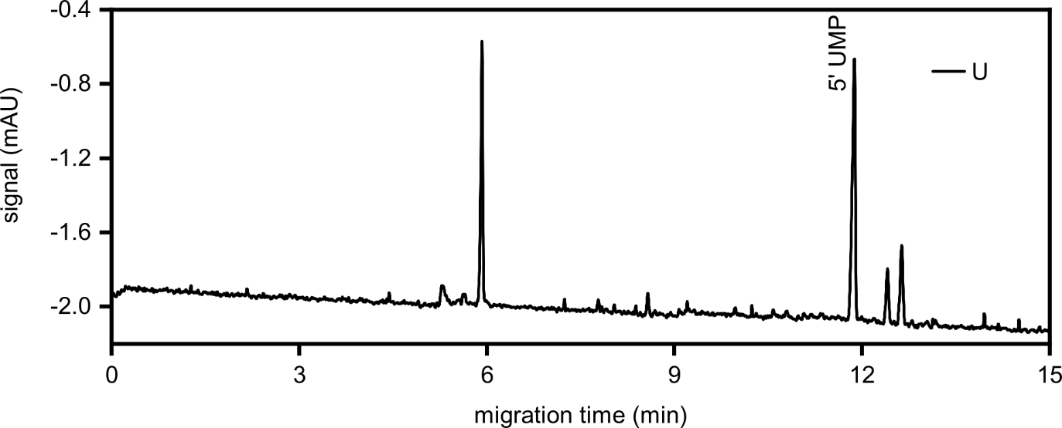
Figure S63. First analysis run of the reaction starting from uridine (U) (100 mM, 1.0 eq.), H₃PO₃ (3.0 eq.) and urea (1.0 eq.) after 7 d. The sample was diluted to 200 µM referring to the initial U concentration for determination of the 5’ UMP yield.

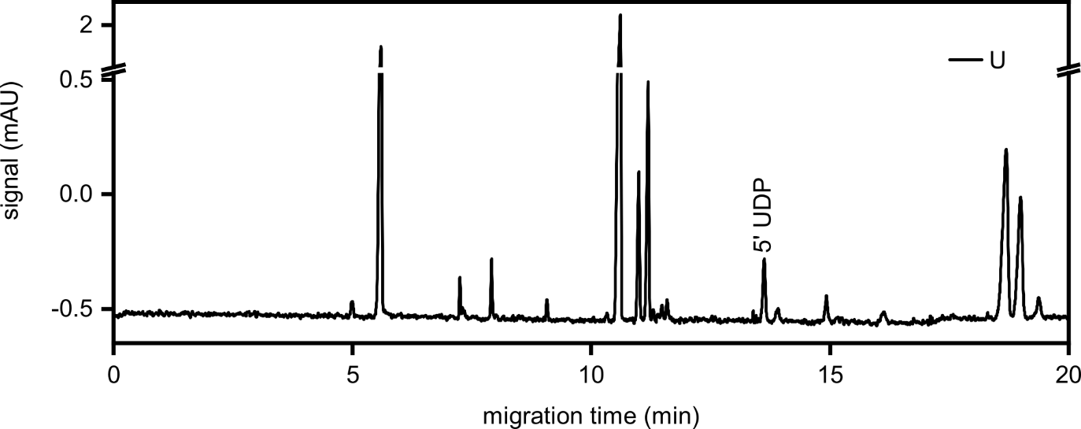
Figure S64. First analysis run of the reaction starting from U (100 mM, 1.0 eq.), H₃PO₃ (3.0 eq.) and urea (1.0 eq.) after 7 d. The sample was diluted to 500 µM referring to the initial U concentration for determination of the 5’ UDP yield.

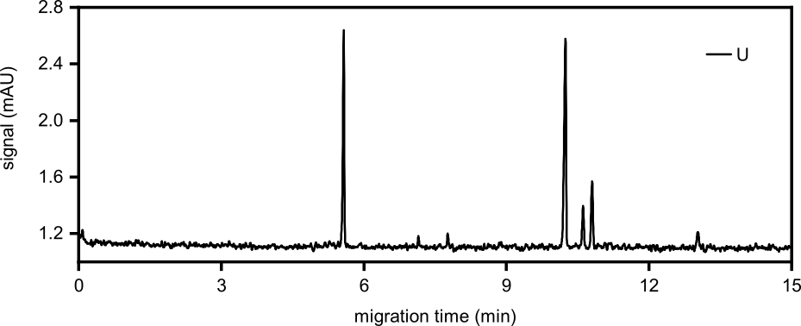
Figure S65. Second analysis run of the reaction starting from U (100 mM, 1.0 eq.), H₃PO₃ (3.0 eq.) and urea (1.0 eq.) after 7 d. The sample was diluted to 200 µM referring to the initial U concentration for determination of the 5’ UMP yield.

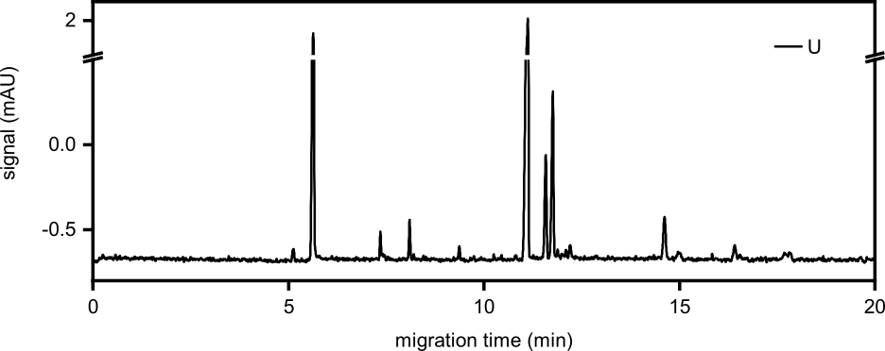
Figure S66. Second analysis run of the reaction starting from U (100 mM, 1.0 eq.), H₃PO₃ (3.0 eq.) and urea (1.0 eq.) after 7 d. The sample was diluted to 500 µM referring to the initial U concentration for determination of the 5’ UDP yield.

Table S31. First analysis runs of the reaction starting from U (100 mM, 1.0 eq.), H₃PO₃ (3.0 eq.) and urea (1.0 eq.) after 7 d. The sample was diluted to 200 µM referring to the initial U concentration for determination of the 5’ UMP yield and to 500 µM for determination of the 5’ UDP yield.
Product | Integral  (mAU x min) | c_{sample vial}  (µM) | c_{reaction mixture}  (mM) | Yield  (%)
5’ UMP | 0.0816 | 62.77 | 31.38 | 31.38
5’ UDP | 0.0176 | 7.65 | 1.53 | 1.53

Table S32. Second analysis runs of the reaction starting from U (100 mM, 1.0 eq.), H₃PO₃ (3.0 eq.) and urea (1.0 eq.) after 7 d. The sample was diluted to 200 µM referring to the initial U concentration for determination of the 5’ UMP yield and to 500 µM for determination of the 5’ UDP yield.
Product | Integral  (mAU x min) | c_{sample vial}  (µM) | c_{reaction mixture}  (mM) | Yield  (%) | Ø Yield  (%)
5’ UMP | 0.0725 | 55.76 | 27.88 | 27.88 | 29.63 ± 2.48
5’ UDP | 0.0178 | 7.76 | 1.55 | 1.55 | 1.54 ± 0.01

2.8 Reactions with guanosine
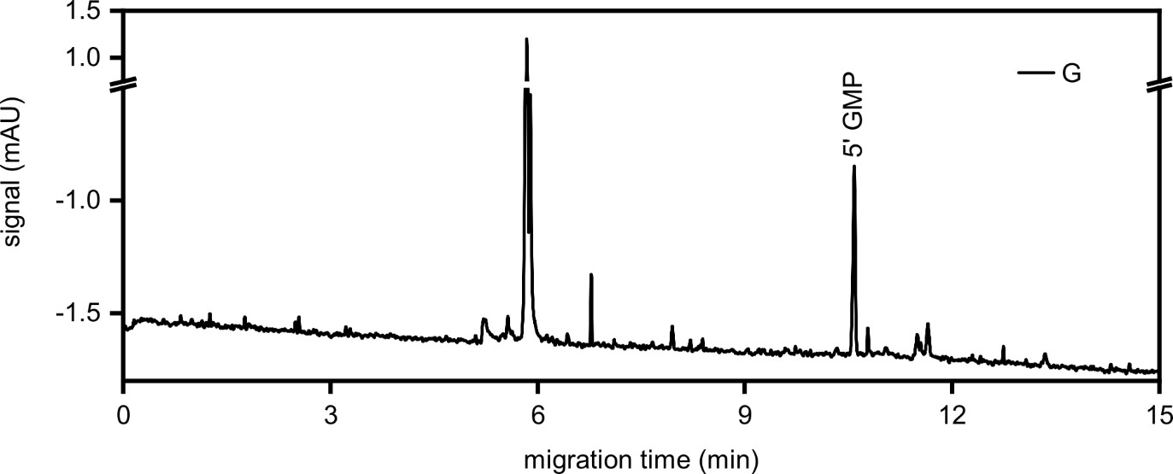
Figure S67. First analysis run of the reaction starting from guanosine (G) (100 mM, 1.0 eq.), H₃PO₃ (3.0 eq.) and urea (1.0 eq.) after 7 d. The sample was diluted to 200 µM referring to the initial G concentration for determination of the 5’ GMP yield.

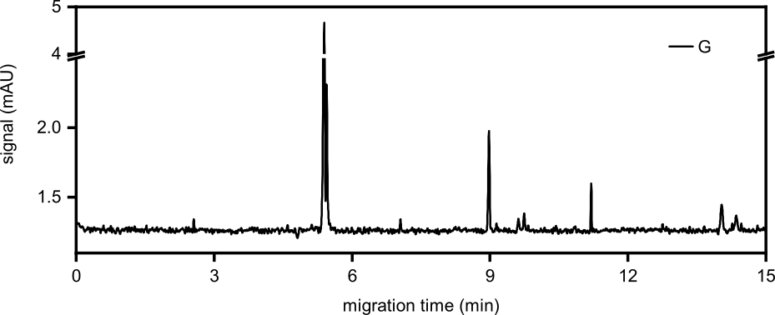
Figure S68. Second analysis run of the reaction starting from G (100 mM, 1.0 eq.), H₃PO₃ (3.0 eq.) and urea (1.0 eq.) after 7 d. The sample was diluted to 200 µM referring to the initial G concentration for determination of the 5’ GMP yield.

Table S33. First analysis run of the reaction starting from G (100 mM, 1.0 eq.), H₃PO₃ (3.0 eq.) and urea (1.0 eq.) after 7 d. The sample was diluted to 200 µM referring to the initial G concentration for determination of the 5’ GMP yield.
Product | Integral  (mAU x min) | c_{sample vial}  (µM) | c_{reaction mixture}  (mM) | Yield  (%)
5’ GMP | 0.0351 | 16.41 | 8.20 | 8.20

Table S34. Second analysis run of the reaction starting from G (100 mM, 1.0 eq.), H₃PO₃ (3.0 eq.) and urea (1.0 eq.) after 7 d. The sample was diluted to 200 µM referring to the initial G concentration for determination of the 5’ GMP yield.
Product | Integral  (mAU x min) | c_{sample vial}  (µM) | c_{reaction mixture}  (mM) | Yield  (%) | Ø Yield  (%)
5’ GMP | 0.0255 | 11.91 | 5.96 | 5.96 | 7.08 ± 1.59

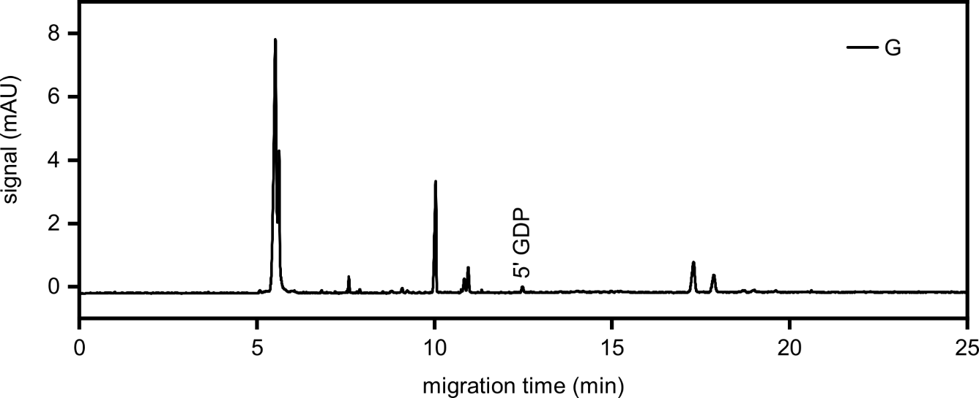
Figure S69. Assignment of 5’ guanosine diphosphate obtained from the reaction with G (100 mM, 1.0 eq.), H₃PO₃ (3.0 eq.) and urea (1.0 eq.) after 7 d. The sample was diluted to 1 mM referring to the initial G concentration.

2.9 Reactions with deoxycytidine
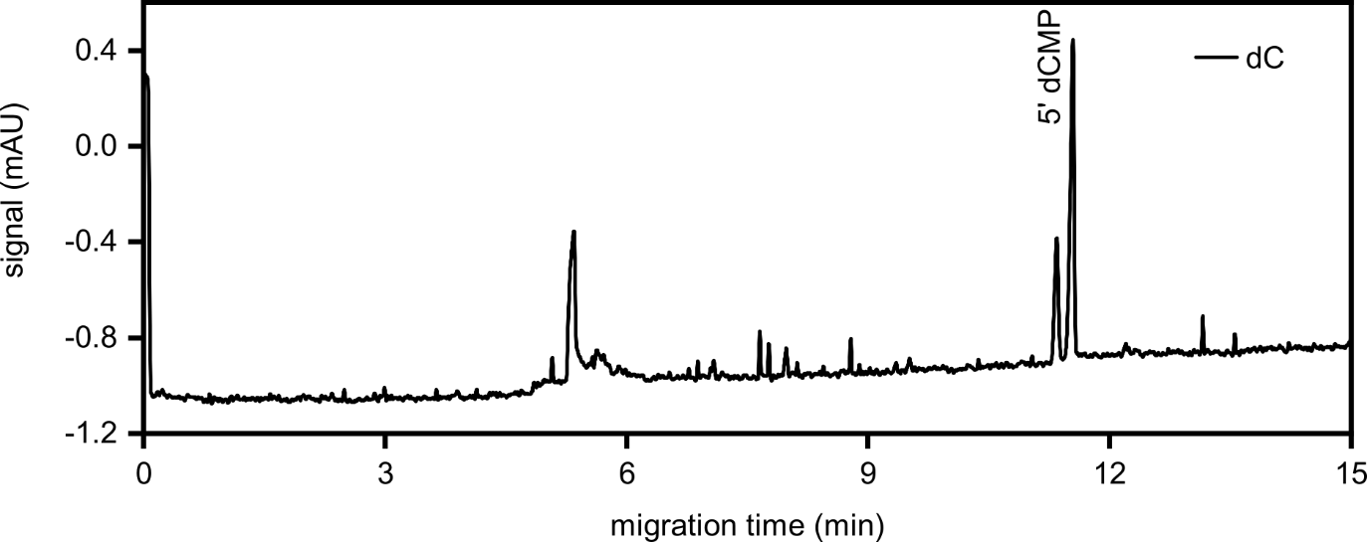
Figure S70. First analysis run of the reaction starting from deoxycytidine (dC) (100 mM, 1.0 eq.), H₃PO₃ (3.0 eq.) and urea (1.0 eq.) after 7 d. The sample was diluted to 200 µM referring to the initial dC concentration for determination of the 5’ dCMP yield.

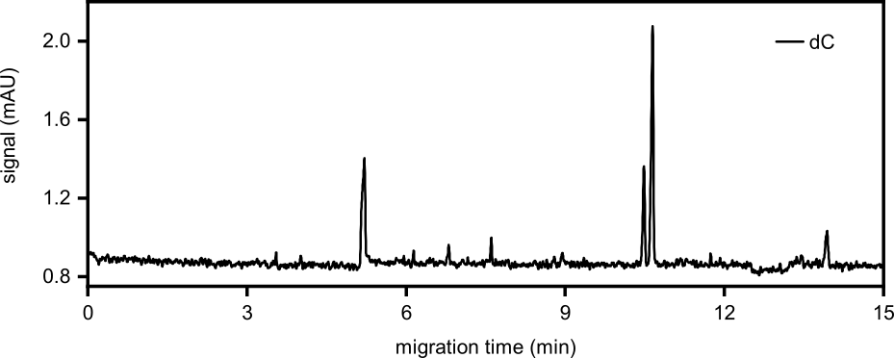
Figure S71. Second analysis run of the reaction starting from dC (100 mM, 1.0 eq.), H₃PO₃ (3.0 eq.) and urea (1.0 eq.) after 7 d. The sample was diluted to 200 µM referring to the initial dC concentration for determination of the 5’ dCMP yield.

Table S35. First analysis run of the reaction starting from dC (100 mM, 1.0 eq.), H₃PO₃ (3.0 eq.) and urea (1.0 eq.) after 7 d. The sample was diluted to 200 µM referring to the initial dC concentration for determination of the 5’ dCMP yield.
Product | Integral  (mAU x min) | c_{sample vial}  (µM) | c_{reaction mixture}  (mM) | Yield  (%)
5’ dCMP | 0.0738 | 73.08 | 36.54 | 36.54

Table S36. Second analysis run of the reaction starting from dC (100 mM, 1.0 eq.), H₃PO₃ (3.0 eq.) and urea (1.0 eq.) after 7 d. The sample was diluted to 200 µM referring to the initial dC concentration for determination of the 5’ dCMP yield.
Product | Integral  (mAU x min) | c_{sample vial}  (µM) | c_{reaction mixture}  (mM) | Yield  (%) | Ø Yield  (%)
5’ dCMP | 0.0580 | 57.42 | 28.71 | 28.71 | 32.62 ± 5.54

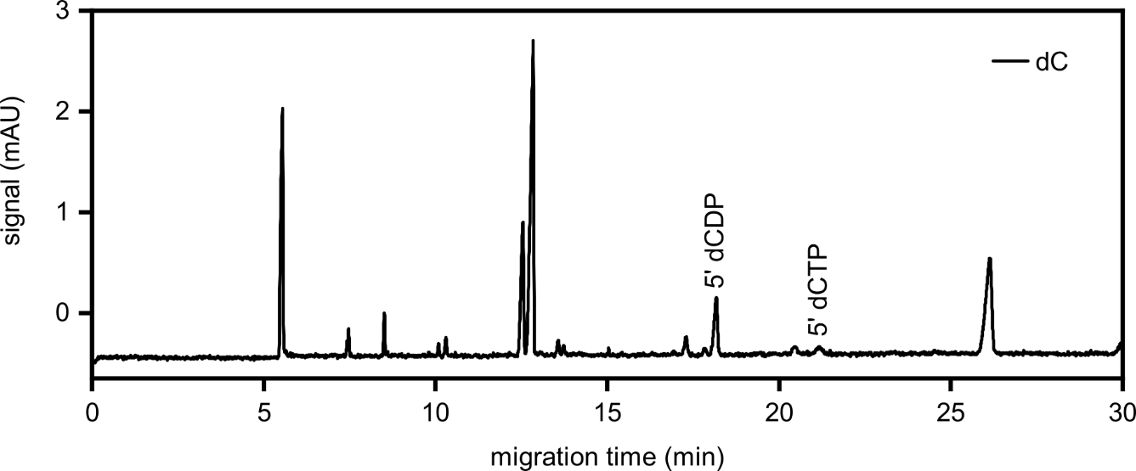
Figure S72. Assignment of the 5’ substituted polyphosphate products obtained from the reaction with dC (100 mM, 1.0 eq.), H₃PO₃ (3.0 eq.) and urea (1.0 eq.) after 7 d. The sample was diluted to 1 mM referring to the initial dC concentration.

2.10 Reactions with deoxythymidine
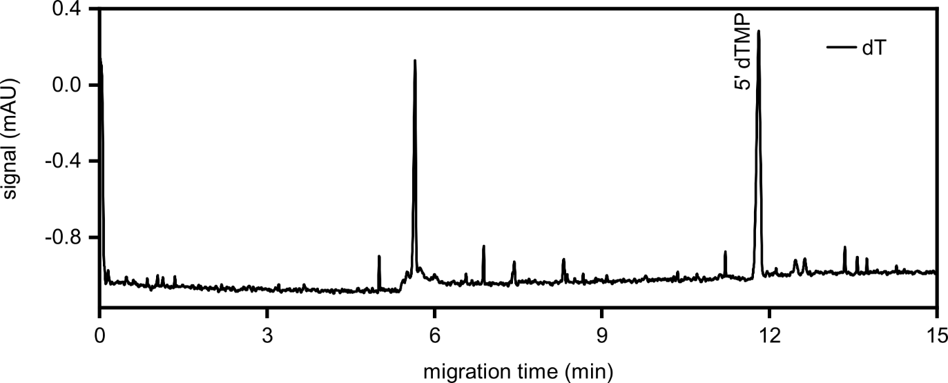
Figure S73. First analysis run of the reaction starting from deoxythymidine (dT) (100 mM, 1.0 eq.), H₃PO₃ (3.0 eq.) and urea (1.0 eq.) after 7 d. The sample was diluted to 200 µM referring to the initial dT concentration for determination of the 5’ dTMP yield.

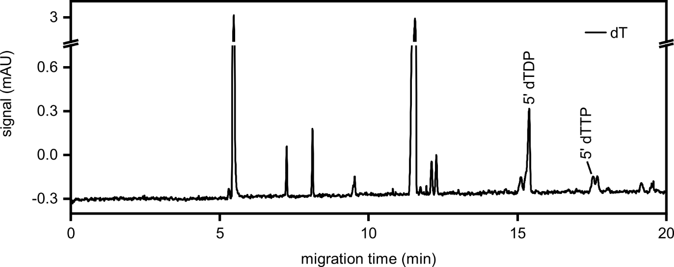
Figure S74. First analysis run of the reaction starting from dT (100 mM, 1.0 eq.), H₃PO₃ (3.0 eq.) and urea (1.0 eq.) after 7 d. The sample was diluted to 1 mM referring to the initial dT concentration for determination of the 5’ dTDP yield and assignment of the 5’ deoxythymidine triphosphate (5’ dTTP) signal.

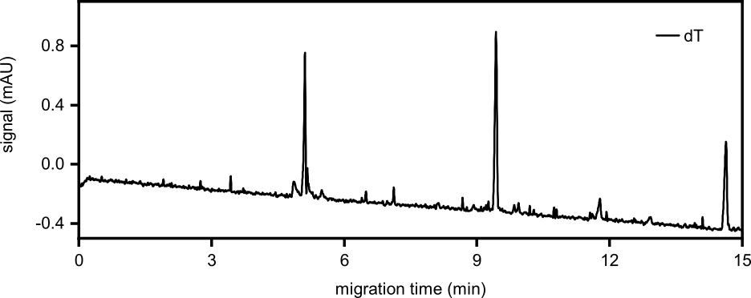
Figure S75. Second analysis run of the reaction starting from dT (100 mM, 1.0 eq.), H₃PO₃ (3.0 eq.) and urea (1.0 eq.) after 7 d. The sample was diluted to 200 µM referring to the initial dT concentration for determination of the 5’ dTMP yield.

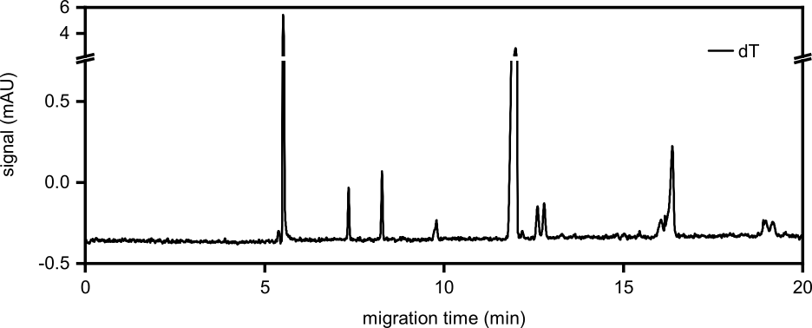
Figure S76. Second analysis run of the reaction starting from dT (100 mM, 1.0 eq.), H₃PO₃ (3.0 eq.) and urea (1.0 eq.) after 7 d. The sample was diluted to 1 mM referring to the initial dT concentration for determination of the 5’ dTDP yield.

Table S37. First analysis runs of the reaction starting from dT (100 mM, 1.0 eq.), H₃PO₃ (3.0 eq.) and urea (1.0 eq.) after 7 d. The sample was diluted to 200 µM referring to the initial dT concentration for determination of the 5’ dTMP yield and to 1 mM for determination of the 5’ dTDP yield.
Product | Integral  (mAU x min) | c_{sample vial}  (µM) | c_{reaction mixture}  (mM) | Yield  (%)
5’ dTMP | 0.1004 | 76.66 | 38.33 | 38.33
5’ dTDP | 0.0555 | 34.24 | 3.42 | 3.42

Table S38. Second analysis runs of the reaction starting from dT (100 mM, 1.0 eq.), H₃PO₃ (3.0 eq.) and urea (1.0 eq.) after 7 d. The sample was diluted to 200 µM referring to the initial dT concentration for determination of the 5’ dTMP yield and to 1 mM for determination of the 5’ dTDP yield.
Product | Integral  (mAU x min) | c_{sample vial}  (µM) | c_{reaction mixture}  (mM) | Yield  (%) | Ø Yield  (%)
5’ dTMP | 0.0657 | 50.13 | 25.06 | 25.06 | 31.70 ± 9.38
5’ dTDP | 0.0608 | 37.56 | 3.76 | 3.76 | 3.59 ± 0.23

3 Extracted ion electropherograms and mass spectra (CE-MS)

3.1 Reactions with adenosine

3.1.1 Variation of the H₃PO₃ concentration
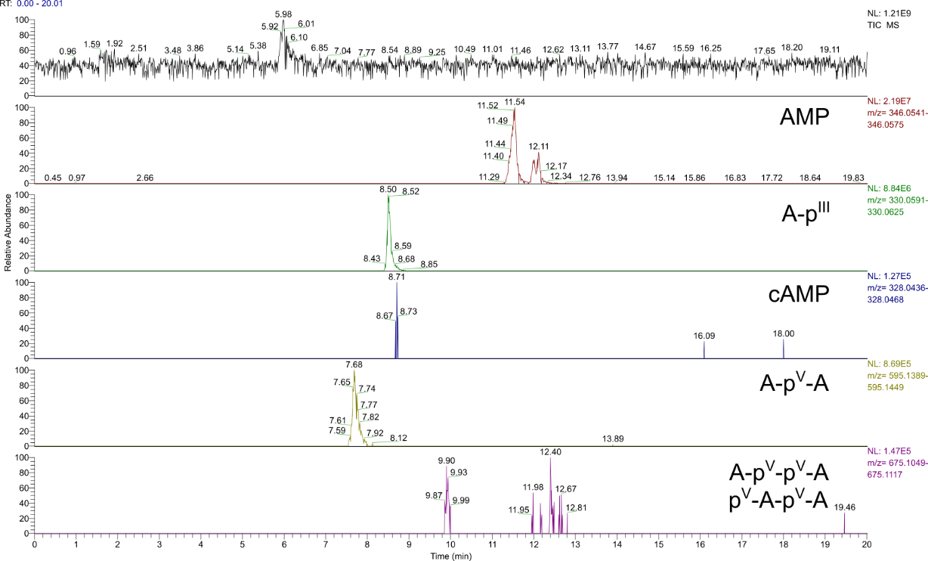
Figure S77. Total ion electropherogram (TIC) (m/z 50-750) and extracted ion electropherograms (EIEs) (Δ = 5.0 ppm) of the products of the reaction starting from A (100 mM) and H₃PO₃ (1.0 eq.) after 7 d. Constitution of potential isomers has not been determined. Labels illustrate all possible phosphate/phosphonate binding modes and refer to the entirety of all formed isomers.
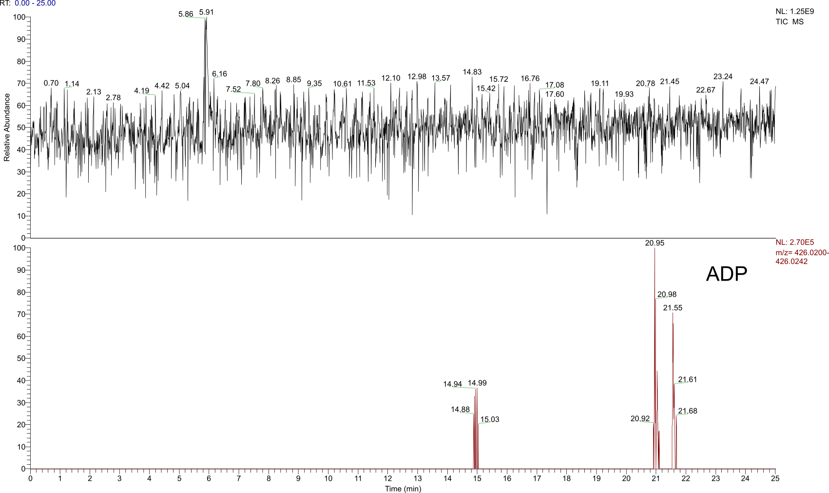
Figure S78. TIC (m/z 50-750) and EIE (Δ = 5.0 ppm) of the products of the reaction starting from A (100 mM) and H₃PO₃ (1.0 eq.) after 7 d. Constitution of potential isomers has not been determined. The label illustrates all possible phosphate binding modes and refers to the entirety of all formed isomers.
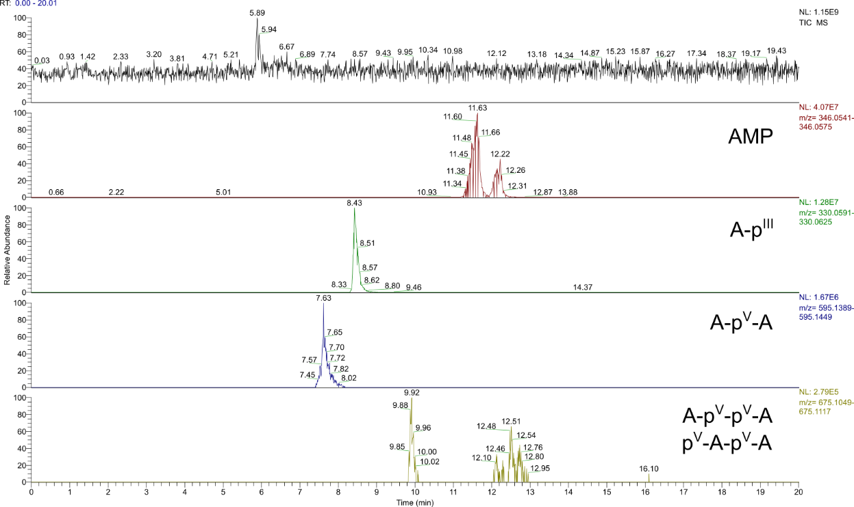
Figure S79. TIC (m/z 50-750) and EIEs (Δ = 5.0 ppm) of the products of the reaction starting from A (100 mM) and H₃PO₃ (3.0 eq.) after 7 d. Constitution of potential isomers has not been determined. Labels illustrate all possible phosphate/phosphonate binding modes and refer to the entirety of all formed isomers.

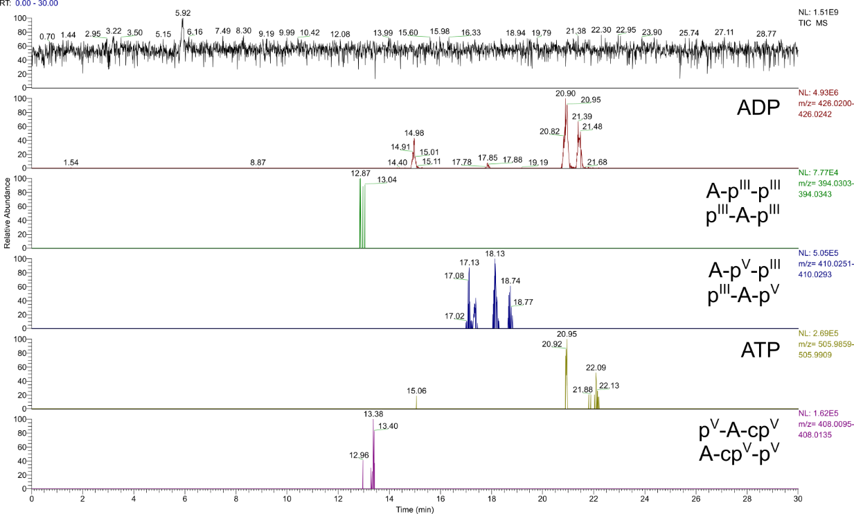
Figure S80. TIC (m/z 50-750) and EIEs (Δ = 5.0 ppm) of the products of the reaction starting from A (100 mM) and H₃PO₃ (3.0 eq.) after 7 d. Constitution of potential isomers has not been determined. Labels illustrate all possible phosphate/phosphonate binding modes and refer to the entirety of all formed isomers.

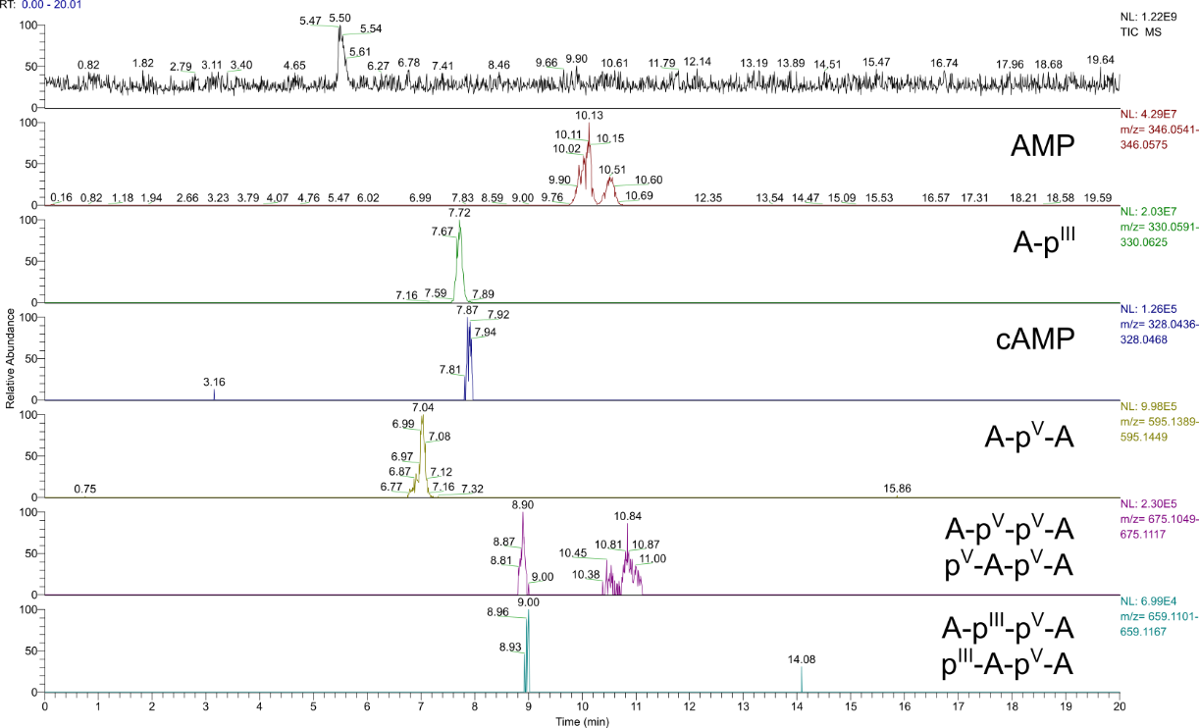
Figure S81. TIC (m/z 50-750) and EIEs (Δ = 5.0 ppm) of the products of the reaction starting from A (100 mM) and H₃PO₃ (5.0 eq.) after 7d. Constitution of potential isomers has not been determined. Labels illustrate all possible phosphate/phosphonate binding modes and refer to the entirety of all formed isomers.

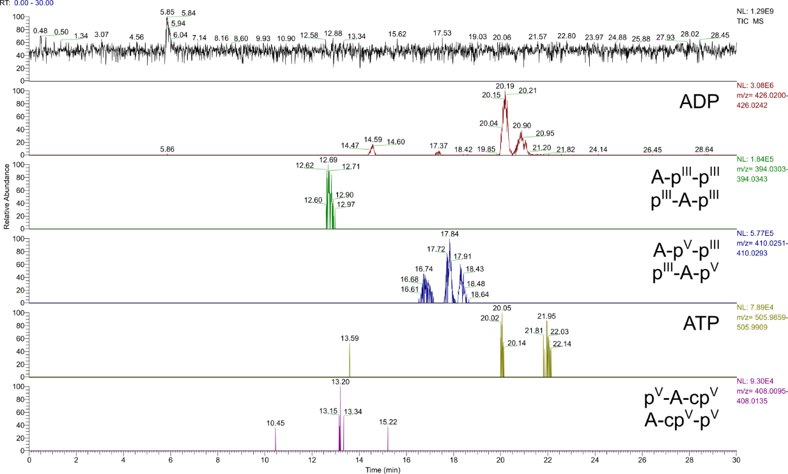
Figure S82. TIC (m/z 50-750) and EIEs (Δ = 5.0 ppm) of the products of the reaction starting from A (100 mM) and H₃PO₃ (5.0 eq.) after 7 d. Constitution of potential isomers has not been determined. Labels illustrate all possible phosphate/phosphonate binding modes and refer to the entirety of all formed isomers.

3.1.2 Variation of the urea concentration
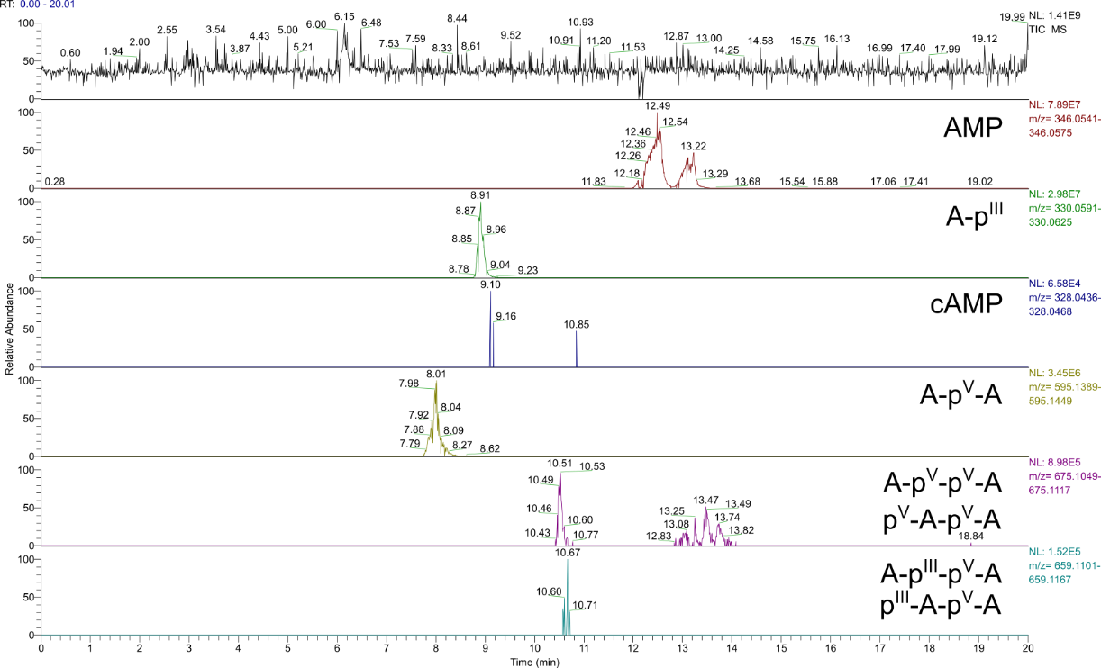
Figure S83. TIC (m/z 50-750) and EIEs (Δ = 5.0 ppm) of the products of the reaction starting from A (100 mM), H₃PO₃ (3.0 eq.) and urea (1.0 eq.) after 7 d. Constitution of potential isomers has not been determined. Labels illustrate all possible phosphate/phosphonate binding modes and refer to the entirety of all formed isomers.

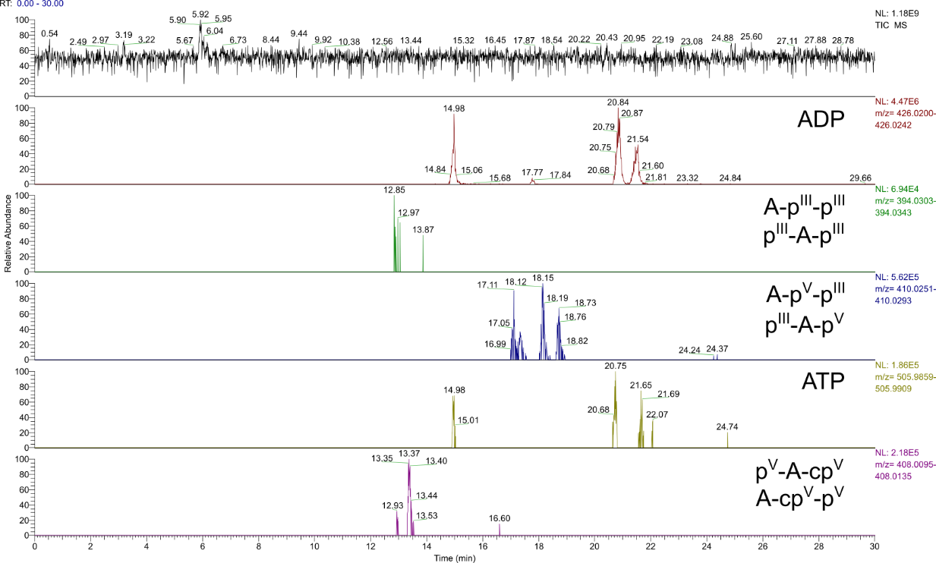
Figure S84. TIC (m/z 50-750) and EIEs (Δ = 5.0 ppm) of the products of the reaction starting from A (100 mM), H₃PO₃ (3.0 eq.) and urea (1.0 eq.) after 7 d. Constitution of potential isomers has not been determined. Labels illustrate all possible phosphate/phosphonate binding modes and refer to the entirety of all formed isomers.

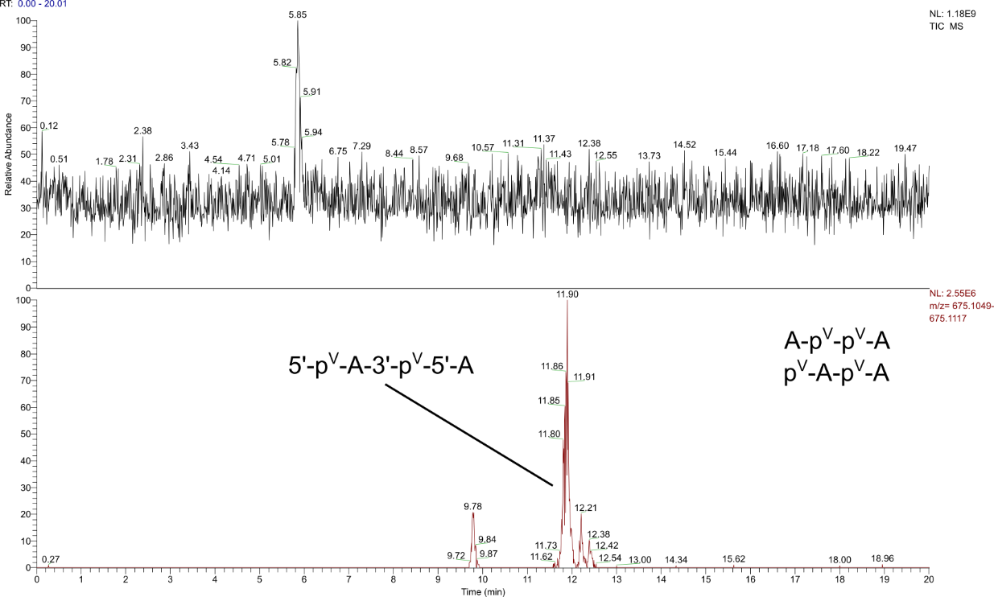
Figure S85. TIC (m/z 50-750) and EIE (Δ = 5.0 ppm) of the product mixture from the reaction of A (100 mM), H₃PO₃ (3.0 eq.) and urea (1.0 eq.) after 7 d with co-injected 5’-p^{V}-A-3’-p^{V}-5’-A (50 µM). The constitution of the other potential isomers has not been determined. Labels illustrate all possible phosphate/phosphonate binding modes and refer to the entirety of all formed isomers.

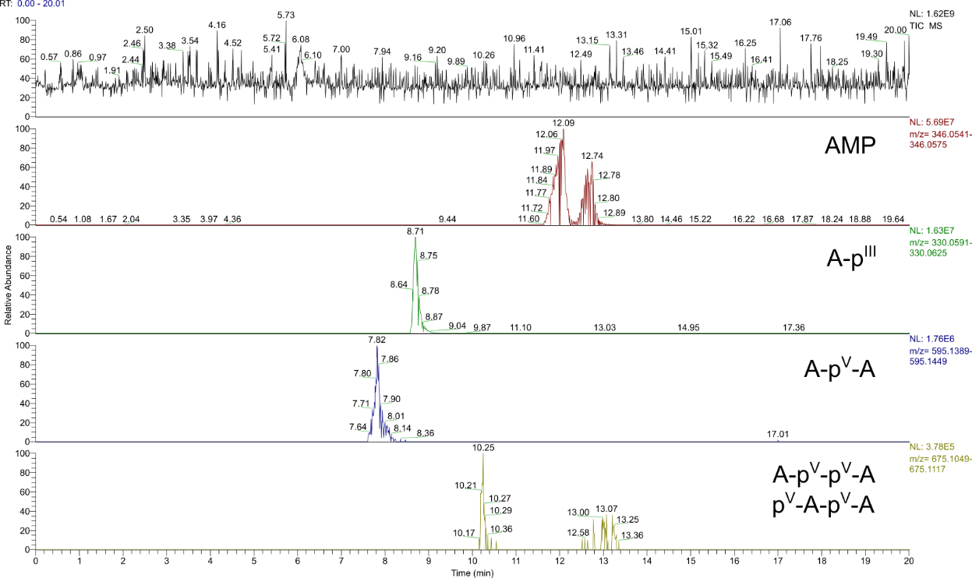
Figure S86. TIC (m/z 50-750) and EIEs (Δ = 5.0 ppm) of the products of the reaction starting from A (100 mM), H₃PO₃ (3.0 eq.) and urea (3.0 eq.) after 7 d. Constitution of potential isomers has not been determined. Labels illustrate all possible phosphate/phosphonate binding modes and refer to the entirety of all formed isomers.

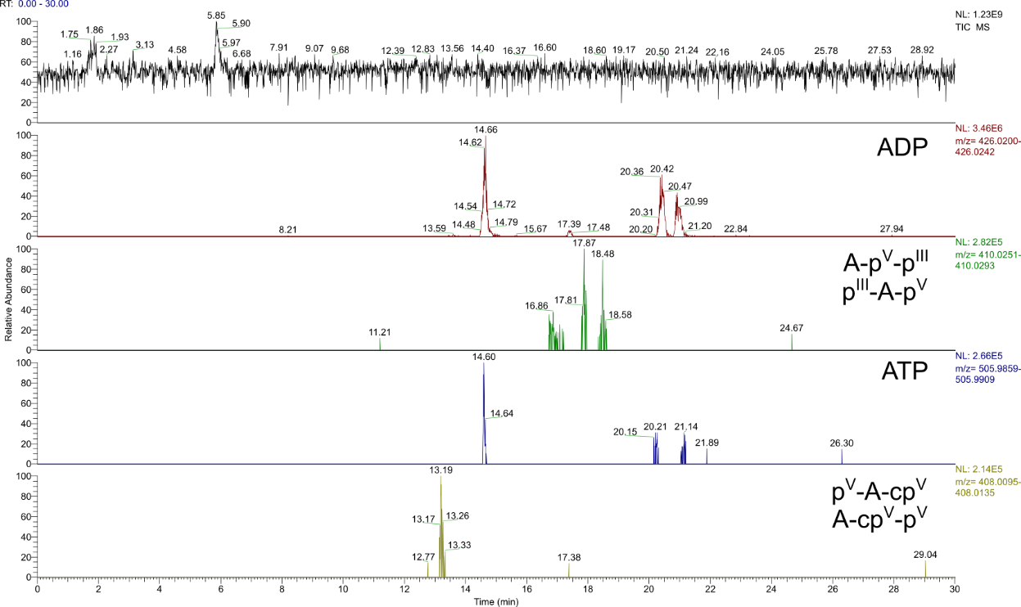
Figure S87. TIC (m/z 50-750) and EIEs (Δ = 5.0 ppm) of the products of the reaction starting from A (100 mM), H₃PO₃ (3.0 eq.) and urea (3.0 eq.) after 7 d. Constitution of potential isomers has not been determined. Labels illustrate all possible phosphate/phosphonate binding modes and refer to the entirety of all formed isomers.

3.1.3 Variation of the adenosine concentration
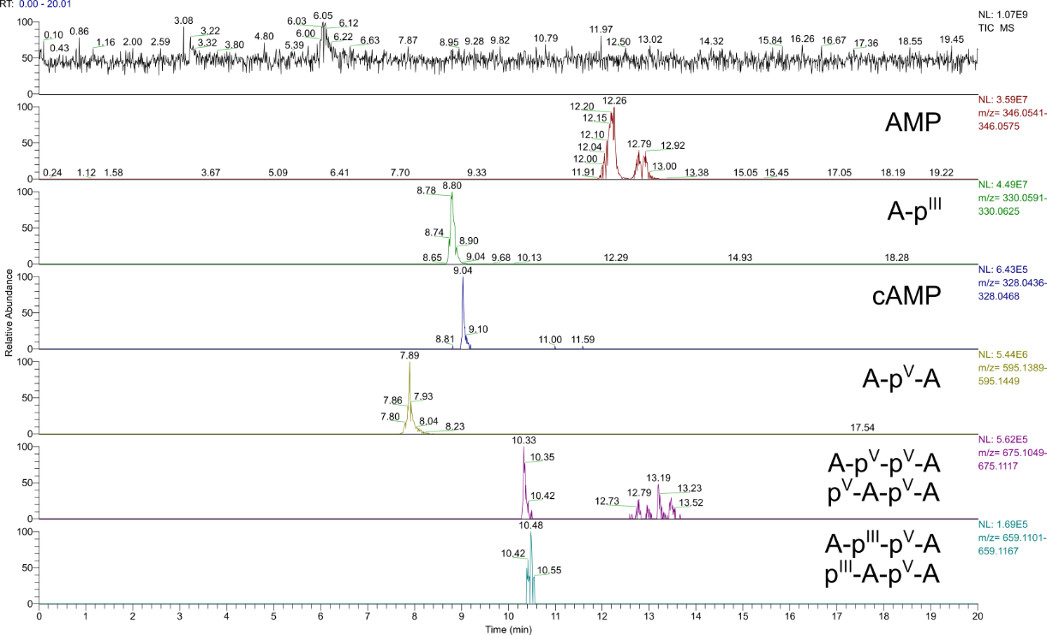
Figure S88. TIC (m/z 50-750) and EIEs (Δ = 5.0 ppm) of the products of the reaction starting from A (25 mM) and H₃PO₃ (1.0 eq.) after 7 d. Constitution of potential isomers has not been determined. Labels illustrate all possible phosphate/phosphonate binding modes and refer to the entirety of all formed isomers.

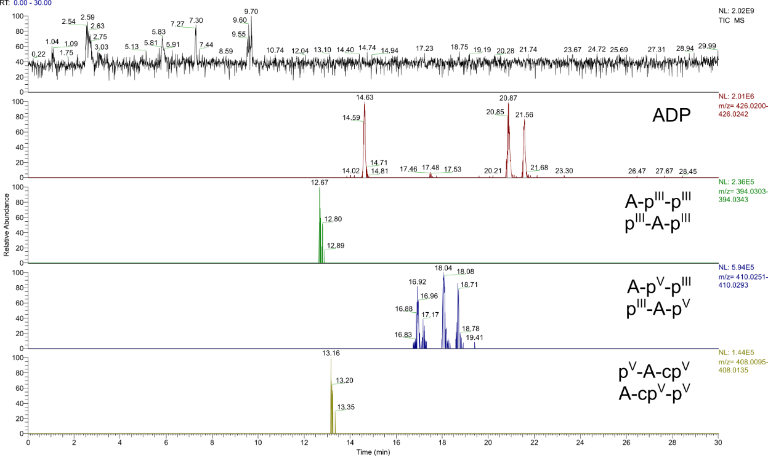
Figure S89. TIC (m/z 50-750) and EIEs (Δ = 5.0 ppm) of the products of the reaction starting from A (25 mM) and H₃PO₃ (1.0 eq.) after 7 d. Constitution of potential isomers has not been determined. Labels illustrate all possible phosphate/phosphonate binding modes and refer to the entirety of all formed isomers.

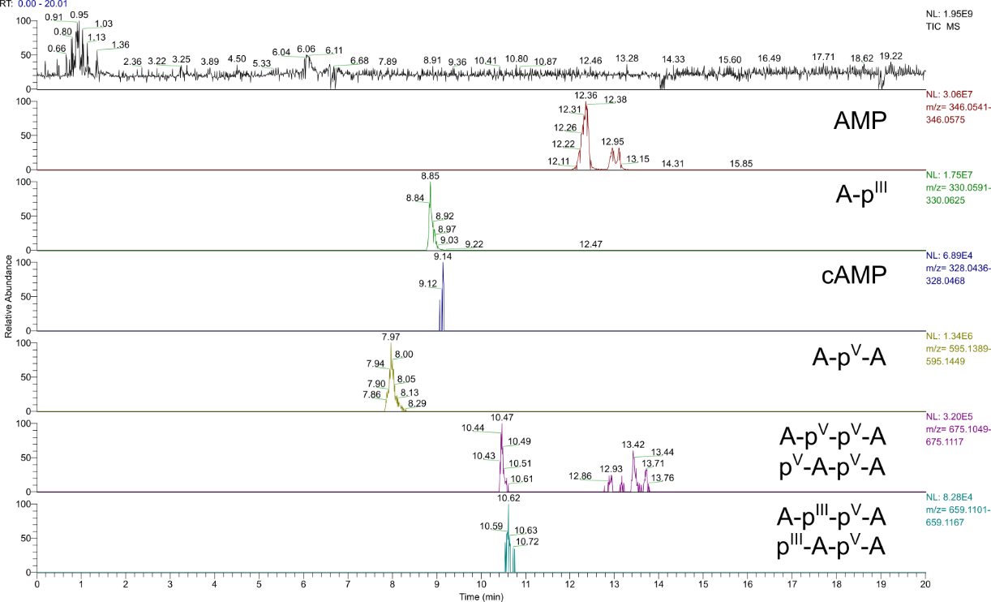
Figure S90. TIC (m/z 50-750) and EIEs (Δ = 5.0 ppm) of the products of the reaction starting from A (50 mM) and H₃PO₃ (1.0 eq.) after 7 d. Constitution of potential isomers has not been determined. Labels illustrate all possible phosphate/phosphonate binding modes and refer to the entirety of all formed isomers.

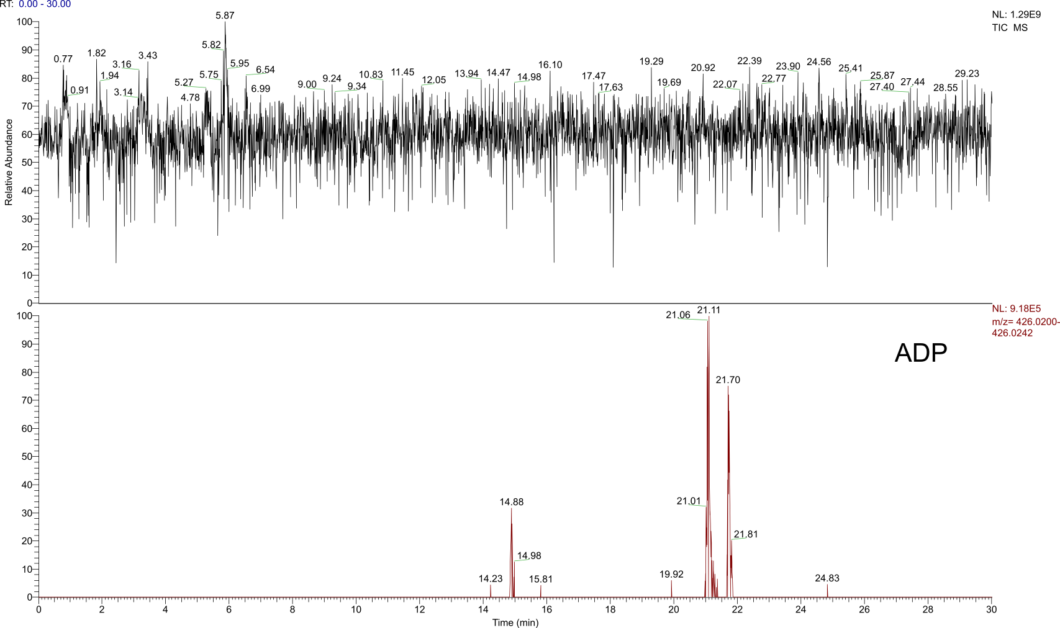
Figure S91. TIC (m/z 50-750) and EIE (Δ = 5.0 ppm) of the products of the reaction starting from A (50 mM) and H₃PO₃ (1.0 eq.) after 7 d. Constitution of potential isomers has not been determined. The label illustrates all possible phosphate binding modes and refers to the entirety of all formed isomers.

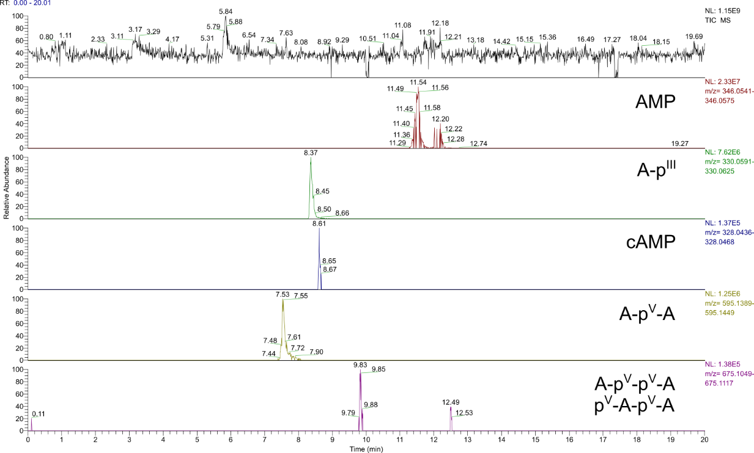
Figure S92. TIC (m/z 50-750) and EIEs (Δ = 5.0 ppm) of the products of the reaction starting from A (400 mM) and H₃PO₃ (1.0 eq.) after 7 d. Constitution of potential isomers has not been determined. Labels illustrate all possible phosphate/phosphonate binding modes and refer to the entirety of all formed isomers.

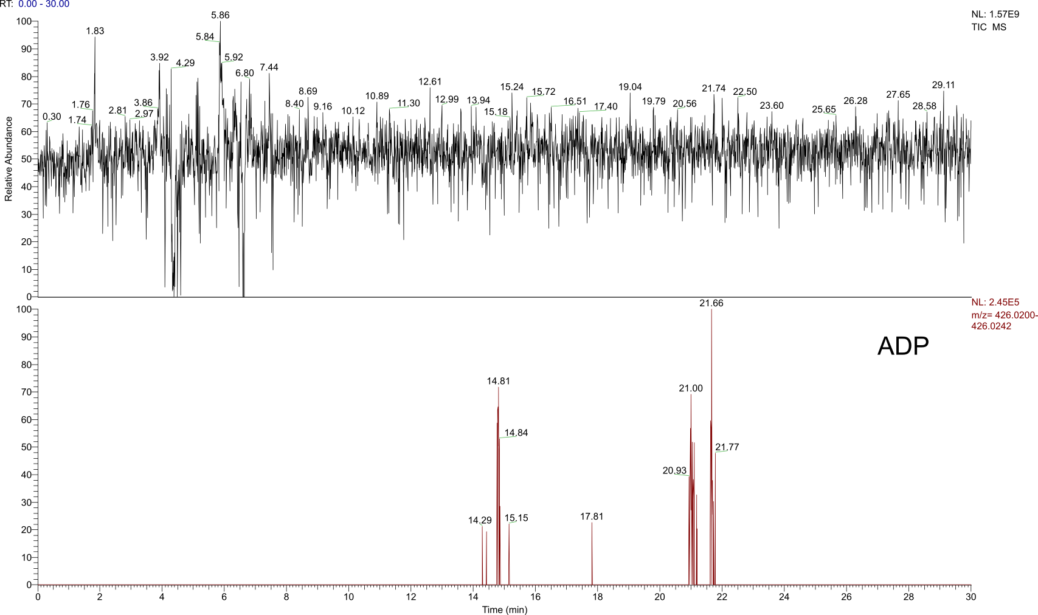
Figure S93. TIC (m/z 50-750) and EIE (Δ = 5.0 ppm) of the products of the reaction starting from A (400 mM) and H₃PO₃ (1.0 eq.) after 7 d. Constitution of potential isomers has not been determined. The label illustrates all possible phosphate binding modes and refers to the entirety of all formed isomers.

3.1.4 Time dependence of the reaction
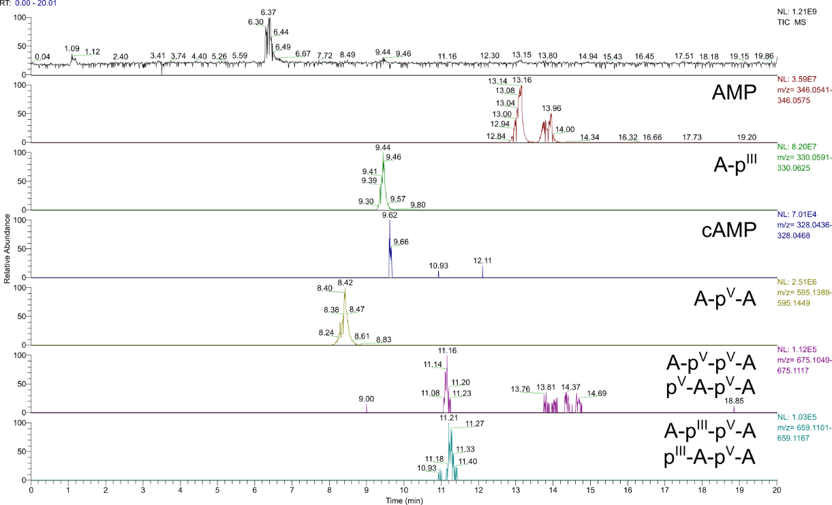
Figure S94. TIC (m/z 80-1200) and EIEs (Δ = 5.0 ppm) of the products of the reaction starting from A (100 mM), H₃PO₃ (3.0 eq.) and urea (1.0 eq.) after 1 d. Constitution of potential isomers has not been determined. Labels illustrate all possible phosphate/phosphonate binding modes and refer to the entirety of all formed isomers.

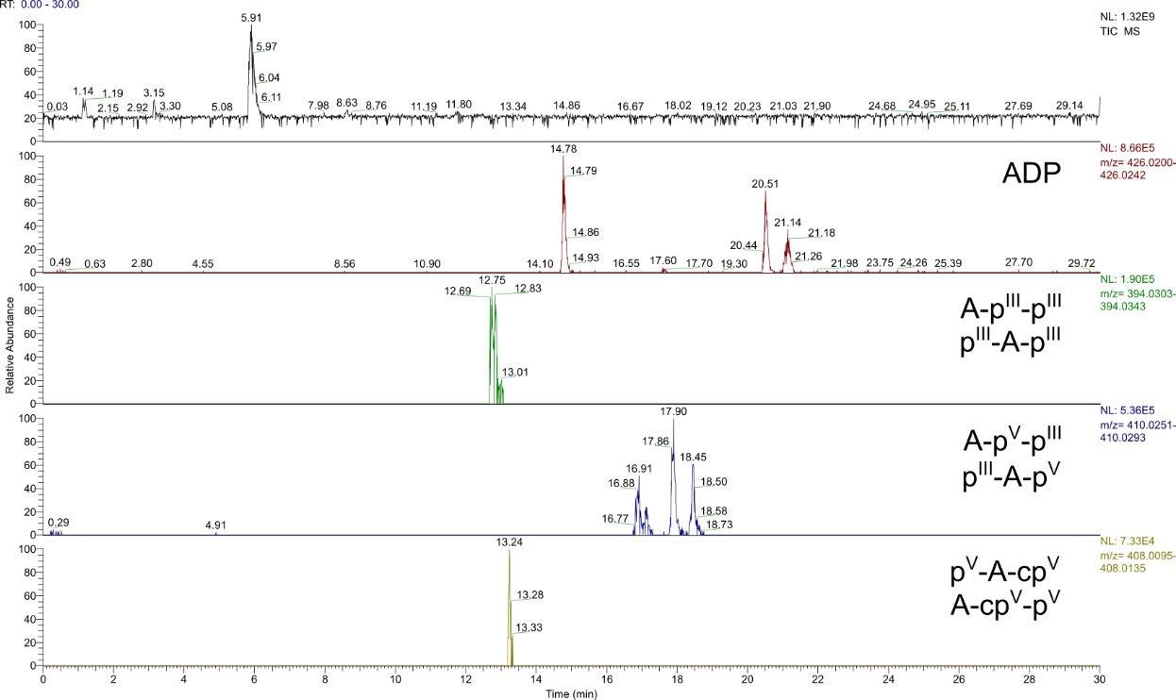
Figure S95. TIC (m/z 80-1200) and EIEs (Δ = 5.0 ppm) of the products of the reactions starting from A (100 mM), H₃PO₃ (3.0 eq.) and urea (1.0 eq.) after 1 d. Constitution of potential isomers has not been determined. Labels illustrate all possible phosphate/phosphonate binding modes and refer to the entirety of all formed isomers.

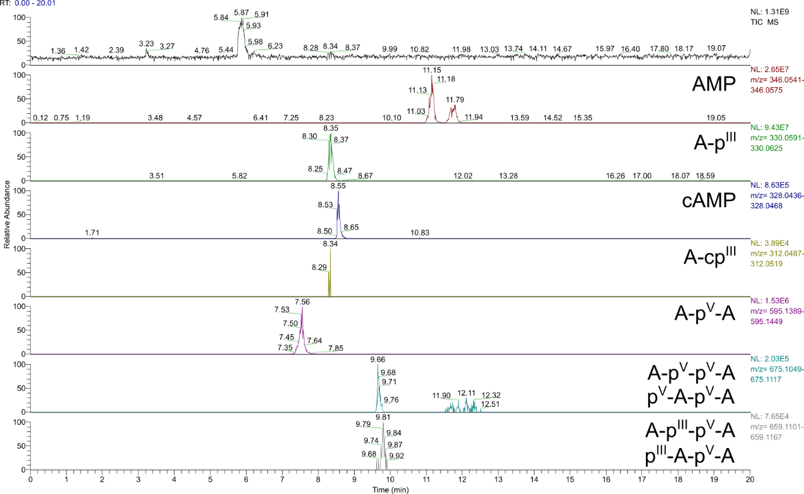
Figure S96. TIC (m/z 80-1200) and EIEs (Δ = 5.0 ppm) of the products of the reaction starting from A (100 mM), H₃PO₃ (3.0 eq.) and urea (1.0 eq.) after 3 d. Constitution of potential isomers has not been determined. Labels illustrate all possible phosphate/phosphonate binding modes and refer to the entirety of all formed isomers.

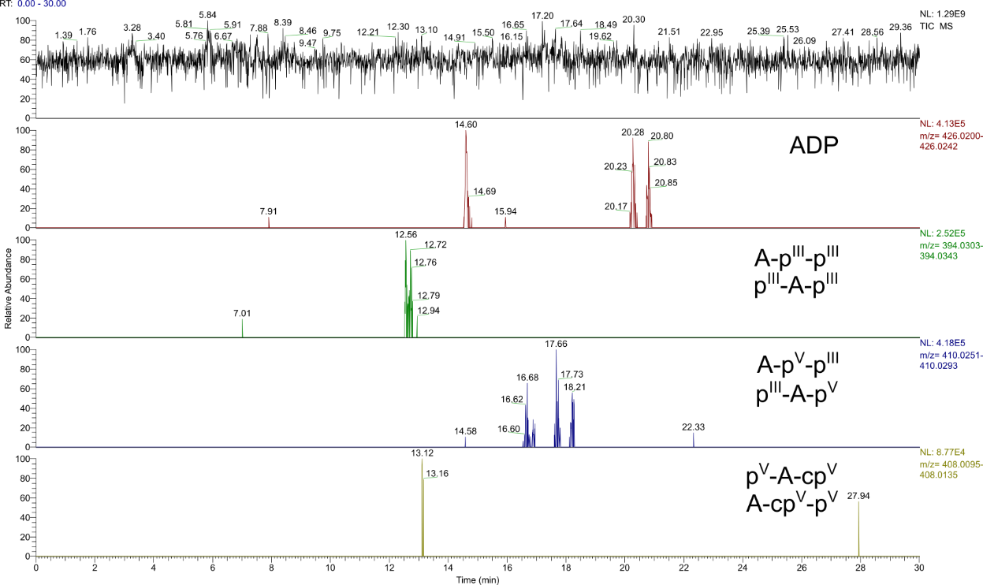
Figure S97. TIC (m/z 50-750) and EIEs (Δ = 5.0 ppm) of the products of the reaction starting from A (100 mM), H₃PO₃ (3.0 eq.) and urea (1.0 eq.) after 3 d. Constitution of potential isomers has not been determined. Labels illustrate all possible phosphate/phosphonate binding modes and refer to the entirety of all formed isomers.

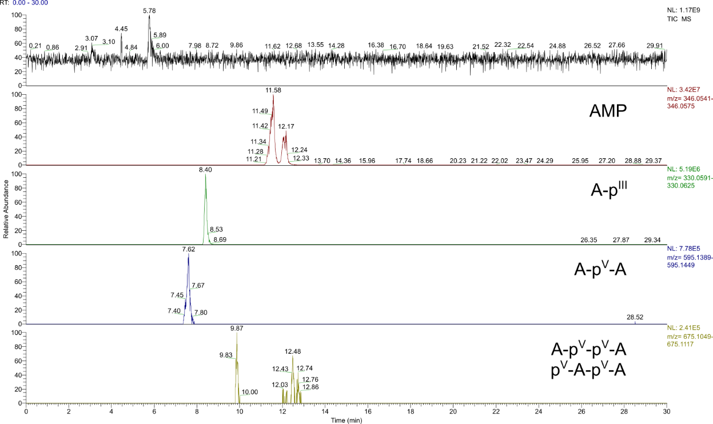
Figure S98. TIC (m/z 50-750) and EIEs of the products of the reaction starting from A (100 mM), H₃PO₃ (3.0 eq.) and urea (1.0 eq.) after 26 d. Constitution of potential isomers has not been determined. Labels illustrate all possible phosphate/phosphonate binding modes and refer to the entirety of all formed isomers.

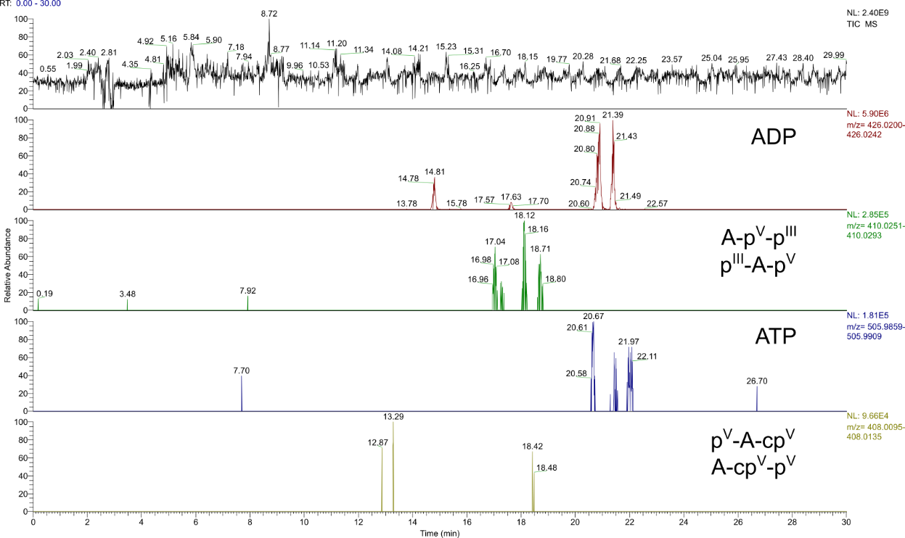
Figure S99. TIC (m/z 50-750) and EIEs of the products of the reaction starting from A (100 mM), H₃PO₃ (3.0 eq.) and urea (1.0 eq.) after 26 d. Constitution of potential isomers has not been determined. Labels illustrate all possible phosphate/phosphonate binding modes and refer to the entirety of all formed isomers.

3.1 Reactions with H₃PO₄
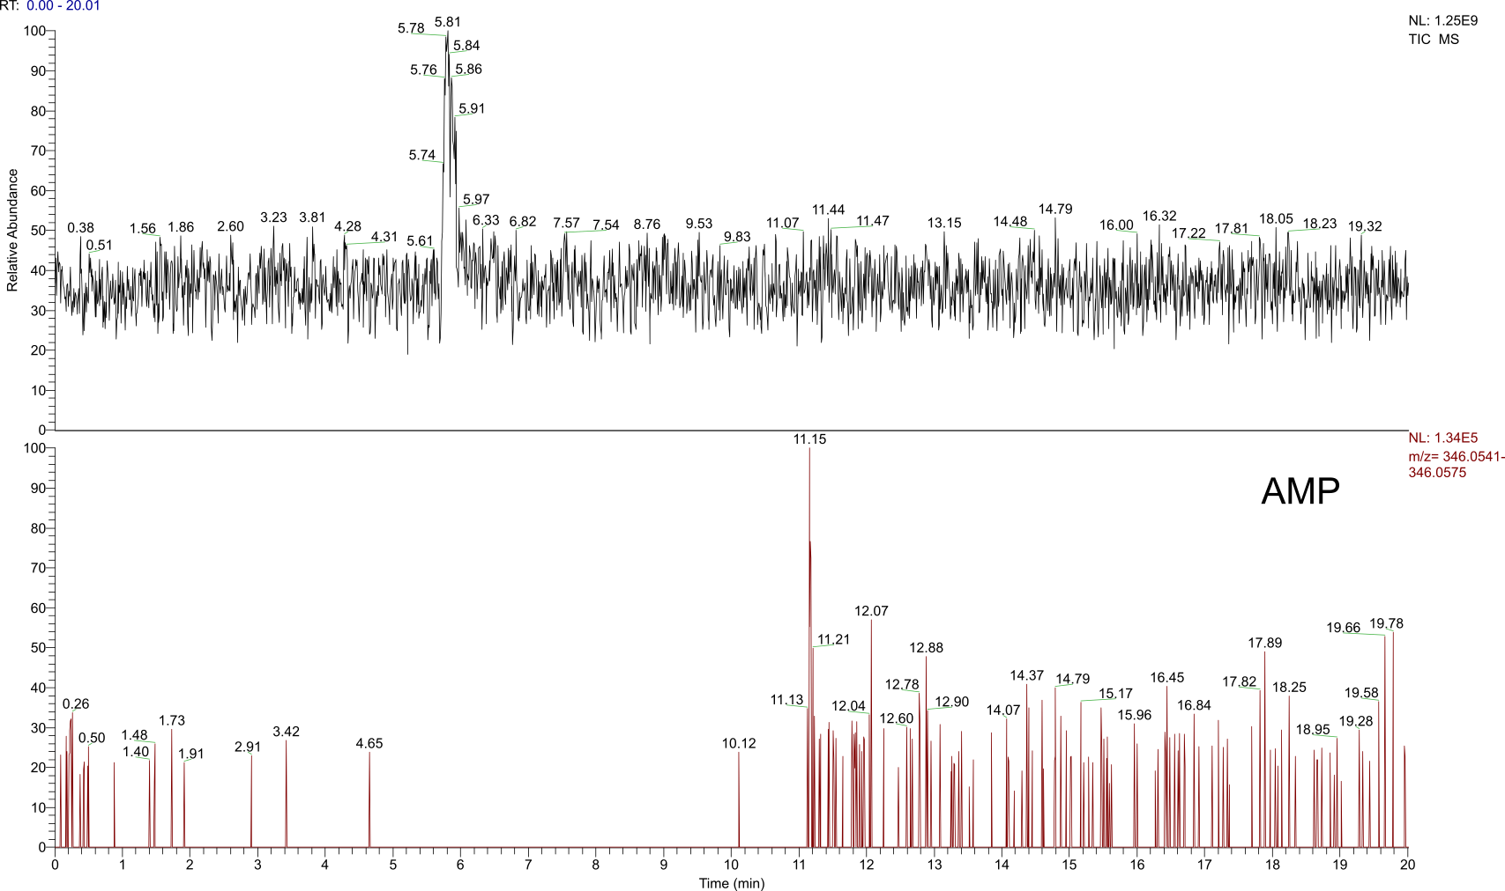
Figure S100. TIC (m/z 50-750) and EIE (Δ = 5.0 ppm) of the product of the reaction starting from A (100 mM) and H₃PO₄ (1.0 eq.) after 7 d. Constitution of potential isomers has not been determined. The label illustrates all possible phosphate binding modes and refers to the entirety of all formed isomers.

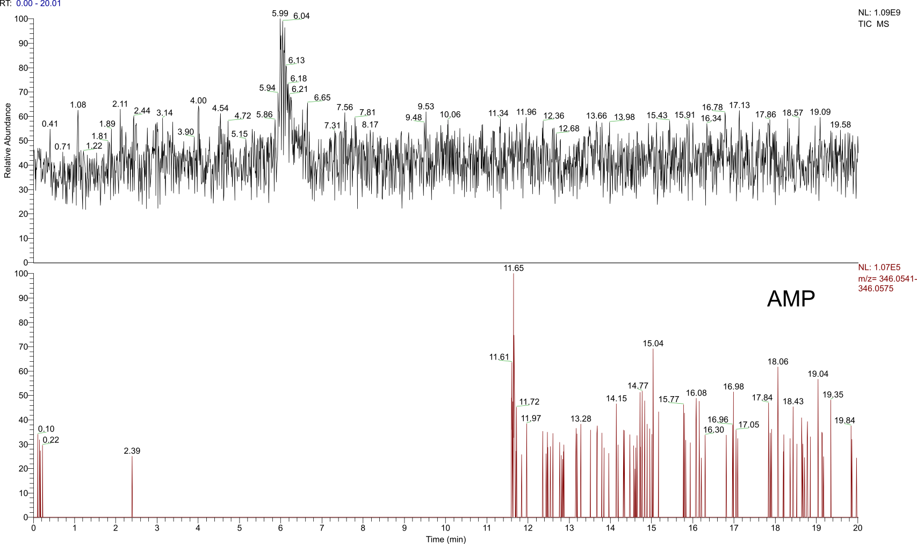
Figure S101. TIC (m/z 50-750) and EIE (Δ = 5.0 ppm) of the product of the reaction starting from A (100 mM), H₃PO₄ and urea (each 1.0 eq.) after 14 d. Constitution of potential isomers has not been determined. The label illustrates all possible phosphate binding modes and refers to the entirety of all formed isomers.

3.2 Reaction with 5’ AMP
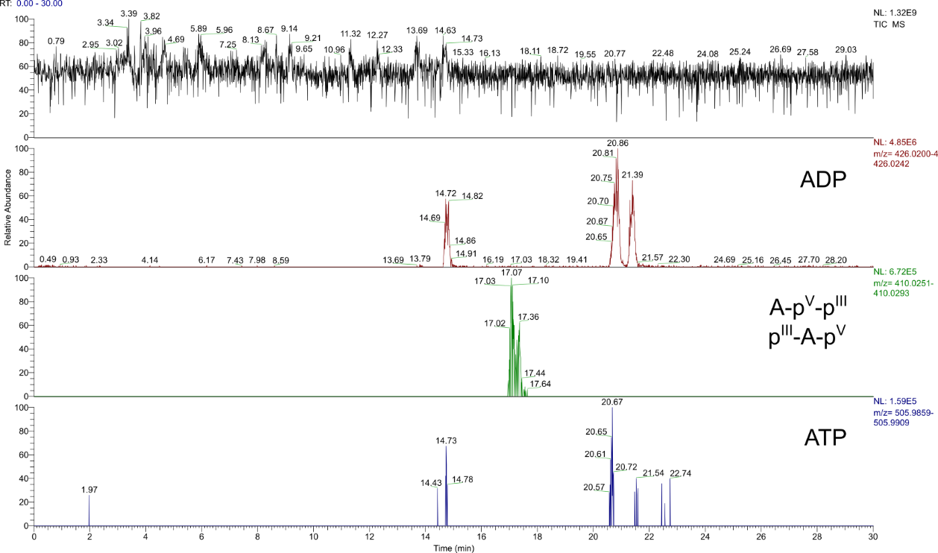
Figure S102. TIC (m/z 50-750) and EIEs (Δ = 5.0 ppm) of the products of the reaction starting from 5’ AMP (100 mM), H₃PO₃ (3.0 eq.) and urea (1.0 eq.) after 7 d. Constitution of potential isomers has not been determined. Labels illustrate all possible phosphate/phosphonate binding modes and refer to the entirety of all formed isomers.

3.3 Reactions with 5’ ADP
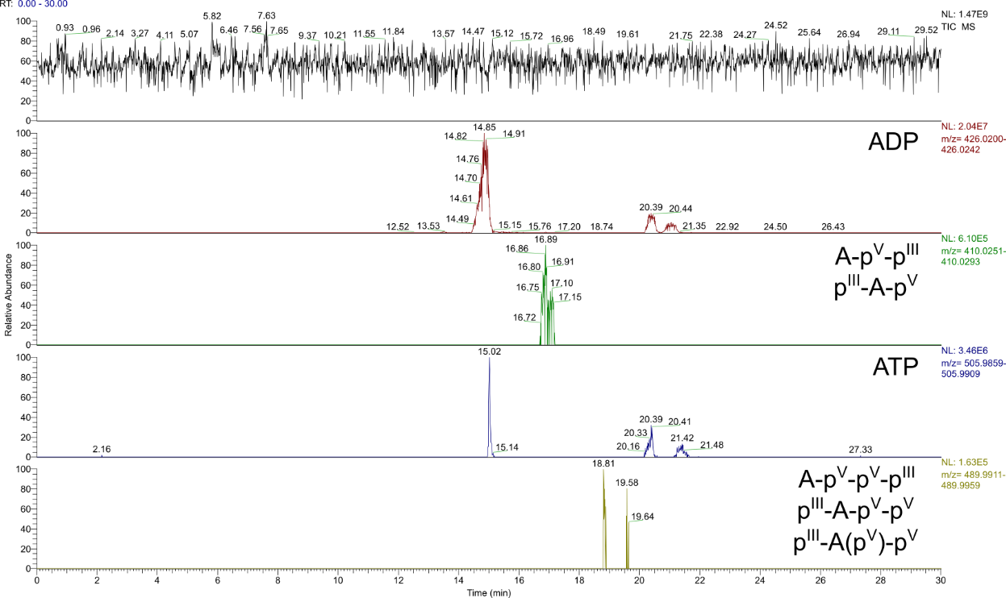
Figure S103. TIC (m/z 50-750) and EIEs (Δ = 5.0 ppm) of the products of the reaction starting from 5’ ADP (100 mM), H₃PO₃ (3.0 eq.) and urea (1.0 eq.) after 7 d. Constitution of potential isomers has not been determined. Labels illustrate all possible phosphate/phosphonate binding modes and refer to the entirety of all formed isomers.

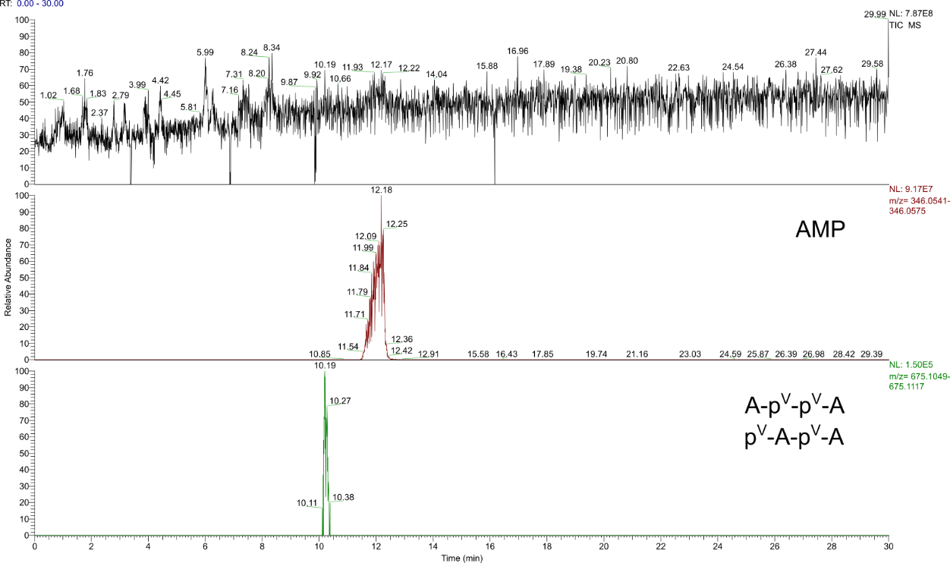
Figure S104. TIC (m/z 50-750) and EIEs (Δ = 5.0 ppm) of the products of the reaction starting from 5’ ADP (100 mM), H₃PO₃ (3.0 eq.) and urea (1.0 eq.) after 7 d. Constitution of potential isomers has not been determined. Labels illustrate all possible phosphate/phosphonate binding modes and refer to the entirety of all formed isomers.

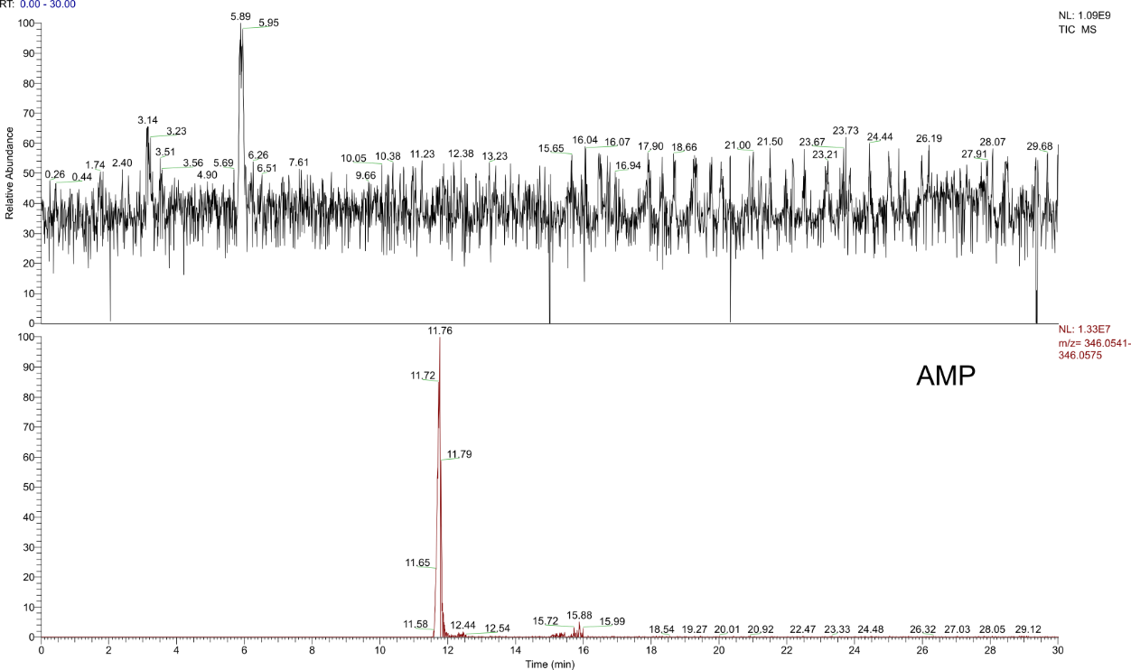
Figure S105. TIC (m/z 50-750) and EIEs (Δ = 5.0 ppm) of the products of the reaction starting from 5’ ADP, A and urea (each 100 mM) after 7 d. Constitution of potential isomers has not been determined. The label illustrates all possible phosphate binding modes and refers to the entirety of all formed isomers.

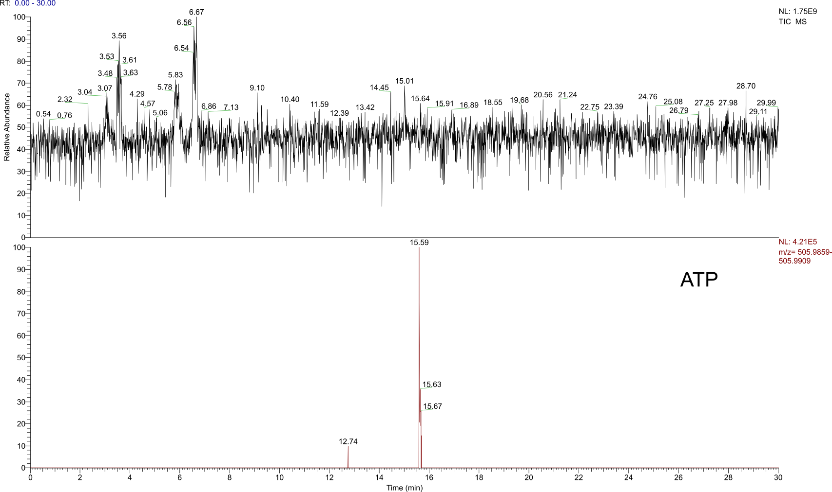
Figure S106. TIC (m/z 50-750) and EIEs (Δ = 5.0 ppm) of the products of the reaction starting from 5’ ADP, A and urea (each 100 mM) after 7 d. Constitution of potential isomers has not been determined. The label illustrates all possible phosphate binding modes and refers to the entirety of all formed isomers.

3.4 Reaction with cytidine
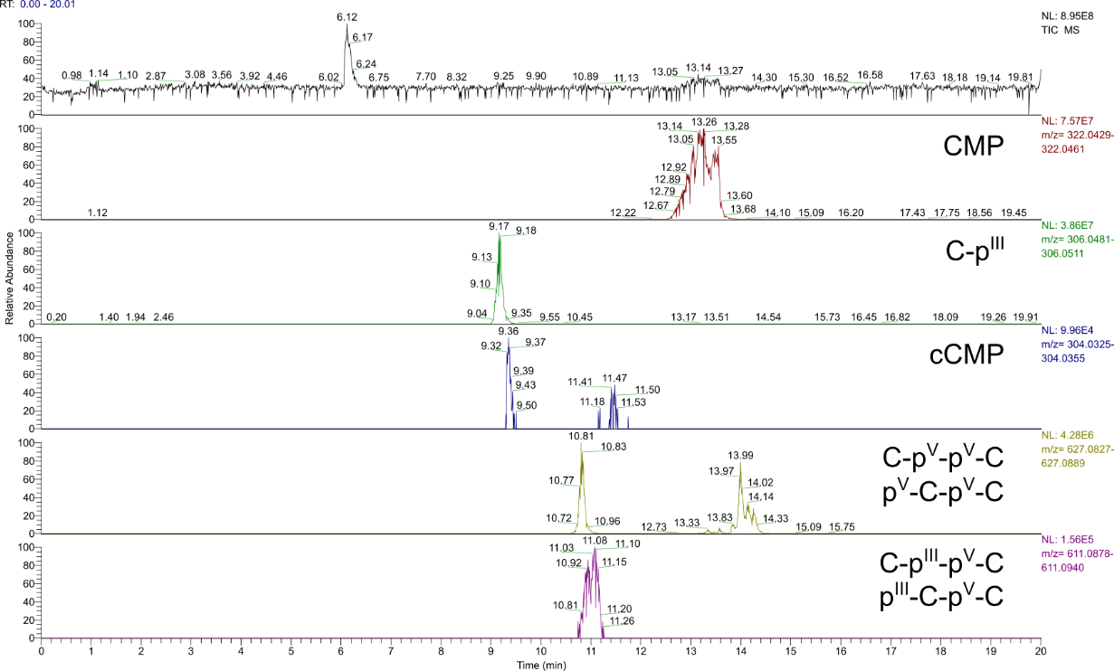
Figure S107. TIC (m/z 80-1200) and EIEs (Δ = 5.0 ppm) of the products of the reaction starting from C (100 mM), H₃PO₃ (3.0 eq.) and urea (1.0 eq.) after 7 d. Constitution of potential isomers has not been determined. Labels illustrate all possible phosphate/phosphonate binding modes and refer to the entirety of all formed isomers.

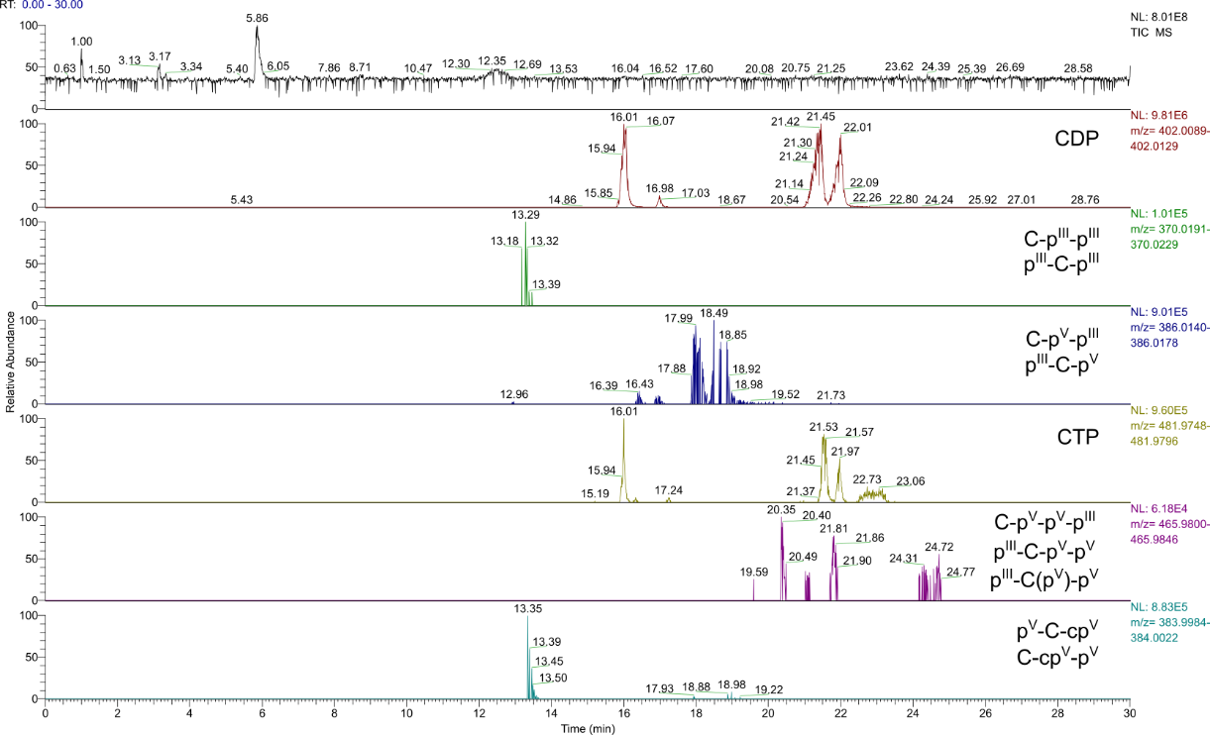
Figure S108. TIC (m/z 80-1200) and EIEs (Δ = 5.0 ppm) of the products of the reaction starting from C (100 mM), H₃PO₃ (3.0 eq.) and urea (1.0 eq.) after 7 d. Constitution of potential isomers has not been determined. Labels illustrate all possible phosphate/phosphonate binding modes and refer to the entirety of all formed isomers.

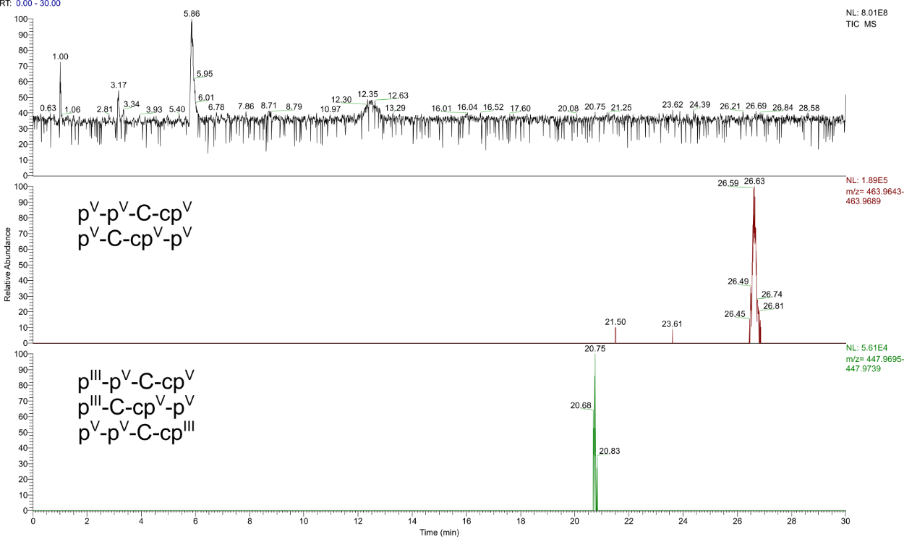
Figure S109. TIC (m/z 80-1200) and EIEs (Δ = 5.0 ppm) of the products of the reaction starting from C (100 mM), H₃PO₃ (3.0 eq.) and urea (1.0 eq.) after 7 d. Constitution of potential isomers has not been determined. Labels illustrate all possible phosphate/phosphonate binding modes and refer to the entirety of all formed isomers.

3.5 Reaction with uridine
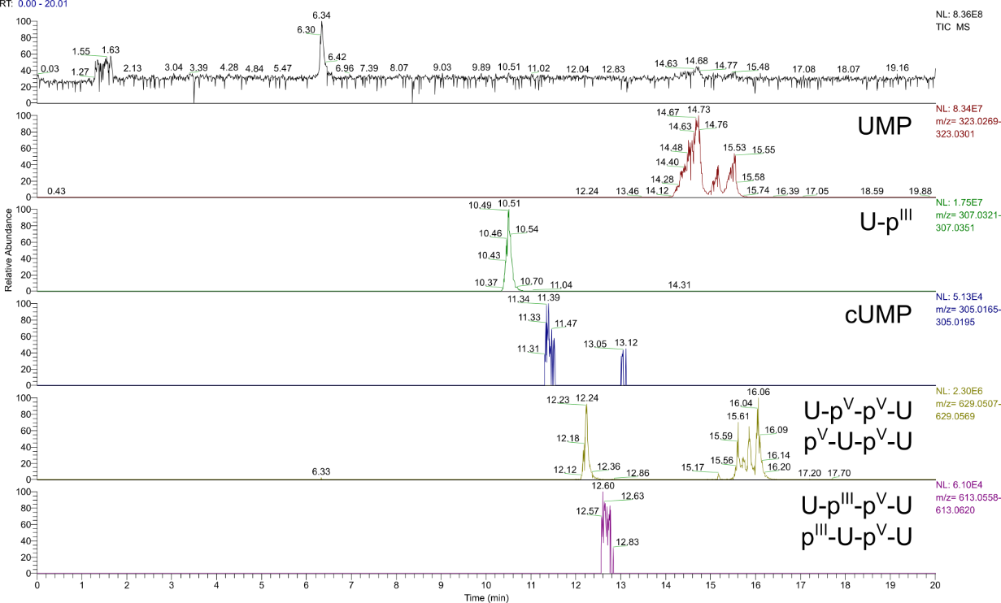
Figure S110. TIC (m/z 80-1200) and EIEs (Δ = 5.0 ppm) of the products of the reaction starting from U (100 mM), H₃PO₃ (3.0 eq.) and urea (1.0 eq.) after 7 d. Constitution of potential isomers has not been determined. Labels illustrate all possible phosphate/phosphonate binding modes and refer to the entirety of all formed isomers.

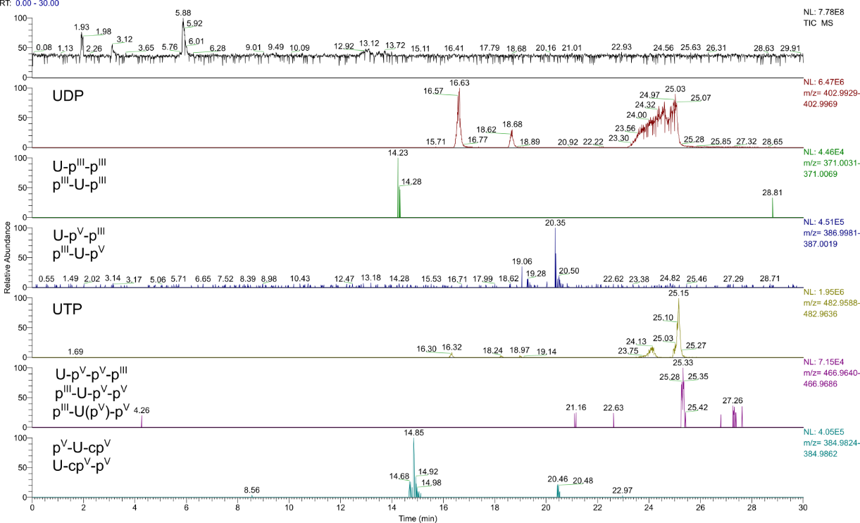
Figure S111. TIC (m/z 80-1200) and EIEs (Δ = 5.0 ppm) of the products of the reaction starting from U (100 mM), H₃PO₃ (3.0 eq.) and urea (1.0 eq.) after 7 d. Constitution of potential isomers has not been determined. Labels illustrate all possible phosphate/phosphonate binding modes and refer to the entirety of all formed isomers.

3.6 Reaction with guanosine
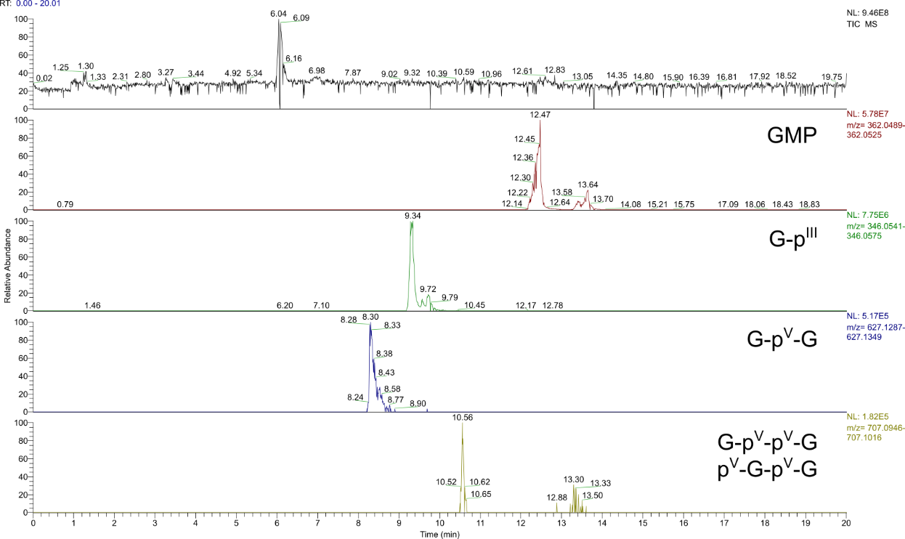
Figure S112. TIC (m/z 80-1200) and EIEs (Δ = 5.0 ppm) of the products of the reaction starting from G (100 mM), H₃PO₃ (3.0 eq.) and urea (1.0 eq.) after 7 d. Constitution of potential isomers has not been determined. Labels illustrate all possible phosphate/phosphonate binding modes and refer to the entirety of all formed isomers.

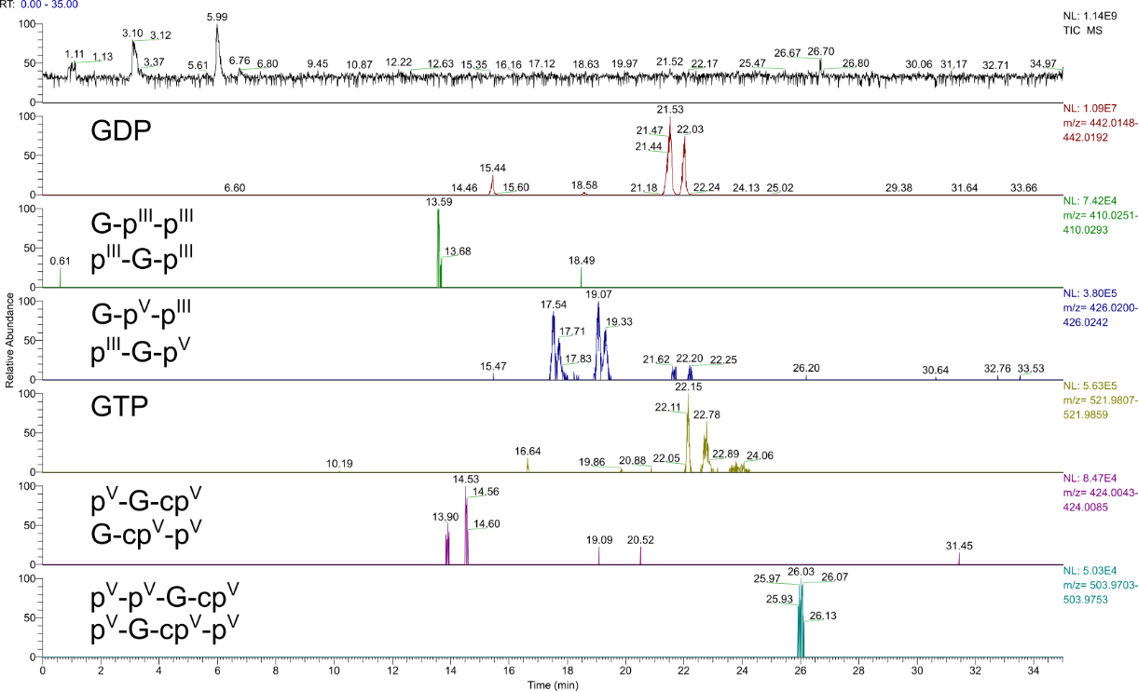
Figure S113. TIC (m/z 80-1200) and EIEs (Δ = 5.0 ppm) of the products of the reaction starting from G (100 mM), H₃PO₃ (3.0 eq.) and urea (1.0 eq.) after 7 d. Constitution of potential isomers has not been determined. Labels illustrate all possible phosphate/phosphonate binding modes and refer to the entirety of all formed isomers.

3.7 Reaction with deoxyadenosine
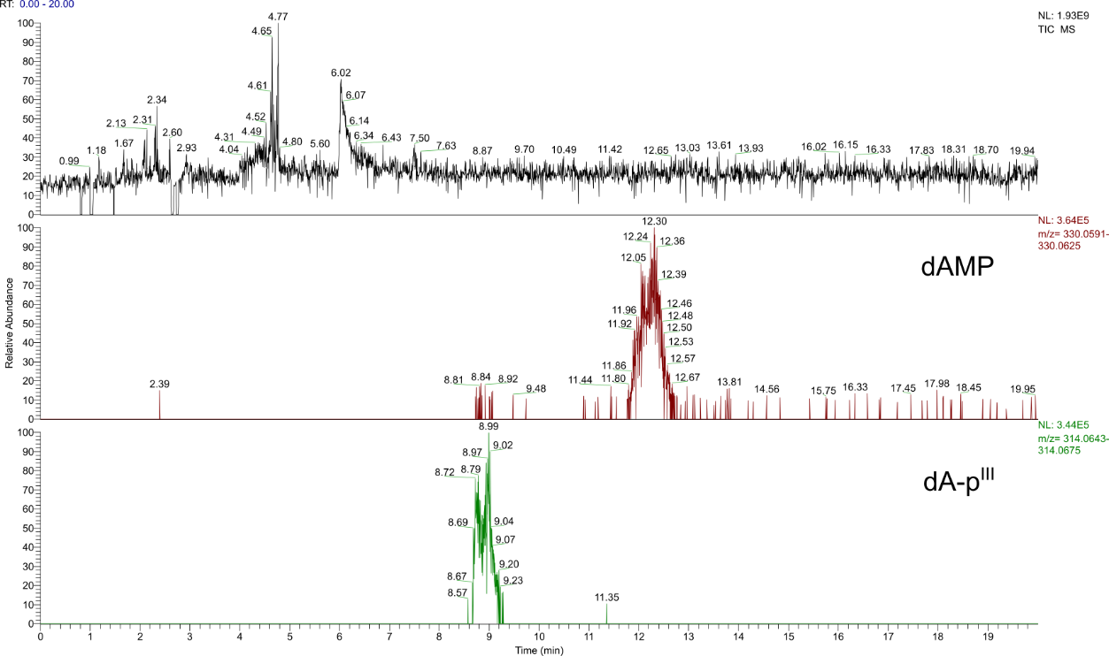
Figure S114. TIC (m/z 50-750) and EIEs (Δ = 5.0 ppm) of the products of the reaction starting from deoxyadenosine (dA) (100 mM), H₃PO₃ (3.0 eq.) and urea (1.0 eq.) after7 d. Constitution of potential isomers has not been determined. Labels illustrate all possible phosphate/phosphonate binding modes and refer to the entirety of all formed isomers.

3.8 Reaction with deoxyguanosine
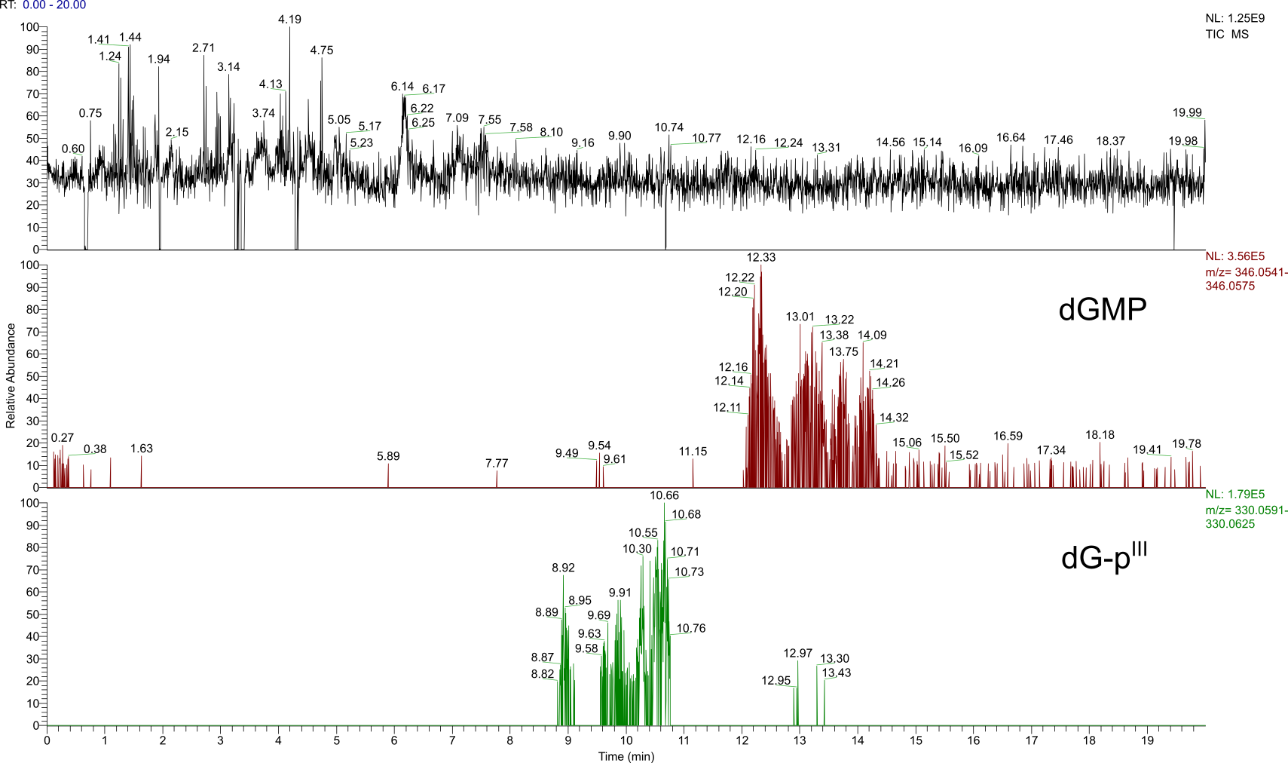
Figure S115. TIC (m/z 50-750) and EIEs (Δ = 5.0 ppm) of the products of the reaction starting from deoxyguanosine (dG) (100 mM), H₃PO₃ (3.0 eq.) and urea (1.0 eq.) after 7 d. Constitution of potential isomers has not been determined. Labels illustrate all possible phosphate/phosphonate binding modes and refer to the entirety of all formed isomers.

3.9 Reaction with deoxycytidine
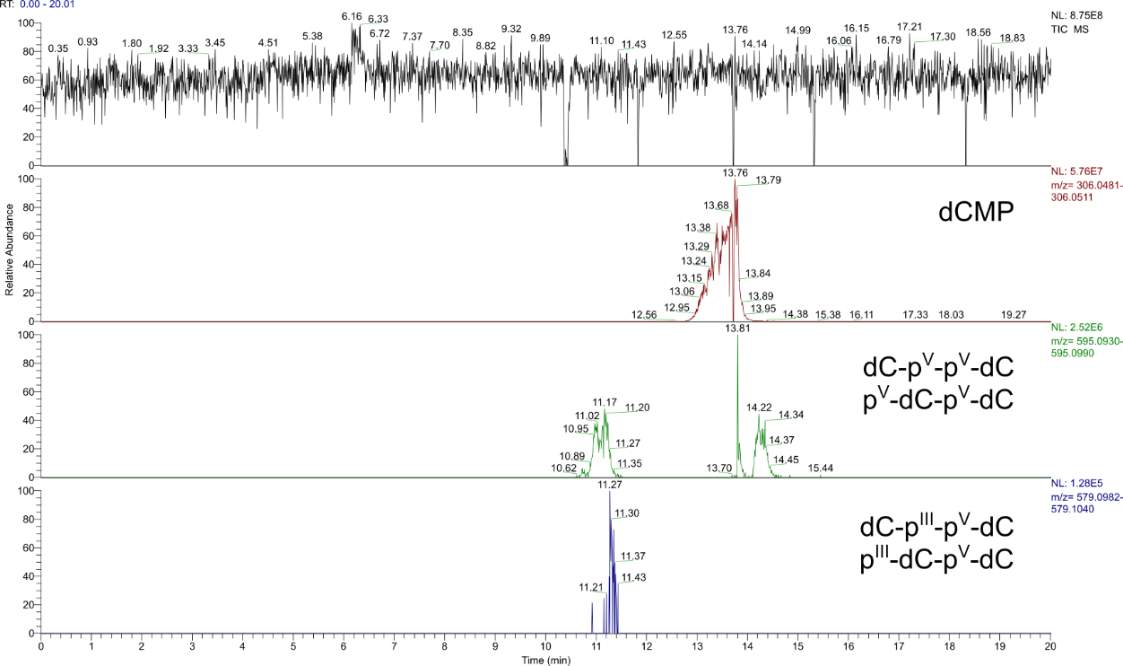
Figure S116. TIC (m/z 50-750) and EIEs (Δ = 5.0 ppm) of the products of the reaction starting from dC (100 mM), H₃PO₃ (3.0 eq.) and urea (1.0 eq.) after 7 d. Constitution of potential isomers has not been determined. Labels illustrate all possible phosphate/phosphonate binding modes and refer to the entirety of all formed isomers.

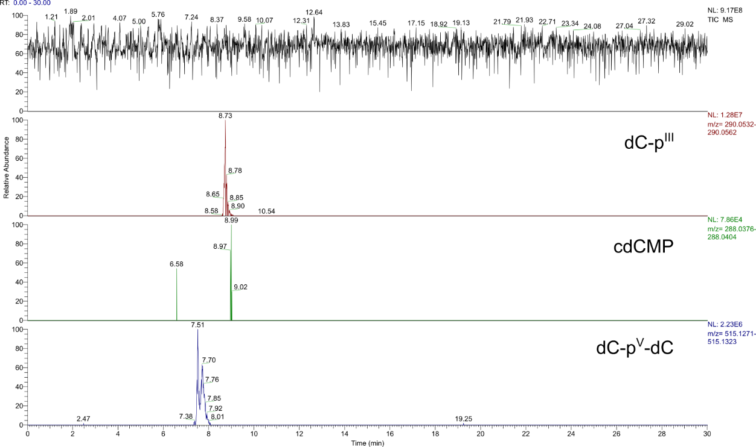
Figure S117. TIC (m/z 50-750) and EIEs (Δ = 5.0 ppm) of the products of the reaction starting from dC (100 mM), H₃PO₃ (3.0 eq.) and urea (1.0 eq.) after 7 d. Constitution of potential isomers has not been determined. Labels illustrate all possible phosphate/phosphonate binding modes and refer to the entirety of all formed isomers.
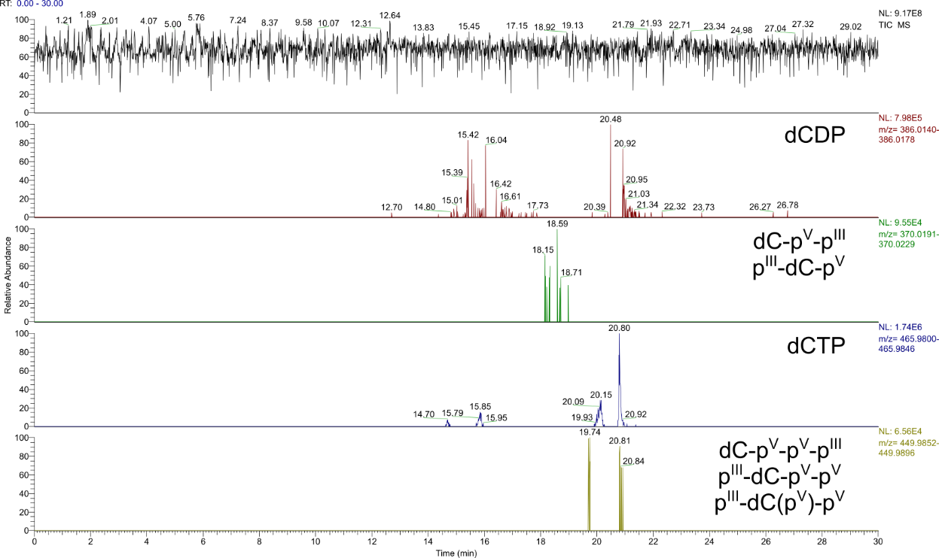
Figure S118. TIC (m/z 50-750) and EIEs of the products of the reaction starting from dC (100 mM), H₃PO₃ (3.0 eq.) and urea (1.0 eq.) after 7 d. Constitution of potential isomers has not been determined. Labels illustrate all possible phosphate/phosphonate binding modes and refer to the entirety of all formed isomers.

3.10 Reaction with deoxythymidine
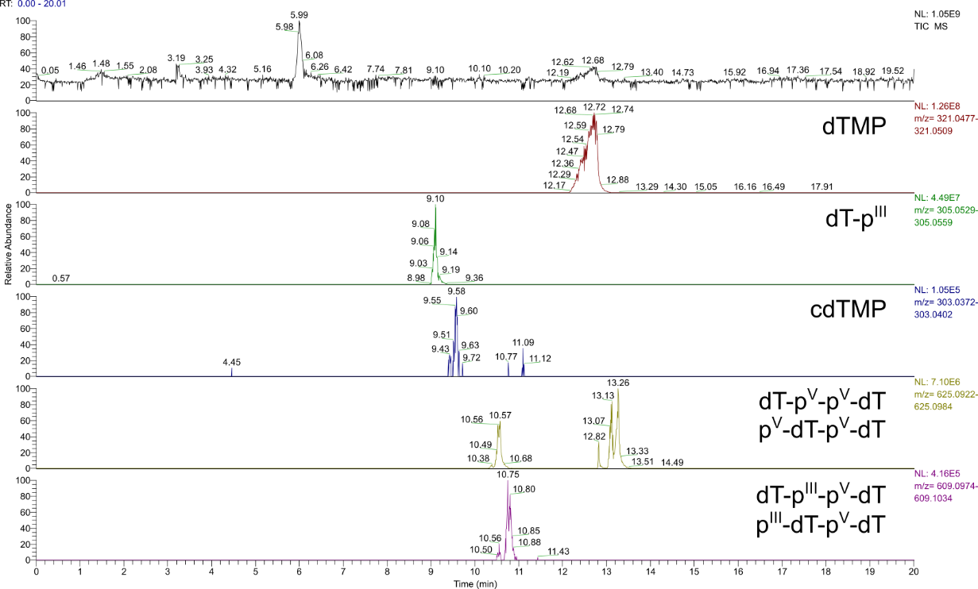
Figure S119. TIC (m/z 80-1200) and EIEs (Δ = 5.0 ppm) of the products of the reaction starting from dT (100 mM), H₃PO₃ (3.0 eq.) and urea (1.0 eq.) after 7 d. Constitution of potential isomers has not been determined. Labels illustrate all possible phosphate/phosphonate binding modes and refer to the entirety of all formed isomers.

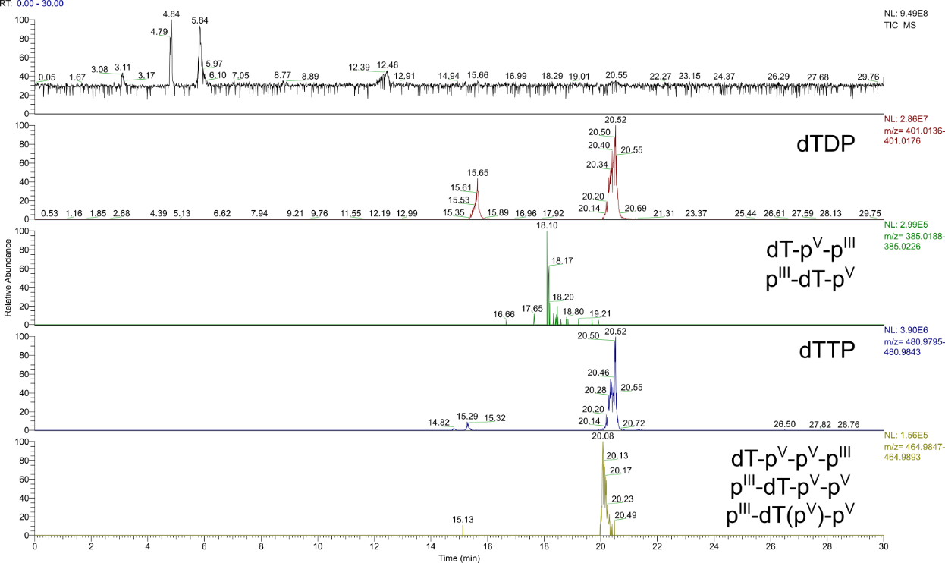
Figure S120. TIC (m/z 80-1200) and EIEs (Δ = 5.0 ppm) of the products of the reaction starting from dT (100 mM), H₃PO₃ (3.0 eq.) and urea (1.0 eq.) after 7 d. Constitution of potential isomers has not been determined. Labels illustrate all possible phosphate/phosphonate binding modes and refer to the entirety of all formed isomers.

3.11 Reaction with glycerol
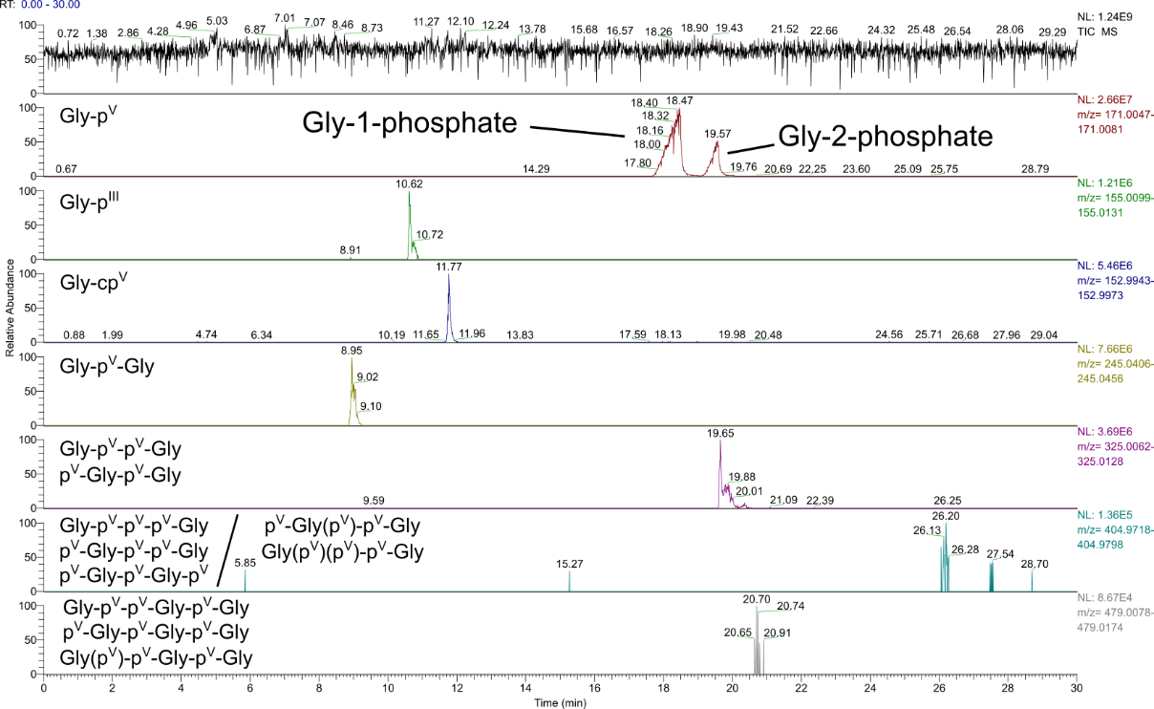
Figure S121. TIC (m/z 50-750) and EIEs (Δ = 10.0 ppm) of the products of the reaction starting from glycerol (Gly) (100 mM), H₃PO₃ (3.0 eq.) and urea (1.0 eq.) after 7 d. Signals of Gly-1-phosphate and Gly-2-phosphate were assigned by co-injection with reference compounds. The constitution of the other potential isomers has not been determined. Labels illustrate all possible phosphate/phosphonate binding modes and refer to the entirety of all formed isomers.

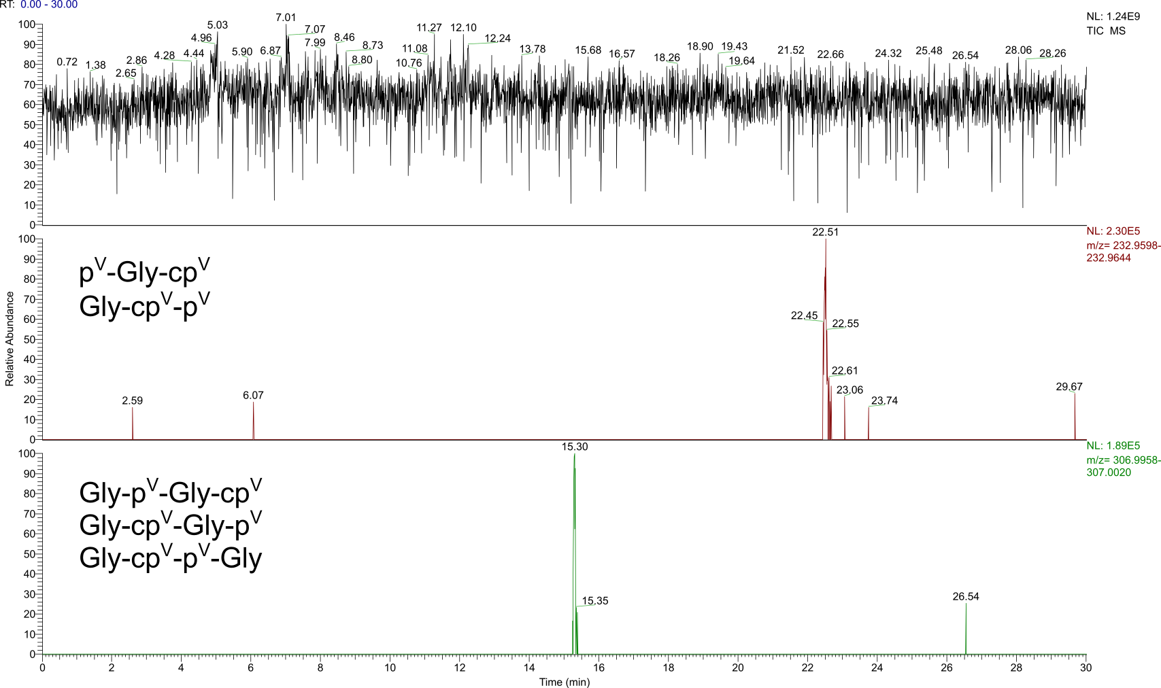
Figure S122. TIC (m/z 50-750) and EIEs (Δ = 10.0 ppm) of the products of the reaction starting from Gly (100 mM), H₃PO₃ (3.0 eq.) and urea (1.0 eq.) after 7 d. Constitution of potential isomers has not been determined. Labels illustrate all possible phosphate binding modes and refer to the entirety of all formed isomers.

3.12 Reaction with glyceraldehyde
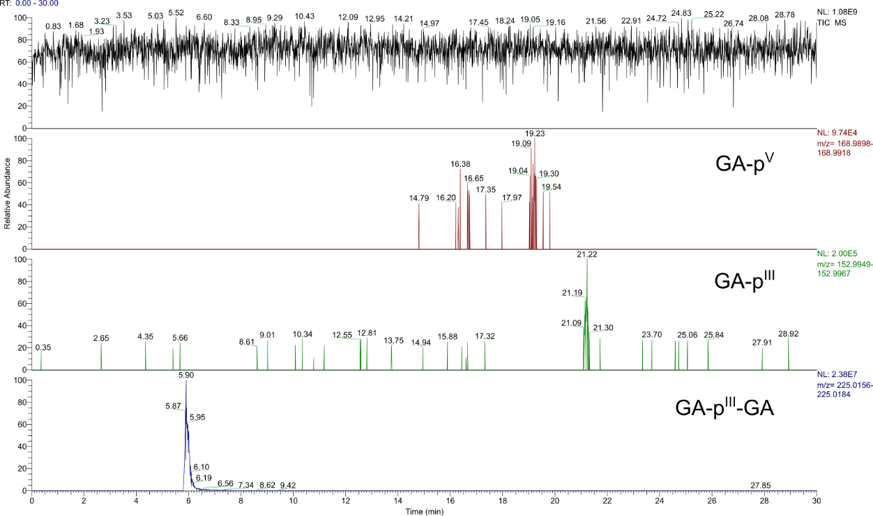
Figure S123. TIC (m/z 50-750) and EIEs (Δ = 6.0 ppm) of the products of the reaction starting from glyceraldehyde (GA) (100 mM), H₃PO₃ (3.0 eq.) and urea (1.0 eq.) after 7 d. Constitution of potential isomers has not been determined. Labels illustrate all possible phosphate/phosphonate binding modes and refer to the entirety of all formed isomers.

3.13 Reaction with D-ribose
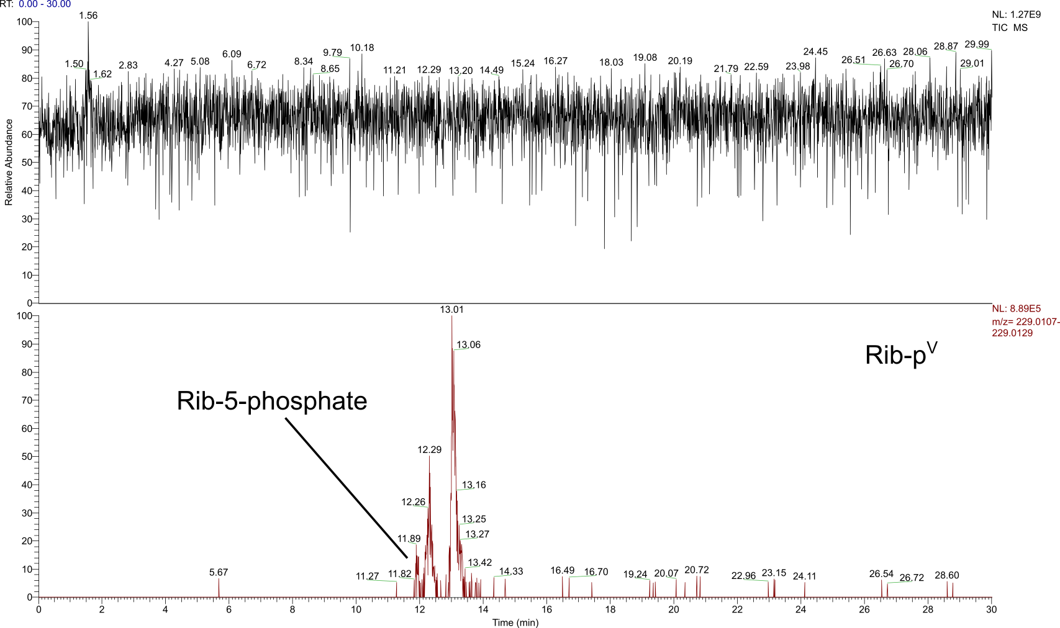
Figure S124. TIC (m/z 50-750) and EIE (Δ = 5.0 ppm) of the products of the reaction starting from D-ribose (Rib) (100 mM), H₃PO₃ (3.0 eq.) and urea (1.0 eq.) after 7 d. The signal of Rib-5-phosphate was assigned by co-injection with a reference compound. The constitution of the other potential isomers has not been determined. The label illustrates all possible phosphate binding modes and refers to the entirety of all formed isomers.

3.14 Reaction with sodium L-lactate
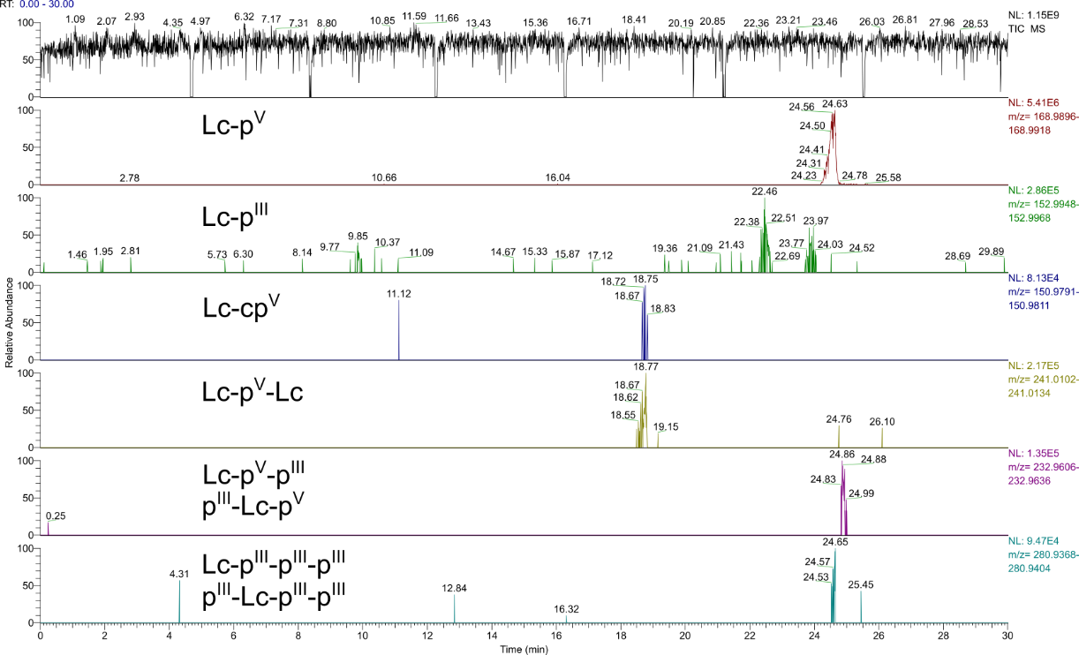
Figure S125. TIC (m/z 50-750) and EIEs (Δ = 6.5 ppm) of the products of the reaction starting from sodium L-lactate (Lc) (100 mM), H₃PO₃ (30 eq.) and urea (1.0 eq.) after 7 d. Constitution of potential isomers has not been determined. Labels illustrate all possible phosphate/phosphonate binding modes and refer to the entirety of all formed isomers.

3.15 Reaction with L-serine
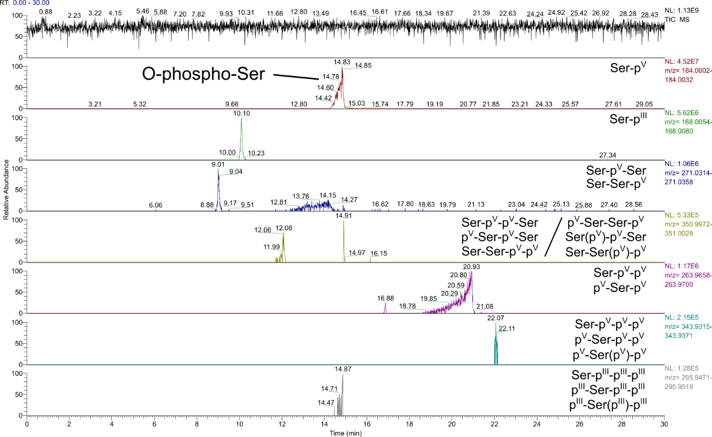
Figure S126. TIC (m/z 50-750) and EIEs (Δ = 8.0 ppm) of the products of the reaction starting from L-serine (Ser) (100 mM), H₃PO₃ (3.0 eq.) and urea (1.0 eq.) after 7 d. The signal of O-phospho-Ser was assigned by co-injection with a reference compound. The constitution of the other potential isomers has not been determined. Labels illustrate all possible phosphate/phosphonate binding modes and refer to the entirety of all formed isomers.

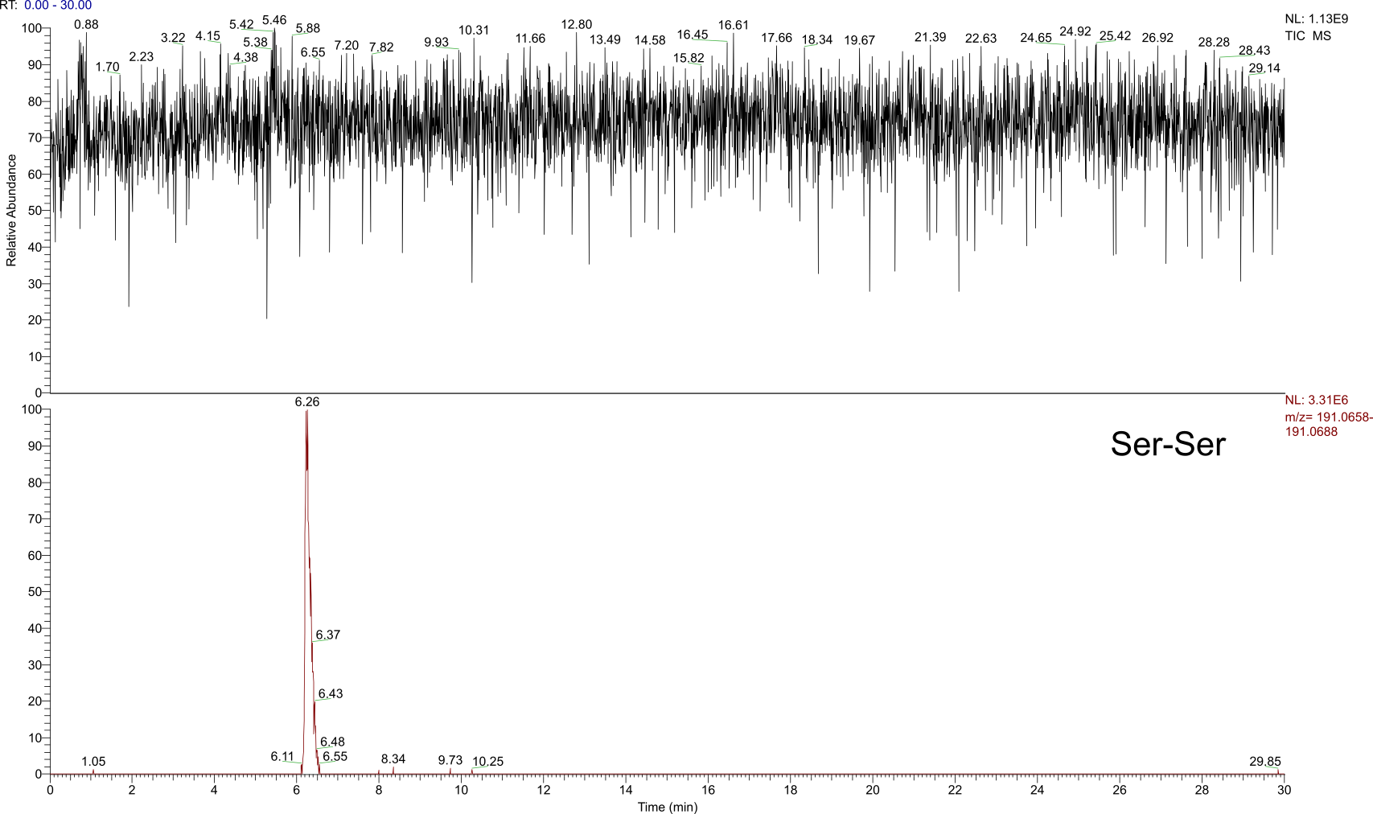
Figure S127. TIC (m/z 50-750) and EIE (Δ = 8.0 ppm) of the dipeptide product of the reaction starting from Ser (100 mM), H₃PO₃ (3.0 eq.) and urea (1.0 eq.) after 7 d.

3.18 Reaction of the complete nucleoside mixture
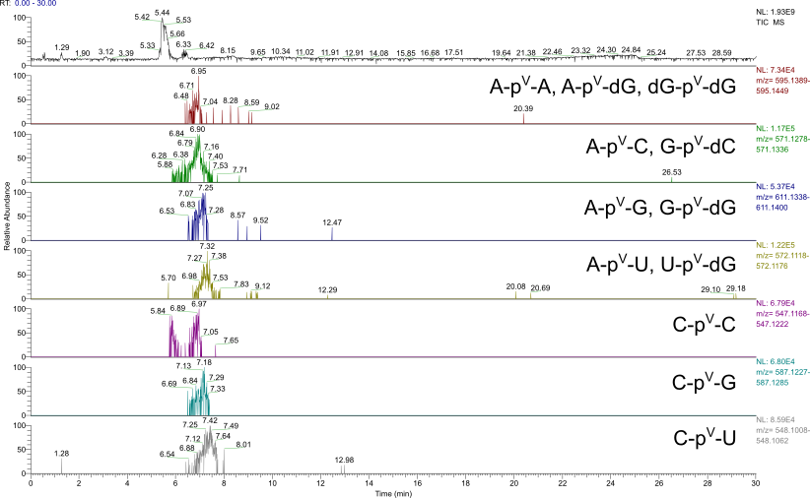
Figure S128: TIC (m/z 80-1200) and EIEs (Δ = 5.0 ppm) of the products of the reaction starting from A, C, G, U, dA, dC, dG and dT (each 25 mM, in total 1.0 eq.) with H₃PO₃ (3.0 eq.) and urea (1.0 eq.) after 7 d. Constitution of potential isomers has not been determined. Labels illustrate all possible phosphate binding modes and refer to the entirety of all formed isomers (including inverse deoxyribo- and ribonucleoside combinations, e. g. G-dC and dG-C).

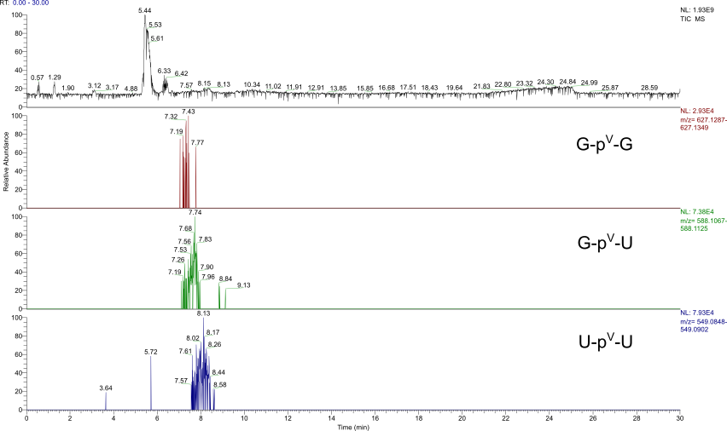
Figure S129. TIC (m/z 80-1200) and EIEs (Δ = 5.0 ppm) of the products of the reaction starting from A, C, G, U, dA, dC, dG and dT (each 25 mM, in total 1.0 eq.) with H₃PO₃ (3.0 eq.) and urea (1.0 eq.) after 7 d. Constitution of potential isomers has not been determined. Labels illustrate all possible phosphate binding modes and refer to the entirety of all formed isomers.
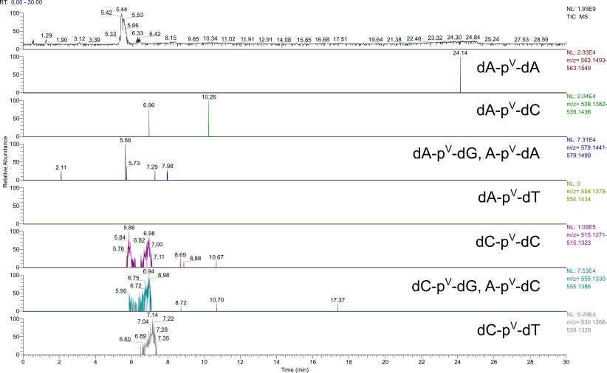
Figure S130. TIC (m/z 80-1200) and EIEs (Δ = 5.0 ppm) of the products of the reaction starting from A, C, G, U, dA, dC, dG and dT (each 25 mM, in total 1.0 eq.) with H₃PO₃ (3.0 eq.) and urea (1.0 eq.) after 7 d. Constitution of potential isomers has not been determined. Labels illustrate all possible phosphate binding modes and refer to the entirety of all formed isomers (including inverse deoxyribo- and ribonucleoside combinations, e. g. A-dC and dA-C).

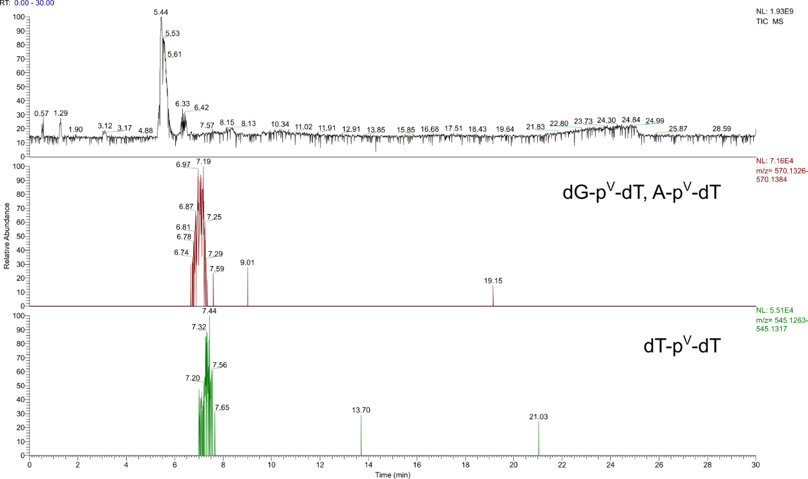
Figure S131. TIC (m/z 80-1200) and EIEs (Δ = 5.0 ppm) of the products of the reaction starting from A, C, G, U, dA, dC, dG and dT (each 25 mM, in total 1.0 eq.) with H₃PO₃ (3.0 eq.) and urea (1.0 eq.) after 7 d. Constitution of potential isomers has not been determined. Labels illustrate all possible phosphate binding modes and refer to the entirety of all formed isomers.
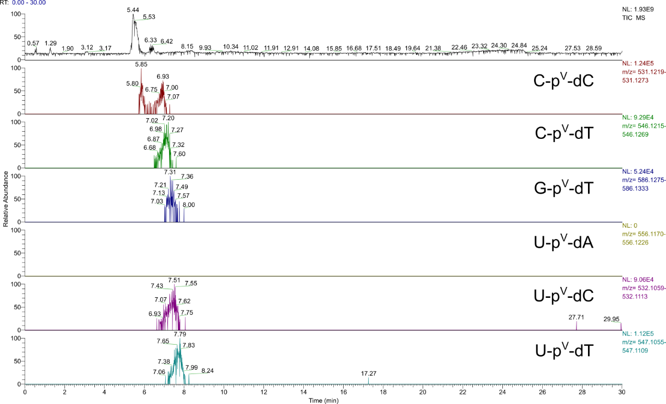
Figure S132. TIC (m/z 80-1200) and EIEs (Δ = 5.0 ppm) of the products of the reaction starting from A, C, G, U, dA, dC, dG and dT (each 25 mM, in total 1.0 eq.) with H₃PO₃ (3.0 eq.) and urea (1.0 eq.) after 7 d. Constitution of potential isomers has not been determined. Labels illustrate all possible phosphate binding modes and refer to the entirety of all formed isomers.

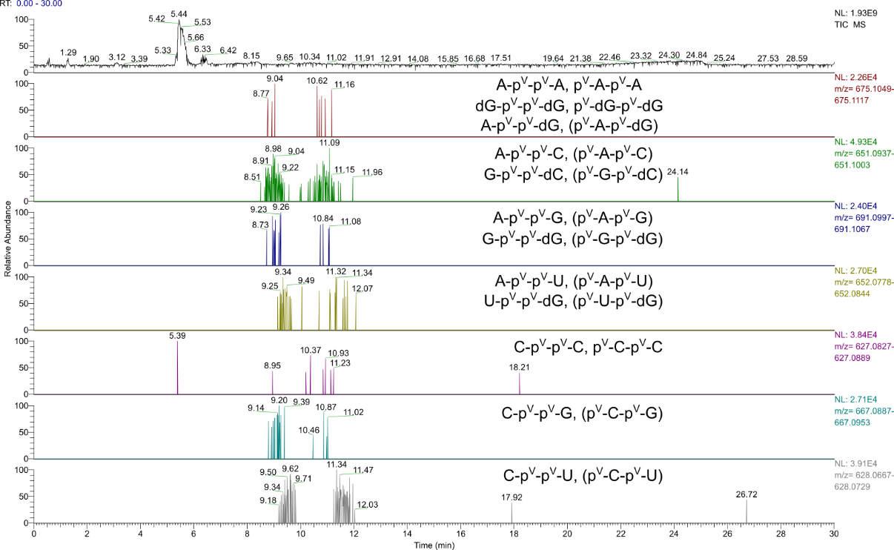
Figure S133. TIC (m/z 80-1200) and EIEs (Δ = 5.0 ppm) of the products of the reaction starting from A, C, G, U, dA, dC, dG and dT (each 25 mM, in total 1.0 eq.) with H₃PO₃ (3.0 eq.) and urea (1.0 eq.) after 7 d. Constitution of potential isomers has not been determined. Labels in brackets indicate that an inverse nucleoside sequence is possible (e. g. A-C and C-A). Labels illustrate all possible phosphate binding modes and refer to the entirety of all formed isomers (including inverse deoxyribo- and ribonucleoside combinations, e. g. G-dC and dG-C).

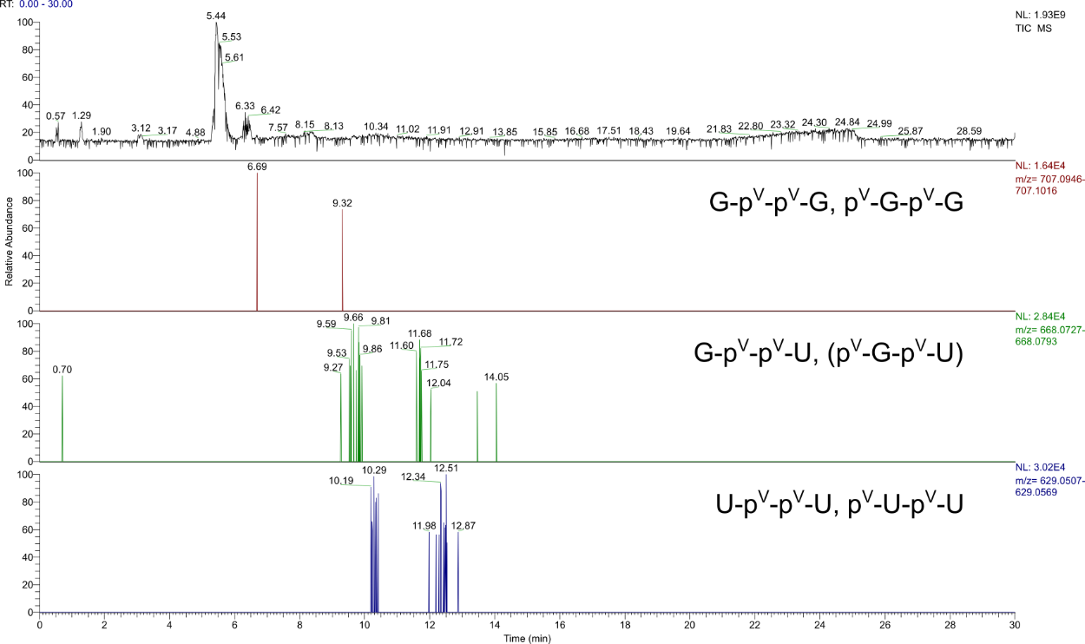
Figure S134. TIC (m/z 80-1200) and EIEs (Δ = 5.0 ppm) of the products of the reaction starting from A, C, G, U, dA, dC, dG and dT (each 25 mM, in total 1.0 eq.) with H₃PO₃ (3.0 eq.) and urea (1.0 eq.) after 7 d. Constitution of potential isomers has not been determined. Labels in brackets indicate that an inverse nucleoside sequence is possible (e.g. G-U and U-G). Labels illustrate all possible phosphate binding modes and refer to the entirety of all formed isomers.

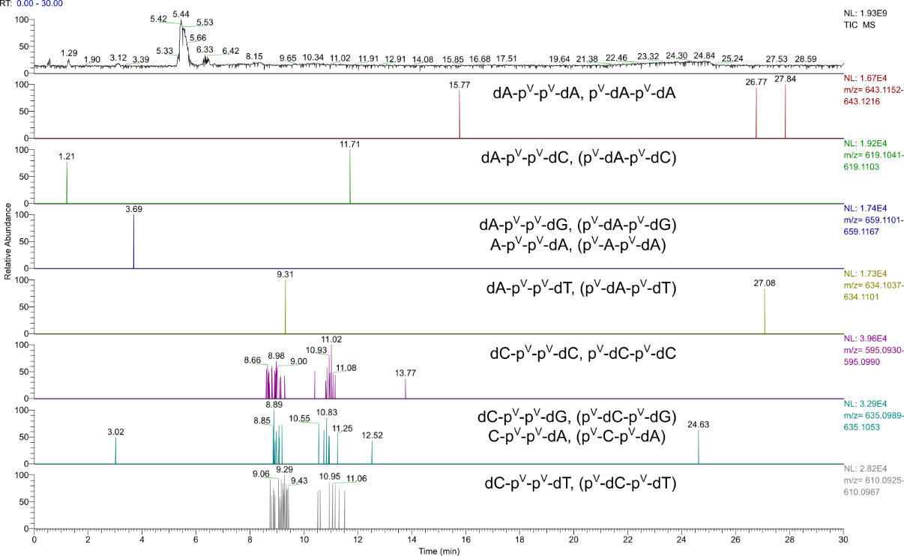
Figure S135. TIC (m/z 80-1200) and EIEs (Δ = 5.0 ppm) of the products of the reaction starting from A, C, G, U, dA, dC, dG and dT (each 25 mM, in total 1.0 eq.) with H₃PO₃ (3.0 eq.) and urea (1.0 eq.) after 7 d. Constitution of potential isomers has not been determined. Labels in brackets indicate that an inverse nucleoside sequence is possible (e. g. dA-dC and dC-dA). Labels illustrate all possible phosphate binding modes and refer to the entirety of all formed isomers (including inverse deoxyribo- and ribonucleoside combinations, e. g. C-dA and dC-A).
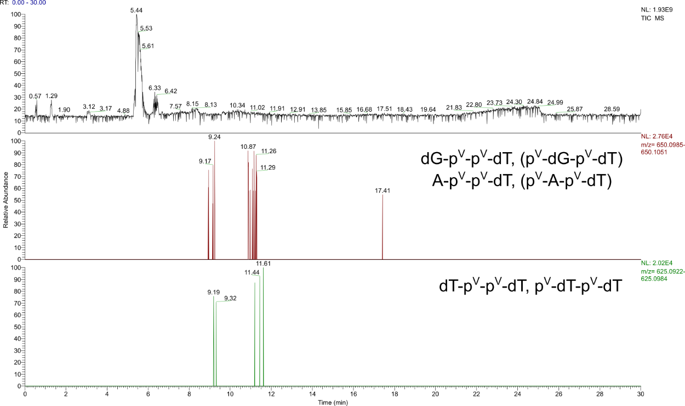
Figure S136. TIC (m/z 80-1200) and EIEs (Δ = 5.0 ppm) of the products of the reaction starting from A, C, G, U, dA, dC, dG and dT (each 25 mM, in total 1.0 eq.) with H₃PO₃ (3.0 eq.) and urea (1.0 eq.) after 7 d. Constitution of potential isomers has not been determined. Labels in brackets indicate that an inverse nucleoside sequence is possible (e. g. dG-dT and dT-dG). Labels illustrate all possible phosphate binding modes and refer to the entirety of all formed isomers.

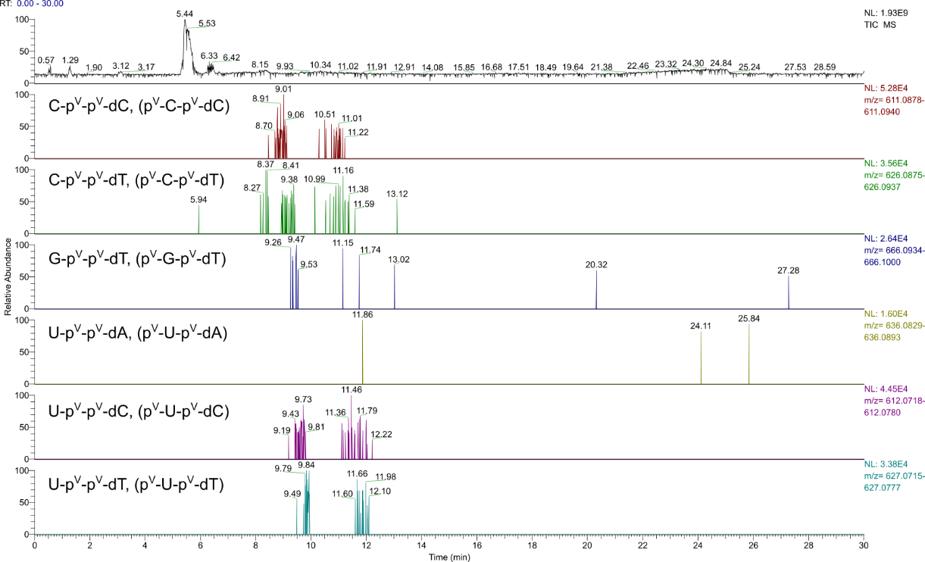
Figure S137. TIC (m/z 80-1200) and EIEs (Δ = 5.0 ppm) of the products of the reaction starting from A, C, G, U, dA, dC, dG and dT (each 25 mM, in total 1.0 eq.) with H₃PO₃ (3.0 eq.) and urea (1.0 eq.) after 7 d. Constitution of potential isomers has not been determined. Labels in brackets indicate that an inverse nucleoside sequence is possible (e. g. C-dT and dT-C). Labels illustrate all possible phosphate binding modes and refer to the entirety of all formed isomers.

4 MS/MS Spectra of p-N-p-N and N-p-p-N species
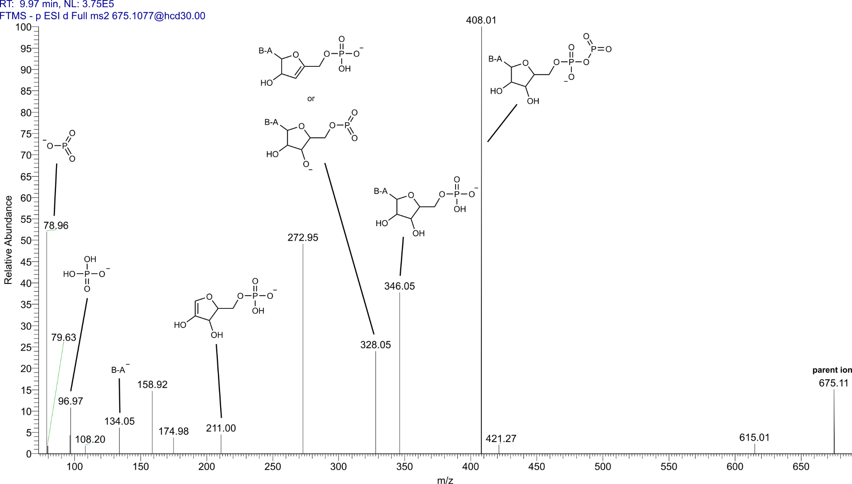
Figure S138. MS/MS spectrum of the A based dinucleotide (m/z 675.1083) obtained from the reaction of A (100 mM) with H₃PO₃ (3.0 eq.) for 7 d. Collision induced dissociation (NCE 30%) of the parent ion at t_{mig} = 9.97 min after CE separation led to the assigned fragments. Displayed fragment structures have model character since there are multiple possible isomers (B-A: adenine).

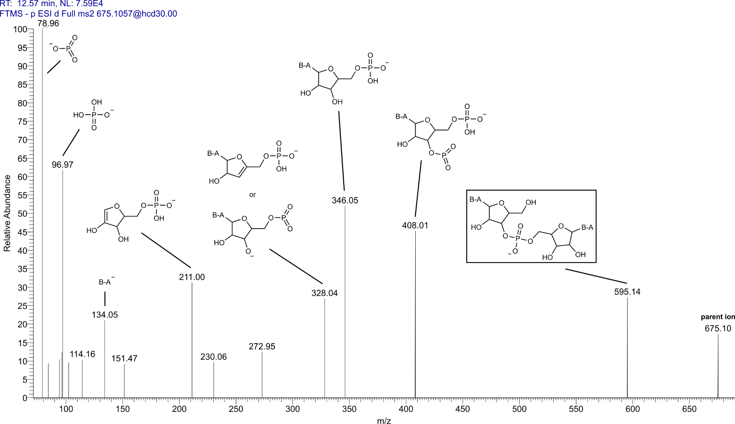
Figure S139. MS/MS spectrum of the dinucleotide (m/z 675.1083) obtained from the reaction of A (100 mM) with H₃PO₃ (3.0 eq.) for 7 d. Collision induced dissociation (NCE 30%) at t_{mig} = 12.57 min led to the assigned fragments. Fragments in boxes are characteristic for alternating A and phosphate units. Displayed structures have model character since there are multiple possible isomers.
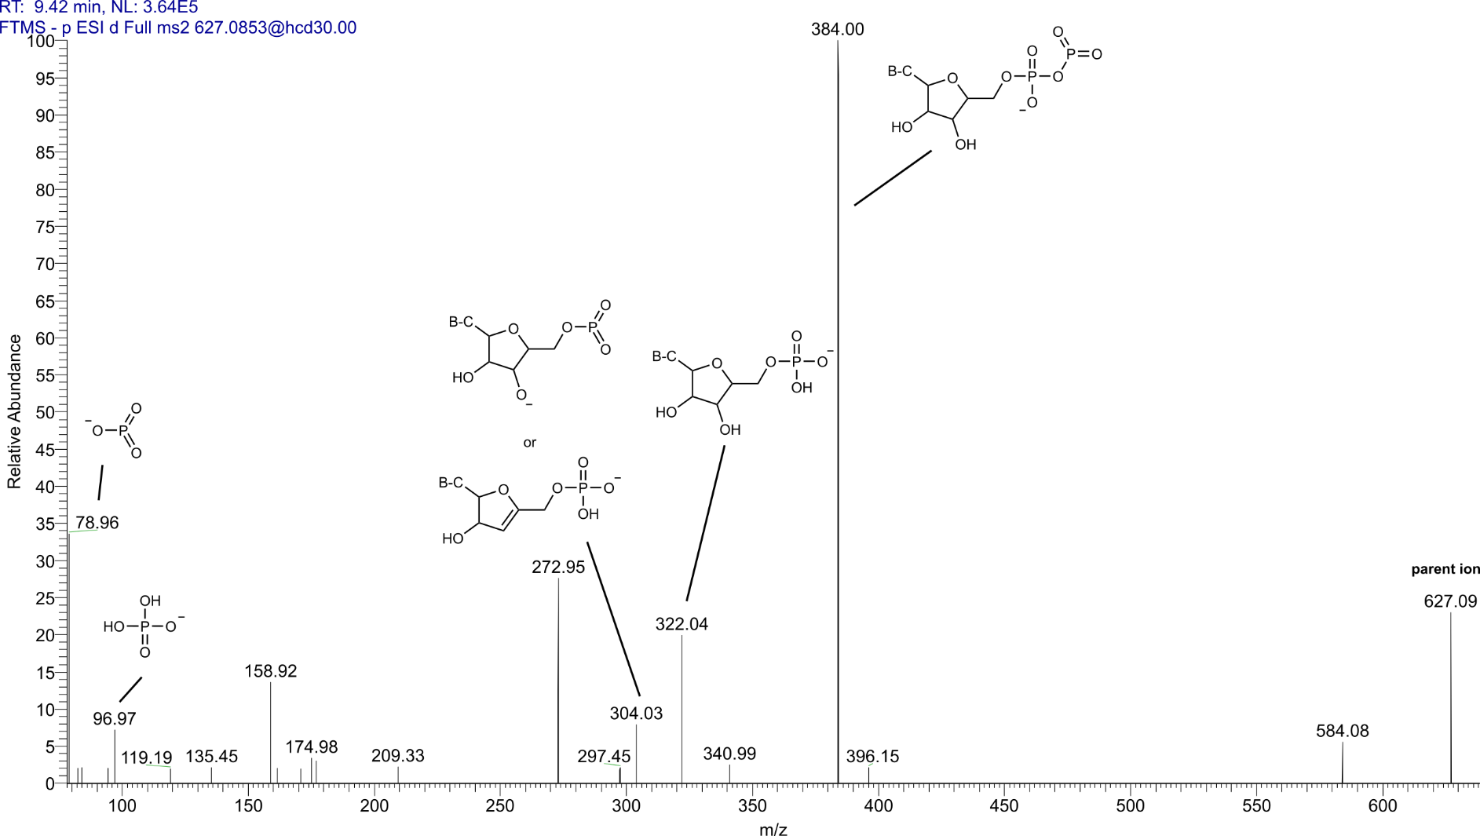
Figure S140. MS/MS spectrum of the C based dinucleotide (m/z 627.0858) obtained from the reaction of C (100 mM) with H₃PO₃ (3.0 eq.) and urea (1.0 eq.) for 7 d. Collision induced dissociation (NCE 30%) of the parent ion at t_{mig} = 9.42 min after CE separation led to the assigned fragments. Displayed fragment structures have model character since there are multiple possible isomers (B-C: cytosine).
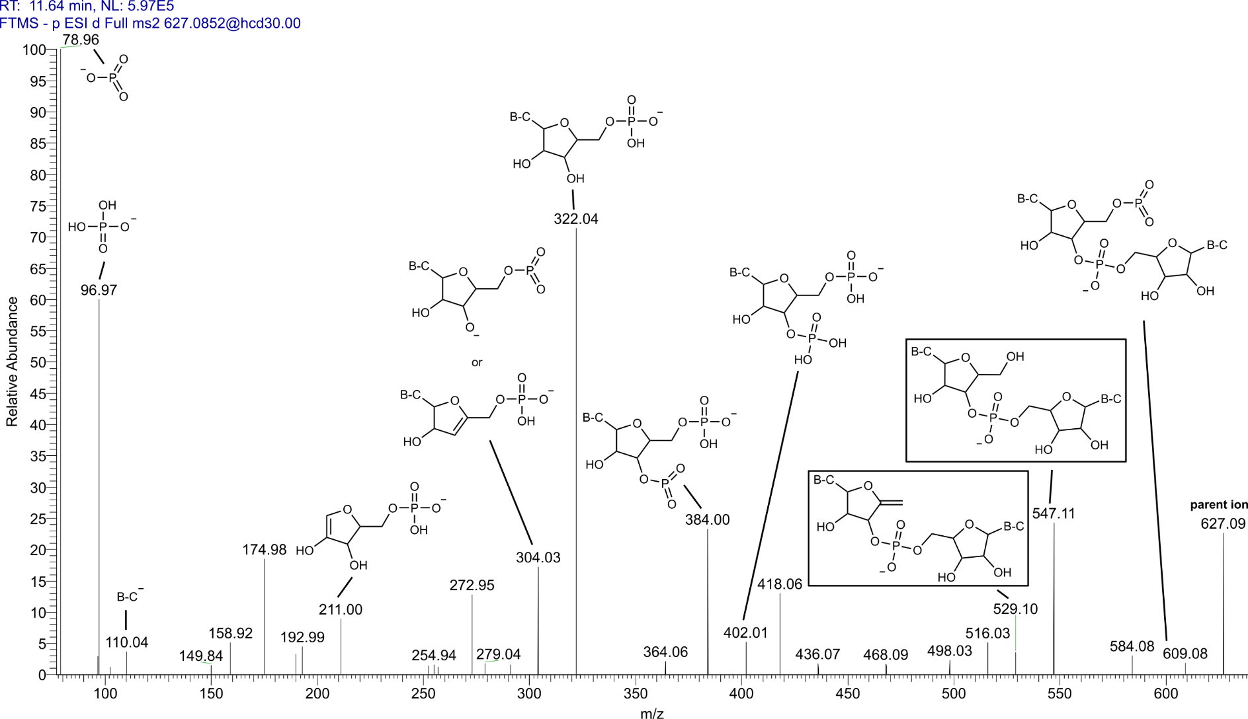
Figure S141. MS/MS spectrum of the C based dinucleotide (m/z 627.0858) obtained from the reaction of C (100 mM) with H₃PO₃ (3.0 eq.) and urea (1.0 eq.) for 7 d. Collision induced dissociation (NCE 30%) of the parent ion at t_{mig} = 11.64 min after CE separation led to the assigned fragments. Fragments in boxes are characteristic for alternating C and phosphate units. Displayed fragment structures have model character since there are multiple possible isomers.
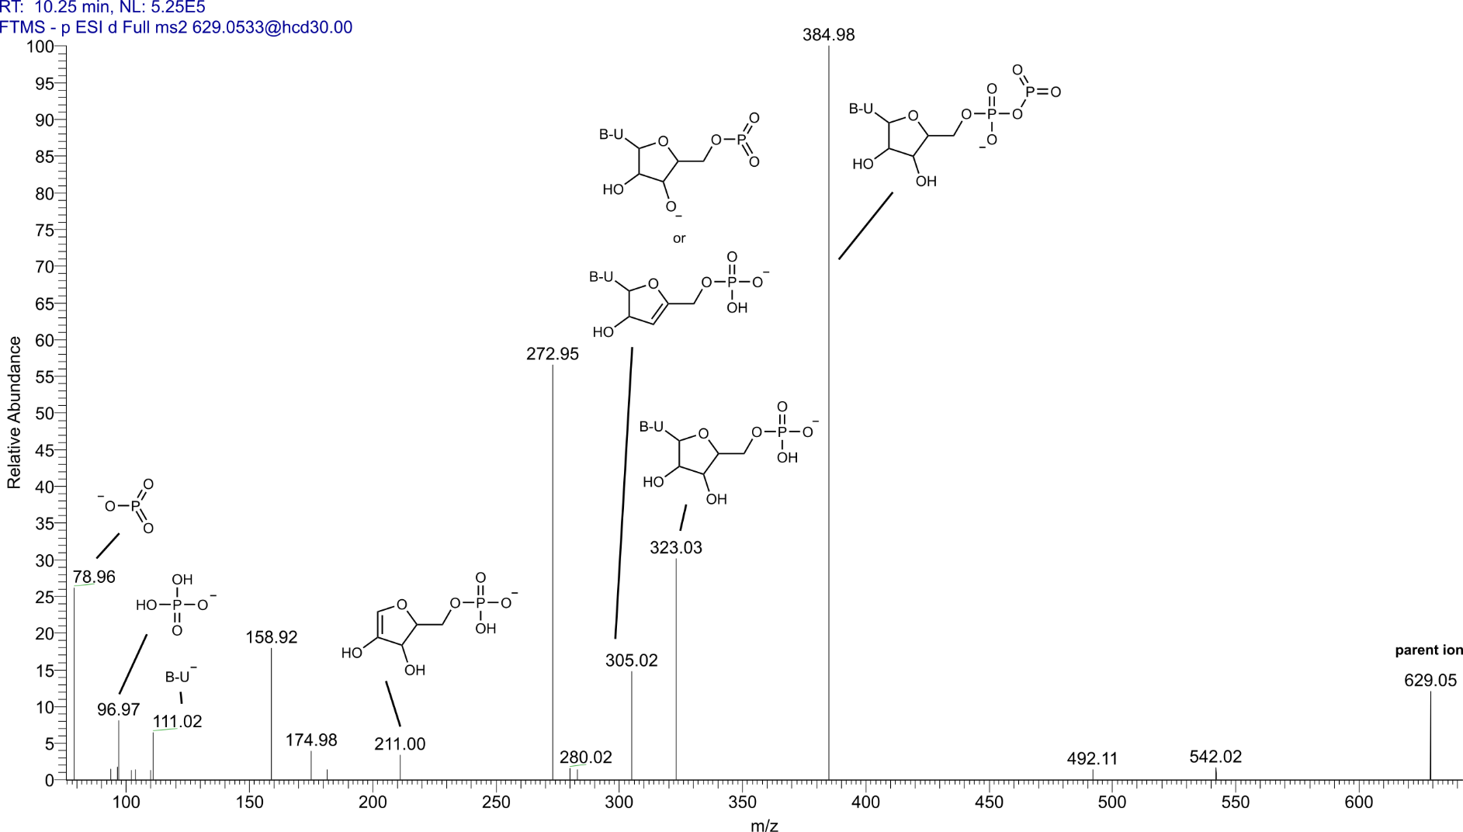
Figure S142. MS/MS spectrum of the U based dinucleotide (m/z 629.0538) obtained from the reaction of U (100 mM) with H₃PO₃ (3.0 eq.) and urea (1.0 eq.) for 7 d. Collision induced dissociation (NCE 30%) of the parent ion at t_{mig} = 10.25 min after CE separation led to the assigned fragments. Displayed fragment structures have model character since there are multiple possible isomers
(B-U: uracil).
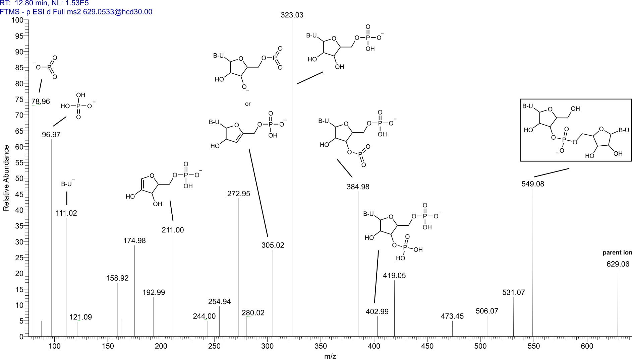
Figure S143. MS/MS spectrum of the U based dinucleotide (m/z 629.0538) obtained from the reaction of U (100 mM) with H₃PO₃ (3.0 eq.) and urea (1.0 eq.) for 7 d. Collision induced dissociation (NCE 30%) of the parent ion at t_{mig} = 12.80 min after CE separation led to the assigned fragments. Fragments in boxes are characteristic for alternating U and phosphate units. Displayed fragment structures have model character since there are multiple possible isomers.

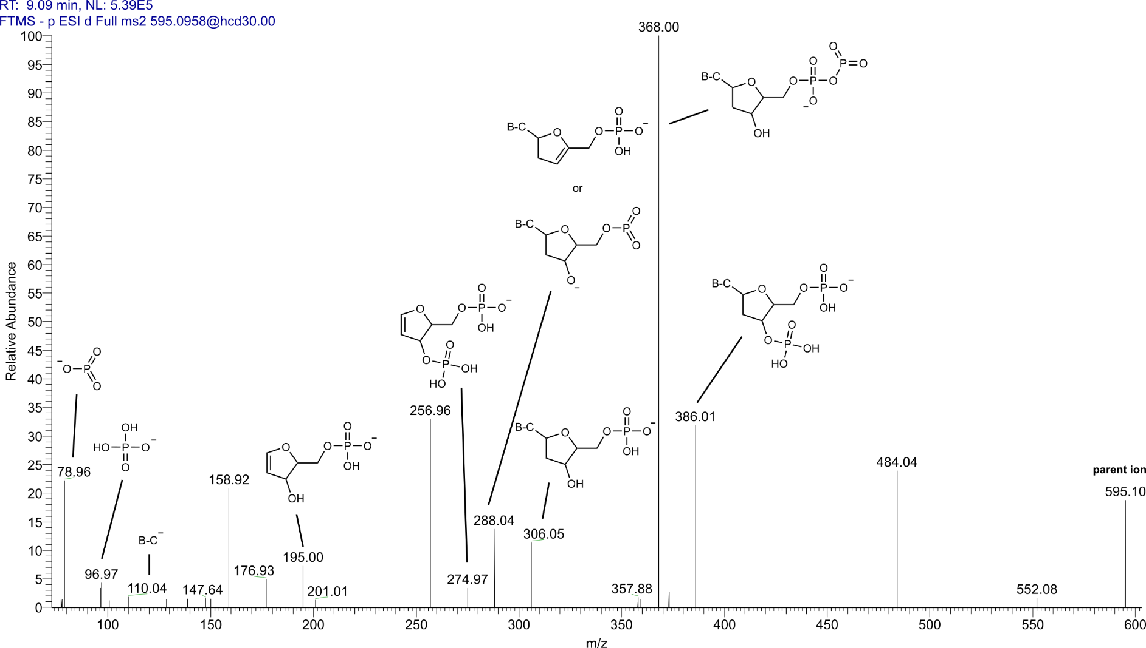
Figure S144. MS/MS spectrum of the dC based dinucleotide (m/z 595.0960) obtained from the reaction of dC (100 mM) with H₃PO₃ (3.0 eq.) and urea (1.0 eq.) for 7 d. Collision induced dissociation (NCE 30%) of the parent ion at t_{mig} = 9.09 min after CE separation led to the assigned fragments. Displayed fragment structures have model character since there are multiple possible isomers.

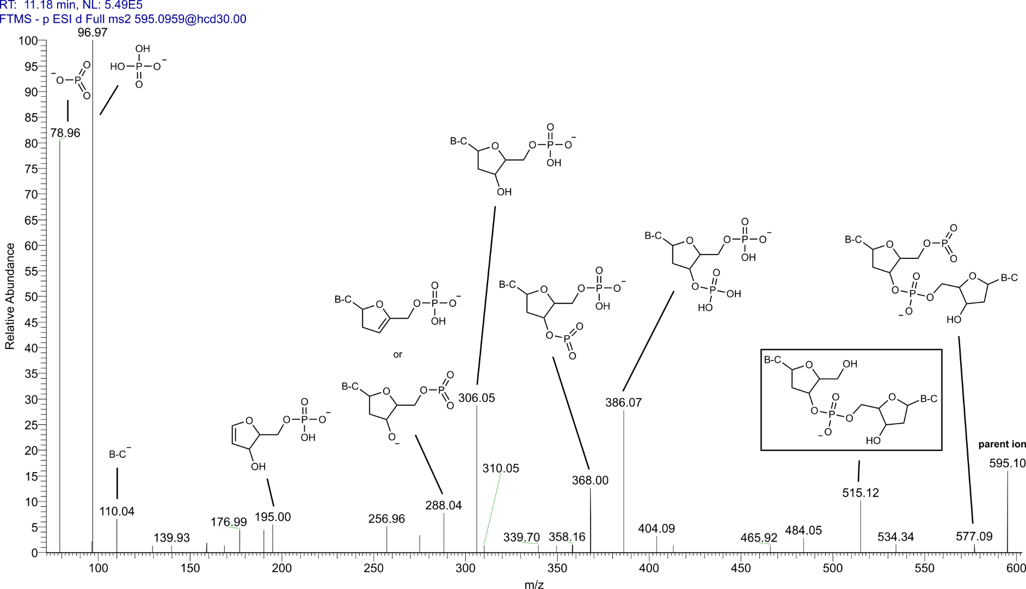
Figure S145. MS/MS spectrum of the dC based dinucleotide (m/z 595.0960) obtained from the reaction of dC (100 mM) with H₃PO₃ (3.0 eq.) and urea (1.0 eq.) for 7 d. Collision induced dissociation (NCE 30%) of the parent ion at t_{mig} = 11.18 min after CE separation led to the assigned fragments. Fragments in boxes are characteristic for alternating dC and phosphate units. Displayed fragment structures have model character since there are multiple possible isomers.
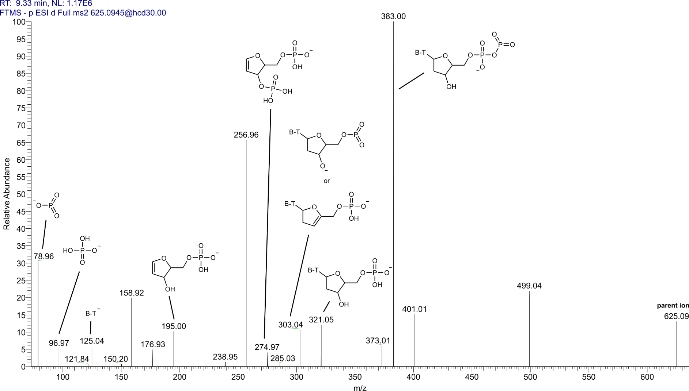
Figure S146. MS/MS spectrum of the dT based dinucleotide (m/z 625.0953) obtained from the reaction of dT (100 mM) with H₃PO₃ (100 mM) and urea (1.0 eq.) for 7 d. Collision induced dissociation (NCE 30%) of the parent ion at t_{mig} = 9.33 min after CE separation led to the assigned fragments. Displayed fragment structures have model character since there are multiple possible isomers (B-T: thymine).
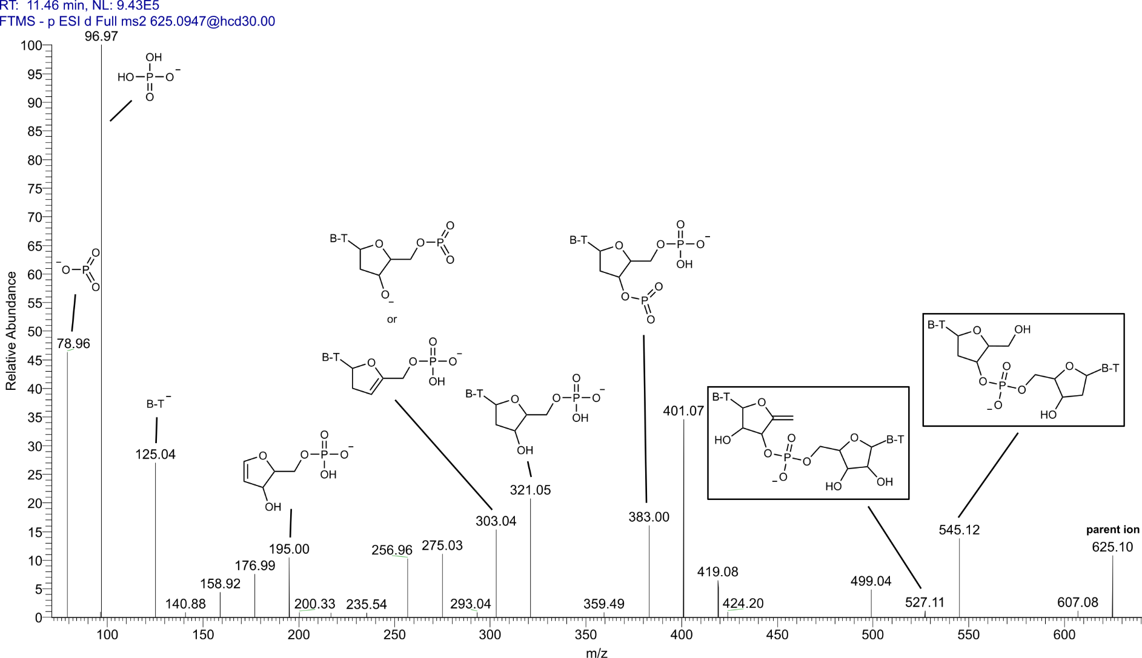
Figure S147. MS/MS spectrum of the dT based dinucleotide (m/z 625.0953) obtained from the reaction of dT (100 mM) with H₃PO₃ (100 mM) and urea (1.0 eq.) for 7 d. Collision induced dissociation (NCE 30%) of the parent ion at t_{mig} = 11.46 min after CE separation led to the assigned fragments. Fragments in boxes are characteristic for alternating dT and phosphate units. Displayed fragment structures have model character since there are multiple possible isomers.

