GRAPHICAL ABSTRACT

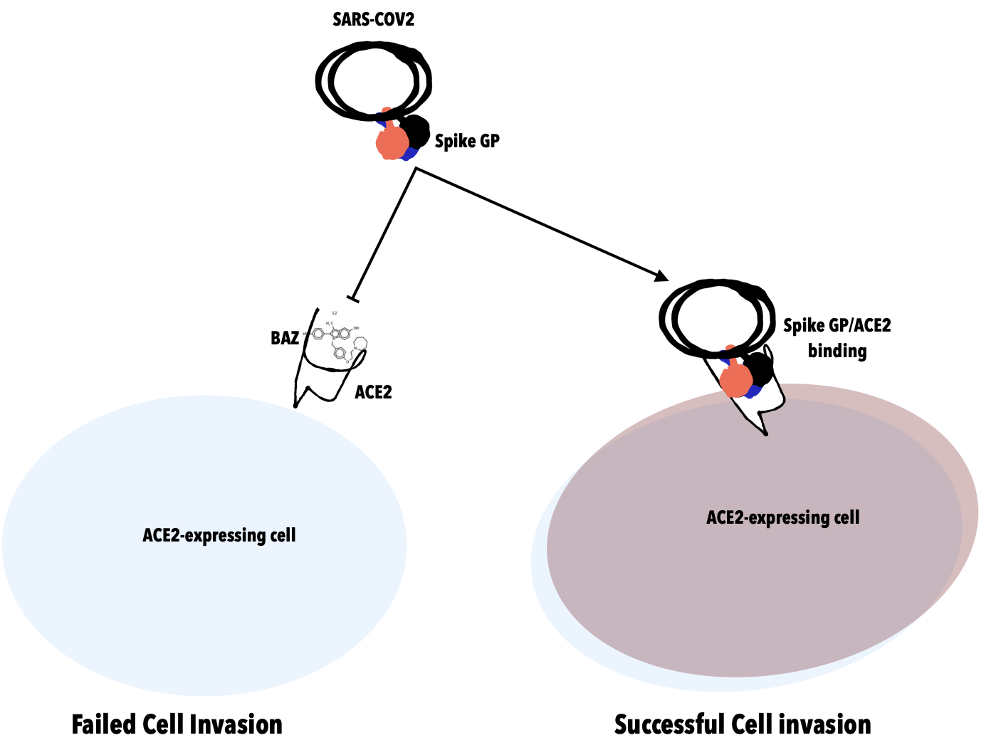
SARS-COV2 bears spike glycoprotein required for host ACE2 interaction; in the presence of Bazedoxifene (BAZ), RBD/ACE2 interaction is impossible; thus resulting in failed cell invasion.

