Supplementary material
Table S1. Relevant variables and subgroup for the construction of the prediction model
Number | Variable | Unit | Subgroup
X1 | Age | years | -
X2 | Temperature | Celsius | -
X3 | Pulse rate | counts per minute | -
X4 | Respiratory frequency | counts per minute | -
X5 | Waist circumference | cm | -
X6 | BMI | kg/m² | -
X7 | Self-assessment of self-care ability of the elderly | - | -
X8 | Cognitive function in the elderly | - | -
X9 | Mini-mental state examination | - | -
X10 | Depression | - | -
X11 | Elderly depression score examination | - | -
X12 | Time of each exercise | minutes | -
X13 | Exercise duration | minutes | -
X14 | Exercise mode | - | -
X15 | Daily smoking | cigarettes | -
X16 | Age of smoking initiation | years | -
X17 | Smoking cessation age | years | -
X18 | Daily alcohol intake | tael | -
X19 | Quit drink | - | -
X20 | Drunkenness in the past year | - | -
X21 | Left eye correction | - | -
X22 | Right eye correction | - | -
X23 | Hearing | - | -
X24 | Motor function | - | -
X25 | Description of fundus abnormalities | - | -
X26 | Hemoglobin | g/L | -
X27 | Leucocyte | ×10⁹/L | -
X28 | Platelets | ×10⁹/L | -
X29 | Urine protein | mg/dL | -
X30 | Urine glucose | mg/dL | -
X31 | Ketone | mg/dL | -
X32 | Urinary occult blood | - | -
X33 | Urinary microalbumin | mg/L | -
X34 | Hemoglobin A1c(HbA1c) | % | -
X35 | HBsAg | ng/mL | -
X36 | Alanine aminotransferase(ALT) | U/L | -
X37 | Aspartate aminotransferase(AST) | U/L | -
X38 | Albumin | g/L | -
X39 | Total bilirubin | μmol/L | -
X40 | Conjugated bilirubin | μmol/L | -
X41 | Serum creatinine(Scr) | μmol/L | -
X42 | Blood urea nitrogen | mmol/L | -
X43 | Potassium | mmol/L | -
X44 | Sodium | mmol/L | -
X45 | Total cholesterol(TC) | mmol/L | -
X46 | Triglyceride(TG) | mmol/L | -
X47 | Low density lipoprotein cholesterol(LDL-C) | mmol/L | -
X48 | High density lipoprotein cholesterol(HDL-C) | mmol/L | -
X49 | Nervous system disease | - | -
X50 | Other systemic diseases | - | -
X51 | Symptoms | - | Dizziness and headache
X52 | Symptoms | - | Nausea and vomiting
X53 | Symptoms | - | Vertigo and tinnitus
X54 | Symptoms | - | Dyspnea
X55 | Symptoms | - | Palpitation and chest distress
X56 | Symptoms | - | Chest pain
X57 | Symptoms | - | Numbness of limbs
X58 | Symptoms | - | Lower limb oedema
X59 | Symptoms | - | Chronic cough
X60 | Symptoms | - | Expectoration
X61 | Symptoms | - | Polydipsia
X62 | Symptoms | - | Polyuria
X63 | Symptoms | - | Weight loss
X64 | Symptoms | - | Malaise
X65 | Symptoms | - | Blurred vision
X66 | Symptoms | - | Urgent micturition
X67 | Symptoms | - | Dysuria
X68 | Symptoms | - | Constipation
X69 | Symptoms | - | Diarrhea
X70 | Symptoms | - | Breast distending pain
X71 | Symptoms | - | Other
X72 | Self-assessment of the health status of the elderly | - | Satisfaction
X73 | Self-assessment of the health status of the elderly | - | Basic satisfaction
X74 | Self-assessment of the health status of the elderly | - | Not clear
X75 | Self-assessment of the health status of the elderly | - | Not very satisfaction
X76 | Self-assessment of the health status of the elderly | - | Not satisfaction
X77 | Exercise frequency | - | Daily
X78 | Exercise frequency | - | More than once a week
X79 | Exercise frequency | - | Occasional
X80 | Exercise frequency | - | No exercise
X81 | Eating habits | - | Balanced meat and vegetables
X82 | Eating habits | - | Meat-based
X83 | Eating habits | - | Vegetable-based
X84 | Eating habits | - | Salt addiction
X85 | Eating habits | - | Oil addiction
X86 | Eating habits | - | Sugar addiction
X87 | Smoking status | - | Never
X88 | Smoking status | - | Smoking Cessation
X89 | Smoking status | - | Smoking
X90 | Drinking frequency | - | Never
X91 | Drinking frequency | - | Occasional
X92 | Drinking frequency | - | Frequent
X93 | Drinking frequency | - | Daily
X94 | Type of drinking | - | Liquor
X95 | Type of drinking | - | Beer
X96 | Type of drinking | - | Red wine
X97 | Type of drinking | - | Rice wine
X98 | Type of drinking | - | Other
X99 | Cardiac rhythm | - | Regular
X100 | Cardiac rhythm | - | Arrhythmia
X101 | Cardiac rhythm | - | Absolute arrhythmia
X102 | Lower limb oedema | - | Unilateral
X103 | Lower limb oedema | - | Bilateral asymmetry
X104 | Lower limb oedema |  | Bilateral symmetry
X105 | Dorsalis pedis pulse | - | Not palpable
X106 | Dorsalis pedis pulse | - | Palpation symmetry
X107 | Dorsalis pedis pulse | - | Weak or absent to left
X108 | Dorsalis pedis pulse | - | Weak or absent to right
X109 | Mammary gland | - | No abnormalities
X110 | Mammary gland | - | Mastectomy
X111 | Mammary gland | - | Abnormal lactation
X112 | Mammary gland | - | Masses
X113 | Mammary gland | - | Other
X114 | Cerebrovascular disease | - | Not found
X115 | Cerebrovascular disease | - | Ischemic stroke
X116 | Cerebrovascular disease | - | Cerebral hemorrhage
X117 | Cerebrovascular disease | - | Subarachnoid hemorrhage
X118 | Cerebrovascular disease | - | Transient ischemic attack
X119 | Cerebrovascular disease | - | Other
X120 | Kidney disease | - | Not found
X121 | Kidney disease | - | Diabetic Nephropathy(DN)
X122 | Kidney disease | - | Renal failure
X123 | Kidney disease | - | Acute nephritis
X124 | Kidney disease | - | Chronic nephritis
X125 | Kidney disease | - | Other
X126 | Heart disease | - | Not found
X127 | Heart disease | - | Myocardial infarction
X128 | Heart disease | - | Angina pectoris
X129 | Heart disease | - | Coronary revascularization
X130 | Heart disease | - | Congestive heart failure
X131 | Heart disease | - | Precordial pain
X132 | Heart disease | - | Other
X133 | Vascular disease | - | Not found
X134 | Vascular disease | - | Dissecting aneurysm
X135 | Vascular disease | - | Arterial occlusive disease
X136 | Vascular disease | - | Other
X137 | Eye disease | - | Not found
X138 | Eye disease | - | Retinal hemorrhage or exudate
X139 | Eye disease | - | Papilledema
X140 | Eye disease | - | Cataract
X141 | Eye disease | - | Other
X142 | Risk factor control | - | Smoking cessation
X143 | Risk factor control | - | Healthy drinking
X144 | Risk factor control | - | Diet
X145 | Risk factor control | - | Exercise
X146 | Risk factor control | - | Weight loss goal
X147 | Risk factor control | - | Vaccination
X148 | Risk factor control | - | Other
X149 | Other | - | Other abnorma
X150 | Fasting blood glucose(FBG) | mmol/L | -
X151 | Blood pressure | mmHg | Diastolic blood pressure(DBP)
X152 | Blood pressure | mmHg | Systolic blood pressure(SBP)
X153 | Current daily smoking | cigarettes | Average daily
X154 | Current daily alcohol intake | tael | Average daily
X155 | Current time of each exercise | minutes | Average daily exercise
X156 | Current number of exercise per week | times | -
X157 | Current staple food | g/day | Average daily
X158 | Adverse drug reaction | - | -
X159 | Symptoms | - | Epistaxis continuous bleeding
X160 | Follow-up method | - | Outpatient
X161 | Follow-up method | - | Home visit
X162 | Follow-up method | - | Telephone
X163 | Dorsalis pedis pulse | - | Normal
X164 | Dorsalis pedis pulse | - | Weak
X165 | Dorsalis pedis pulse | - | Disappearance
X166 | Mental adjustment | - | Good
X167 | Mental adjustment | - | General
X168 | Mental adjustment | - | Poor
X169 | Medical compliance | - | Good
X170 | Medical compliance | - | General
X171 | Medical compliance | - | Poor
X172 | Medication adherence | - | Regularity
X173 | Medication adherence | - | Intermittent
X174 | Medication adherence | - | No medication
X175 | Hypoglycemic reaction | - | -
X176 | Hypoglycemic reaction | - | Occasional
X177 | Hypoglycemic reaction | - | Frequent
X178 | Classification of this follow-up | - | Satisfaction
X179 | Classification of this follow-up | - | Adverse reactions
X180 | Classification of this follow-up | - | Complication
X181 | Sex | - | -
X182 | national | - | -
X183 | Education | - | -
X184 | Profession | - | -
X185 | Marital status | - | -
X186 | Surgery | - | -
X187 | Trauma | - | -
X188 | History of genetic disease | - | -
X189 | ABO blood group | - | Blood type A
X190 | ABO blood group | - | Blood type B
X191 | ABO blood group | - | Blood type O
X192 | ABO blood group | - | Blood type AB
X193 | Rh blood group | - | Not clear
X194 | Rh blood group | - | Negative
X195 | Rh blood group | - | Positive
X196 | History of drug allergy | - | Penicillin
X197 | History of drug allergy | - | Sulphonamide
X198 | History of drug allergy | - | Streptomycin
X199 | History of drug allergy | - | Other
X200 | History of exposure | - | chemical
X201 | History of exposure | - | toxicant
X202 | History of exposure | - | ray
X203 | History of exposure | - | Other
X204 | Disease | - | Hypertension
X205 | Disease | - | Diabetes Mellitus(DM)
X206 | Disease | - | Coronary heart disease
X207 | Disease | - | Chronic obstructive pulmonary disease
X208 | Disease | - | Malignant tumour
X209 | Disease | - | Stroke
X210 | Disease | - | Severe mental disorder
X211 | Disease | - | Tuberculosis
X212 | Disease | - | Hepatitis
X213 | Disease | - | Other notifiable infectious diseases
X214 | Disease | - | Occupation disease
X215 | Disease | - | Other
X216 | Father's disease | - | Hypertension
X217 | Father's disease | - | Diabetes Mellitus(DM)
X218 | Father's disease | - | Coronary heart disease
X219 | Father's disease | - | Chronic obstructive pulmonary disease
X220 | Father's disease | - | Malignant tumour
X221 | Father's disease | - | Stroke
X222 | Father's disease | - | Severe mental disorder
X223 | Father's disease | - | Tuberculosis
X224 | Father's disease | - | Hepatitis
X225 | Father's disease | - | Congenital abnormalities
X226 | Father's disease | - | Other
X227 | Maternal disease | - | Hypertension
X228 | Maternal disease | - | Diabetes Mellitus(DM)
X229 | Maternal disease | - | Coronary heart disease
X230 | Maternal disease | - | Chronic obstructive pulmonary disease
X231 | Maternal disease | - | Malignant tumour
X232 | Maternal disease | - | Stroke
X233 | Maternal disease | - | Severe mental disorder
X234 | Maternal disease | - | Tuberculosis
X235 | Maternal disease | - | Hepatitis
X236 | Maternal disease | - | Congenital abnormalities
X237 | Maternal disease | - | Other
X238 | Sibling disease | - | Hypertension
X239 | Sibling disease | - | Diabetes Mellitus(DM)
X240 | Sibling disease | - | Coronary heart disease
X241 | Sibling disease | - | Chronic obstructive pulmonary disease
X242 | Sibling disease | - | Malignant tumour
X243 | Sibling disease | - | Stroke
X244 | Sibling disease | - | Severe mental disorder
X245 | Sibling disease | - | Tuberculosis
X246 | Sibling disease | - | Hepatitis
X247 | Sibling disease | - | Congenital abnormalities
X248 | Sibling disease | - | Other
X249 | Disease of child | - | Hypertension
X250 | Disease of child | - | Diabetes Mellitus(DM)
X251 | Disease of child | - | Coronary heart disease
X252 | Disease of child | - | Chronic obstructive pulmonary disease
X253 | Disease of child | - | Malignant tumour
X254 | Disease of child | - | Stroke
X255 | Disease of child | - | Severe mental disorder
X256 | Disease of child | - | Tuberculosis
X257 | Disease of child | - | Hepatitis
X258 | Disease of child | - | Congenital abnormalities
X259 | Disease of child | - | Other
X260 | Disability | - | visual disability
X261 | Disability | - | Hearing disability
X262 | Disability | - | Speech disability
X263 | Disability | - | Physical disability
X264 | Disability | - | Intellectual disability
X265 | Disability | - | Mental disability
X266 | Disability | - | Other
X267 | Atherosclerotic cardiovascular disease | - | -
X268 | Metformin | - | -
X269 | Metformin sustained-release capsules | - | -
X270 | Metformin sustained-release tablets | - | -
X271 | Phenformin | - | -
X272 | Tolbutamide | - | -
X273 | Glibenclamide | - | -
X274 | Glibenclamide sustained-release tablets | - | -
X275 | Metformin and glibenclamide | - | -
X276 | Metformin and glibenclamide sustained-release | - | -
X277 | Glimepirde | - | -
X278 | Glimepirde sustained-release | - | -
X279 | Metformin and Glimepirde | - | -
X280 | Metformin and Glimepirde sustained-release | - | -
X281 | Metformin and glipizide | - | -
X282 | Gliclazide sustained-release | - | -
X283 | Metformin and Gliclazide | - | -
X284 | Metformin and glipizide sustained-release tablets | - | -
X285 | Gliclazide tablets | - | -
X286 | Glipizide tablets | - | -
X287 | Glipizide controlled release tablets | - | -
X288 | Gliquidone tablets | - | -
X289 | Metformin and gliquidone dispersible tablets | - | -
X290 | Pioglitazone tablets | - | -
X291 | Pioglitazone tablets 15mg | - | -
X292 | Pioglitazone tablets 30mg | - | -
X293 | Pioglitazone sustained-release tablets | - | -
X294 | Pioglitazone and metformin tablets (15mg/500mg) | - | -
X295 | Pioglitazone and metformin tablets | - | -
X296 | Pioglitazone and metformin sustained-release tablets (15mg/500mg) | - | -
X297 | Pioglitazone and metformin sustained-release tablets | - | -
X298 | Rosiglitazone tablets | - | -
X299 | Rosiglitazone sustained-release tablets | - | -
X300 | Metformin and rosiglitazone tablets | - | -
X301 | Metformin hydrochloride and rosiglitazone maleate sustained-release tablets | - | -
X302 | Repaglinide tablets | - | -
X303 | GLP-1 receptor agonist | - | -
X304 | Metformin and vildagliptin | - | -
X305 | Vildagliptin tablets 50mg | - | -
X306 | Vildagliptin tablets | - | -
X307 | Sitagliptin | - | -
X308 | Sitagliptin and metformin | - | -
X309 | Empagliflozin | - | -
X310 | Mecobalamin | - | -
X311 | Epalrestat | - | -
X312 | Miglitol | - | -
X313 | Voglibose | - | -
X314 | Acarbose | - | -
X315 | Insulin aspart | - | -
X316 | Insulin lispro | - | -
X317 | Insulin glulisine | - | -
X318 | NovoRapid | - | -
X319 | Other rapid-acting insulins | - | -
X320 | Short-acting insulin | - | -
X321 | Protamine Zinc Insulin | - | -
X322 | Insulin glargine | - | -
X323 | Regular recombinant human insulin | - | -
X324 | Insulin detemir | - | -
X325 | Isophane recombinant human insulin | - | -
X326 | Long-acting insulin | - | -
X327 | Recombinant human insulin injection (mixed 30/70) | - | -
X328 | Pre-Mixed insulin | - | -
X329 | Other types of insulin | - | -
X330 | Chinese patent drug | - | -
X331 | Other types antidiabetic drugs | - | -
X332 | Levamlodipine | - | -
X333 | Nifedipine | - | -
X334 | Nifedipine tablets | - | -
X335 | Nifedipine sustained-release tablets | - | -
X336 | Lacidipine | - | -
X337 | Felodipine | - | -
X338 | Felodipine sustained-release | - | -
X339 | Nimodipine tablets | - | -
X340 | Nimodipine | - | -
X341 | Nitrendipine | - | -
X342 | Amlodipine and Benazepril | - | -
X343 | Benazepril | - | -
X344 | Fosinopril | - | -
X345 | Captopril | - | -
X346 | Perindopril | - | -
X347 | Lisinopril | - | -
X348 | Bisoprolol | - | -
X349 | Bisoprolol (Dosage and administration are not distinguished) | - | -
X350 | Metoprolol | - | -
X351 | Propranolol tablets | - | -
X352 | Propranolol capsules | - | -
X353 | Candesartan | - | -
X354 | Valsartan | - | -
X355 | Telmisartan tablets 80mg | - | -
X356 | Telmisartan | - | -
X357 | Irbesartan | - | -
X358 | Irbesartan tablets | - | -
X359 | Irbesartan and hydrochlorothiazide | - | -
X360 | Irbesartan tablets and hydrochlorothiazide | - | -
X361 | Losartan potassium | - | -
X362 | Losartan | - | -
X363 | Compound reserpine tablets | - | -
X364 | Reserpine tablets | - | -
X365 | Reserpine | - | -
X366 | Hydrochlorothiazide tablets | - | -
X367 | Hydrochlorothiazide | - | -
X368 | Spironolactone tablets | - | -
X369 | Spironolactone | - | -
X370 | Indapamide | - | -
X371 | Indapamide tablets | - | -
X372 | Indapamide sustained-release | - | -
X373 | Compound reserpineand triamterene tablets | - | -
X374 | Triamterene tablets | - | -
X375 | Triamterene | - | -
X376 | Antihypertensive Chinese patent medicines | - | -
X377 | Compound Danshen pills | - | -
X378 | Compound Danshen tablets | - | -
X379 | Compound Danshen | - | -
X380 | Ginkgo folium | - | -
X381 | Atorvastatin calcium | - | -
X382 | Atorvastatin | - | -
X383 | Rosuvastatin | - | -
X384 | Simvastatin tablets | - | -
X385 | Simvastatin tablets 20mg | - | -
X386 | Pravastatin | - | -
X387 | Pitavastatin | - | -
X388 | Other statins | - | -
X389 | Fenofibrate | - | -
X390 | Aspirin | - | -
X391 | Clopidogrel | - | -
X392 | Cardiovascular proprietary Chinese medicine | - | -
X393 | Propolis nourishes trypsin | - | -
X394 | Propolis capsules | - | -
X395 | Propolis | - | -
X396 | Nitroglycerin tablets | - | -
X397 | Isosorbide dinitrate tablets | - | -
X398 | Isosorbide mononitrate tablets | - | -
X399 | Isosorbide mononitrate sustained-release tablets | - | -
X400 | Nitrates | - | -
X401 | Lumbrokinase enteric - coated capsules | - | -
X402 | Calcium dobesilate capsules | - | -
X403 | Type 2 diabetes mellitus | - | -
X404 | Other diabetes types (not used) | - | -
X405 | Diabetes distal symmetrical polyneuropathy | - | -
X406 | Ophthalmopathy | - | -
X407 | Diabetic nephropathy | - | -
X408 | Diabetic foot | - | -
X409 | Diabetic ketoacidosis | - | -
X410 | Hypoglycemia | - | -
X411 | T2DM with other complications | - | -
X412 | Other diabetes types (Delete this part of patients) | - | -
X413 | Hypertension | - | -
X414 | Atherosclerosis | - | -
X415 | Hyperlipidemias | - | -
X416 | Coronary atherosclerotic heart disease | - | -
X417 | Heart failure | - | -
X418 | Angina pectoris | - | -
X419 | Myocardial infarction | - | -
X420 | Arrhythmia | - | -
X421 | Heart valve diseases | - | -
X422 | Cardiomyopathies | - | -
X423 | Pericardial disease | - | -
X424 | Hypertensive heart disease | - | -
X425 | Congenital cardiovascular disease | - | -
X426 | Rheumatic heart disease | - | -
X427 | Pulmonary heart disease | - | -
X428 | Myocardial ischemia | - | -
X429 | Other diseases of circulatory system | - | -
X430 | Stroke | - | -
X431 | Cerebral infarction | - | -
X432 | Cerebral hemorrhage | - | -
X433 | Transient ischemic attack | - | -
X434 | Cerebral atherosclerosis | - | -
X435 | Subarachnoid hemorrhage | - | -
X436 | Other cerebrovascular diseases | - | -
X437 | Epilepsy | - | -
X438 | Parkinsonism | - | -
X439 | Alzheimer's disease | - | -
X440 | Brain neoplasms | - | -
X441 | Other encephalopathy | - | -
X442 | Chronic obstructive pulmonary disease | - | -
X443 | acute tracheitis or acute tracheitis | - | -
X444 | Chronic bronchitis | - | -
X445 | Pulmonary emphysema | - | -
X446 | Bronchiectasis | - | -
X447 | Asthma | - | -
X448 | Disease of pleura | - | -
X449 | Pneumonia | - | -
X450 | Pneumoconiosis | - | -
X451 | Silicosis | - | -
X452 | Lung neoplasms | - | -
X453 | Tuberculosis | - | -
X454 | Rhinitis | - | -
X455 | Other diseases of respiratory system | - | -
X456 | Nephritis | - | -
X457 | Renal failure | - | -
X458 | Renal cyst | - | -
X459 | Nephrolithiasis | - | -
X460 | Other kidney diseases | - | -
X461 | Ureteral calculi | - | -
X462 | Uremia | - | -
X463 | Prostatitis | - | -
X464 | Prostatic hyperplasia | - | -
X465 | Other prostate diseases | - | -
X466 | Bladder disease | - | -
X467 | Anemia | - | -
X468 | Lymphoma | - | -
X469 | Other blood system diseases | - | -
X470 | Metabolic liver disease | - | -
X471 | Hepatitis | - | -
X472 | Hepatic space-occupying lesions | - | -
X473 | Hepatic cyst | - | -
X474 | Liver Neoplasms | - | -
X475 | Liver cirrhosis | - | -
X476 | Hepatic calcification | - | -
X477 | Hepatic insufficiency | - | -
X478 | Hepatic congestion | - | -
X479 | Other diseases of liver | - | -
X480 | Gallstones | - | -
X481 | Absence of gallbladder | - | -
X482 | Cholecystectomy | - | -
X483 | Gallbladder polyp | - | -
X484 | Cholangiectasis | - | -
X485 | Other biliary diseases | - | -
X486 | Gastritis | - | -
X487 | Peptic ulcer | - | -
X488 | Gastrointestinal haemorrhage | - | -
X489 | Pancreatitis | - | -
X490 | Other diseases of pancreas | - | -
X491 | Other diseases of digestive system | - | -
X492 | Hypothyroidism | - | -
X493 | Hyperthyroidism | - | -
X494 | Other thyroid diseases | - | -
X495 | Hyperuricemia | - | -
X496 | Gout | - | -
X497 | Rheumatic arthritides | - | -
X498 | Rheumatoid arthritis | - | -
X499 | Osteoarthritis | - | -
X500 | Scapulohumeral periarthritis | - | -
X501 | Synovitis | - | -
X502 | Spondylosis | - | -
X503 | Lumbar spondylosis | - | -
X504 | Fracture | - | -
X505 | Other diseases in orthopedics | - | -
X506 | Hyperostosis | - | -
X507 | Osteoporosis | - | -
X508 | Uterine leiomyoma | - | -
X509 | Other diseases of the uterus | - | -
X510 | Cataract | - | -
X511 | Eczema | - | -

Table S2 Delete variables
FBG |  |  | HbA1c
Missing ratio >90%（N=12） | single category ratio＞ 90%（N=412） | coefficient of variatio＜0.1（N=2） | Missing ratio >90%（N=20） | single category ratio＞ 90%（N=410） | coefficient of variatio＜0.1（N=2）
X9，X11，X17，X21，X22，X29，X31，X32，X33，X43，X44，X49 | X24，X53，X54，X55，X56，X57，X58，X59，X60，X61，X62，X63，X64，X65，X66，X67，X68，X69，X70，X71，X74，X75，X76，X78，X79，X81，X83，X84，X85，X86，X88，X91，X92，X93，X95，X96，X97，X98，X100，X101，X102，X103，X104，X105，X107，X108，X109，X110，X111，X112，X113，X115，X116，X117，X118，X119，X121，X122，X123，X124，X125，X127，X128，X129，X130，X131，X132，X134，X135，X136，X138，X139，X140，X141，X142，X143，X145，X146，X147，X148，X149，X158，X159，X162，X163，X164，X165，X168，X171，X175，X176，X177，X180，X182，X188，X189，X190，X191，X192，X193，X194，X195，X196，X197，X198，X199，X200，X201，X202，X203，X205，X206，X207，X208，X209，X210，X211，X212，X213，X214，X216，X217，X218，X219，X220，X221，X222，X223，X224，X225，X226，X227，X228，X229，X230，X231，X232，X233，X234，X235，X236，X237，X238，X239，X240，X241，X242，X243，X244，X245，X246，X247，X248，X249，X250，X251，X252，X253，X254，X255，X256，X257，X258，X259，X260，X261，X262，X263，X264，X265，X266，X267，X270，X271，X272，X273，X274，X275，X276，X277，X278，X279，X280，X281，X282，X283，X284，X286，X287，X288，X289，X290，X291，X292，X293，X294，X295，X296，X297，X298，X299，X300，X301，X302，X303，X304，X305，X306，X307，X308，X309，X310，X311，X312，X313，X314，X315，X316，X317，X318，X319，X320，X321，X322，X323，X324，X325，X326，X327，X328，X329，X330，X331，X332，X333，X334，X335，X336，X337，X338，X339，X340，X341，X342，X343，X344，X345，X346，X347，X348，X349，X350，X351，X352，X353，X354，X355，X356，X357，X358，X359，X360，X361，X362，X363，X364，X365，X366，X367，X368，X369，X370，X371，X372，X373，X374，X375，X376，X377，X378，X379，X380，X381，X382，X383，X384，X385，X386，X387，X388，X389，X390，X391，X392，X393，X394，X395，X396，X397，X398，X399，X400，X401，X402，X404，X405，X406，X407，X408，X409，X410，X411，X412，X413，X414，X415，X416，X417，X418，X419，X420，X421，X422，X423，X424，X425，X426，X427，X428，X429，X430，X431，X432，X433，X434，X435，X436，X437，X438，X439，X440，X441，X442，X443，X444，X445，X446，X447，X448，X449，X450，X451，X452，X453，X454，X455，X456，X457，X458，X459，X460，X461，X462，X463，X464，X465，X466，X467，X468，X469，X470，X471，X472，X473，X474，X475，X476，X477，X478，X479，X480，X481，X482，X483，X484，X485，X486，X487，X488，X489，X490，X491，X492，X493，X494，X495，X496，X497，X498，X499，X500，X501，X502，X503，X504，X505，X506，X507，X508，X509，X510，X511 | X2，X4 | X9，X11，X15，X16，X17，X18，X19，X21，X22，X29，X30，X31，X32，X33，X35，X38，X40，X43，X44，X49 | X53，X54，X55，X56，X57，X58，X59，X60，X61，X62，X63，X64，X65，X66，X67，X68，X69，X70，X71，X73，X74，X75，X76，X78，X79，X81，X83，X84，X85，X86，X88，X89，X91，X92，X93，X94，X95，X96，X97，X98，X100，X101，X102，X103，X104，X105，X107，X108，X109，X110，X111，X112，X113，X115，X116，X117，X118，X119，X121，X122，X123，X124，X127，X128，X129，X130，X131，X132，X134，X135，X136，X138，X139，X140，X141，X142，X143，X145，X146，X147，X148，X158，X159，X162，X163，X164，X165，X168，X175，X176，X177，X180，X182，X188，X189，X190，X191，X192，X193，X194，X195，X196，X197，X198，X199，X200，X201，X202，X203，X205，X206，X207，X208，X209，X210，X211，X212，X213，X214，X216，X217，X218，X219，X220，X221，X222，X223，X224，X225，X226，X227，X228，X229，X230，X231，X232，X233，X234，X235，X236，X237，X238，X240，X241，X242，X243，X244，X245，X246，X247，X248，X249，X250，X251，X252，X253，X254，X255，X256，X257，X258，X259，X260，X261，X262，X263，X264，X265，X266，X267，X268，X269，X270，X271，X272，X273，X274，X275，X276，X277，X278，X279，X280，X281，X282，X283，X284，X285，X286，X287，X288，X289，X290，X291，X292，X293，X294，X295，X296，X297，X298，X299，X300，X301，X302，X303，X304，X305，X306，X307，X308，X309，X310，X311，X312，X313，X314，X315，X316，X317，X318，X319，X320，X321，X322，X323，X324，X325，X326，X327，X328，X329，X330，X331，X332，X333，X334，X335，X336，X337，X338，X339，X340，X341，X342，X343，X344，X345，X346，X347，X348，X349，X350，X351，X352，X353，X354，X355，X356，X357，X358，X359，X360，X361，X362，X363，X364，X365，X366，X367，X368，X369，X370，X371，X372，X373，X374，X375，X376，X377，X378，X379，X380，X381，X382，X383，X384，X385，X386，X387，X388，X389，X390，X391，X392，X393，X394，X395，X396，X397，X398，X399，X400，X401，X402，X404，X405，X406，X407，X408，X409，X410，X411，X412，X413，X414，X415，X416，X417，X418，X419，X420，X421，X422，X423，X424，X425，X426，X427，X428，X429，X430，X431，X432，X433，X434，X435，X436，X437，X438，X439，X440，X441，X442，X443，X444，X445，X446，X447，X448，X449，X450，X451，X452，X453，X454，X455，X456，X457，X458，X460，X461，X462，X463，X464，X465，X466，X467，X468，X469，X471，X472，X473，X474，X475，X476，X477，X478，X479，X480，X481，X482，X483，X484，X485，X486，X487，X488，X489，X490，X491，X492，X493，X494，X495，X496，X497，X498，X499，X500，X501，X502，X503，X504，X505，X506，X507，X508，X509，X510 | X2，X4

Table S3 Inclusion variables

Final inclusion variables | FBG(N=85) | X1，X3，X5，X6，X7，X8，X10，X12，X13，X14，X15，X16，X18，X19，X20，X23，X25，X26，X27，X28，X30，X34，X35，X36，X37，X38，X39，X40，X41，X42，X45，X46，X47，X48，X50，X51，X52，X72，X73，X77，X80，X82，X87，X89，X90，X94，X99，X106，X114，X120，X126，X133，X137，X144，X150，X151，X152，X153，X154，X155，X156，X157，X160，X161，X166，X167，X169，X170，X172，X173，X174，X178，X179，X181，X183，X184，X185，X186，X187，X204，X215，X268，X269，X285，X403
Final inclusion variables | HbA1c(N=78) | X1，X3，X5，X6，X7，X8，X10，X12，X13，X14，X15，X16，X18，X19，X23，X25，X26，X27，X28，X34，X35，X36，X37，X38，X39，X40，X41，X42，X45，X46，X47，X48，X50，X51，X52，X72，X73，X77，X80，X82，X87，X89，X90，X94，X99，X106，X120，X126，X144，X150，X151，X152，X153，X154，X155，X158，X159，X164，X165，X167，X168，X170，X171，X172，X176，X177，X179，X181，X182，X183，X184，X202，X213，X266，X267，X283，X401，X510

Table S4. Ten-fold cross-validation analysis results for the data imputing method

FBG | AUC |  | Accuracy |  | Precision |  | Recall |  | F1Score
FBG | Mean±SD | 95%CI | Mean±SD | 95%CI | Mean±SD | 95%CI | Mean±SD | 95%CI | Mean±SD | 95%CI
Modified Random Forest | 0.749±0.044 | 0.745-0.753 | 0.688±0.035 | 0.684-0.691 | 0.693±0.049 | 0.689-0.698 | 0.683±0.042 | 0.679-0.687 | 0.686±0.031 | 0.684-0.689
Not | 0.710±0.038 | 0.706-0.713 | 0.662±0.030 | 0.660-0.665 | 0.649±0.033 | 0.646-0.652 | 0.639±0.039 | 0.635-0.642 | 0.644±0.034 | 0.640-0.647
P value | P<0.0001 |  | P<0.0001 |  | P<0.0001 |  | P<0.0001 |  | P<0.0001

HbA1c | AUC |  | Accuracy |  | Precision |  | Recall |  | F1Score
HbA1c | Mean±SD | 95%CI | Mean±SD | 95%CI | Mean±SD | 95%CI | Mean±SD | 95%CI | Mean±SD | 95%CI
Modified Random Forest | 0.901±0.078 | 0.894-0.907 | 0.844±0.099 | 0.836-0.853 | 0.834±0.103 | 0.825-0.842 | 0.848±0.112 | 0.838-0.857 | 0.838±0.102 | 0.829-0.847
Not | 0.622±0.123 | 0.611-0.633 | 0.606±0.097 | 0.598-0.615 | 0.651±0.094 | 0.643-0.659 | 0.736±0.168 | 0.722-0.751 | 0.682±0.105 | 0.673-0.691
P value | P<0.0001 |  | P<0.0001 |  | P<0.0001 |  | P<0.0001 |  | P<0.0001

Table S5. Ten-fold cross-validation analysis results of the feature screening method

FBG | AUC |  | Accuracy |  | Precision |  | Recall |  | F1Score
FBG | Mean±SD | 95%CI | Mean±SD | 95%CI | Mean±SD | 95%CI | Mean±SD | 95%CI | Mean±SD | 95%CI
Boruta | 0.725±0.044 | 0.721-0.728 | 0.672±0.034 | 0.669-0.675 | 0.667±0.041 | 0.663-0.670 | 0.675±0.050 | 0.671-0.680 | 0.670±0.039 | 0.667-0.673
Lasso | 0.728±0.038 | 0.725-0.731 | 0.674±0.029 | 0.671-0.676 | 0.670±0.038 | 0.667-0.673 | 0.674±0.041 | 0.670-0.677 | 0.671±0.032 | 0.668-0.673
Not | 0.724±0.043 | 0.721-0.727 | 0.671±0.033 | 0.668-0.673 | 0.666±0.041 | 0.663-0.669 | 0.673±0.038 | 0.670-0.676 | 0.669±0.033 | 0.666-0.672
P value | P=0.2424 |  | P=0.1056 |  | P=0.0950 |  | P=0.0136 |  | P=0.0677

HbA1c | AUC |  | Accuracy |  | Precision |  | Recall |  | F1Score
HbA1c | Mean±SD | 95%CI | Mean±SD | 95%CI | Mean±SD | 95%CI | Mean±SD | 95%CI | Mean±SD | 95%CI
Boruta | 0.753±0.142 | 0.743-0.764 | 0.712±0.126 | 0.703-0.721 | 0.721±0.124 | 0.711-0.730 | 0.725±0.134 | 0.715-0.735 | 0.718±0.116 | 0.709-0.727
Lasso | 0.776±0.130 | 0.766-0.785 | 0.719±0.126 | 0.709-0.728 | 0.720±0.130 | 0.711-0.730 | 0.750±0.154 | 0.738-0.761 | 0.728±0.124 | 0.718-0.737
Not | 0.735±0.145 | 0.724-0.746 | 0.688±0.132 | 0.678-0.698 | 0.698±0.130 | 0.688-0.708 | 0.715±0.150 | 0.704-0.727 | 0.699±0.120 | 0.690-0.708
P value | P<0.0001 |  | P<0.0001 |  | P=0.0009 |  | P<0.0001 |  | P<0.0001

Table S6. Bootstrapping sampling analysis results of data imputing method
FBG | AUC |  | Accuracy |  | Precision |  | Recall |  | F1Score
FBG | Mean±SD | 95%CI | Mean±SD | 95%CI | Mean±SD | 95%CI | Mean±SD | 95%CI | Mean±SD | 95%CI
Modified Random Forest | 0.754±0.048 | 0.754-0.755 | 0.693±0.038 | 0.693-0.694 | 0.701±0.052 | 0.701-0.701 | 0.683±0.037 | 0.683-0.683 | 0.691±0.033 | 0.690-0.691
Not | 0.715±0.034 | 0.715-0.716 | 0.668±0.027 | 0.668-0.668 | 0.653±0.030 | 0.653-0.654 | 0.650±0.030 | 0.650-0.650 | 0.651±0.028 | 0.651-0.652
P value | P<0.0001 |  | P<0.0001 |  | P<0.0001 |  | P<0.0001 |  | P<0.0001

HbA1c | AUC |  | Accuracy |  | Precision |  | Recall |  | F1Score
HbA1c | Mean±SD | 95%CI | Mean±SD | 95%CI | Mean±SD | 95%CI | Mean±SD | 95%CI | Mean±SD | 95%CI
Modified Random Forest | 0.902±0.083 | 0.902-0.903 | 0.849±0.099 | 0.848-0.849 | 0.822±0.100 | 0.822-0.823 | 0.876±0.109 | 0.875-0.876 | 0.845±0.100 | 0.845-0.846
Not | 0.652±0.094 | 0.651-0.652 | 0.628±0.080 | 0.627-0.628 | 0.679±0.090 | 0.678-0.679 | 0.725±0.113 | 0.724-0.726 | 0.695±0.077 | 0.694-0.695
P value | P<0.0001 |  | P<0.0001 |  | P<0.0001 |  | P<0.0001 |  | P<0.0001

Table S7.Bootstrapping Sampling Analysis Results of Feature Screening Method
FBG | AUC |  | Accuracy |  | Precision |  | Recall |  | F1Score
FBG | Mean±SD | 95%CI | Mean±SD | 95%CI | Mean±SD | 95%CI | Mean±SD | 95%CI | Mean±SD | 95%CI
Boruta | 0.732±0.040 | 0.731-0.732 | 0.679±0.031 | 0.678-0.679 | 0.674±0.041 | 0.674-0.675 | 0.680±0.037 | 0.680-0.680 | 0.676±0.031 | 0.676-0.677
Lasso | 0.729±0.048 | 0.729-0.730 | 0.677±0.037 | 0.677-0.677 | 0.675±0.045 | 0.674-0.675 | 0.673±0.040 | 0.672-0.673 | 0.673±0.036 | 0.673-0.673
Not | 0.731±0.039 | 0.731-0.731 | 0.678±0.029 | 0.677-0.678 | 0.674±0.039 | 0.674-0.675 | 0.677±0.027 | 0.676-0.677 | 0.675±0.027 | 0.675-0.675
P value | P<0.0001 |  | P<0.0001 |  | P<0.0001 |  | P<0.0001 |  | P<0.0001

HbA1c | AUC |  | Accuracy |  | Precision |  | Recall |  | F1Score
HbA1c | Mean±SD | 95%CI | Mean±SD | 95%CI | Mean±SD | 95%CI | Mean±SD | 95%CI | Mean±SD | 95%CI
Boruta | 0.765±0.135 | 0.764-0.766 | 0.723±0.121 | 0.722-0.723 | 0.718±0.120 | 0.717-0.719 | 0.757±0.121 | 0.757-0.758 | 0.734±0.112 | 0.733-0.735
Lasso | 0.772±0.131 | 0.772-0.773 | 0.720±0.129 | 0.720-0.721 | 0.720±0.127 | 0.720-0.721 | 0.758±0.132 | 0.757-0.759 | 0.733±0.116 | 0.733-0.734
Not | 0.758±0.131 | 0.757-0.758 | 0.709±0.126 | 0.708-0.709 | 0.706±0.126 | 0.706-0.707 | 0.751±0.134 | 0.751-0.752 | 0.723±0.116 | 0.722-0.723
P value | P<0.0001 |  | P<0.0001 |  | P<0.0001 |  | P<0.0001 |  | P<0.0001

FBG | AUC |  | Accuracy |  | Precision |  | Recall |  | F1Score
FBG | Mean±SD | 95%CI | Mean±SD | 95%CI | Mean±SD | 95%CI | Mean±SD | 95%CI | Mean±SD | 95%CI
AdaBoost | 0.746±0.014 | 0.745-0.746 | 0.687±0.009 | 0.687-0.687 | 0.685±0.019 | 0.685-0.686 | 0.680±0.013 | 0.680-0.680 | 0.682±0.010 | 0.682-0.683
Bagging | 0.751±0.033 | 0.751-0.752 | 0.693±0.025 | 0.693-0.694 | 0.698±0.037 | 0.698-0.699 | 0.670±0.022 | 0.670-0.670 | 0.684±0.027 | 0.683-0.684
Bernoulli_Naive_Bayes | 0.725±0.010 | 0.725-0.725 | 0.677±0.007 | 0.677-0.677 | 0.668±0.011 | 0.668-0.668 | 0.689±0.016 | 0.689-0.689 | 0.678±0.013 | 0.678-0.678
Decision_Tree | 0.742±0.019 | 0.742-0.742 | 0.689±0.014 | 0.688-0.689 | 0.690±0.030 | 0.690-0.690 | 0.675±0.032 | 0.675-0.675 | 0.682±0.018 | 0.681-0.682
Ensemble_Learning | 0.767±0.029 | 0.767-0.768 | 0.705±0.023 | 0.705-0.706 | 0.711±0.038 | 0.710-0.711 | 0.683±0.014 | 0.683-0.683 | 0.696±0.023 | 0.696-0.696
Extra_Tree | 0.726±0.018 | 0.726-0.727 | 0.680±0.016 | 0.679-0.680 | 0.685±0.028 | 0.685-0.685 | 0.654±0.022 | 0.654-0.654 | 0.669±0.015 | 0.668-0.669
Gaussian_Naive_Bayes | 0.697±0.014 | 0.697-0.697 | 0.650±0.012 | 0.650-0.650 | 0.633±0.010 | 0.633-0.633 | 0.693±0.026 | 0.693-0.694 | 0.662±0.015 | 0.661-0.662
Gradient_Boosting | 0.754±0.018 | 0.754-0.754 | 0.695±0.014 | 0.695-0.695 | 0.702±0.029 | 0.701-0.702 | 0.669±0.012 | 0.669-0.669 | 0.684±0.013 | 0.684-0.685
LDA | 0.739±0.010 | 0.739-0.740 | 0.683±0.006 | 0.683-0.683 | 0.674±0.009 | 0.674-0.674 | 0.694±0.019 | 0.693-0.694 | 0.683±0.013 | 0.683-0.684
Logistic_Regression | 0.740±0.011 | 0.740-0.740 | 0.683±0.006 | 0.683-0.683 | 0.675±0.010 | 0.675-0.675 | 0.689±0.020 | 0.689-0.690 | 0.682±0.014 | 0.682-0.682
Multinomial_Naive_Bayes | 0.708±0.008 | 0.708-0.708 | 0.669±0.005 | 0.669-0.669 | 0.660±0.007 | 0.660-0.661 | 0.679±0.030 | 0.679-0.680 | 0.669±0.015 | 0.669-0.670
Passive_Aggressive | 0.607±0.041 | 0.607-0.608 | 0.580±0.031 | 0.580-0.581 | 0.573±0.033 | 0.573-0.574 | 0.594±0.055 | 0.593-0.594 | 0.582±0.037 | 0.582-0.583
QDA | 0.725±0.009 | 0.725-0.725 | 0.676±0.006 | 0.676-0.676 | 0.667±0.010 | 0.667-0.667 | 0.687±0.016 | 0.687-0.687 | 0.677±0.012 | 0.677-0.677
Random_Forest | 0.760±0.027 | 0.760-0.760 | 0.701±0.021 | 0.700-0.701 | 0.708±0.034 | 0.708-0.709 | 0.672±0.018 | 0.672-0.672 | 0.689±0.023 | 0.689-0.690
SGD | 0.740±0.011 | 0.740-0.740 | 0.674±0.004 | 0.674-0.674 | 0.656±0.005 | 0.656-0.656 | 0.715±0.026 | 0.715-0.715 | 0.684±0.013 | 0.684-0.684
XGBoost | 0.764±0.028 | 0.763-0.764 | 0.701±0.023 | 0.701-0.701 | 0.706±0.036 | 0.706-0.706 | 0.679±0.017 | 0.679-0.679 | 0.692±0.024 | 0.692-0.692
P value | P<0.0001 |  | P<0.0001 |  | P<0.0001 |  | P<0.0001 |  | P<0.0001
Table S8. Machine learning bootstrapping sampling analysis results

HbA1c | AUC |  | Accuracy |  | Precision |  | Recall |  | F1Score
HbA1c | Mean±SD | 95%CI | Mean±SD | 95%CI | Mean±SD | 95%CI | Mean±SD | 95%CI | Mean±SD | 95%CI
AdaBoost | 0.800±0.123 | 0.798-0.801 | 0.755±0.111 | 0.754-0.756 | 0.765±0.112 | 0.764-0.767 | 0.762±0.115 | 0.760-0.763 | 0.759±0.100 | 0.758-0.761
Bagging | 0.799±0.152 | 0.797-0.801 | 0.751±0.133 | 0.749-0.753 | 0.754±0.128 | 0.752-0.755 | 0.770±0.129 | 0.768-0.772 | 0.759±0.123 | 0.758-0.761
Bernoulli_Naive_Bayes | 0.733±0.082 | 0.732-0.734 | 0.696±0.082 | 0.695-0.697 | 0.682±0.078 | 0.681-0.683 | 0.736±0.104 | 0.735-0.737 | 0.706±0.085 | 0.705-0.707
Decision_Tree | 0.776±0.136 | 0.774-0.778 | 0.747±0.118 | 0.746-0.749 | 0.748±0.121 | 0.746-0.749 | 0.786±0.095 | 0.784-0.787 | 0.762±0.097 | 0.761-0.763
Ensemble_Learning | 0.843±0.118 | 0.841-0.844 | 0.784±0.120 | 0.783-0.786 | 0.784±0.120 | 0.783-0.786 | 0.806±0.106 | 0.805-0.807 | 0.793±0.108 | 0.792-0.795
Extra_Tree | 0.746±0.107 | 0.745-0.748 | 0.712±0.104 | 0.711-0.714 | 0.715±0.121 | 0.713-0.716 | 0.751±0.109 | 0.750-0.753 | 0.725±0.091 | 0.724-0.727
Gaussian_Naive_Bayes | 0.680±0.094 | 0.679-0.681 | 0.604±0.106 | 0.602-0.605 | 0.597±0.109 | 0.596-0.599 | 0.825±0.136 | 0.824-0.827 | 0.677±0.065 | 0.677-0.678
Gradient_Boosting | 0.819±0.131 | 0.818-0.821 | 0.767±0.126 | 0.766-0.769 | 0.772±0.129 | 0.770-0.773 | 0.782±0.117 | 0.780-0.783 | 0.775±0.117 | 0.773-0.776
LDA | 0.782±0.117 | 0.781-0.784 | 0.735±0.106 | 0.734-0.736 | 0.722±0.095 | 0.721-0.723 | 0.775±0.111 | 0.773-0.776 | 0.746±0.098 | 0.745-0.747
Logistic_Regression | 0.797±0.128 | 0.795-0.799 | 0.754±0.126 | 0.752-0.755 | 0.748±0.119 | 0.747-0.750 | 0.782±0.123 | 0.781-0.784 | 0.763±0.118 | 0.762-0.765
Multinomial_Naive_Bayes | 0.657±0.056 | 0.656-0.657 | 0.602±0.044 | 0.601-0.602 | 0.595±0.056 | 0.594-0.596 | 0.631±0.145 | 0.629-0.633 | 0.605±0.078 | 0.604-0.606
Passive_Aggressive | 0.705±0.124 | 0.704-0.707 | 0.643±0.107 | 0.642-0.644 | 0.641±0.106 | 0.640-0.643 | 0.673±0.148 | 0.671-0.675 | 0.651±0.110 | 0.649-0.652
QDA | 0.733±0.084 | 0.731-0.734 | 0.692±0.081 | 0.691-0.693 | 0.675±0.082 | 0.674-0.676 | 0.754±0.077 | 0.753-0.755 | 0.711±0.073 | 0.710-0.712
Random_Forest | 0.811±0.132 | 0.810-0.813 | 0.753±0.131 | 0.751-0.755 | 0.763±0.126 | 0.761-0.764 | 0.764±0.131 | 0.762-0.765 | 0.759±0.119 | 0.758-0.761
SGD | 0.776±0.164 | 0.774-0.778 | 0.735±0.153 | 0.733-0.737 | 0.730±0.131 | 0.728-0.732 | 0.779±0.128 | 0.778-0.781 | 0.752±0.127 | 0.751-0.754
XGBoost | 0.813±0.142 | 0.811-0.815 | 0.763±0.135 | 0.761-0.765 | 0.768±0.128 | 0.766-0.769 | 0.773±0.131 | 0.772-0.775 | 0.769±0.126 | 0.767-0.771
P value | P<0.0001 |  | P<0.0001 |  | P<0.0001 |  | P<0.0001 |  | P<0.0001

Application number：21ZDYF0656 Project number：2021YFS0197

Sichuan Province Science and Technology Plan Project Contract

Project type: Science and technology support plan

project name: Construction of data-driven artificial intelligence prediction model/platform for treatment effect of type 2 diabetes and exploration of new model of individualized treatment Organizer:Sichuan Academy of Medical Sciences·Sichuan Provincial People’s Hospital

Project manager：Enwu LongDocument date：2021-04-01~2023-03-31

Approval Letter
Project | Construction of data-driven artificial intelligence prediction model/platform for treatment effect of type 2 diabetes and exploration of new model of individualized treatment
Classification | Clinical research | Research Type |  | Non-intervention studies
Review Categories | Initial review | Review Pattern |  | Quick review
Department | Department of Pharmacy | PI/Title |  | Enwu Long/Deputy Chief Pharmacist
Form be handed
Clinical research protocol |  |  | Informed consent
Researcher qualification |  |  | Other files
Decision
Conclusion:agree
Comments:
According to the National Health and Family Planning Commission's "involves people of biomedical research ethics review method"(2016), the CFDA "quality control standard for clinical trials" (2003), "Standard for quality management of clinical trials on medical devices"(2016), "guiding principles for ethical review of clinical trials"(2010). WMA "the declaration of Helsinki "(2013) and CIOMS "the human body biomedical research international moral guide ethical principles" (2002), reviewed by this Ethics Committee, are as follows:
Please follow the protocol approved by the ethics committee to conduct clinical studies to protect subjects' health and rights.
Before the start of the research, please strictly follow the relevant provisions of the "Regulations of the People's Republic of China on the Administration of Human Genetic Resources" (State Order No. 717), apply to the Ministry of Science and Technology for approval or filing, and file with the Ethics Committee.
The review frequency is 12 months. Investigators are requested to submit the research progress report on time within one month before the deadline according to the follow-up review frequency. If serious adverse events occur, applicants are requested to submit serious adverse event reports and follow-up summary reports in a timely manner. When there is any situation that may significantly affect the research progress or increase the risk of the subjects, the applicant is requested to submit a written report to the ethics committee in a timely manner.
Subjects who did not meet the inclusion criteria or exclusion criteria were included in the study; subjects who met the requirements of the suspension test were not removed from the study; subjects were given wrong treatment or dose; In case of any possible adverse impact on the rights/health of the subject or the scientific nature of the study, the investigator shall submit a violation report.
If the applicant suspends or terminates the study in advance, please submit the suspension/termination report in time.
After completing the clinical study, the applicant is requested to submit a final report. If the project is not started within half a year from the date of approval, the approval document shall be automatically abolished, and the applicant shall re-submit the application for ethical review to the ethics committee.
2021.5.17

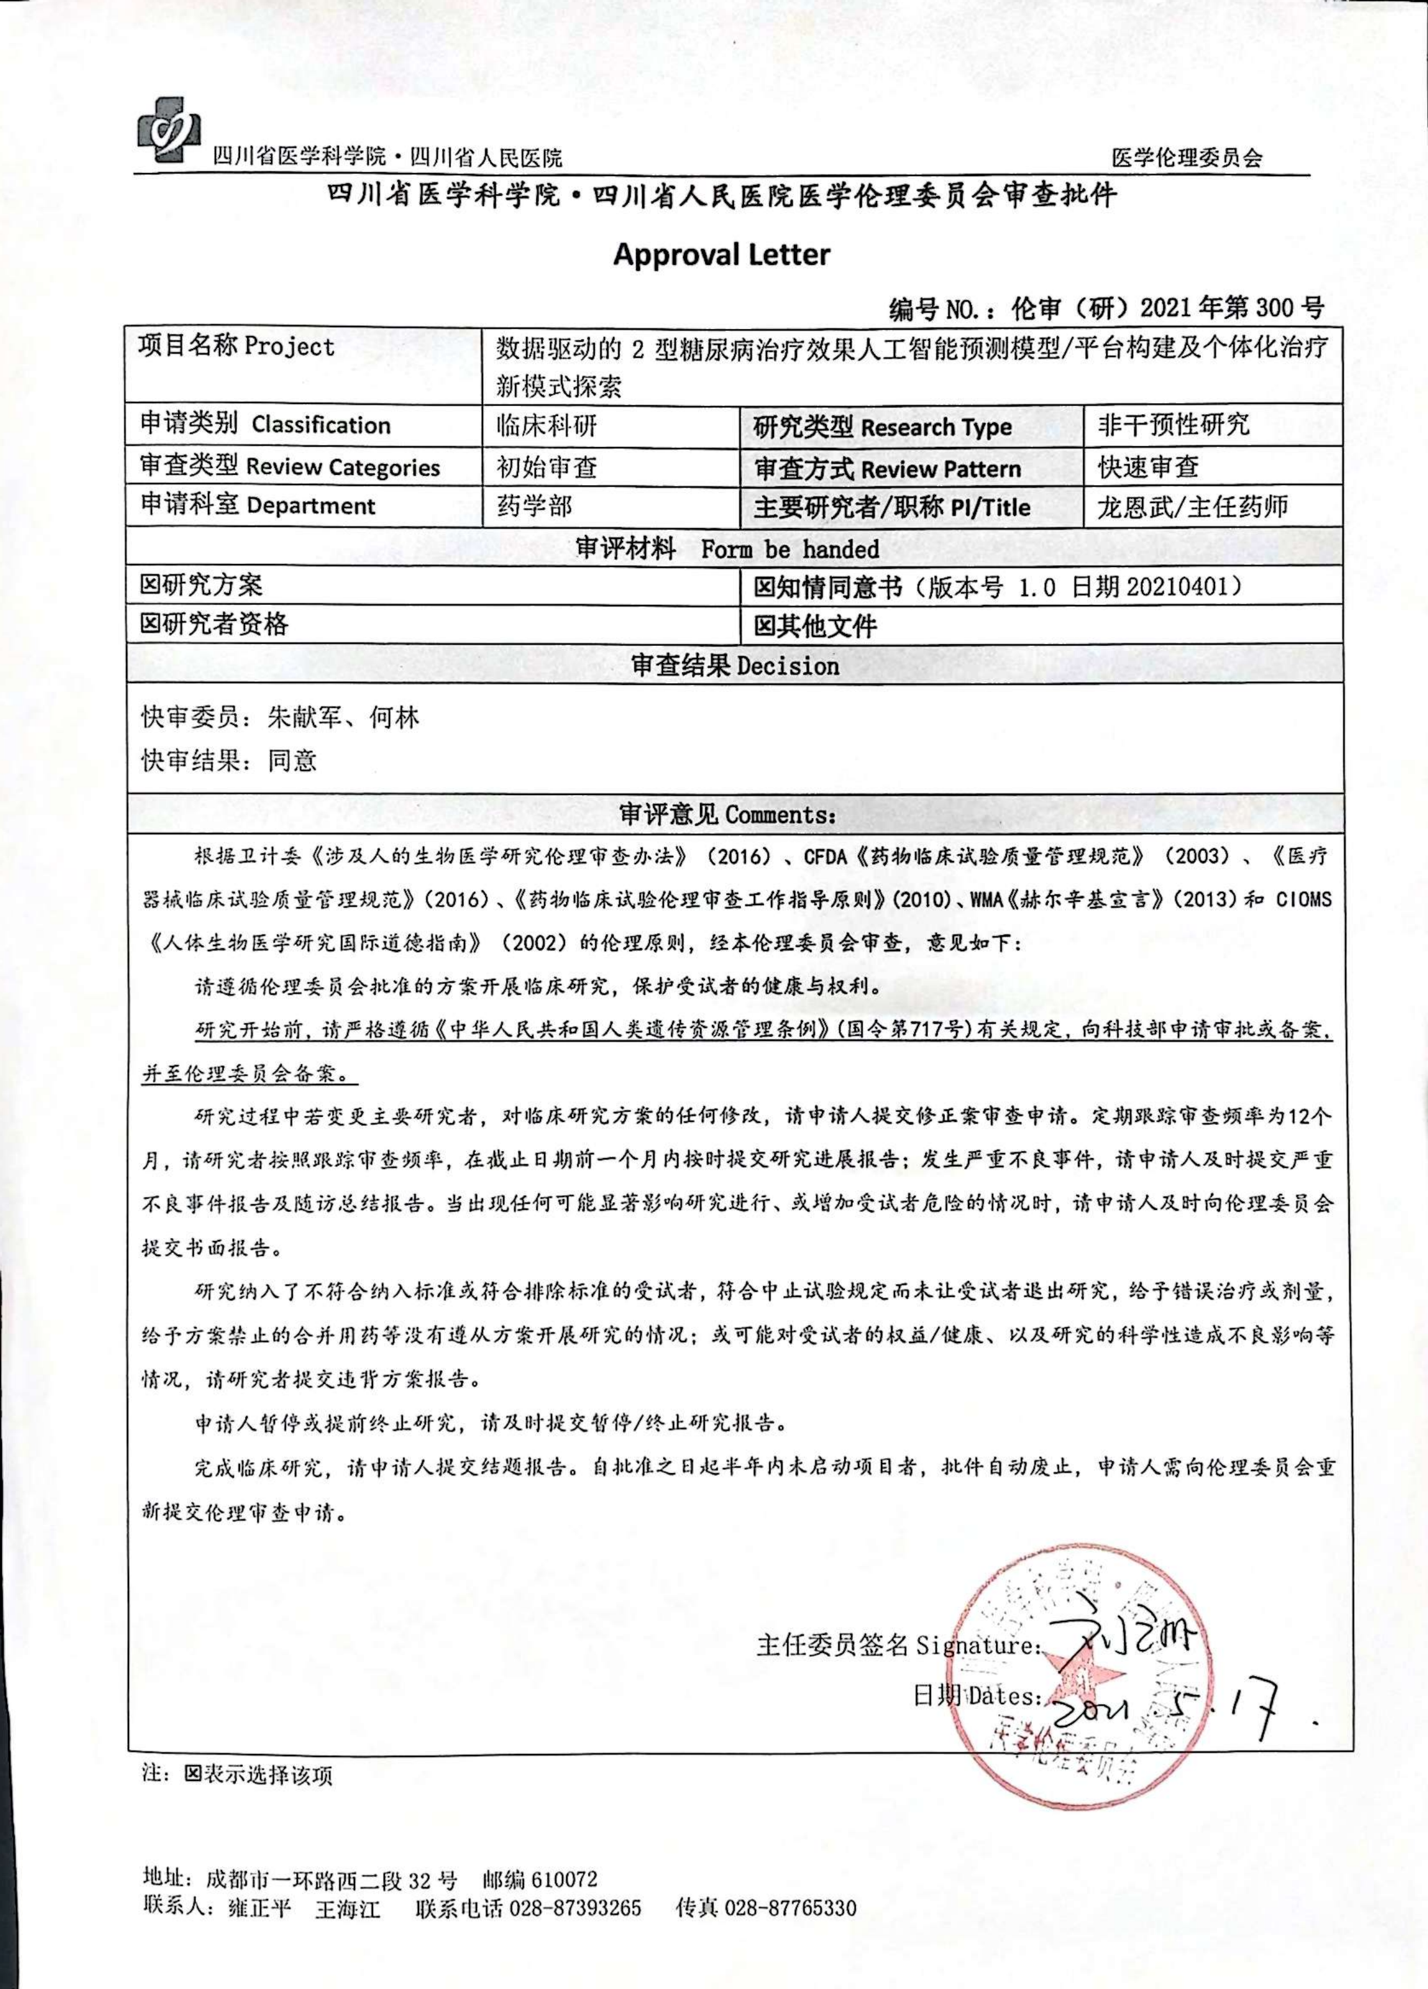
Figure S1. Ethical approval document

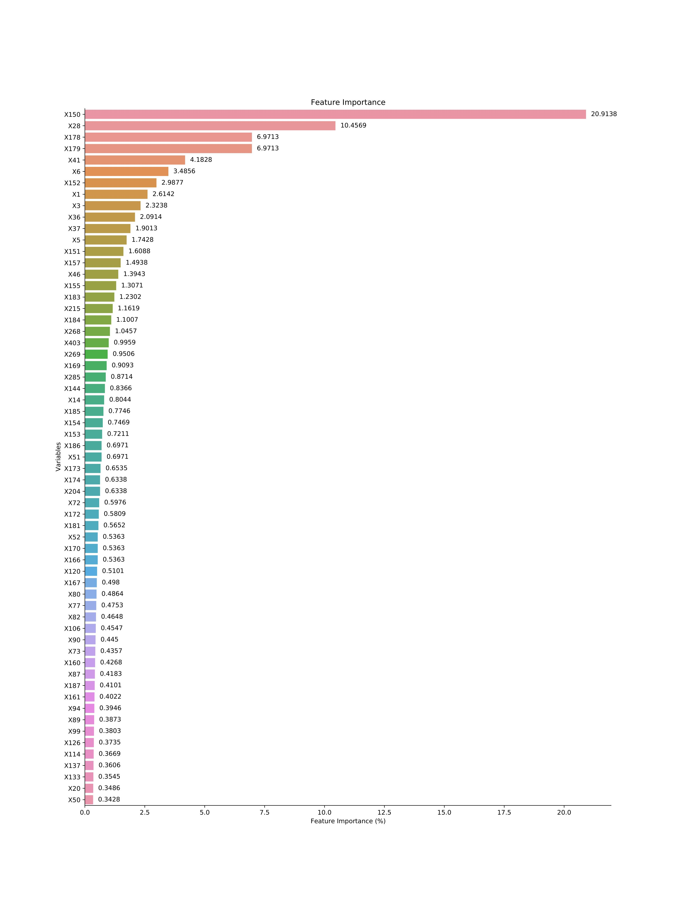

Figure S2.FBG Feature importance bar chart (Imput method:Not;Screening method: Boruta )

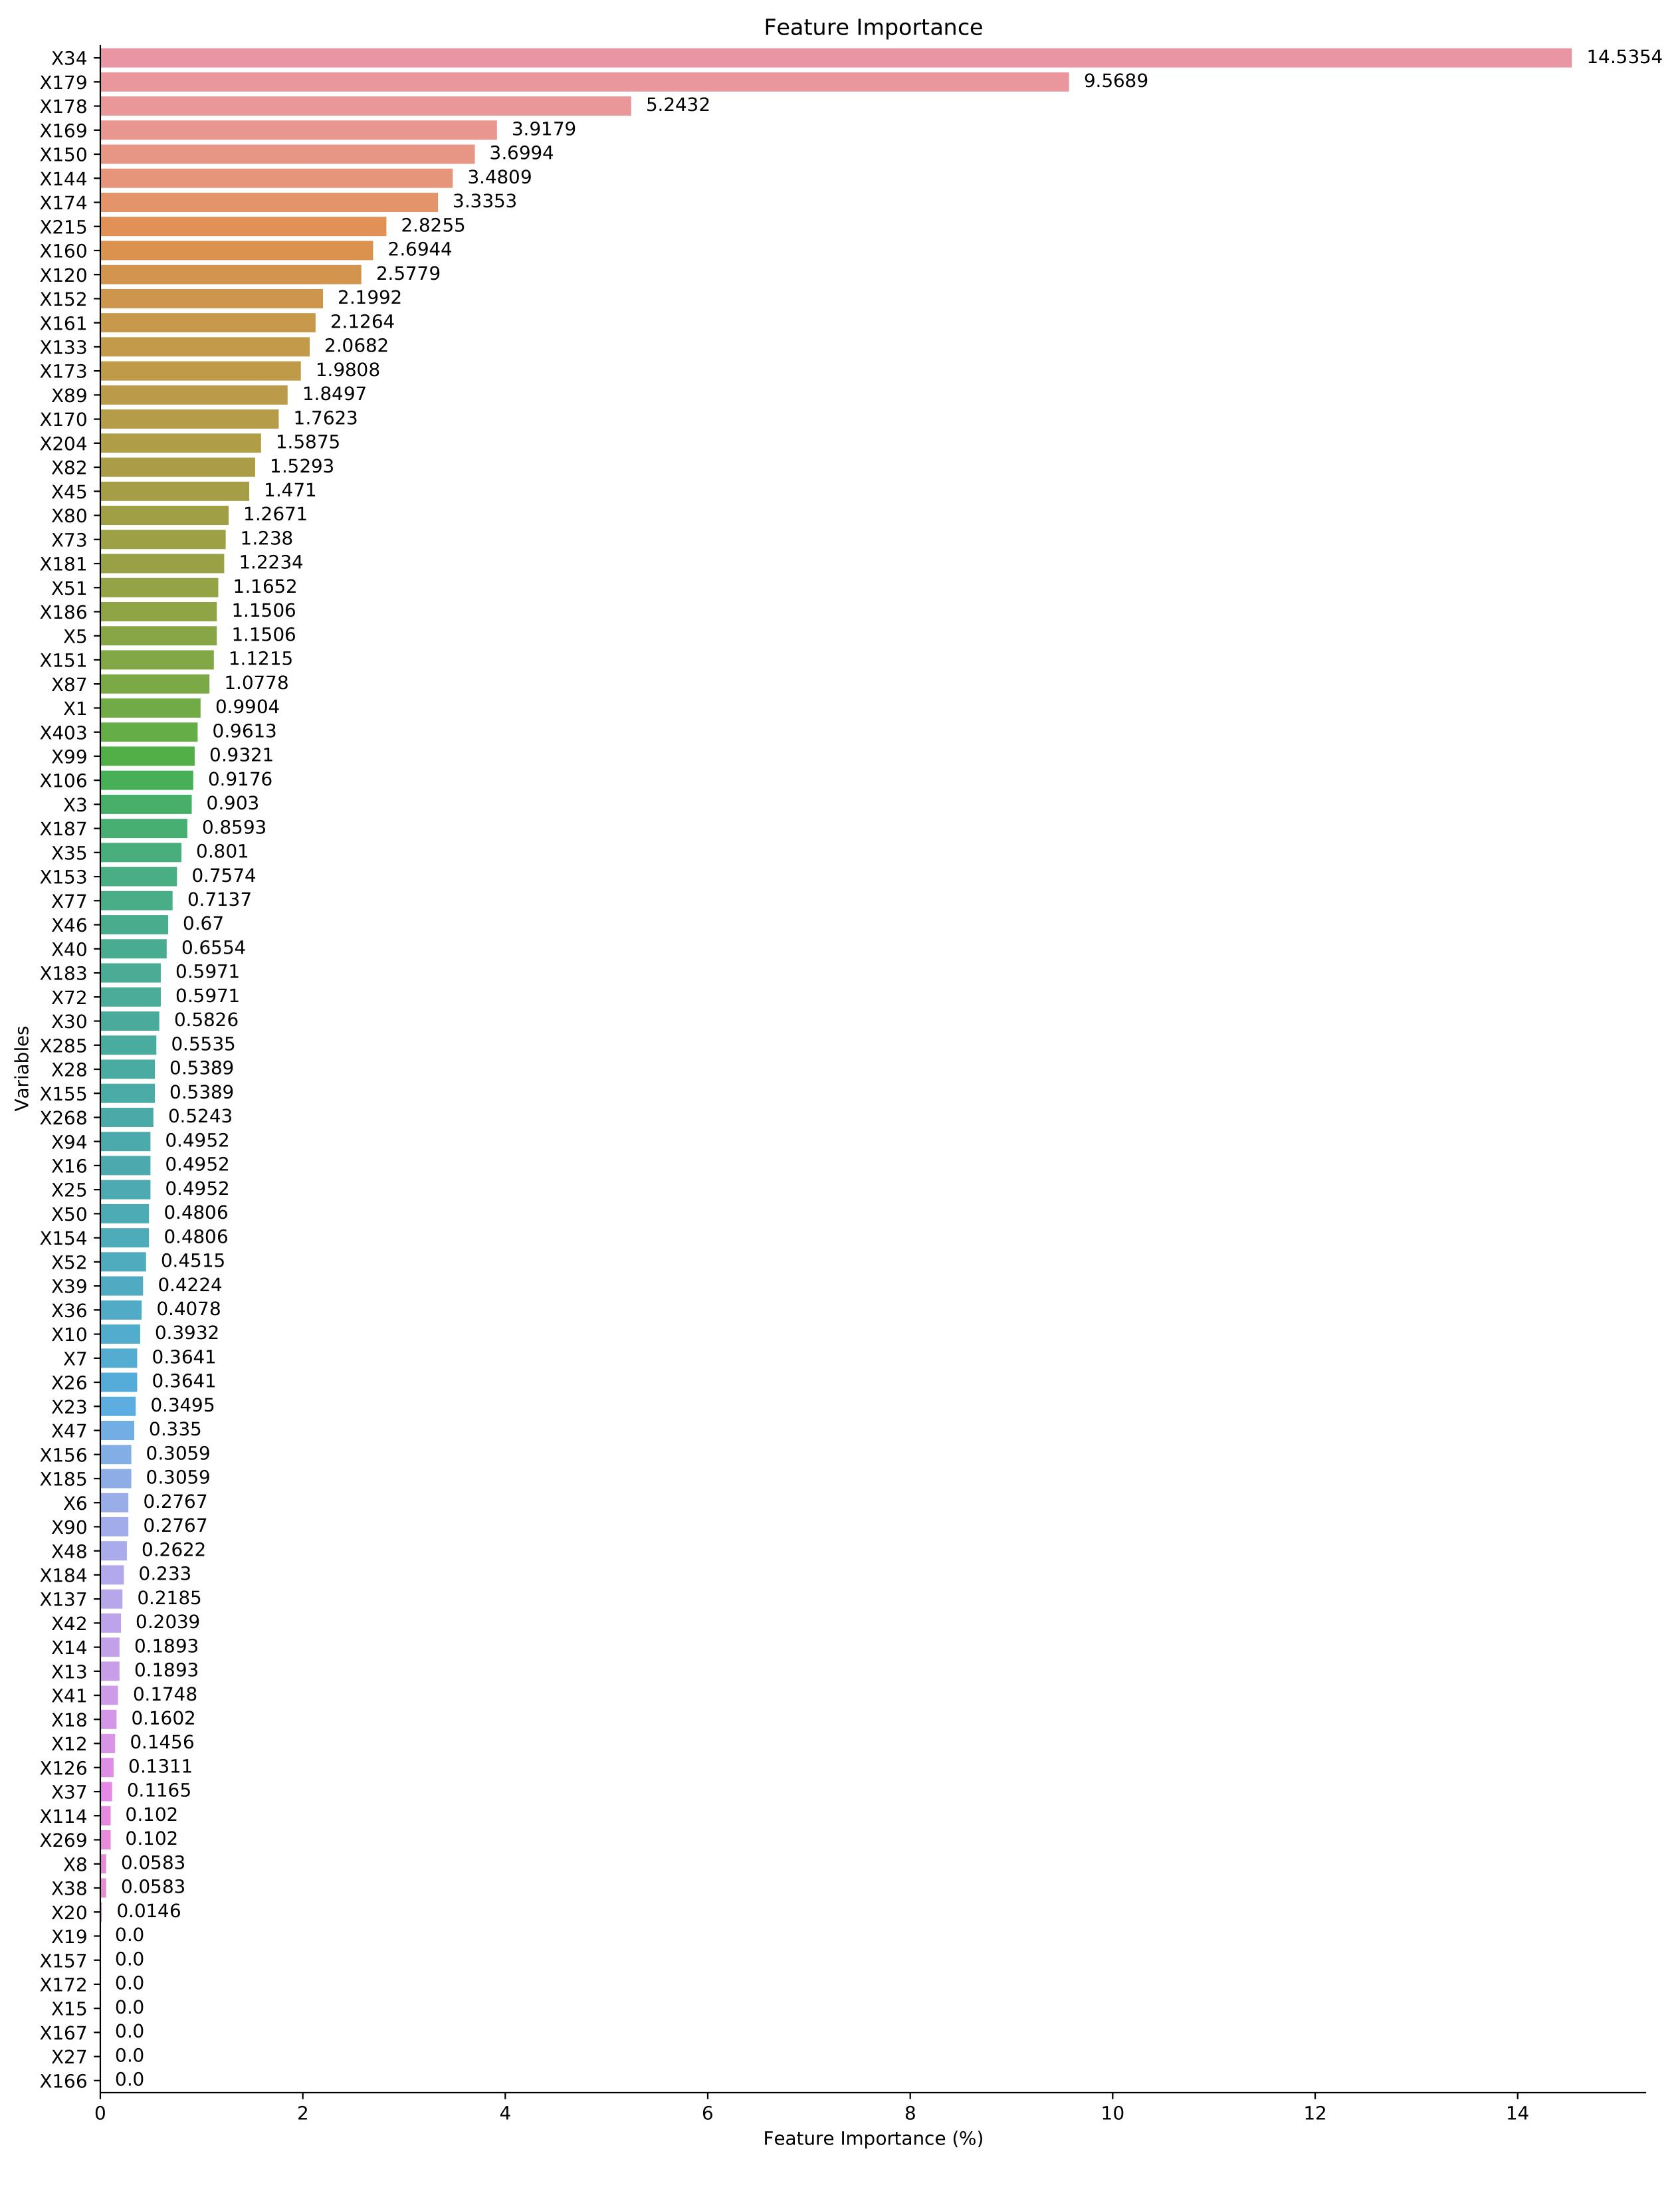

Figure S3.FBG Feature importance bar chart (Imput method:Improved random
forest;Screening method: Lasso)
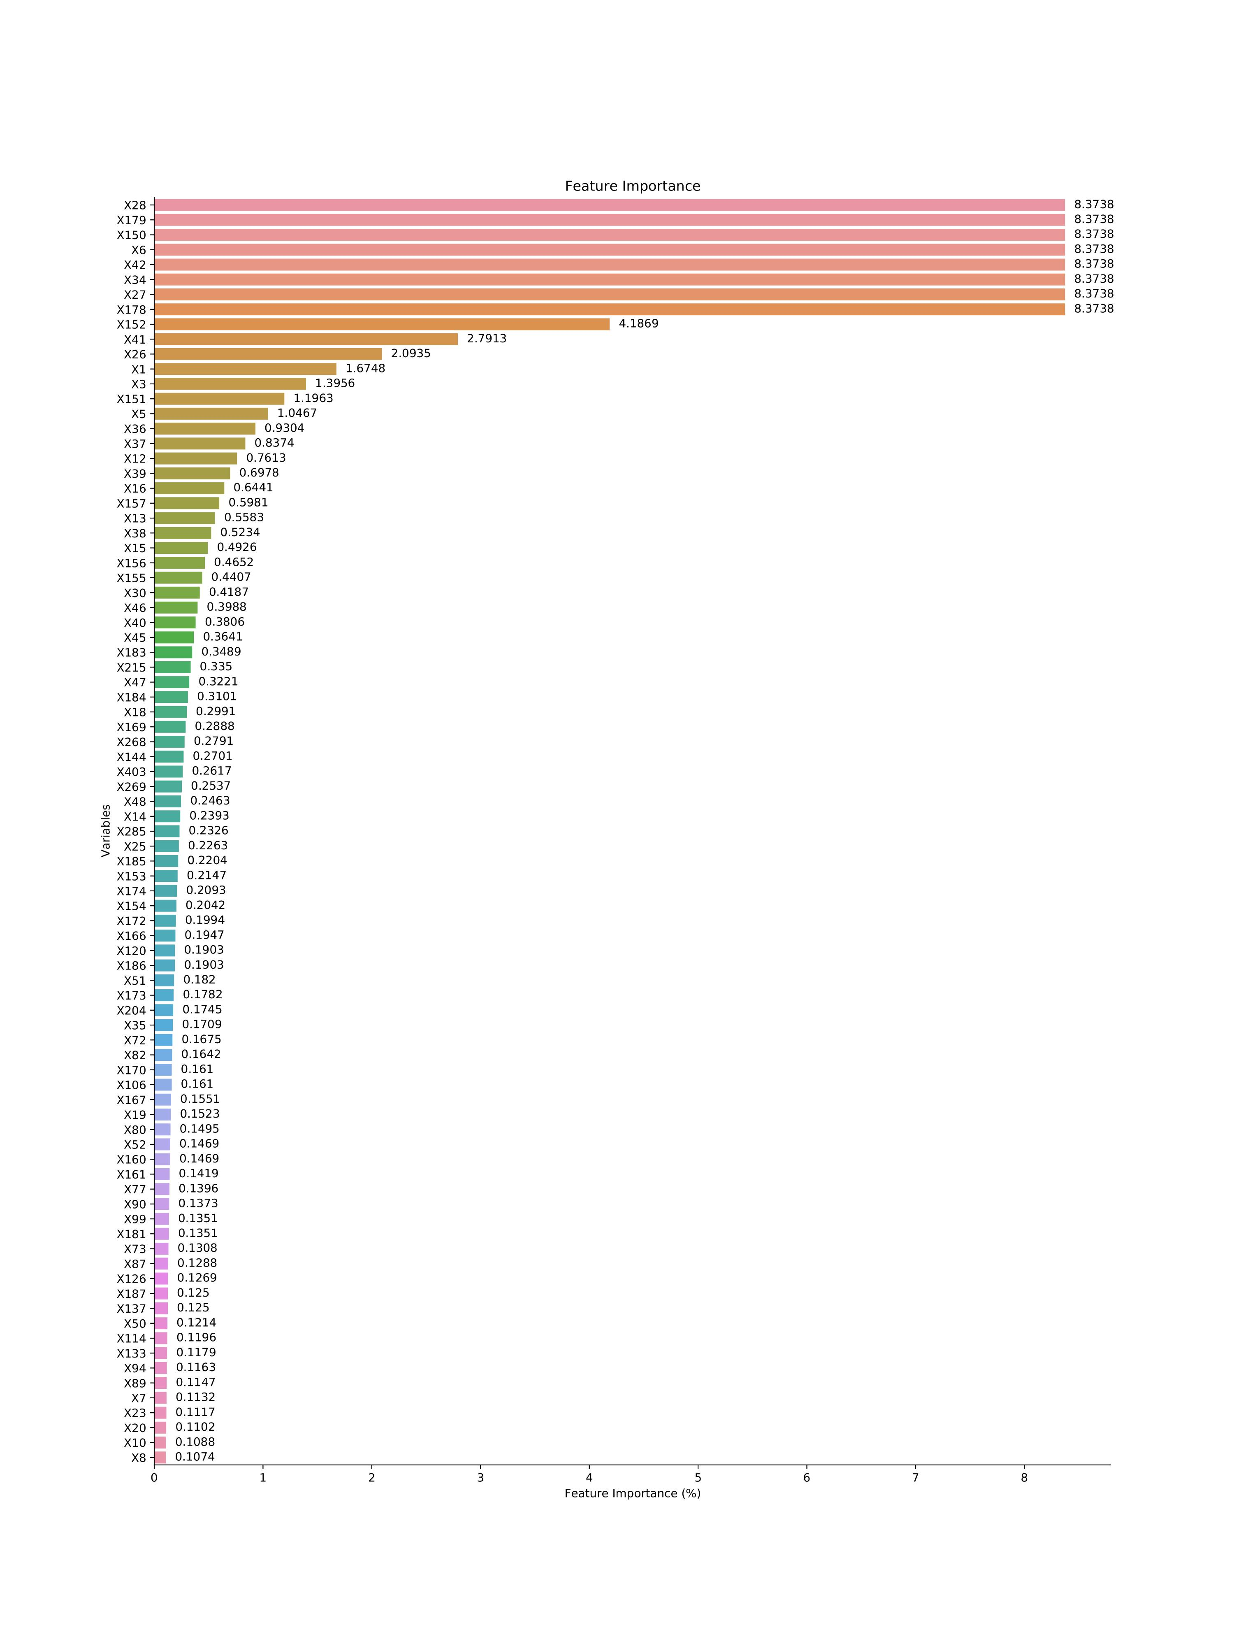
Figure S4.FBG Feature importance bar chart (Imput method:Improved random
forest;Screening method: Boruta)
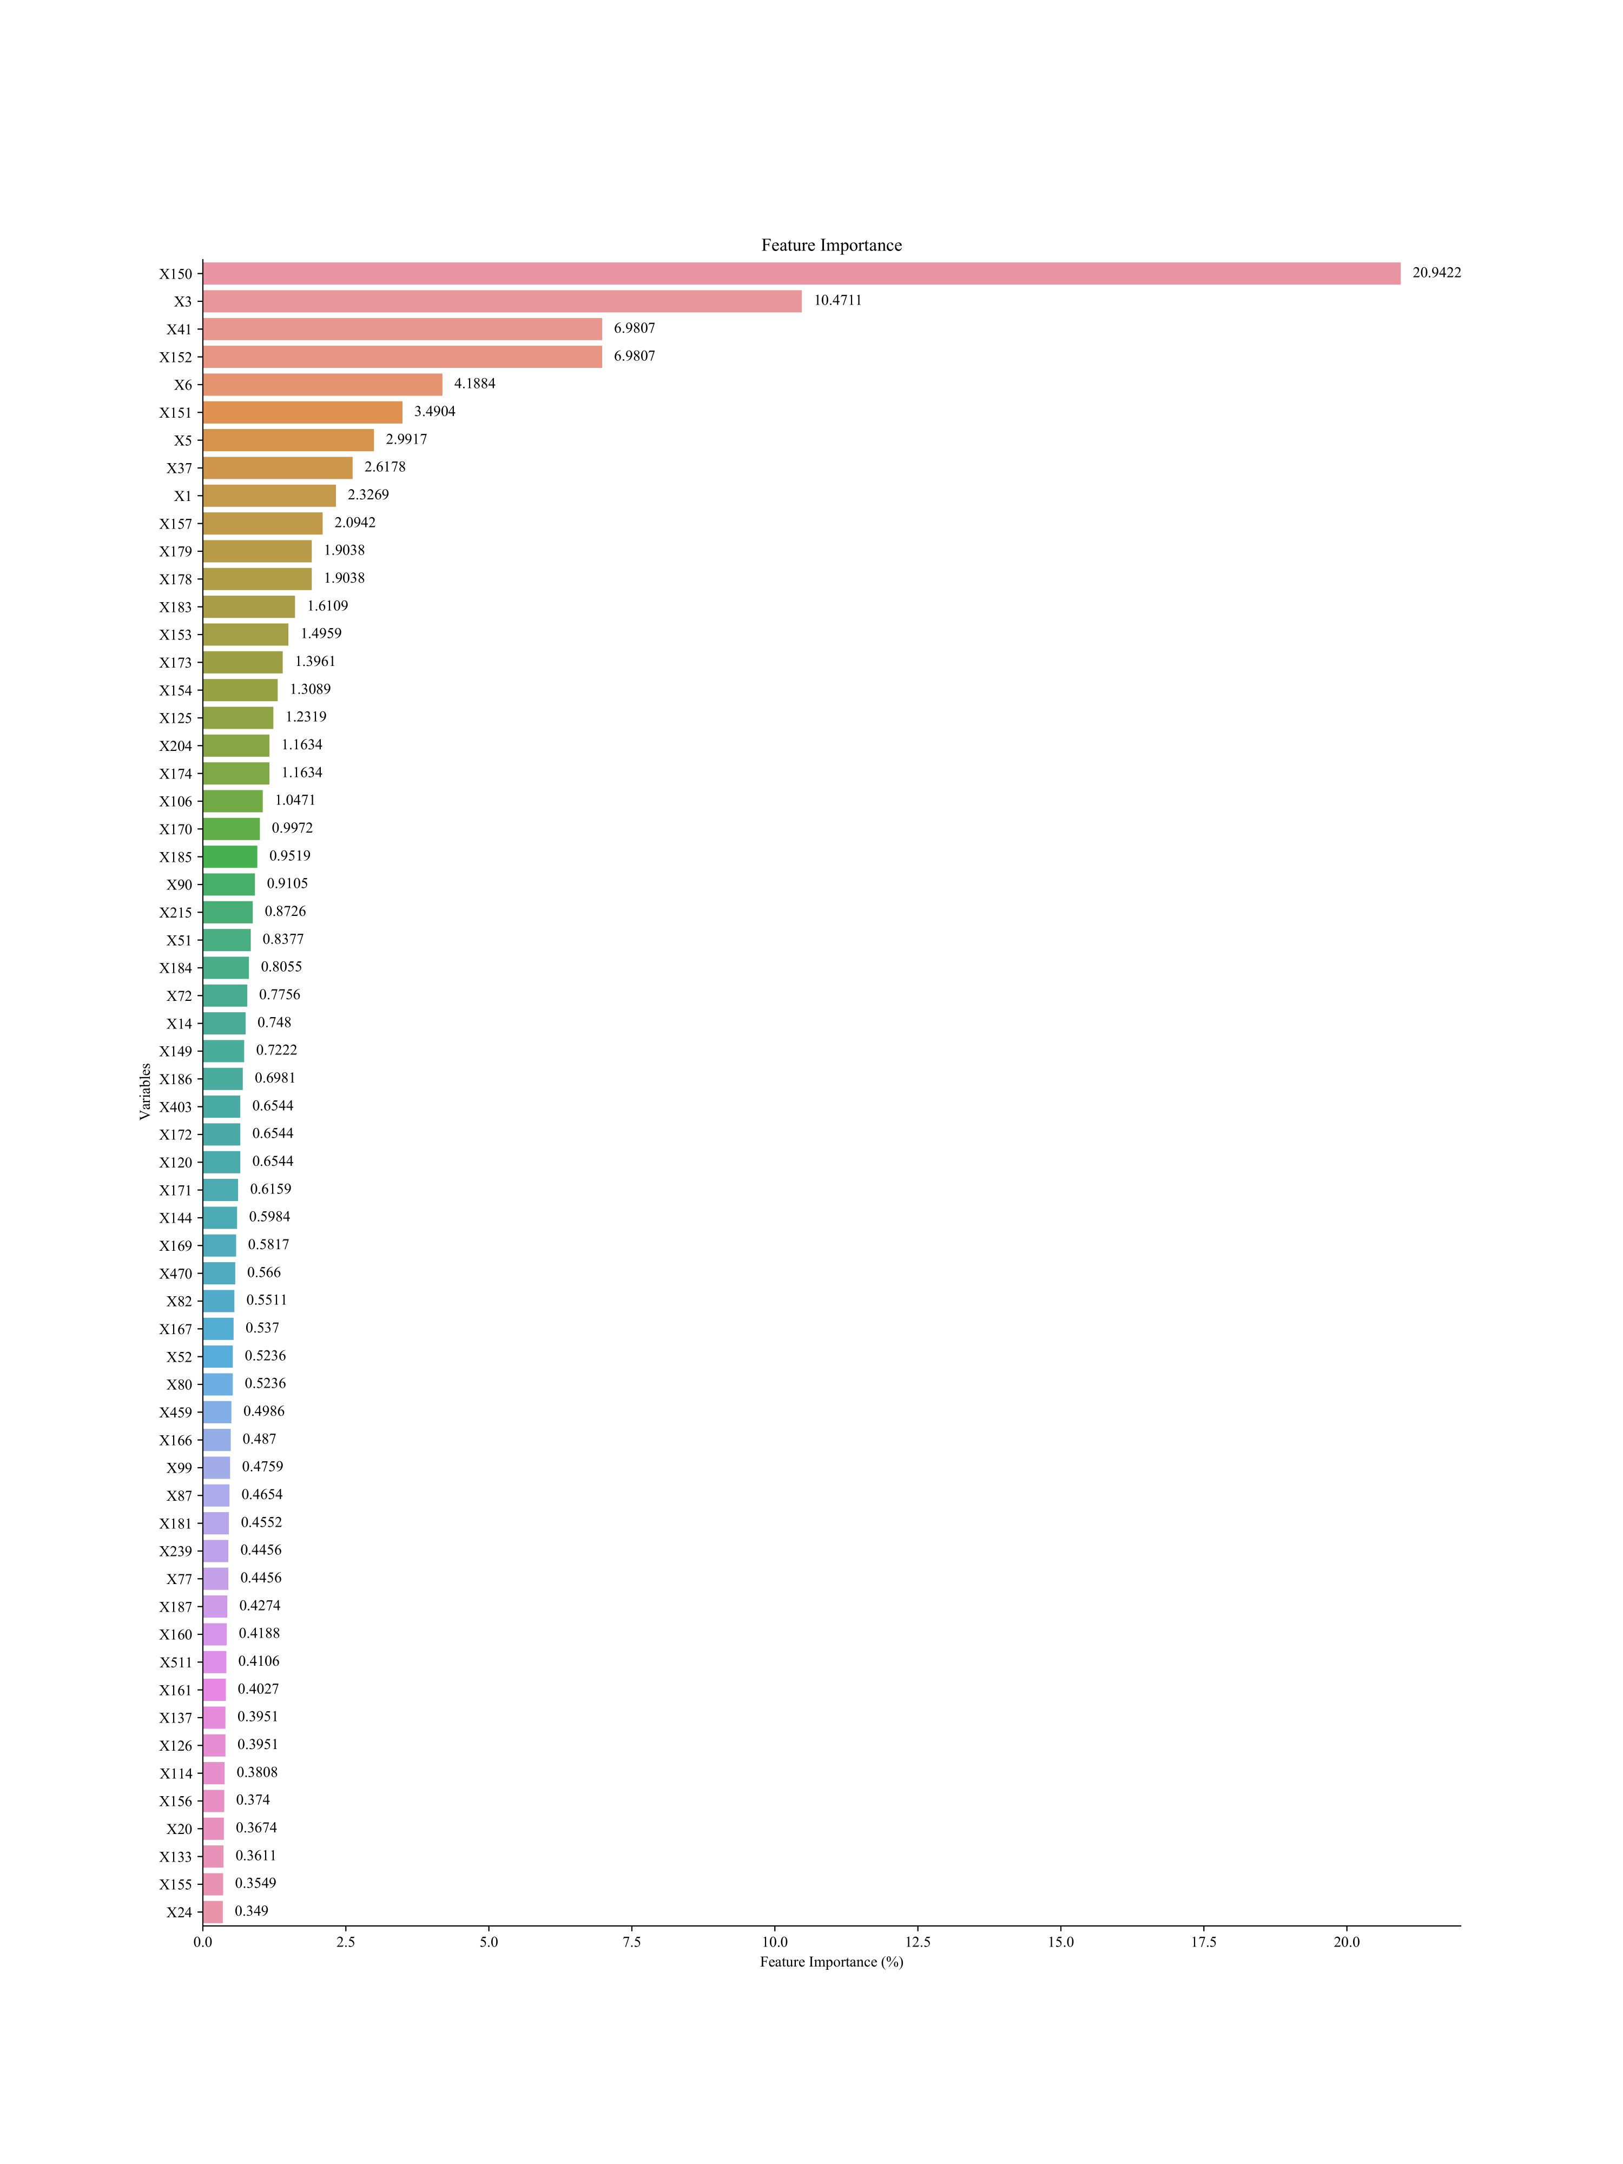
Figure S5.HbA1c Feature importance bar chart (Imput method:Not;Screening method: Boruta )

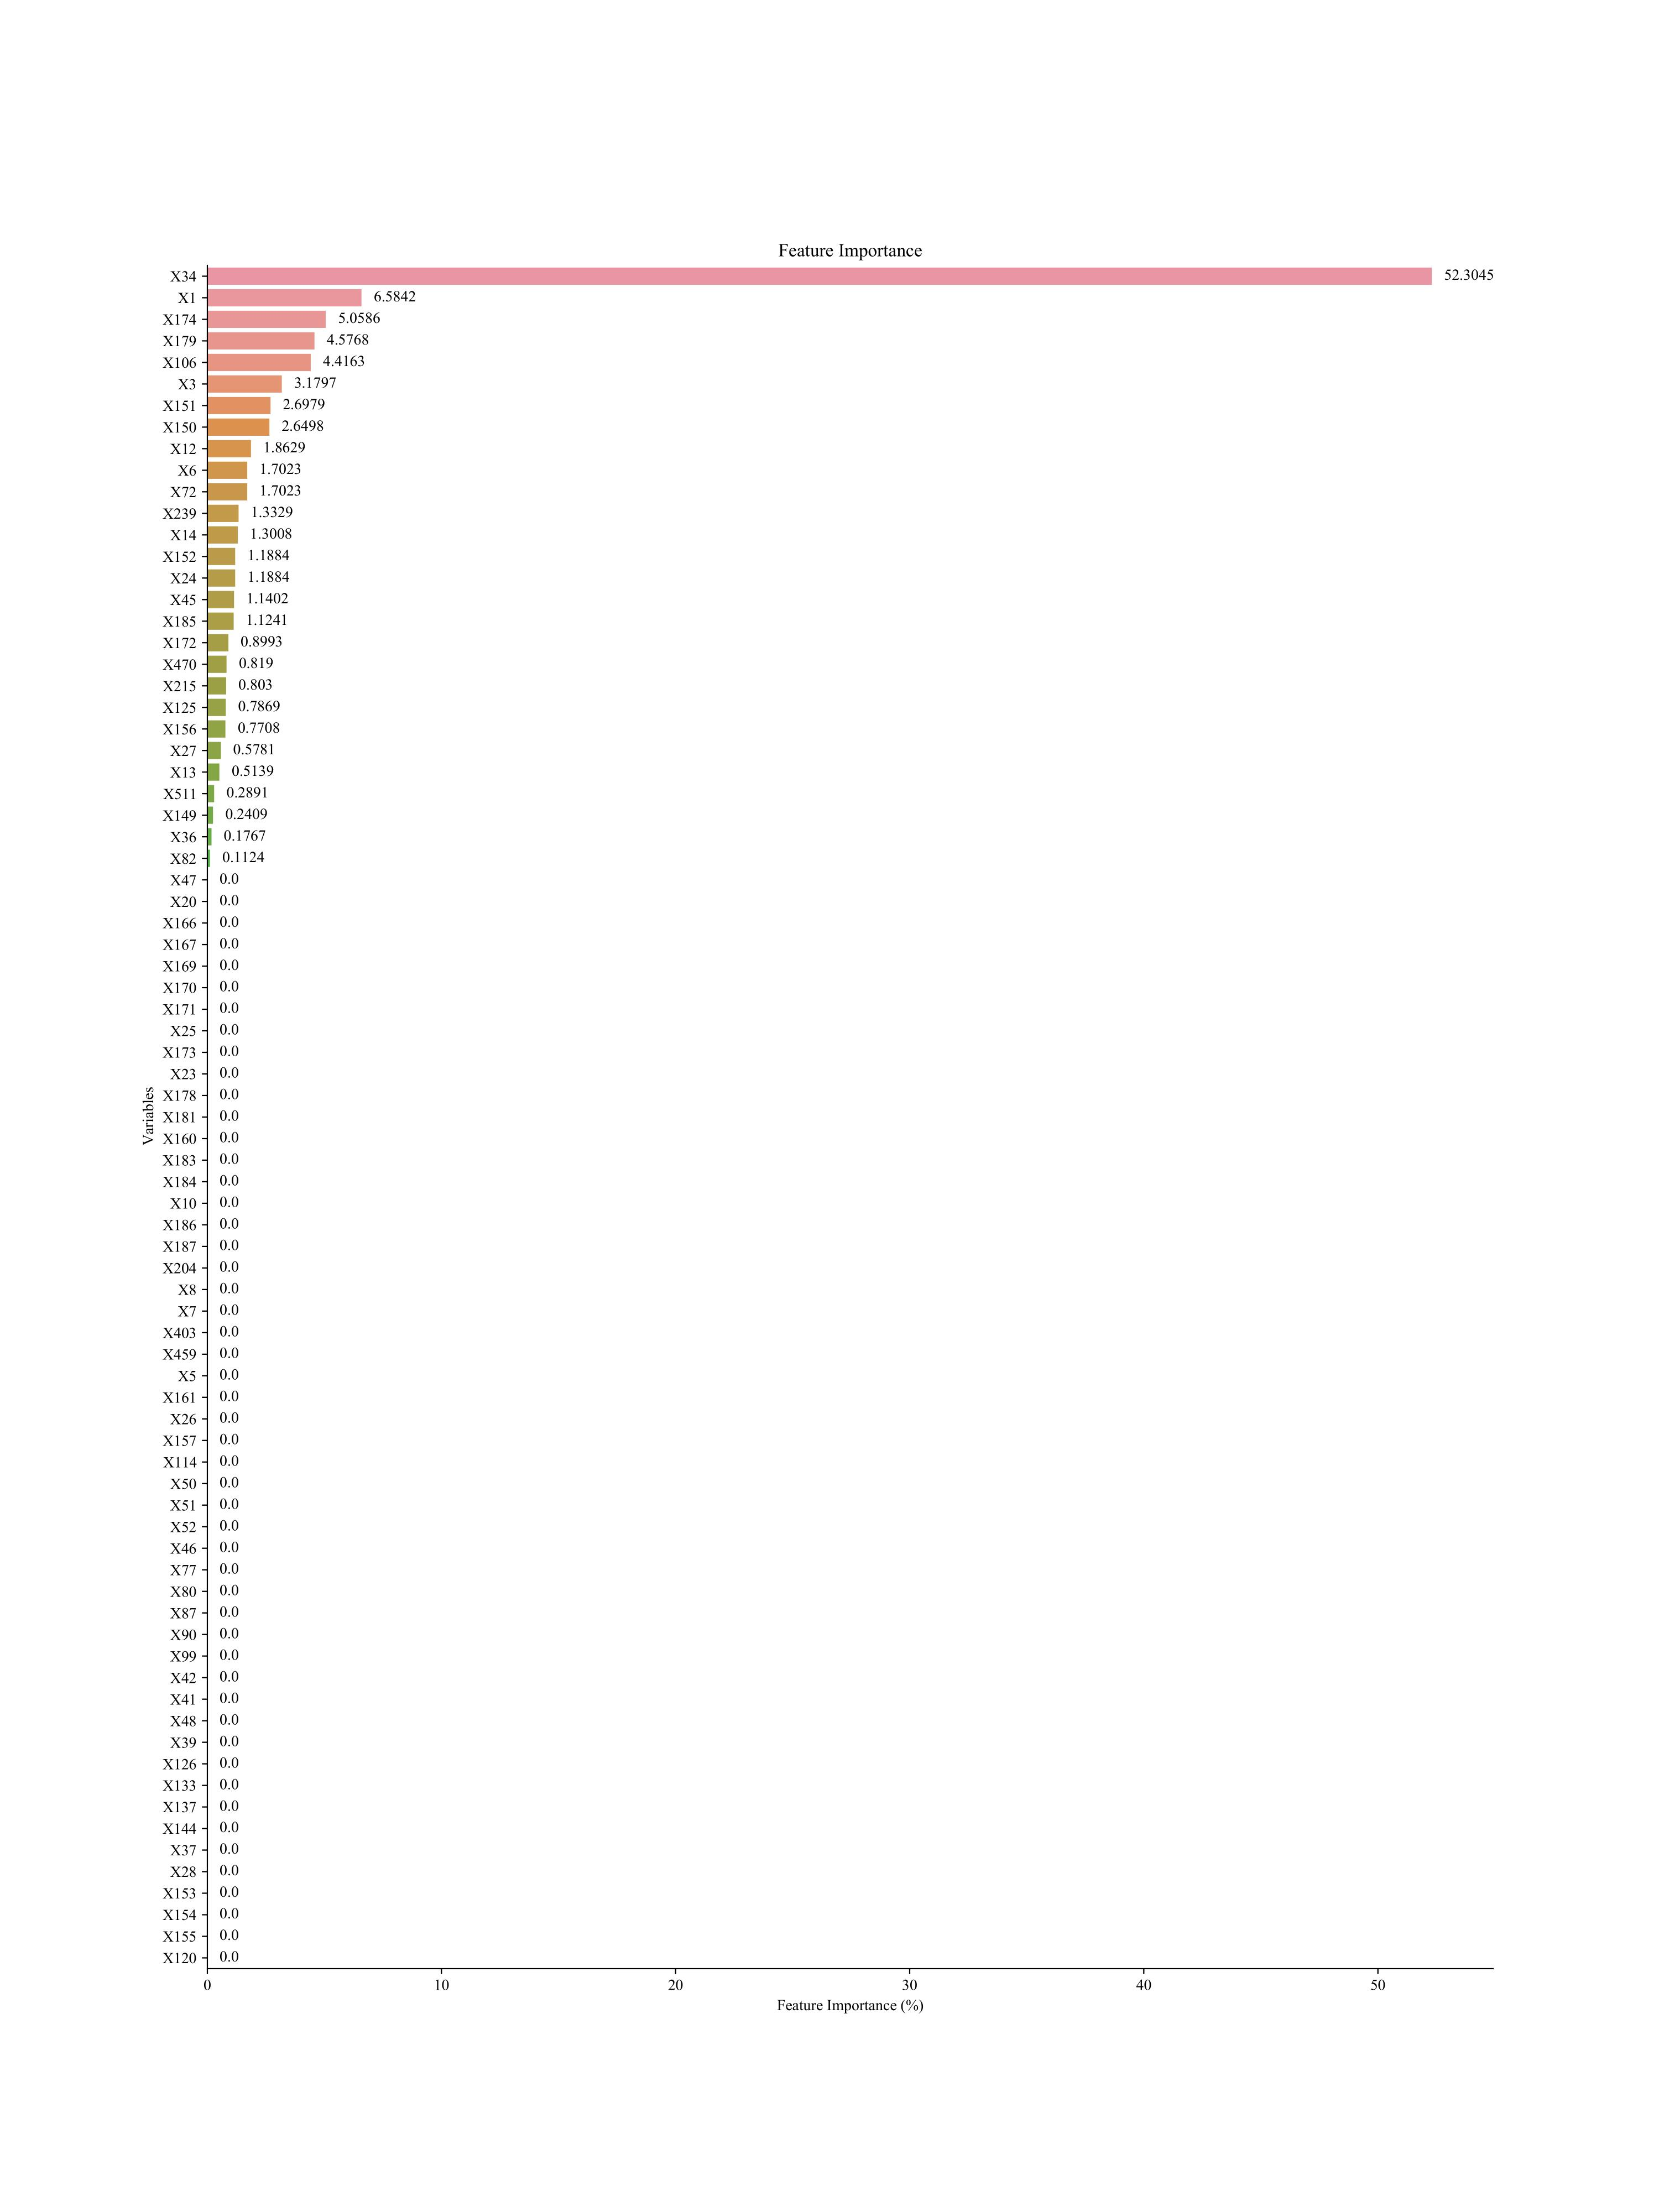
Figure S6.HbA1c Feature importance bar chart (Imput method:Improved random
forest;Screening method: Lasso)

Figure S7.HbA1c Feature importance bar chart (Imput method:Improved random
forest;Screening method: Boruta)

