Supplementary information
Role of actin cytoskeleton in cargo delivery mediated by vertically aligned silicon nanotubes
Yaping Chen^{1,2}*, Hao Zhe Yoh^{1,2,3}, Ali-Reza Shokouhi^{1,2}, Takahide Murayama⁴, Koukou Suu⁴, Yasuhiro Morikawa⁴, Nicolas H. Voelcker^{1,2,3,5,6}*, Roey Elnathan^{1,2,7}*
¹Monash Institute of Pharmaceutical Sciences, Monash University, 381 Royal Parade, Parkville, VIC 3052, Australia
²Melbourne Centre for Nanofabrication, Victorian Node of the Australian National Fabrication Facility, 151 Wellington Road, Clayton, VIC 3168, Australia
³Commonwealth Scientific and Industrial Research Organization (CSIRO), Clayton, VIC 3168, Australia
⁴Institute of Semiconductor and Electronics Technologies, ULVAC Inc., 1220-1 Suyama, Susono, Shizuoka, 410-1231, Japan
⁵Department of Materials Science and Engineering, Monash University, 22 Alliance Lane, Clayton, VIC 3168, Australia.
⁶INM-Leibnitz Institute for New Materials, Campus D2 2, Saarbrücken 66123, Germany
⁷School of Medicine, Faculty of Health, Deakin University, Waurn Ponds, 3216, Australia

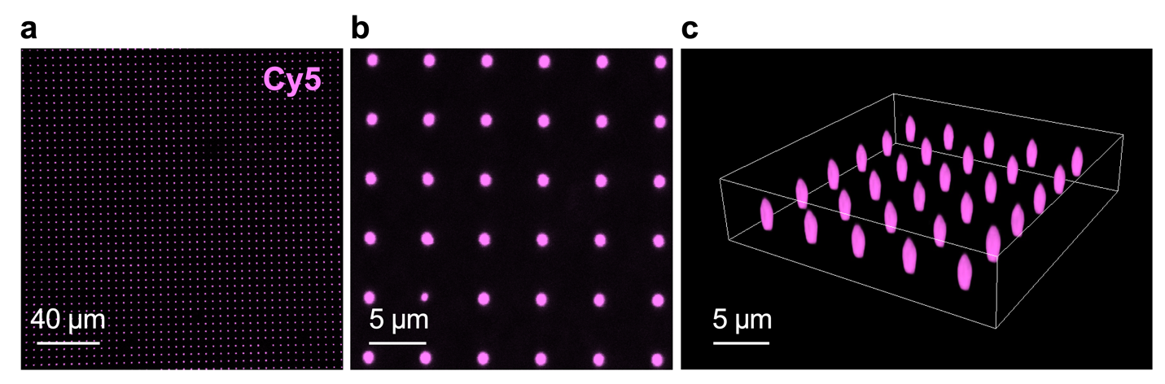
Figure S1: Loading Cy5-mRNA-GFP onto SiNT arrays. Representative confocal microscopy images showing top views, (a) zoom-out and (b) zoom-in, and (c) 3D view of SiNTs loaded with Cy5-mRNA-GFP (magenta).
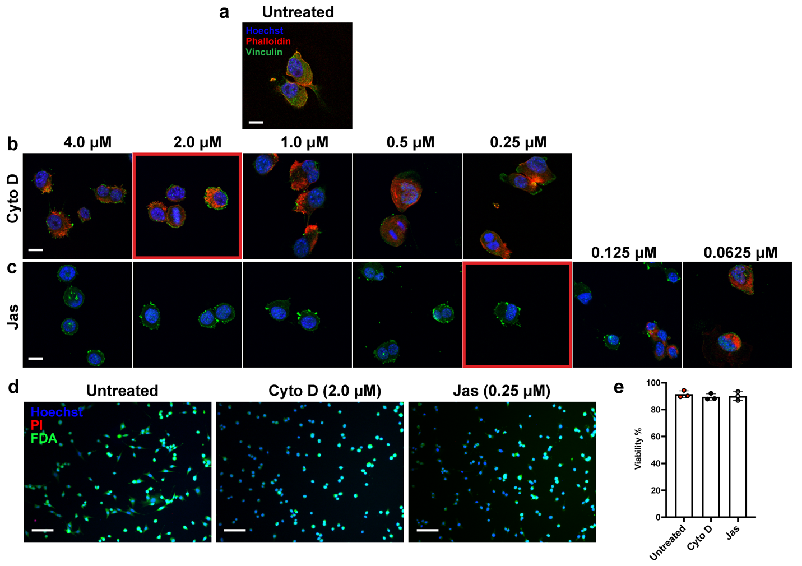
Figure S2: Titration of optimal condition for actin inhibitor treatment. (a–c) Confocal images of (a) untreated cells, and cells treated with (b) Cyto D and (c) Jas at different concentrations from 0.0625 to 4.0 µM. Cells were stained with Hoechst (blue), phalloidin (red), and vinculin (green) for the nucleus, F-actin, and cytoskeletal elements, respectively. Red squares indicate the threshold concentration required to induce sufficient actin inhibition for Cyto D and Jas. Scale bars, 10 µm. (d) Fluorescence images showing live/dead staining by Hoechst (blue), FDA (green, live cells), and PI (red, dead cells) of untreated cells and cells treated with Cyto D (2.0 µM) or Jas (0.25 µM). (e): Quantification of cell viability of the untreated and Cyto D/Jas-treated cells as in d. Scale bars, 100 µm. n =3
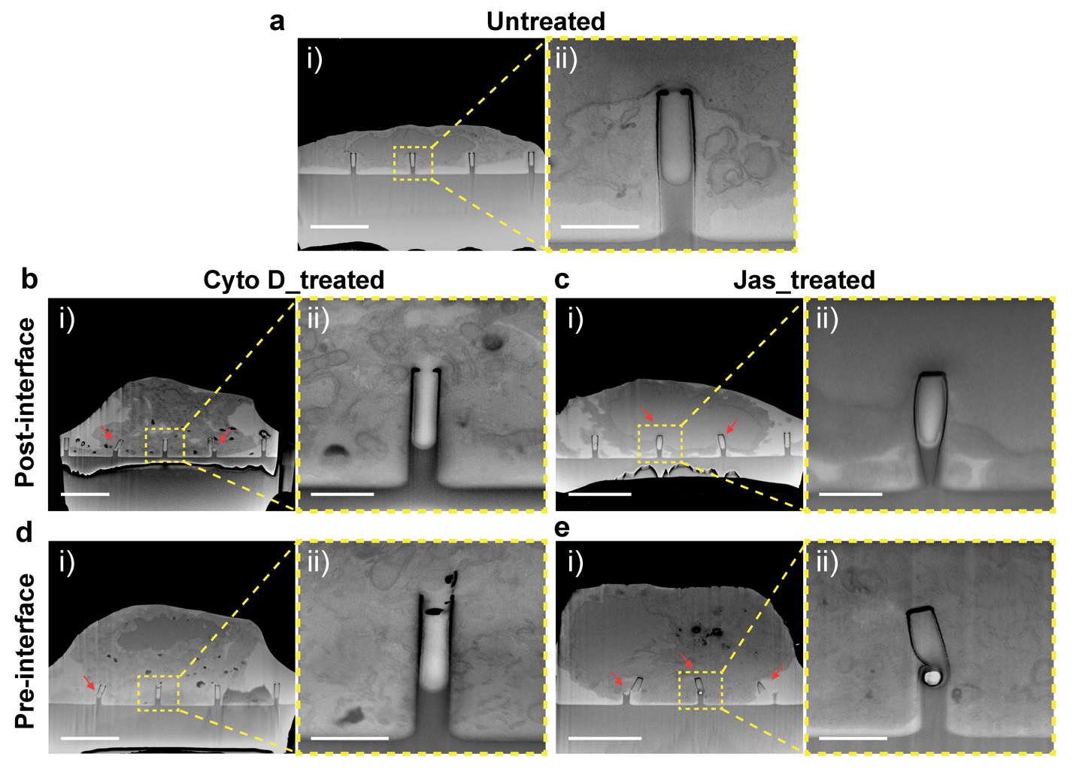
Figure S3: Effects of actin inhibition on cell–SiNT interface. FIB-SEM images of (a) untreated, and (b,d) Cyto D_treated and (c,e) Jas_treated GPE86 cells under pre- or post-interface treatment; (ii) are enlarged views of insets from (i). Red arrows indicate broken SiNTs. Scale bars, (i) 5 µm and (ii) 1 µm.

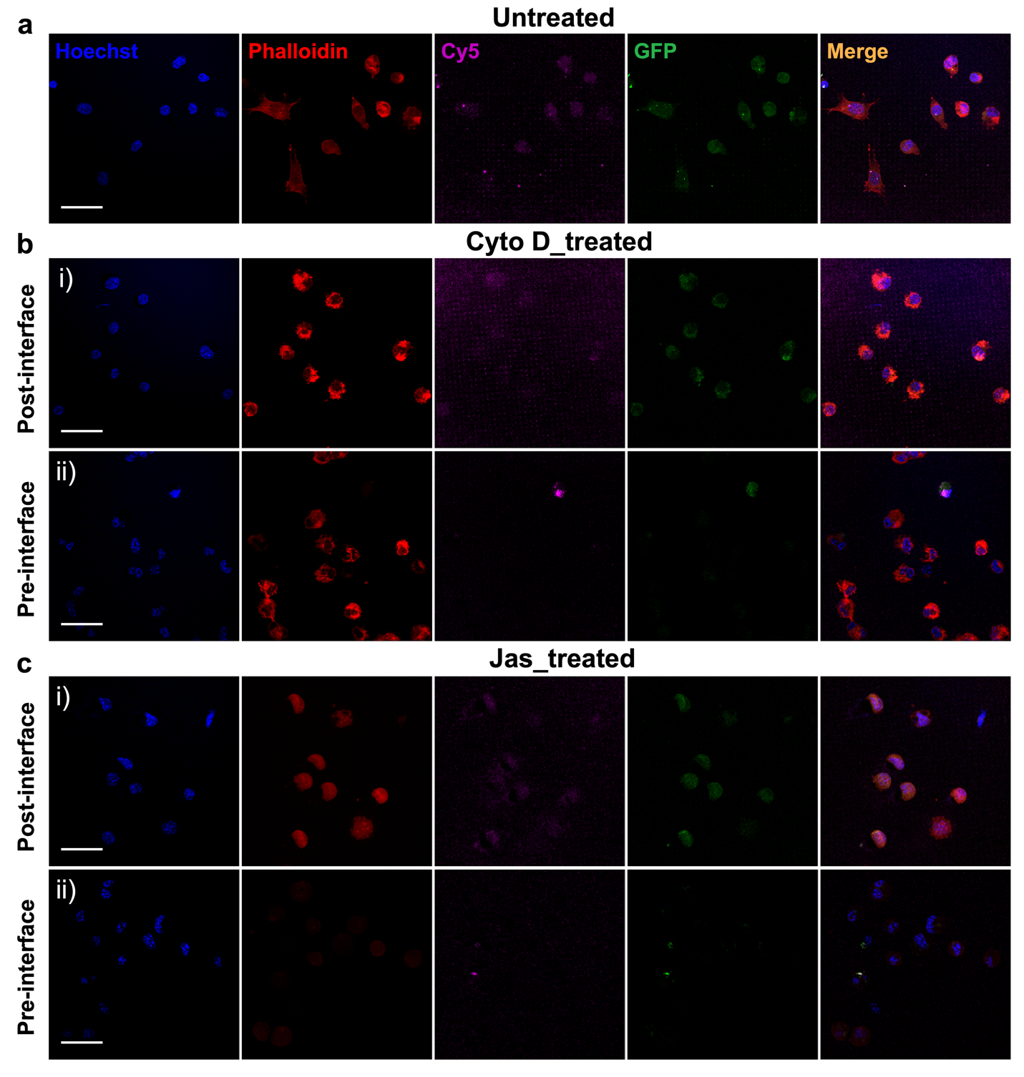
Figure S4: Effects of actin inhibition on SiNT-mediated mRNA delivery. Confocal images of (a) untreated GPE86 cells, and cells with pre- or post-interface treatment of (b) Cyto D or (c) Jas on Cy5 (magenta)-mRNA-GFP (green) loaded SiNTs after 6 h interfacing. Cells were stained with Hoechst (blue) and phalloidin (red) to indicate the nucleus and F-actin, respectively. Scale bars, 20 µm.

