Supplementary Information (SI)

Genome-wide SNPs reveals inbreeding, small populations, and strong genetic isolation in a threatened frog (Litoria littlejohni)
Sarah E. Stock¹, Kaya Klop-, Samantha Wallace¹, Oliver Kelly¹, Alex Callen¹, Rebecca Seeto¹, Stephen Mahony^{1,2}, Matt W. Hayward¹, Michael J. Mahony¹
¹ School of Environmental and Life Sciences, The University of Newcastle, University Drive, Callaghan, 2308, Australia.
²Australian Museum Research Institute, Australian Museum, 1 William Street, Sydney, New South Wales 2010, Australia

Content

Figure S1 Alpha score analysis
Figure S2 Best K Puechmaille method
Figure S3 Survey locations
Figure S4 Genetic Relatedness Matrix Networks
Table S1 Survey Results and sampling design
Table S2 Climatic variables
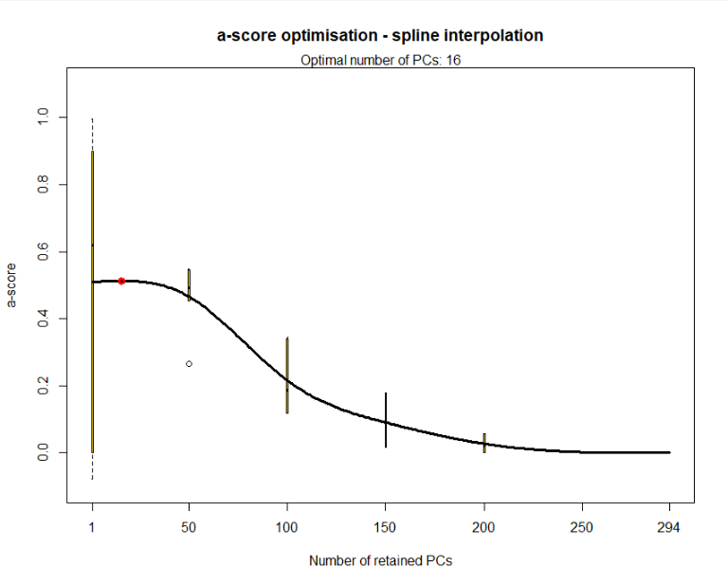
Figure S1Alpha score analysis used to obtain number of PCs to retain. Red circles indicate optimal number of clusters and PCs.

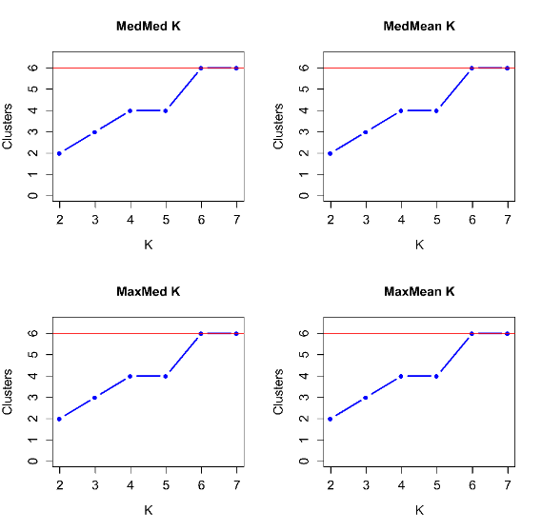
Figure S2 Results of the Puechmaille method for best K for Dataset 1 (outgroup).

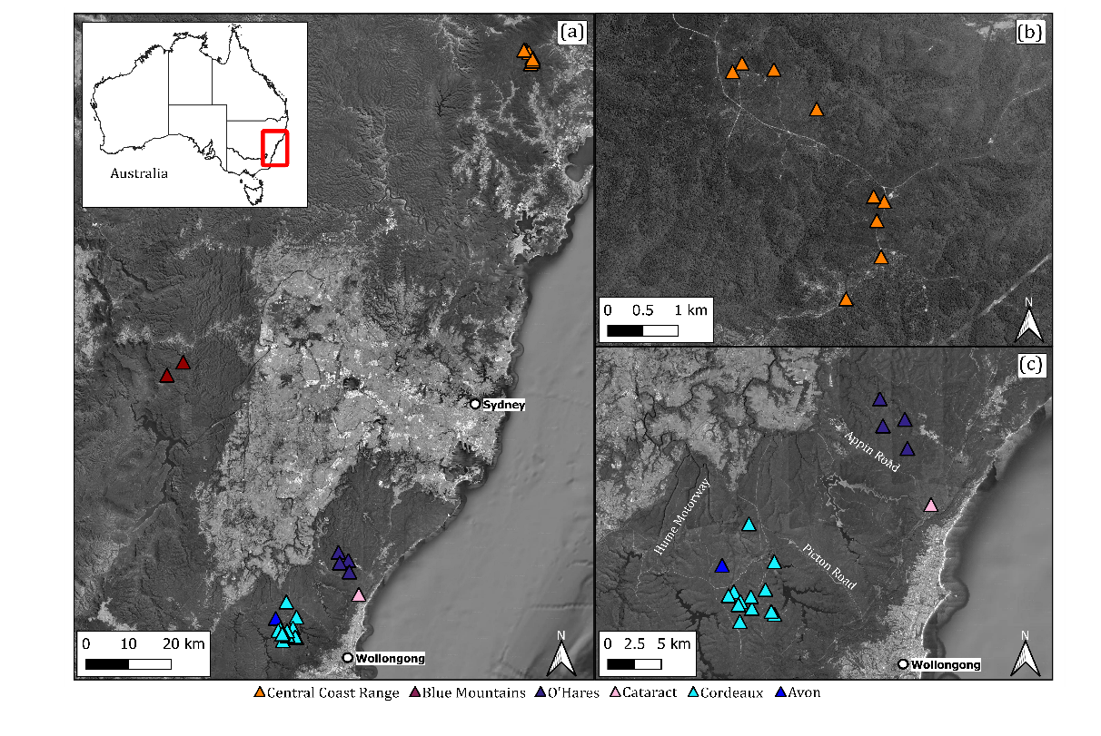
Fig. S3 (a) Map of all sites that were routinely surveyed from 2018 to 2021 for L. littlejohni adults and tadpoles. (b) Zoomed in map of Central Coast Range sites (C) Zoomed in map of Woronora Plateau Sites. Orange: Central Coast range, Red: Blue Mountains, Purple: O’Hares, Pink: Cataract, Light Blue: Cordeaux, Dark Blue: Avon, Yellow: Nepean, Green circles: L. watsoni
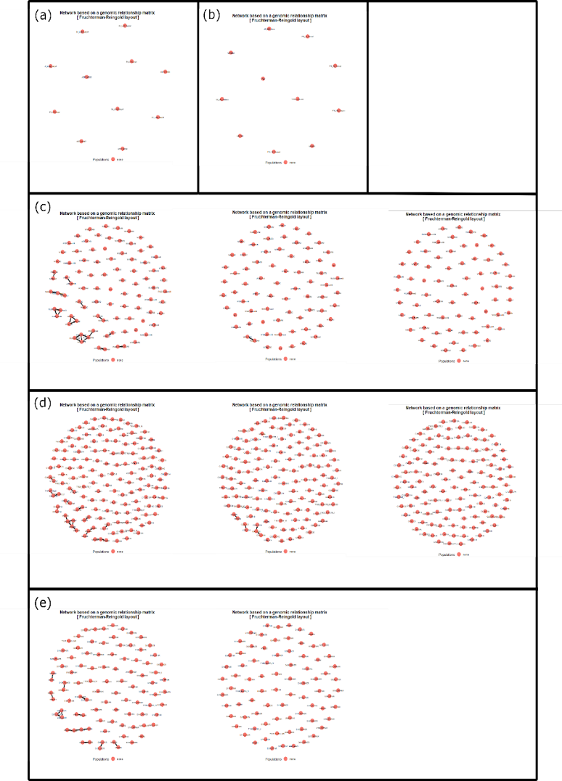
Fig. S4 Genetic Relatedness Matrix Networks (a) Blue Mountains region samples; (b) L. watsoni samples; (c) Central Coast Range iterative GRM Networks after removal of individuals until no links were present; (d) Cordeaux/Avon Catchment iterative GRM Networks after the removal of individuals until no links were present; and (e) O’Hares/Cataract Catchment iterative GRM Networks after the removal of individuals until no links were present.
Table S1 Summary of surveys and sampling of L. littlejohni. Table includes region, site code, and the number of unique frogs caught, unique recaptures, tadpoles’ genetic samples, samples from Mahony et al. (2020) and number of samples post filtering. CCR- Central Coast Range, WP- Woronora Plateau, BM- Blue Mountains.
Region | Site | Frogs | Recaps | Surveys | Tadpoles | Mahony et al (2020) | Samples
BM | IP | 3 | 0 | 8 | 0 | 0 | 2
BM | SW | 0 | 0 | 9 | 5 | 0 | 5
BM | RRR | - | - | 0 | 0 | 4 | 4
BM Total | 3 | 3 | 0 | 17 | 4 | 4 | 10
CCR | ABR | 1 | 0 | 1 | 1 | 0 | 2
CCR | BC | 33 | 8 | 13 | 0 | 0 | 29
CCR | FDAM | 20 | 7 | 12 | 0 | 0 | 13
CCR | LP | 6 | 1 | 7 | 4 | 0 | 9
CCR | MCKN | 3 | 0 | 2 | 0 | 0 | 2
CCR | OTB | 6 | 0 | 2 | 0 | 0 | 3
CCR | PNS | 11 | 0 | 5 | 0 | 0 | 7
CCR | SMB | 7 | 0 | 5 | 0 | 0 | 4
CCR | SM | 1 | 0 | 6 | 0 | 0 | 1
CCR Total | 9 | 81 | 16 | 53 | 0 | 0 | 71
WP - Avon | AR19 | 13 | 1 | 5 | 0 | 0 | 12
WP- Avon | ARTR | - | - | 0 | 0 | 2 | 2
Avon Total | 2 | 13 | 1 | 5 | 0 | 2 | 14
WP-Cataract | LDCR | 18 | 4 | 7 | 0 | 0 | 13
Cataract Total | 1 | 18 | 4 | 7 | 0 | 0 | 13
WP - Cordeaux | CR29 | 5 | 0 | 5 | 1 | 0 | 4
WP - Cordeaux | CR36 | 5 | 0 | 3 | 4 | 0 | 8
WP - Cordeaux | CRTR | - | - | 0 | 0 | 3 | 3
WP - Cordeaux | DC(1) | 9 | 3 | 7 | 0 | 0 | 8
WP - Cordeaux | DC13A | 7 | 0 | 7 | 0 | 0 | 7
WP - Cordeaux | DC13B | 7 | 0 | 7 | 0 | 0 | 6
WP- Cordeaux | DCTR | - | - | 0 | 0 | 3 | 3
WP - Cordeaux | LC5 | 16 | 0 | 4 | 0 | 1 | 16
WP - Cordeaux | SC10C | 7 | 1 | 7 | 0 | 0 | 6
WP - Cordeaux | SC10CTB | 0 | 0 | 7 | 3 | 0 | 3
WP - Cordeaux | WC15 | 7 | 1 | 7 | 0 | 0 | 9
WP - Cordeaux | WC17 | 2 | 0 | 7 | 0 | 0 | 2
WP - Cordeaux | WC20 | 18 | 2 | 5 | 0 | 0 | 17
WP - Cordeaux | WC21A | 11 | 0 | 7 | 0 | 0 | 14
WP - Cordeaux | WC21B | 4 | 0 | 4 | 0 | 0 | 4
Cordeaux Total | 15 | 98 | 7 | 77 | 8 | 7 | 109
WP-Nepean | DUCR | - | 0 | - | - | 1 | 1
Nepean Total | 1 | - | 0 | - | - | 1 | 1
WP - O’Hares | FT10R | 26 | 0 | 8 | 0 | 0 | 25
WP - O’Hares | Illuka | 6 | 0 | 9 | 4 | 0 | 9
WP - O’Hares | OHTR | - | - | 0 | 0 | 1 | 1
WP-O’Hares | POWER | 30 | 3 | 9 | 0 | 3 | 26
WP-O’Hares | STTR | - | - | 0 | 0 | 3 | 3
WP-O’Hares | WRIV | - | - | 0 | 0 | 3 | 3
O’ Hares Total | 6 | 62 | 3 | 26 | 4 | 10 | 67
LW- Outgroup |  | - | - | - | - | 4 | 10
Total |  | 265 | 31 | 185 | 16 | 26 | 295

Table S2 Climatic Variables identified as significantly associated with genetic variation using forward selection with RDA. Yellow cells indicate variables retained for partial RDA.
Environmental Variables | R2 | Cum R2 | AIC | F | p-value
Bio23 Radiation seasonality | 0.117 | 0.117 | 1492.6 | 38.71 | 0.002**
Bio14 Precipitation of Driest Month | 0.020 | 0.137 | 1487.1 | 7.51 | 0.002**
Bio06 Min Temperature of Coldest Month | 0.012 | 0.149 | 1484.0 | 5.08 | 0.002**
Bio04 Temperature Seasonality | 0.016 | 0.165 | 1479.7 | 6.28 | 0.002**
Bio26 Radiation warmest of quarter | 0.006 | 0.171 | 1478.5 | 3.18 | 0.002**
Bio07 Temperature Annual Range | 0.006 | 0.177 | 1477.3 | 3.08 | 0.002**
Bio12 Annual Precipitation | 0.005 | 0.182 | 1476.6 | 2.66 | 0.002**
Elevation | 0.003 | 0.185 | 1476.4 | 2.16 | 0.002**
Bio16 Precipitation of Wettest Quarter | 0.003 | 0.188 | 1476.4 | 1.88 | 0.002**
Bio19 Precipitation of Coldest Quarter | 0.003 | 0.191 | 1476.5 | 1.90 | 0.002**
Bio17 Precipitation of Driest Quarter | 0.002 | 0.193 | 1476.6 | 1.76 | 0.002**
Bio01 Annual Mean Temperature | 0.002 | 0.195 | 1476.9 | 1.62 | 0.002**
Bio05 Max Temperature of Warmest Month | 0.002 | 0.196 | 1477.3 | 1.59 | 0.002**
Bio08 Mean Temperature of Wettest Quarter | 0.001 | 0.198 | 1477.7 | 1.47 | 0.002**
Bio09 Mean Temperature of Driest Quarter | 0.002 | 0.200 | 1478 | 1.67 | 0.002**
Bio11 Mean Temperature of Coldest Quarter | 0.002 | 0.202 | 1478.3 | 1.57 | 0.002**
Bio02 Mean Diurnal Range | 0.002 | 0.203 | 1478.7 | 1.54 | 0.002**
Bio15 Precipitation Seasonality | 0.001 | 0.204 | 1479.2 | 1.37 | 0.002**
Bio20 Annual Mean Radiation | 0.001 | 0.205 | 1479.8 | 1.32 | 0.002**
Bio13 Precipitation of Wettest Month | 0.001 | 0.207 | 1480.2 | 1.45 | 0.002**
Bio03 Isothermality | 0.001 | 0.207 | 1480.8 | 1.25 | 0.004**
Bio18 Precipitation of Warmest Quarter | 0.001 | 0.208 | 1481.5 | 1.22 | 0.008**
^{**p<0.01}

