Appendix.1 Questionnaires
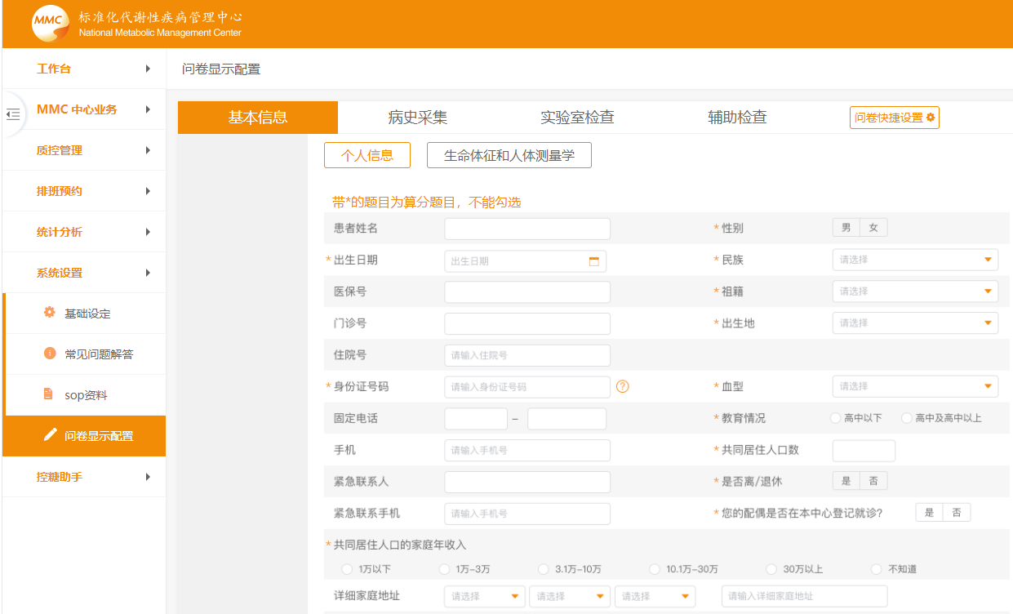

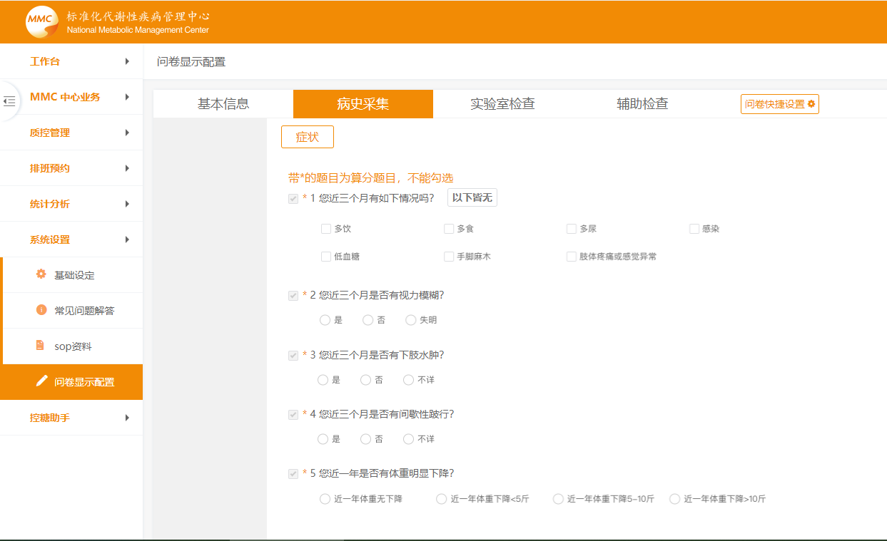

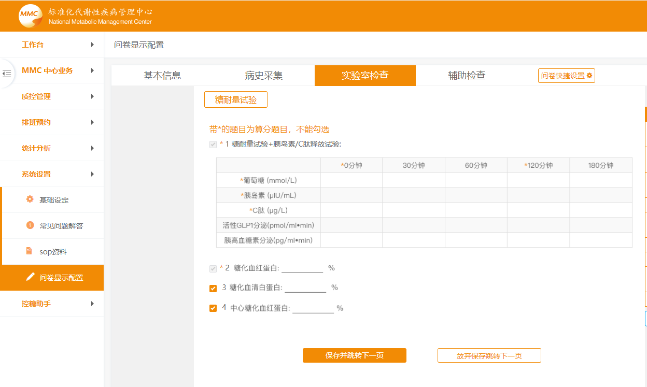

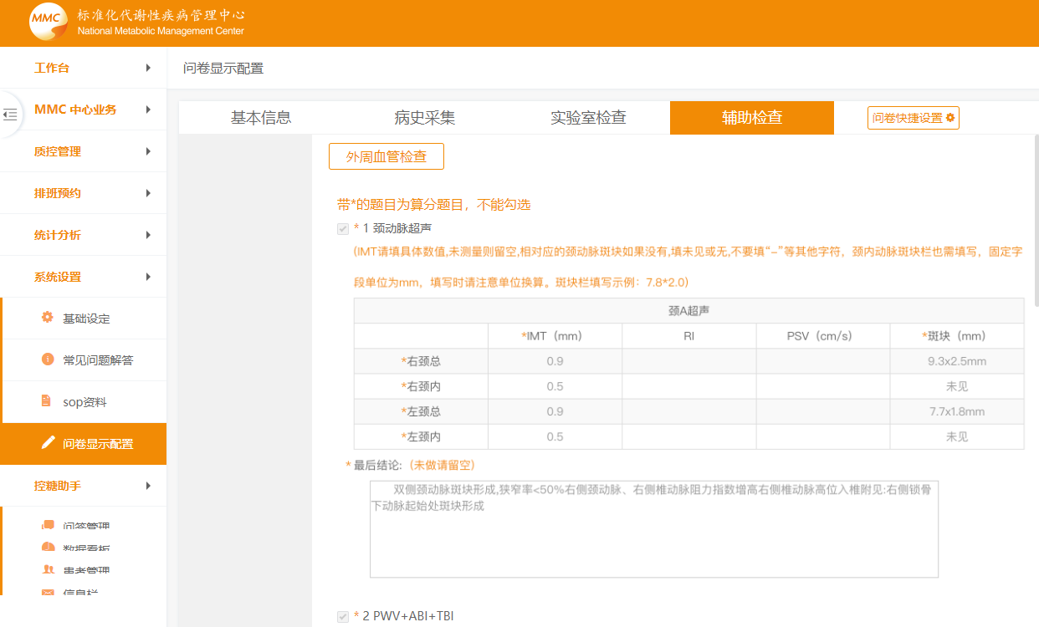

Appendix.2 Interview guideline

Perceived susceptibility and severity
Could you please talk about your perceptions of your poor blood glucose control?
Perceived benefits
What do you think about lifestyle management?
What do you think about medication therapy?
What do you think about blood glucose monitoring?
Perceived barriers
How is your lifestyle management practice?
How is your medication therapy engagement?
How is your blood glucose monitoring conducted?

