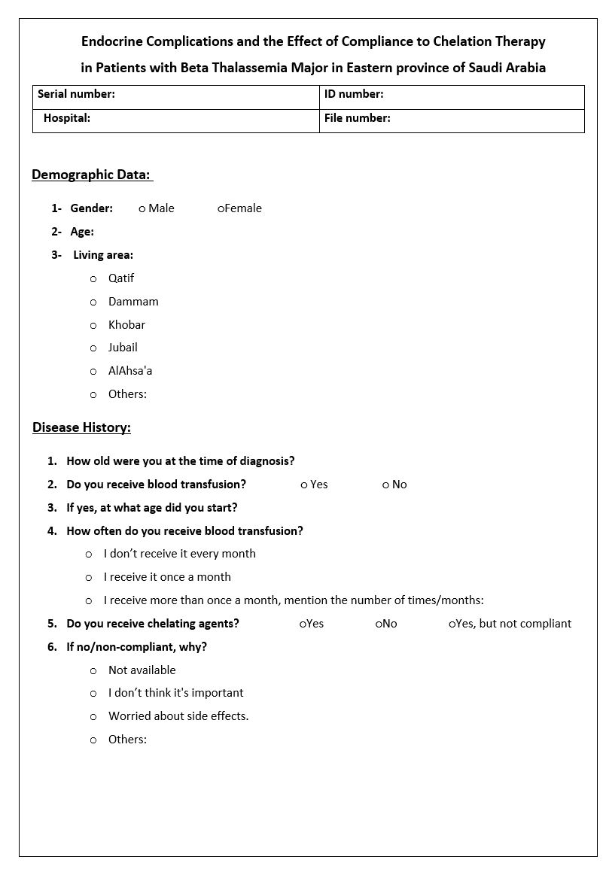
Appendix
Appendix (1)
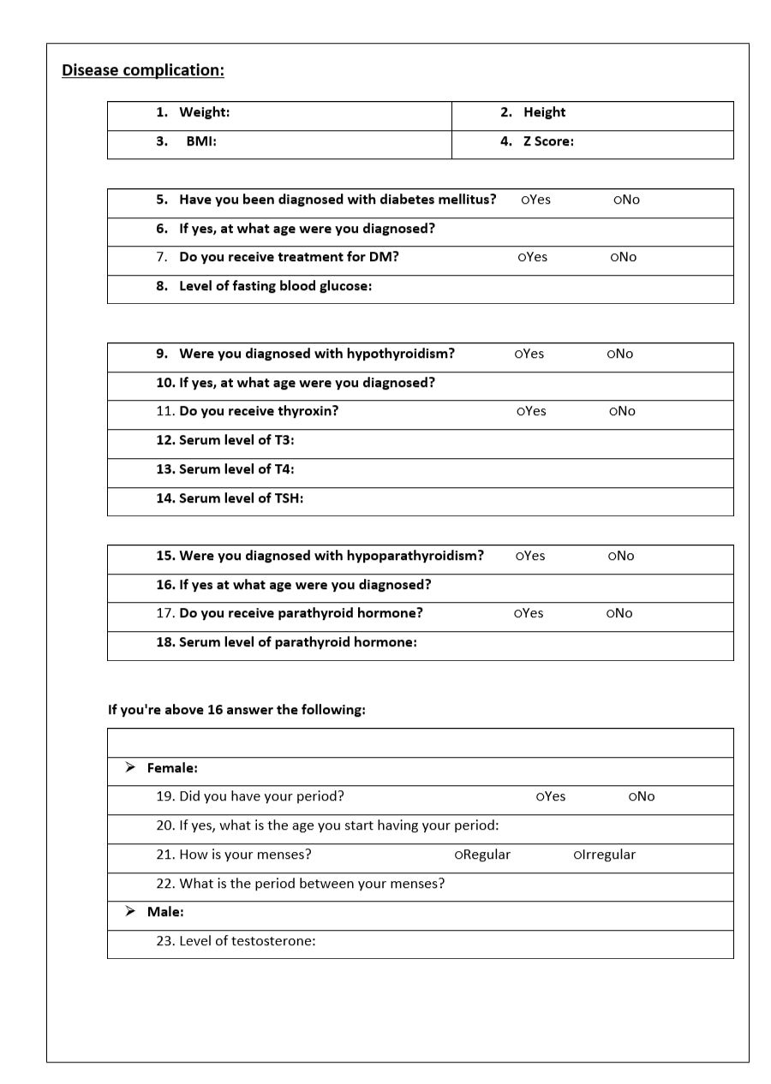
Appendix (2)
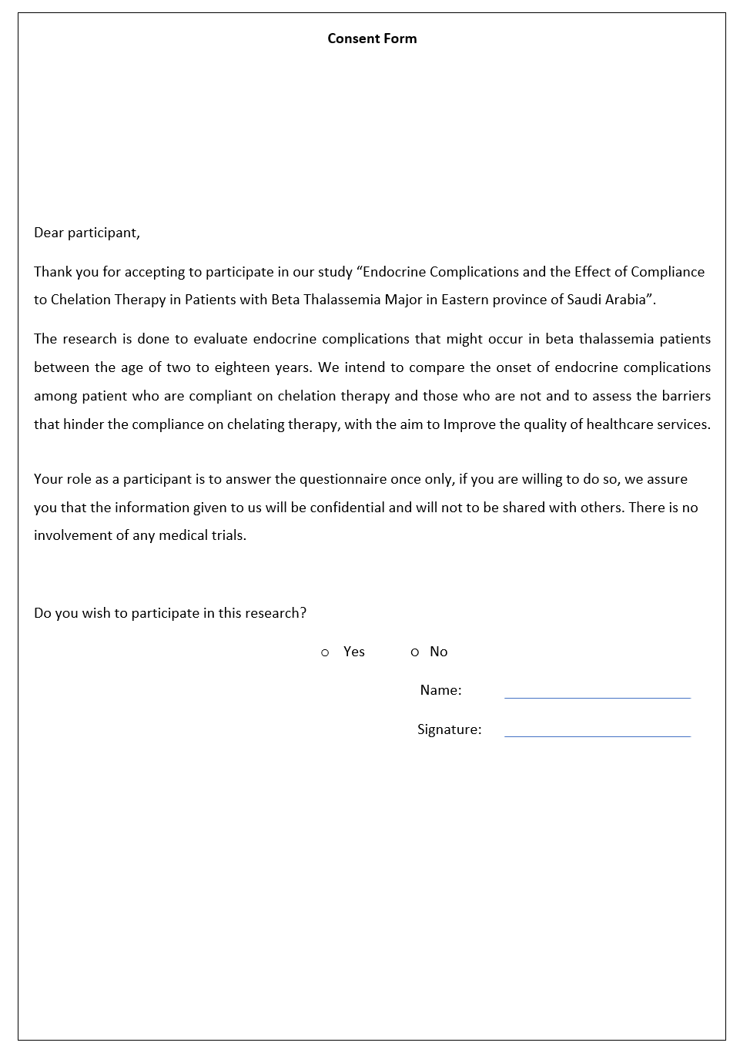
Appendix (3)

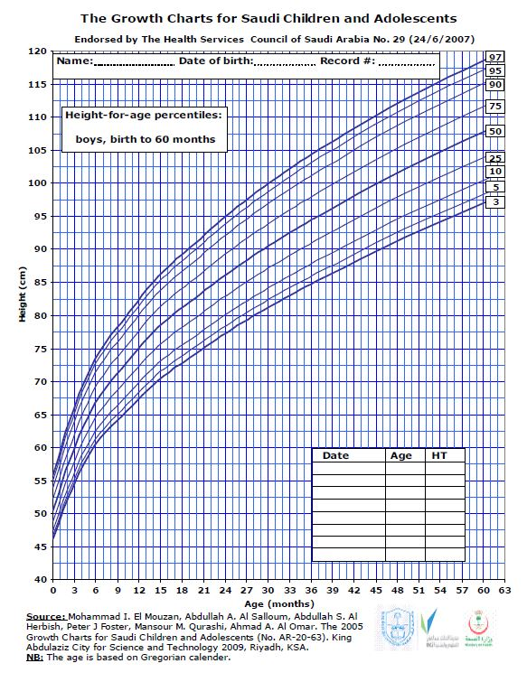
Appendix (4)

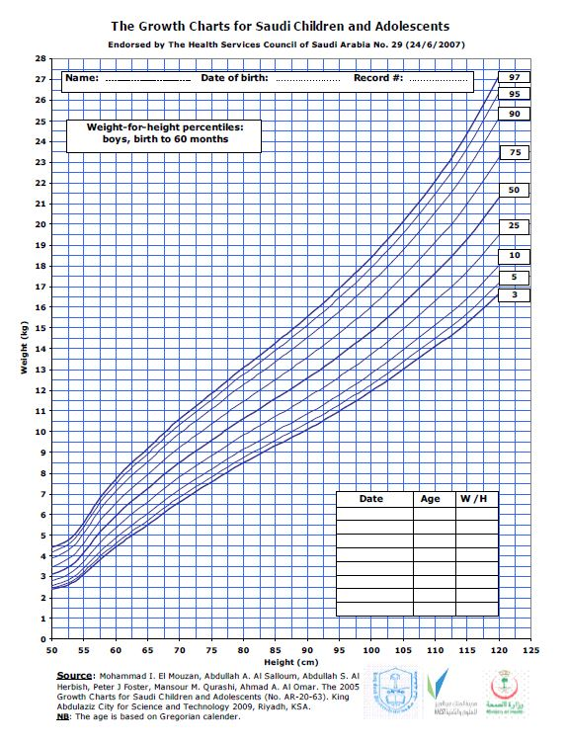
Appendix (5)
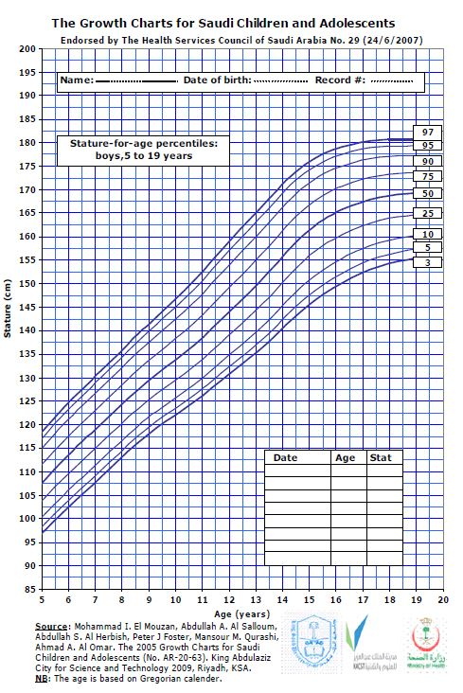
Appendix (6)
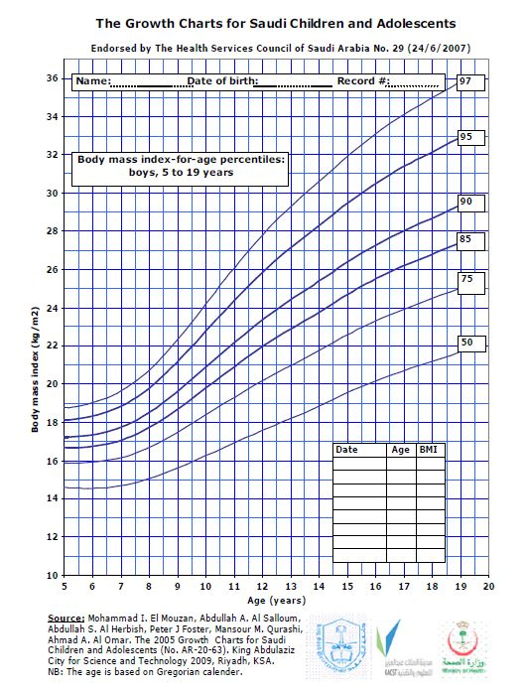
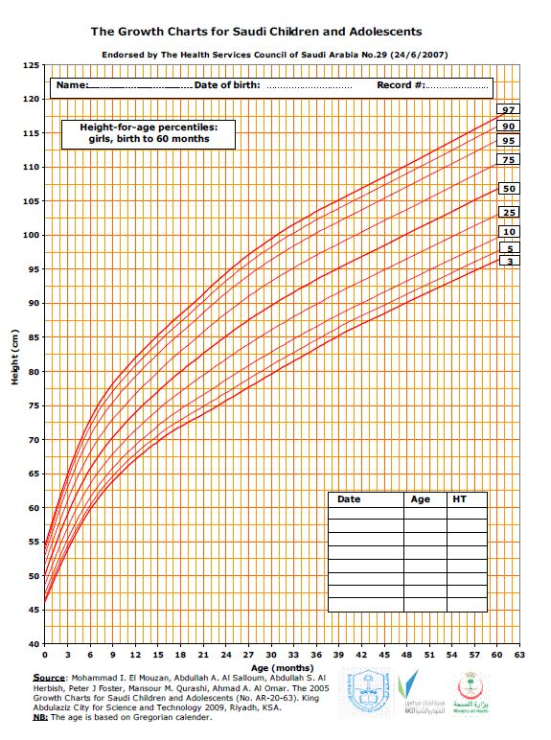
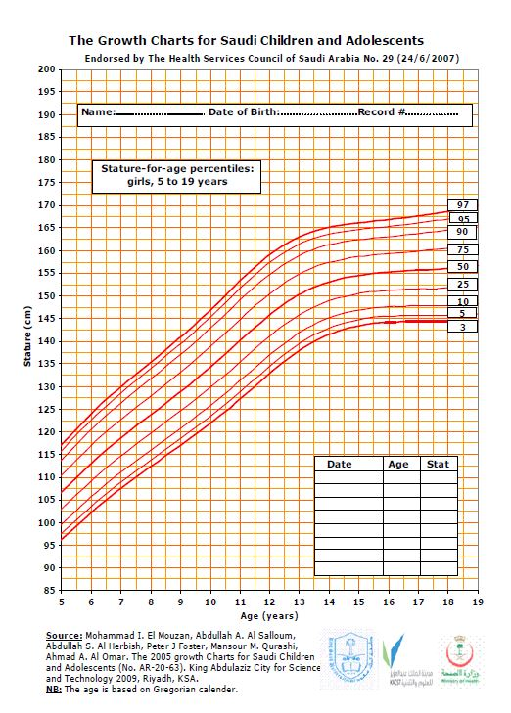
Appendix (7)
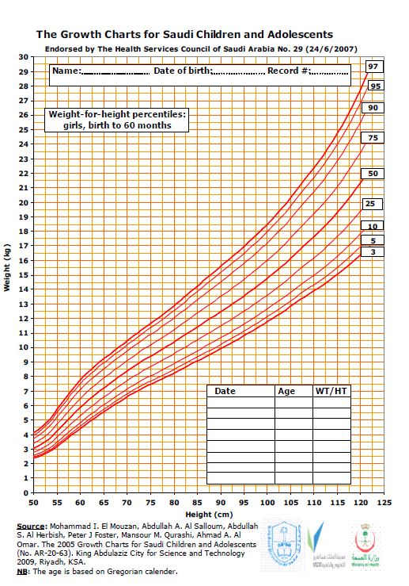
Appendix (8)
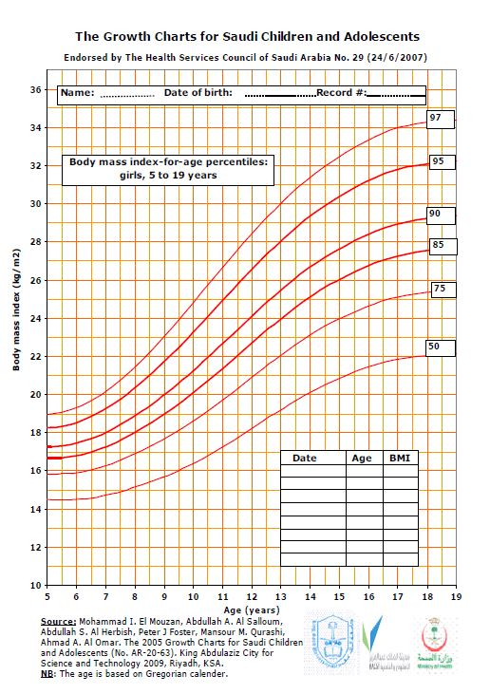
Appendix (9)

Interpretation | Fasting Blood glucose level
Normal | < 5.5 mmol/l
Impaired fasting blood glucose | 5.5 mmol/l – 7 mmol/l
Diabetic | ˃ 7 mmol/l
Reference Ranges of Biochemical hormones endorsed by World Health Organization

Appendix (10)

Interpretation | Free thyroxine level (T4)
Normal | 0.8 ng/dl -1.8 ng/dl
Low | ˂ 0.8 ng/dl
High | ˃ 1.8 ng/dl

Appendix (11)

Interpretation | Thyroid stimulating hormone level (TSH)
Normal | 0.4 mIU/l – 4 mIU/l
Low | ˂ 0.4 mIU/l
High | ˃ 4 mIU/l

Appendix (12)

