Appendix
Qualitative study questionnaire

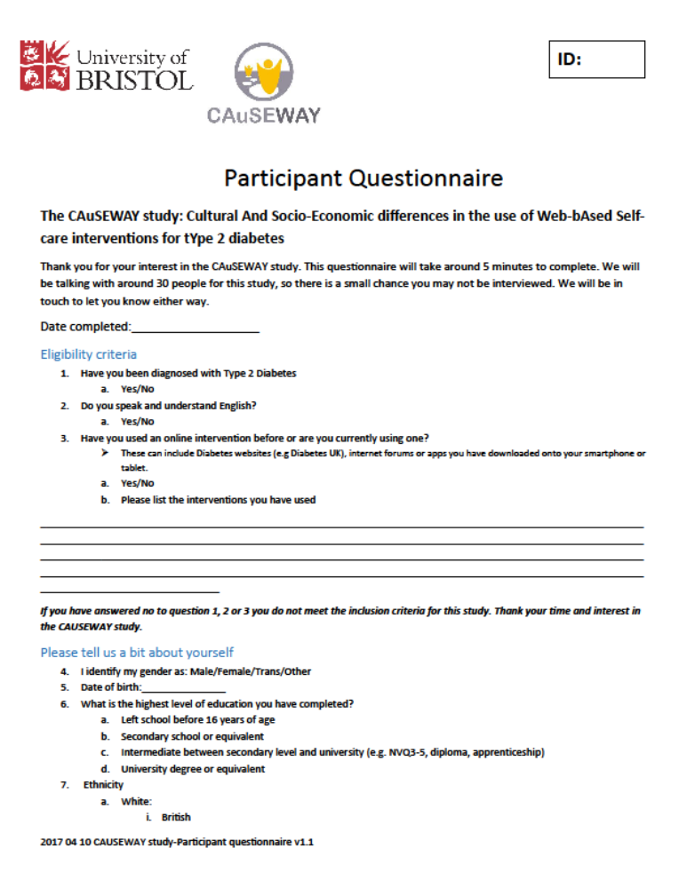
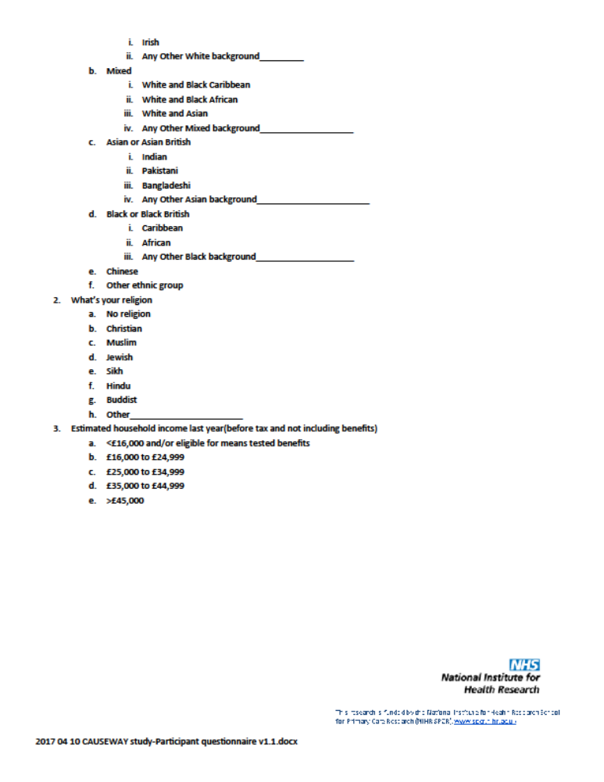

Topic guide
Version 1.0 (original version)
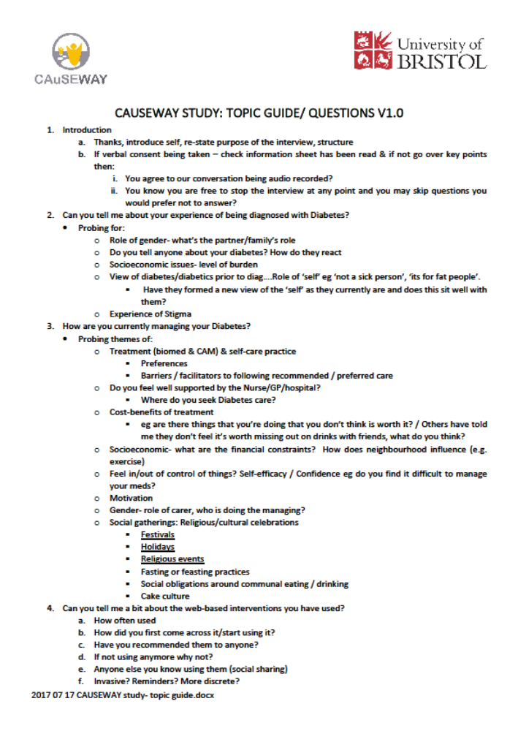


Version 1.3 (final version)
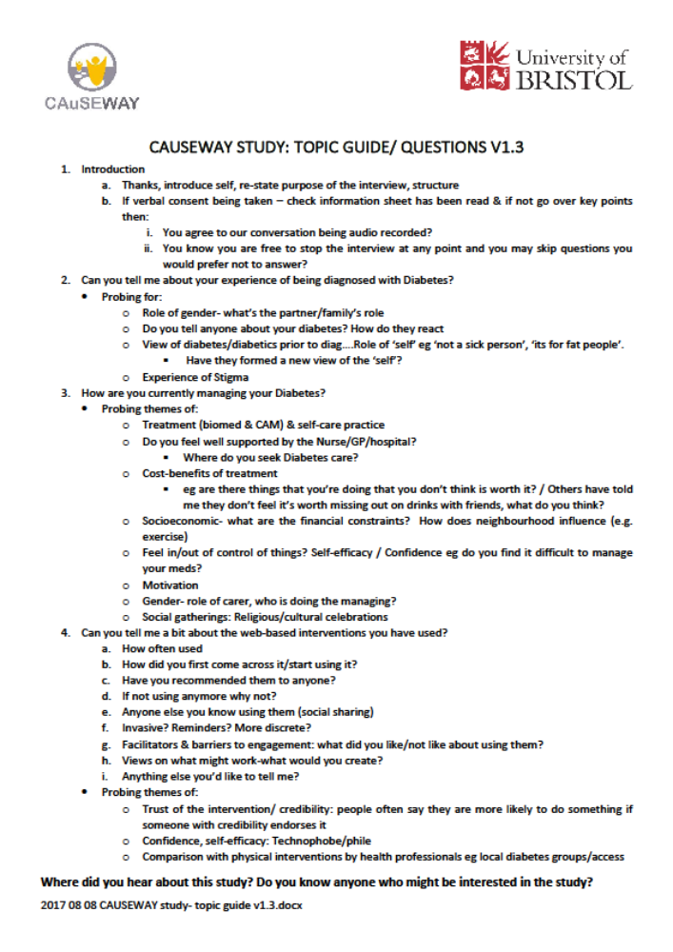

Table 2: Profile of individual participants
ID | Gender | Age range | Ethnicity | Highest level of education | Estimated household income last year(before tax and not including benefits) | IMD quintile
10 | Female | 61-70 | White- British | Intermediate between secondary level and university (e.g. NVQ3-5, diploma, apprenticeship) | £16,000 to £24,999 | 1
11 | Female | 41-60 | White- British | University degree or equivalent | £35,000 to £44,999 | 5
20 | Male | 71-80 | White- British | Intermediate between secondary level and university (e.g. NVQ3-5, diploma, apprenticeship) | £25,000 to £34,999 | 2
22 | Male | 61-70 | White- British | Secondary school or equivalent | £25,000 to £34,999 | 5
23 | Male | 21-40 | Asian or Asian British-Indian | University degree or equivalent | <£16,000 and/or eligible for means tested benefits | 3
24 | Female | 21-40 | Asian or Asian British-Indian | University degree or equivalent | £16,000 to £24,999 | 2
26 | Male | 41-60 | Asian or Asian British-Indian | Intermediate between secondary level and university (e.g. NVQ3-5, diploma, apprenticeship) | £16,000 to £24,999 | 2
27 | Male | 41-60 | White- British | Intermediate between secondary level and university (e.g. NVQ3-5, diploma, apprenticeship) | Prefer not to say | 5
28 | Male | 61-70 | White- British | Intermediate between secondary level and university (e.g. NVQ3-5, diploma, apprenticeship) | >£45,000 | 3
29 | Male | 61-70 | White- British | University degree or equivalent | >£45,000 | 5
30 | Female | 41-60 | White- British | University degree or equivalent | >£45,000 | NA
31 | Female | 41-60 | White- British | Intermediate between secondary level and university (e.g. NVQ3-5, diploma, apprenticeship) | Prefer not to say | 5
33 | Female | 41-60 | White- British | University degree or equivalent | Prefer not to say | 5
34 | Male | 41-60 | White- British | Intermediate between secondary level and university (e.g. NVQ3-5, diploma, apprenticeship) | £25,000 to £34,999 | 1
35 | Female | 61-70 | Other-White European, with mixed racial ancestry | University degree or equivalent | £35,000 to £44,999 | 3
36 | Male | 41-60 | White- British | University degree or equivalent | <£16,000 and/or eligible for means tested benefits | 4
37 | Female | 61-70 | White- British | University degree or equivalent | £16,000 to £24,999 | 4
38 | Male | 61-70 | White- British | University degree or equivalent | <£16,000 and/or eligible for means tested benefits | 5
40 | Female | 71-80 | White- British | University degree or equivalent | £16,000 to £24,999 | 4
41 | Female | 41-60 | White- British | University degree or equivalent | >£45,000 | 1
42 | Male | 71-80 | White- British | University degree or equivalent | Prefer not to say | 3

