Comprehensive proteome and phosphoproteome analysis revealed the protein characterization of invasive ductal carcinoma and lobular carcinoma

Ganglong Yang^{1,#} | Chenyang Zuo^{1,#} | Yuxiang Lin^{2,3,4,#} | Piaopiao Wen¹ | Wenyan Chen¹ | Chairui Zhang¹ | Han Xiao⁵ | Meichen Jiang⁵ | Xiaoman Zhou¹ | Morihisa Fujita¹ | Xiao-Dong Gao^{1*} | Fangmeng Fu^{2,3,4*}
¹ The Key Laboratory of Carbohydrate Chemistry & Biotechnology, Ministry of Education; School of Biotechnology, Jiangnan University, Wuxi, China
² Department of Breast Surgery, Fujian Medical University Union Hospital, Fuzhou, Fujian Province, 350001, China
³ Department of General Surgery, Fujian Medical University Union Hospital, Fuzhou, Fujian Province, 350001, China
⁴ Breast Cancer Institute, Fujian Medical University, Fuzhou, Fujian Province, China
⁵ Department of Pathology, Fujian Medical University Union Hospital, Fuzhou, Fujian Province, 350001, China

*Corresponding author: Dr. Xiao-Dong Gao at xdgao@jiangnan.edu.cn
Dr. Fangmeng Fu at ffm@fjmu.edu.cn
# These authors contributed equally

Supplementary figures
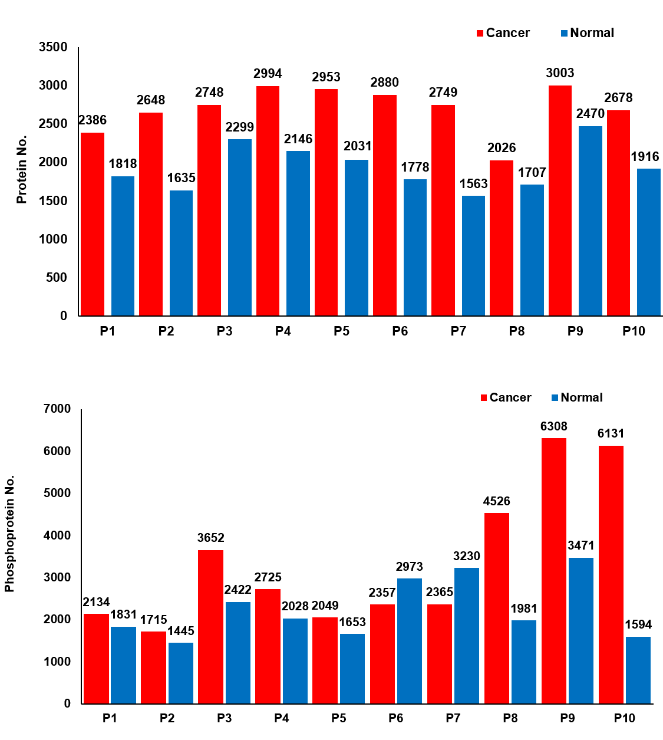
Figure S1:
The number of proteins identified in 10 pairs of patient samples after proteomics analysis (top), The number of phosphoproteins identified after phosphorylated proteomics analysis (below).

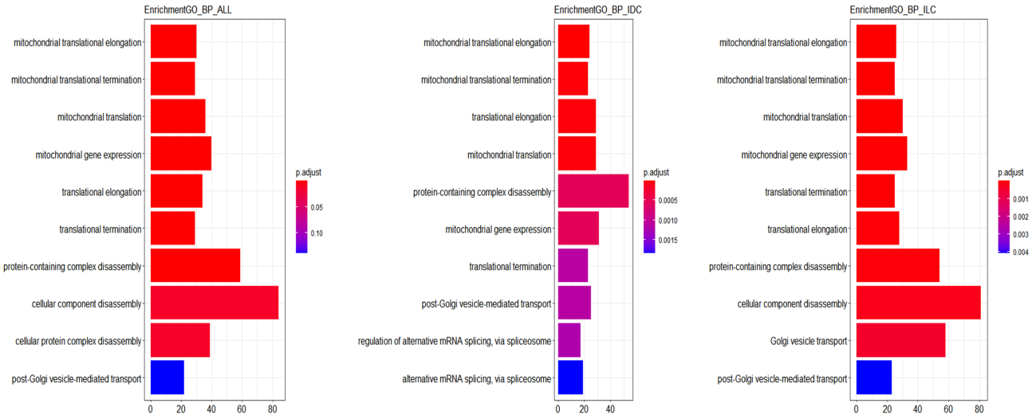
a
b
c

Figure S2:
- GO_BP result of the proteins identified in the whole BRCA tissues
- (C) GO_BP results of the proteins identified in the IDCs and ILCs subtypes

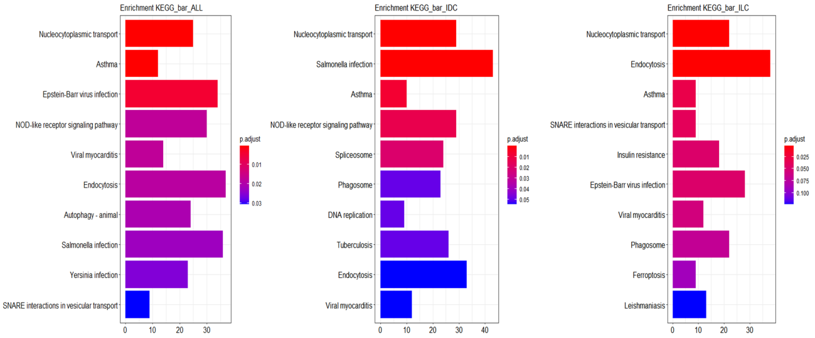
a
b
c

Figure S3:
- KEGG result of the proteins identified in the whole BRCA tissues
- (C) KEGG results of the proteins identified in the IDCs and ILCs subtypes

b
c
a
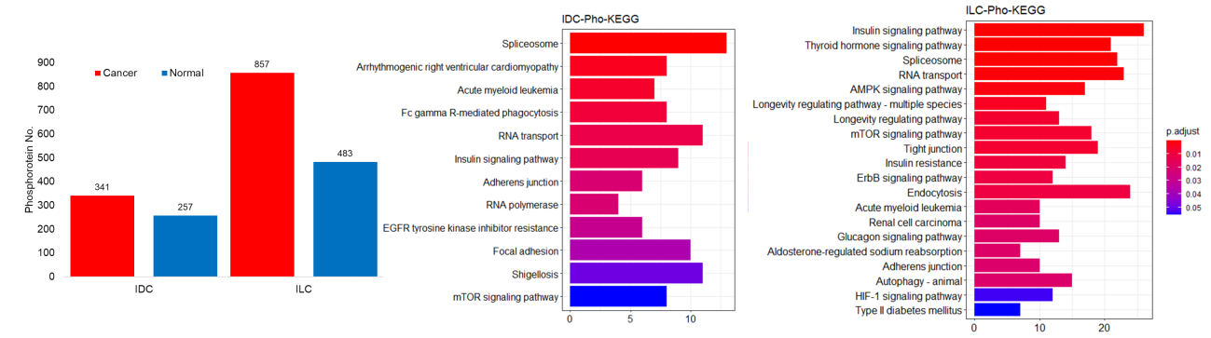

Figure S4:
- The number of phosphoproteins with ≥2 phosphosites simultaneously modified In IDCs or ILCs.
- (C) KEGG result of the phosphoproteins identified with ≥2 phosphosites simultaneously modified in the IDCs or ILCs.

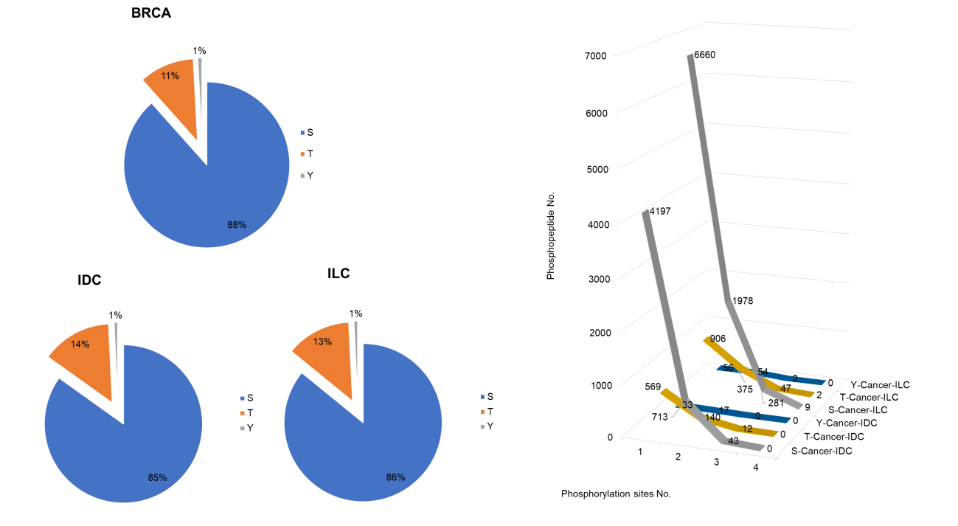
a
b

Figure S5:
- The proportions of phosphoserine (blue), phosphothreonine (orange), phosphotyrosine (gray).
- Statistics of the number of peptides corresponding to phosphoserine, phosphothreonine and phosphotyrosine in cancer tissues of IDCs and ILCs.

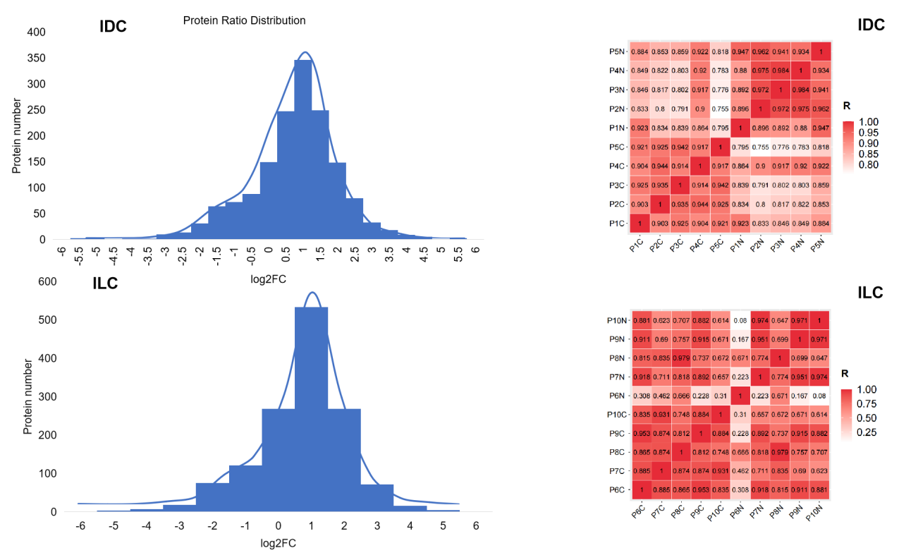
a
b

Figure S6:
- Normal distribution analysis of proteomics results
- Correlation matrix of IDCs or ILCs proteomes (Spearman’s correlation coefficients)

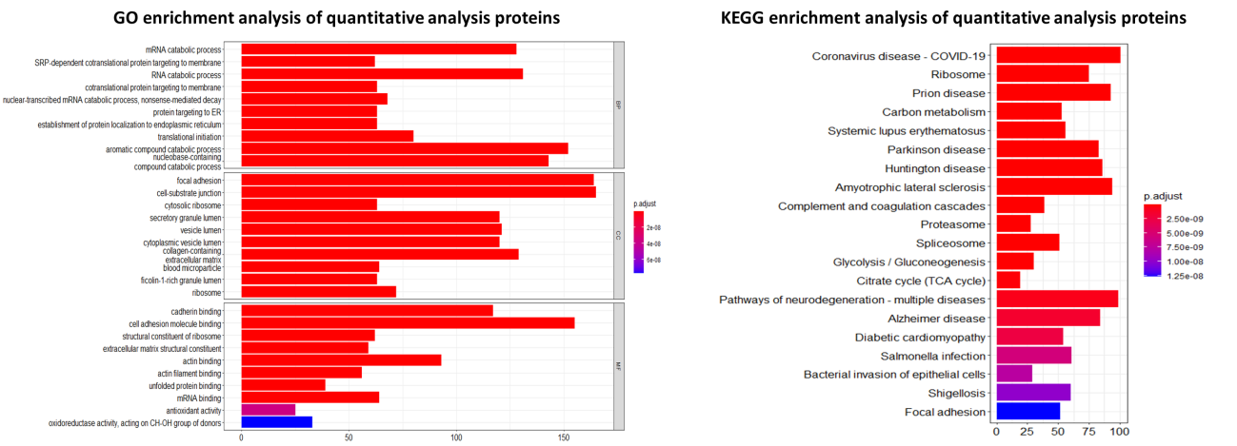
a
b

Figure S7: GO and KEGG analysis of 1,259 proteins.

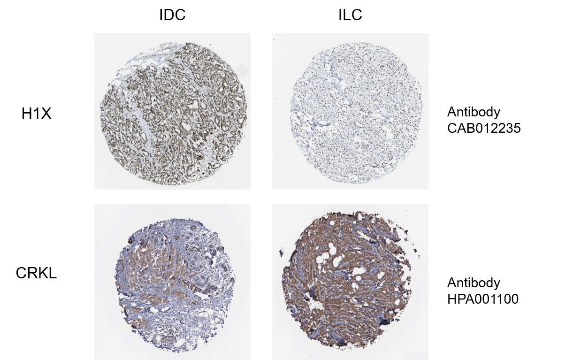
Figure S8: Immunohistochemical analysis of selected significantly different proteins.

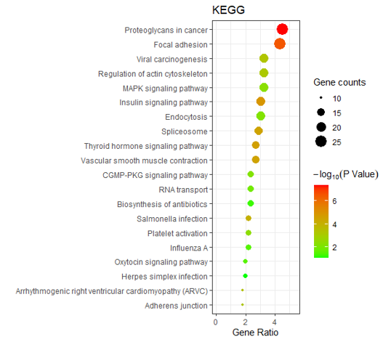
Figure S9: KEGG analysis results of 560 phosphoproteins

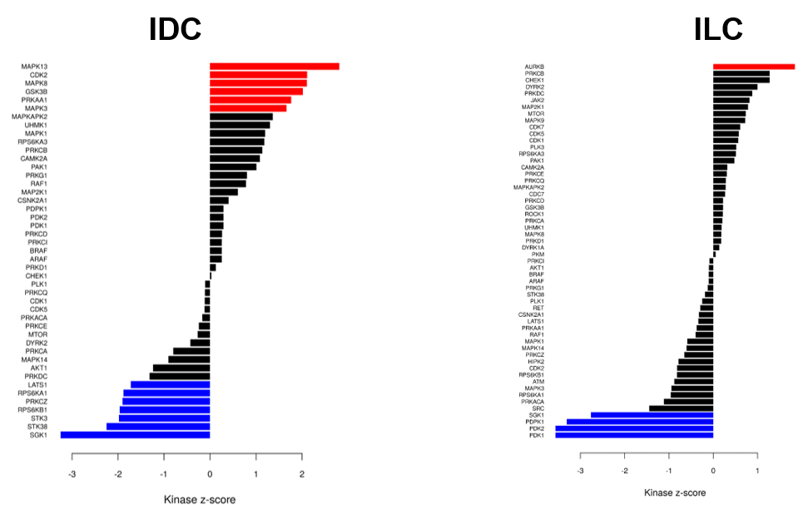
Figure S10: Evaluation of kinase activities by KSEA in IDCs and ILCs across the phosphoproteomic results.

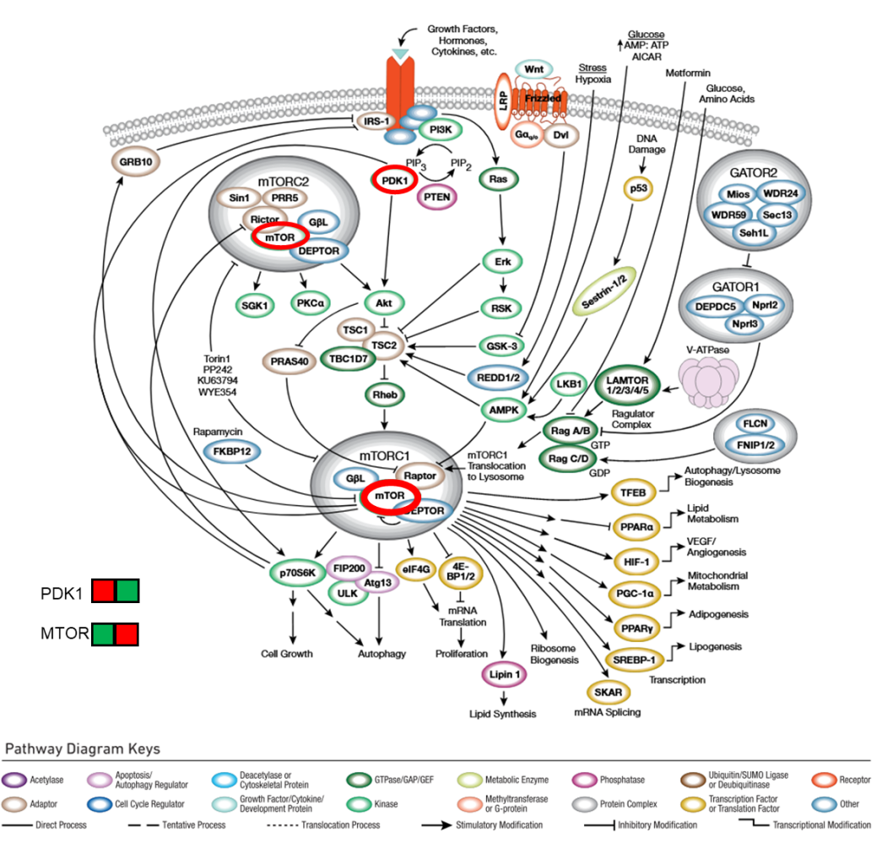
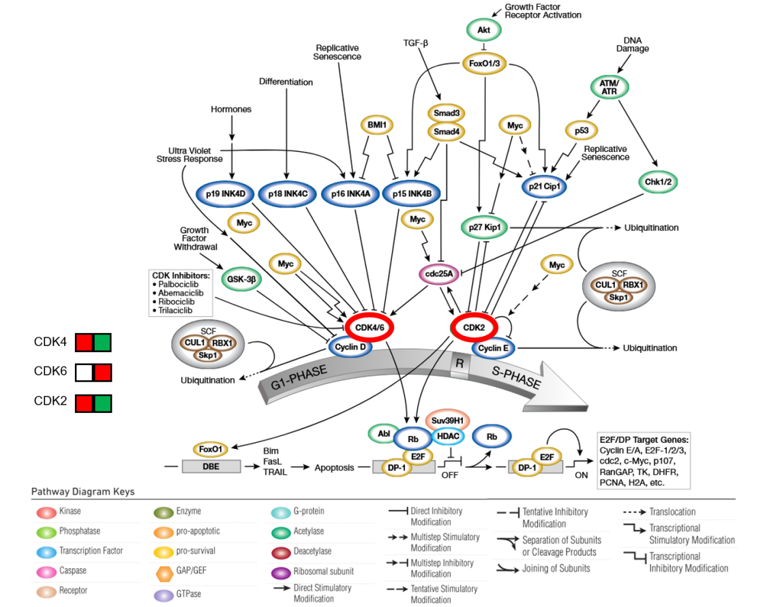
b
a

Supplementary Figure S11: Selected important kinases detected in their activated (red) or inactivated (green) state in IDCs (right) or ILCs(left) are shown in the context of their molecular signaling pathway.

