Supplementary Materials for

In situ growth of graphene catalyzed by phase-change material at 400 ºC for wafer-scale optoelectronic device application

Liangchen Hu,^{1,4} Yibo Dong,^{2,4} Yiyang Xie,^{1,*} Fengsong Qian,¹ Pengying Chang,¹ Mengqi Fan,³ Jun Deng,^{1,*} Chen Xu^{1,*}

¹ Key Laboratory of Optoelectronics Technology, Beijing University of Technology, Ministry of Education, Beijing 100124, China
² Institute of Photonic Chips, University of Shanghai for Science and Technology, Shanghai, 200093 China.
³ School of Integrated Circuits, Peking University, Beijing, 100871, China
⁴ These authors contributed equally.

- Effect of substrate surface morphology on the growth of graphene
Figure 1a is the Raman spectra (=532 nm) of graphene grown on copper foil under the same conditions at 400 ºC. The black line is grown directly on ordinary copper foil without any pretreatment, the red is obtained by growth on annealing copper foil with 1020 ℃ in hydrogen for 30min. The quality of graphene grown by copper foil after treatment with high temperature is much higher than the another. Specifically, the D-peak decreases significantly and the 2D peak increases. Figure 1b is the SEM image of copper foil surface. The left of dotted line is the surface morphology before annealing, and the right is the surface morphology after annealing. After annealing, it is obvious that less fissure and defects compare with before annealing. The Raman spectra in Fig. 1a reflects the influence of two different surface characteristics to grow graphene. It indicates that perfect surface lattice structure is conducive to the grow graphene.
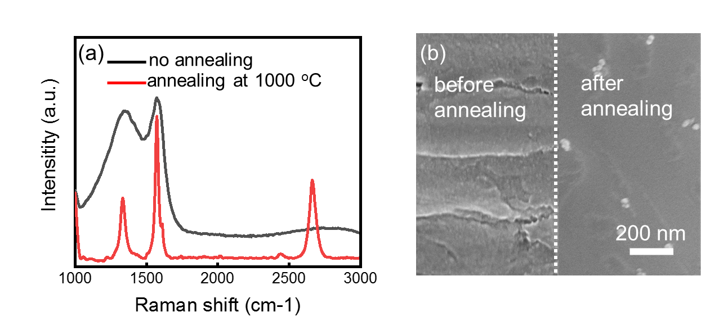
Supplementary Figure 1. (a) Raman spectra of graphene grown on copper foil. (b) SEM image of copper foil surface morphology.

- Characterization of the graphene grown on V₂O₅
Figure 2a show the graphene Raman spectrum grown on V₂O₅, which is similar to the graphene grown on unannealed copper foil. Comparing with the surface morphology of copper foil, V₂O₅ has smaller grains and more defects in Fig. 2b. Which maybe means that it is possible to grow high-quality graphene by optimizing the crystal quality of V₂O₅ surface.
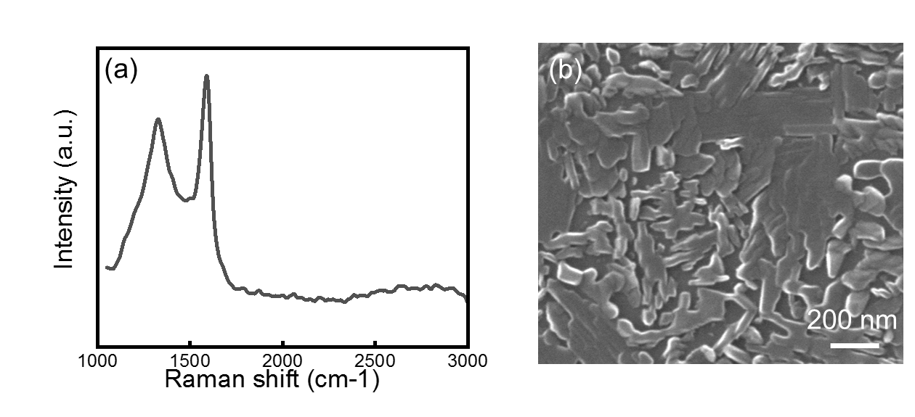
Supplementary Figure 2. (a) Raman spectrum of the graphene grown on V₂O₅. (d) SEM image of V₂O₅ surface morphology obtained by sputtering.

- Optical characterization of graphene
Graphene is a two-dimensional transparent material with low light absorption, obvious graphene films on V₂O₅ surface cannot be observed by naked eyes. However, on a certain thickness of SiO₂ substrate, the interference between graphene and SiO₂ light can enhance the light reflection when the light is irradiated with a specific wavelength, and then the graphene can be distinguished by the naked eye. Therefore, in order to observe the continuity of the graphene film, the graphene was transferred to a Si wafer with 300nm SiO₂. Specifically, a layer of PMMA was spined on surface to protect graphene, and then the marble solution (CuSO₄: HCl: H₂O=10:50:50) was used to etch V2O5, which makes the graphene film fall off and float in the solution. Finally, the graphene film is cleaned in DI water and be transferred to Si wafer. In the Fig. 3, continuous graphene films can be clearly seen on both sides through the graphene strip crossed out in the middle.
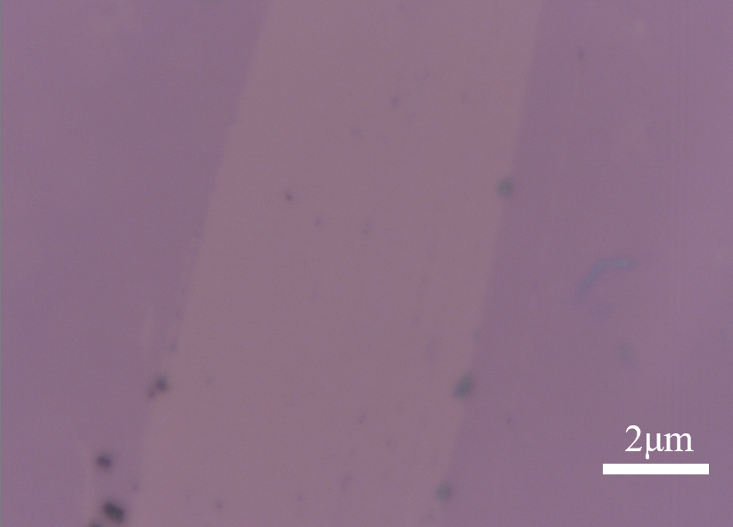
Supplementary Figure 3. Optical images of the graphene.

- TEM characterization of graphene
A transmission electron microscope (TEM) image of a graphene film is shown in Fig. 4. The illustration shows the corresponding electron diffraction (SAED) image of the selected region and the inset in that figure shows the corresponding selected area electron diffraction (SAED) pattern. Even though the graphene quality is not very perfect, the graphene hexagonal lattices can still be observed clearly.
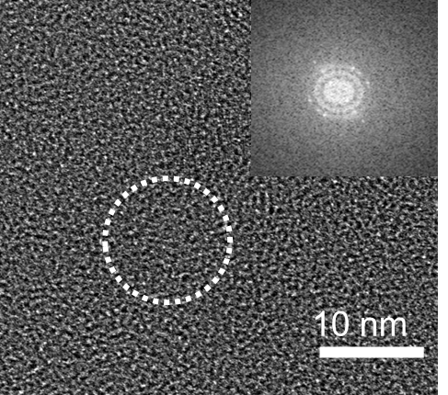
Supplementary Figure 4. The TEM image graphene grown at 400 ºC. The inset is a SAED pattern highlighted by the white dotted circle.

- The procession of photodetector fabrication
The procession of fabricated the device is shown in Fig.5a. In the whole process, there is no need to etch the V₂O₅ substrate and transfer graphene, thus avoiding damage along with graphene. Fig. 5b, c is the schematic diagram of the cross-section structure of the device and the SEM diagram of the surface structure of the device
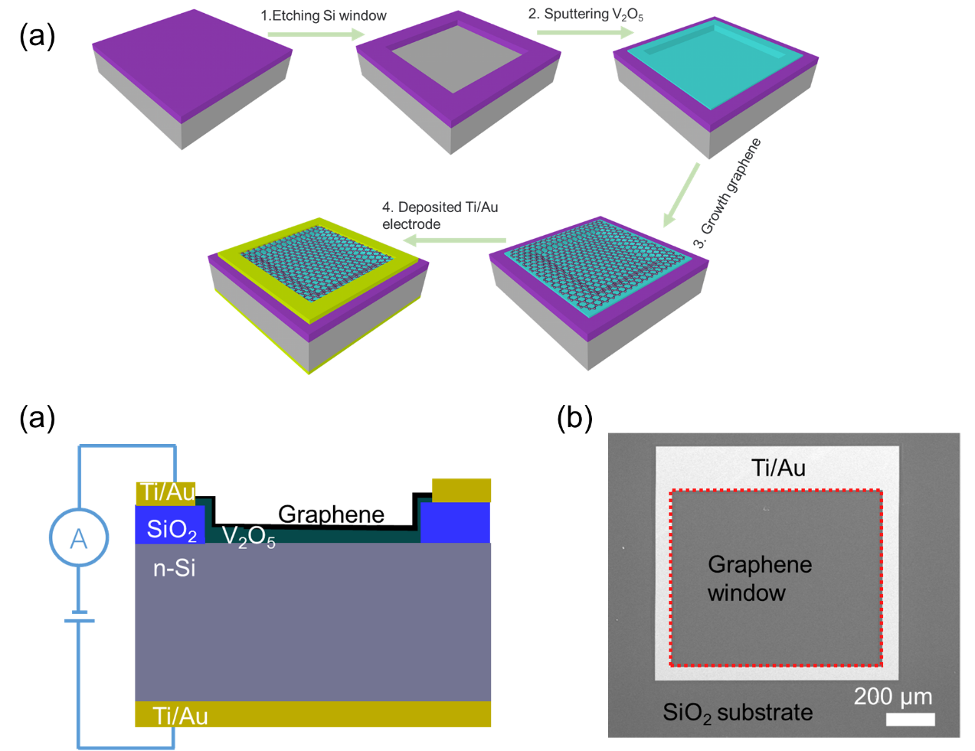
Supplementary Figure 5. (a) The procession of photodetector fabrication with V₂O₅ Catalytic growth of graphene. (b) Illustration of the device profile structure. (c) SEM image of the device.

- The I-V characteristics of photodetector with or without graphene
Since V₂O₅ and Si can also form a built-in electric field due to band difference¹, it is necessary to prove that the higher response is caused by graphene. The device with and without graphene were fabricated. In order to avoid errors in the process, V₂O₅ was place in PECVD chamber for annealing at the condition of growth graphene (CH₄ was not included) to avoid the influence of temperature when grow graphene on V₂O₅. Then, The I-V characteristic were measured. The results are shown in Fig. 6. When absence of graphene, the device has a weaker current at positive voltage, which may be related to the high resistance state of the phase change material at room temperature. When illuminated by white light, the device exhibits obvious photocurrent. After growth graphene, the I-V characteristic is more similar to ordinary graphene-Si schottky junction. The photocurrent increases nearly two orders of magnitude when illuminated by white light,
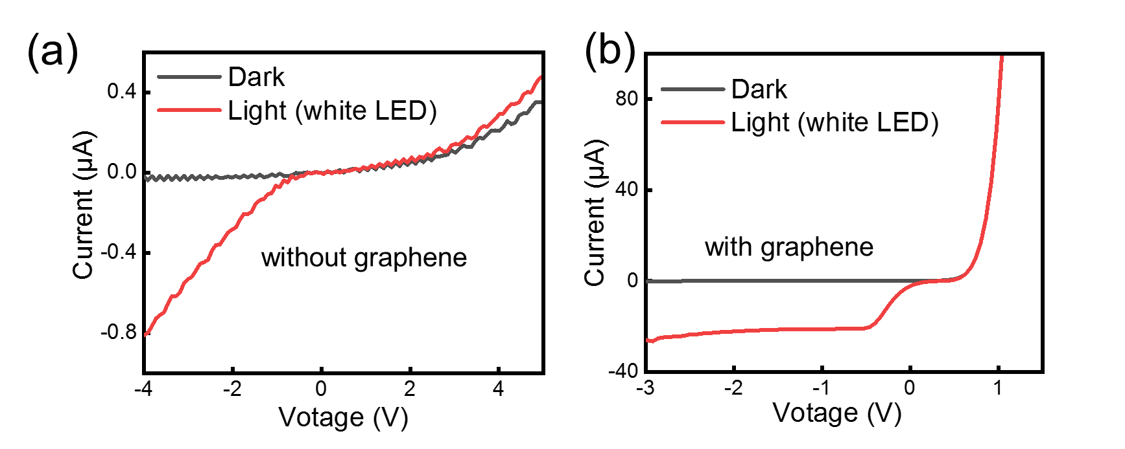

Supplementary Figure 6. (a) The photodetector interface diagram. (b) The SEM image photodetector surface. (c,d) The I-V characteristics (dark and illuminated) of the schottky junction with and without graphene.

- The I-V characteristics of the photodetector with different temperatures.
In order to understand the current transfer mechanism of the photodetector, we measured the dark I-V characteristics of the device with and without graphene at different temperatures. The heating device is realized by hot plate. As shown in Fig. 7, whatever the device with or without graphene, the photocurrent increases significantly as the temperature increases. The reverse current of thermionic emission mechanism increases with the increase of temperature, so thermionic emission should be the main current transport mechanism of the device. At the same time, V₂O₅ is a phase change material and exhibits metallic properties above 257 ºC². When the temperature is close to or greater than the critical phase transition temperature. The reverse current abrupt increase. Which may be caused that the schottky junction have a change due to V₂O₅ transition to metallic properties.
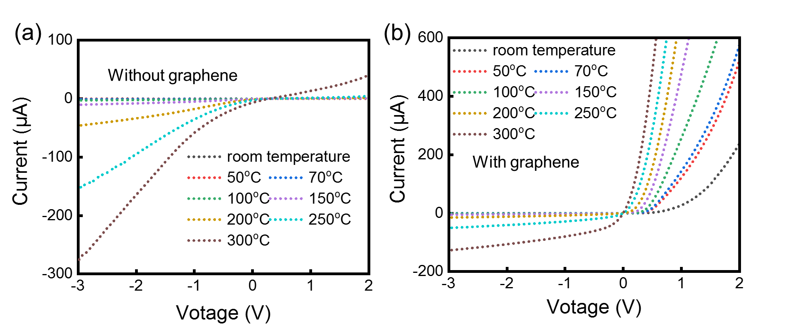
Supplementary Figure 7. The dark I−V characteristics of the device operating at different temperatures. (a) V₂O₅-Si schottky photodetector. (b) Graphene-V₂O₅-Si schottky photodetector.

- Calculation of barrier height of Schottky junction
The working mechanism of the device was determined by the performance of the device at temperature. The barrier height of schottky junction formed by graphene, V₂O₅ and silicon was calculated by using thermal-electron emission theory³. The I-V characteristic can be described by the following functions:
$I=I_{s}(exp\frac{qV_{D}}{nkT}-1)$ (1)
$I_{s}=AA^{**}T^{2}exp⁡(-\frac{qΦ_{B}}{kT})$ (2)
$V_{D}=V-IR_{s}$, (3)
where T is the Kelvin temperature, q is the elementary charge, K is the Boltzmann constant, n is the ideal coefficient, A is the effective area of the diode, $Φ_{B}$ is the effective barrier height at zero bias, R_{S} is the series resistance, and A** is the effective Richardson constant.
When$V_{D}＞3kT/q$, function (1) can be approximated as
$I=I_{s}(exp\frac{qV-qIR_{s}}{nkT})$. (4)
It can be rewritten as
$V=IR_{s}+nΦ_{B}+(\frac{nkT}{q})ln⁡(\frac{I}{AA^{**}T^{2}})$, (5)
then
$\frac{dV}{d(lnI)}=IR_{s}+\frac{nkT}{q}$. (6)
Define function
$H\left(I\right)=V-(\frac{nkT}{q})ln⁡(\frac{I}{AA^{**}T^{2}})$. (7)
We can rewrite it as

$H\left(I\right)=IR_{s}+nΦ_{B}$. (8)
Through the I - V characteristics of in Fig. 8a, dV/d (lnI) versus I and H(I) versus I for the device can be obtained. Through the linear fitting of the data in Fig. 8b,c, the calculated parameters from function 6 and 9 are n = 12.7, Φ_{B} = 0.54 eV and R s = 77 Ω.
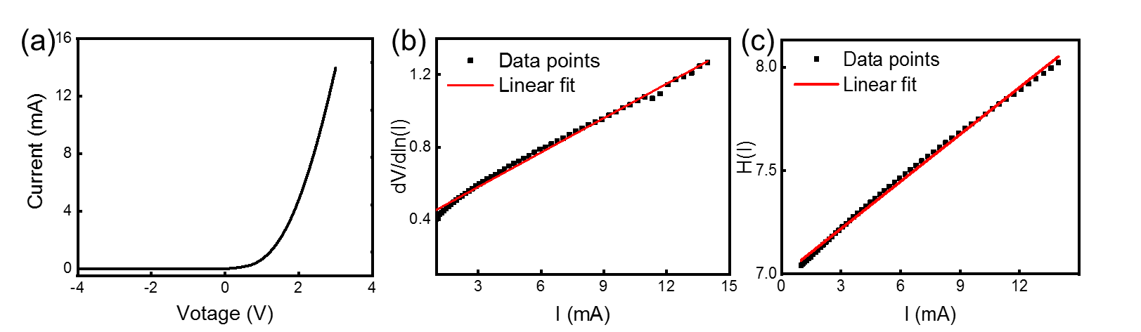
Supplementary Figure 8. (a) The I−V characteristics of the device in Dark; (b,c) dV/d(ln I) (b) and H(I) (c) curves vs the current I.

References
1. Fu, Y., Liu, Y., Ma, K., Ji, Z., Mai, W. & Zhao, C. Interfacial engineering to boost photoresponse performance and stability of V2O5/n-Si heterojunction photodetectors. J. Alloy. Compd. 819, 153063 (2020).
2. Nadkarni, G. S. & Shirodkar, V. S. Experiment and theory for switching in Al/V2O5/Al devices. Thin Solid Films. 105, 115-129 (1983).
3. Cheung, S. K. & Cheung, N. W. Extraction of Schottky diode parameters from forward current‐voltage characteristics. Appl. Phys. Lett. 49, 85-87 (1986).

