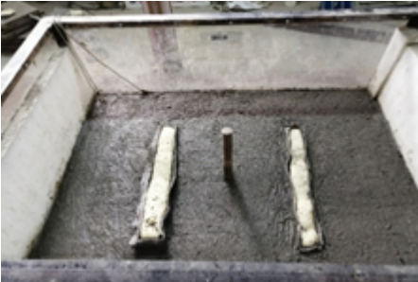
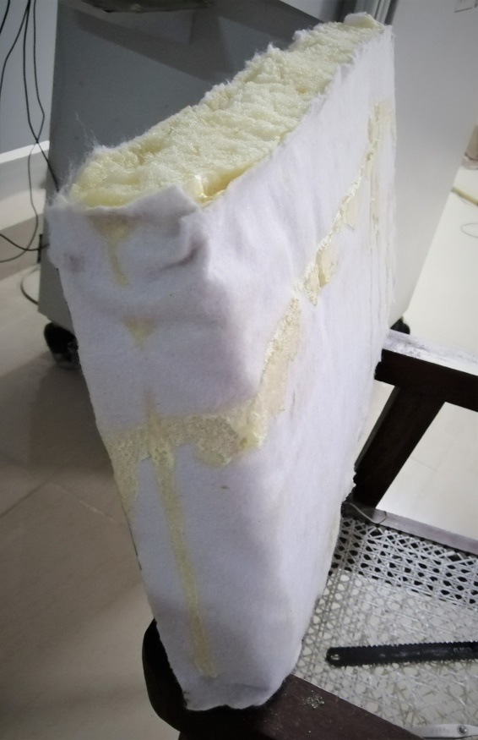
(c)
(b)

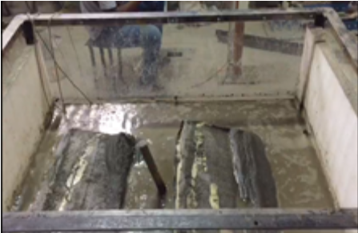

(a)

(a)

Supplementary Figure (1): (a) Plane rectangular isolation curtain made of PU foam; (b) The rectangular isolation curtain installed inside the prepared model ground; (c) The uplift of the isolation curtain observed after 0.1g intensity loading

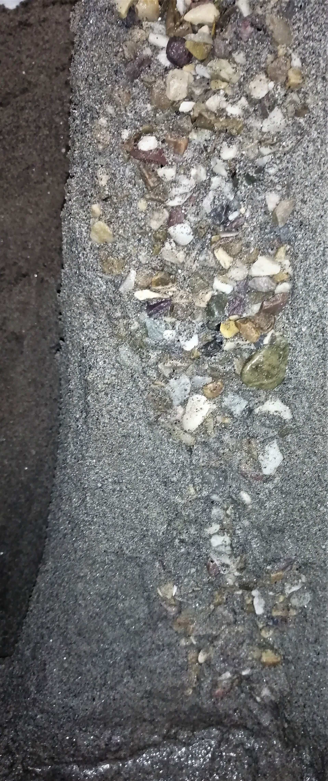
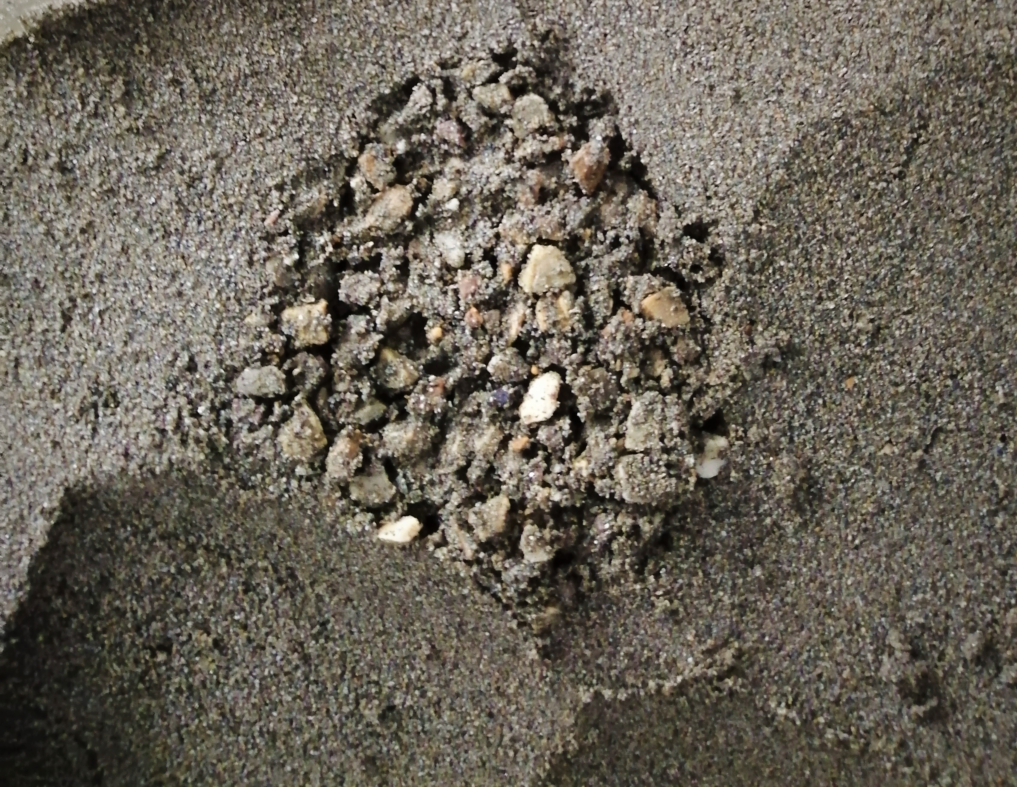

(a)
(b)

Supplementary Figure (2): (a) The clogging observed in stone columns (Top view) during the removal of soil sample (b) The clogging accompanied with bulging of cross sectional area (side view) observed during the removal of soil sample

