Electronic Supplementary Material

Characterization and complete genome analysis of a novel Escherichia phage,
vB_EcoM-RPN187

Napakhwan Imklin¹, Pattaraporn Sriprasong¹, Narut Thanantong², Porntippa Lekcharoensuk^{3,4,*} and Rujikan Nasanit^{1,*}
¹ Department of Biotechnology, Faculty of Engineering and Industrial Technology, Silpakorn University, Sanamchandra Palace Campus, Nakhon Pathom 73000, Thailand
² Department of Farm Resources and Production Medicine, Faculty of Veterinary Medicine, Kasetsart University, Kamphaeng Saen Campus, Nakhon Pathom 73140, Thailand.
³ Department of Microbiology and Immunology, Faculty of Veterinary Medicine, Kasetsart University, Bangkok 10900, Thailand.
⁴ Center for Advanced Studies in Agriculture and Food, Kasetsart University Institute for Advanced Studies, Kasetsart University, Bangkok 10900, Thailand.
*Corresponding author:
Rujikan Nasanit
Email: nasanit_r@su.ac.th
Tel.: +66 34 300 463 ext. 25209
Fax: +66 34 300 463
Porntippa Lekcharoensuk
E-mail: fvetptn@ku.ac.th
Tel.: +66 2 942 8436
Fax: +66 2 942 8436

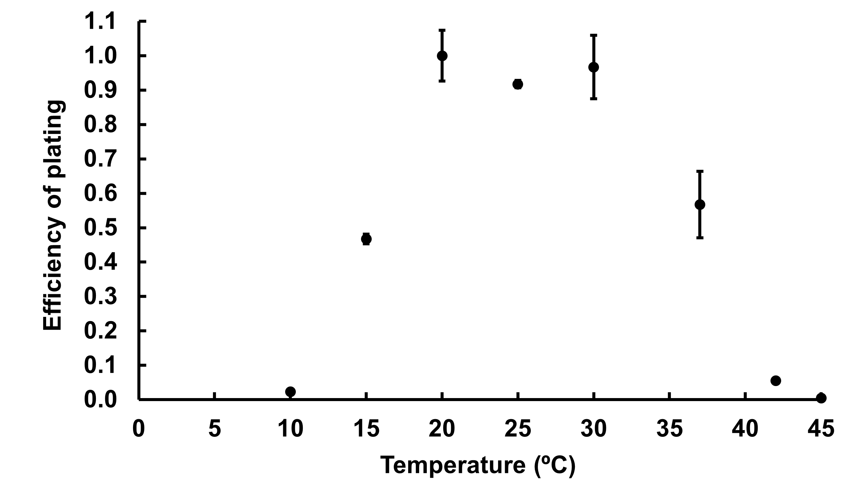
Supplementary Fig. S1 Efficiency of plating of the vB_EcoM-RPN187 thrice performed at 8 different temperatures. The result was displayed using the mean and SE values.

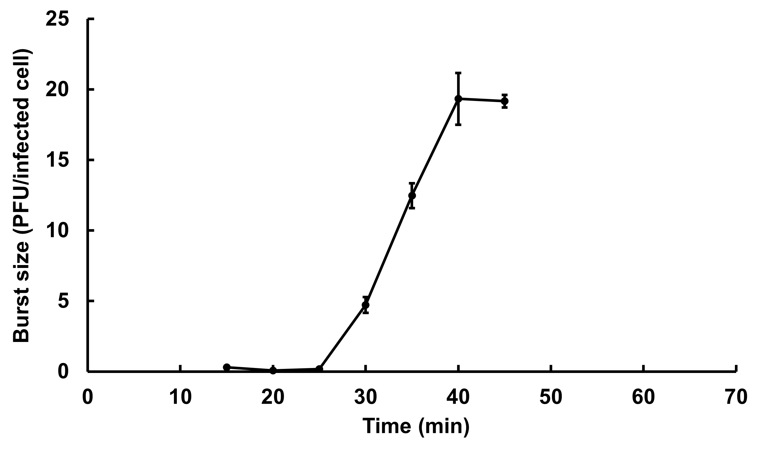
Supplementary Fig. S2 One-step growth curve of the vB_EcoM-RPN187 phage presented by the mean and SE.

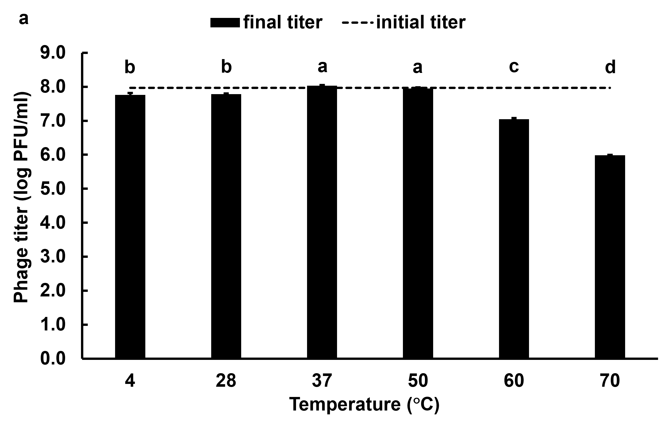
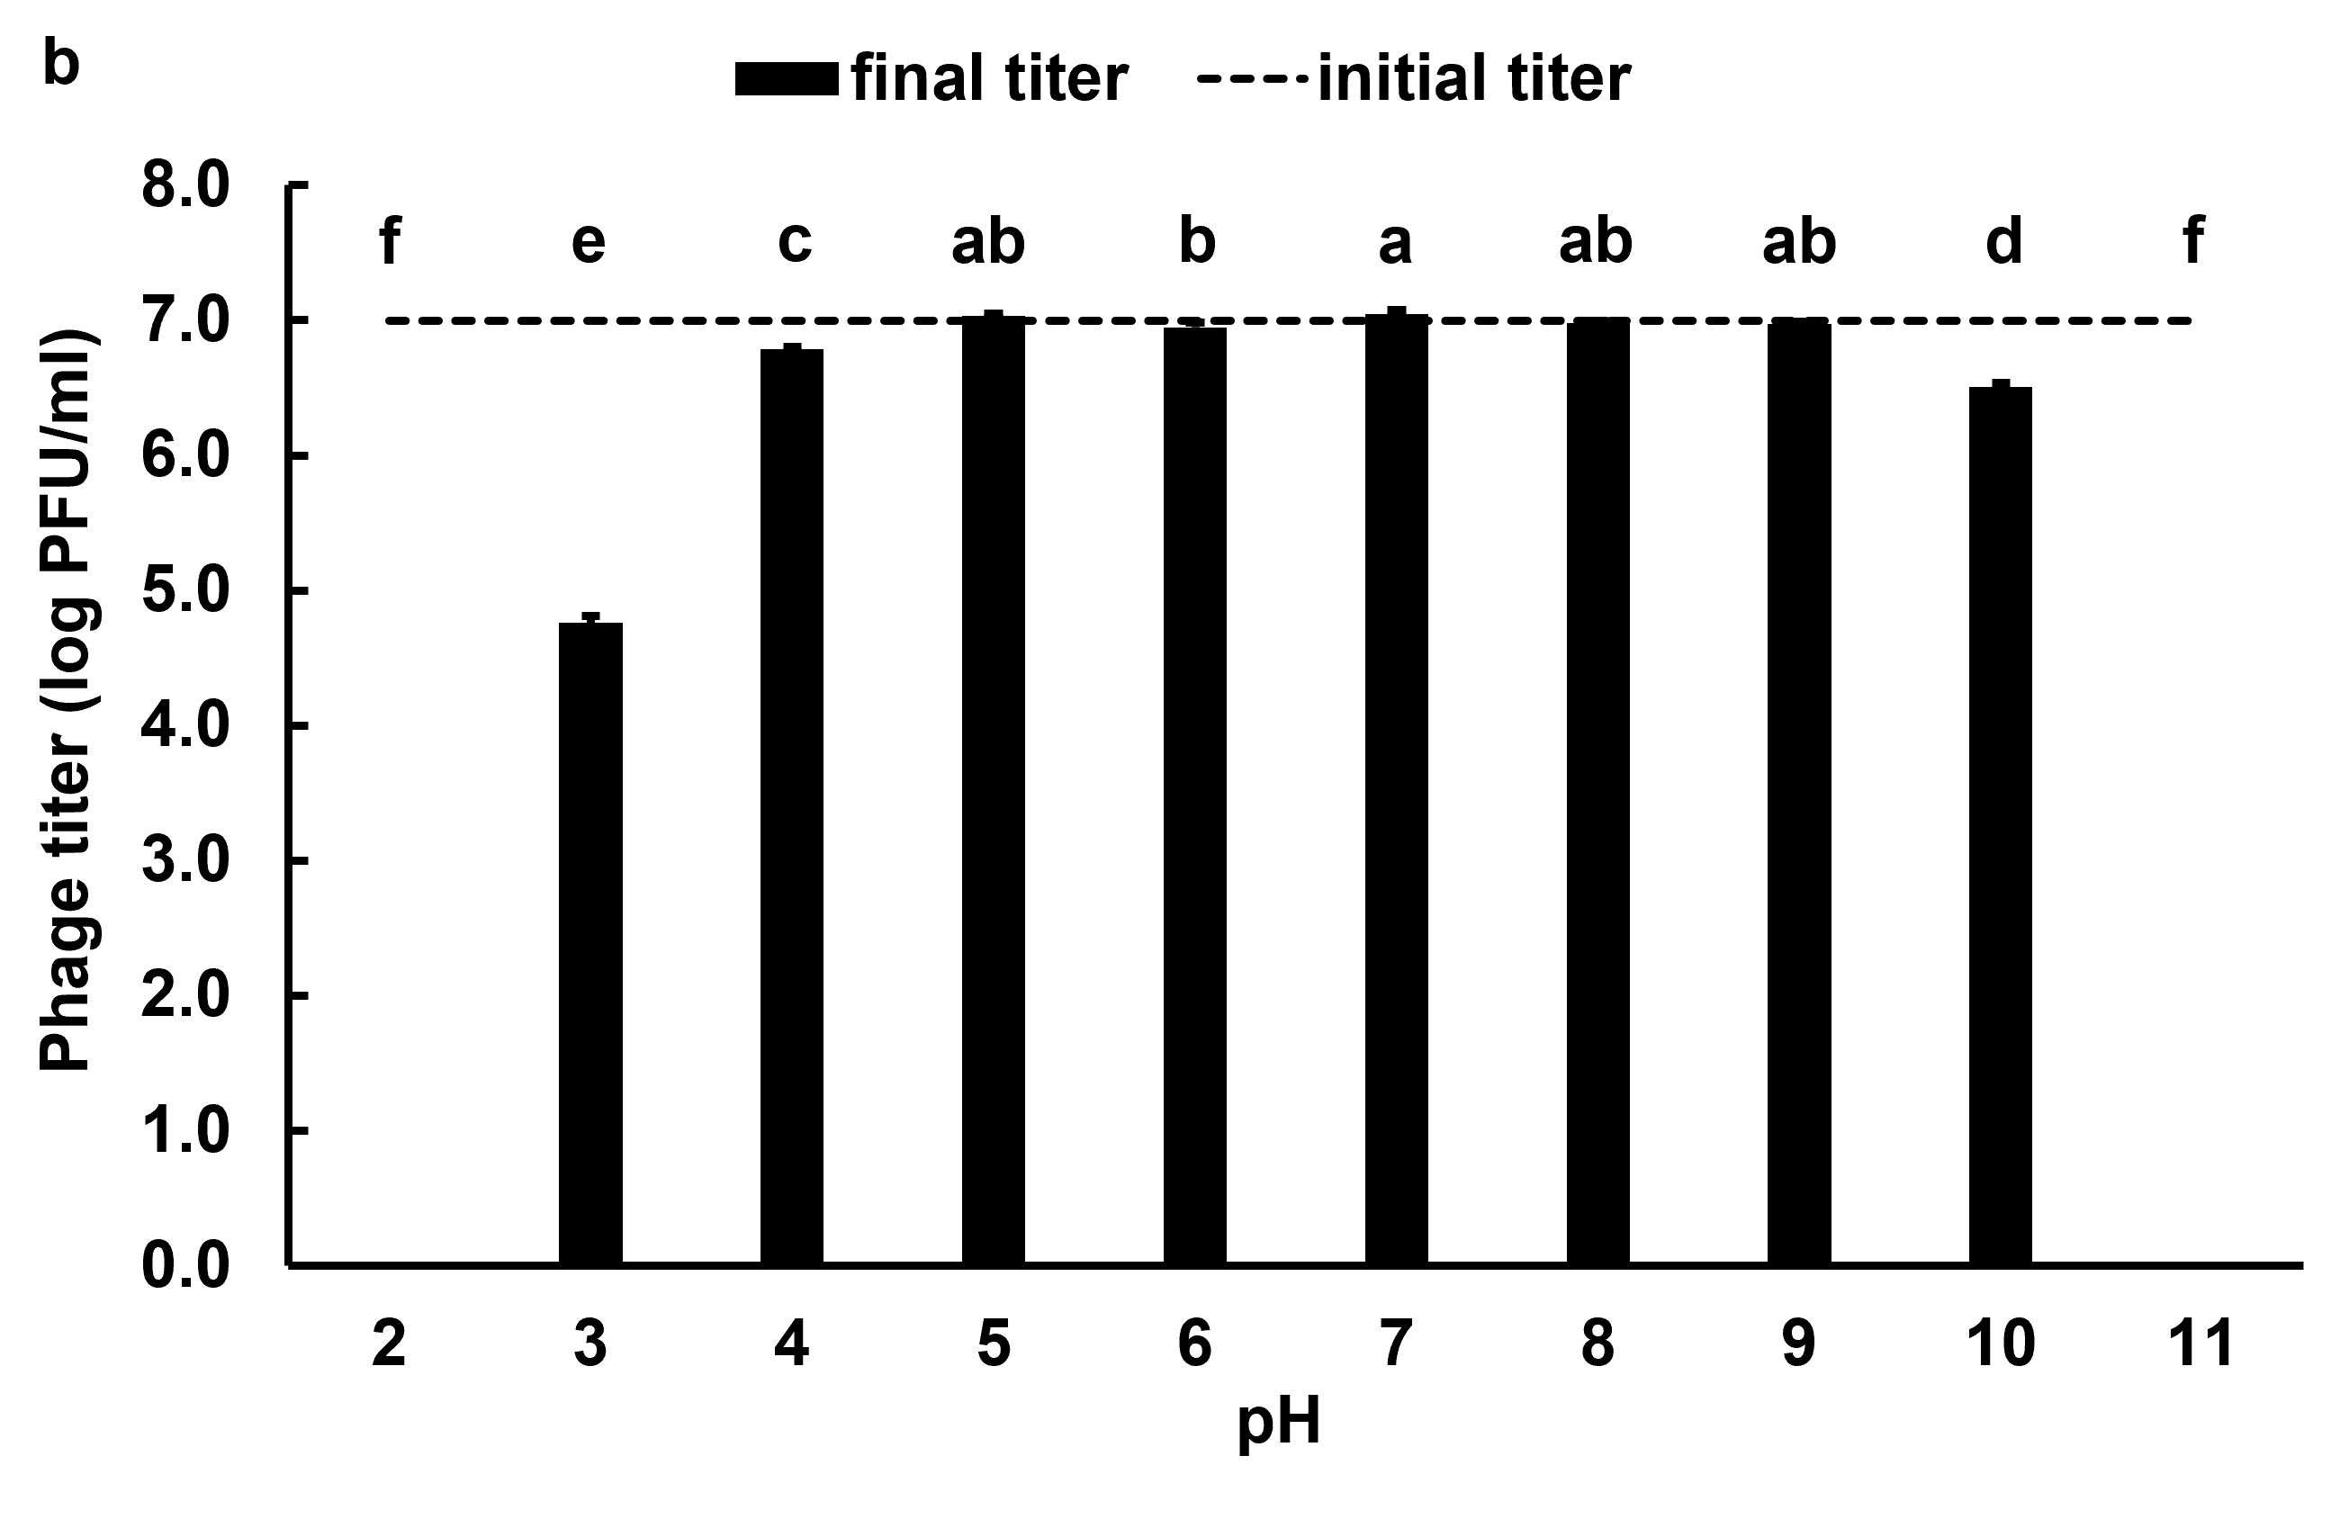
Supplementary Fig. S3 Stabilities of the vB_EcoM-RPN187 phage at different temperatures (a) and pH values (b). The results were reported using the mean and SE values of three individual experiments. The significant differences (p < 0.05) were highlighted by lowercase letters.
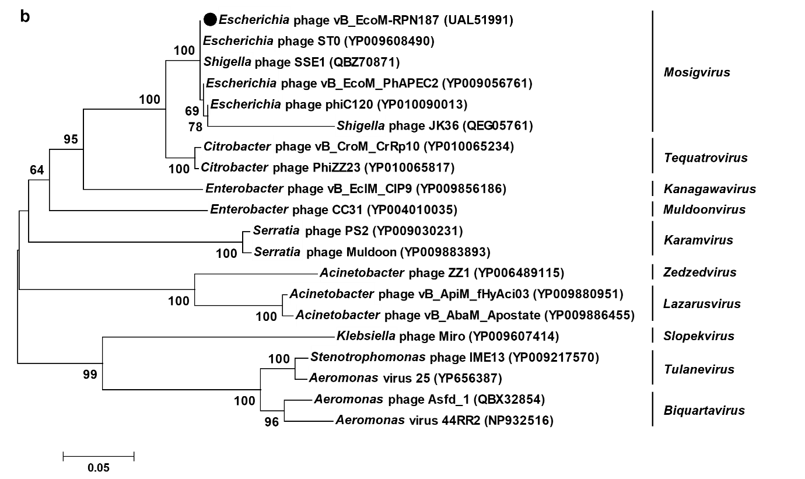
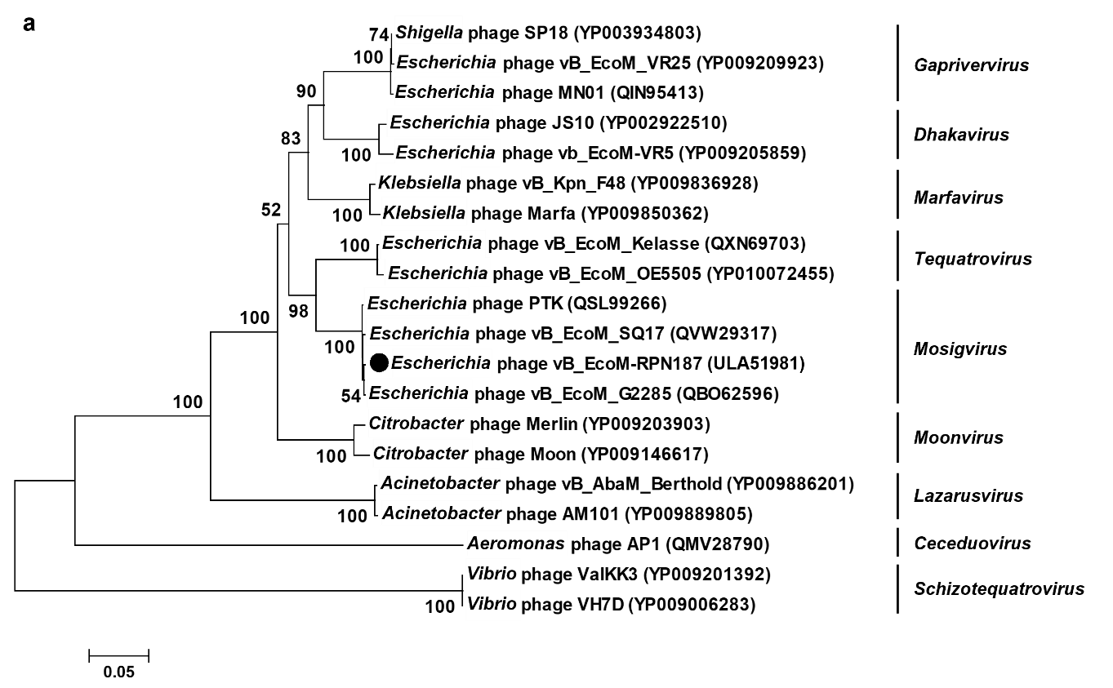
Supplementary Fig. S4 Phylogenetic analysis based on the amino acid sequence alignment of terminase large subunit (a) and major capsid protein (b) between the vB_EcoM-RPN187 (black circle) and other phages. Sequences were gathered from the GenBank database. The phylogenetic trees were constructed by MEGA7 using the neighbor-joining method with 1,000 bootstrap replication.

Supplementary Table S1 Homologous open reading frames of the vB_EcoM-RPN187 phage genome to other organism ORFs
ORF | Strand | Blast hit ID | Homology | Organism match | E-value | Identity | aa
1 | + | QVW29281.1 | hypothetical protein | Escherichia phage vB_EcoM_SQ17 | 3.00E-89 | 100% | 132/132
2 | + | QYC95572.1 | nudix hydrolase | Escherichia phage vB_EcoM_TU01 | 2.00E-110 | 100% | 152/152
3 | + | QWY13425.1 | lysozyme | Escherichia phage vB_EcoM-ZQ3 | 7.00E-116 | 99% | 161/162
4 | + | CUL02667.1 | hypothetical protein | Escherichia phage slur08 | 3.00E-58 | 100% | 93/93
5 | + | YP_009100662.1 | bifunctional N-glycosylase and DNA endonuclease | Shigella phage Shf125875 | 1.00E-96 | 99% | 135/137
6 | + | QWV60471.1 | hypothetical protein | Escherichia phage W143 | 3.00E-50 | 98% | 82/84
7 | + | YP_010093168.1 | hypothetical protein KNT78_gp084 | Shigella phage phi25-307 | 1.00E-132 | 98% | 188/192
8 | + | QBQ79172.1 | hypothetical protein MM02_00122 | Escherichia phage vB_EcoM_MM02 | 4.00E-64 | 99% | 99/100
9 | + | YP_010093165.1 | hypothetical protein KNT78_gp081 | Shigella phage phi25-307 | 3.00E-128 | 98% | 175/179
10 | + | YP_010088379.1 | hypothetical protein KNT12_gp200 | Enterobacteria phage ATK47 | 6.00E-71 | 100% | 102/102
11 | + | QYC95582.1 | autonomous glycyl radical cofactor | Escherichia phage vB_EcoM_TU01 | 9.00E-82 | 99% | 119/120
12 | + | YP_010093162.1 | hypothetical protein KNT78_gp078 | Shigella phage phi25-307 | 2.00E-45 | 97% | 72/74
13 | + | YP_010069021.1 | hypothetical protein KMC05_gp244 | Escherichia phage F2 | 1.00E-57 | 100% | 88/88
14 | + | YP_009037389.1 | hypothetical protein JS09_066 | Escherichia phage vB_EcoM_JS09 | 8.00E-45 | 100% | 71/71
15 | + | QSL99207.1 | endoribonuclease | Escherichia phage PTK | 2.00E-107 | 99% | 151/152
16 | + | VCU43181.1 | hypothetical protein MAR007P3_00033 | Escherichia virus vB_Eco_mar005P1 | 1.00E-128 | 100% | 180/180
17 | + | QBO62539.1 | hypothetical protein G2285_00111 | Escherichia phage vB_EcoM_G2285 | 1.00E-75 | 99% | 111/112
18 | + | AYD79314.1 | hypothetical protein FFEPELFE_00072 | Shigella phage phi25-307 | 6.00E-110 | 99% | 154/155
19 | + | YP_010071156.1 | hypothetical protein KMC13_gp228 | Escherichia phage vB_EcoM_IME537 | 3.00E-45 | 100% | 70/70
20 | + | YP_010068768.1 | hypothetical protein KMC05_gp004 | Escherichia phage F2 | 3.00E-43 | 100% | 68/68
21 | + | QBQ78661.1 | hypothetical protein KAW3E185_00106 | Escherichia phage vB_EcoM_KAW3E185 | 1.00E-32 | 98% | 59/60
22 | + | NP_861801.1 | thymidine kinase | Escherichia phage RB69 | 3.00E-141 | 100% | 193/193
23 | + | YP_009037397.1 | hypothetical protein JS09_074 | Escherichia phage vB_EcoM_JS09 | 8.00E-42 | 100% | 70/70
24 | + | QNI20608.1 | hypothetical protein | Escherichia phage JN02 | 4.00E-68 | 99% | 99/100
25 | + | YP_009056688.1 | hypothetical protein LD34_gp096 | Escherichia phage vB_EcoM_PhAPEC2 | 4.00E-35 | 100% | 59/59
* Possible to be functional protein but no conserve domain detected; ** putative function with conserved domain
Supplementary Table S1 cont.
ORF | Strand | Blast hit ID | Homology | Organism match | E-value | Identity | aa
26 | + | QWY13446.1 | hypothetical protein | Escherichia phage vB_EcoM-ZQ3 | 1.00E-32 | 100% | 54/54
27 | + | YP_009037401.1 | hypothetical protein JS09_078 | Escherichia phage vB_EcoM_JS09 | 9.00E-13 | 100% | 31/31
28 | + | YP_009056685.1 | hypothetical protein LD34_gp093 | Escherichia phage vB_EcoM_PhAPEC2 | 9.00E-43 | 99% | 70/71
29 | + | YP_006907235.1 | hypothetical protein HX01_077 | Escherichia phage HX01 | 3.00E-18 | 100% | 40/40
30 | + | QSL99193.1 | hypothetical protein FEPPCPPO_00096 | Escherichia phage PTK | 5.00E-32 | 97% | 57/59
31 | + | QWY13451.1 | hypothetical protein | Escherichia phage vB_EcoM-ZQ3 | 1.00E-125 | 99% | 175/176
32 | + | YP_010096351.1 | hypothetical protein KNT93_gp100 | Escherichia phage SF | 4.00E-108 | 97% | 153/157
33 | + | YP_009608306.1 | putative nucleotidyltransferase | Escherichia phage ST0 | 0.00E+00 | 99% | 327/328
34 | + | YP_010093142.1 | hypothetical protein KNT78_gp058 | Shigella phage phi25-307 | 3.00E-58 | 98% | 91/93
35 | + | QWV60175.1 | hypothetical protein | Escherichia phage S143_2 | 2.00E-54 | 98% | 87/89
36 | + | YP_010068781.1 | hypothetical protein KMC05_gp017 | Escherichia phage F2 | 0.00E+00 | 100% | 326/326
37 | + | YP_006907236.1 | hypothetical protein HX01_083 | Escherichia phage HX01 | 2.00E-61 | 100% | 95/95
38 | + | YP_009037411.1 | hypothetical protein JS09_088 | Escherichia phage vB_EcoM_JS09 | 9.00E-122 | 99% | 173/175
39 | + | YP_009608311.1 | hypothetical protein FDI17_gp022 | Escherichia phage ST0 | 0.00E+00 | 99% | 329/331
40 | + | QWY13460.1 | hypothetical protein | Escherichia phage vB_EcoM-ZQ3 | 0.00E+00 | 98% | 304/310
41 | + | QBO62521.1 | hypothetical protein G2285_00093 | Escherichia phage vB_EcoM_G2285 | 0.00E+00 | 92% | 292/316
42 | + | YP_009037415.1 | hypothetical protein JS09_092 | Escherichia phage vB_EcoM_JS09 | 2.00E-68 | 99% | 100/101
43 | + | YP_009965718.1 | hypothetical protein FDH37_gp106 | Escherichia phage HP3 | 5.00E-95 | 99% | 136/137
44 | + | YP_009056671.1 | phage-associated thioredoxin | Escherichia phage vB_EcoM_PhAPEC2 | 9.00E-58 | 100% | 87/87
45 | + | YP_009056670.1 | hypothetical protein LD34_gp078 | Escherichia phage vB_EcoM_PhAPEC2 | 7.00E-65 | 91% | 101/111
46 | + | YP_010068790.1 | hypothetical protein KMC05_gp026 | Escherichia phage F2 | 7.00E-32 | 100% | 55/55
47 | + | QBO62779.1 | hypothetical protein G2469_00085 | Escherichia phage vB_EcoM_G2469 | 4.00E-33 | 100% | 56/56
48 | + | QBQ78642.1 | putative peptidase inhibitor | Escherichia phage vB_EcoM_KAW3E185 | 2.00E-94 | 98% | 138/141
49 | + | YP_009225180.1 | recombination endonuclease VII | Escherichia phage APCEc01 | 3.00E-113 | 100% | 157/157
50 | + | YP_007004460.1 | anaerobic ribonucleoside-triphosphate reductase | Escherichia phage ime09 | 0.00E+00 | 99% | 600/605
* Possible to be functional protein but no conserve domain detected; ** putative function with conserved domain
Supplementary Table S1 cont.
ORF | Strand | Blast hit ID | Homology | Organism match | E-value | Identity | aa
51 | + | YP_009110895.1 | anaerobic ribonucleoside-triphosphate reductase activating protein | Shigella phage pSs-1 | 8.00E-112 | 100% | 156/156
52 | + | BCT70179.1 | hypothetical protein | Escherichia phage NiC89 | 3.00E-16 | 95% | 35/37
53 | + | YP_010096370.1 | hypothetical protein KNT93_gp119 | Escherichia phage SF | 2.00E-41 | 100% | 71/71
54 | + | QYC95625.1 | hypothetical protein | Escherichia phage vB_EcoM_TU01 | 4.00E-68 | 97% | 102/105
55 | + | YP_009037428.1 | glutaredoxin | Escherichia phage vB_EcoM_JS09 | 4.00E-71 | 100% | 107/107
56 | + | YP_009965706.1 | hypothetical protein FDH37_gp094 | Escherichia phage HP3 | 4.00E-36 | 100% | 60/60
57 | + | QVW29227.1 | hypothetical protein | Escherichia phage vB_EcoM_SQ17 | 2.00E-49 | 99% | 81/82
58 | + | YP_009037431.1 | hypothetical protein JS09_0108 | Escherichia phage vB_EcoM_JS09 | 5.00E-63 | 100% | 97/97
59 | + | YP_009100615.1 | hypothetical protein PI26_gp073 | Shigella phage Shf125875 | 6.00E-23 | 98% | 43/44
60 | + | YP_009037433.1 | hypothetical protein JS09_0110 | Escherichia phage vB_EcoM_JS09 | 1.00E-41 | 100% | 66/66
61 | + | UAW07214.1 | hypothetical protein | Escherichia phage vB_EcoM-pEK20 | 2.00E-50 | 100% | 79/79
62 | + | YP_010093115.1 | hypothetical protein KNT78_gp031 | Shigella phage phi25-307 | 3.00E-73 | 100% | 110/110
63 | + | UAW07216.1 | hypothetical protein | Escherichia phage vB_EcoM-pEK20 | 1.00E-44 | 100% | 75/75
64 | + | YP_006907248.1 | hypothetical protein HX01_0110 | Escherichia phage HX01 | 1.00E-58 | 100% | 89/89
65 | + | YP_009037438.1 | RNA polymerase sigma factor | Escherichia phage vB_EcoM_JS09 | 1.00E-134 | 100% | 185/185
66 | + | YP_009225196.1 | hypothetical protein APCEc01_236 | Escherichia phage APCEc01 | 3.00E-42 | 100% | 69/69
67 | + | NP_861759.1 | hypothetical protein RB69p069 | Escherichia phage RB69 | 3.00E-69 | 100% | 107/107
68 | + | YP_009037441.1 | hypothetical protein JS09_0118 | Escherichia phage vB_EcoM_JS09 | 5.00E-42 | 100% | 68/68
69 | + | YP_009225199.1 | hypothetical protein APCEc01_239 | Escherichia phage APCEc01 | 1.00E-33 | 100% | 57/57
70 | + | AIA80087.1 | recombination endonuclease subunit | Escherichia phage vB_EcoM_JS09 | 0.00E+00 | 99% | 338/339
71 | + | YP_009056649.1 | hypothetical protein LD34_gp057 | Escherichia phage vB_EcoM_PhAPEC2 | 5.00E-55 | 100% | 85/85
72 | + | YP_010093106.1 | DUF5487 family protein | Shigella phage phi25-307 | 2.00E-50 | 100% | 79/79
73 | + | AIA80090.1 | endonuclease subunit | Escherichia phage vB_EcoM_JS09 | 0.00E+00 | 100% | 562/562
74 | + | VCU43395.1 | hypothetical protein MAR007P3_00249 | Escherichia virus vB_Eco_mar005P1 | 4.00E-38 | 100% | 62/62
75 | + | YP_010096391.1 | RNA polymerase binding protein | Escherichia phage SF | 3.00E-98 | 99% | 137/138
* Possible to be functional protein but no conserve domain detected; ** putative function with conserved domain
Supplementary Table S1 cont.
ORF | Strand | Blast hit ID | Homology | Organism match | E-value | Identity | aa
76 | + | NP_861750.1 | sliding clamp | Escherichia phage RB69 | 6.00E-165 | 100% | 228/228
77 | + | QBZ70998.1 | clamp loader subunit | Shigella phage SSE1 | 0.00E+00 | 100% | 320/320
78 | + | NP_861748.1 | clamp loader small subunit | Escherichia phage RB69 | 4.00E-134 | 100% | 187/187
79 | + | YP_009056641.1 | translation repressor protein | Escherichia phage vB_EcoM_PhAPEC2 | 3.00E-84 | 100% | 122/122
80 | + | NP_861746.1 | DNA polymerase | Escherichia phage RB69 | 0.00E+00 | 99% | 902/903
81 | + | QBP05669.1 | D-arabinose 5-phosphate isomerase | Escherichia phage PHB12 | 6.00E-154 | 100% | 211/211
82 | + | YP_010068829.1 | hypothetical protein KMC05_gp065 | Escherichia phage F2 | 1.00E-23 | 100% | 47/47
83 | + | YP_009037455.1 | hypothetical protein JS09_0132 (NTP transferases)** | Escherichia phage vB_EcoM_JS09 | 0.00E+00 | 99% | 560/561
84 | + | QNI20579.1 | hypothetical protein | Escherichia phage JN02 | 8.00E-91 | 100% | 128/128
85 | + | YP_010068832.1 | hypothetical protein KMC05_gp068 (collagenase-like protease)** | Escherichia phage F2 | 0.00E+00 | 100% | 389/389
86 | + | YP_010068833.1 | hypothetical protein KMC05_gp069 | Escherichia phage F2 | 3.00E-21 | 98% | 44/45
87 | + | QBP05663.1 | thymidylate synthase | Escherichia phage PHB12 | 2.00E-179 | 99% | 237/238
88 | + | YP_009225218.1 | hypothetical protein APCEc01_258 | Escherichia phage APCEc01 | 0.00E+00 | 100% | 299/299
89 | + | QBP05661.1 | hypothetical protein | Escherichia phage PHB12 | 2.00E-130 | 99% | 181/182
90 | + | YP_009037462.1 | RecA-like recombination protein | Escherichia phage vB_EcoM_JS09 | 0.00E+00 | 100% | 390/390
91 | + | QWY13241.1 | head vertex assembly initiator | Escherichia phage vB_EcoM-ZQ3 | 6.00E-76 | 98% | 111/113
92 | + | QBO62470.1 | putative helicase | Escherichia phage vB_EcoM_G2285 | 0.00E+00 | 99% | 457/458
93 | + | AWM11831.1 | hypothetical protein vBEcoMNBG1_037 | Escherichia phage vB_EcoM_NBG1 | 1.00E-85 | 99% | 123/124
94 | + | YP_009037466.1 | hypothetical protein JS09_0143 | Escherichia phage vB_EcoM_JS09 | 4.00E-73 | 100% | 105/105
95 | + | YP_010088445.1 | discriminator of mRNA degradation | Enterobacteria phage ATK47 | 1.00E-35 | 98% | 61/62
96 | + | YP_009037469.1 | hypothetical protein JS09_0146 | Escherichia phage vB_EcoM_JS09 | 4.00E-85 | 99% | 121/122
97 | + | NP_861726.1 | Imm immunity to superinfection membrane protein | Escherichia phage RB69 | 8.00E-49 | 100% | 82/82
98 | + | YP_006907258.1 | hypothetical protein HX01_0145 | Escherichia phage HX01 | 9.00E-65 | 99% | 96/97
99 | + | QSL99127.1 | hypothetical protein FEPPCPPO_00030 | Escherichia phage PTK | 5.00E-157 | 99% | 214/216
100 | + | YP_009608373.1 | hypothetical protein FDI17_gp084 | Escherichia phage ST0 | 2.00E-39 | 100% | 65/65
* Possible to be functional protein but no conserve domain detected; ** putative function with conserved domain
Supplementary Table S1 cont.
ORF | Strand | Blast hit ID | Homology | Organism match | E-value | Identity | aa
101 | + | YP_009037474.1 | hypothetical protein JS09_0151 (major capsid protein)** | Escherichia phage vB_EcoM_JS09 | 5.00E-110 | 100% | 155/155
102 | + | YP_009100572.1 | DNA primase subunit | Shigella phage Shf125875 | 0.00E+00 | 99% | 338/340
103 | + | YP_009608376.1 | hypothetical protein FDI17_gp087 | Escherichia phage ST0 | 2.00E-35 | 100% | 65/65
104 | + | UAW07257.1 | dCTP pyrophosphatase | Escherichia phage vB_EcoM-pEK20 | 1.00E-124 | 99% | 171/173
105 | + | QSL99121.1 | small outer capsid protein | Escherichia phage PTK | 2.00E-49 | 97% | 76/78
106 | + | YP_009037479.1 | hypothetical protein JS09_0156 | Escherichia phage vB_EcoM_JS09 | 2.00E-48 | 100% | 75/75
107 | + | YP_010093337.1 | hypothetical protein KNT78_gp121 | Shigella phage phi25-307 | 1.00E-51 | 98% | 80/82
108 | + | YP_009288997.1 | hypothetical protein BI097_gp036 | Shigella phage SHSML-52-1 | 7.00E-32 | 93% | 55/59
109 | + | YP_009608382.1 | hypothetical protein FDI17_gp093 | Escherichia phage ST0 | 1.00E-108 | 100% | 154/154
110 | + | YP_009056612.1 | hypothetical protein LD34_gp020 | Escherichia phage vB_EcoM_PhAPEC2 | 1.00E-30 | 100% | 54/54
111 | + | YP_009608384.1 | hypothetical protein FDI17_gp095 | Escherichia phage ST0 | 3.00E-28 | 100% | 54/54
112 | + | QBO65159.1 | hypothetical protein G53_00018 | Escherichia phage vB_EcoM_G53 | 3.00E-141 | 100% | 192/193
113 | + | QBO62449.1 | hypothetical protein G2285_00017 | Escherichia phage vB_EcoM_G2285 | 5.00E-148 | 99% | 199/202
114 | + | YP_009608387.1 | hypothetical protein FDI17_gp098 | Escherichia phage ST0 | 1.00E-178 | 99% | 247/248
115 | + | YP_010068862.1 | hypothetical protein KMC05_gp098 | Escherichia phage F2 | 7.00E-69 | 100% | 103/103
116 | + | UAW07268.1 | DNA helicase | Escherichia phage vB_EcoM-pEK20 | 0.00E+00 | 99% | 436/437
117 | + | YP_009289006.1 | exonuclease A | Shigella phage SHSML-52-1 | 5.00E-166 | 100% | 225/225
118 | + | QHR67171.1 | modifier of transcription | Escherichia phage mogra | 2.00E-115 | 97% | 160/165
119 | + | QHR72802.1 | MotB-like protein | Escherichia phage mobillu | 7.00E-96 | 99% | 138/139
120 | + | QNI20553.1 | hypothetical protein | Escherichia phage JN02 | 6.00E-126 | 99% | 173/174
121 | + | YP_009037495.1 | hypothetical protein JS09_0172 | Escherichia phage vB_EcoM_JS09 | 8.00E-47 | 100% | 75/75
122 | + | YP_010093324.1 | hypothetical protein KNT78_gp134 | Shigella phage phi25-307 | 1.00E-95 | 99% | 134/136
123 | + | VCU43344.1 | hypothetical protein MAR007P3_00198 (regulatory protein and zinc ribbon domain)** | Escherichia virus vB_Eco_mar005P1 | 3.00E-35 | 98% | 58/59
124 | + | QBZ71043.1 | hypothetical protein | Shigella phage SSE1 | 3.00E-95 | 99% | 140/141
125 | + | YP_009608398.1 | DNA topoisomerase subunit DNA-dependent ATPase | Escherichia phage ST0 | 0.00E+00 | 99% | 604/605
* Possible to be functional protein but no conserve domain detected; ** putative function with conserved domain
Supplementary Table S1 cont.
ORF | Strand | Blast hit ID | Homology | Organism match | E-value | Identity | aa
126 | + | YP_010076082.1 | hypothetical protein KMC32_gp004 | Shigella phage JK45 | 0.00E+00 | 100% | 366/366
127 | + | YP_006907264.1 | hypothetical protein HX01_0176 | Escherichia phage HX01 | 6.00E-37 | 100% | 66/66
128 | + | EAA6275471.1 | hypothetical protein (HATPase domain)** | Salmonella enterica subsp. enterica | 0.00E+00 | 99% | 731/737
129 | + | YP_010093316.1 | hypothetical protein KNT78_gp142 (Homeodomain-like domain)** | Shigella phage phi25-307 | 0.00E+00 | 98% | 306/311
130 | + | YP_009037504.1 | hypothetical protein JS09_0181 | Escherichia phage vB_EcoM_JS09] | 2.00E-62 | 100% | 95/95
131 | + | YP_009056844.1 | DNA endonuclease IV* | Escherichia phage vB_EcoM_PhAPEC2 | 4.00E-112 | 99% | 157/158
132 | + | UAW07018.1 | hypothetical protein | Escherichia phage vB_EcoM-pEK20 | 4.00E-57 | 100% | 87/87
133 | + | YP_010096448.1 | hypothetical protein KNT93_gp197 | Escherichia phage SF | 7.00E-41 | 100% | 66/66
134 | + | ASD53829.1 | nucleoid disruption protein | Escherichia phage ST0 | 7.00E-92 | 95% | 141/148
135 | + | YP_007004185.1 | conserved hypothetical predicted membrane protein | Escherichia phage Bp7 | 3.00E-26 | 98% | 52/53
136 | + | QBP35602.1 | hypothetical protein | Phage NC-G | 7.00E-10 | 81% | 30/37
137 | + | ANZ50961.1 | DNA topisomerase II medium subunit | Enterobacteria phage ATK47 | 0.00E+00 | 99% | 438/441
138 | + | QBO62683.1 | putative transcription factor | Escherichia phage vB_EcoM_G2285 | 1.00E-147 | 99% | 209/210
139 | + | YP_010093305.1 | hypothetical protein KNT78_gp153 | Shigella phage phi25-307 | 6.00E-73 | 98% | 107/109
140 | + | YP_010096455.1 | hypothetical protein KNT93_gp204 | Escherichia phage SF | 3.00E-110 | 100% | 153/153
141 | + | YP_006907269.1 | hypothetical protein HX01_0190 | Escherichia phage HX01 | 1.00E-61 | 100% | 93/93
142 | + | YP_009037517.1 | hypothetical protein JS09_0194 | Escherichia phage vB_EcoM_JS09 | 9.00E-47 | 100% | 74/74
143 | + | YP_009037518.1 | hypothetical protein JS09_0195 | Escherichia phage vB_EcoM_JS09 | 1.00E-17 | 100% | 39/39
144 | + | QYC95437.1 | hypothetical protein | Escherichia phage vB_EcoM_TU01 | 6.00E-65 | 98% | 97/99
145 | + | YP_009608418.1 | hypothetical protein FDI17_gp129 | Escherichia phage ST0 | 2.00E-28 | 100% | 53/53
146 | + | NP_861947.1 | AsiA anti-sigma 70 protein | Escherichia phage RB69 | 1.00E-54 | 98% | 88/90
147 | - | YP_010076334.1 | holin | Shigella phage JK45 | 1.00E-159 | 100% | 219/219
148 | - | QBO62946.1 | putative tail fiber assembly protein | Escherichia phage vB_EcoM_G2469 | 9.00E-129 | 98% | 180/183
149 | - | YP_009180747.1 | Phage Tail Collar Domain protein | Escherichia phage slur14 | 0.00E+00 | 78% | 791/1016
150 | - | QWV60329.1 | long-tail fiber protein | Escherichia phage S143_2 | 3.00E-153 | 95% | 210/220
* Possible to be functional protein but no conserve domain detected; ** putative function with conserved domain
Supplementary Table S1 cont.
ORF | Strand | Blast hit ID | Homology | Organism match | E-value | Identity | aa
151 | - | YP_010068897.1 | tail connector protein* | Escherichia phage F2 | 0.00E+00 | 99% | 371/375
152 | - | YP_009608425.1 | long tail fiber proximal subunit | Escherichia phage ST0 | 0.00E+00 | 99% | 1273/1291
153 | + | QVW29389.1 | RnaseH | Escherichia phage vB_EcoM_SQ17 | 0.00E+00 | 99% | 304/305
154 | + | NP_861939.1 | double-stranded DNA binding protein | Escherichia phage RB69 | 8.00E-55 | 99% | 88/89
155 | + | YP_009056820.1 | late promoter transcription accessory protein | Escherichia phage vB_EcoM_PhAPEC2 | 9.00E-75 | 100% | 112/112
156 | + | YP_010076325.1 | 59 protein | Shigella phage JK45 | 4.00E-156 | 99% | 216/217
157 | + | QVW29385.1 | single-stranded DNA binding protein | Escherichia phage vB_EcoM_SQ17 | 0.00E+00 | 99% | 299/300
158 | + | QBO62936.1 | FRD2 protein | Escherichia phage vB_EcoM_G2469 | 2.00E-89 | 100% | 130/130
159 | + | AWM11895.1 | hypothetical protein vBEcoMNBG1_239 | Escherichia phage vB_EcoM_NBG1 | 9.00E-52 | 98% | 80/82
160 | + | YP_010099948.1 | dihydrofolate reductase | Escherichia phage p000v | 3.00E-141 | 98% | 192/195
161 | + | QBZ71081.1 | dTMP (thymidylate) synthase | Shigella phage SSE1 | 0.00E+00 | 99% | 285/286
162 | + | QVW29378.1 | hypothetical protein | Escherichia phage vB_EcoM_SQ17 | 6.00E-53 | 99% | 83/84
163 | + | YP_010093280.1 | ribonucleoside-diphosphate reductase subunit alpha | Shigella phage phi25-307 | 0.00E+00 | 99% | 750/751
164 | + | QBO65374.1 | putative ribonucleoside-diphosphate reductase 1 subunit beta | Escherichia phage vB_EcoM_G53 | 0.00E+00 | 99% | 388/392
165 | + | YP_009037541.1 | endonuclease II | Escherichia phage vB_EcoM_JS09 | 5.00E-95 | 100% | 136/136
166 | + | YP_009037542.1 | RNA ligase A | Escherichia phage vB_EcoM_JS09 | 0.00E+00 | 99% | 373/374
167 | + | YP_010068917.1 | inhibitor of host transcription | Escherichia phage F2 | 2.00E-117 | 98% | 163/166
168 | + | QVW29372.1 | hypothetical protein | Escherichia phage vB_EcoM_SQ17 | 3.00E-67 | 97% | 106/109
169 | + | YP_009965858.1 | hypothetical protein FDH37_gp246 | Escherichia phage HP3 | 2.00E-65 | 100% | 96/96
170 | + | YP_009037546.1 | hypothetical protein JS09_0223 | Escherichia phage vB_EcoM_JS09 | 3.00E-45 | 100% | 72/72
171 | + | YP_009037547.1 | hypothetical protein JS09_0224 | Escherichia phage vB_EcoM_JS09 | 5.00E-64 | 100% | 99/99
172 | + | YP_009037548.1 | hypothetical protein JS09_0225 | Escherichia phage vB_EcoM_JS09 | 9.00E-38 | 100% | 63/63
173 | + | QBP05571.1 | 3'-phosphatase, 5'-polynucleotide kinase | Escherichia phage PHB12 | 0.00E+00 | 98% | 293/299
174 | + | YP_006907278.1 | hypothetical protein HX01_0225 | Escherichia phage HX01 | 3.00E-37 | 100% | 63/63
175 | + | YP_009100759.1 | hypothetical protein PI26_gp192 | Shigella phage Shf125875 | 2.00E-44 | 100% | 71/71
* Possible to be functional protein but no conserve domain detected; ** putative function with conserved domain
Supplementary Table S1 cont.
ORF | Strand | Blast hit ID | Homology | Organism match | E-value | Identity | aa
176 | + | YP_010096492.1 | hypothetical protein KNT93_gp241 | Escherichia phage SF | 6.00E-55 | 97% | 88/91
177 | + | YP_006907280.1 | hypothetical protein HX01_0228 | Escherichia phage HX01 | 1.00E-48 | 99% | 77/78
178 | + | UAW07066.1 | 2-keto-3-deoxy-D-arabino-heptulosonate-7- phosphate synthase I alpha | Escherichia phage vB_EcoM-pEK20 | 0.00E+00 | 99% | 329/330
179 | + | QBP05564.1 | dCMP deaminase | Escherichia phage PHB12 | 5.00E-141 | 100% | 193/193
180 | + | YP_009037557.1 | hypothetical protein JS09_0234 (WYL_2, Sm-like SH3 beta-barrel fold)** | Escherichia phage vB_EcoM_JS09 | 4.00E-65 | 100% | 98/98
181 | + | NP_861912.1 | co-chaperone GroES family protein | Escherichia phage RB69 | 1.00E-71 | 100% | 110/110
182 | + | YP_010093261.1 | hypothetical protein KNT78_gp197 | Shigella phage phi25-307 | 5.00E-51 | 98% | 80/82
183 | + | YP_006907283.1 | hypothetical protein HX01_0235 | Escherichia phage HX01 | 9.00E-32 | 100% | 59/59
184 | + | YP_009592751.1 | hypothetical protein FDG79_gp034 | Escherichia coli O157 typing phage 3 | 1.00E-83 | 98% | 120/122
185 | + | YP_010075745.1 | hypothetical protein KMC30_gp200 | Serratia phage PhiZZ30 | 2.00E-84 | 98% | 119/121
186 | + | YP_007004239.1 | hypothetical protein F392_gp041 | Escherichia phage Bp7 | 2.00E-63 | 99% | 94/95
187 | + | YP_001595330.1 | gp30.5 hypothetical protein | Escherichia phage JS98 | 5.00E-33 | 90% | 57/63
188 | + | QVW29352.1 | hypothetical protein | Escherichia phage vB_EcoM_SQ17 | 1.00E-105 | 99% | 148/149
189 | + | YP_010096506.1 | hypothetical protein KNT93_gp255 | Escherichia phage SF | 0.00E+00 | 99% | 269/271
190 | + | YP_006907286.1 | hypothetical protein HX01_0243 | Escherichia phage HX01 | 4.00E-59 | 100% | 89/89
191 | + | YP_009225056.1 | DNA ligase | Escherichia phage APCEc01 | 0.00E+00 | 99% | 495/497
192 | + | YP_006907287.1 | hypothetical protein HX01_0245 | Escherichia phage HX01 | 3.00E-37 | 100% | 62/62
193 | + | QWV60283.1 | NAD(+)--arginine ADP-ribosyltransferase | Escherichia phage S143_2 | 0.00E+00 | 99% | 691/695
194 | + | YP_006907288.1 | hypothetical protein HX01_0247 | Escherichia phage HX01 | 8.00E-64 | 100% | 97/97
195 | - | YP_009100739.1 | baseplate subunit | Shigella phage Shf125875 | 0.00E+00 | 99% | 319/320
196 | - | YP_009608472.1 | baseplate tail tube junction | Escherichia phage ST0 | 0.00E+00 | 100% | 369/369
197 | - | YP_009592765.1 | hypothetical protein FDG79_gp048 | Escherichia coli O157 typing phage 3 | 0.00E+00 | 99% | 584/590
198 | - | YP_009100736.1 | base plate distal hub subunit | Shigella phage Shf125875 | 2.00E-125 | 100% | 177/177
199 | - | YP_010068951.1 | baseplate hub subunit | Escherichia phage F2 | 0.00E+00 | 100% | 390/390
200 | - | YP_009037578.1 | baseplate hub assembly protein | Escherichia phage vB_EcoM_JS09 | 0.00E+00 | 100% | 250/250
* Possible to be functional protein but no conserve domain detected; ** putative function with conserved domain
Supplementary Table S1 cont.
ORF | Strand | Blast hit ID | Homology | Organism match | E-value | Identity | aa
201 | + | NP_861892.1 | gp26 baseplate hub subunit | Escherichia phage RB69 | 6.00E-153 | 99% | 207/208
202 | + | VCU43263.1 | baseplate wedge subunit | Escherichia virus vB_Eco_mar005P1 | 2.00E-90 | 100% | 132/132
203 | + | YP_010096257.1 | recombination, repair and ssDNA binding protein | Escherichia phage SF | 1.00E-109 | 100% | 156/156
204 | + | YP_009056771.1 | hypothetical protein LD34_gp211 | Escherichia phage vB_EcoM_PhAPEC2 | 2.00E-46 | 100% | 74/74
205 | + | YP_009037583.1 | DUF2685 domain-containing protein | Escherichia phage vB_EcoM_JS09 | 6.00E-32 | 100% | 55/55
206 | - | YP_010090022.1 | UvsW-1 domain-containing protein | Escherichia phage phiC120 | 8.00E-44 | 97% | 74/76
207 | - | QBO62613.1 | putative helicase | Escherichia phage vB_EcoM_G2285 | 0.00E+00 | 99% | 502/504
208 | + | QBO62882.1 | hypothetical protein G2469_00190 | Escherichia phage vB_EcoM_G2469 | 1.00E-156 | 99% | 220/222
209 | + | YP_010068961.1 | large head outer capsid protein* | Escherichia phage F2 | 1.00E-124 | 70% | 197/282
210 | + | QWY13363.1 | hypothetical protein | Escherichia phage vB_EcoM-ZQ3 | 8.00E-37 | 100% | 64/64
211 | + | YP_010096265.1 | hypothetical protein KNT93_gp014 | Escherichia phage SF | 5.00E-55 | 100% | 83/83
212 | + | QVW29328.1 | RNA ligase 2 | Escherichia phage vB_EcoM_SQ17 | 0.00E+00 | 99% | 330/332
213 | - | QBO65323.1 | putative capsid vertex protein | Escherichia phage vB_EcoM_G53 | 0.00E+00 | 99% | 424/427
214 | + | YP_009056762.1 | hypothetical protein LD34_gp220 | Escherichia phage vB_EcoM_PhAPEC2 | 1.00E-57 | 99% | 88/89
215 | - | YP_009608490.1 | capsid protein | Escherichia phage ST0 | 0.00E+00 | 100% | 522/522
216 | - | YP_009037595.1 | prohead core protein | Escherichia phage vB_EcoM_JS09 | 0.00E+00 | 100% | 270/270
217 | - | QWY13370.1 | prohead core scaffold and protease | Escherichia phage vB_EcoM-ZQ3 | 2.00E-154 | 100% | 215/215
218 | - | NP_861874.1 | prohead core protein | Escherichia phage RB69 | 1.00E-95 | 100% | 141/141
219 | - | YP_009608494.1 | hypothetical protein FDI17_gp205 (prohead core protein)** | Escherichia phage ST0 | 2.00E-41 | 99% | 75/76
220 | - | YP_009225085.1 | portal protein | Escherichia phage APCEc01 | 0.00E+00 | 99% | 522/523
221 | - | YP_009030624.1 | tail protein | Escherichia phage vB_EcoM_JS09 | 3.00E-116 | 100% | 163/163
222 | - | QBP05788.1 | tail sheath monomer | Escherichia phage PHB12 | 0.00E+00 | 99% | 656/660
223 | - | QBO62596.1 | large terminase protein | Escherichia phage vB_EcoM_G2285 | 0.00E+00 | 99% | 610/611
224 | - | YP_009289117.1 | small terminase protein | Shigella phage SHSML-52-1 | 3.00E-117 | 100% | 164/164
225 | - | YP_010090003.1 | tail sheath stabilizer and completion protein | Escherichia phage phiC120 | 0.00E+00 | 99% | 272/273
* Possible to be functional protein but no conserve domain detected; ** putative function with conserved domain
Supplementary Table S1 cont.
ORF | Strand | Blast hit ID | Homology | Organism match | E-value | Identity | aa
226 | - | YP_010068979.1 | neck protein | Escherichia phage F2 | 0.00E+00 | 100% | 254/254
227 | - | YP_010068980.1 | putative endonuclease | Escherichia phage F2 | 8.00E-155 | 100% | 211/211
228 | - | YP_009037597.1 | putative neck protein | Escherichia phage vB_EcoM_JS09 | 0.00E+00 | 100% | 308/308
229 | - | QWV60247.1 | fibritin | Escherichia phage S143_2 | 0.00E+00 | 99% | 475/482
230 | - | QIG57553.1 | putative short tail fiber protein | Escherichia phage F2 | 0.00E+00 | 99% | 524/527
231 | - | YP_009608505.1 | baseplate wedge subunit and tail pin | Escherichia phage ST0 | 1.00E-157 | 99% | 217/219
232 | - | QBZ70887.1 | baseplate wedge subunit and tail pin | Shigella phage SSE1 | 0.00E+00 | 99% | 598/601
233 | - | YP_010068986.1 | baseplate wedge tail fiber connector | Escherichia phage F2 | 0.00E+00 | 100% | 290/290
234 | - | YP_009037339.1 | baseplate wedge subunit | Escherichia phage vB_EcoM_JS09 | 0.00E+00 | 99% | 333/334
235 | - | YP_009965792.1 | baseplate wedge subunit | Escherichia phage HP3 | 0.00E+00 | 99% | 1017/1032
236 | - | QWY13388.1 | baseplate wedge subunit | Escherichia phage vB_EcoM-ZQ3 | 0.00E+00 | 100% | 657/657
237 | - | YP_010096290.1 | PAAR domain-containing protein | Escherichia phage SF | 6.00E-63 | 98% | 95/97
238 | - | YP_010068991.1 | hypothetical protein KMC05_gp227 | Escherichia phage F2 | 1.00E-110 | 100% | 157/157
239 | - | UAW07127.1 | baseplate hub structural protein / lysozyme R | Escherichia phage vB_EcoM-pEK20 | 0.00E+00 | 99% | 576/577
240 | - | YP_010093203.1 | baseplate wedge protein 53 | Shigella phage phi25-307 | 6.00E-138 | 100% | 191/191
241 | + | YP_009037346.1 | head completion | Escherichia phage vB_EcoM_JS09 | 8.00E-106 | 100% | 149/149
242 | + | QBO62578.1 | putative DNA end protector protein | Escherichia phage vB_EcoM_G2285 | 0.00E+00 | 100% | 273/273
243 | + | YP_009037348.1 | tail completion and sheath stabilizer protein | Escherichia phage vB_EcoM_JS09 | 2.00E-142 | 99% | 193/194
244 | + | QHR76611.1 | deoxynucleotide monophosphate kinase | Escherichia phage moskry | 3.00E-177 | 99% | 241/244
245 | + | YP_009225109.1 | chaperone for tail fiber formation | Escherichia phage APCEc01 | 4.00E-42 | 99% | 75/76
246 | + | NP_861847.1 | hypothetical protein RB69p157 | Escherichia phage RB69 | 1.00E-107 | 100% | 151/151
247 | + | YP_009608521.1 | hypothetical protein FDI17_gp232 | Escherichia phage ST0 | 2.00E-54 | 98% | 85/87
248 | + | QUD16203.1 | hypothetical protein SYGD1_189 | Escherichia phage vB_EcoM_SYGD1 | 7.00E-56 | 97% | 87/90
249 | + | YP_010068630.1 | hypothetical protein KMC04_gp145 | Escherichia phage vB_EcoM_F1 | 4.00E-33 | 98% | 60/61
250 | + | YP_009619345.1 | hypothetical protein FDJ03_gp269 | Shigella phage Sf24 | 2.00E-85 | 98% | 123/126
* Possible to be functional protein but no conserve domain detected; ** putative function with conserved domain
Supplementary Table S1 cont.
ORF | Strand | Blast hit ID | Homology | Organism match | E-value | Identity | aa
251 | + | YP_010065783.1 | hypothetical protein KMB93_gp270 | Citrobacter phage PhiZZ23 | 3.00E-63 | 100% | 95/95
tRNA | + |  | tRNA-Gln (anticodon TTG)
tRNA | + |  | tRNA-Leu (anticodon TAA)
tRNA | + |  | tRNA-Gly (anticodon TCC)
tRNA | + |  | tRNA-Pro (anticodon TGG)
tRNA | + |  | tRNA-Ser (anticodon TGA)
tRNA | + |  | tRNA-Thr (anticodon TGT)
tRNA | + |  | tRNA-Met (anticodon CAT)
tRNA | + |  | tRNA-Tyr (anticodon GTA)
tRNA | + |  | tRNA-Asn (anticodon GTT)
tRNA | + |  | tRNA-Arg (anticodon TCT)
252 | + | YP_010096307.1 | hypothetical protein KNT93_gp056 | Escherichia phage SF | 2.00E-105 | 99% | 153/154
253 | + | VCU43212.1 | hypothetical protein MAR007P3_00064 | Escherichia virus vB_Eco_mar005P1 | 1.00E-115 | 99% | 166/167
254 | + | BBK09118.1 | hypothetical protein | Klebsiella phage 05F01 | 2.00E-18 | 51% | 39/76
255 | + | QHR67047.1 | hypothetical protein mogra_138 | Escherichia phage mogra | 8.00E-136 | 100% | 197/197
256 | + | YP_010088622.1 | hypothetical protein KNT13_gp155 | Escherichia phage phiE142 | 3.00E-144 | 99% | 196/198
257 | + | QBP05753.1 | hypothetical protein | Escherichia phage PHB12 | 1.00E-84 | 98% | 122/124
258 | + | YP_009037365.1 | hypothetical protein JS09_042 | Escherichia phage vB_EcoM_JS09 | 8.00E-83 | 100% | 119/119
259 | + | YP_009037366.1 | hypothetical protein JS09_043 | Escherichia phage vB_EcoM_JS09 | 9.00E-67 | 100% | 101/101
260 | + | YP_010096316.1 | hypothetical protein KNT93_gp065 | Escherichia phage SF | 5.00E-60 | 100% | 90/90
261 | + | UAW07151.1 | hypothetical protein | Escherichia phage vB_EcoM-pEK20 | 6.00E-38 | 100% | 65/65
262 | + | NP_861825.1 | RB69ORF135c hypothetical protein | Escherichia phage RB69 | 3.00E-51 | 99% | 78/79
263 | + | QHR68185.1 | hypothetical protein moha_52 | Escherichia phage moha | 0.00E+00 | 99% | 314/318
264 | + | QWV60210.1 | hypothetical protein | Escherichia phage S143_2 | 7.00E-68 | 99% | 100/101
265 | + | QBO62824.1 | hypothetical protein G2469_00130 | Escherichia phage vB_EcoM_G2469 | 1.00E-167 | 98% | 224/228
* Possible to be functional protein but no conserve domain detected; ** putative function with conserved domain
Supplementary Table S2 The nucleotide comparison of complete genome sequences of the vB_EcoM-RPN187 phage and its closest relatives conducted by PAirwise Sequence Comparison
The overall nucleotide sequence identity (%) | Accession number | Bacteriophage | genome size (kb) | % GC content | Number of protein encoding gene | Number of tRNA
- | OL770074 | Escherichia phage vB_EcoM-RPN187 | 167.16 | 37.8 | 265 | 10
94.07 | MZ189261 | Escherichia phage S143_2 | 168.77 | 37.7 | 270 | 10
93.48 | MN850579 | Escherichia phage mogra | 168.72 | 37.7 | 266 | 2
93.01 | NC_029091 | Escherichia phage APCEc01 | 168.77 | 37.7 | 272 | 2
92.83 | MK047718 | Escherichia phage p000y | 169.87 | 37.7 | 266 | 10
92.81 | NC_024124 | Escherichia phage vB_EcoM_JS09 | 169.15 | 37.6 | 273 | 2
92.51 | NC_041863 | Escherichia coli O157 typing phage 3 | 168.73 | 37.6 | 270 | 2
92.34 | KT184310 | Enterobacteria phage ATK48 | 169.73 | 37.6 | 218 | 2
92.26 | NC_055708 | Enterobacteria phage ATK47 | 170.02 | 37.6 | 209 | 2
92.26 | NC_054940 | Shigella phage JK45 | 170.74 | 37.6 | 273 | 2
91.98 | NC_055781 | Escherichia phage p000v | 167.8 | 37.6 | 263 | 1

