Supplemental Information
sTable 1. Recombinant and synthetic antigens used in antibody assays
Antigen | Strain  or sequence | Type | Expression  system | Antigen amount used per million beads
MSP1₄₂ | FVO | Recombinant | Escherichia coli | 1 µg
MSP1₄₂ | 3D7 | Recombinant | Escherichia coli | 1 µg
MSP2 | FC27 | Recombinant | Escherichia coli | 1 µg
MSP2 | 3D7 | Recombinant | Escherichia coli | 1 µg
MSP3 | 3D7, C-Terminal | Recombinant | Escherichia coli | 0.2 µg
AMA1 | FVO | Recombinant | Yeast cells | 1 µg
AMA1 | 3D7 | Recombinant | Yeast cells | 1 µg
EBA175 | Region II | Recombinant | Yeast cells | 0.2 µg
RESA | [EENV]5-BSA | *Synthetic | n/a | 2.5 µg
CSP | [PNAN]5-BSA | *Synthetic | n/a | 2.5 µg
LSA1 | -BSA | *Synthetic | n/a | 4 nmol
* The peptide antigens were synthesized by AnaSpec.

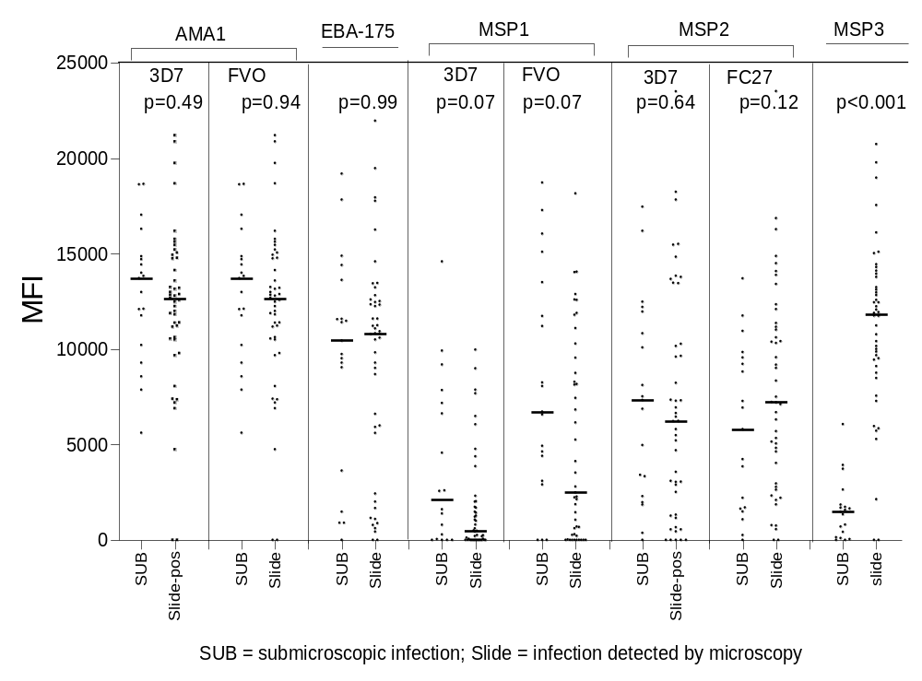
sFig. 1: Comparison of antibody levels in babies at 1 week of life whose subsequent primary infections were submicroscopic or detected by slide-microscopy. Horizontal lines = medians. SUB=submicroscopic infection; Slide=infection detected by microscopy.
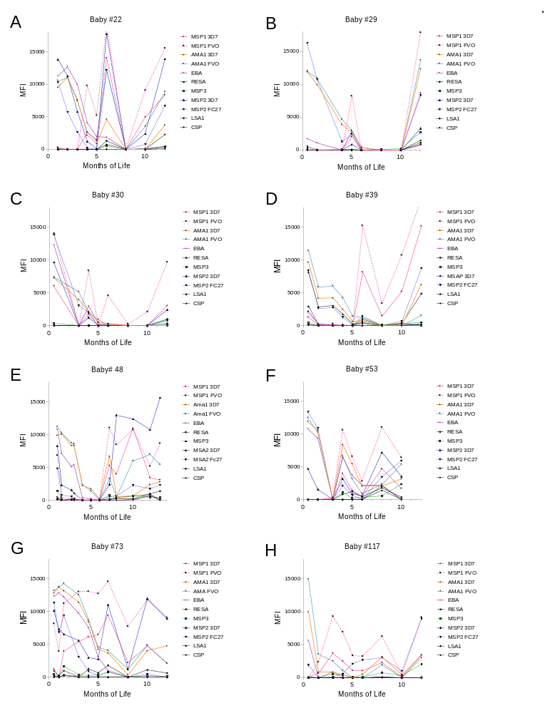
sFig. 2. Some infants had several IgG responses during the first year of life. Note: MFI were similar between the primary and secondary IgG Ab response. Figure A-H show IgG responses of different infants (Baby#)

