Supplementary Material: In-situ temperature and major species measurements of sooting flames based on short-gated spontaneous Raman scattering
Hu Meng, Yihua Ren*, Florence Cameron, Heinz Pitsch
Institute for Combustion Technology, RWTH Aachen University, Templergraben 64, Aachen 52056, Germany
∗ Corresponding author. E-mail address: y.ren@itv.rwth-aachen.de (Y. Ren).

Contents:
S1. Fitting of Time-resolved Rayleigh scattering profile and Gaussian function
S2. Fitting of the experimental spectrum and simulated Raman scattering

S1. Fitting of time-resolved Rayleigh scattering profile and Gaussian function
Each point in the time-resolved Rayleigh scattering profile can be seen as the result of a convolution function I(t) between a laser pulse temporal profile (i.e. Gaussian function g(t; t₀, t_{σ}), where t₀ and t_{σ} are the mean and the variance of the distribution) and the ICCD gate width (i.e. square function S(t) with the width of Δ) as shown in the Fig. S1.
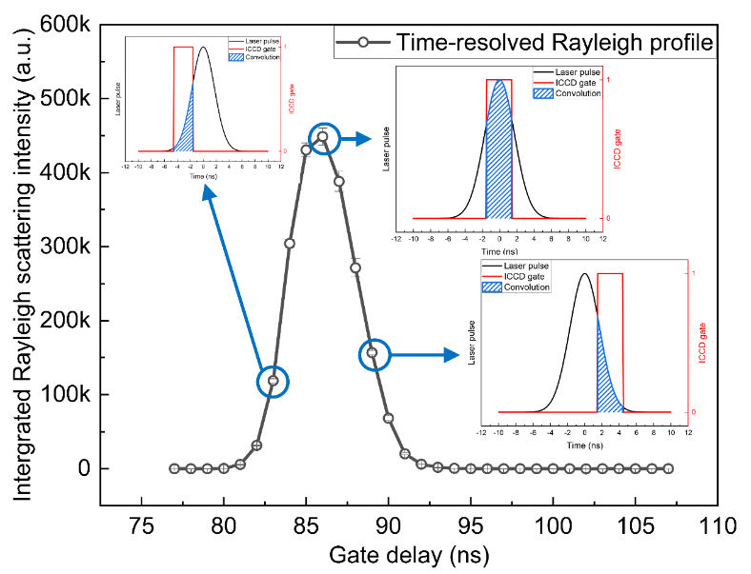
Fig. S1. Time-resolved Rayleigh profile (open dot and black solid line), the convolution result (blue shadow), laser pulse temporal profile (black solid line), and ICCD gate function (red solid line)

Mathematically, the result of the convolution function can be calculated with
$$\begin{aligned} I\left(t;t_{0},t_{σ}\right)=ϕ\left(t+∆\right)-ϕ\left(t\right),\#\left(S.1\right)\end{aligned}$$
where $ϕ\left(t\right)$ is the cumulative distribution function (CDF) of the Gaussian distribution, given by
$$\begin{aligned}ϕ\left(t\right)=\int_{-∞}^{t}{g\left(t;t_{0},t_{σ}\right)}=\frac{1}{2}\left(1+\operatorname{erf}\left(\frac{t-t_{0}}{\sqrt{2}t_{σ}}\right)\right).\#\left(S.2\right)\end{aligned}$$
Figure S2 (a) and (b) show the fitting result of I(t; t₀, t_{σ}) and the best-fitted laser pulse, respectively. The maximum point of the laser intensity profile occurred at the ICCD delay time t₀ of approx. 87.5 ns and thus was denoted as a relative delay time of 0.
Fig. S2. (a) Fitting result of time-resolved Rayleigh (open circle) and fitted cureve (red solid line); (b) Best fitted Gaussian function for the laser pulse profile.

S2. Raman spectrum simulation and nonlinear fitting
Figure S3 shows the normalized discrete vibrational-rotational Raman spectrum of N₂ over a range of temperatures. However, we still need to consider the line broadening, which is related to the laser pulse, the collection system, and the slit of the spectrometer. The line broadening was simulated by the Voigt function. Then the convolution function between the discrete Raman spectrum and the Voigt function can be used as the final simulated Raman spectrum. Figure S4 shows the final simulated N₂ Raman spectrum with different temperatures.
The convolution function has 6 parameters including temperature, shift, stretch, Lorentzian width, Gaussian width, and offset. Considering the laser wavelength is not exactly always 355 nm and the left-shifted Raman spectrum at high temperature, the fitting parameter “shift” was introduced to compensate for it. In addition, the molecule constants are determined from other experiments, which means those constants might have small errors. Thus, the fitting parameter “stretch” was introduced. It is noted that the parameter “stretch” has a very narrow boundary ($±$0.001). Lorentzian width and Gaussian width were used to reflect the width of the Voigt profile. Offset was used to compensate for background, but in this fitting process, it was set to be 0 all the time because the baseline has been corrected already.

Fig. S3. Simulated normalized discrete N₂ Raman spectral with different temperatures
Fig. S4. Simulated normalized N₂ Raman spectral with different temperatures

Figure S5 demonstrates the flow chart of the non-linear fitting process for the temperatures. The discrete Raman scattering and the Voigt profile were simulated with the given initial fitting parameters and the Raman spectrum can be obtained by convolving the two functions with each other. Then, the errors between simulated Raman scattering spectra and the measured spectra were minimized to optimize the fitting parameters by the non-linear least-square-fitting method. When the minimum can be found, the present parameters are the best-fitted result. Otherwise, the initial fitting parameters will be changed and the experimental spectrum will be fitted again.
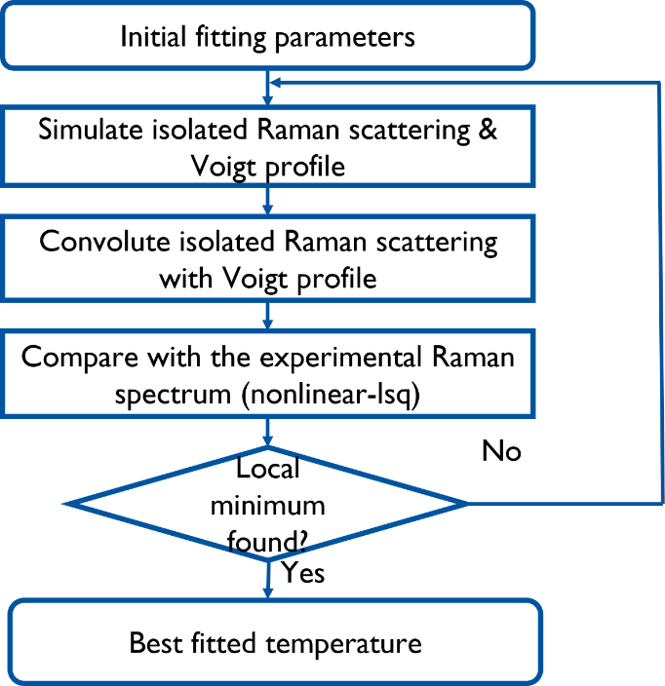
Fig. S5. Flow chart of the non-linear fitting process for temperature measurement

