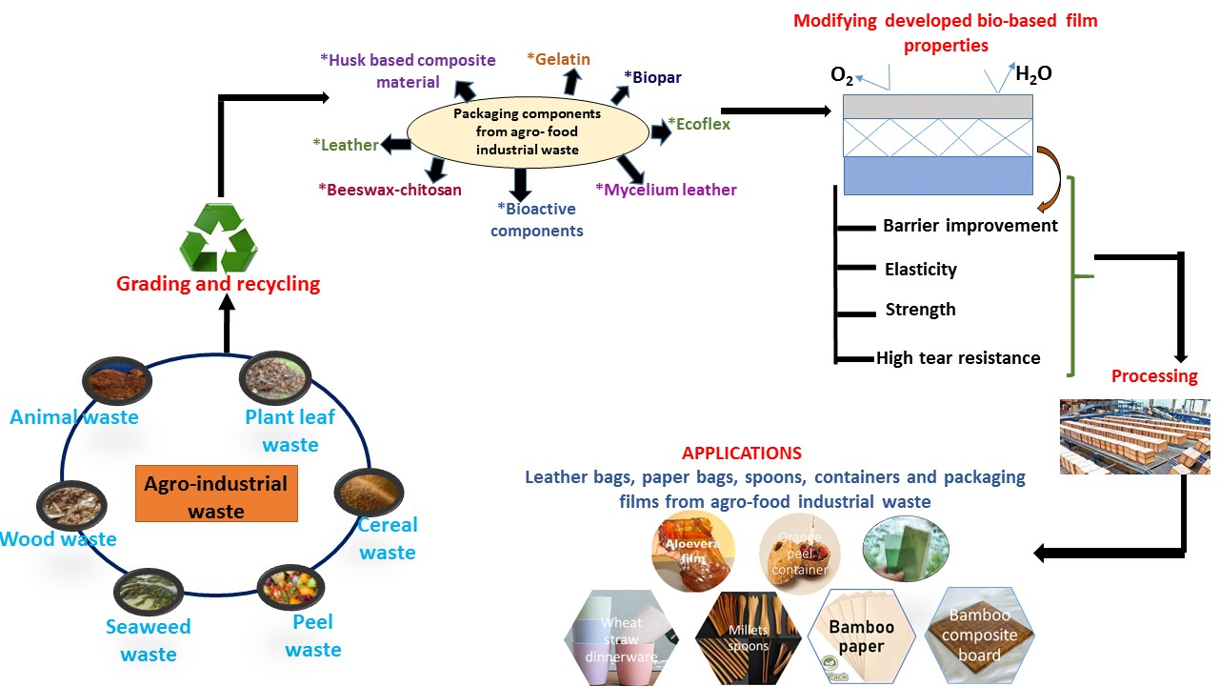
Agro waste Based biodegradable products and their applications to replace single use plastic

