Supplementary material:
Talking Heads: Bone conduction facilitates self-other voice discrimination

Pavo Orepic¹, Oliver Alan Kannape², Nathan Faivre³, Olaf Blanke^{1, 4}

1 Laboratory of Cognitive Neuroscience, Center for Neuroprosthetics and Brain Mind Institute, Faculty of Life Sciences, Swiss Federal Institute of Technology (EPFL), Switzerland
2 Virtual Medicine Center, University Hospital of Geneva, Geneva, Switzerland
3 University Grenoble Alpes, University Savoie Mont Blanc, CNRS, LPNC, Grenoble, France.
4 Department of Clinical Neurosciences, University Hospital of Geneva, Geneva, Switzerland

Corresponding author

Olaf Blanke
Bertarelli Chair in Cognitive Neuroprosthetics, Center for Neuroprosthetics & Brain Mind Institute, School of Life Sciences, Campus Biotech, Swiss Federal Institute of Technology (EPFL), 1012 Geneva, Switzerland
E-mail: olaf.blanke@epfl.ch
Tel: +41 (0)21 693 69 21
Fax: +41 (0)21 693 69 22

Bayesian analyses of the null effects
To further validate null findings of the mixed-effects binomial regressions reported in the main text, we ran two main regressions in a Bayesian framework for the absence of the sound conduction effect in familiar-other task (1) for Study 2, and (3) for Study 3. All Bayesian models were created in Stan computational framework (http://mc-stan.org/) accessed with the brms package¹, based on four chains of 10000 iterations including 2000 warmup samples. We report the highest density probability for all estimates, which specifies the range covering the 95% most credible values of the posterior estimates.
For the null effect of Conduction in the familiar-other task of Study 2 we had a prior assumption of a better performance with bone conduction (i.e., prior on the main effect Conduction with Gaussian distribution of mean = -0.47 and SD = 0.16, based on the same main effect observed in Study 1 for the self-other task). No main effect of Conduction was found (estimate = -0.05, highest posterior density interval = [-0.31 0.21], Bayes factor = 0.17). For the null effect of Conduction in the familiar-other task of Study 3 we had a prior assumption of a better performance with bone conduction (i.e., prior on the main effect Conduction with Gaussian distribution of mean = 0.4 and SD = 0.16, based on the same main effect observed in Study 3 for the self-other task). No main effect of Conduction was found (estimate = 0.14, highest posterior density interval = [-0.16 0.44], Bayes factor = 0.21). Bayes factors smaller than 1 support the null hypothesis, according to which sound conduction did not familiar-other voice discrimination in Studies 2 and 3.
As exploratory analysis, both for Studies 2 and 3, we ran equivalent regressions in a Bayesian framework with a prior assumption of better performance with bone conduction, but represented as a steeper slope (i.e., prior on the interaction between the effects of Conduction and Voice Morph). For the regression in Study 2, the prior had a Gaussian distribution of mean = 0.43 and SD = 0.15 (based on the same interaction observed in the self-other task of Study 1). No interaction between Conduction and Voice Morph was found (estimate = 0.29, highest posterior density interval = [-0.06 0.63], Bayes factor = 0.85). For the regression in Study 3, the prior had a Gaussian distribution of mean = -0.1 and SD = 0.04 (based on the same interaction observed in the self-other task of Study 3). No interaction between Conduction and Voice Morph was found (estimate = -0.05, highest posterior density interval = [-0.13 0.03], Bayes factor = 0.3).

Reaction times
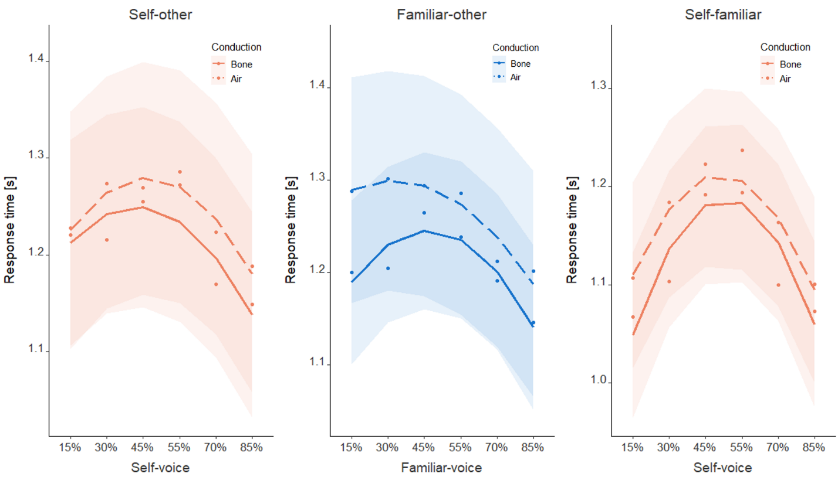
Both in studies 1 and 2, the linear mixed-effect regression on response times identified the main effect of Previous Exposure (1: estimate=-2.03, t(3574)=-14.4, p<.001; 2: estimate=-0.38, t(15.98)=-2.99, p=.009). Participants responded faster when they previously heard the target voice. In none of the four tasks of Study 3 (self-other, familiar-other, self-familiar, control) were reaction times significantly affected by the effect of Conduction, nor was there a significant interaction with the effect of Voice Morph. Polynomial expansion of Voice Morph was significant for all voice discrimination tasks, indicating the ‘inverse-u’ shape of reaction times with the increasing levels of Voice Morph. The details of the models are given in Supplementary Table 1 and the results of the discrimination tasks are illustrated on Supplementary Figure S1.
Fig. S1. Reaction times for the three tasks of Study 3. Shaded areas represent 95% confidence intervals. Sound conduction did not affect reaction times in any task.
Table S1. An overview of the linear mixed-effects models with Reaction Times as dependent variable for all tasks of Study 3.
Task | Effect | estimate | df | t value | p value
Self-other | Conduction | 0.03 | 42.86 | 0.69 | 0.492
Self-other | Voice Morph | -1.92 | 4718.88 | -3.38 | < 0.001
Self-other | Conduction * Voice Morph | -0.15 | 4718.68 | -0.18 | 0.854
Familiar-other | Conduction | 0.04 | 42.98 | 1.34 | 0.188
Familiar-other | Voice Morph | -3.73 | 4825.44 | -6.49 | < 0.001
Familiar-other | Conduction * Voice Morph | 0.66 | 4825.6 | 0.81 | 0.417
Self-familiar | Conduction | 0.05 | 43 | 1.19 | 0.239
Self-familiar | Voice Morph | -2.17 | 4698.25 | -3.75 | < 0.001
Self-familiar | Conduction * Voice Morph | 0.87 | 4697.89 | 1.07 | 0.287
Control | Conduction | 0.02 | 2719.91 | 0.94 | 0.345
Control | Voice | -0.02 | 104.81 | -0.72 | 0.476
Control | Conduction * Voice | -0.02 | 2717.07 | -0.78 | 0.434

Other-to-self voice confusion
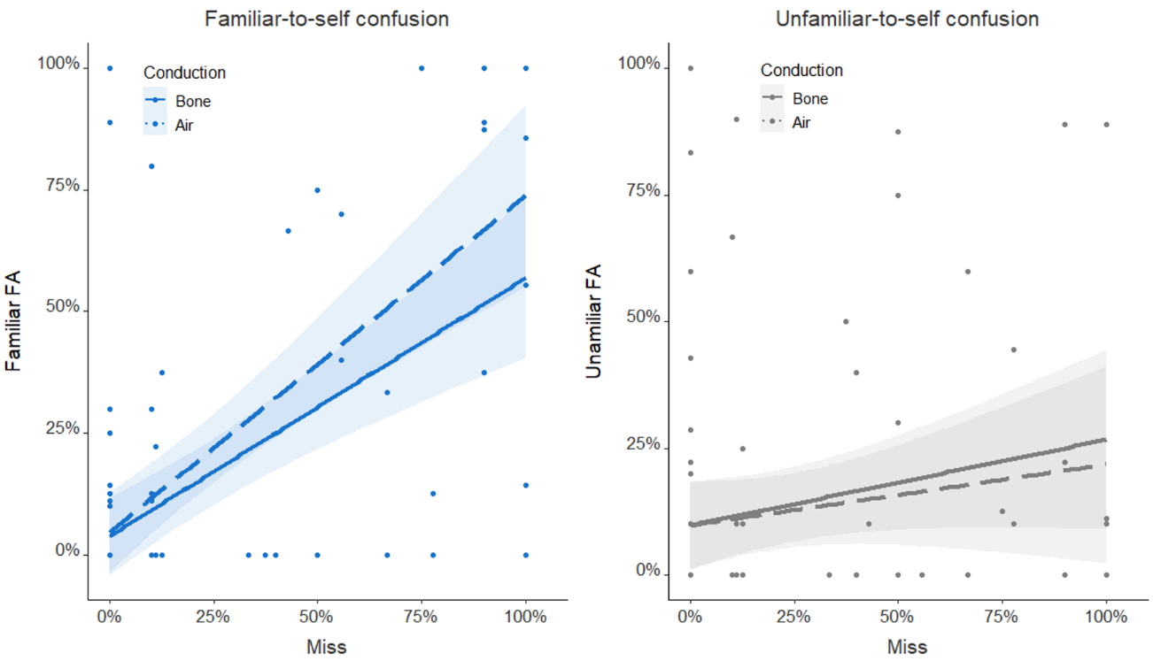
Pearson and Filon’s z-test did not indicate significant differences in correlations between miss and familiar-FA rates with bone and air conduction (z=-0.74, p=.462, Figure S2, left). No such differences were observed for unfamiliar-FAs (z=1, p=.314, Supplementary Figure S2, right).
Fig. S2. Self-confusion effects were unaffected by sound conduction. Regression plots indicate relationships between false alarm rates for familiar (left) and unfamiliar (right) voice with the miss rate for self-voice, separately for air and bone conduction. Shaded areas around linear regressions indicate 95% confidence intervals. Neither familiar-FA nor unfamiliar-FA rates were affected by sound conduction.

Self-other VD acoustic analysis
As the voice-space differs for male and female voices², we placed our voice recordings in the corresponding gender-based space (Figure S3A and S3C) and correlated voice distances with task performance separately for each gender (Figure S3B and S3D). (In the main text we report the same analysis with all participants – male and female – placed in the same voice-space).
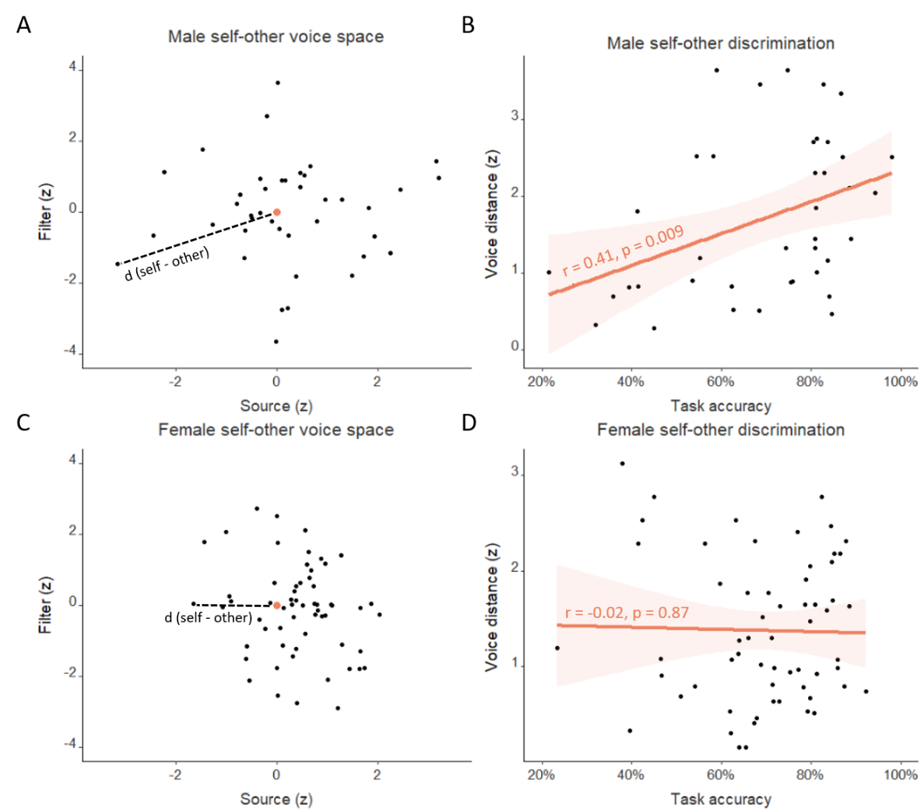
Correlation analysis indicated a positive association between self-other voice distances and self-other task performance for male participants (r=0.41, 95% CI = [0.11, 0.64]; t(38)=2.76, p=.009; Figure S3B). This was not found for female voices (r=-0.02, 95% CI = [-0.27, 0.23]; t(58)=-0.17, p=.869; Figure S3D).
Fig. S3: Self-other voice discrimination – acoustic analysis. Upper plots (A, B) refer to male and lower plots (C, D) to female participants. Left plots (A, C) indicate voice spaces in which the origin (enlarged orange dot) represents the other voice in self-other discrimination tasks. Distance to the origin (dashed line) thus represents each participant’s self-other voice distance in z-score units. On the right plots (B, D), self-other distances were correlated to the self-other task performances. Shaded areas around linear regressions indicate 95% confidence intervals. Positive relationship between voice distances and task performances was found only for male participants (B).
We conducted two exploratory analyses investigating the effects of sound conduction and familiarity of other voice on the relationship between voice-space distances and task performance. None were significant (all p>0.05 in Pearson and Filon’s z-test). (Supplementary Figure S4).
We further split the voice distances to source and filter components as, although both carry identity information^{3,4}, the filter component has explicitly been related to speaker identification⁵ and further been shown to contribute to self-voice recognition⁶. We thus investigated whether the filter component would account more strongly for self-other, as compared to familiar-other discrimination. Pearson and Filon’s z-test revealed a difference in relationships (z=2.41, p=.016) between filter-distances and self-other task (r=0.35, p=.132) and between filter-distances and familiar-other task (r=-0.35, p=.164) (Figure S5B), which did not occur for source-distances (self-other: r=0.33, p=.156; familiar-other: r=0.39, p=.086; z=-0.22, p=.819) (Figure S5A). In addition, the observed difference between self-other and familiar-other tasks in filter-component correlations was more pronounced for bone conduction (self-other: r=0.36, p=.115; familiar-other: r=-0.41, p=.07; z=2.89, p=0.004), as compared to air conduction (self-other: r=0.29, p=.216; familiar-other: r=-0.19, p=.416; z=1.64, p=0.1) (Figure S5C).

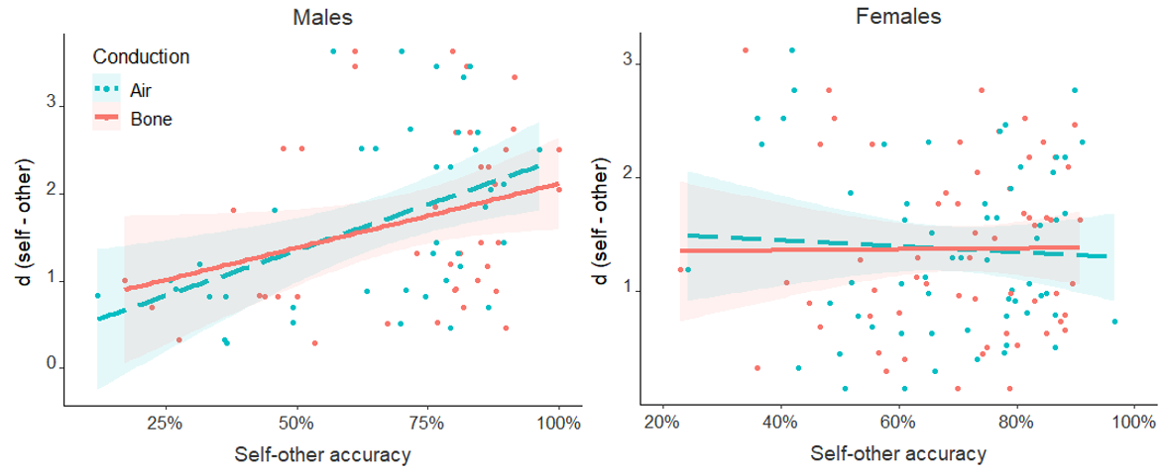
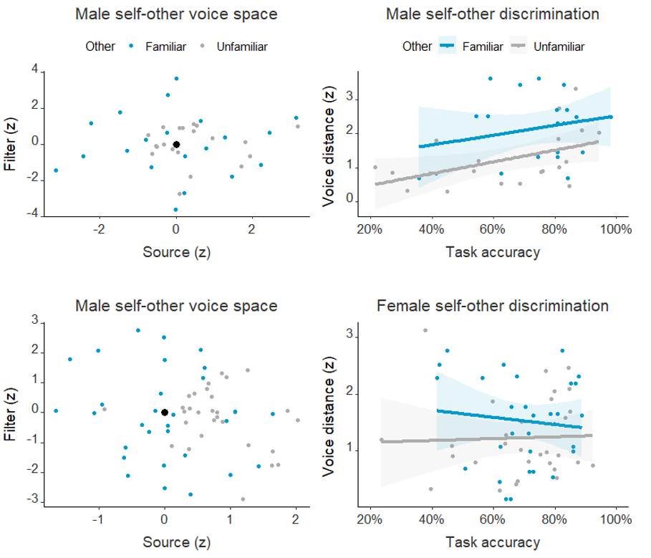
Fig. S4. Neither sound conduction (A) nor other-voice familiarity (B) did affect the relationship between task performance and voice-space distances.
A)
B)
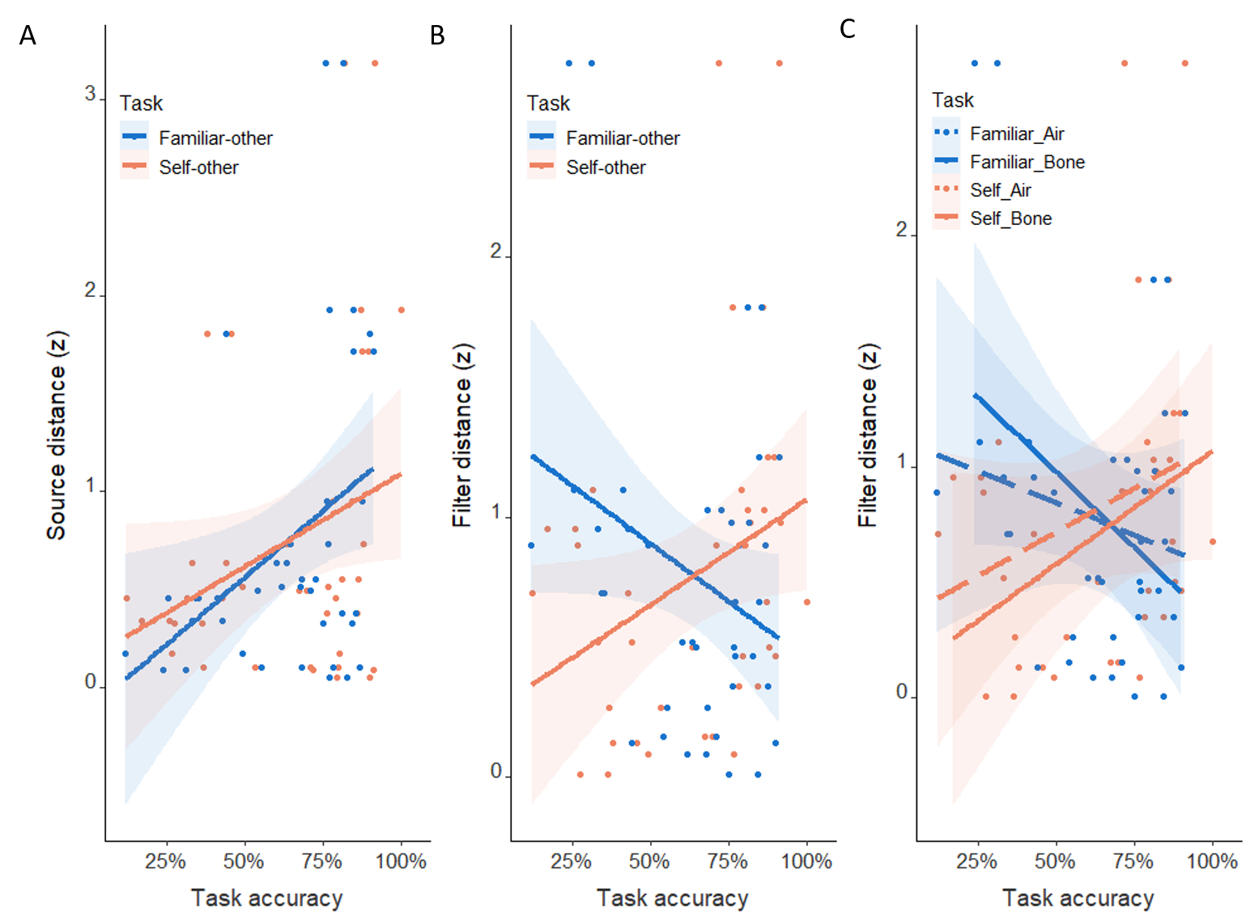
Fig. S5. Different contributions of source and filter components of the source-filter voice space to self-other and familiar-other discriminations. Accuracy of the two discriminations was correlated with source (A) and filter (B) components of voice distances. Shaded areas represent 95% confidence intervals. The difference in relationships was significant only for the filter component (B), which was more prominent for bone, as compared to air conduction (C).

Together, these results indicate that the same acoustic parameters that have been linked to discrimination of other voices² account for VD of the self-voice, and that acoustic parameters related to the filter component of voice production⁷ are related to self-other VD differently than to familiar-other discrimination. However, this was shown only for male voices, possibly because male-voice distances had a higher standard deviation (1.02, z-score) compared to female-voice distances (0.75), although mean voice distance was similar for both genders (male = 1.69, female = 1.37). Female voices have been shown to be less distinctive in terms of auditory properties⁸ and a lack of correlation for female voices might thus simply arise from a reduced variability in female voice distances (which was indeed present in our data; see Figure S3).
Our acoustic analysis further supports the importance of higher formant information for self-voice and extend the understanding of the different roles acoustic properties of voice signals play for speaker identification. By indicating a stronger contribution of the second as compared to the first voice-space dimension to self-other VD, we further extend previous reports⁶ of higher formant information being specific for self-voice. Namely, the two dimensions in Baumann and Belin’s voice space^{2,5,8} correspond to contributions of source (pitch and lower formants, larynx) and filter (higher formants, vocal tract) in the source-filter model of voice production⁷, respectively. Although both are related to speaker’s identity^{3,4}, lower formants can be altered by the speaker⁹, whereas higher formants cannot, as they reflect the morphology of individual vocal cavities¹⁰. Higher formants were thus more closely related to speaker’s identity⁵ and were further shown to play an important role in self-voice recognition⁶. In sum, these findings show that both familiarity mechanisms and acoustic processes contribute to self-voice perception and future studies should identify ways to delineate the corresponding contributions of these factors.

Supplementary references
1. Bürkner, P. C. brms: An R package for Bayesian Multilevel Models using Stan. Journal of Statistical Software 80, (2017).
2. Baumann, O. & Belin, P. Perceptual scaling of voice identity: Common dimensions for different vowels and speakers. Psychological Research 74, 110–120 (2010).
3. Latinus, M. & Belin, P. Perceptual auditory aftereffects on voice identity using brief vowel stimuli. PLoS ONE 7, 1–7 (2012).
4. Schweinberger, S. R. et al. Auditory Adaptation in Voice Perception. Current Biology 18, 684–688 (2008).
5. López, S. et al. Vocal caricatures reveal signatures of speaker identity. Scientific Reports 3, 1–7 (2013).
6. Xu, M., Homae, F., Hashimoto, R. & Hagiwara, H. Acoustic cues for the recognition of self-voice and other-voice. Frontiers in Psychology 4, 1–7 (2013).
7. Ghazanfar, A. A. & Rendall, D. Evolution of human vocal production. Current Biology 18, R457–R460 (2008).
8. Skuk, V. G. & Schweinberger, S. R. Gender differences in familiar voice identification. Hearing Research 296, 131–140 (2013).
9. Maeda, S. Compensatory articulation during speech: Evidence from the analysis and synthesis of vocal-tract shapes using an articulatory model. in Speech production and speech modelling 131–149 (Springer, Dordrecht, 1990).
10. Kitamura, T. & Akagi, M. Speaker individualities in speech spectral envelopes. Journal of the Acoustical Society of Japan (E) (English translation of Nippon Onkyo Gakkaishi) 16, 283–289 (1995).

