Naked-eye optical recognition of ammonia vapor and melamine in water using a fluorophore appended polymer matrix
Shouvik Bhuin and Manab Chakravarty*

Topic | Page No.
Fig. S1 ¹H NMR spectrum for PMMA blended sample and individual components | 2-3
Fig. S2 Detection of different compounds with electronic diversities by AThio4PH powder in solid state | 4
Table S1 Spectral shifts of analytes structurally similar to melamine, by AThio4PH powder at 10⁻⁵ M concentration of each analyte | 4

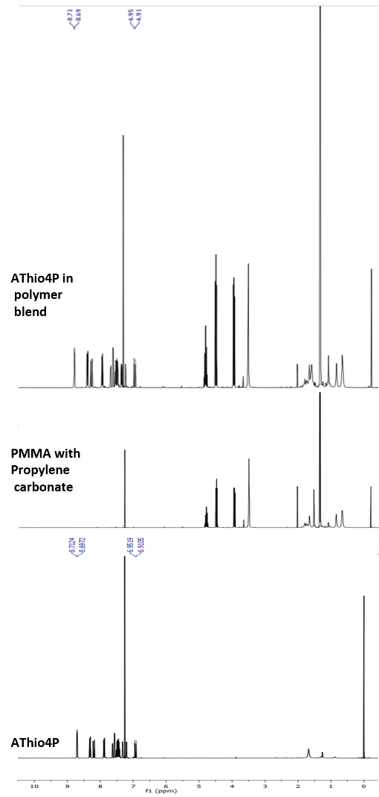
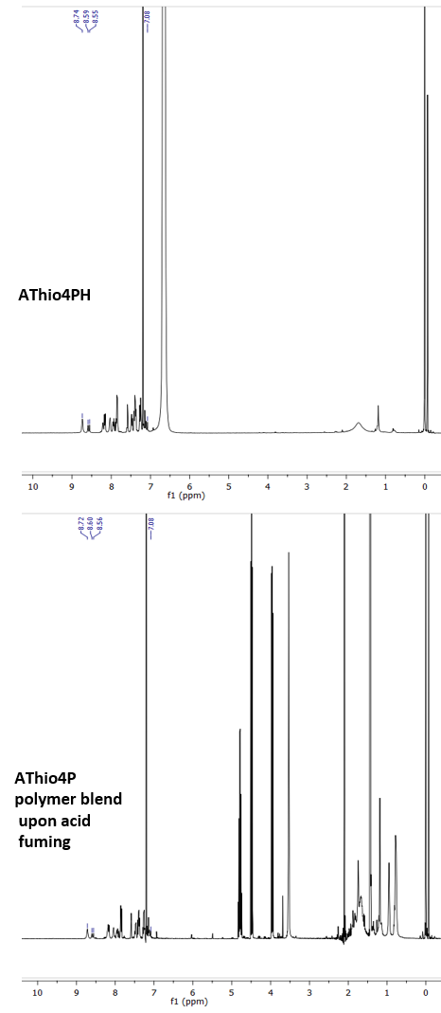
Fig. S1 ¹H NMR spectrum: Solid AThio4P & AThio4P protonated (AThio4PH) sample and their respective polymer blend in comparison to the without sample PMMA+propylene carbonate mixture in d₆-DMSO solvent with the reference signal to TMS at 2.50 ppm, for ¹H NMR

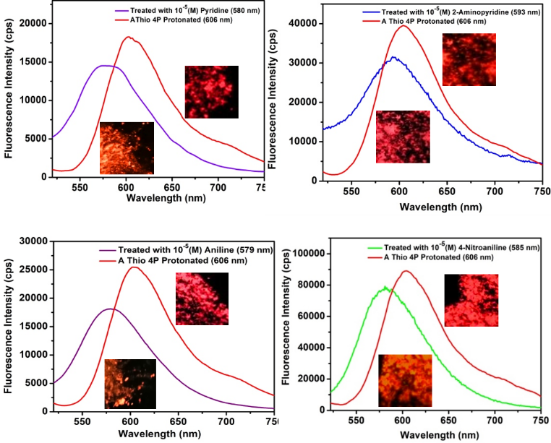
Fig. S2 Sensing of different compounds with electronic diversities by AThio4PH powder in solid state
Table S1 Spectral shifts of analytes structurally similar to melamine, by AThio4PH powder at 10⁻⁵(M) concentration of each analyte
Probe | Analytes | pK_{b} | Concentration of analytes (M) | Spectral blue shift (nm)
AThio4PH powder | Melamine | 9.0 | 10⁻⁵ | 34
AThio4PH powder | Pyridine | 8.8 | 10⁻⁵ | 26
AThio4PH powder | 2-aminopyridine | 7.20 | 10⁻⁵ | 13
AThio4PH powder | Aniline | 9.38 | 10⁻⁵ | 27
AThio4PH powder | 4-nitroaniline | 12.99 | 10⁻⁵ | 21

_________________________________END_______________________________________

