Supplementary Information
Regio-isomers of 2,5,6,7,8-pentaaryl-1H-azepino[3,2,1-ij]quinazoline-1,3(2H)-dione containing various aryl substituents in the azepine ring: structures determination using NMR methods

Julia A. Pronina¹, Darya D. Komolova², Vitali M. Boitsov³, Alexander V. Stepakov^{1,2}, Stanislav I. Selivanov²,*

Stanislav I. Selivanov, contact E-mail: nmr.group.spbu@gmail.com; s.selivanov@spbu.ru;
^{2, *} Laboratory of Biomolecular NMR, St. Petersburg State University, 199034, St. Petersburg, Russia

Table of Contents page

Figure S1. ¹H NMR spectrum of mixture (3) in CDCl₃ (300 MHz) 3
Figure S2. ¹³C NMR spectrum of mixture (3) in CDCl₃ (300 MHz) 4
Figure S3. Low-field fragment of COSY spectrum of mixture (3) in CDCl₃ (300 MHz) 5
Figure S4. NOESY spectrum of mixture (3) in CDCl₃ (300 MHz) 6
Figure S5. Low-field region of ¹H-¹³C HSQCnd spectrum of adducts (3a) and (3d) in CDCl₃
(300 MHz) 7
Figure S6. ¹H-¹³C HMBC spectrum of adducts (3a) and (3d) in CDCl₃ (400 MHz) 8
Figure S7. Low-field region of J-COSY spectrum of mixture (3) in CDCl₃ (300 MHz) 9
Figure S8. Fragments of ¹³C NMR spectrum of mixture (3) in CDCl₃ (300 MHz) 10
Figure S9. Fragment of ¹H-¹³C HSQCnd spectrum of adducts (3a) and (3d) in CDCl₃
(300 MHz) for assignments of protonated ortho-carbon signals in Ph²-Ph⁵ rings 11
Figure S10. Fragment of ¹H-¹³C HMBC spectrum of adducts (3a) and (3d) in CDCl₃
(400 MHz) for assignments of quaternary carbon signals 12
Figure S11. Fragments of NOESY spectrum of mixture (3) in CDCl₃ (300 MHz) for
assignment of methoxy group signals (a) and for interpretation of cross-peak
between H8 and nearest ortho-protons (b). 13
Table S1. Difference of chemical shifts ∆δ (ppm) in NMR ¹H and ¹³C spectra of
regio-isomers (3a) and (3d) in CDCl₃ 14
Experimental information 15
Structure optimization 15

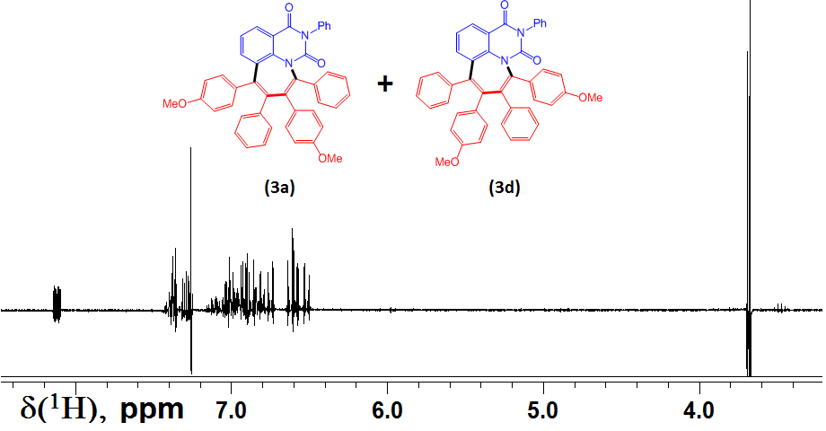
Figure S1. ¹H NMR spectrum of mixture (3) in CDCl₃ (300 MHz). Spectral width 3.6 kHz, 16 k data points, number of transients 32, relaxation delay 2 s and excitation 90° pulse -11μs.

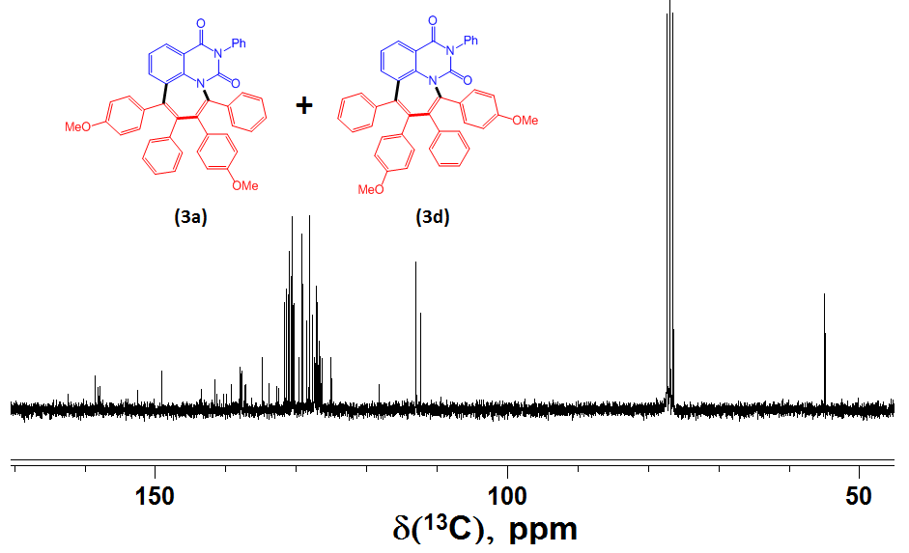
Figure S2. ¹³C NMR spectrum of mixture (3) in CDCl₃ (300 MHz). Spectral width 16.5 kHz, 32 k data points, relaxation delay 1.5 s, excitation 45° pulse and number of transients 1024.

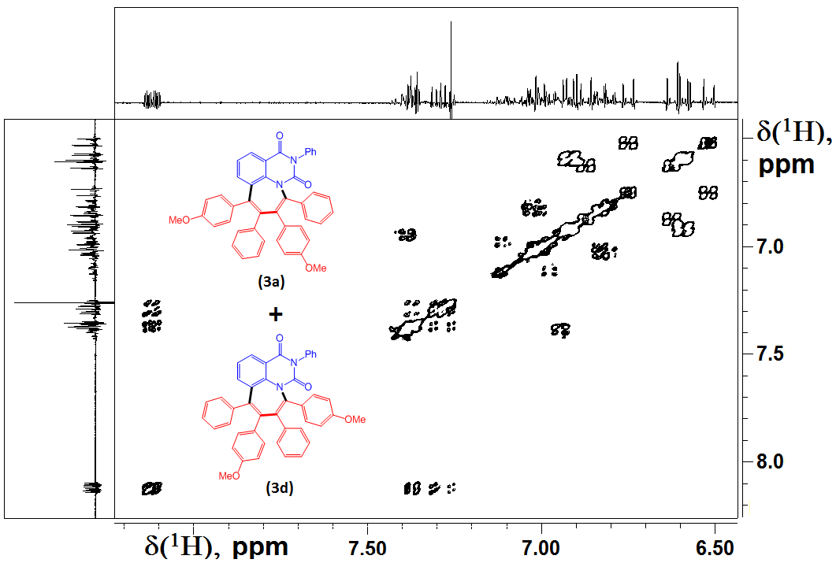
Figure S3. Low-field fragment of spectrum COSY of mixture (3) in CDCl₃ (300 MHz).

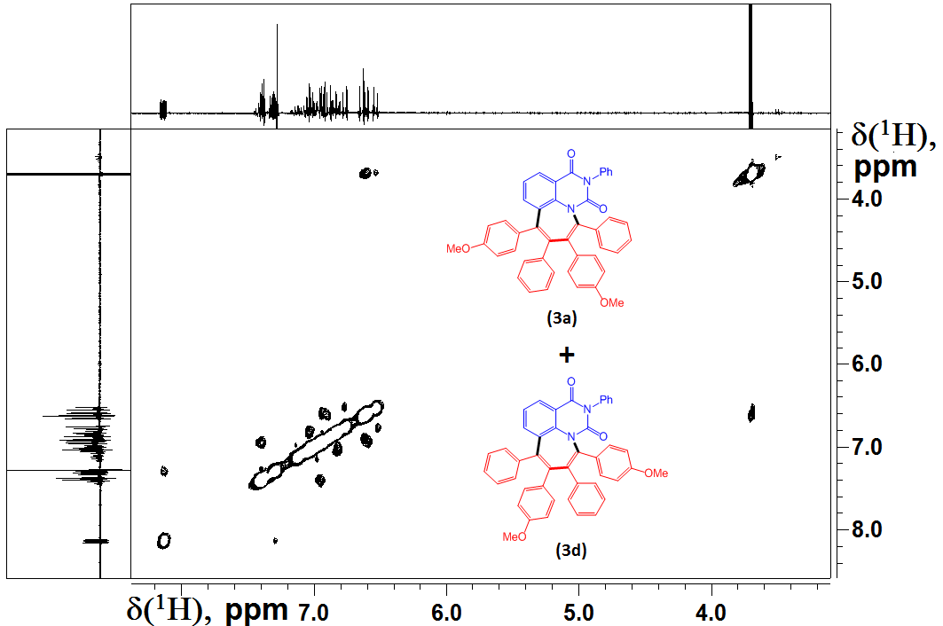
Figure S4. NOESY spectrum of mixture (3) in CDCl₃ (300 MHz) at mixing time 0.5 s.

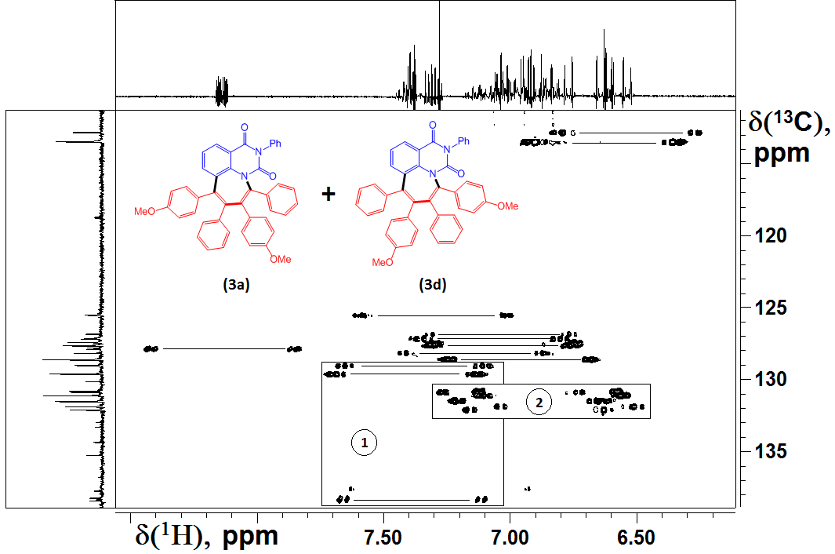
Figure S5. Low-field region of ¹H-¹³C HSQCnd of adducts (3a) and (3d) in CDCl₃ (300 MHz). Fragments in rectangles 1 and 2 were used for preparation of picture for Fig. 6 and Fig. S9, respectively.

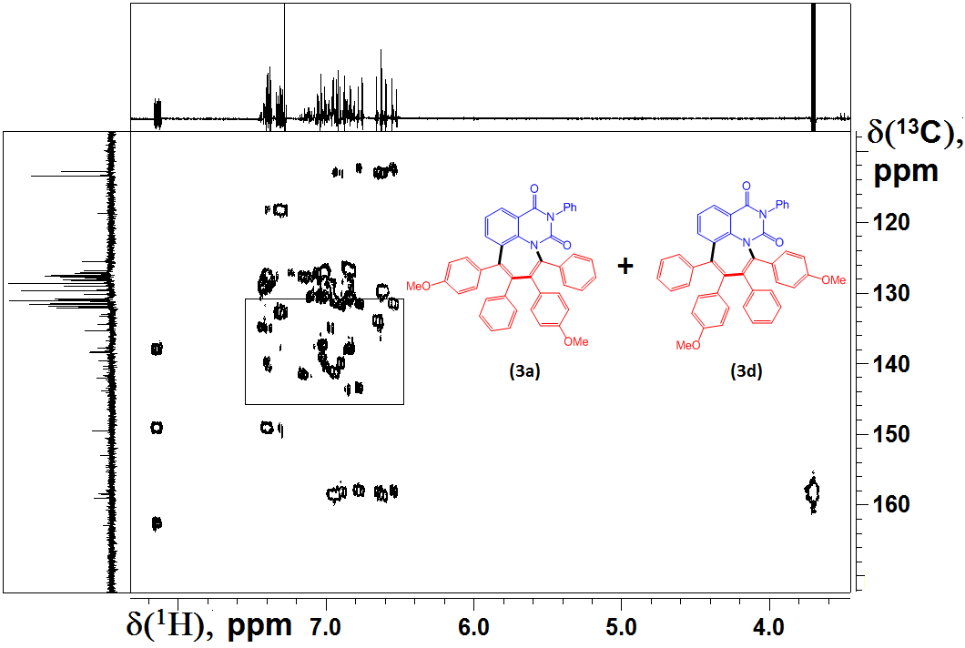
Figure S6. ¹H-¹³C HMBC spectrum of adducts (3a) and (3d) in CDCl₃ (400 MHz). Fragment in rectangle was used for preparation of picture for Fig. S10.

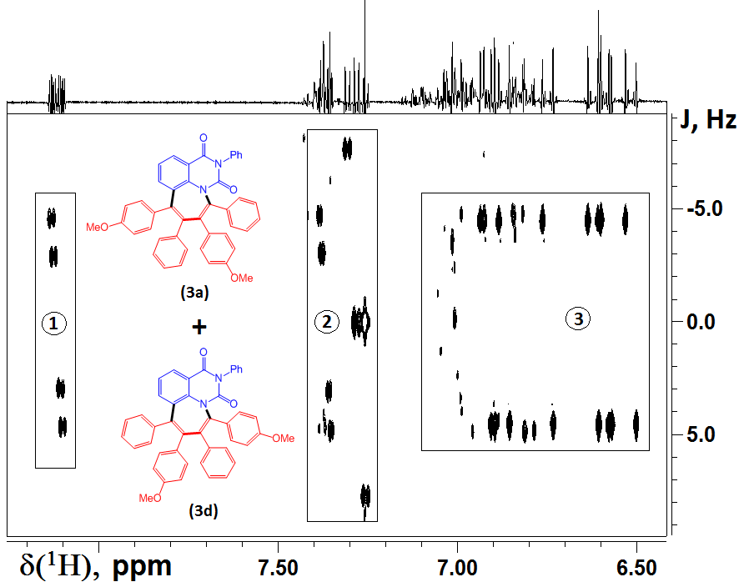
Figure S7. Low-field region of J-COSY spectrum of mixture (3) in CDCl₃ (300 MHz). Fragments in rectangles 1 and 2 were used for preparation of picture for Fig. 3 and fragment in rectangle 3 for Fig. 4.

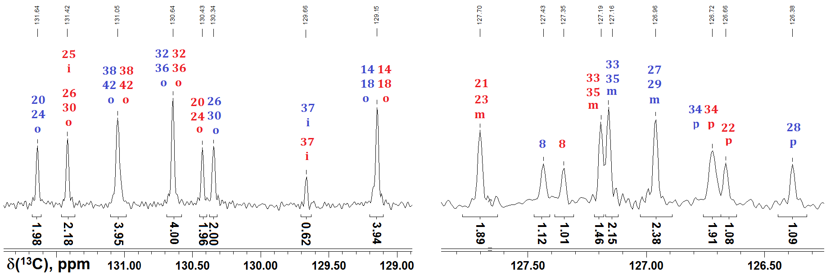
Figure S8. Fragments of ¹³C NMR spectrum of mixture (3) in CDCl₃ (300 MHz). Relative signal integral values of dominant (3a) and minor (3d) regio-isomers are shown by blue and red figures and ortho-, meta-, para-, ipso-carbon signals by letters “o”, “m”, “p”, “i”, respectively.

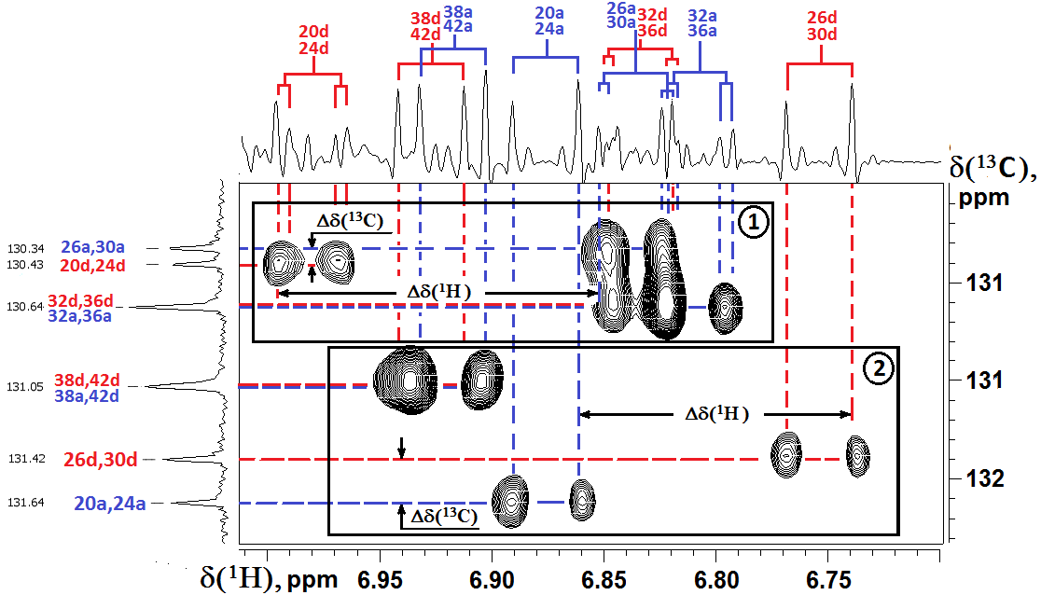
Figure S9. Fragment of ¹H-¹³C HSQCnd spectrum of adducts (3a) and (3d) in CDCl₃ (300 MHz) for assignments of protonated ortho-carbon signals in Ph²-Ph⁵ rings. In rectangles 1 and 2 ortho-proton and ortho-carbon chemical shift differences between their values in (3a) and (3d) regio-isomers are shown.

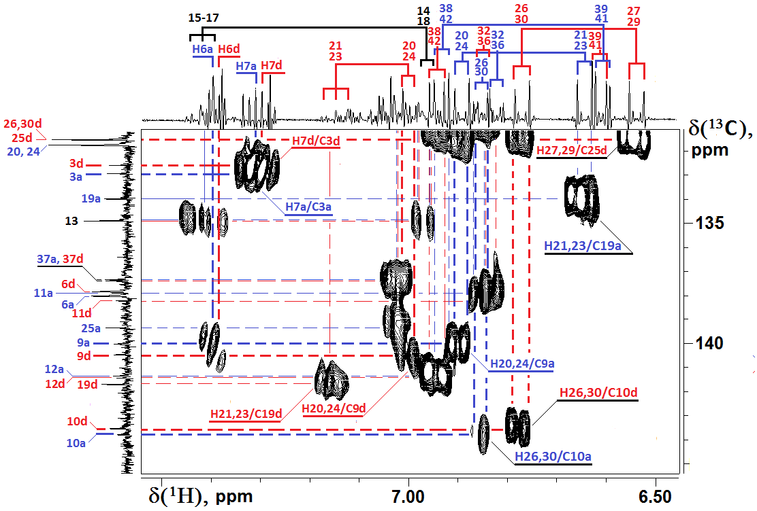
Figure S10. Fragment of ¹H-¹³C HMBC spectrum of adducts (3a) and (3d) in CDCl₃ (400 MHz) for assignments of quaternary carbon signals. Only most important for assignment cross-peaks are depicted.

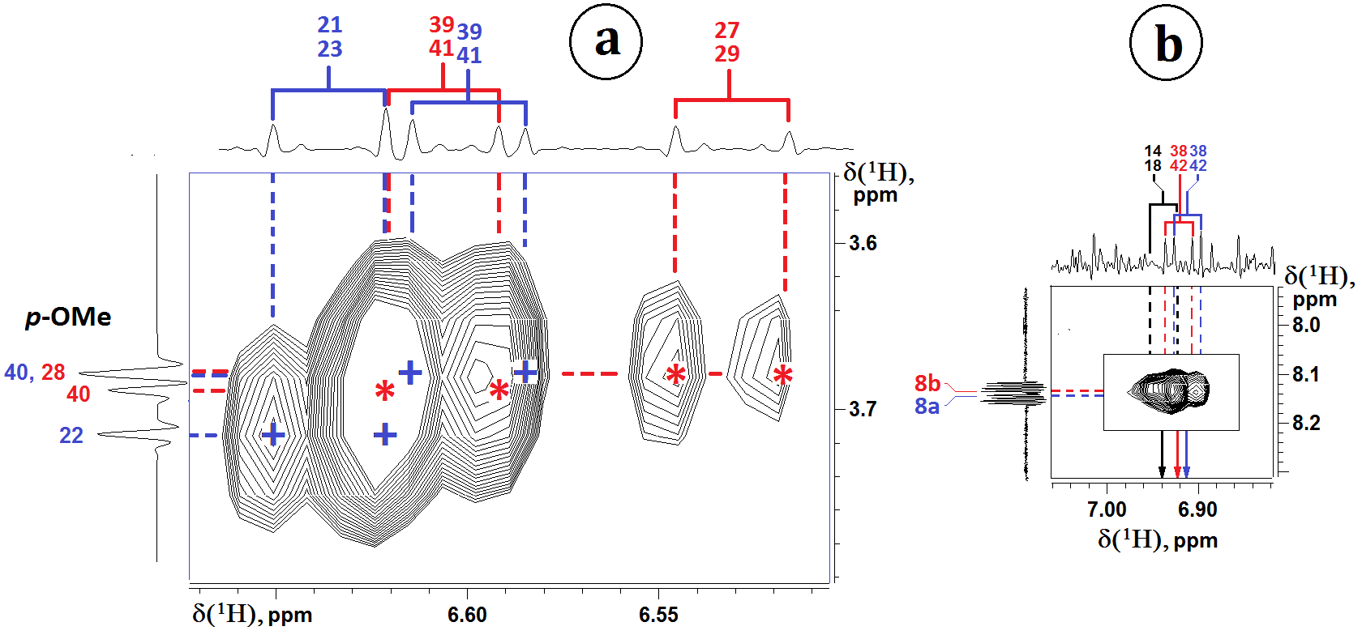
Figure S11. Fragments of NOESY spectrum of mixture 3 in CDCl₃ (300 MHz) for assignment of methoxy group signals (a) and for interpretation of cross-peak between H8 and nearest ortho-protons (b). Positions of meta-proton doublet signals in dominant (3a) and minor (3d) regio-izomers are shown using blue “+” and red “*” risks, respectively.

Table S1. Difference of chemical shifts ∆δ (ppm) in NMR ¹H and ¹³C spectra of regio-isomers (3a) and (3d) in CDCl₃^{*)}
№  of atom | ¹H | ¹³C | № of atom | ¹H | ¹³C
№  of atom | ∆δ = δ^{(3a)} – δ^{(3d)} | ∆δ = δ^{(3a)} – δ^{(3d)} | № of atom | ∆δ = δ^{(3a)} – δ^{(3d)} | ∆δ = δ^{(3a)} – δ^{(3d)}
1 | - | 0.00 | 23 (m) | -0.48 | -14,69
2 | - | 0.00 | 24 (o) | -0.1 | 1,21
3 | - | 0.34 | 25 (i) | - | 7,82
4 | - | 0.00 | 26 (о) | 0.08 | -1,07
5 | - | 0.06 | 27 (m) | 0.49 | 14,6
6 | 0.006 | 0.18 | 28 (p) | - | -31,57
7 | 0.013 | -0.03 | 29 (m) | 0.49 | 14,6
8 | 0.011 | 0.08 | 30 (o) | 0.08 | -1,07
9 | - | -0.45 | 31 (i) | - | 0.05
10 | - | 0.25 | 32 (o) | -0.03 | 0.00
11 | - | -0.33 | 33 (m) | 0.00 | -0.03
12 | - | -0.38 | 34 (p) | 0.00 | 0.00
13 | - | 0.00 | 35 (m) | 0.00 | -0.03
14(o) | 0.00 | 0.00 | 36 (o) | -0.03 | 0.00
15(m) | 0.00 | 0.00 | 37 (i) | - | 0.00
16 (p) | 0.00 | 0.00 | 38 (o) | -0.009 | 0.00
17 (m) | 0.00 | 0.00 | 39 (m) | -0.007 | 0.00
18 (o) | 0.00 | 0.00 | 40 (p) | - | 0.00
19 (i) | - | -7,71 | 41 (m) | -0.007 | 0.00
20 (o) | -0.1 | 1,21 | 42 (o) | -0.009 | 0.00
21 (m) | -0.48 | -14,69 | p-ОСН₃  (Рh²) | -0.005 | 0.00
22 (p) | - | 31,46 | p-ОСН₃ (Рh^{4,5}) | 0.018 | 0.06
^{*)} - ∆δ were calculated on base experimental chemical shift data in Table 1

Experimental information
¹H and ¹³C NMR spectra and all 2D-experiments were recorded at 295 °K on “Bruker” NMR spectrometers DPX 300 and AVANCE 400 with ¹H Larmor frequencies of 300 and 400 MHz, respectively. ¹H and ¹³C chemical shifts are given relative to solvent signal CHCl₃/CDCl₃ as reference at 7.26 and 76.9 ppm, respectively. In case of quantitative NOE measurements spectrometer DPX 300 was used and full experimental time was about 25 hours. Peak amplitude normalization for improved cross-relaxation (PANIC) was used to obtain quantitative estimates of interproton distances. HSQCnd and HMBC experiments were optimized on scalar constant values ¹J_{C-H} and ^{2,3}J_{C-H} of 145 and 8 Hz, respectively. The concentration of adducts under study (3a) and (3d) was about (5 ̶ 10)%.
Structure optimization
Molecular mechanic calculations (Molecular Modeling System, PC program HyperChemTM, release 8.0.8, HyperCube Inc.) were used for geometry optimizations of preferable conformers which may exist in solution during rotation of side substitutes R¹-R⁵ of regio-isomers (3a) and (3d). These calculated data were taken into account at interpretation of the experimental time-averaged values of long-range interproton distances determined from NOESY spectra using cross-peak volume integrals.

