Supplementary information

Silver lining to a climate crisis: multiple prospects for alleviating crop waterlogging under future climates

Supplementary Tables 1-3
Supplementary Figures 1-9

Supplementary Table 1. Global climate models (GCMs) used to project Shared Socioeconomic Pathways Scenario SSP585 in this study.
Model ID | Name of GCM | GCM abbreviation | Institute ID | Country
1 | ACCESS-CM2 | ACC1 | CSIRO-ACCESS | Australia
2 | ACCESS-ESM1-5 | ACC2 | CSIRO-ACCESS | Australia
3 | BCC-CSM2-MR | BCCC | BCC | China
4 | CanESM5 | Can1 | CCCma | Canada
5 | CanESM5-CanOE | Can2 | CCCma | Canada
6 | CIESM | CIES | THU | China
7 | CMCC-CM2-SR5 | CMCS | CMCC | Italy
8 | CNRM-CM6-1 | CNR2 | CNRM-CERFACS | France
9 | CNRM-CM6-1-HR | CNR3 | CNRM-CERFACS | France
10 | CNRM-ESM2-1 | CNR1 | CNRM-CERFACS | France
11 | EC-Earth3 | ECE1 | EC-EARTH-Consortium | Europe
12 | EC-Earth3-Veg | ECE2 | EC-EARTH-Consortium | Europe
13 | FGOALS-g3 | FGOA | CAS | China
14 | GFDL-CM4 | GFD1 | NOAA-GFDL | USA
15 | GFDL-ESM4 | GFD2 | NOAA-GFDL | USA
16 | GISS-E2-1-G | GISS | NASA-GISS | USA
17 | HadGEM3-GC31-LL | HafG | MOHC | UK
18 | INM-CM4-8 | INM1 | INM | Rusia
19 | INM-CM5-0 | INM2 | INM | Rusia
20 | IPSL-CM6A-LR | IPSL | IPSL | France
21 | MIROC6 | MIR1 | MIROC | Japan
22 | MIROC-ES2L | MIR2 | MIROC | Japan
23 | MPI-ESM1-2-HR | MPI1 | MPI-M | Germany
24 | MPI-ESM1-2-LR | MPI2 | MPI-M | Germany
25 | MRI-ESM2-0 | MTIE | MRI | Japan
26 | NESM3 | NESM | NUIST | China
27 | UKESM1-0-LL | UKES | MOHC | UK

Supplementary Table 2 APSIM phenology parameters for genotypes sown at each location under early (ESD) and late (LSD) sowing. Parameters were chosen to ensure that flowering occurred during the typical flowering period for the location assuming current practice. Parameters ‘vern’ and ‘ppd’ refer to vernalisation and photoperiod respectively, representing cumulative cold temperature requirement to initiate reproductive development and sensitivity to day length; higher values denote greater sensitivity. Parameter ‘tt_emerg_to_endjuv’ refers to the thermal time between emergence and the end of the juvenile phase (°C), another key determinant of development.
Country | Sub-region | Abbre | Lat | Long | Soil type | Barley type | tt_emerg_  to_endjuv | vern | ppd | ESD | LSD
 |  |  |  |  |  |  | (°C) |  |  | (DOY) | (DOY)
UK | Norwich | UKNo | 52.68 | 1.31 | Haplic Cambisols | Spring | 400 | 1 | 1 | 61 | 122
UK | Burghed Beach | UkBu | 57.69 | -3.47 | Haplic Cambisols | Spring | 400 | 1 | 1 | 61 | 122
UK | Arborath | UKAr | 56.59 | -2.7 | Endoleyic Cambisols | Spring | 400 | 1 | 1 | 61 | 122
UK | Duns | UKDu | 55.77 | -2.34 | Endoleyic Cambisols | Spring | 400 | 1 | 1 | 61 | 122
Spain | Leon | ESle | 42.67 | -5.59 | Haplic Luvisols | Spring | 400 | 1 | 1 | 61 | 122
Spain | Cuenca | ESCu | 40.21 | -2.14 | Halic Kasanozems | Spring | 400 | 1 | 1 | 61 | 122
France | Arras | FRAr | 50.37 | 2.63 | Haplic Luvi sols | Spring | 400 | 1 | 1 | 46 | 102
France | Merz | FRMe | 49.24 | 6.14 | Haplic Cambisols | Spring | 400 | 1 | 1 | 46 | 102
Germany | Weiden | DEWe | 49.61 | 12.11 | Haplic Cambisols | Spring | 400 | 1 | 1 | 62 | 131
Germany | Munich | DEMu | 48.31 | 11.58 | Haplic Cambisols | Spring | 400 | 1 | 1 | 62 | 131
Ethiopia | Holetta | ETHo | 9.05 | 38.48 | Haplic Luvisols | Spring | 400 | 1 | 1 | 153 | 243
USA | Lewistown | USLe | 47.09 | -109.46 | Halic Kasanozems | Spring | 400 | 1 | 1 | 61 | 151
USA | Logan | USLo | 41.8 | -111.92 | Halic Kasanozems | Spring | 400 | 1 | 1 | 61 | 151
USA | Rugby | USRu | 48.42 | -99.98 | Halic Chernozems | Spring | 400 | 1 | 1 | 61 | 151
Canada | Lethbridge | CALe | 49.81 | -112.74 | Halic Kasanozems | Spring | 400 | 1 | 1 | 122 | 182
Canada | Saskatoon | CASa | 52.25 | -106.65 | Halic Chernozems | Spring | 400 | 1 | 1 | 122 | 182
Russia | Suzemka | RUSu | 52.31 | 34.07 | Halic Albeluvisols | Spring | 400 | 1 | 1 | 92 | 122
Russia | Morozovski | RUMo | 48.38 | 41.7 | Halic Chernozems | Spring | 400 | 1 | 1 | 92 | 122
Russia | Tambov | RUTa | 52.73 | 41.44 | Halic Chernozems | Spring | 400 | 1 | 1 | 92 | 122
Russia | Livny | RULi | 52.39 | 37.58 | Halic Chernozems | Spring | 400 | 1 | 1 | 92 | 122
Australia | Wagga Wagga | AUWa | -34.83 | 147.49 | Haplic Luvisols | Winter | 400 | 4 | 1 | 92 | 172
Australia | Campbell Town | AUCa | -41.95 | 147.59 | Haplic Cambisols | Winter | 400 | 4 | 1 | 92 | 172
Argentina | Sierra de La Ventana | ARSi | -38.13 | -61.79 | Haplic Luvisols | Spring | 400 | 1 | 4 | 162 | 223
Argentina | Loberia | ARLo | -38.1 | -58.83 | Luvic Phaeozems | Spring | 400 | 1 | 4 | 162 | 223
China | Yancheng | CNYa | 33.43 | 120.14 | Haplic Fluvisols | Winter | 400 | 4 | 2.5 | 294 | 330
China | Huaian | CNHu | 33.62 | 119.12 | Haplic Fluvisols | Winter | 400 | 4 | 2.5 | 294 | 330
Germany | Weiden | DEWe | 49.61 | 12.11 | Haplic Cambisols | Winter | 660 | 4 | 2.8 | 245 | 306
Germany | Munich | DEMu | 48.31 | 11.58 | Haplic Cambisols | Winter | 660 | 4 | 2.8 | 245 | 306
Russia | Metelev | RUMe | 46.88 | 39.07 | Halic Chernozems | Winter | 500 | 4 | 3 | 306 | 335
Russia | Stavropol | RUSt | 45.12 | 41.82 | Halic Chernozems | Winter | 500 | 4 | 3 | 306 | 335
UK | Norwich | UKNo | 52.68 | 1.31 | Haplic Cambisols | Winter | 690 | 4 | 3 | 259 | 306
UK | Burghed Beach | UkBu | 57.69 | -3.47 | Haplic Cambisols | Winter | 690 | 4 | 3 | 259 | 306
UK | Arborath | UKAr | 56.59 | -2.7 | Endoleyic Cambisols | Winter | 690 | 4 | 3 | 259 | 306
UK | Duns | UKDu | 55.77 | -2.34 | Endoleyic Cambisols | Winter | 690 | 4 | 3 | 259 | 306
Ukraine | Kharkiv | UAKh | 50.00 | 36.26 | Halic Chernozems | Spring | 400 | 1 | 4 | 101 | 141
Ukraine | Mykolaiv | UAMy | 47.07 | 32.06 | Halic Chernozems | Spring | 400 | 2.5 | 4 | 70 | 92
Australia | Esperance | AUEs | -33.59 | 121.87 | Haplic Luvisols | Spring | 400 | 2.5 | 4 | 92 | 172
Australia | Yarloop | AUYa | -32.95 | 115.9 | Haplic Solonetz | Spring | 400 | 2.5 | 4 | 92 | 172
Australia | Mortana | AUMo | -33.01 | 134.43 | Haplic Solonetz | Spring | 400 | 2.5 | 4 | 92 | 172
Australia | Minnipa | AUMi | -32.72 | 135.21 | Haplic Arenosols | Spring | 400 | 2.5 | 4 | 92 | 172
Australia | Cummins | AUCu | -34.15 | 135.79 | Haplic Solonetz | Spring | 400 | 2.5 | 4 | 92 | 172
Australia | Clare | AUCl | -33.75 | 138.68 | Haplic Solonetz | Spring | 400 | 2.5 | 4 | 92 | 172
Spain | Leon | ESle | 42.67 | -5.59 | Haplic Luvisols | Winter | 400 | 4 | 4 | 306 | 366
Spain | Cuenca | ESCu | 40.21 | -2.14 | Halic Kasanozems | Winter | 400 | 4 | 4 | 306 | 366
Turkey | Konya | TUKo | 37.94 | 32.49 | Haplic Calcisols | Winter | 400 | 4 | 4 | 275 | 335
Turkey | Sanliurfa | TUSa | 37.16 | 38.79 | Calcic Vertisols | Winter | 400 | 4 | 4 | 275 | 335
France | Arras | FRAr | 50.37 | 2.63 | Haplic Luvisols | Winter | 750 | 4 | 4 | 245 | 306
France | Merz | FRMe | 49.24 | 6.14 | Haplic Cambisols | Winter | 750 | 4 | 4 | 245 | 306

Supplementary Table 3. Change in yield of winter and spring barley for the 2040s (2030-2059) and 2080s (2070-2099) relative to the baseline (1985-2016) under early (ES) or late sowing (ES) for SSP585. Values are averaged for each climate period (2040s and 2080) across 27 GCMs.
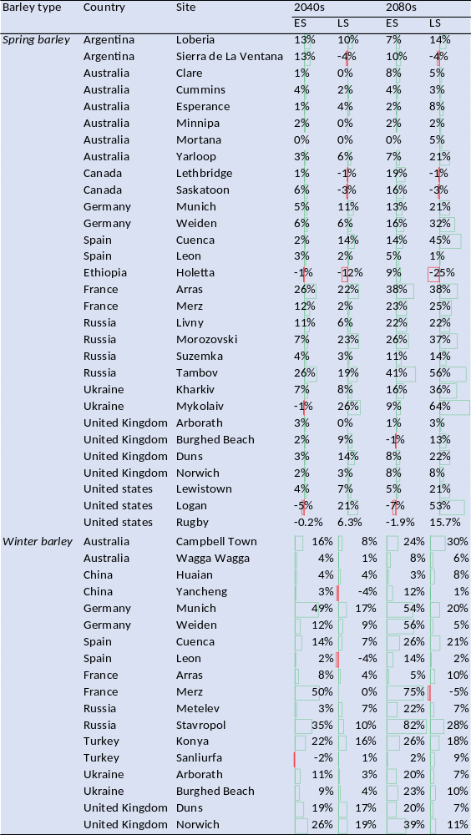
Supplementary Table 4 Parameterised APSIM genotypic coefficients of genotypes used in waterlogging experiments. Abbreviations: tt_end_of_juvenile (TEJ, thermal time from sowing to end of juvenile stage), tt_start_grain_fill (TSGF, thermal time at the beginning of grain filling), photop_sens (PPD, photoperiod sensitivity), vern_sens (VERN, vernalisation sensitivity), grains_per_gram_stem (GPGS, the number of grain per gram of stem), potential_grain_filling_rate (PGFR, grain growth rate during grain-filling stage). Measured data from experiments conducted in five countries were used for model development and validation. Exp1 was conducted under controlled conditions (Launceston, Tasmania, Australia) with four waterlogging treatments using six contemporary Australian barley genotypes differing in their waterlogging tolerance from 2019 to 2020 (see ref.^{1, 2}). In Exp2, barley yields were measured under five waterlogging treatments in the greenhouse and field conditions at the School of Agronomy, University of Buenos Aires, Argentina during 2010 (see ref.³). In Exp3, barley genotypes were evaluated for waterlogging tolerance in controlled field conditions at Brandon Research and Development Centre, Brandon, Manitoba, Canada from 2016 to 2017. Waterlogging treatments were initiated at the tillering stage by adding the water to heights of 0.5–1 cm above the soil surface (see ref.⁴). In Exp4, barley yields were measured in field conditions carried out at Oak Park, Carlow, Ireland from 2017 to 2018. Waterlogging treatments were initiated at the tillering stage using a boom irrigator (see ref.⁵). In Exp5, field experiments were conducted in 2003-2004 and 2005-2006 at Zhejiang University, Hangzhou, China (see ref.^{6, 7}).
Experiments | Genotypes | TEJ (°C) | TSGF (°C) | VERN | PPD | GPGS (g) | PGFR  (g grain⁻¹ d⁻¹) | oxdef_photo rtfr | oxdef_photo | x_oxdef_stage  _photo | y_oxdef_lim  _photo
Exp1 | Macquarie | 873 | 410 | 1 | 0.5 | 27.5 | 0.0029 | 0, 0.8, 1.0 | 1.0, 1.0, 0.8 | 4.179, 4.271, 4.382, 5.667 | 0.03, 0.95, 0.72, 0
Exp1 | Macquarie (T） | 870 | 428 | 1 | 0.5 | 27.5 | 0.0025 | 0, 0.8, 1.0 | 1.0, 1.0, 0.8 | 4.179, 4.271, 4.382, 5.667 | 0.38, 0.90, 0.87, 0
Exp1 | Planet | 590 | 440 | 1 | 2.3 | 28.8 | 0.003 | 0, 0.8, 1.0 | 1.0, 1.0, 0.8 | 4.179, 4.271, 4.382, 5.667 | 0.03, 0.99, 0.80, 0
Exp1 | TamF169 | 620 | 430 | 1 | 2.1 | 28.0 | 0.0027 | 0, 0.8, 1.0 | 1.0, 1.0, 0.8 | 4.179, 4.271, 4.382, 5.667 | 0.3, 0.93, 0.84, 0
Exp1&Exp5 | Franklin | 710 | 410 | 1.5 | 2.2 | 27.0 | 0.0026 | 0, 0.8, 1.0 | 1.0, 1.0, 0.8 | 4.179, 4.271, 4.382, 5.667 | 0.04, 0.95, 0.75, 0
Exp1 | Westminster | 890 | 410 | 1 | 0.2 | 27.7 | 0.003 | 0, 0.8, 1.0 | 1.0, 1.0, 0.8 | 4.179, 4.271, 4.382, 5.667 | 0.03, 0.95, 0.73, 0
Exp2 | Scarlett | 590 | 540 | 0.2 | 2.4 | 28.8 | 0.003 | 0, 0.8, 1.0 | 1.0, 1.0, 0.8 | 4.5, 4.8, 5.0, 6.0, 7.0 | 0.7, 0.65, 0.60
Exp3 | PI370983 | 265 | 340 | 0.3 | 2.9 | 28.2 | 0.0028 | 0, 0.8, 1.0 | 1.0, 1.0, 0.8 | 5.0, 5.467 | 0.031, 0.011
Exp3 | PI371100 | 250 | 320 | 0.1 | 3.1 | 25 | 0.0027 | 0, 0.8, 1.0 | 1.0, 1.0, 0.8 | 5.0, 5.467 | 0.033, 0.013
Exp3 | PI573617 | 270 | 380 | 0.2 | 3.6 | 33 | 0.0027 | 0, 0.8, 1.0 | 1.0, 1.0, 0.8 | 5.0, 5.467 | 0.032, 0.014
Exp3 | TX9425 | 230 | 180 | 1 | 3.1 | 35 | 0.003 | 0, 0.8, 1.0 | 1.0, 1.0, 0.8 | 5.0, 5.467 | 0.033, 0.012
Exp3 | PI349896 | 300 | 320 | 0.5 | 1 | 29.1 | 0.003 | 0, 0.8, 1.0 | 1.0, 1.0, 0.8 | 5.0, 5.467 | 0.032, 0.011
Exp3 | PI498439 | 295 | 330 | 0.1 | 0.8 | 29.8 | 0.0029 | 0, 0.8, 1.0 | 1.0, 1.0, 0.8 | 5.0, 5.467 | 0.034, 0.013
Exp4 | Arma | 690 | 550 | 4.2 | 3.3 | 30.1 | 0.0028 | 0, 0.8, 1.0 | 1.0, 1.0, 0.8 | 4.025, 4.076, 4.108 | 0.03, 0.61, 0.70
Exp4 | Louise | 610 | 590 | 4.5 | 3.2 | 32.5 | 0.0025 | 0, 0.8, 1.0 | 1.0, 1.0, 0.8 | 4.025, 4.076, 4.108 | 0.04, 0.65, 0.72
Exp4 | Masquerade | 650 | 570 | 3.5 | 3.2 | 33.2 | 0.0029 | 0, 0.8, 1.0 | 1.0, 1.0, 0.8 | 4.025, 4.076, 4.108 | 0.03, 0.60, 0.70
Exp4 | Merode | 650 | 565 | 4.8 | 3.8 | 29.8 | 0.003 | 0, 0.8, 1.0 | 1.0, 1.0, 0.8 | 4.025, 4.076, 4.108 | 0.05, 0.65, 0.74
Exp4 | Portrait | 625 | 555 | 4.2 | 3.5 | 33.1 | 0.0032 | 0, 0.8, 1.0 | 1.0, 1.0, 0.8 | 4.025, 4.076, 4.108 | 0.03, 0.62, 0.70

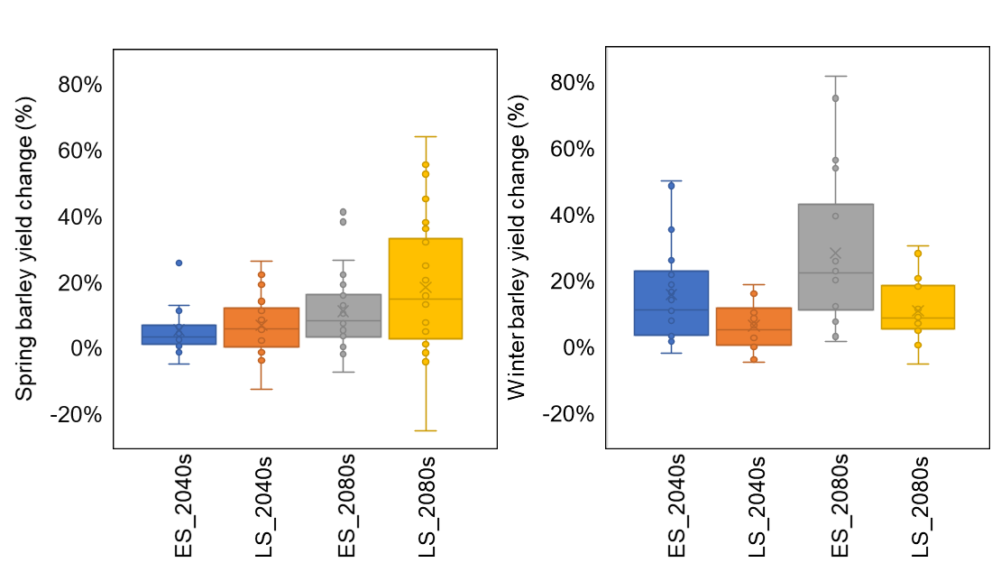
Supplementary Fig. 1 | Change in yield of winter and spring barley for 2040 (2030-2059) and 2080 (2070-2099) relative to the baseline period of 1985-2016 under early (ES) or late sowing (LS) for SSP585. Yield projections were simulated with a modified version of APSIM using climate projections from 27 GCMs. Boxplots indicate simulated yield change across sites and GCMs; box boundaries indicate 25th and 75th percentiles, and whiskers below and above the box indicate the 10th and 90th percentiles.

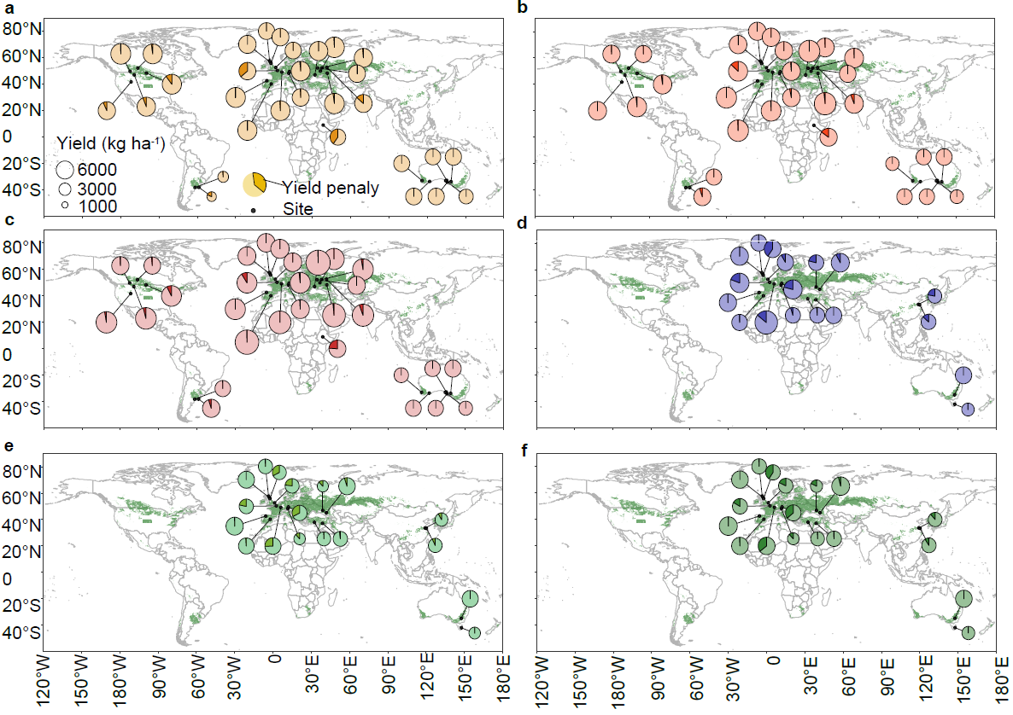
Supplementary Fig. 2 | Simulated yields for 2040 (2030-2059) and 2080 (2070-2099) under early (ES) or late sowing (LS). a-f, simulated yields (expressed as circles with two portions: yield penalty caused by waterlogging stress highlighted with darker shade) for spring barley under early sowing in 2040 (a), yields from spring barley under late sowing in 2040 (b) and 2080 (c), yields for winter barley under early sowing in 2040 (d), and simulated yields for winter barley under late sowing in 2040 (e) and 2080 (f). Yields were simulated with APSIM using downscaled data from 27 GCMs. Green regions on each map depict predominant barley cropping regions.
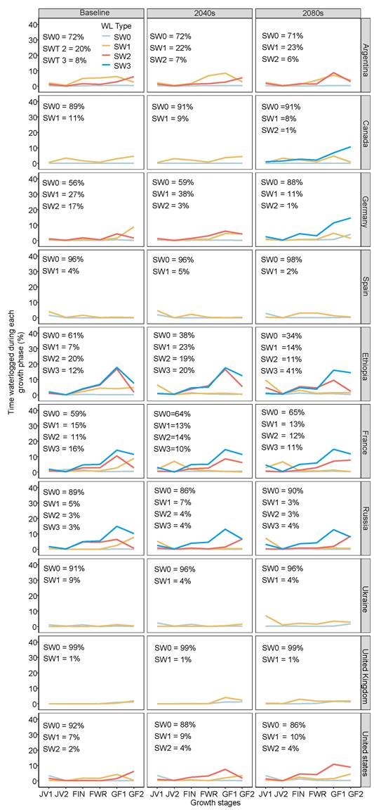
Supplementary Fig. 3| Waterlogging stress patterns and frequencies for the baseline (1985-2016), 2040 (2030-2059) and 2080 (2070-2090) periods across countries, genotypes and sowing dates. Waterlogging stress patterns for spring barley include (SW0, low waterlogging; SW1: low moderate-late waterlogging; SW2; late-onset moderate waterlogging; SW3: late-onset severe waterlogging) and winter barley (WW0: low waterlogging; WW1: low early-onset waterlogging relieved later; WW2: moderate early-onset waterlogging; WW3: severe early-onset waterlogging) and were identified by clustering seasonal time-courses of waterlogging stress across years, sowing dates, genotypes and countries. Growth stages include the early juvenile phase (JV1, 10<=APSIM growth stage<21); the late juvenile phase (JV2, 21<=APSIM growth stage<32); floral initiation to heading (FIN, 32<=APSIM growth stage<65); flowering to grain filling (FIN, 65<=APSIM growth stage<71; early grain filling (GF1, 71<=APSIM growth stage<80) and late grain filling (GF2, 80<=APSIM growth stage<87).

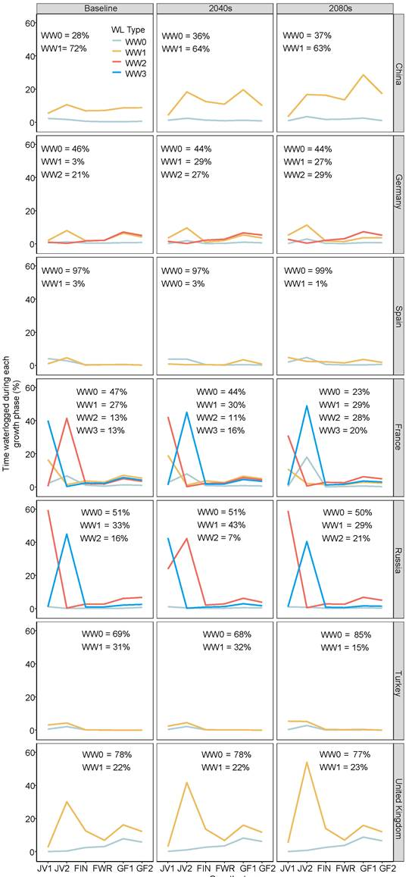
Supplementary Fig. 4| Waterlogging stress patterns and frequencies for the baseline period (1985-2016), 2040 (2030-2059) and 2080 (2070-2099) across countries and sowing dates. Waterlogging stress patterns for winter barley include (WW0: low waterlogging; WW1: low early-onset waterlogging relieved later; WW2: moderate early-onset waterlogging; WW3: severe early-onset waterlogging) and were identified by clustering seasonal time-courses of waterlogging stress across years, sowing dates, genotypes and countries. Growth stages include early juvenile development (JV1, 10<=APSIM growth stage<21); late juvenile development (JV2, 21<=APSIM growth stage<32); floral initiation to heading (FIN, 32<=APSIM growth stage<65); flowering to grain filling (FIN, 65<=APSIM growth stage<71; early grain filling (GF1, 71<=APSIM growth stage<80); late grain filling (GF2, 80<=APSIM growth stage<87).

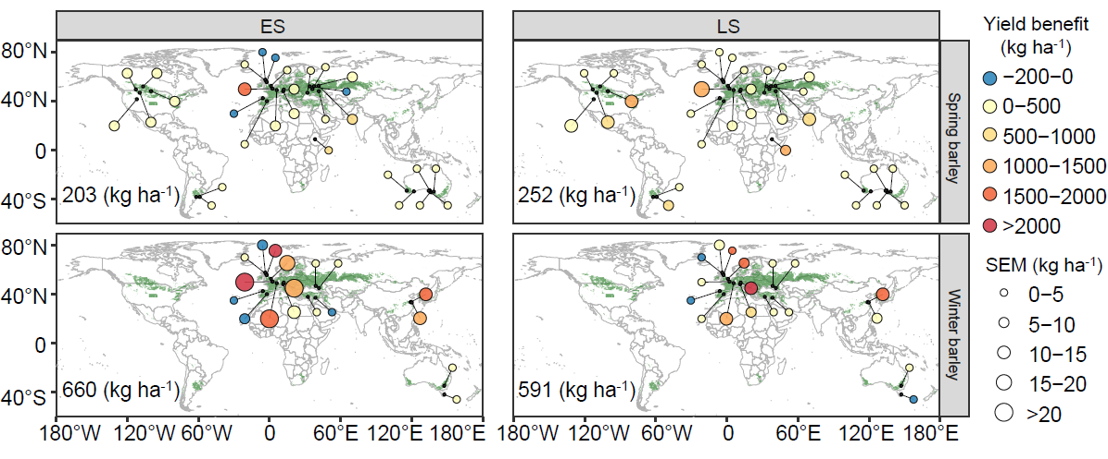
Supplementary Fig. 5| Mean and SEM of yield benefit associated with waterlogging tolerant barley genotypes compared with genotypes without waterlogging tolerance genes for the 2080 (2070-2099). Points are averaged across years and 27 GCMs in which growing season rainfall is higher than the 90th percentile; numerical values shown in each panel represent mean yield benefit across sites, years and GCMs.

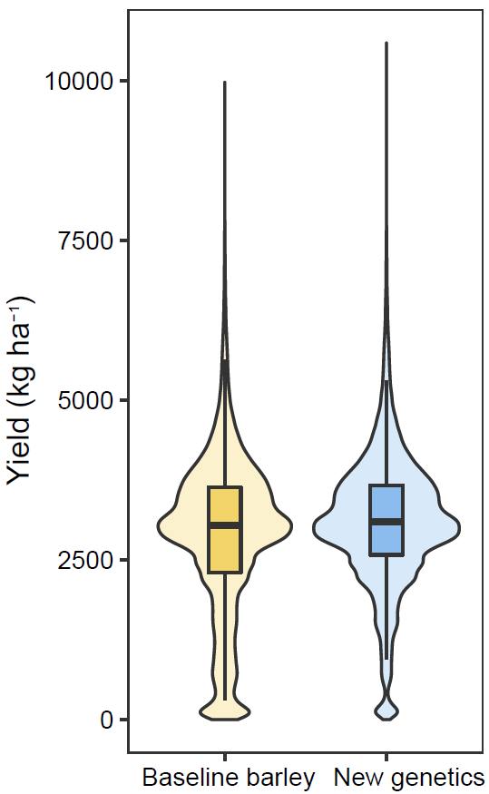
Supplementary Fig. 6. | Simulated yield of barley genotypes with and without waterlogging tolerance genetics. Yield distributions were simulated under historical climates (1985-2016) across sites and sowing dates. Violin plots are plotted using the average of simulated values (1985-2016) at each site. The bottom, centre and top lines of the box represent the 25th, median and 75th percentiles.

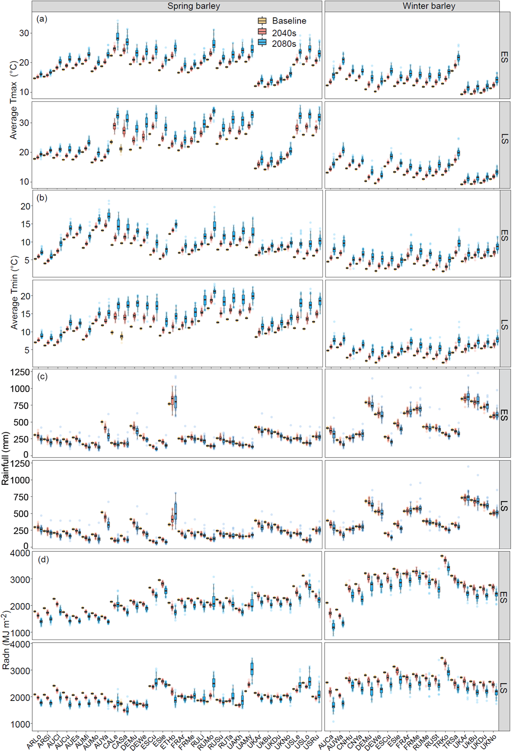
Supplementary Fig. 7| Projected changes in temperature, rainfall and solar radiations projected from 27 GCMs for SSP585 in 2040 (2030-2059) and 2080 (2070-2099) compared with measured baseline values (1985-2016) at each site. a-d, maximum temperature (a), minimum temperature (b), growing season rainfall (c), and growing season solar radiation (d). Boxplots show the 10th, 25th, 75th and 90th percentiles. Full names of the 27 GCMs are shown in Supplementary Table 4; ESD and LSD refer to early sowing and late sowing dates, respectively. Labels on the x-axis are abbreviations depicting country name concatenated with site name e.g. ARLo = Loberia, Argentina; ARSi = Sierra de La Ventana, Argentina; see Supplementary Table 1.

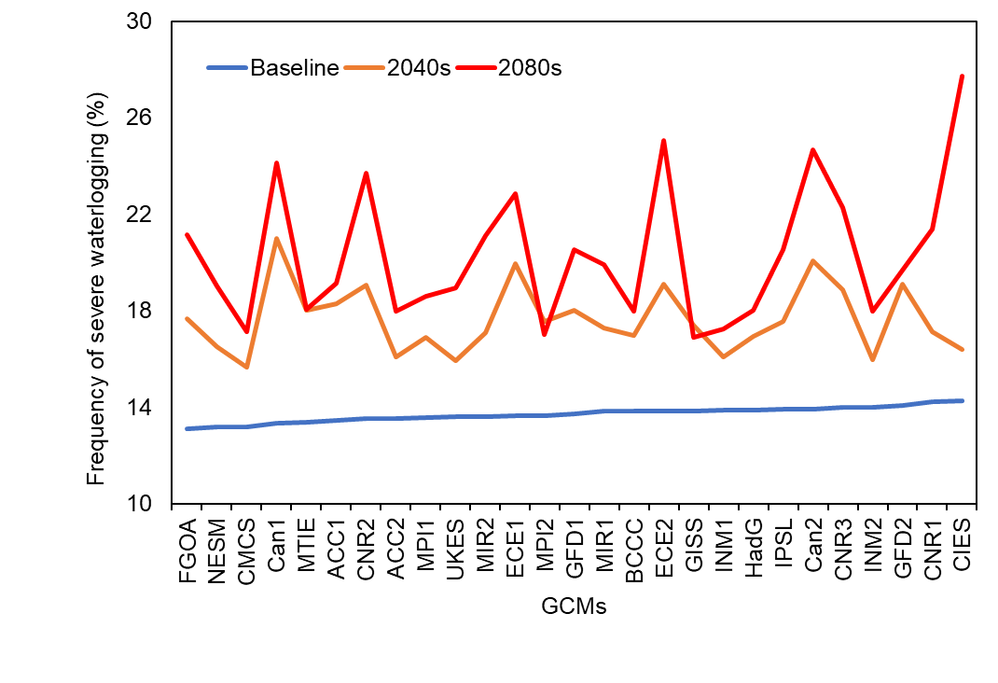
Supplementary Fig. 8| Projected risk of extreme waterlogging for each GCM for SSP585 for the baseline (1985-2016), 2040 (2030-2059) and 2080 (2070-2099). Risk of extreme waterlogging was computed as the sum of SW2 and SW3 for spring barley and WW2 and WW3 for winter barley (see Supplementary Fig. 3).

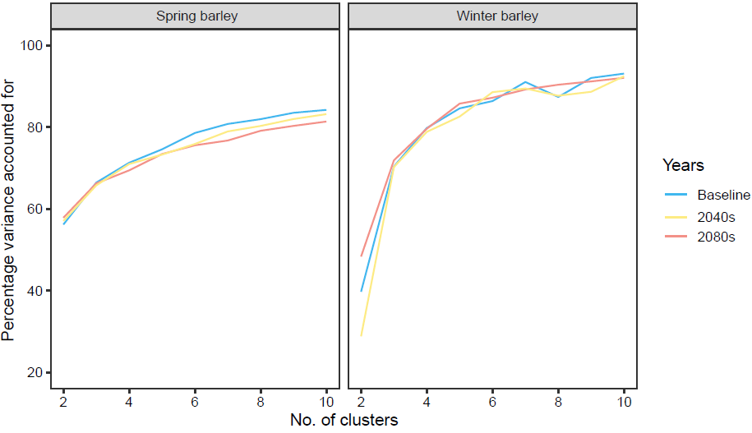
Supplementary Fig. 9| Percentage variance accounted for by k-means clusters for the baseline (1985-2016), 2040 (2030-2059) and 2080 (2070-2099).

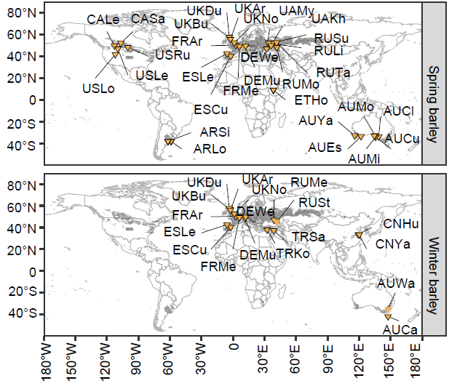
Supplementary Fig. 10| Study sites representing global barley production regions^{8,9}. Point labels are abbreviations depicting country name concatenated with site name e.g. ARLo = Loberia, Argentina; ARSi = Sierra de La Ventana, Argentina; see Supplementary Table 1.

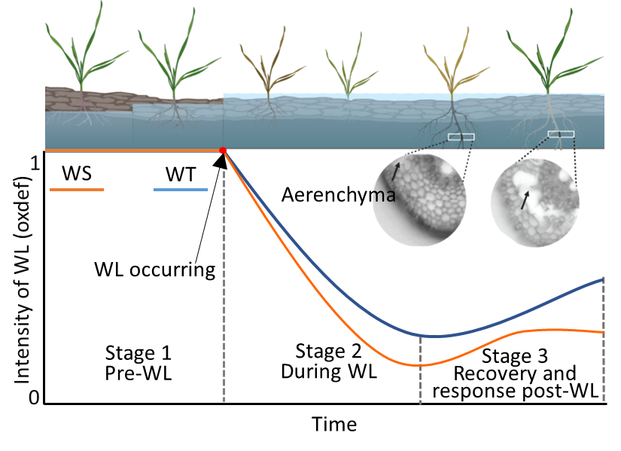
Supplementary Fig. 11| Conceptual design of crop response, adaptation and recovery from waterlogging for alternative genotypes (WS: waterlogging susceptible; WT: waterlogging tolerant).

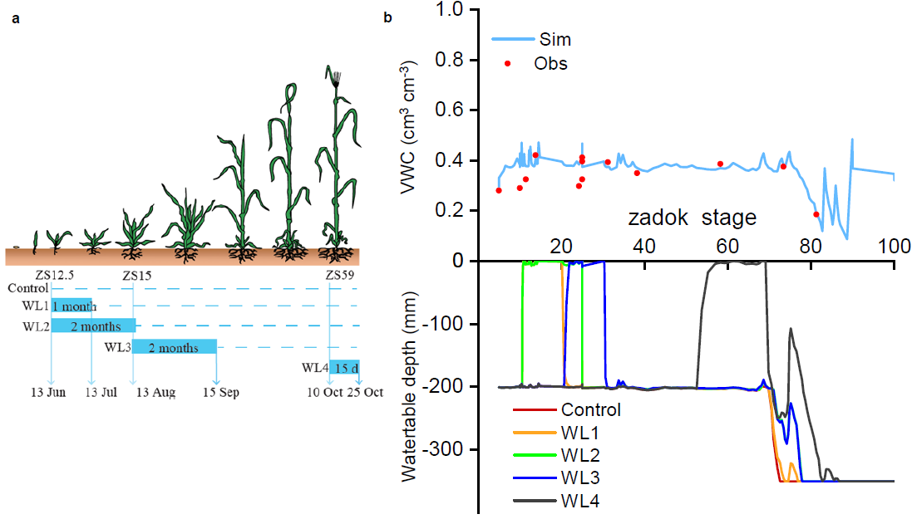
Supplementary Fig. 12| Simulated and observed volumetric soil water content (VWC) and water table dynamics with SWIM3 in APSIM. Experiments were conducted at Mt Pleasant Laboratories, Launceston, Tasmania, Australia². a, diagram indicating the start and end date of each waterlogging treatment. WL1: waterlogging exposed at ZS12.5 for 1 month; WL2: waterlogging exposed at ZS12.5 for 2 months; WL3: waterlogging exposed at ZS15 for 2 months; WL4: waterlogging exposed at ZS59 for 15 days. WL4 treatment was not conducted on Franklin and Westminster. b, simulated and observed VWC and water table depth during the growing season.

3 Supplementary methods
Atmospheric CO₂ concentrations
For the 1985-2016 simulations, atmospheric CO₂ concentration was set to 350 ppm. For SSP585, the atmospheric CO₂ concentration was computed after Wang et al¹⁰:
$$\left[{CO}_{2}\right]year=1034.3+\frac{267.78-1.618*y}{4.0143+\frac{53.342}{y^{5.2822}}}+21.746*{\left(\frac{y-2010}{100}\right)}^{3}+100.65*{(\frac{y-1911}{100})}^{3}$$

Supplementary References
1. Liu K, Harrison MT, Archontoulis SV, Huth N, Yang R, Liu DL, et al. Climate change shifts forward flowering and reduces crop waterlogging stress. Environmental Research Letters 2021, 16(9): 094017.

2. Liu K, Harrison MT, Ibrahim A, Manik SN, Johnson P, Tian X, et al. Genetic factors increasing barley grain yields under soil waterlogging. Food and Energy Security 2020, 9(4): e238.

3. de San Celedonio RP, Abeledo LG, Miralles DJ. Identifying the critical period for waterlogging on yield and its components in wheat and barley. Plant and Soil 2014, 378(1): 265-277.

4. Borrego-Benjumea A, Carter A, Zhu M, Tucker JR, Zhou M, Badea A. Genome-Wide Association Study of Waterlogging Tolerance in Barley (Hordeum vulgare L.) Under Controlled Field Conditions. 2021, 12.

5. Byrne T, Grant J, Kock-Appelgren P, Förster L, Michel T, Miricescu A, et al. Improving phenotyping in winter barley cultivars towards waterlogging tolerance by combining field trials under natural conditions with controlled growth condition experiments. European Journal of Agronomy 2022, 133: 126432.

6. Xue D, Zhou M, Zhang X, Chen S, Wei K, Zeng F, et al. Identification of QTLs for yield and yield components of barley under different growth conditions. J Zhejiang Univ Sci B 2010, 11(3): 169-176.

7. Xiao Y, Wei K, Chen J, Zhou M, Zhang G. Genotypic Difference in Growth Inhibition and Yield Loss of Barley under Waterlogging Stress. Journal of Zhejiang University (Agric & Life Sci) 2007, 33(5): 525-532.

8. International Food Policy Research Institute. Global spatially-disaggregated crop production statistics data for 2010 version 1.0. 2019.

9. Global Active Archive of Large Flood Events, Dartmouth Flood Observatory, University of Colorado. http://floodobservatory.colorado.edu/Archives/index.html (Accessed on 1 January 2022).

10. Wang B, Feng P, Liu DL, O’Leary GJ, Macadam I, Waters C, et al. Sources of uncertainty for wheat yield projections under future climate are site-specific. Nature Food 2020, 1(11): 720-728.

