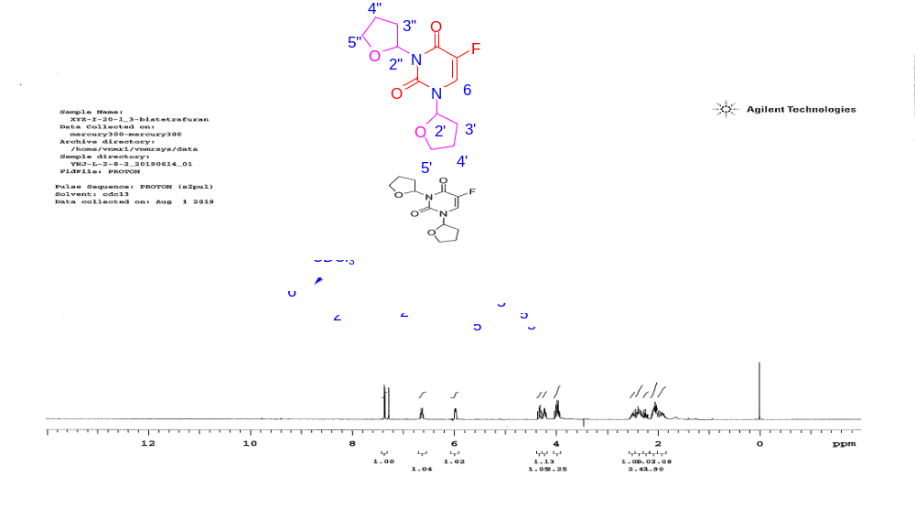
Supporting Figure 1
Figure 1 ¹H NMR analysis for MFU: ¹H NMR (CDCl_{3,} 300 MHz): 7.36 (1H, d, J_{H-F} = 6.0 Hz), 6.60 -6.67 (1H, m), 5.97 - 5.99 (1H, m), 4.32 (1H, td, J = 6.3, 8.4 Hz), 4.23 (1H, dt, J = 4.2, 8.7 Hz), 3.93 - 4.04 (2H, m), 2.44 - 2.54 (1H, m), 2.33 - 2.42 (2H, m), 2.20 - 2.28 (1H, m), 2.03 - 2.13 (2H, m), 1.86 - 1.96 (2H, m).
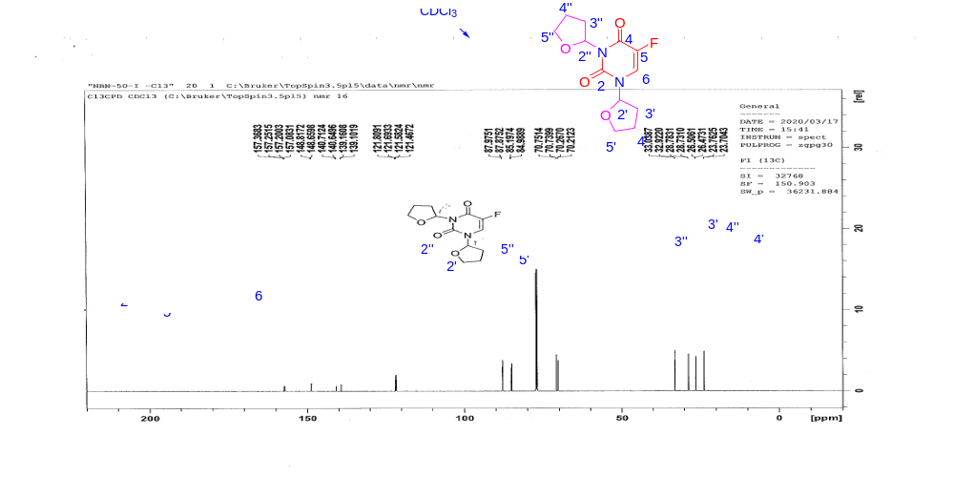
Supporting Figure 2
Figure 2 ¹³C NMR analysis for MFU: ¹³C NMR (CDCl₃, 151 MHz) δ (a mixture of two rotamers): 157.28 (d, J = 25.4 Hz), 157.17 (d, J = 25.4 Hz), 148.2, 148.66, 139.94 (d, J = 234.3 Hz), 139.87 (d, J = 234.3 Hz), 121.75 (d, J = 34.2 Hz), 121.58 (d, J = 34.2 Hz), 87.97, 87.87, 85.20, 84.99, 70.75, 70.74, 70.27, 70.21, 33.04, 32.92, 28.78, 28.73, 26.51, 26.47, 23.76, 23.70.

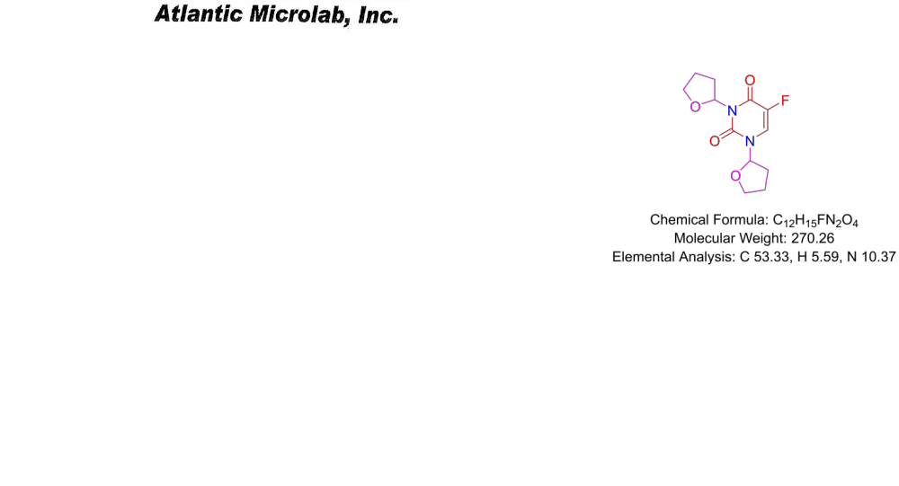
Supporting Figure 3
Figure 3: Micro-elemental analysis of MFU showing the percent by mass of the elements carbon, hydrogen and nitrogen in the structure of MFU compared to theoretical estimates
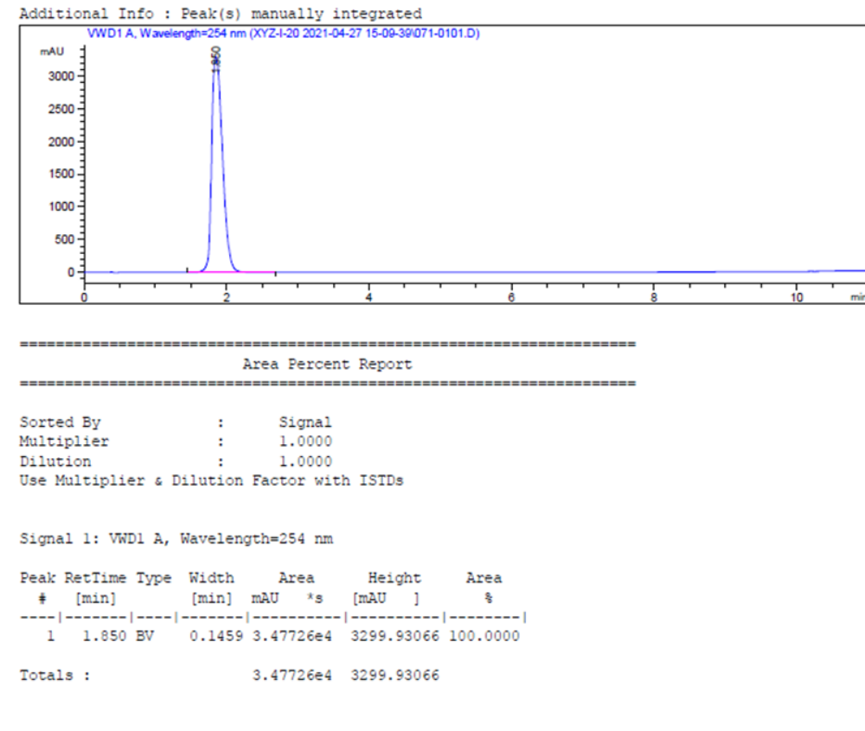
Supporting Figure 4
Figure 4: HPLC analysis of MFU showing a sharp peak at retention time of 1.85, performed by an independent laboratory using acetonitrile/water at a gradient of 20-90% with triethylammonium acetate (50mM) additive.
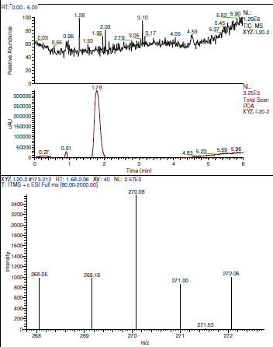
Supporting Figure 5
Figure 5: LC-MS analysis of MFU

