Figure S1
Generalized Principal Component Analyses plots obtained from expression patterns of bulb mite male samples. Color represents temperature (blue: 18°C, green 23°C, red 28°C). Empty triangles denote samples from fighter-selected populations, filled circles – samples from scrambler-selected populations.
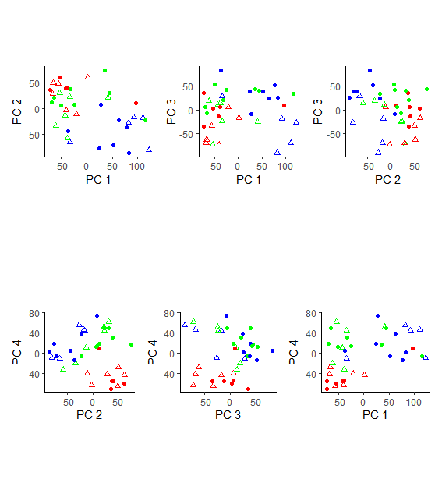

Figure S2
Generalized Principal Component Analyses plots obtained from bulb mite female samples. Color represents temperature (blue: 18°C, green 23°C, red 28°C). Empty triangles denote samples from fighter-selected populations, filled circles – samples from scrambler-selected populations.

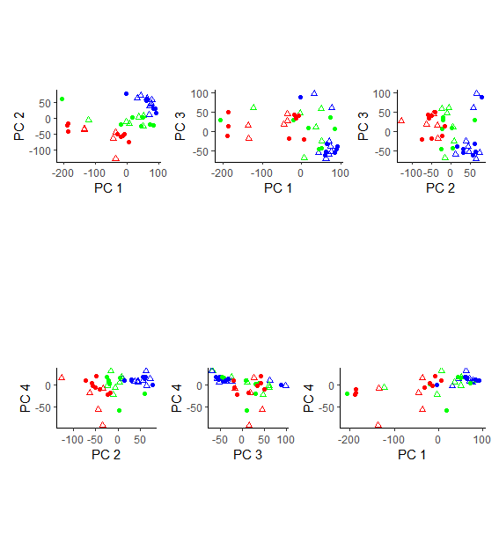

Figure S3. Visual representation of biological processes significantly enriched in males exposed to 18°C compared to 23°C (panel A) and 18°C compared to 23°C (panel B). More semantically similar terms are placed closer to each other. Color and size of circles correspond to a number of genes in a given category. Categories common for both thermal contrasts are marked with asterix.
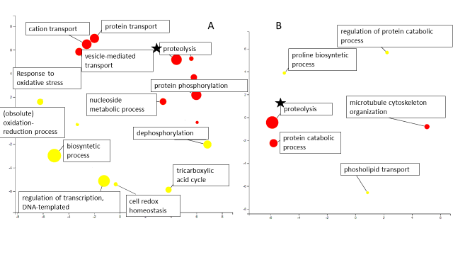

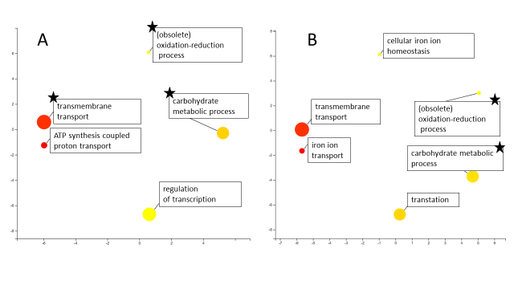
Figure S4. Visual representation of biological processes significantly enriched in females exposed to 18°C compared to 23°C (panel A) and 18°C compared to 23°C (panel B). More semantically similar terms are placed closer to each other. Color and size of circles correspond to a number of genes in a given category. Categories common for both thermal contrasts are marked with asterix.

